- Create one IAM user and assign EC2 and S3 full access roles.
Step 1: Goto IAMUsersCreate user give user detailsclick next.
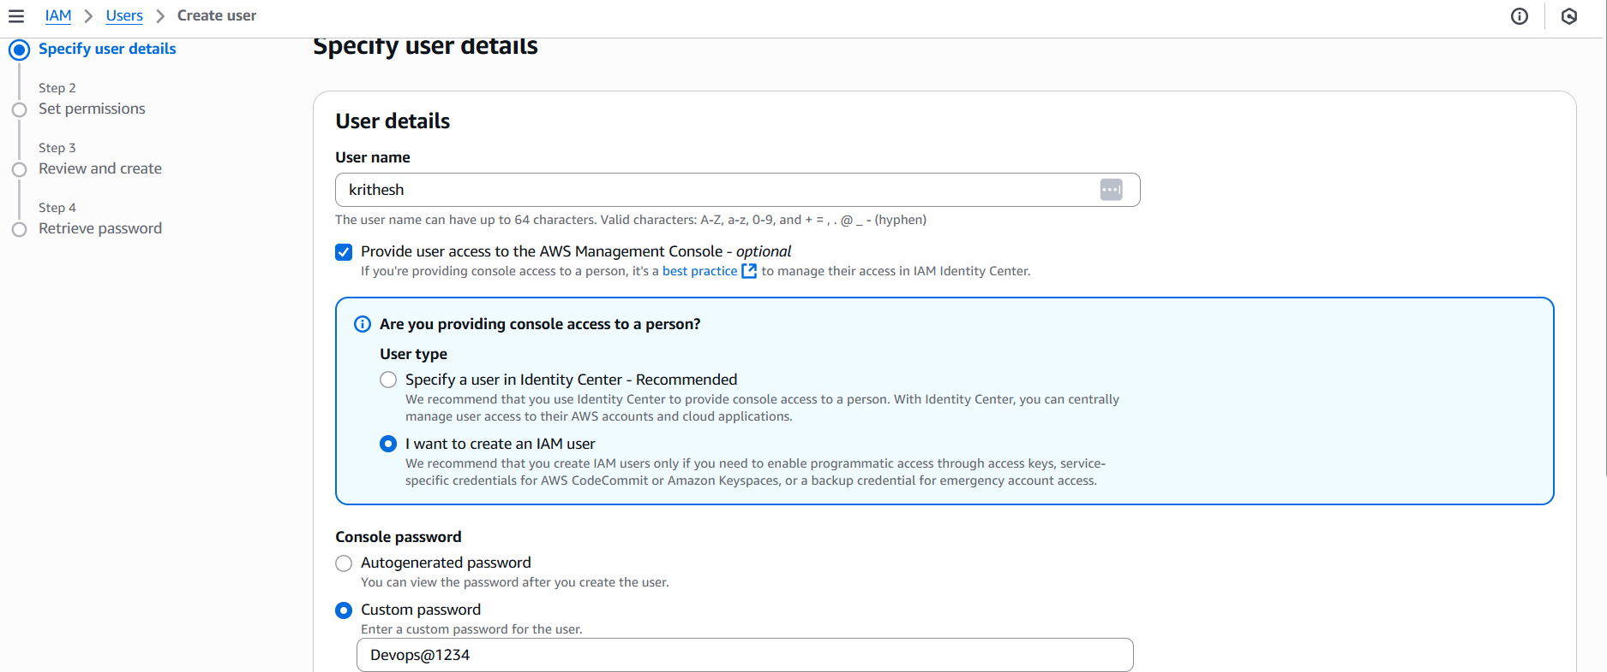
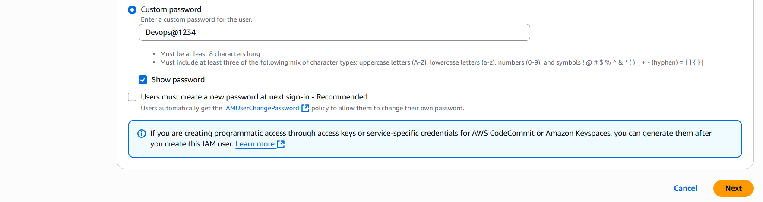
Step 2: select attach policies directlyselect S3, EC2 full accessNext.
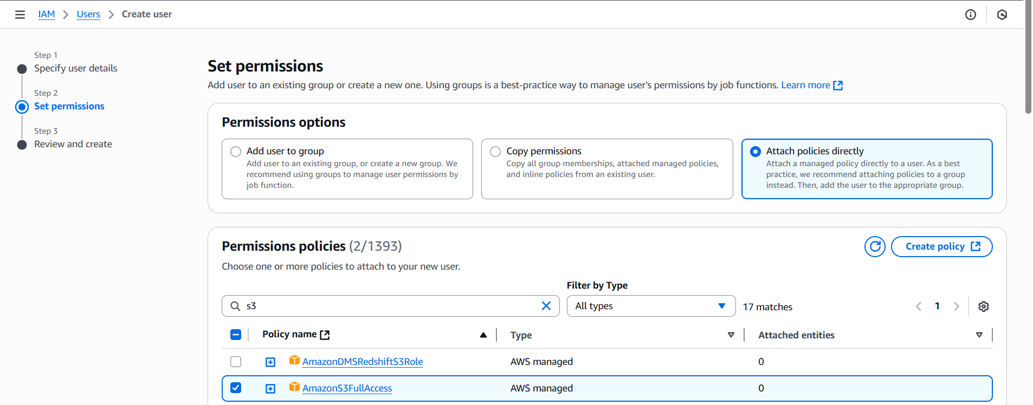
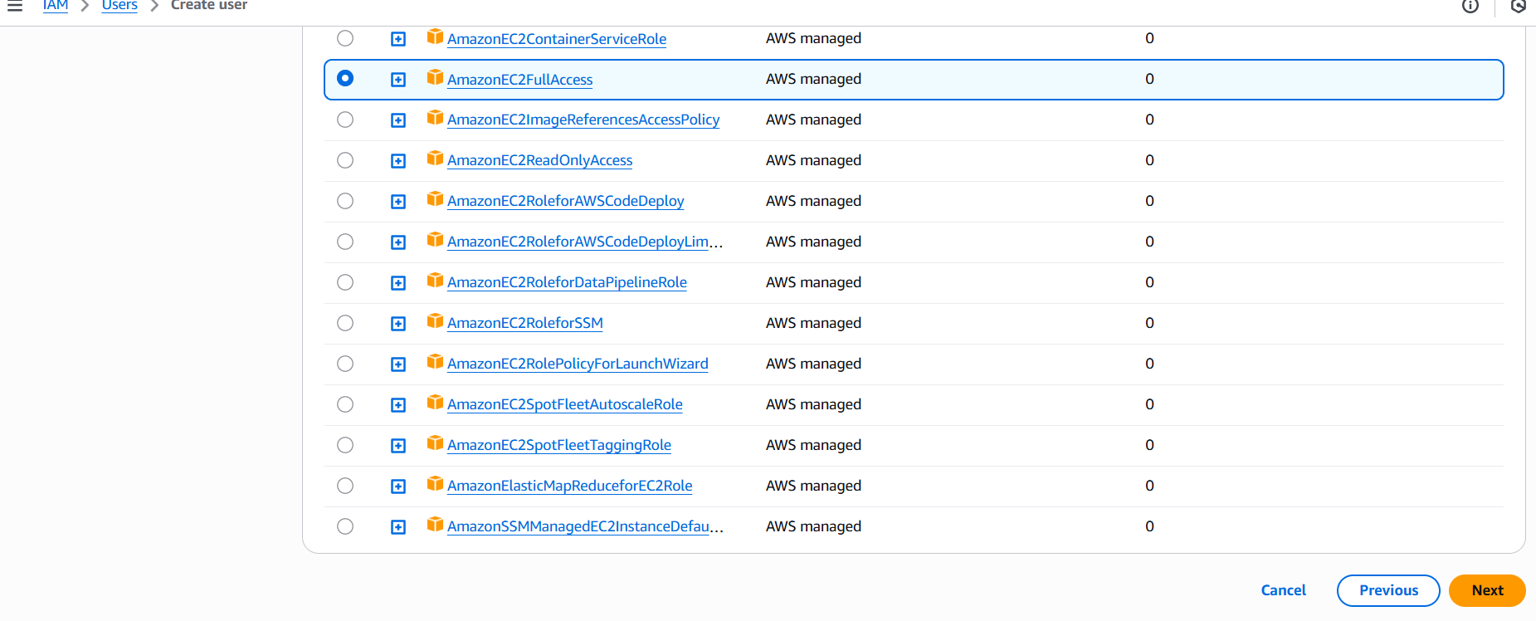
Step 3: Review and select create.
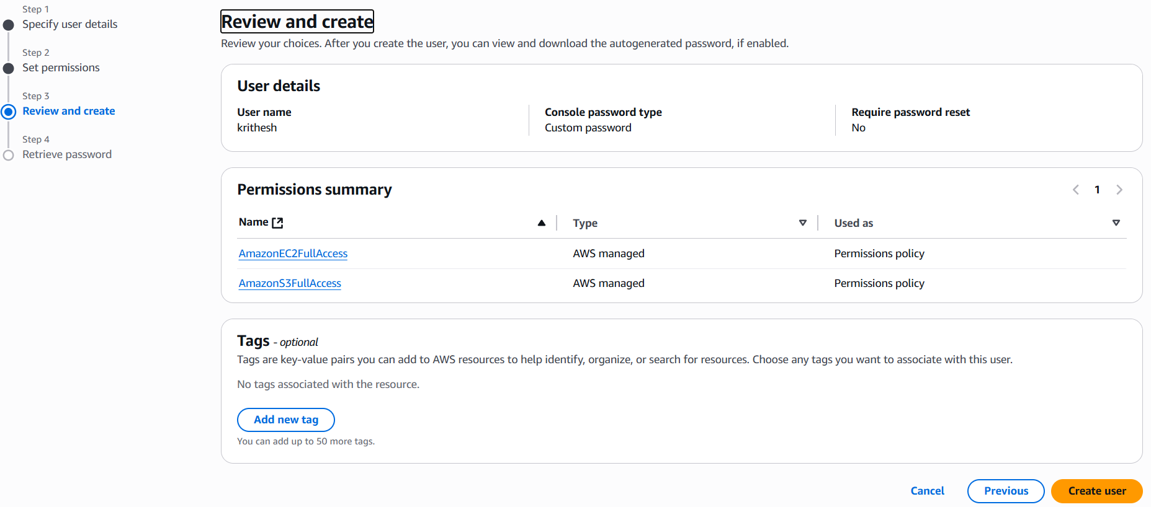
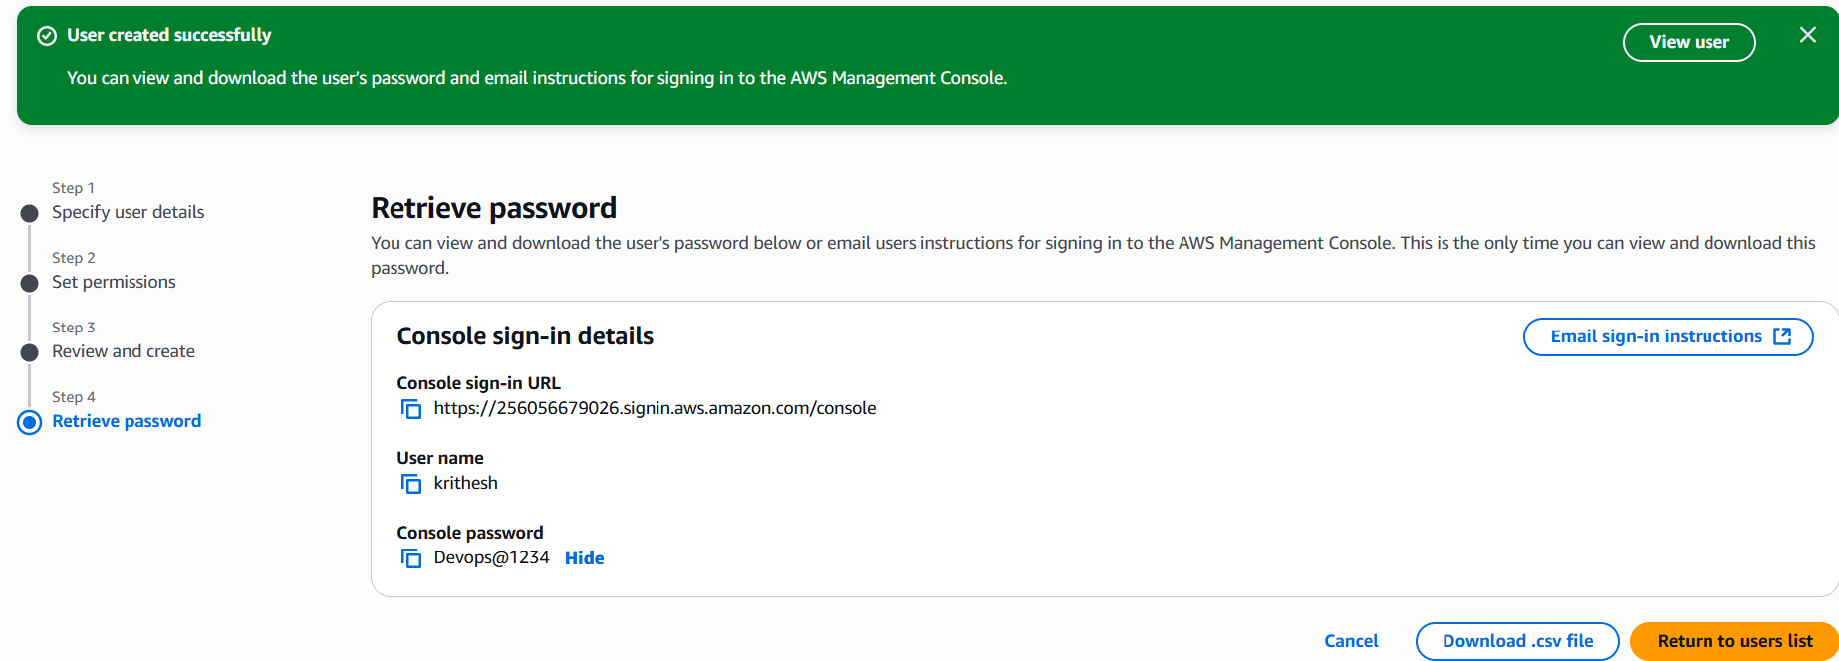

Step 4: Run the sign-in url in browser and login using username and password.
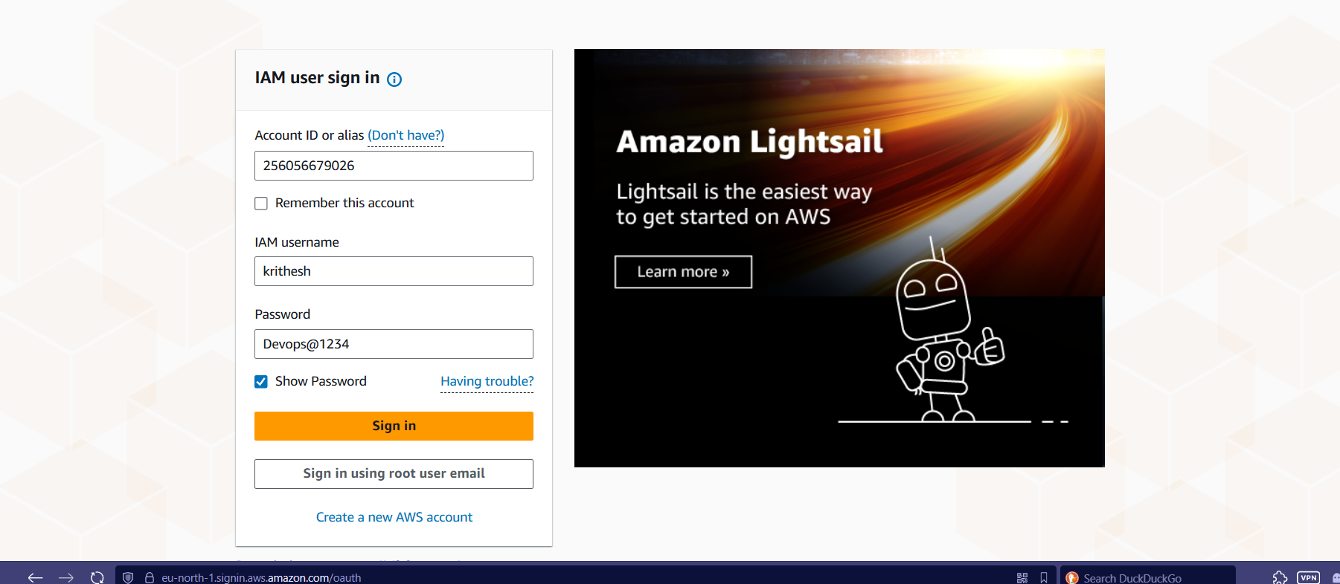
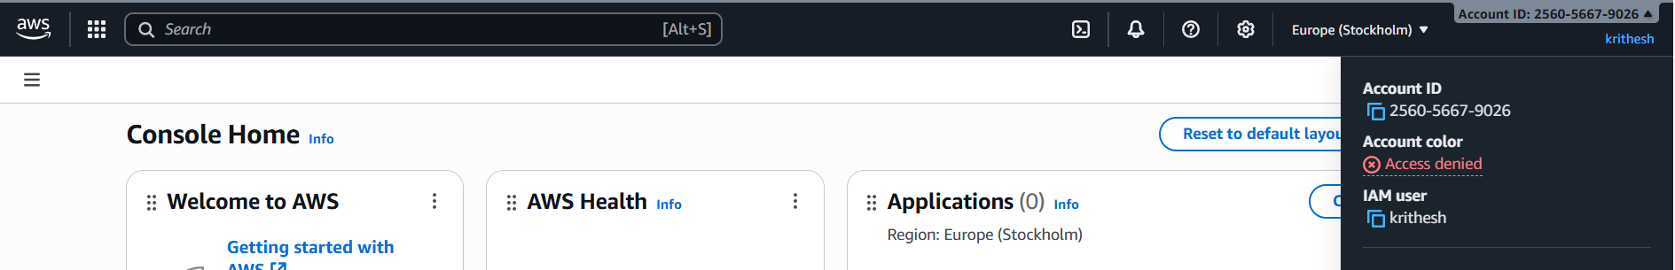
- Create one group in IAM and assign read access for EC2.
Step 1:Goto IAMUser groupsCreate groupprovide detailscreate user group.
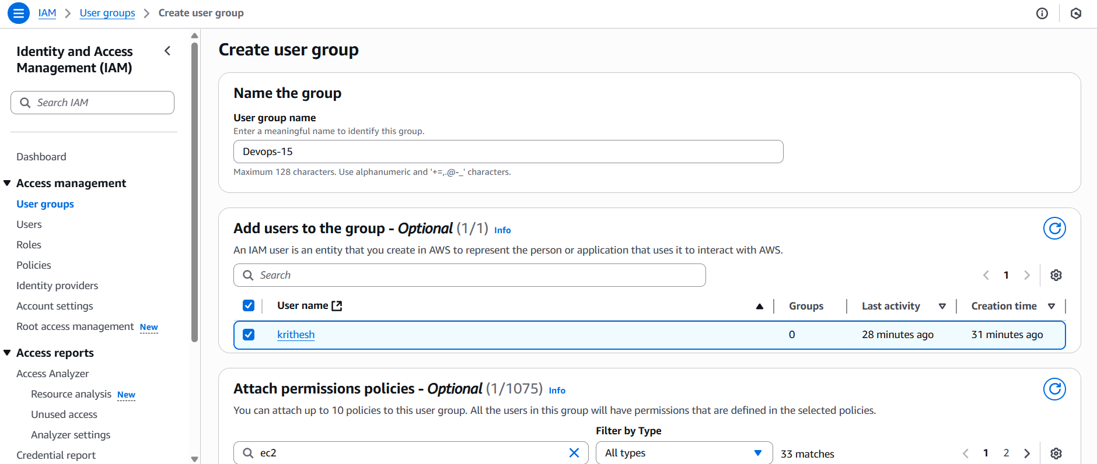
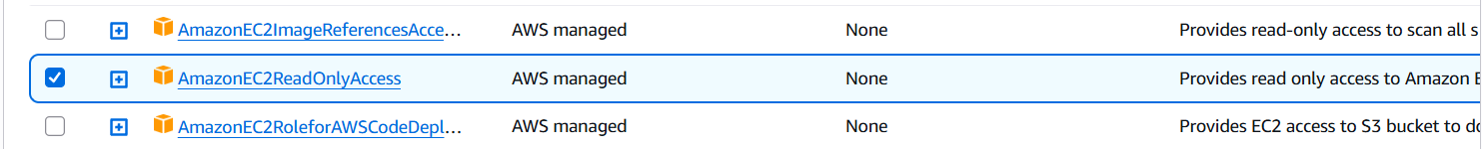

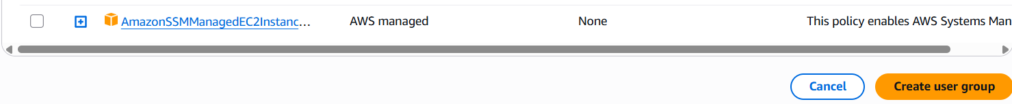
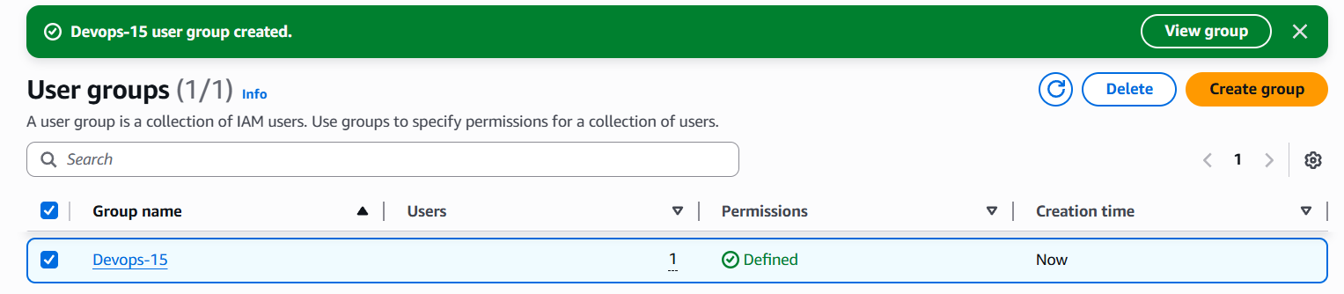

- Create a new user named "Devops" and add to the group created in task 2.
Step 1: Goto IAMUsersCreate userprovide detailsNext.
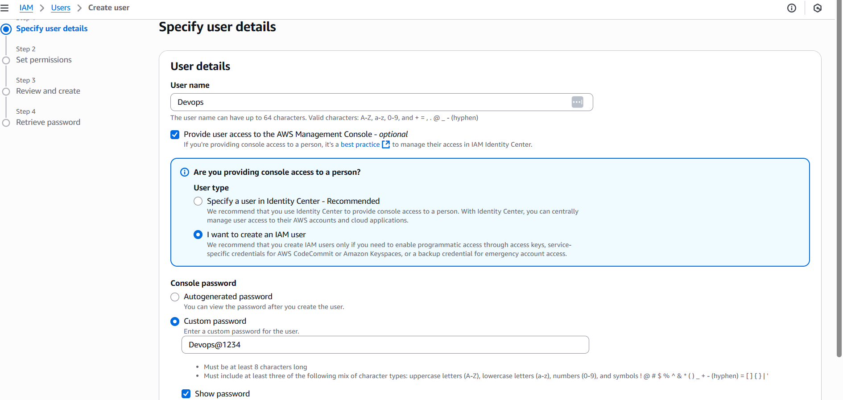
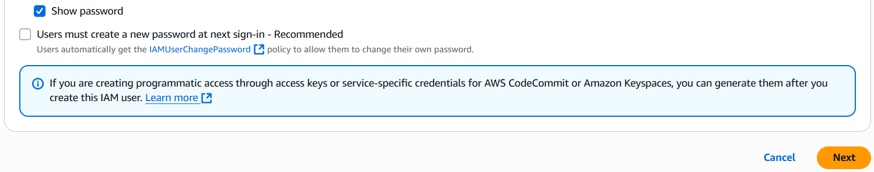
Step 2: Select Add user to group and select group nameNext.
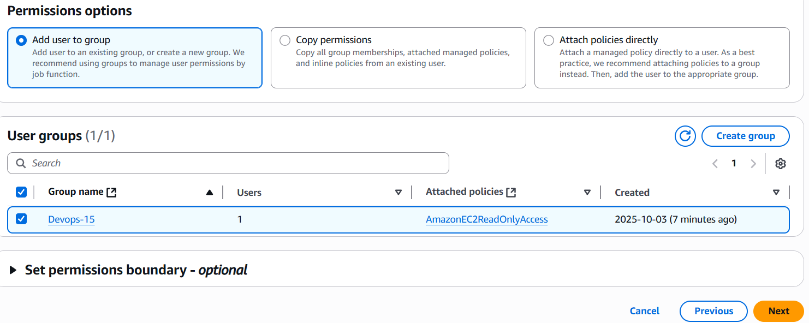

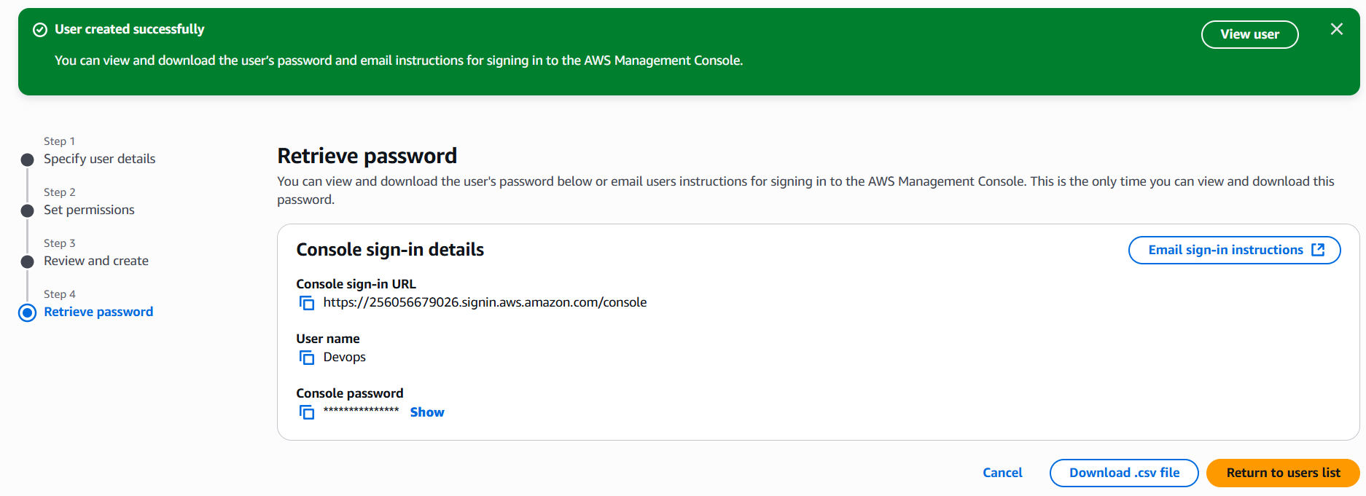

- Write a bash script to create an IAM user with VPC full access.
Step 1:Login to Ec2 instance and install AWS CLI.
Step 2: configure aws using aws configure command.
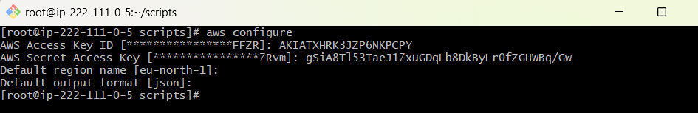
Step 3:Write a script to create IAM user.
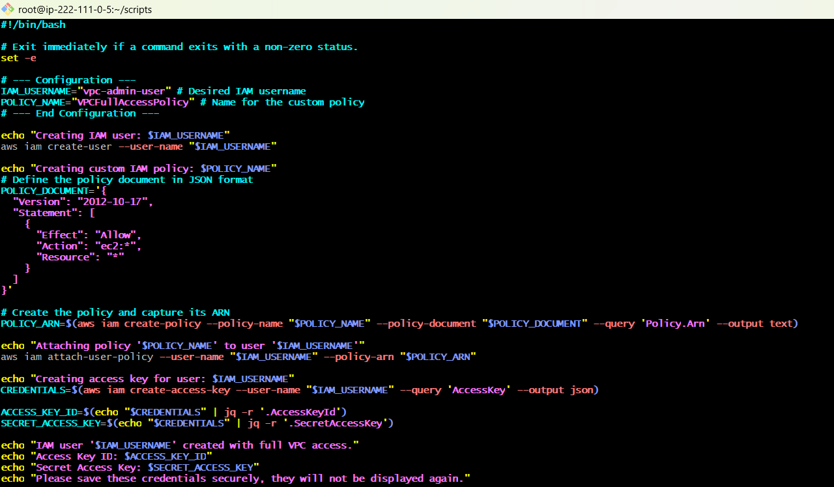

Step 4: Execute the script and check it in the console.
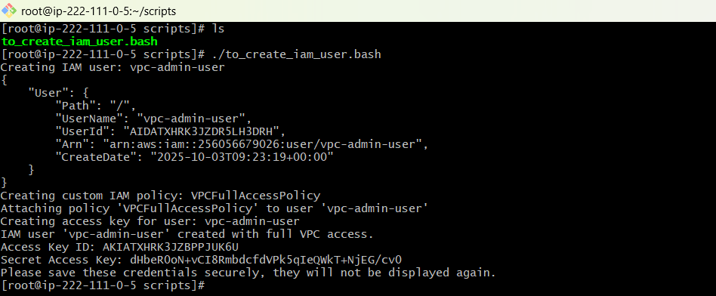
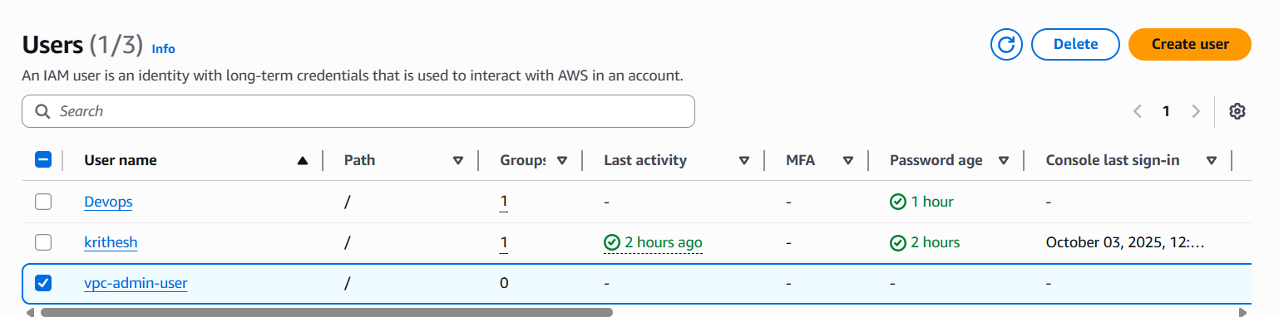

- Create an IAM policy to allow EC2 access for a specific user in specific regions only.
Step 1: Goto IAMPoliciesCreate policiesselect JSONwrite policy scriptNext.
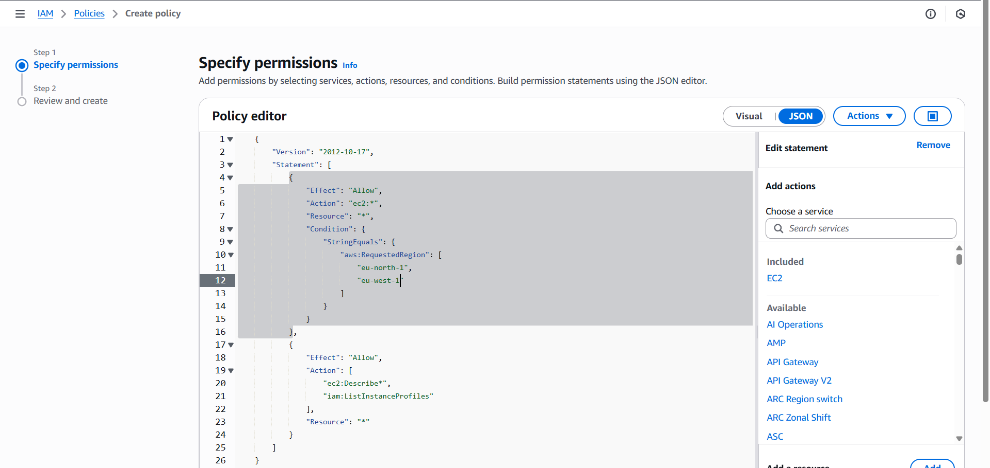

Step 2: Review and select create policy.
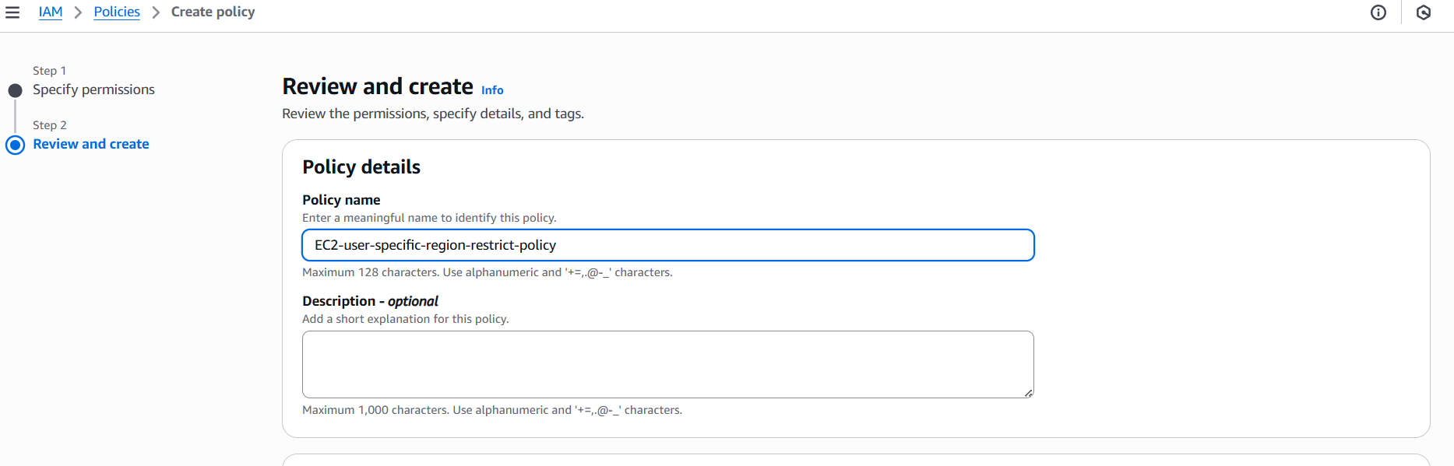
Step 3: Now goto Usersselect userSelect Add permission under Add permission.
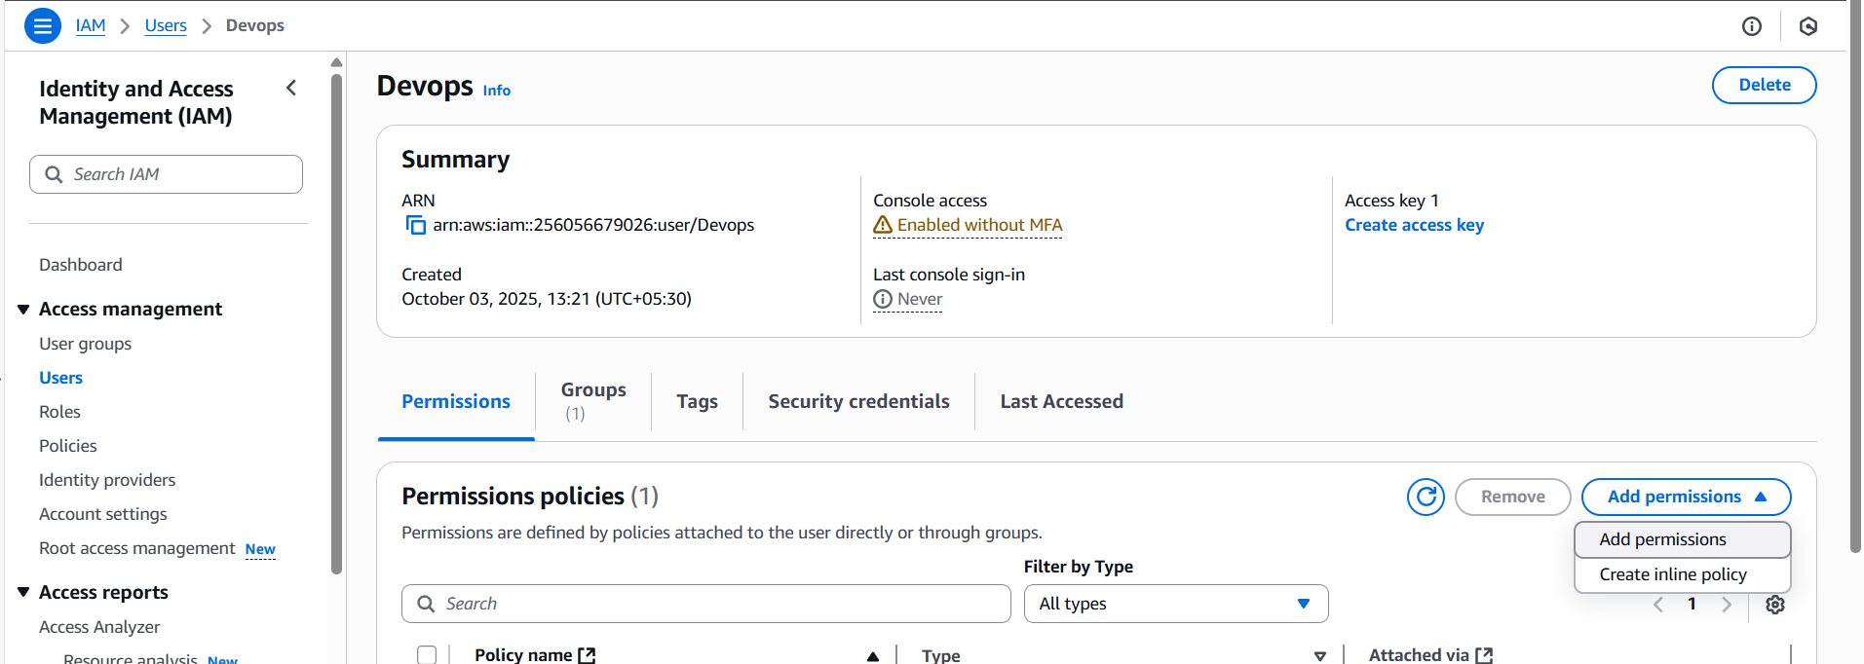
Step 4: select Attach policy directlyIn filter by type select customer managedselect policyselect next.
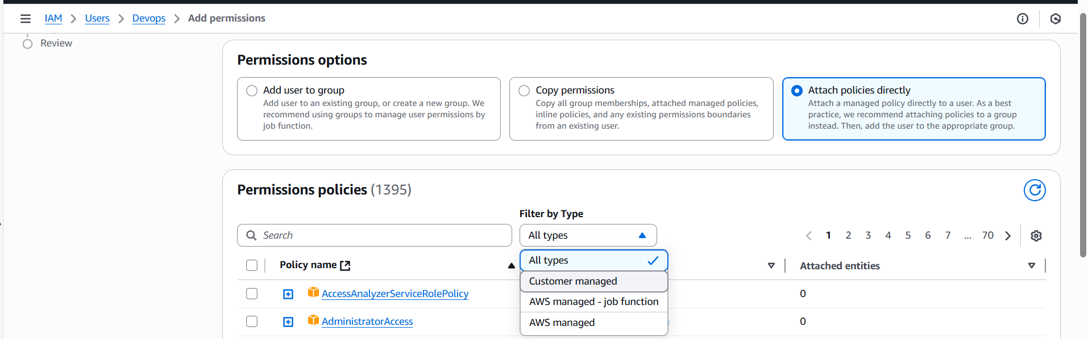

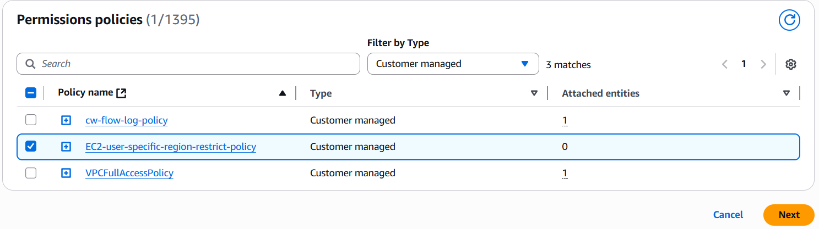
Step 5: Review and select Add permissions.
