1.Create one Declarative pipeline.
Stage 1: Git Clone
Step 1: Goto Jenkins GUI create a new job and Build it .
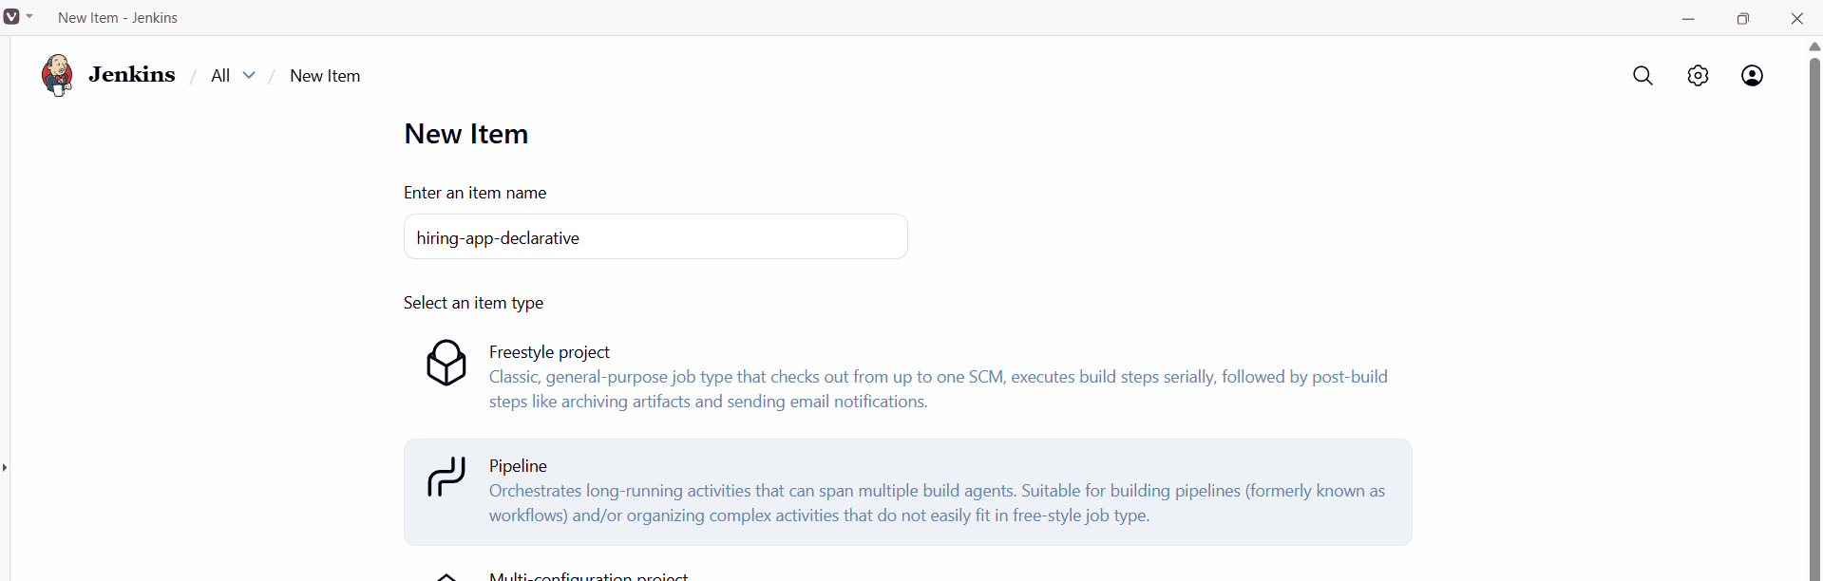
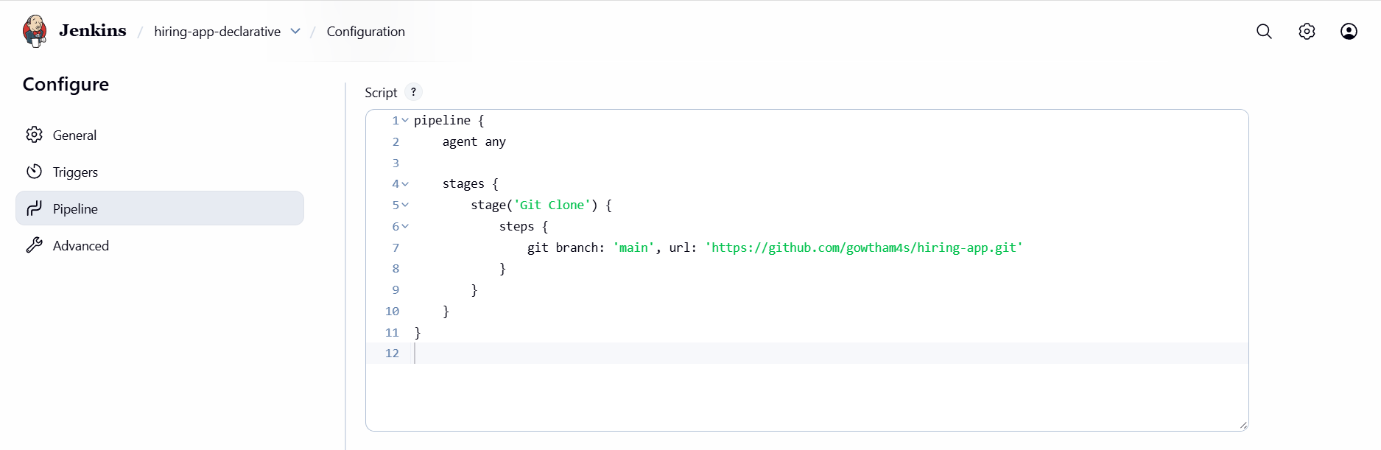
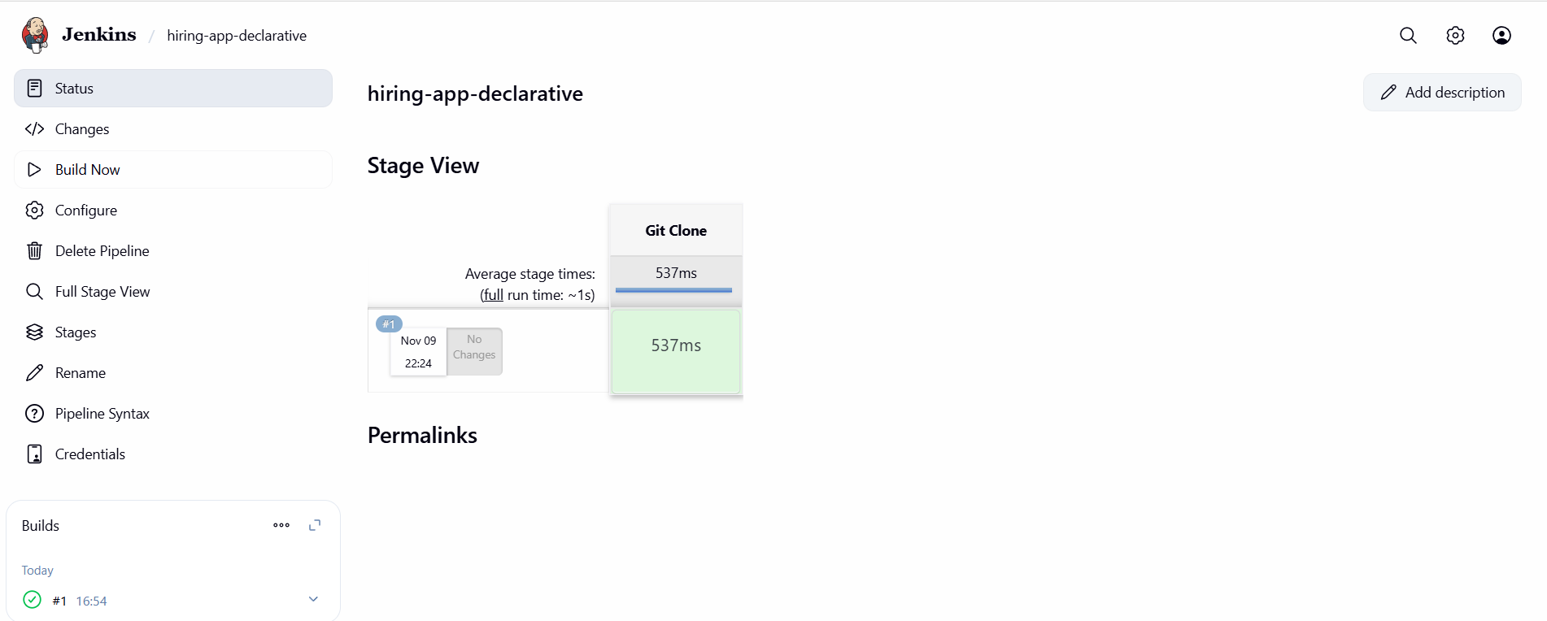
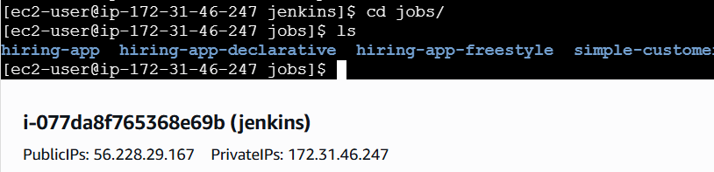
Stage 2: Maven Compilation
Step 1: Add Maven to the script and build it.
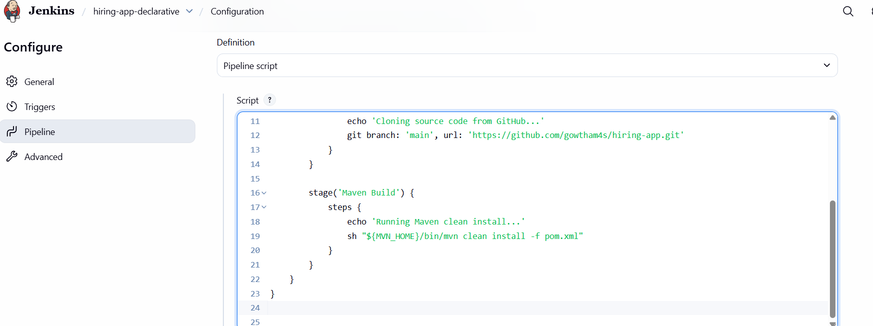
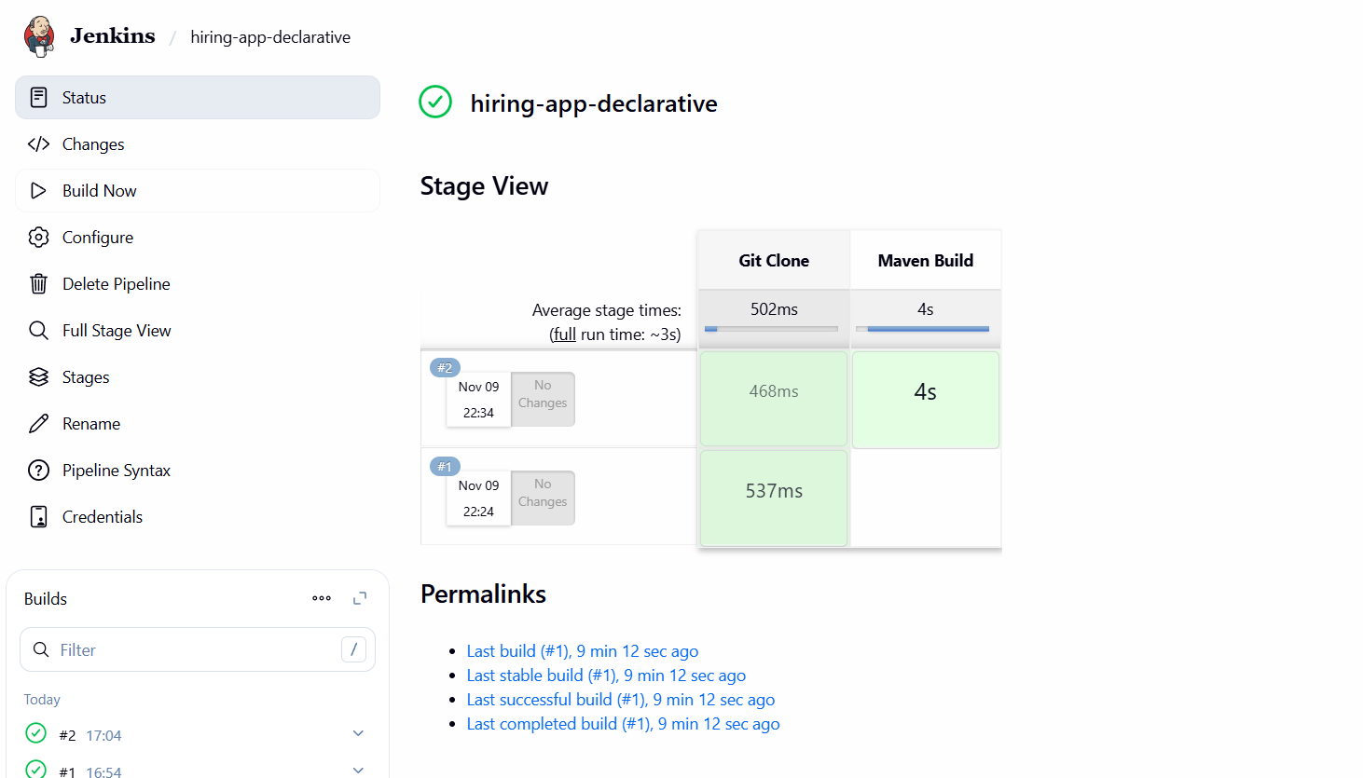
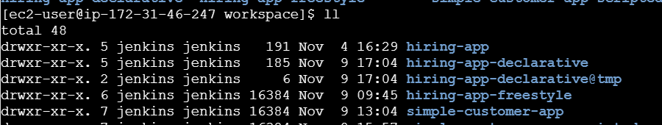

Stage 3: SonarQube Integration
Step 1: Goto Pipeline syntaxselect withSonarQubeEnvclick generate pipeline scriptadd that in declarative pipeline script and Build it.
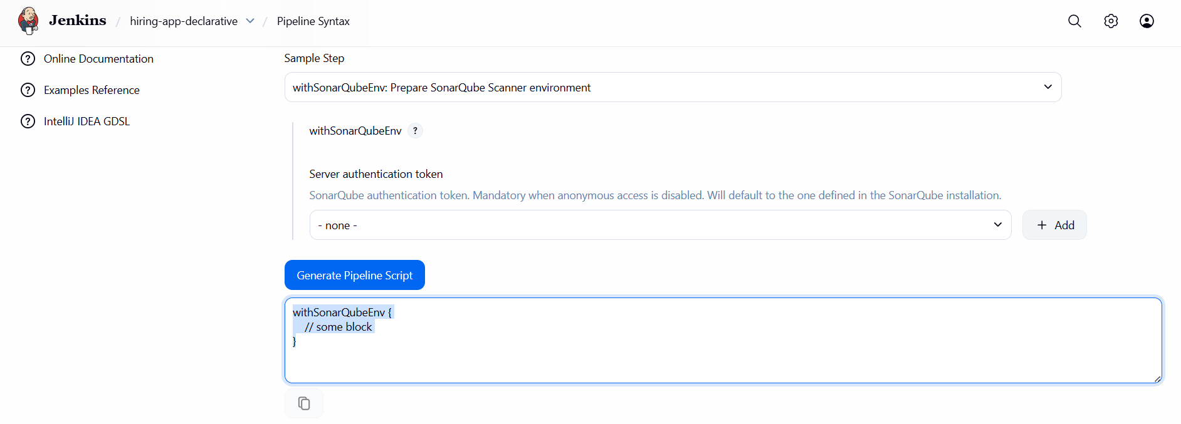
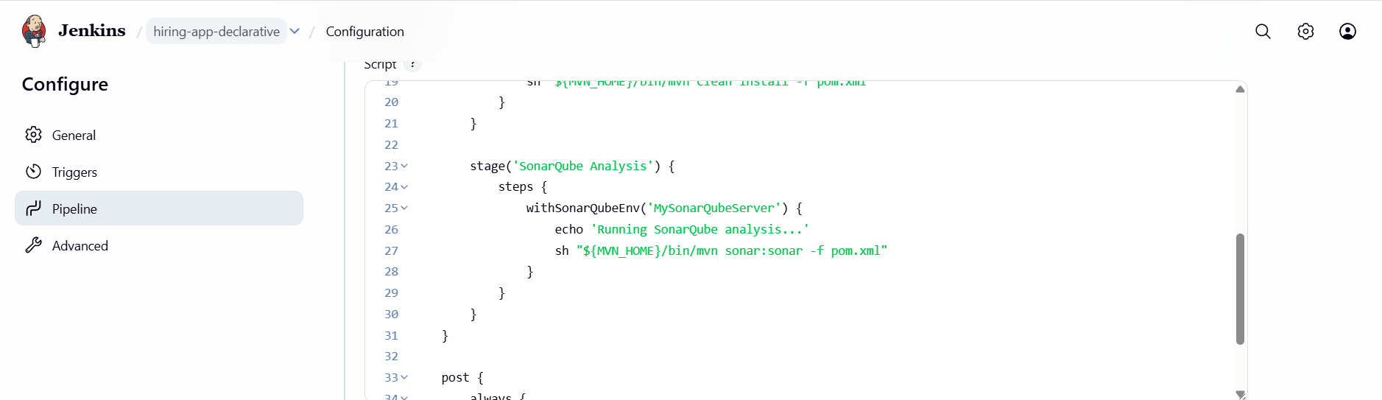
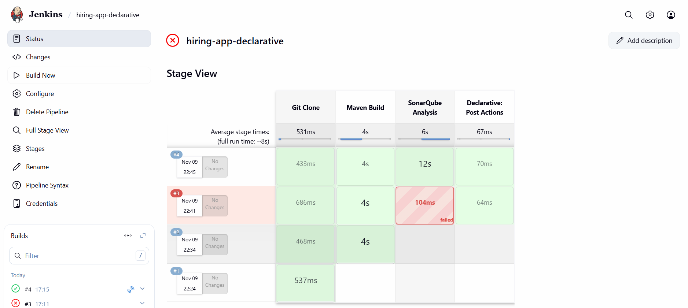
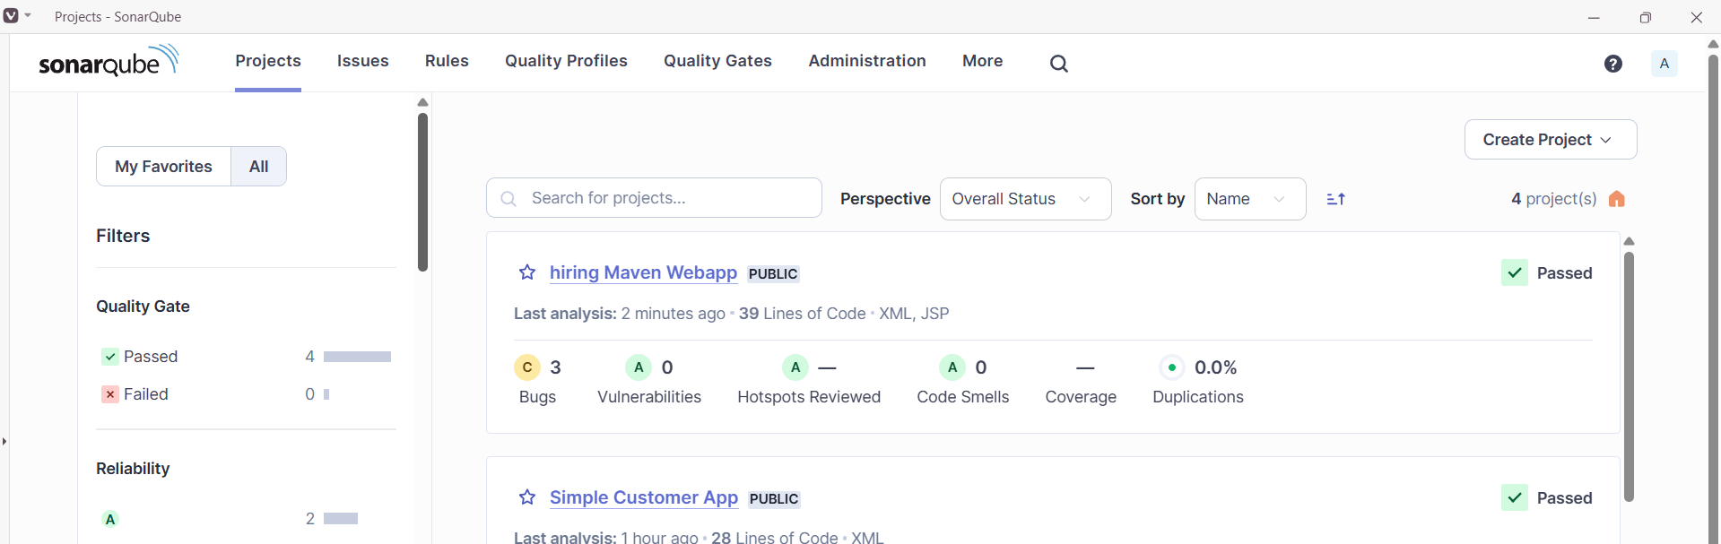
Stage 4:Nexus Artifactory
Step 1:Create a new repository in nexus.
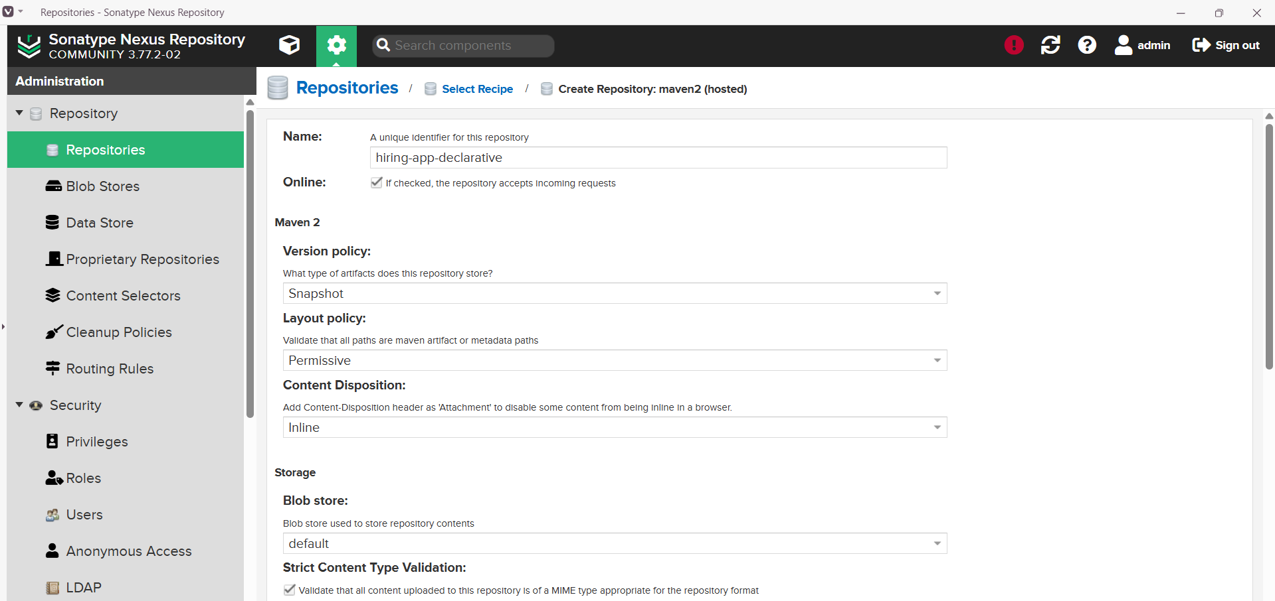
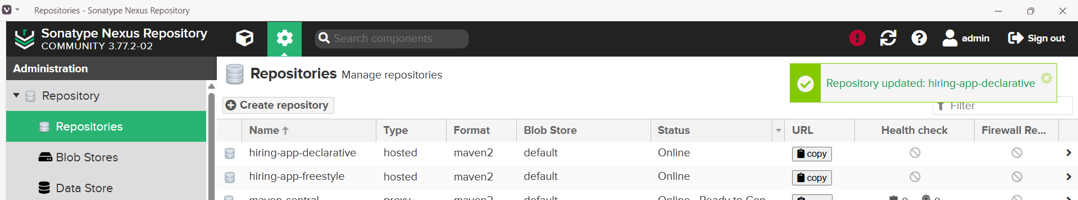
Step 2: Goto pipeline syntaxEnter detailsGenerate pipeline scriptupdate script & Build.
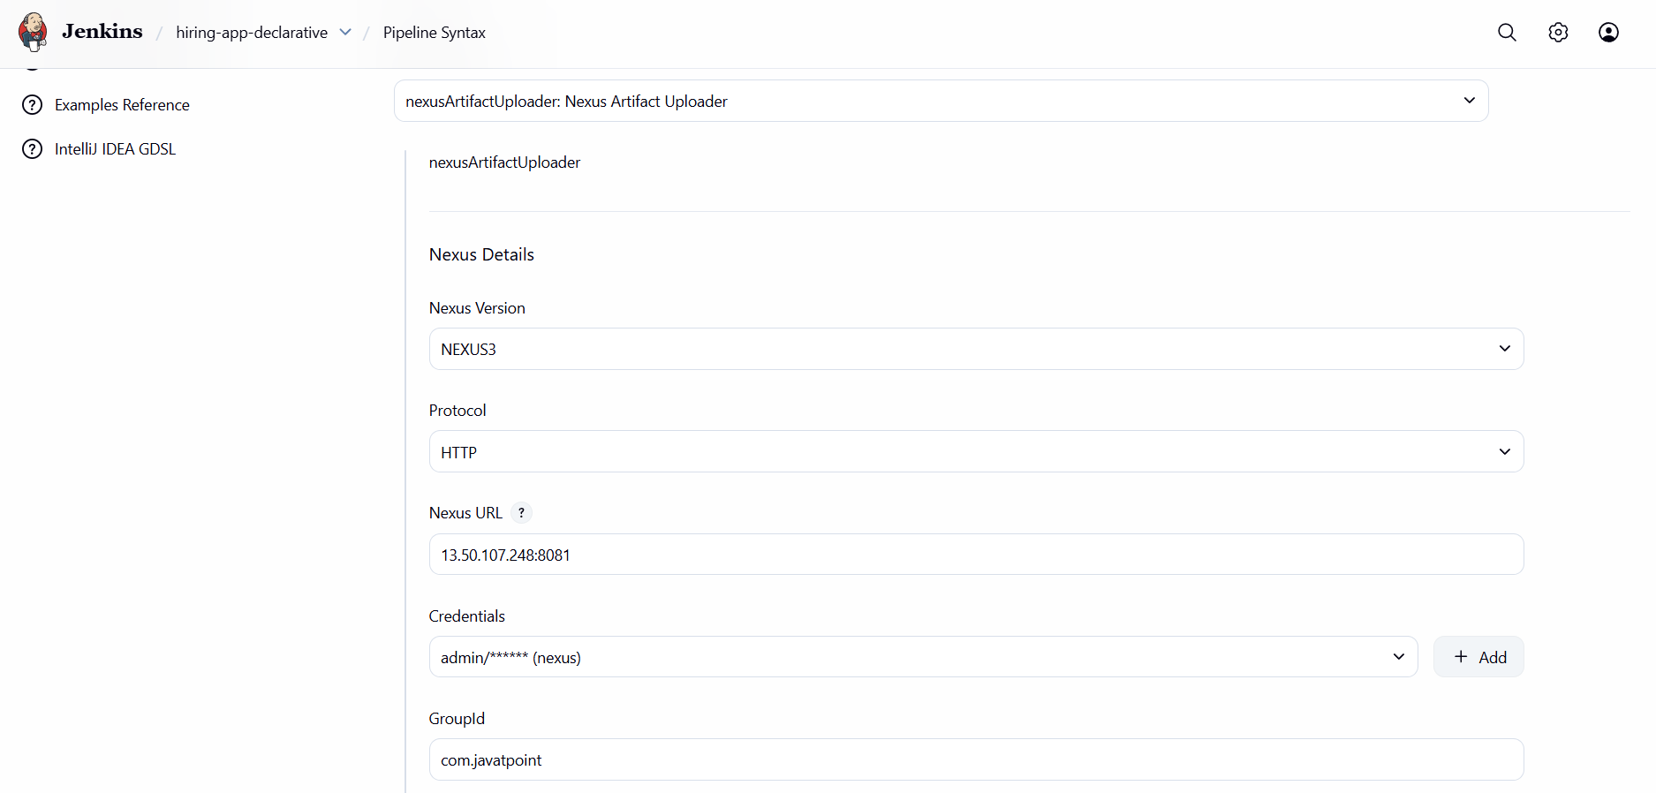
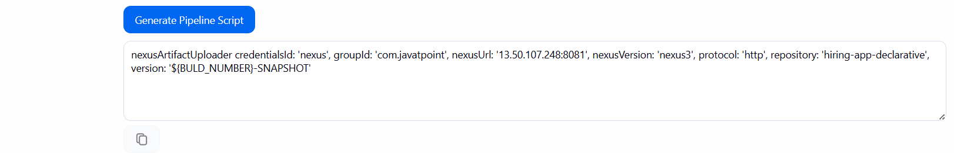
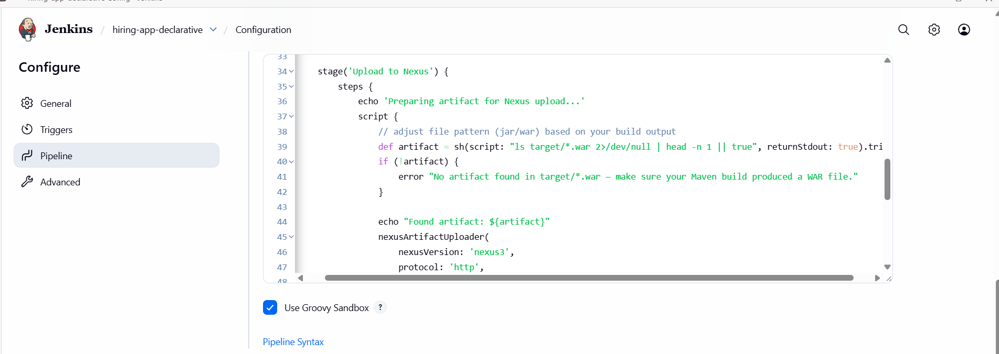
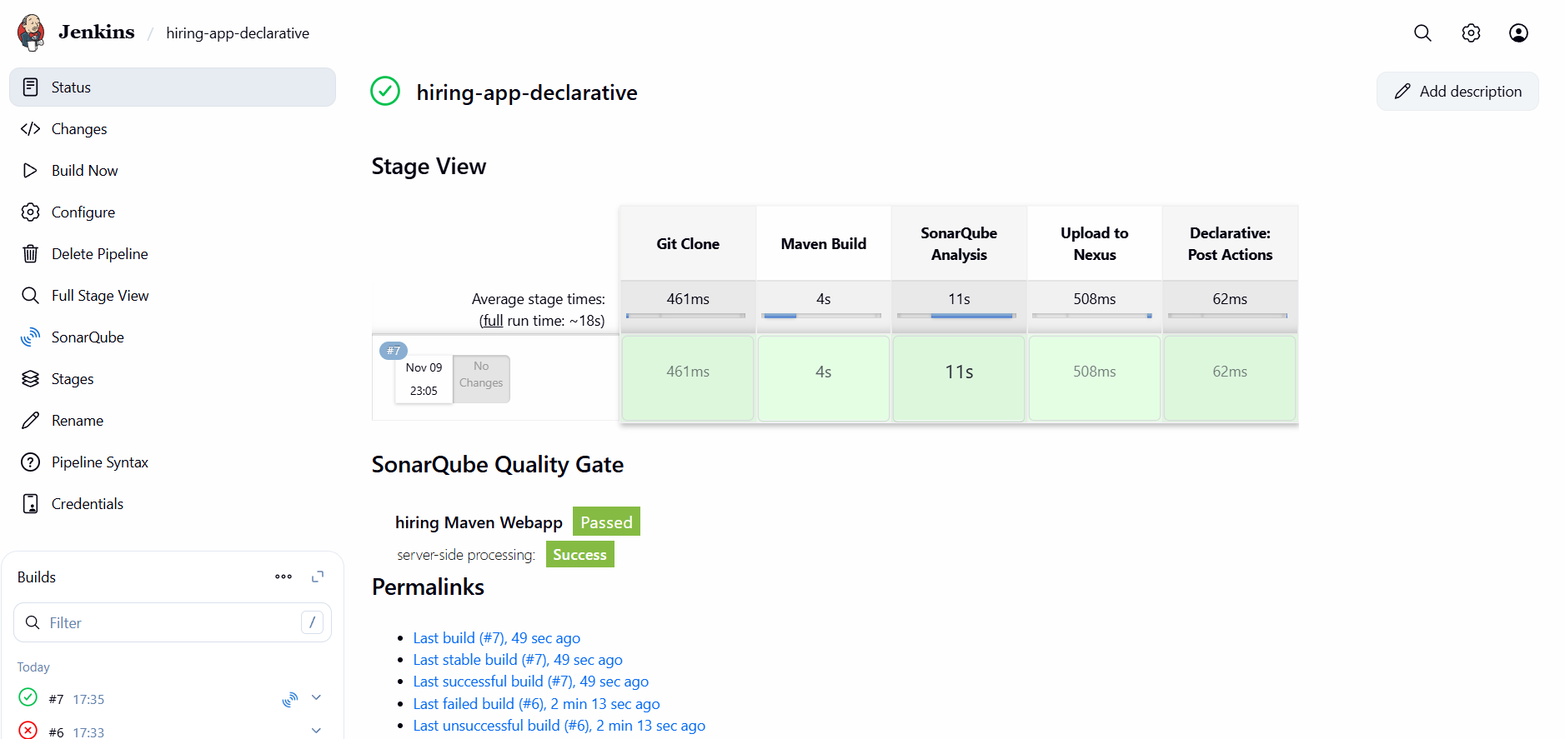
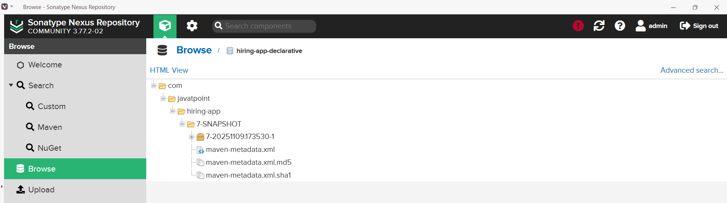

Stage 5:Slack Notification
Step 1: Goto Pipeline syntaxSelect sendSlack: send Slack MessageEnter detailsGenerate pipeline script.
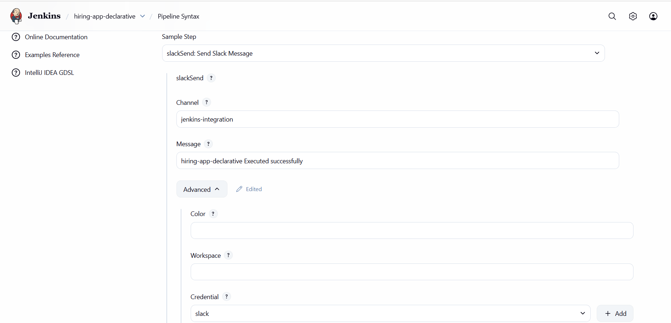
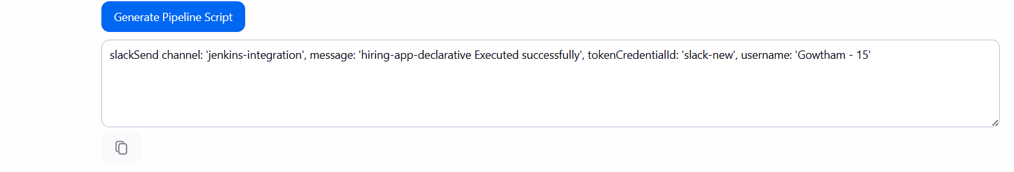
Step 2: Update the Script and Build the Job.
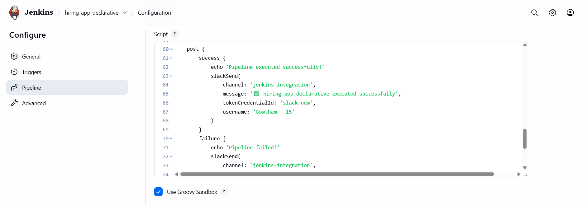
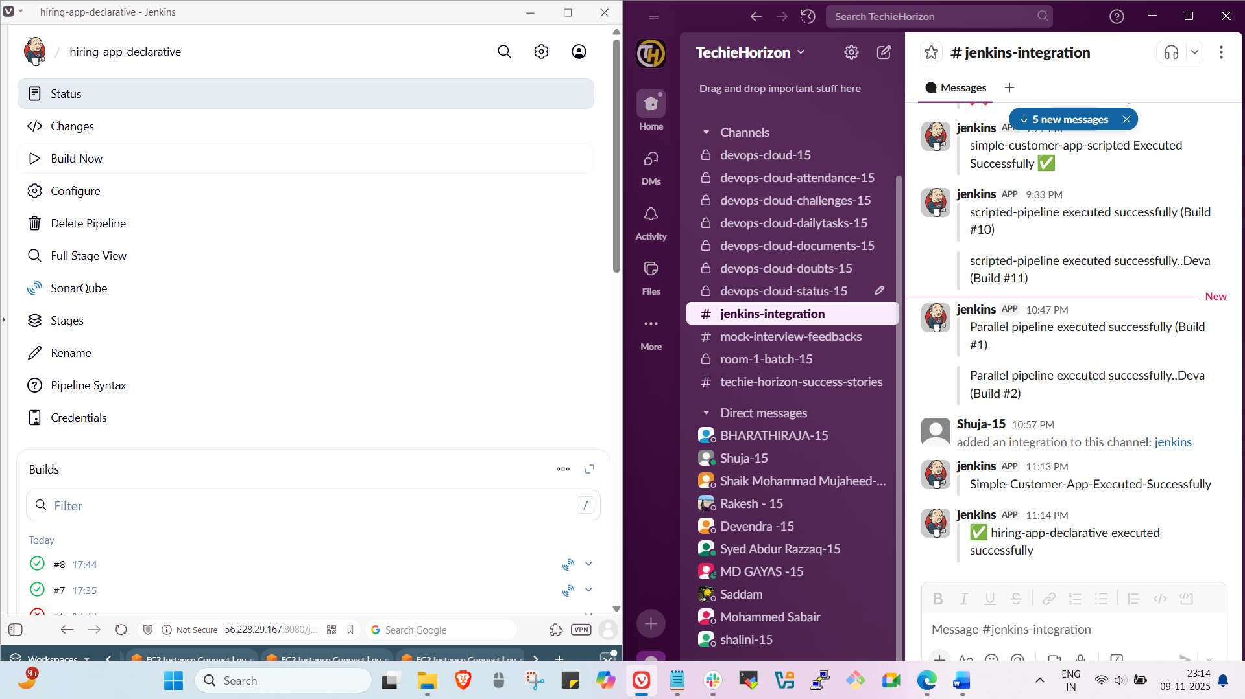

Stage 6:Deploy on Tomcat
Step 1: Goto Pipeline syntaxselect Deploy war to a containerEnter detailsgenerate pipeline scriptUpdate the script & Build the job.
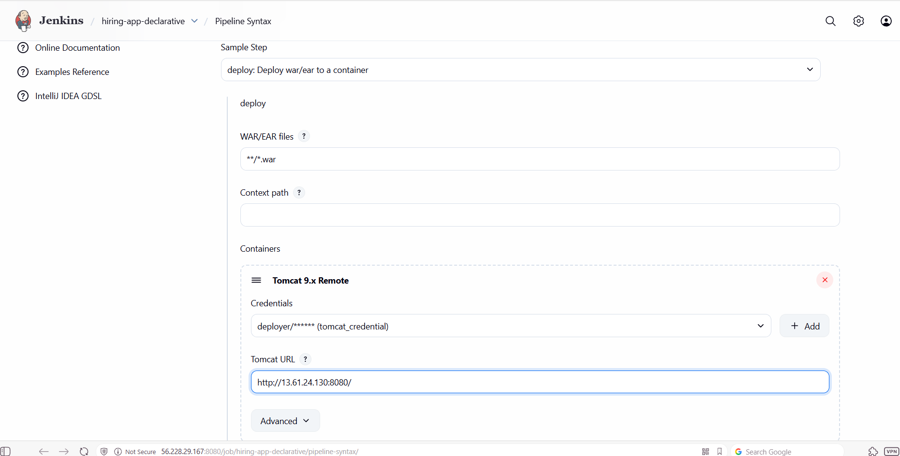
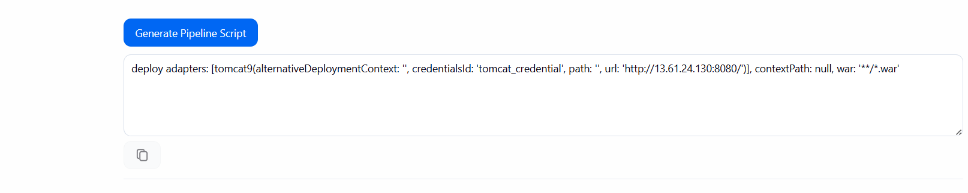

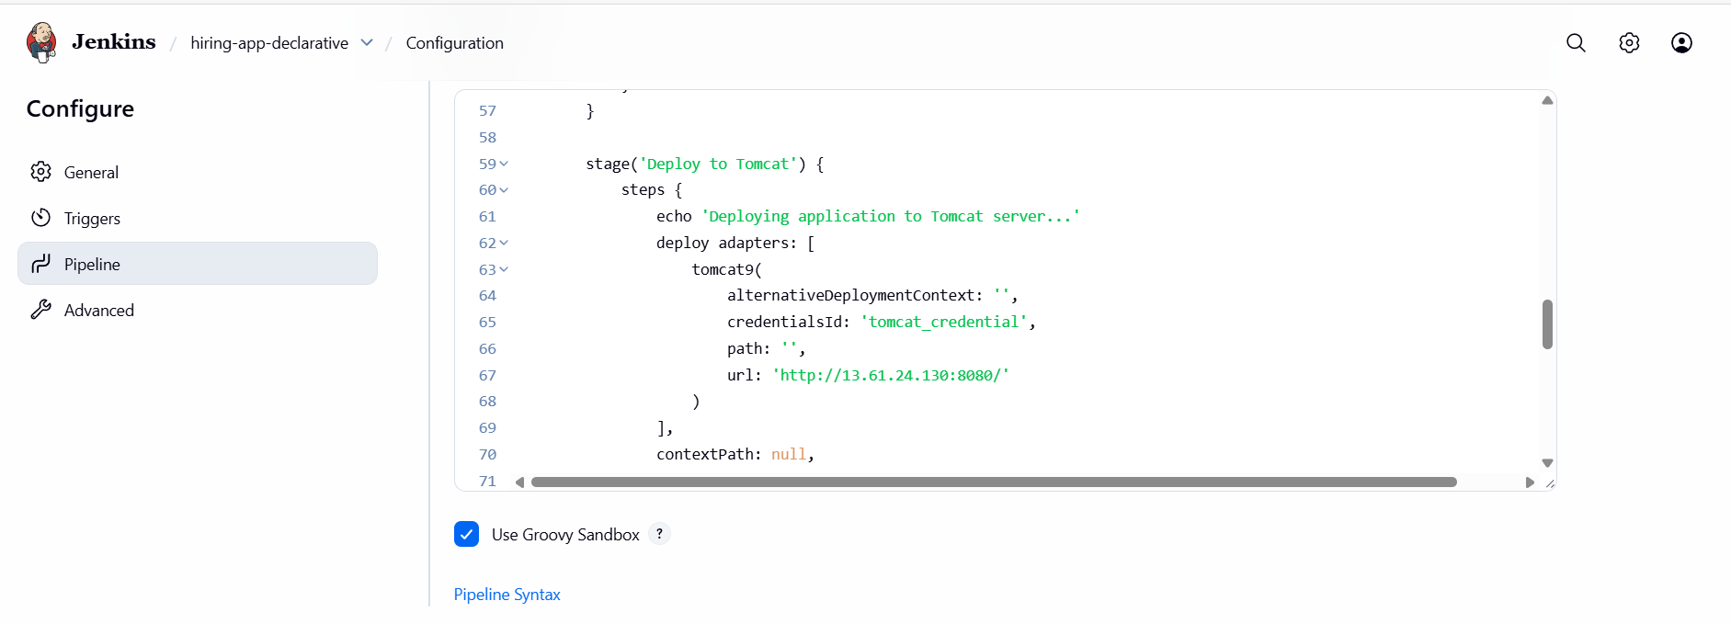
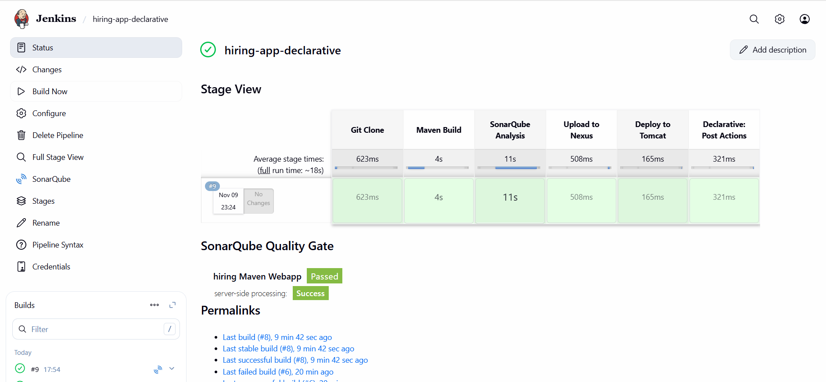

Full Script
pipeline {
agent any

environment {
MVN_HOME = tool 'MVN_HOME'
}

stages {
stage('Git Clone') {
steps {
echo 'Cloning source code from GitHub...'
git branch: 'main', url: 'https://github.com/gowtham4s/hiring-app.git'
}
}

stage('Maven Build') {
steps {
echo 'Running Maven clean install...'
sh "${MVN_HOME}/bin/mvn clean install -f pom.xml"
}
}

stage('SonarQube Analysis') {
steps {
withSonarQubeEnv('MySonarQubeServer') {
echo 'Running SonarQube analysis...'
sh "${MVN_HOME}/bin/mvn sonar:sonar -f pom.xml"
}
}
}

stage('Upload to Nexus') {
steps {
echo 'Preparing artifact for Nexus upload...'
script {
// Adjust file pattern if your build produces a .jar instead of .war
def artifact = sh(script: "ls target/*.war 2>/dev/null | head -n 1 || true", returnStdout: true).trim()
if (!artifact) {
error "No artifact found in target/*.war — make sure your Maven build produced a WAR file."
}

echo "Found artifact: ${artifact}"
nexusArtifactUploader(
nexusVersion: 'nexus3',
protocol: 'http',
nexusUrl: '13.50.107.248:8081',
groupId: 'com.javatpoint',
version: "${BUILD_NUMBER}-SNAPSHOT",
repository: 'hiring-app-declarative',
credentialsId: 'nexus',
artifacts: [
[artifactId: 'hiring-app', file: artifact, type: 'war']
]
)
}
}
}

stage('Deploy to Tomcat') {
steps {
echo 'Deploying application to Tomcat server...'
deploy adapters: [
tomcat9(
alternativeDeploymentContext: '',
credentialsId: 'tomcat_credential',
path: '',
url: 'http://13.61.24.130:8080/'
)
],
contextPath: null,
war: '**/*.war'
}
}
}

post {
success {
echo 'Pipeline executed successfully!'
slackSend(
channel: 'jenkins-integration',
message: '✅ hiring-app-declarative pipeline executed successfully and deployed to Tomcat.',
tokenCredentialId: 'slack-new',
username: 'Gowtham - 15'
)
}
failure {
echo 'Pipeline failed!'
slackSend(
channel: 'jenkins-integration',
message: '❌ hiring-app-declarative pipeline failed. Please check Jenkins logs.',
tokenCredentialId: 'slack-new',
username: 'Gowtham - 15'
)
}
always {
echo 'Pipeline finished.'
}
}
}

2.Create one Scripted pipeline job.
Stage 1:Git Clone.
Step 1: create a new job in Jenkins with declarative pipeline and Build it.
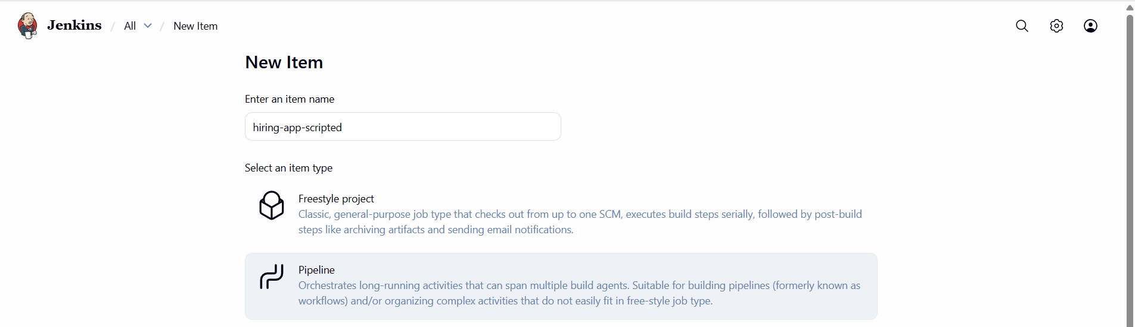
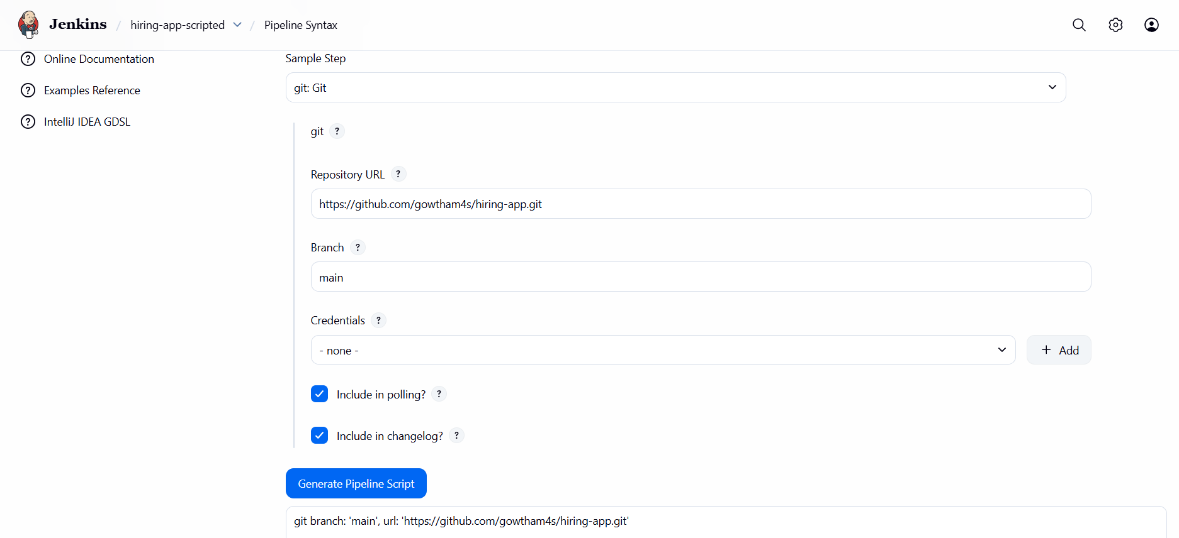
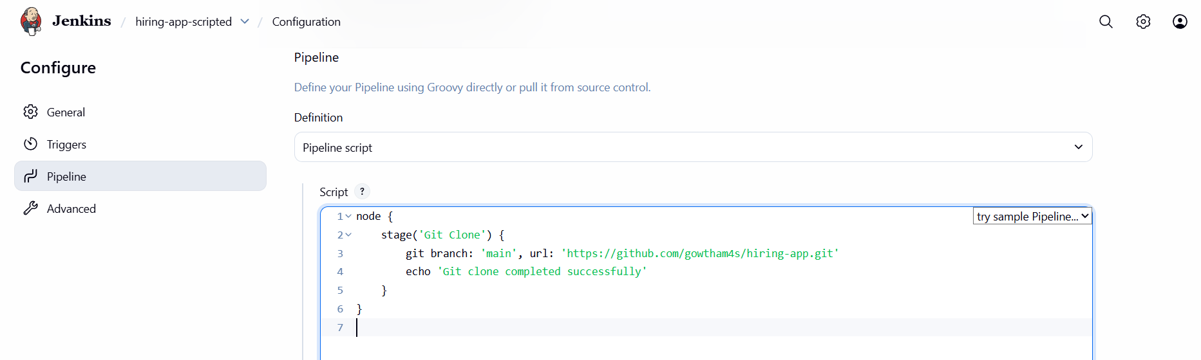
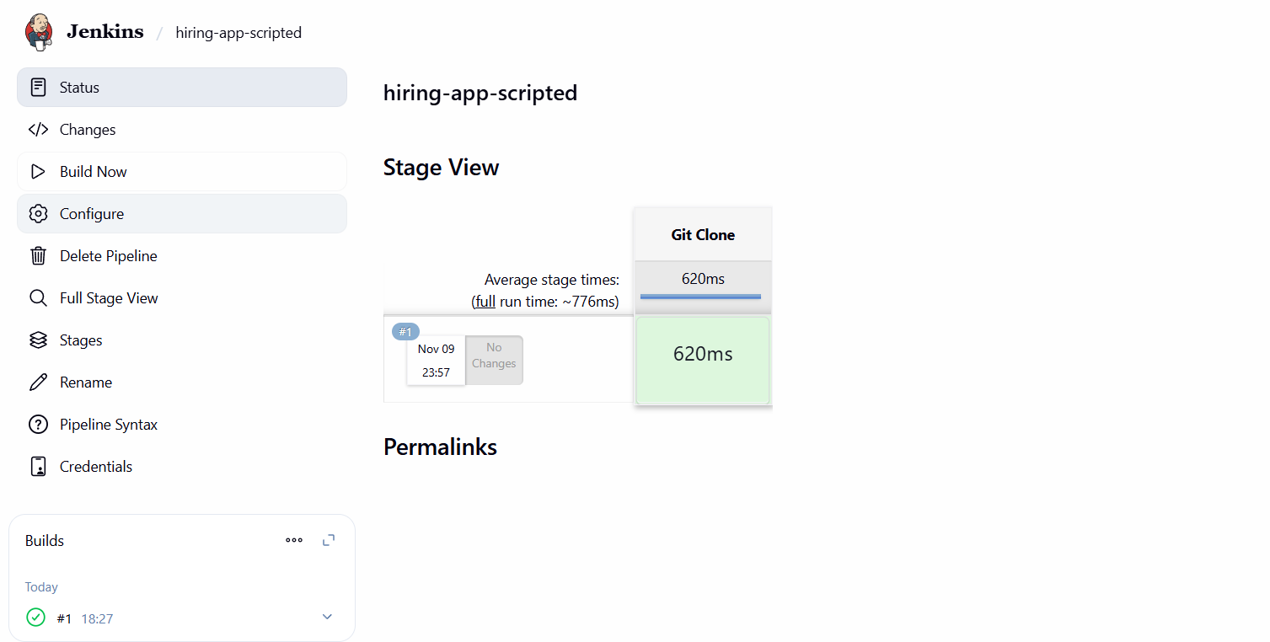

Stage 2:Maven compilation
Step 1: Add maven to the script and build it.
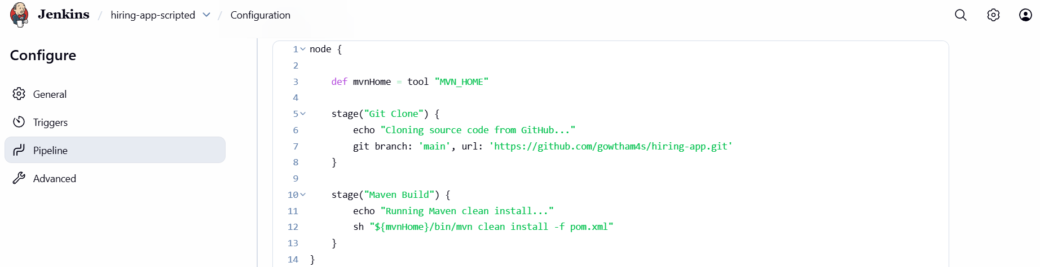
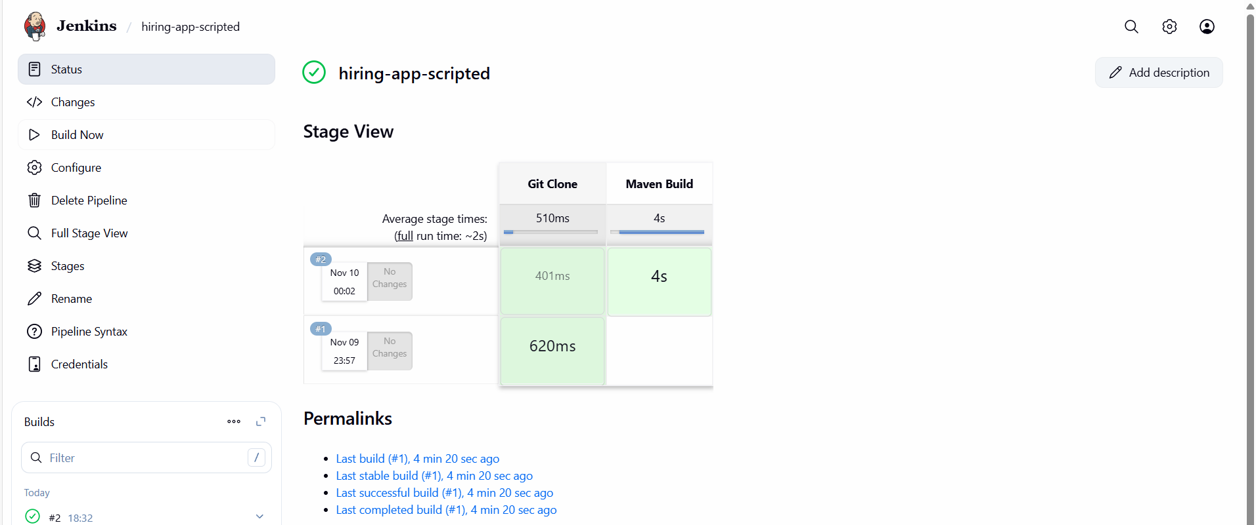

Stage 3:SonarQube Integration
Step 1: Goto Pipeline syntaxselect withSonarQubeEnvclick generate pipeline scriptadd that in declarative pipeline script and Build it.
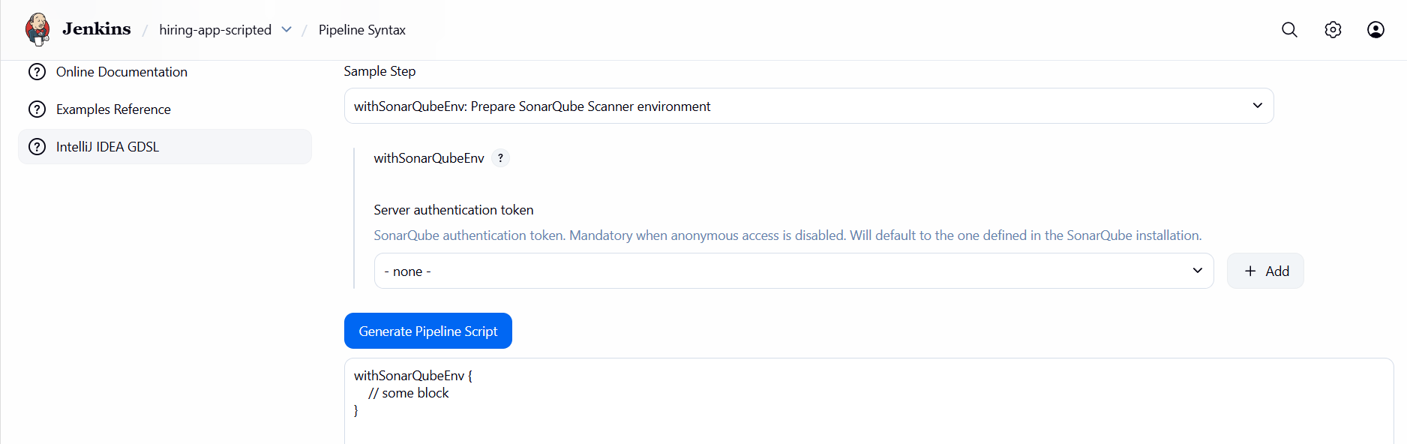
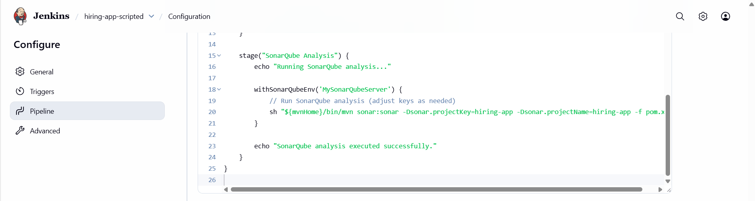
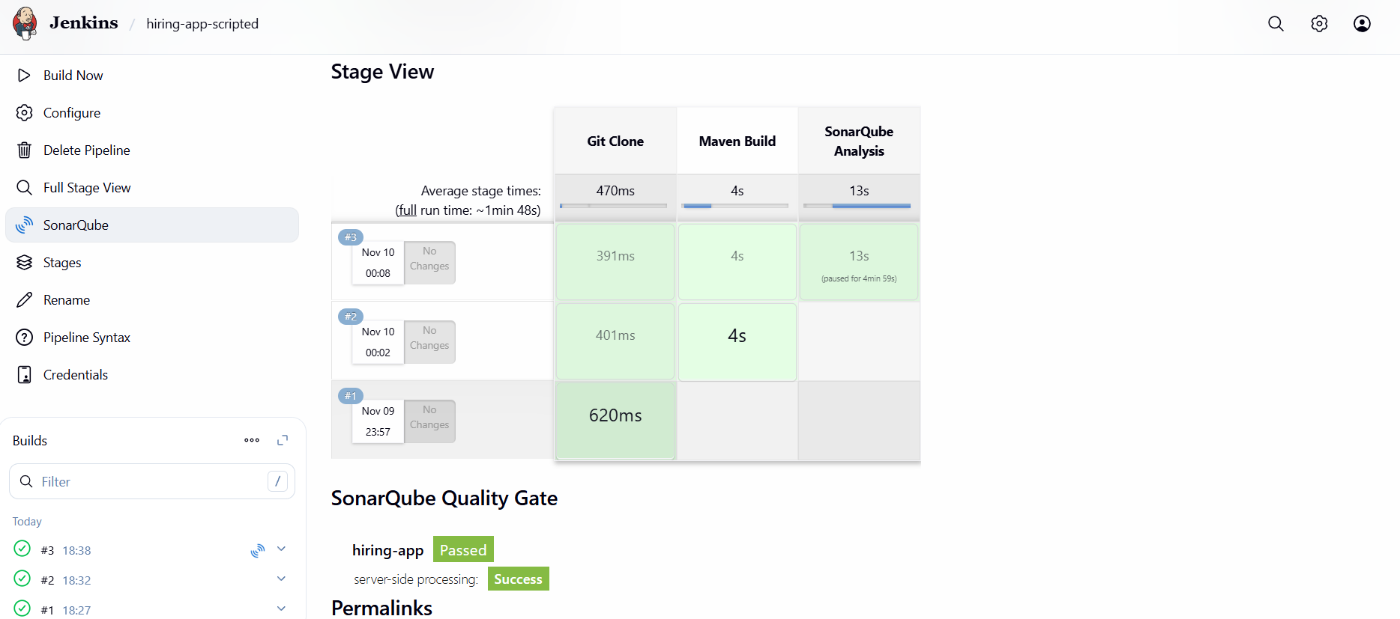
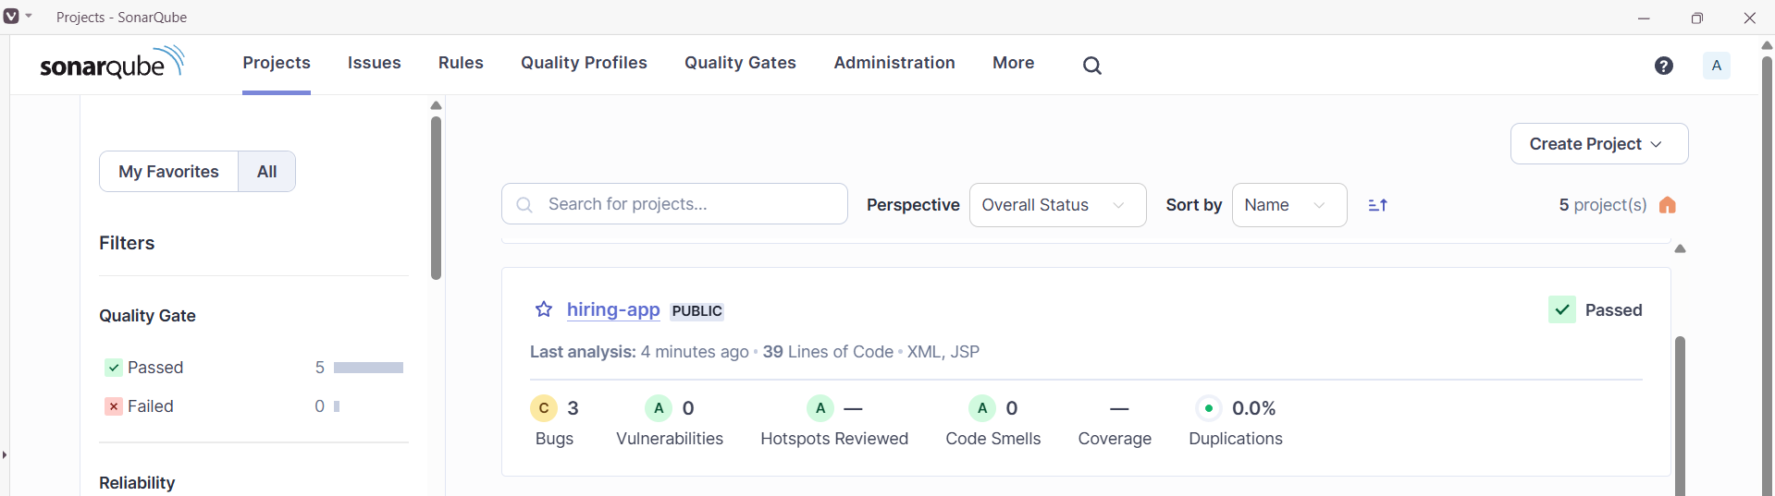
Stage 4:Nexus Artifactory
Step 1:Create a new repository in nexus.
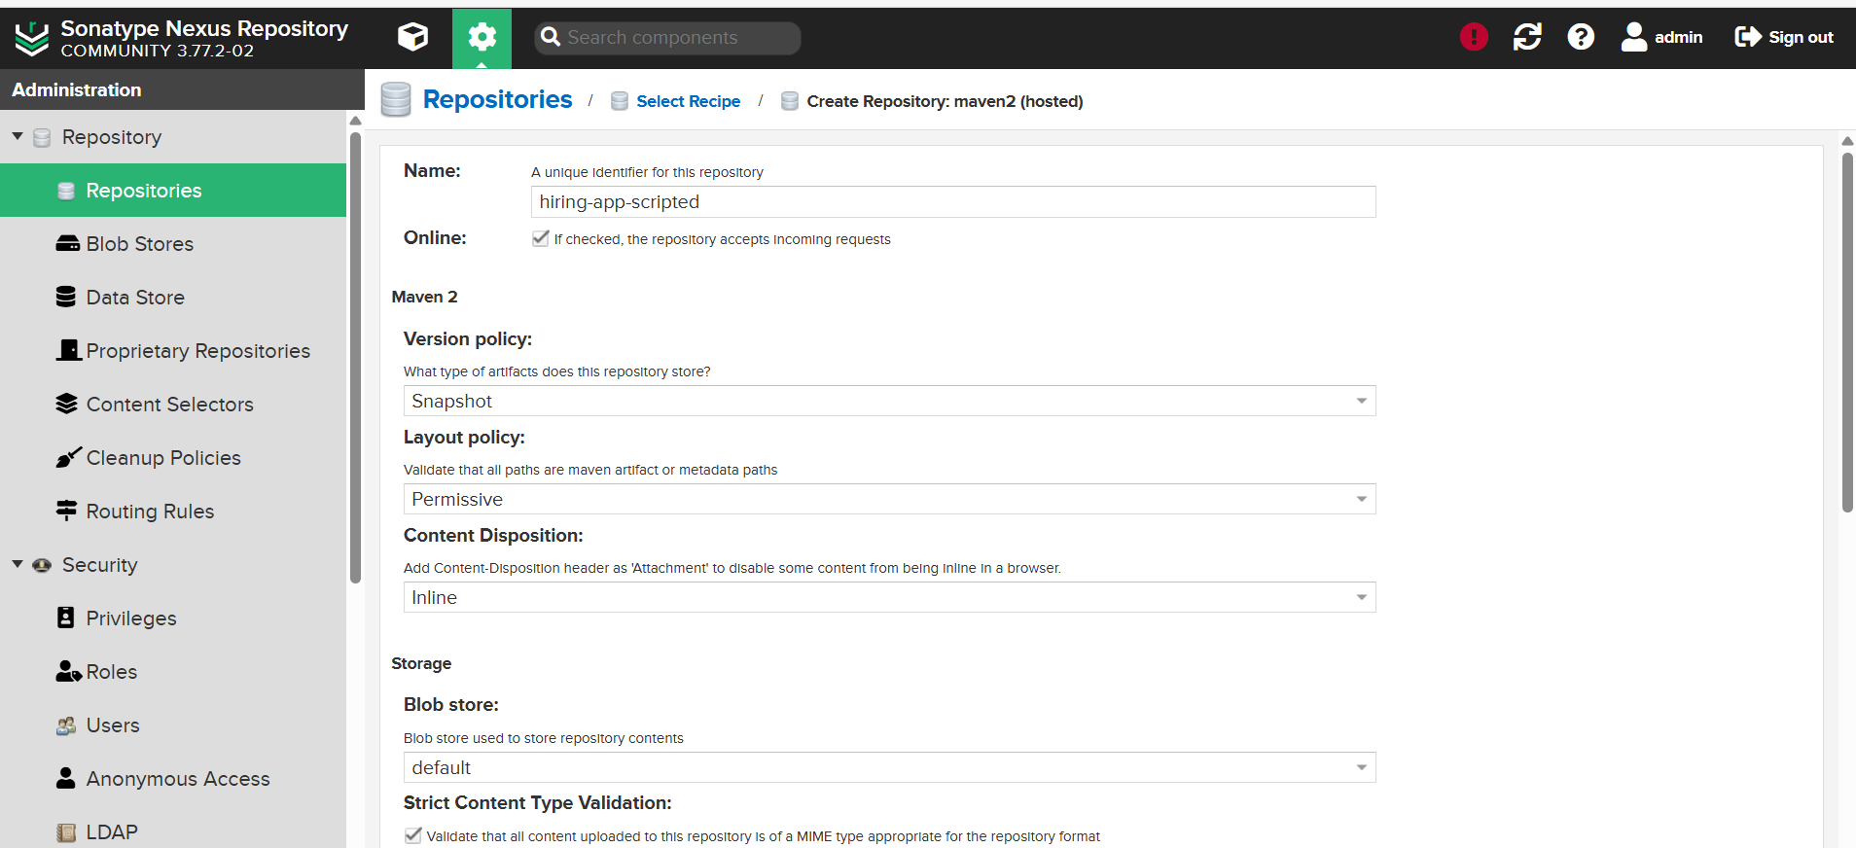
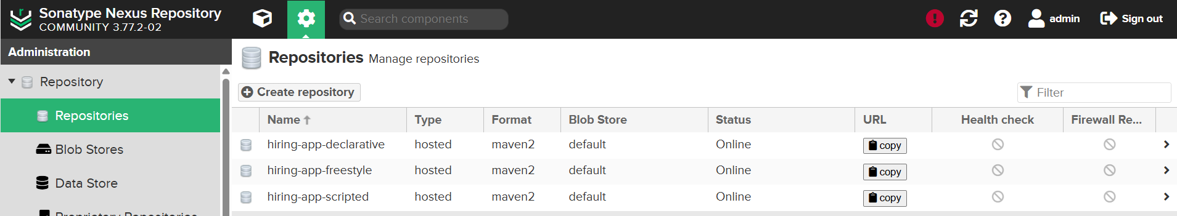
Step 2: Goto pipeline syntaxEnter detailsGenerate pipeline scriptupdate script & Build.
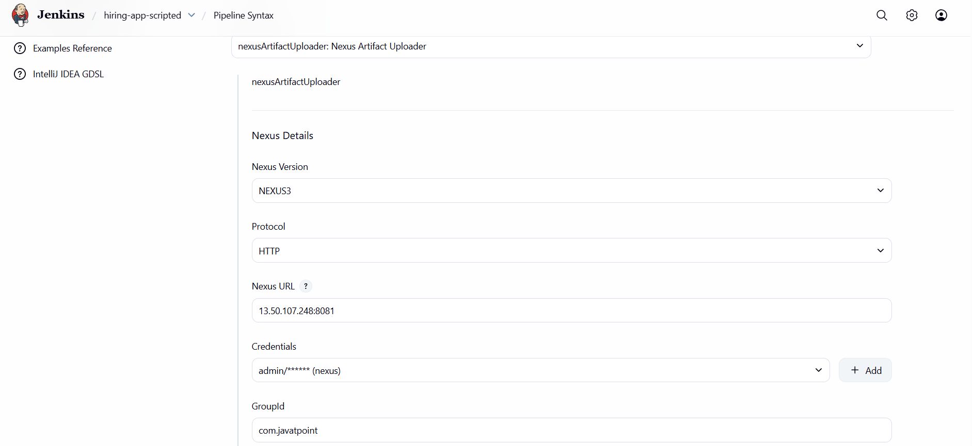
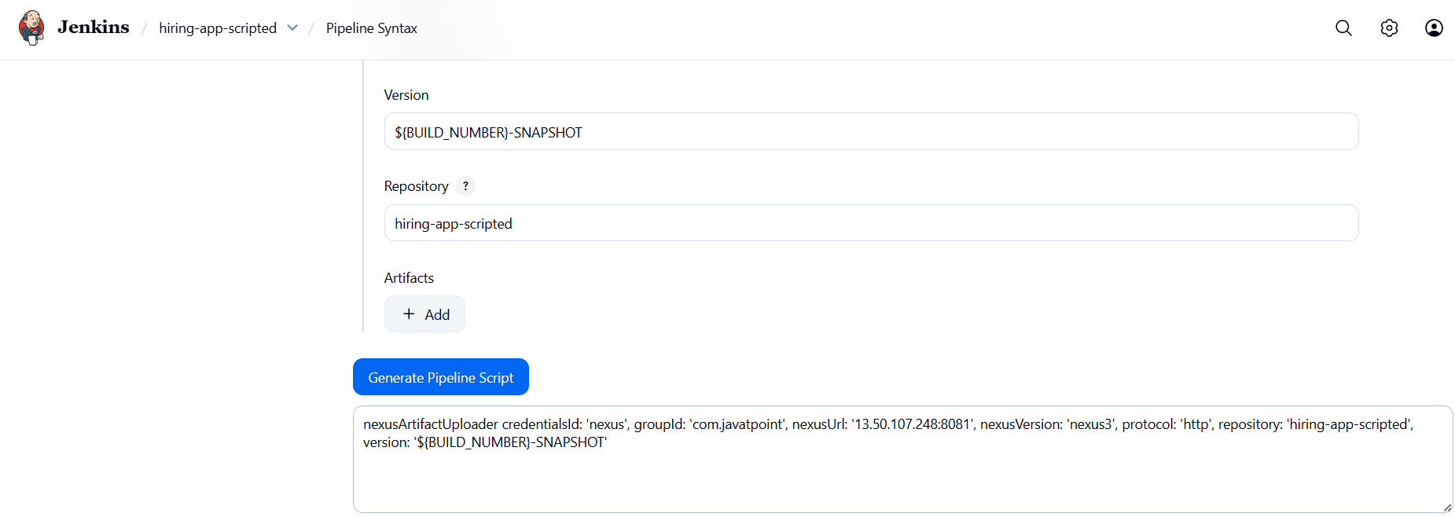
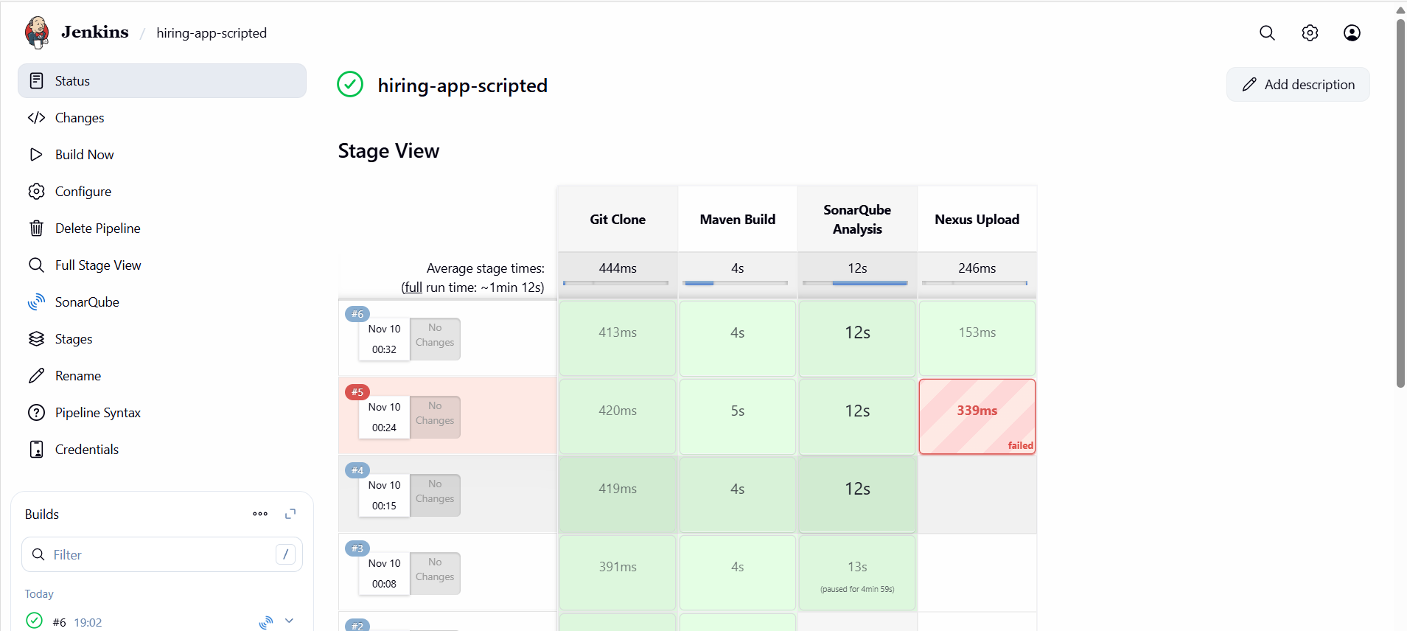
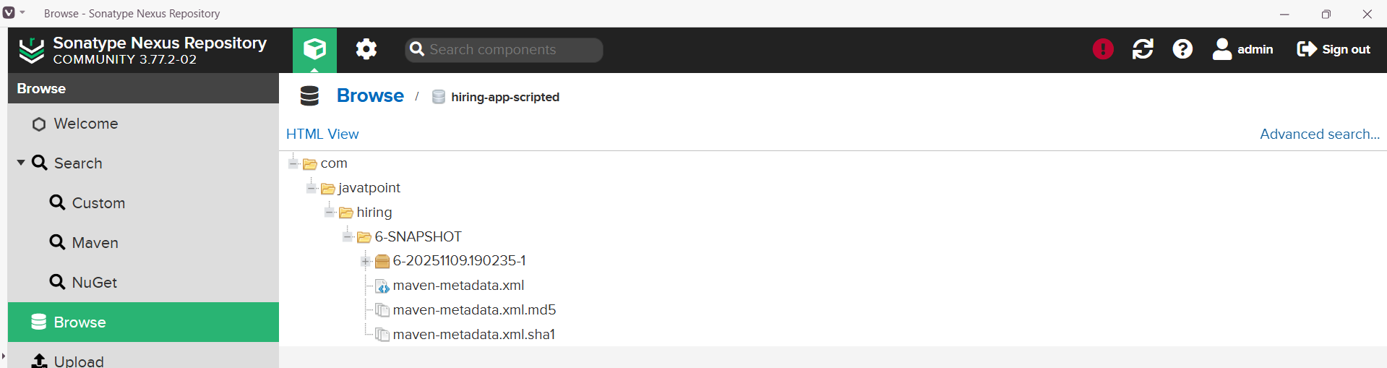

Stage 5:Slack Notification
Step 1: Goto Pipeline syntaxSelect sendSlack: send Slack MessageEnter detailsGenerate pipeline script.
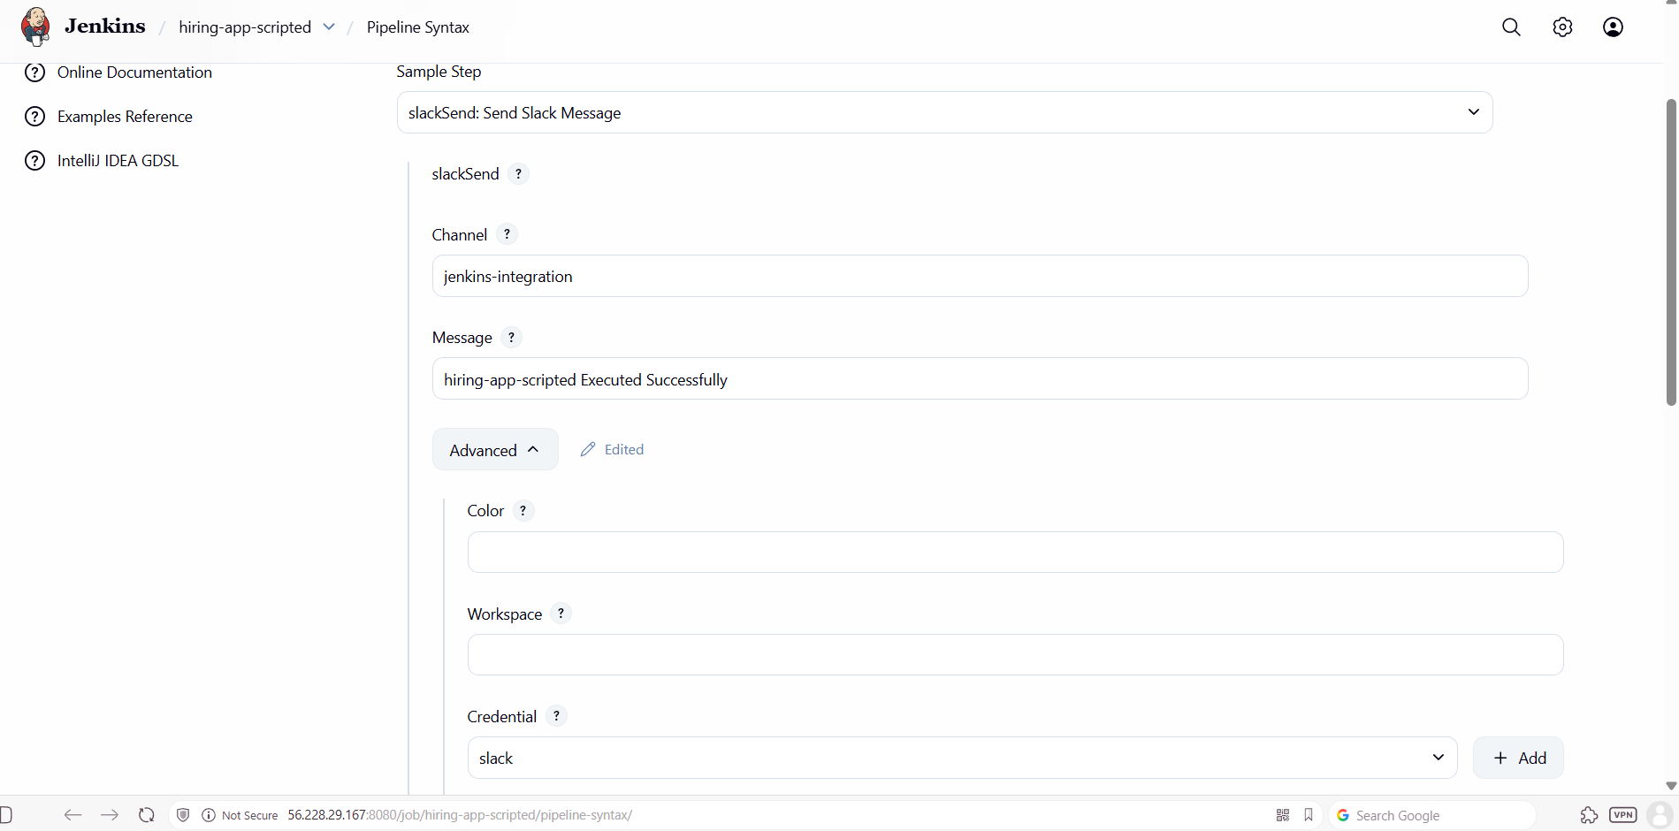

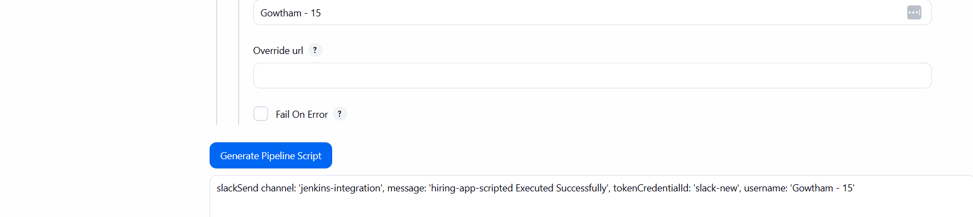
Step 2: Update the Script and Build the Job.
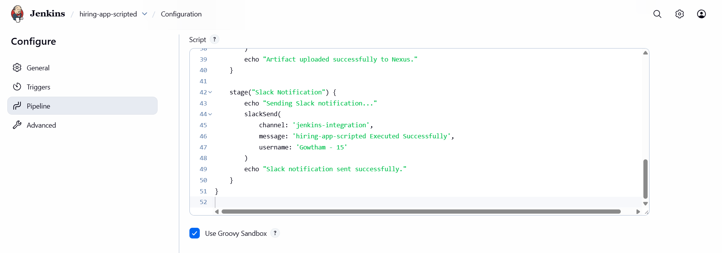
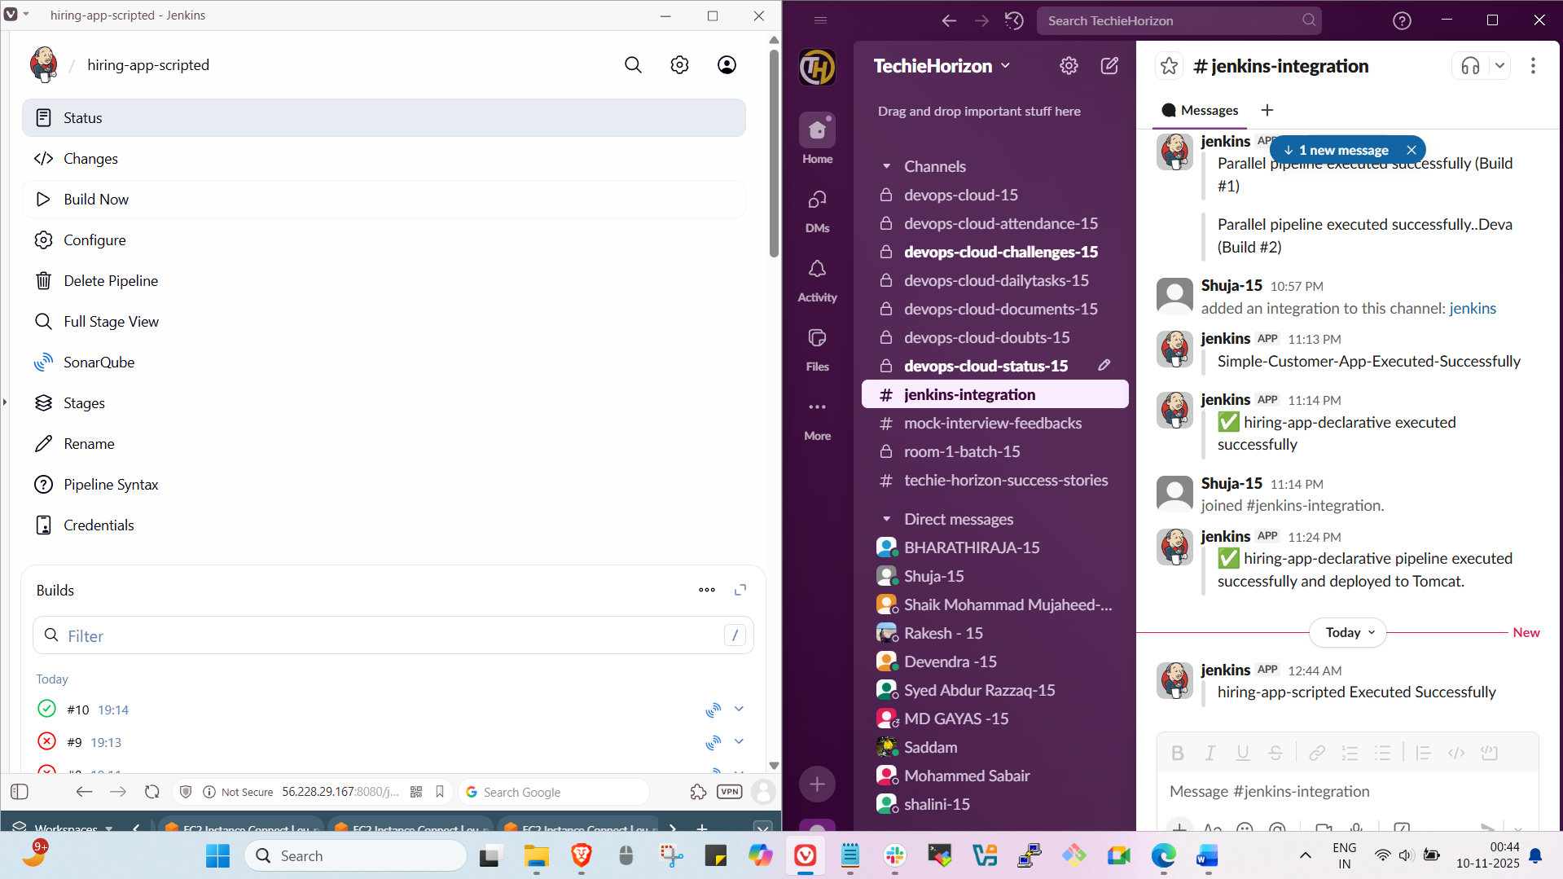

Stage 6: Deploy on Tomcat
Step 1: Goto Pipeline syntaxselect Deploy war to a containerEnter detailsgenerate pipeline scriptUpdate the script & Build the job.
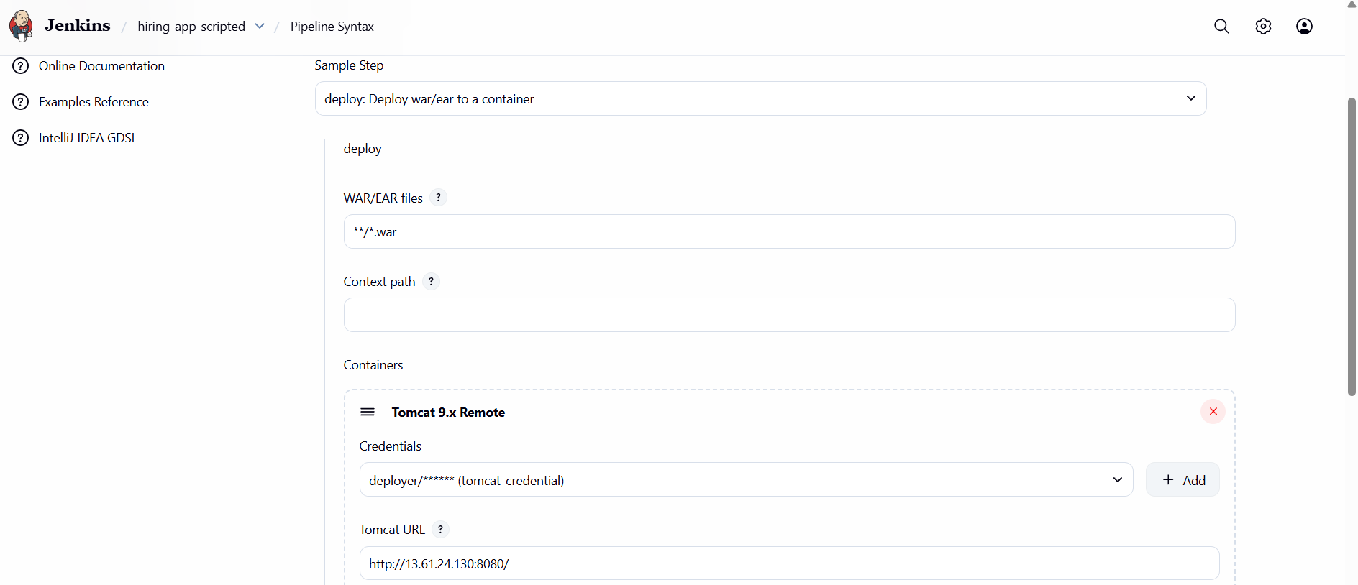
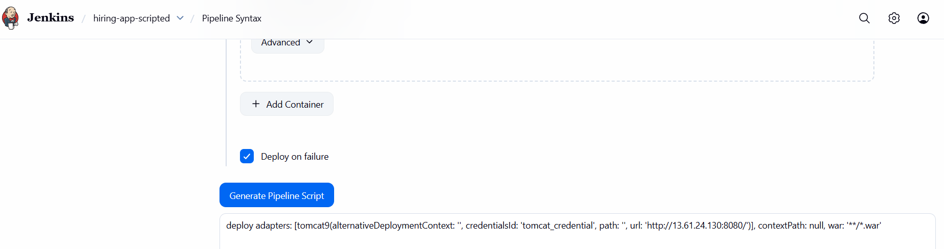
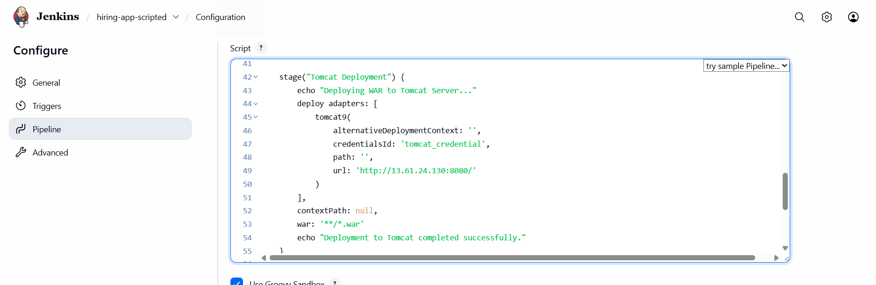
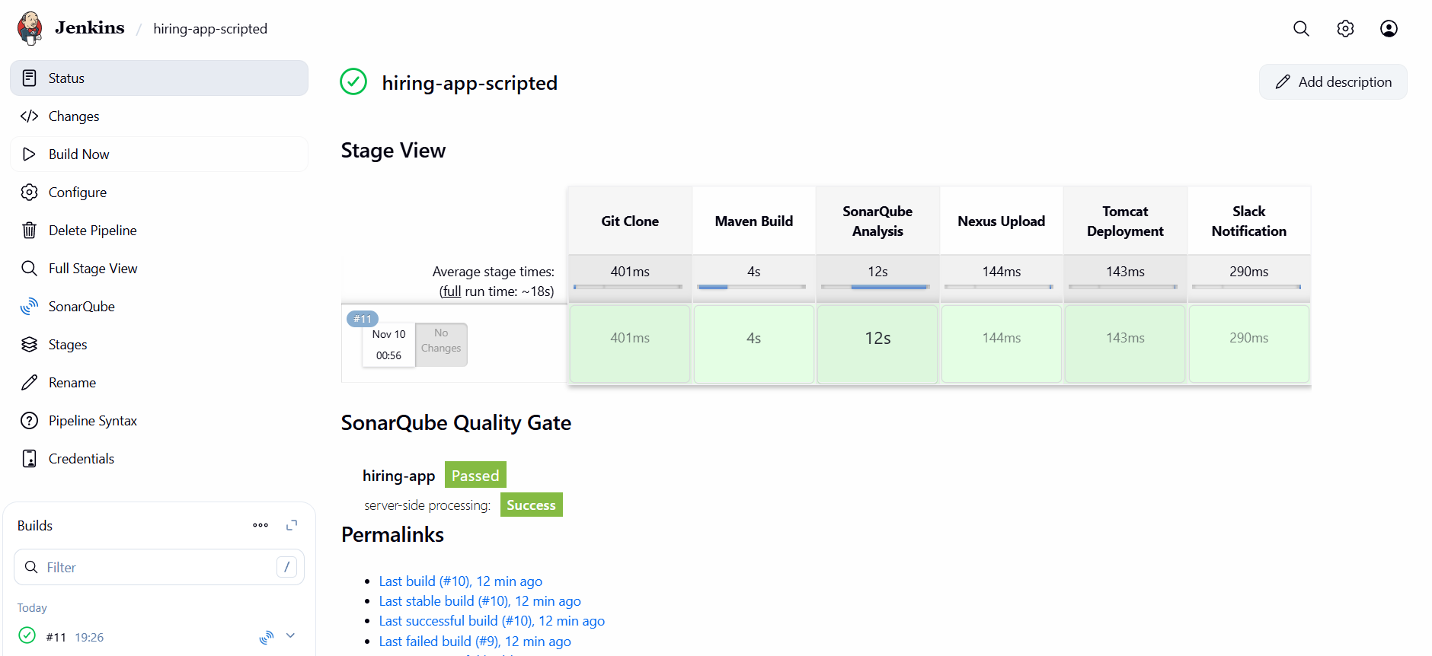
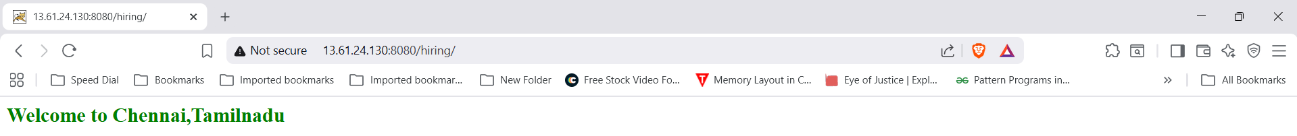

Full Script
node {
def mvnHome = tool "MVN_HOME"

stage("Git Clone") {
echo "Cloning source code from GitHub..."
git branch: 'main', url: 'https://github.com/gowtham4s/hiring-app.git'
}

stage("Maven Build") {
echo "Running Maven clean package..."
sh "${mvnHome}/bin/mvn clean package -DskipTests -f pom.xml"
}

stage("SonarQube Analysis") {
echo "Running SonarQube analysis..."
withSonarQubeEnv('MySonarQubeServer') {
sh "${mvnHome}/bin/mvn sonar:sonar -Dsonar.projectKey=hiring-app -Dsonar.projectName=hiring-app -f pom.xml"
}
echo "SonarQube analysis executed."
}

stage("Nexus Upload") {
echo "Uploading artifact to Nexus..."
nexusArtifactUploader(
artifacts: [[
artifactId: 'hiring',
classifier: '',
file: '/var/lib/jenkins/workspace/hiring-app-scripted/target/hiring.war',
type: 'war'
]],
credentialsId: 'nexus',
groupId: 'com.javatpoint',
nexusUrl: '13.50.107.248:8081',
nexusVersion: 'nexus3',
protocol: 'http',
repository: 'hiring-app-scripted',
version: "${env.BUILD_NUMBER}-SNAPSHOT"
)
echo "Artifact uploaded successfully to Nexus."
}

stage("Tomcat Deployment") {
echo "Deploying WAR to Tomcat Server..."
deploy adapters: [
tomcat9(
alternativeDeploymentContext: '',
credentialsId: 'tomcat_credential',
path: '',
url: 'http://13.61.24.130:8080/'
)
],
contextPath: null,
war: '**/*.war'
echo "Deployment to Tomcat completed successfully."
}

stage("Slack Notification") {
echo "Sending Slack notification..."
slackSend(
channel: 'jenkins-integration',
message: 'hiring-app-scripted Executed Successfully',
username: 'Gowtham - 15'
)
echo "Slack notification sent successfully."
}
}

3.Create one multistage pipeline job
Stage 1: Git Clone
Step 1: Goto Jenkins GUI create a new job and Build it .




Stage 2: Maven Compilation
Step 1: Add Maven to the script and build it.




Stage 3: SonarQube Integration
Step 1: Goto Pipeline syntaxselect withSonarQubeEnvclick generate pipeline scriptadd that in declarative pipeline script and Build it.




Stage 4:Nexus Artifactory
Step 1:Create a new repository in nexus.


Step 2: Goto pipeline syntaxEnter detailsGenerate pipeline scriptupdate script & Build.






Stage 5:Slack Notification
Step 1: Goto Pipeline syntaxSelect sendSlack: send Slack MessageEnter detailsGenerate pipeline script.


Step 2: Update the Script and Build the Job.



Stage 6:Deploy on Tomcat
Step 1: Goto Pipeline syntaxselect Deploy war to a containerEnter detailsgenerate pipeline scriptUpdate the script & Build the job.






4.Create one parallel stage pipeline job
Step 1: Goto Jenkins GUIcreate a new jobenter the scriptBuild it.
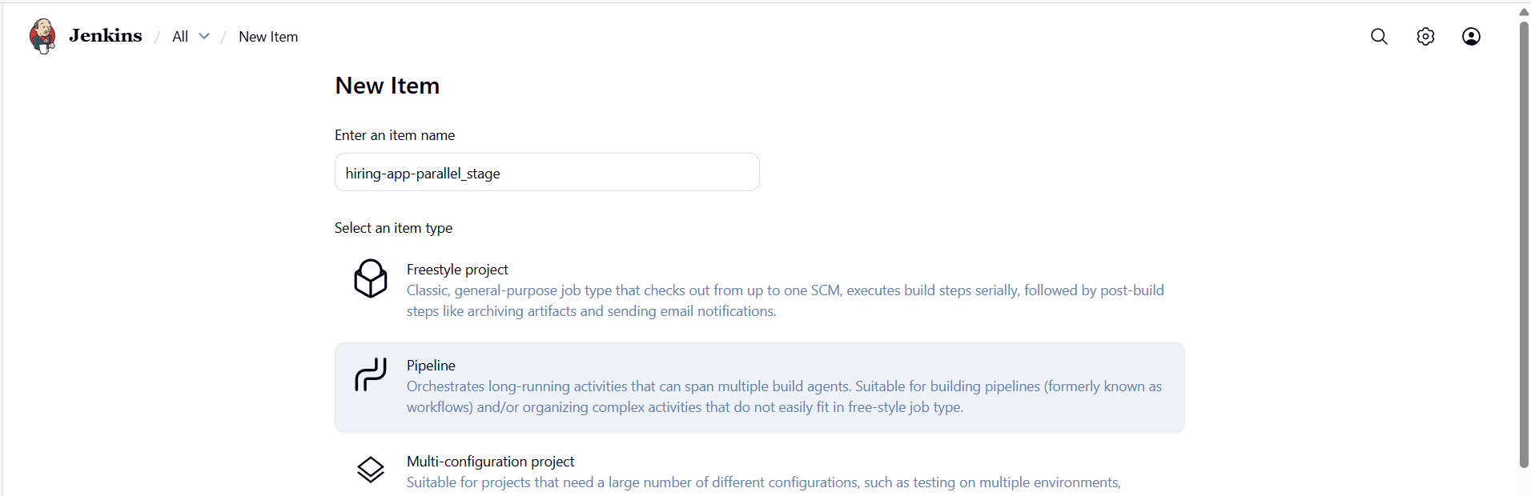
pipeline {
agent any

stages {
stage('ParallelStages') {
parallel {
stage('stage-1') {
steps {
echo 'stage-1 started'
sleep(time: 5, unit: 'MINUTES')
echo 'stage-1 completed'
}
}

stage('stage-2') {
steps {
echo 'stage-2 started'
sleep(time: 5, unit: 'MINUTES')
echo 'stage-2 completed'
}
}
}
}
}
}
