- Create MariaDB DB on EC2.
Step 1: Launch an instance and run following commands to install and start Maria DB.
Sudo -i
Yum install -y mariadb105-server
Systemctl enable mariadb
Systemctl start mariadb
Systemctl status mariadb
Yum -y update
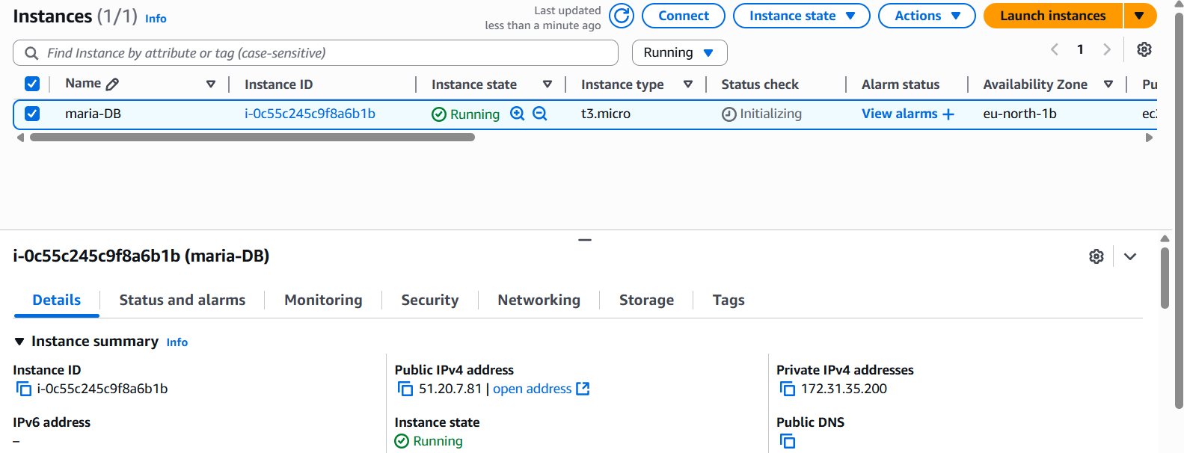
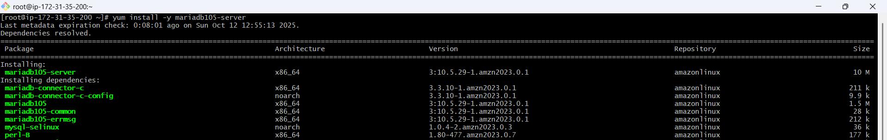
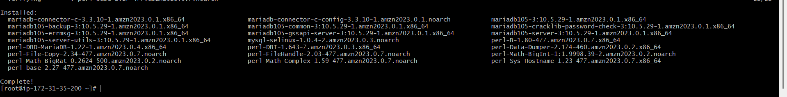
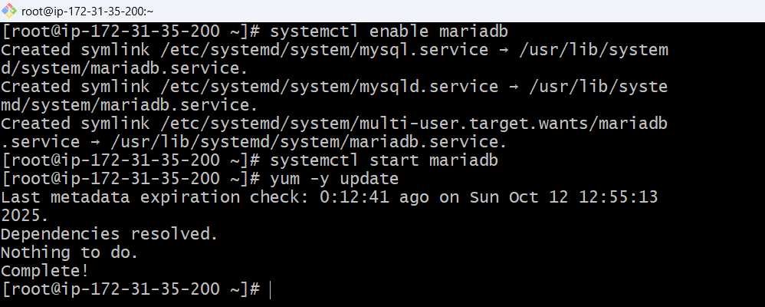
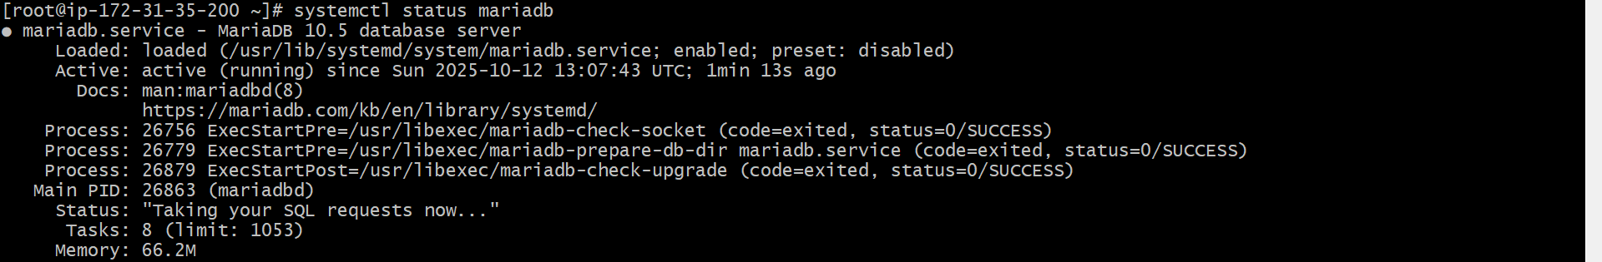
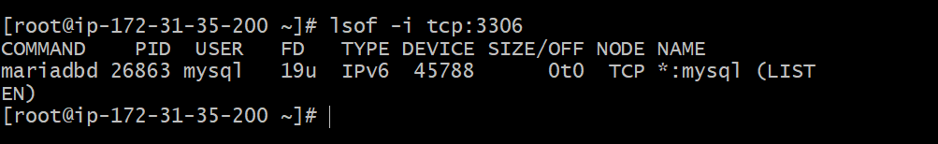

- Insert some dummy data.
Step 1: Run following commands to set environmental variable.
DBName=gowthamdb
DBPassword=admin123456
DBRootPassword=admin123456
DBUser=gowthamdbuser
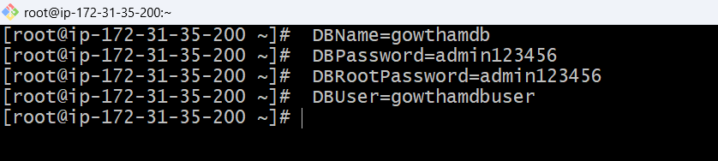
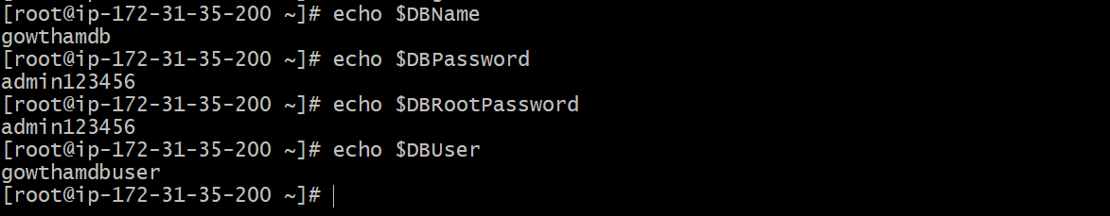
Step 2: Run following commands to create database.
echo "CREATE DATABASE ${DBName};" >> /tmp/db.setup
echo "CREATE USER '${DBUser}' IDENTIFIED BY '${DBPassword}';" >> /tmp/db.setup
echo "GRANT ALL PRIVILEGES ON *.* TO '${DBUser}'@'%';" >> /tmp/db.setup
echo "FLUSH PRIVILEGES;" >> /tmp/db.setup
mysqladmin -u root password "${DBRootPassword}"
mysql -u root --password="${DBRootPassword}" < /tmp/db.setup
rm /tmp/db.setup
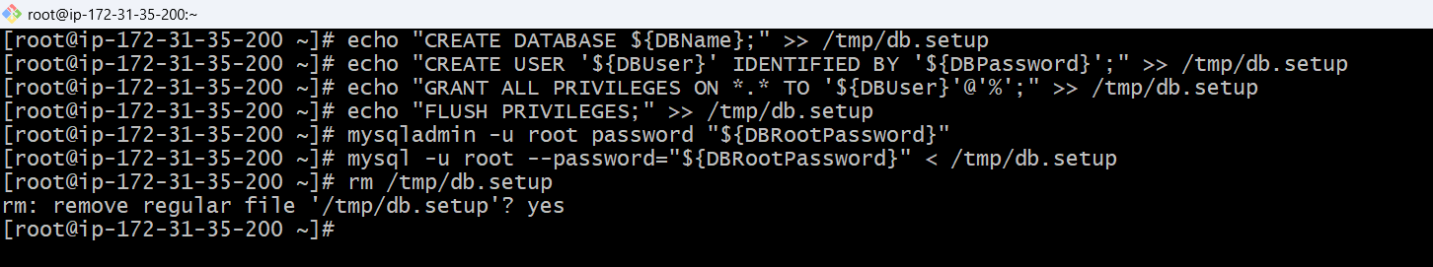
Step 3: Run following commands to add data to database in EC2 instance.
mysql -u root --password="${DBRootPassword}"
show databases;
USE gowthamdb;
CREATE TABLE table1 (id INT, name VARCHAR(45));
INSERT INTO table1 VALUES(1, 'Virat'), (2, 'Sachin'), (3, 'Dhoni'), (4, 'ABD');
SELECT * FROM table1;
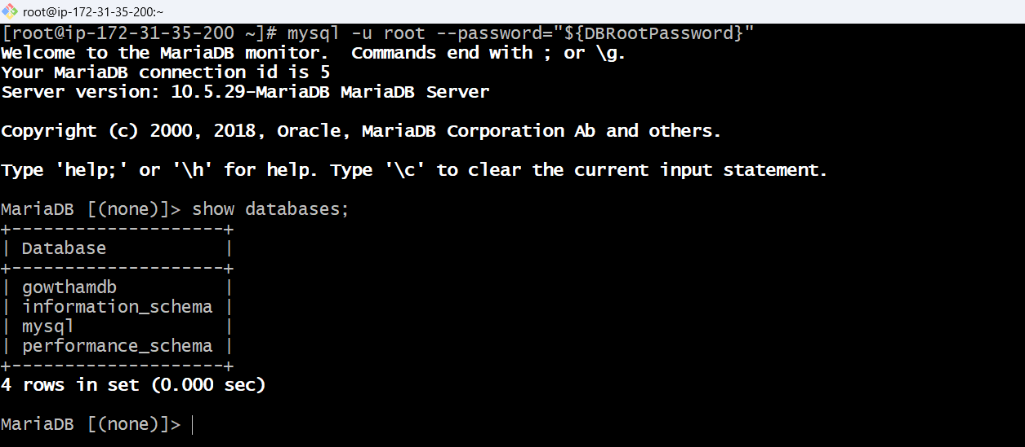
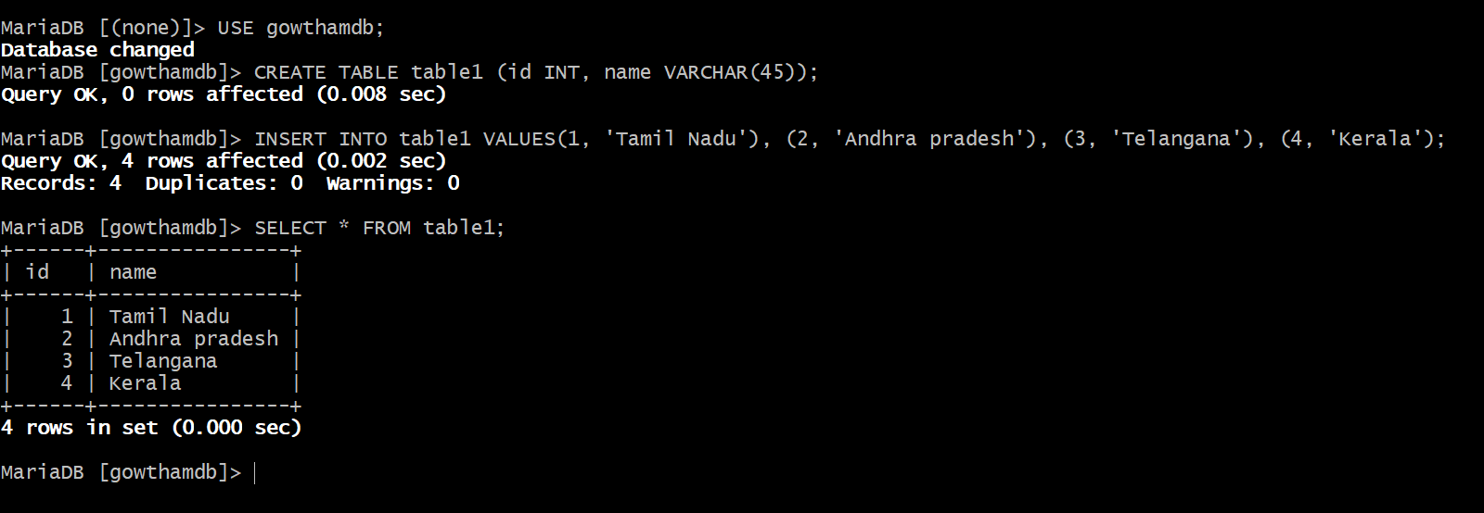

- Take the backup of dummy data on EC2.
Step 1: Run following command to take backup and store it in .sql file
mysql dump -u root -p user_name > file_name.sql
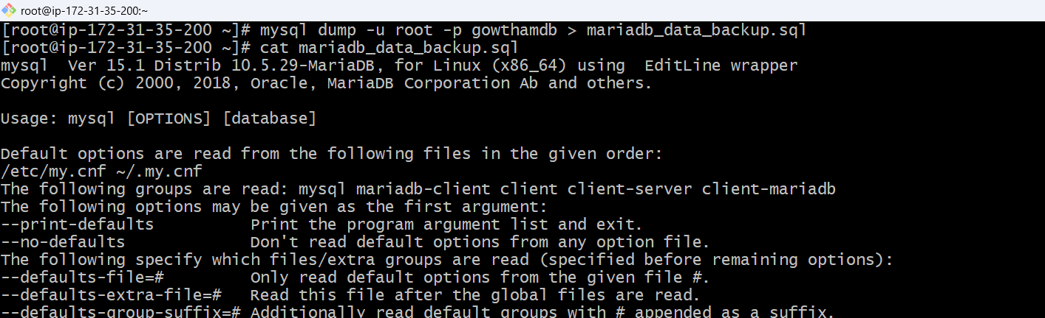
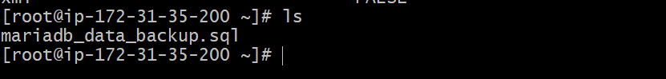

- Launch MariaDB RDS instance.
Step 1: Login to AWS, select Aurora and RDSDatabasecreate databasestandard create MariaDB
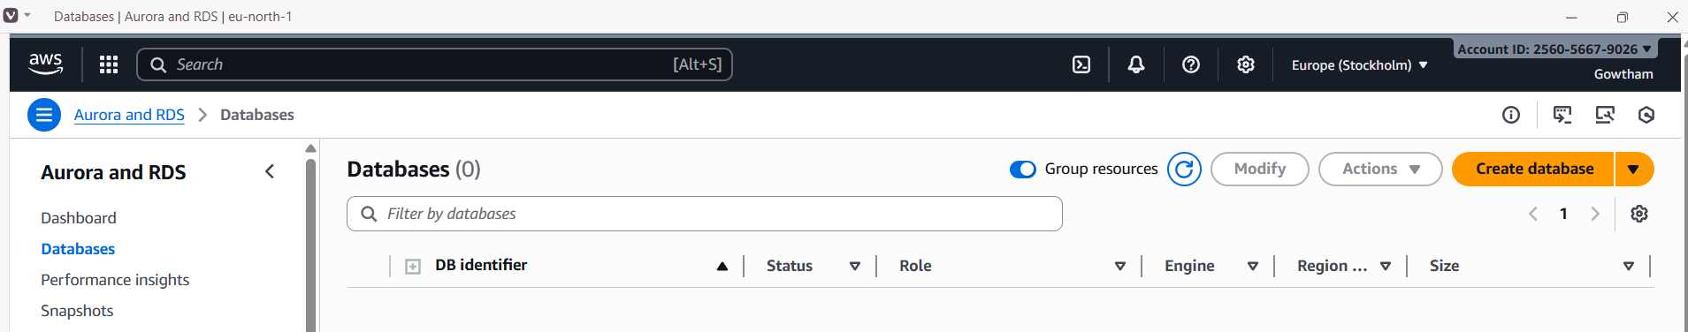
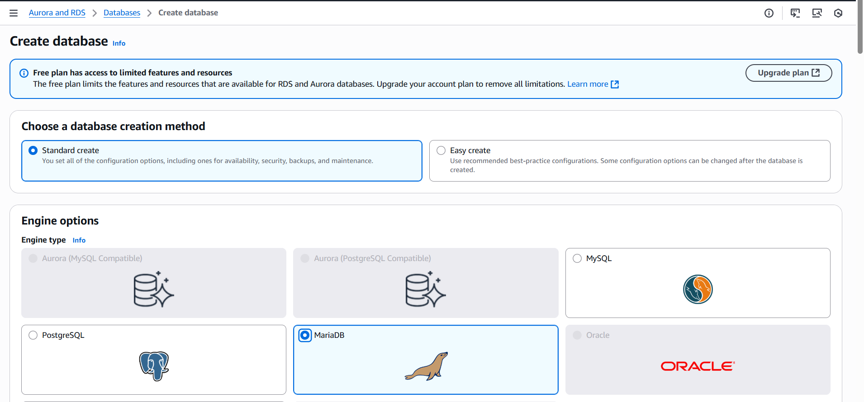
Step 2: select Templateprovide detailsselect instance and storage.
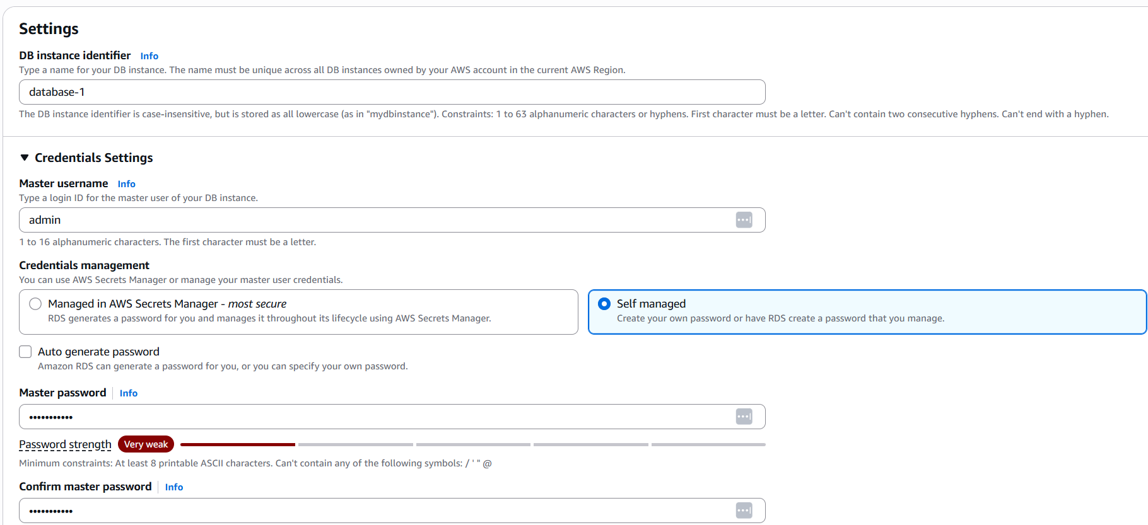
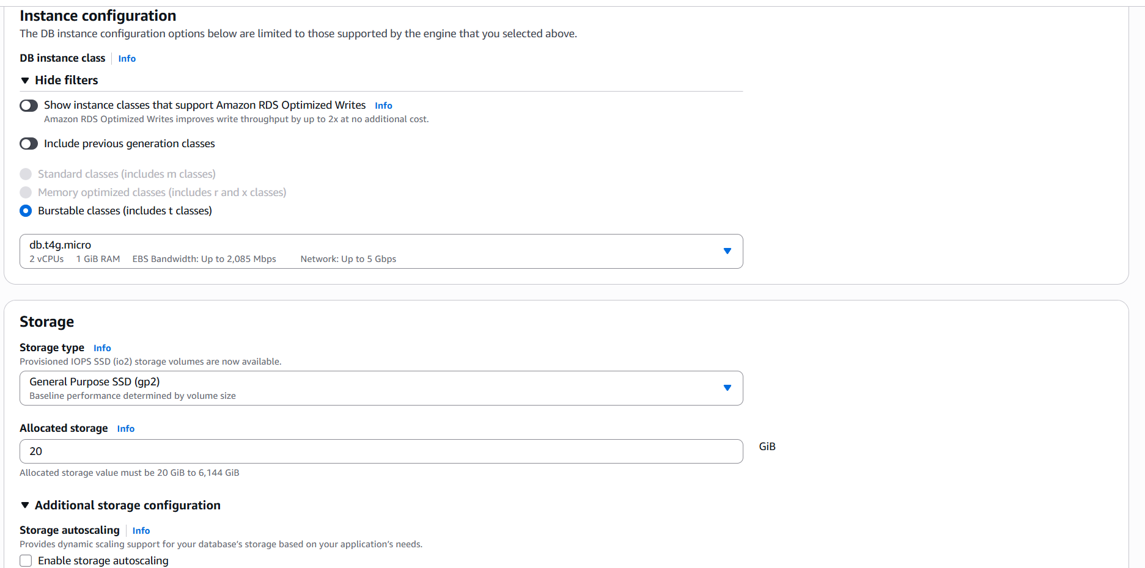

Step 3: Configure connectivity and network settings.
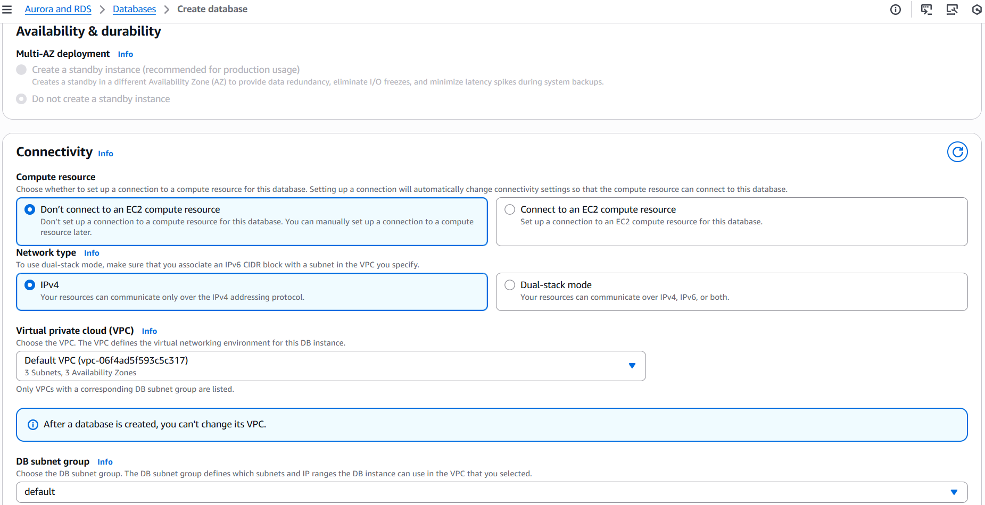
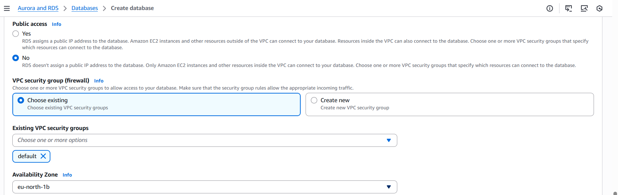

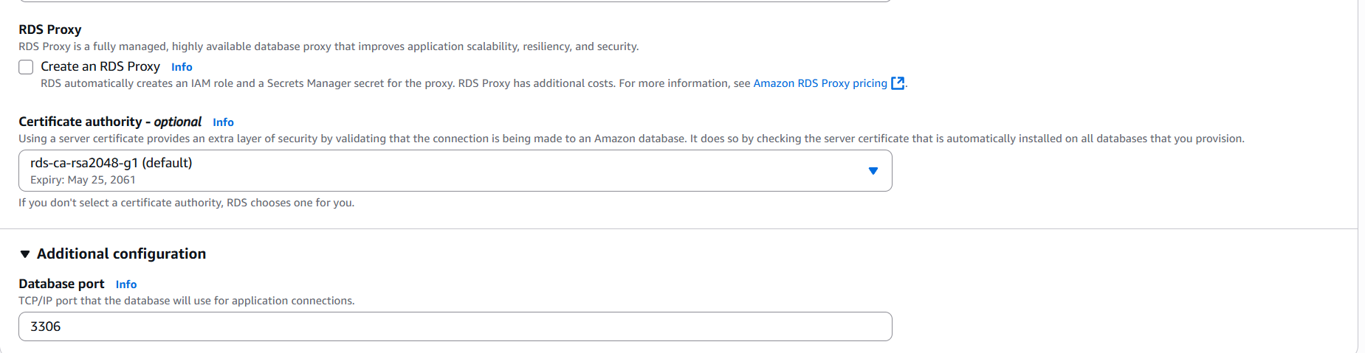
Step 4: Configure Authentication and monitoring settings and click create.
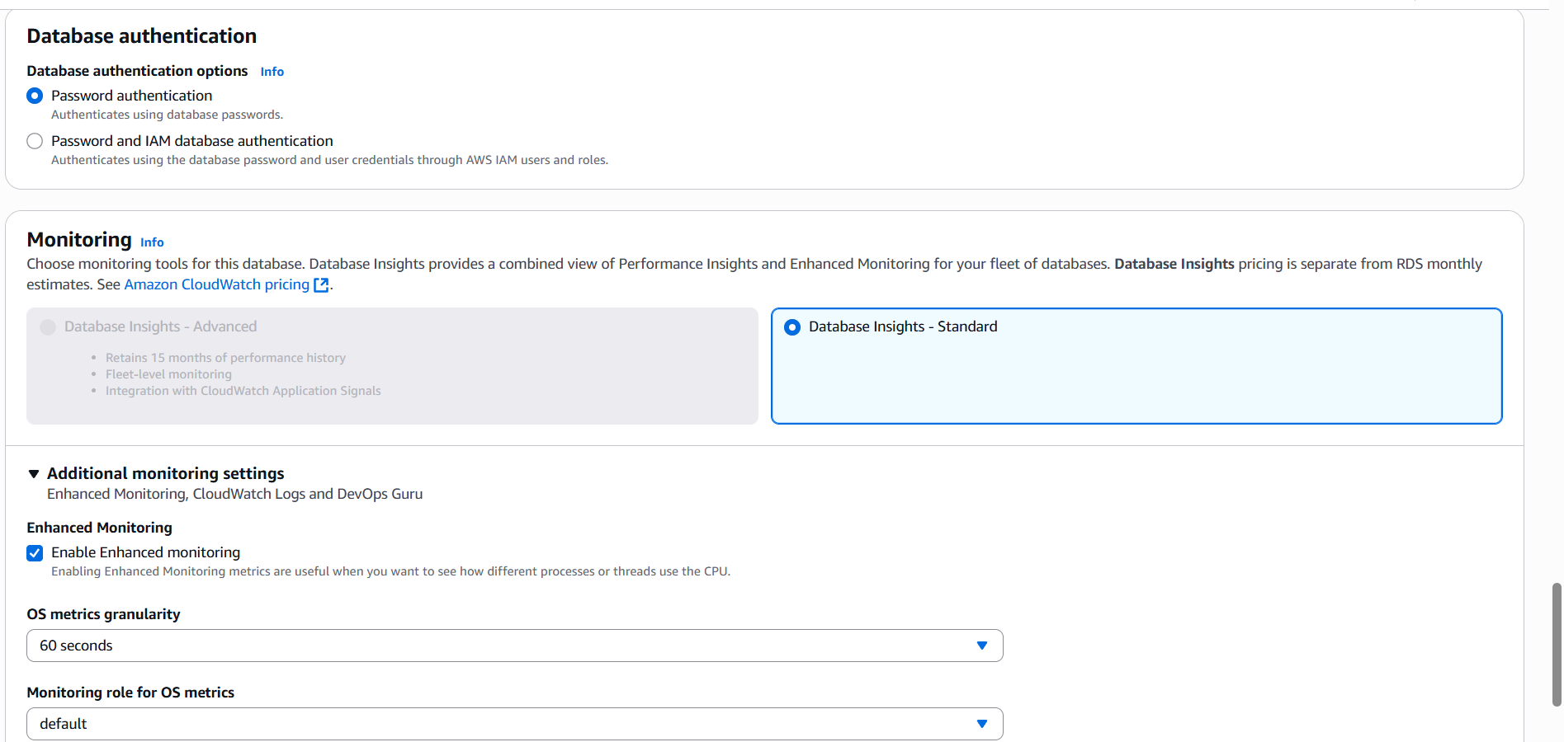
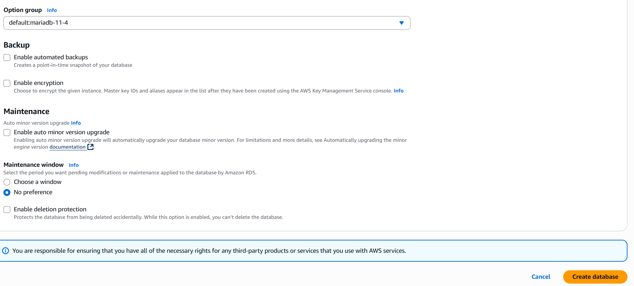
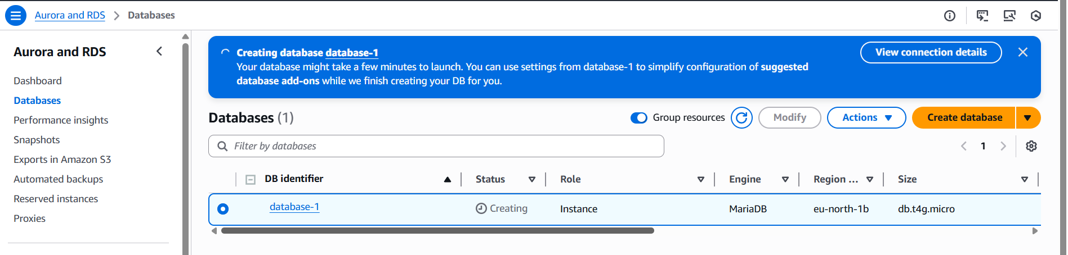
- Migrate database from EC2 to RDS.
Step 1: Take the dump of the DB using the command mqsqldump -u root -p database_name > file_name.sql
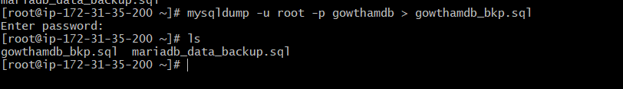
Step 2: Migrate the DB dump to RDS using the following commands
mysql -h endpoint -p 3306 -u user_name –p RDS_database_name
show databases;
create database database_name;
exit
mysql -h endpoint -p 3306 -u user_name –p RDS_database_name < file_name.sql
mysql -h endpoint -p 3306 -u user_name –p RDS_database_name
show database;
use database_name;
select * from table1;

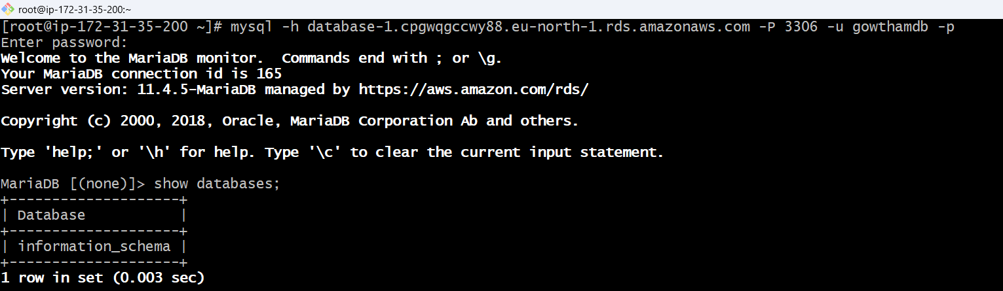
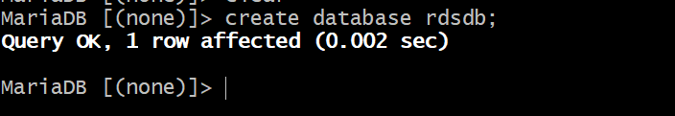
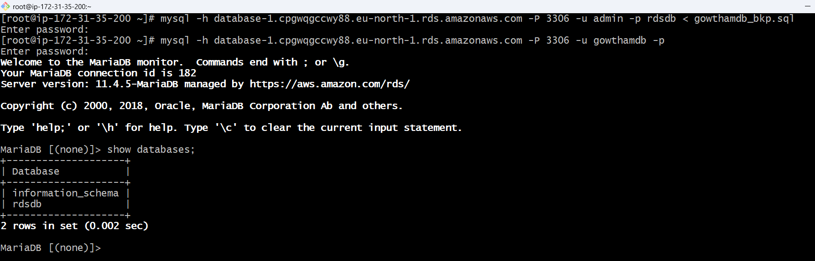
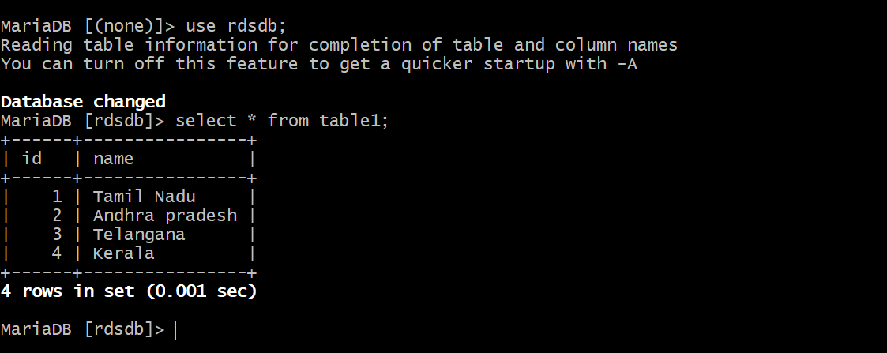

Database has been successfully migrated from EC2 to RDS database.

- Install MySQL DB on EC2
Step 1: Remove Mariadb using following commands
sudo dnf remove -y mariadb105*
sudo dnf clean packages
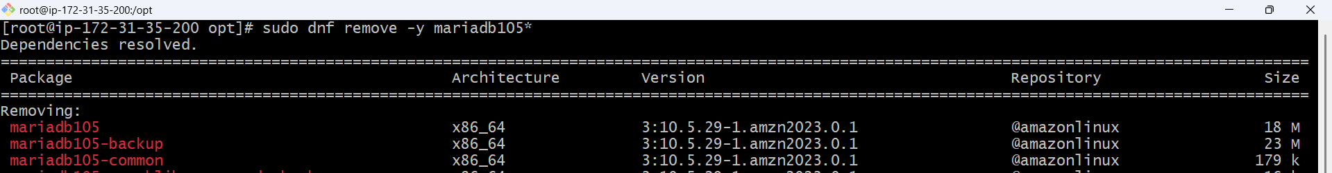
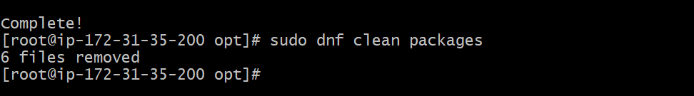
Step 2: Goto /opt directory and run the following commands to download and install the MYSQL.
sudo wget https://dev.mysql.com/get/mysql80-community-release-el9-1.noarch.rpm
sudo dnf install mysql80-community-release-el9-1.noarch.rpm -y
sudo rpm --import https://repo.mysql.com/RPM-GPG-KEY-mysql-2023
sudo dnf install mysql-community-server -y
sudo systemctl start mysqld
sudo systemctl enable mysqld
sudo mysql_secure_installation
sudo systemctl status mysqld
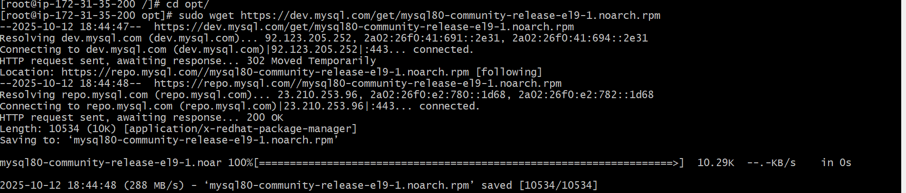
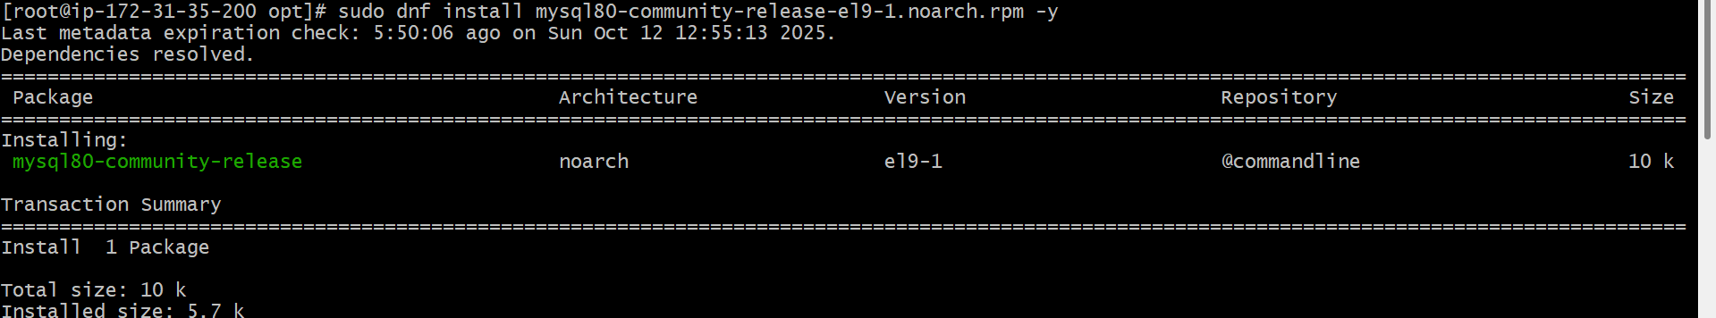
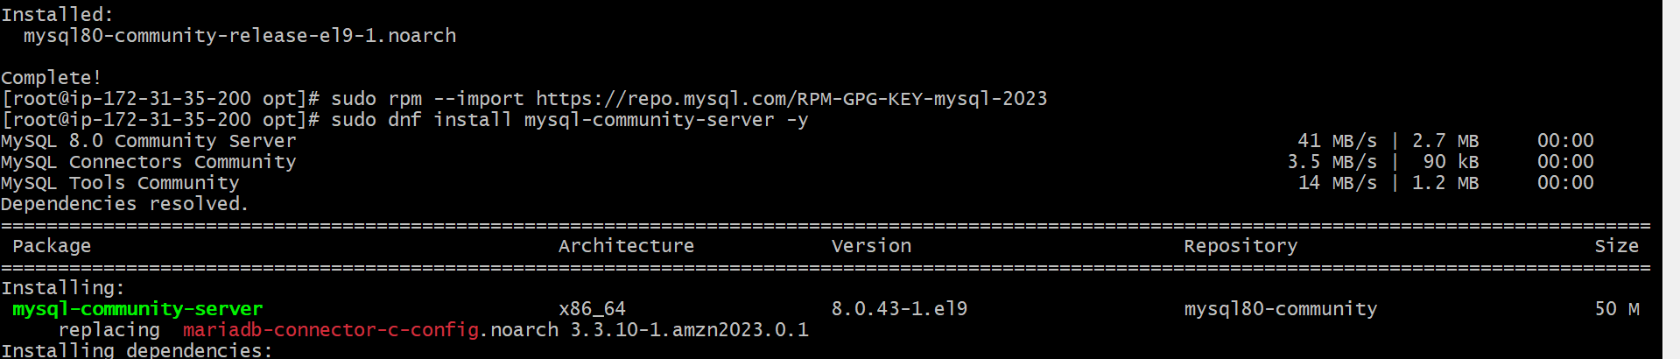
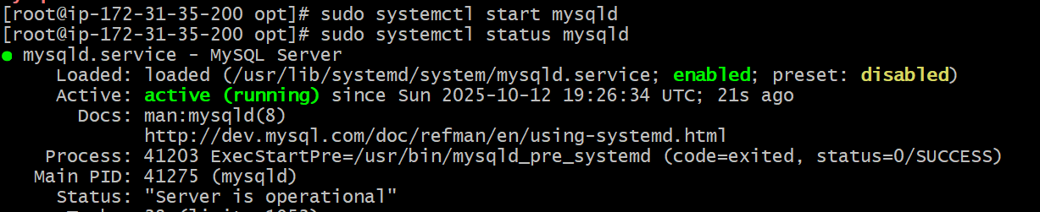
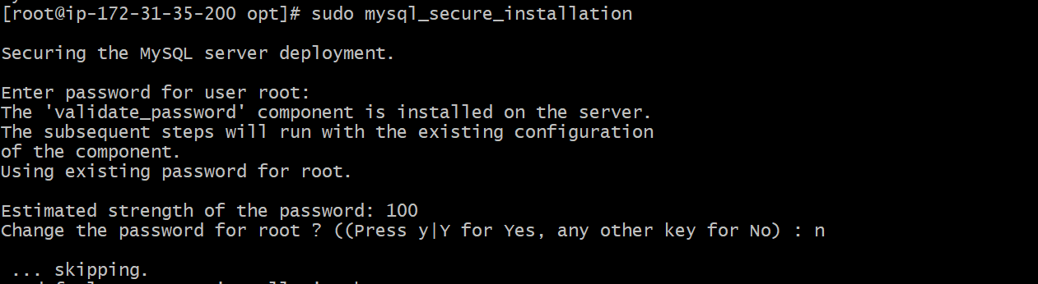
- Launch MySQL RDS image.
Step 1: Login to AWS, select Aurora and RDSDatabasecreate databasestandard create Mysql
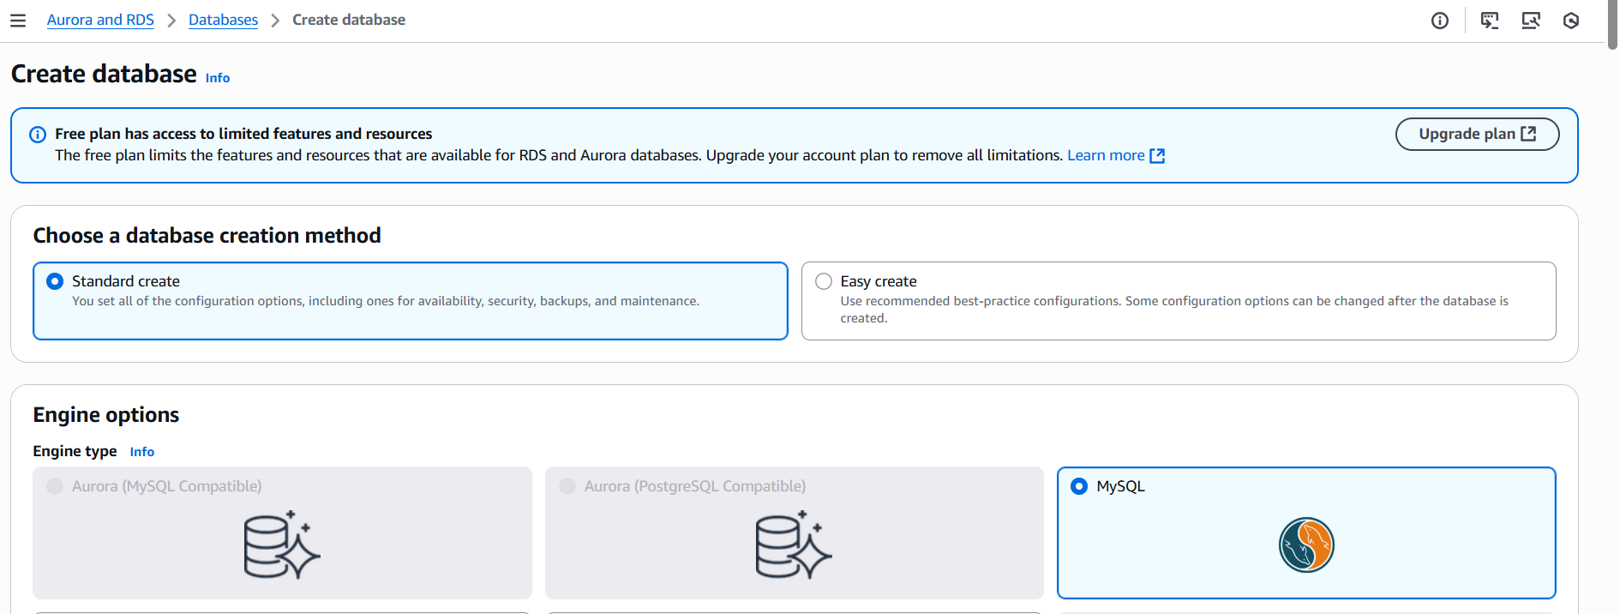

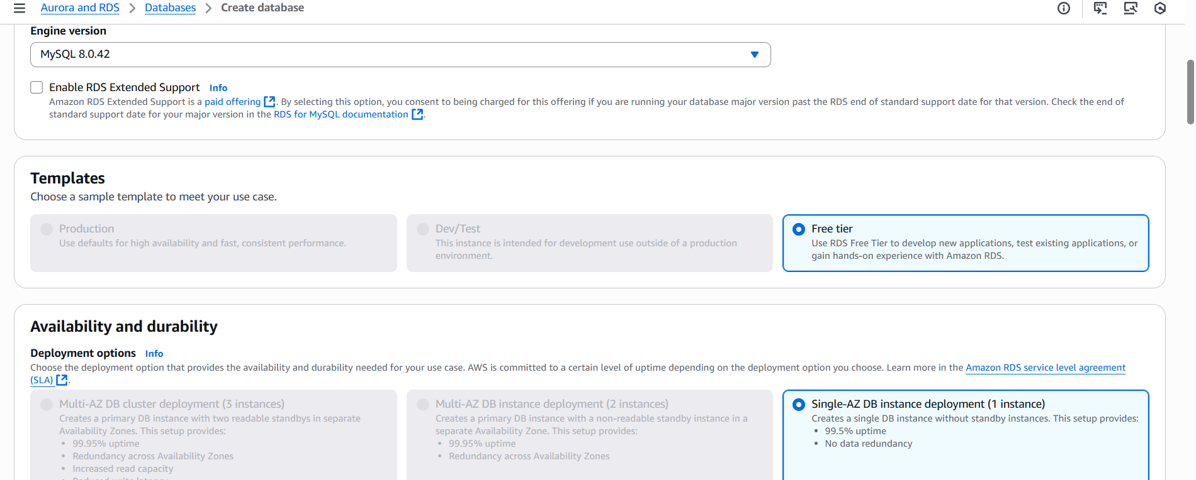
Step 2: Enter Master username &password and select instance and storage.
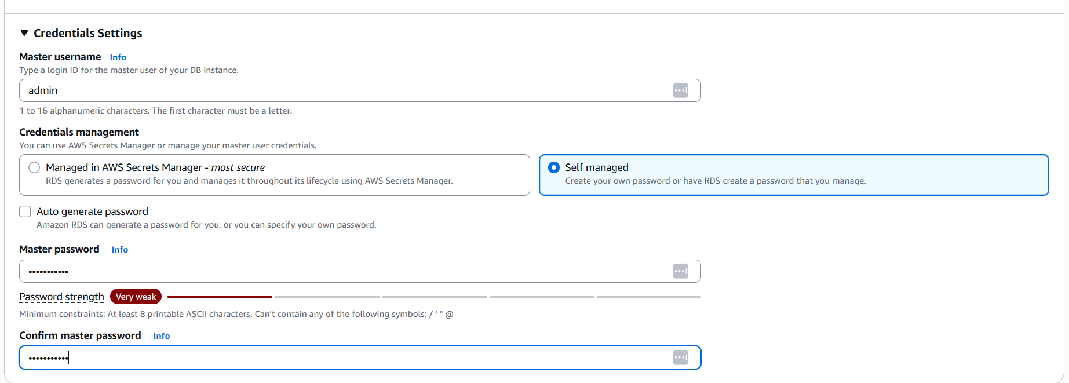
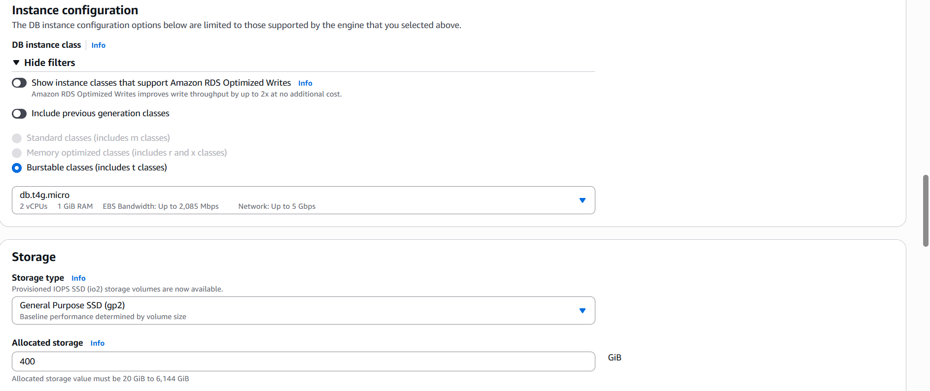

Step 3: select connectivity settings and click create.
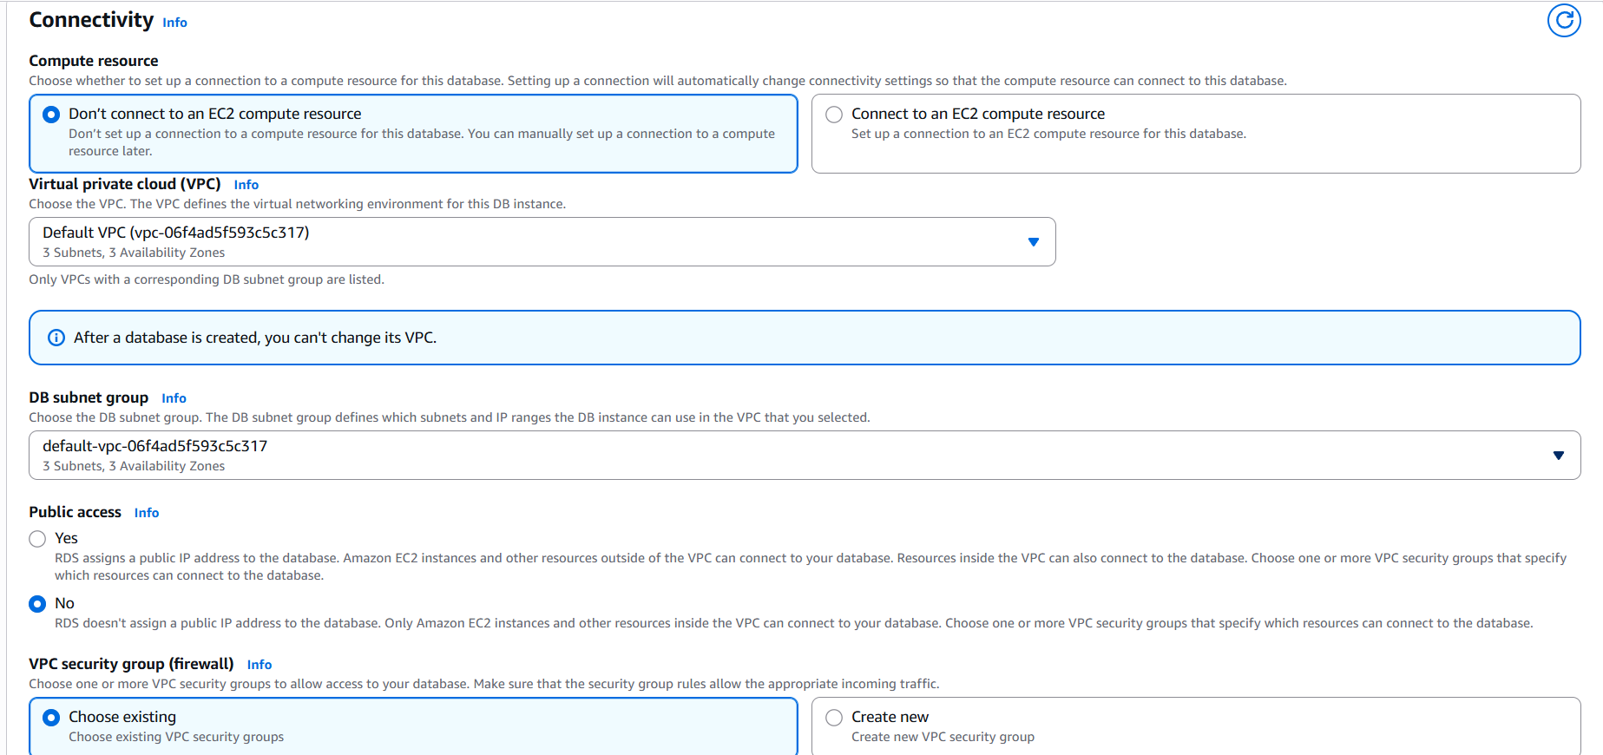
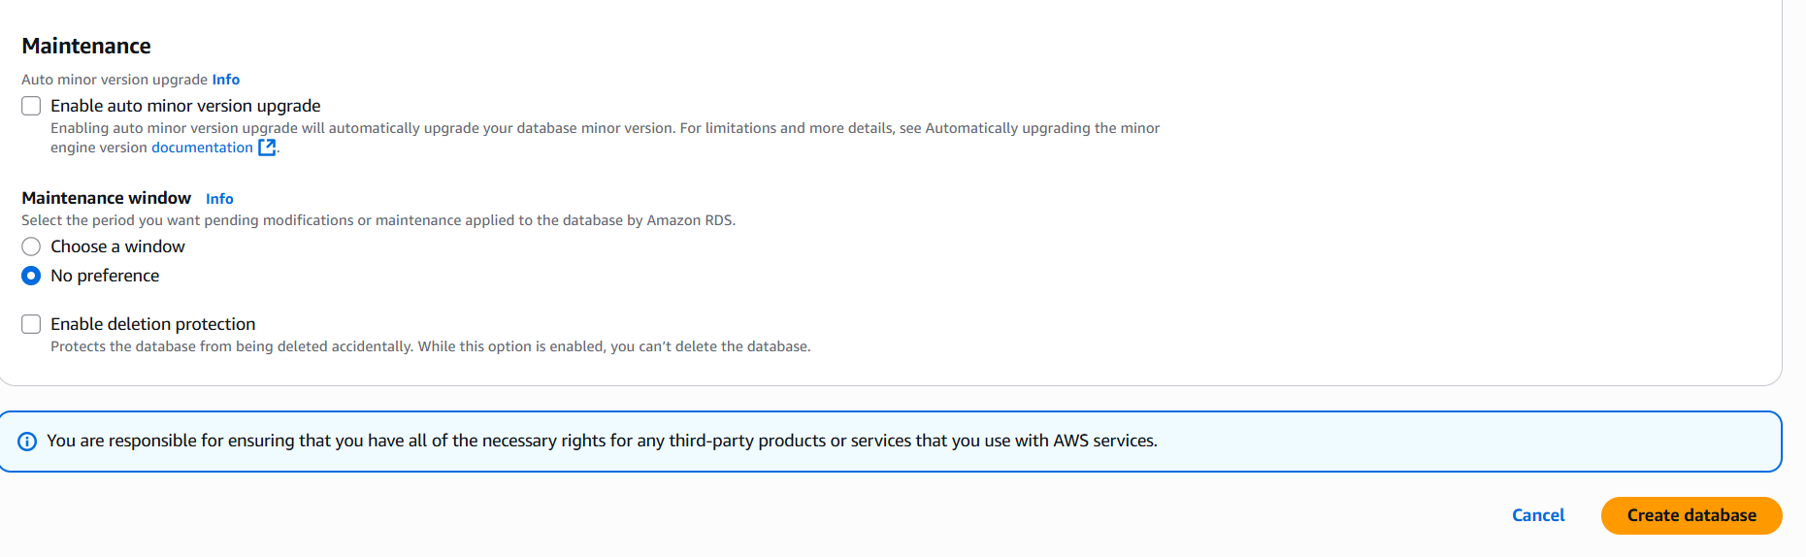
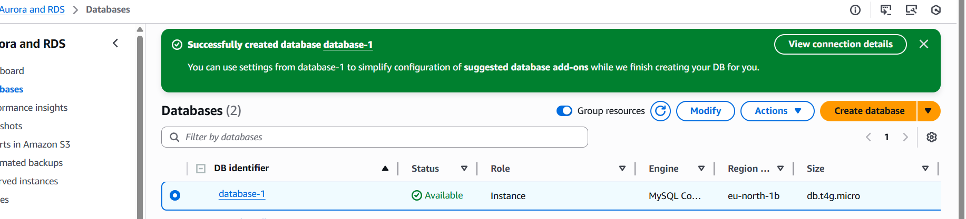

- Configure Multi-AZ.
Step 1: Goto RDSDatabaseselect databaseActions convert to multi AZ deployment.
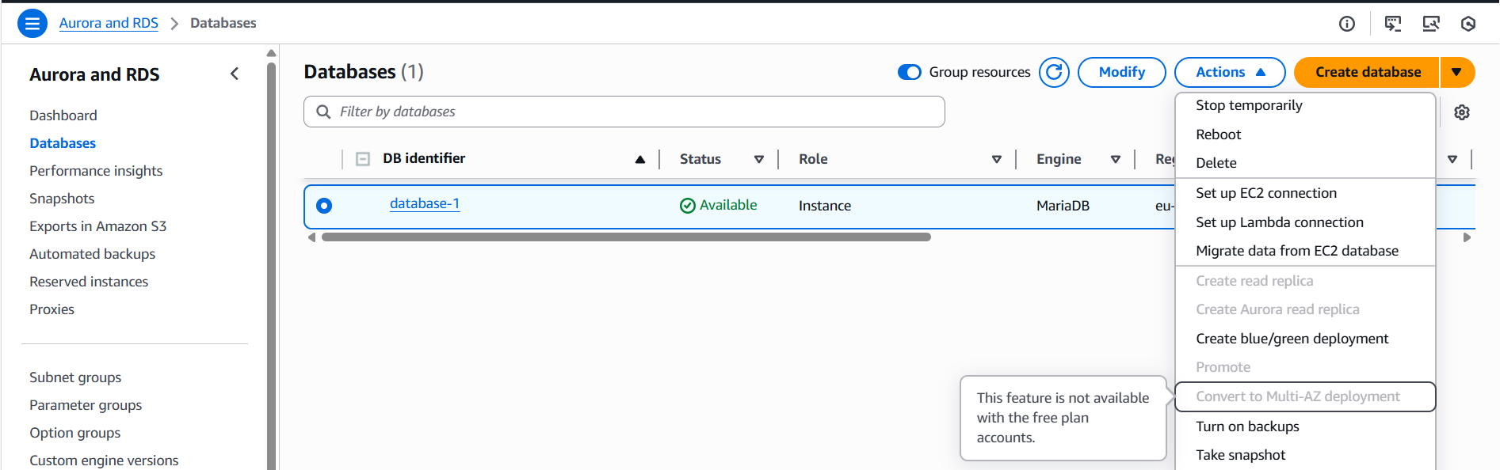

- Take backup of DB and restore the DB.
Step 1: Goto RDSDatabaseselect your databaseActionsTake a snap shot.
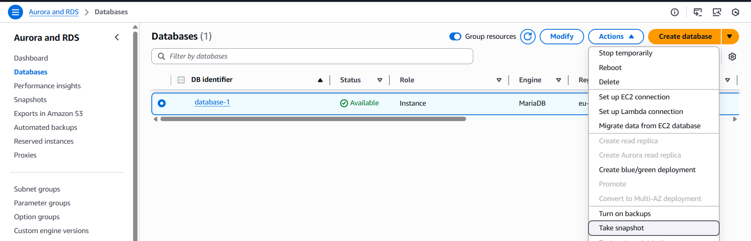
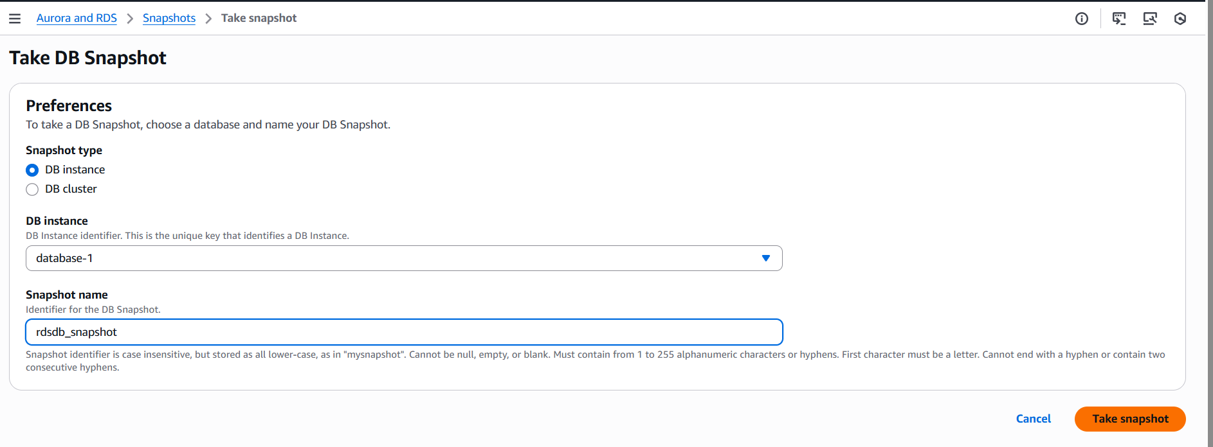
After taking snapshot delete the database.
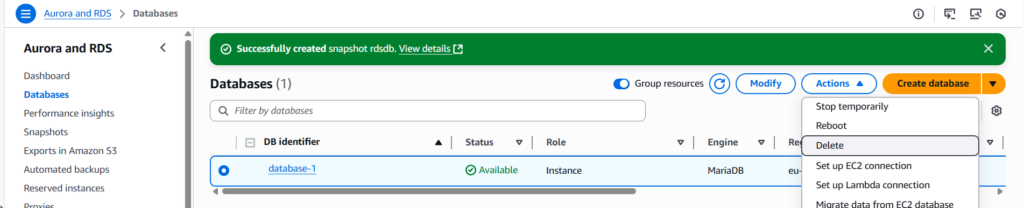
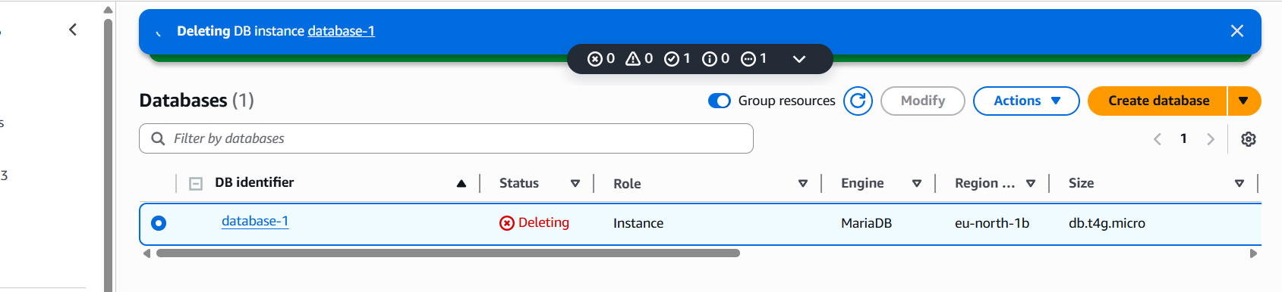

Step 2: Goto RDSsnapshotsselect your snapshotActionsrestore snapshot.
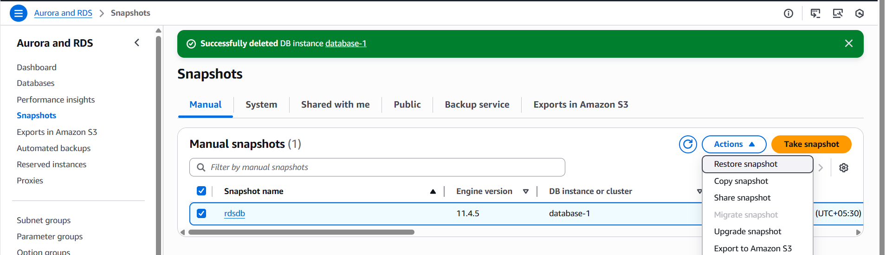
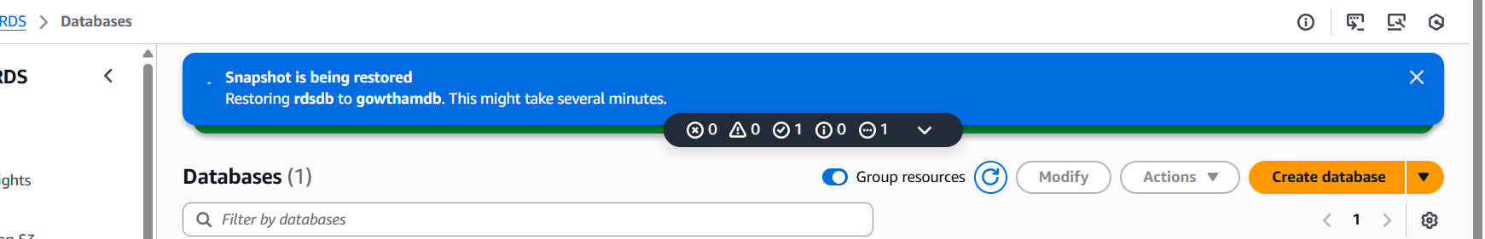

- Create read replica.
Step 1: Goto RDSDatabase select databaseActionscreate read replica
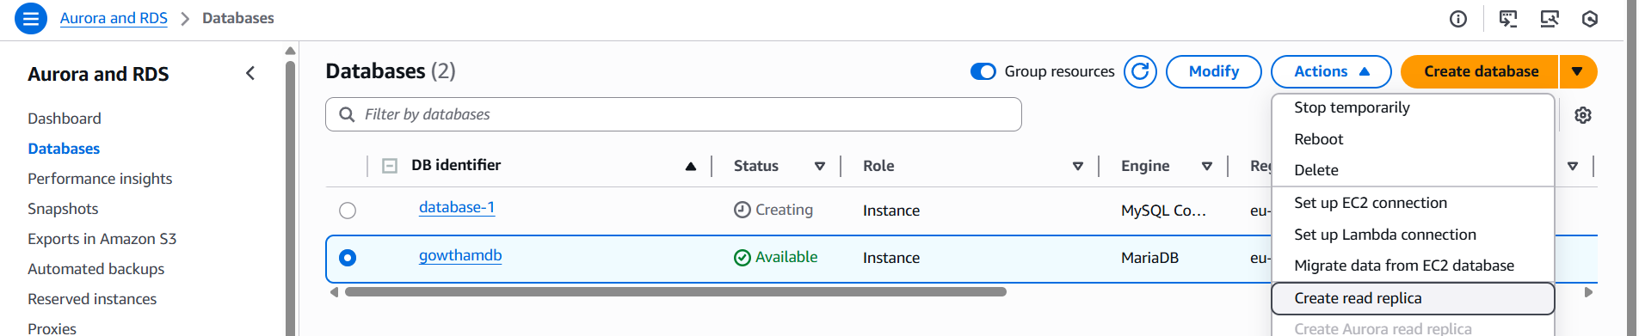

Step 2: Provide all the details and select create read replica.
