**Docker installation, Building and running Angular App.**

I used Windows 7 Professional. These instructions vary based on OS.

For Windows 7: download Docker Toolbox which comes with

Docker client(to run docker engine, creating images and containers)

Docker Machine(to create docker hosts on local mac/windows)

Docker Compose(running multi-container **Docker** applications)

VirtualBox

Kinematic (Docker GUI)

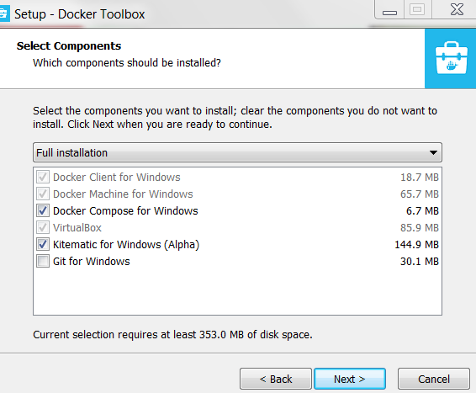After installation, run docker-quick-start. 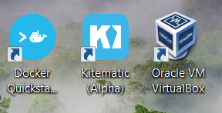

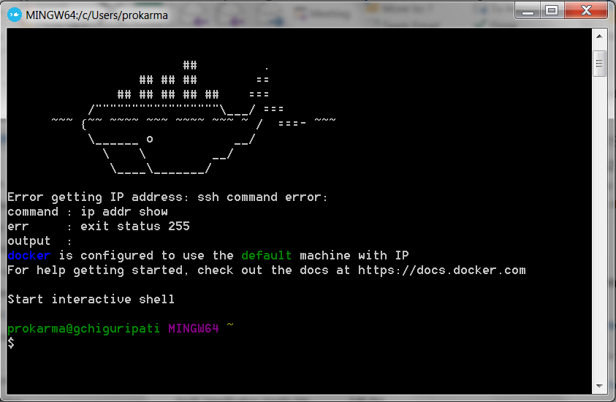

If you see the above ssh command error: installation is not successful, after some research I changed the windows 7 virtualization property in BIOS. This may vary by OS.

Press F1 on system boot,

Under Security->System Security-> Virtualization-technology disabled>enabled

Save & Exit

run docker-quick-start again. Able to see the machine with IP address.

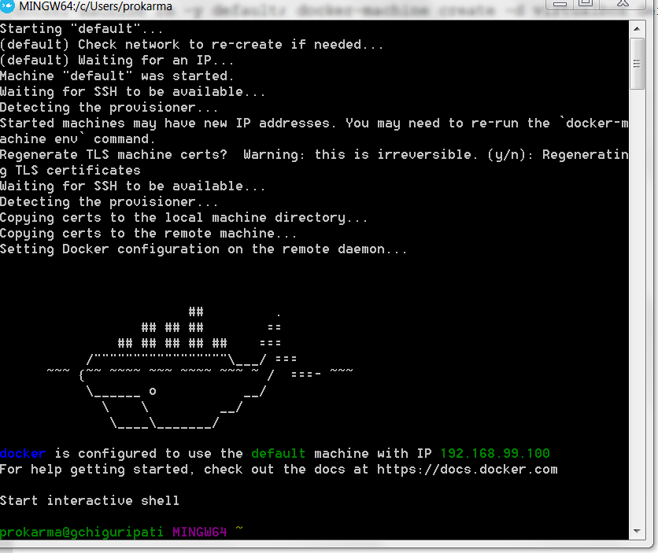

Create a angular or Java application with DockerFile in root folder. Docker file specifies the order of execution of command to assemble an image.

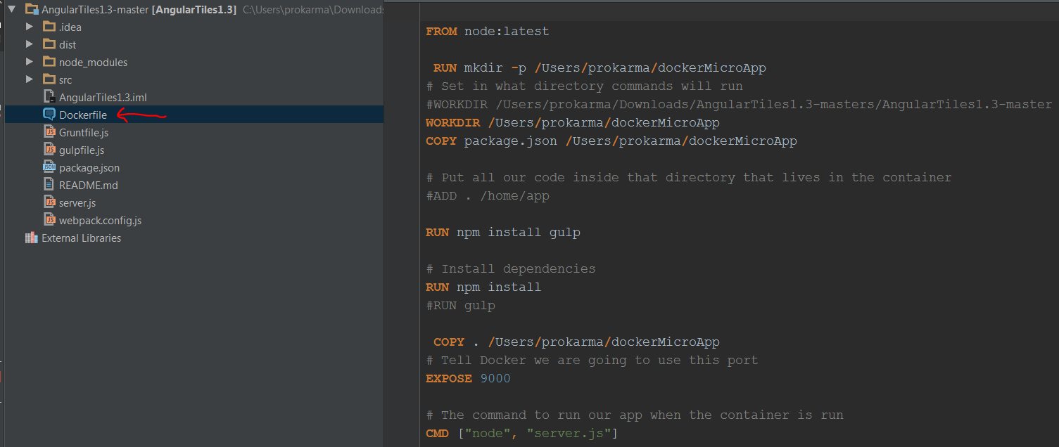

Building the Docker Image: app is name of the image. It executes the steps(1/7) in dockerfile.

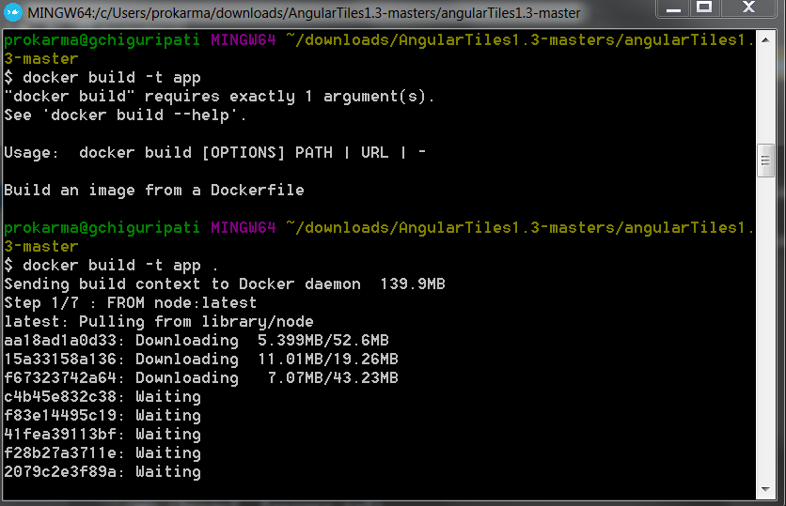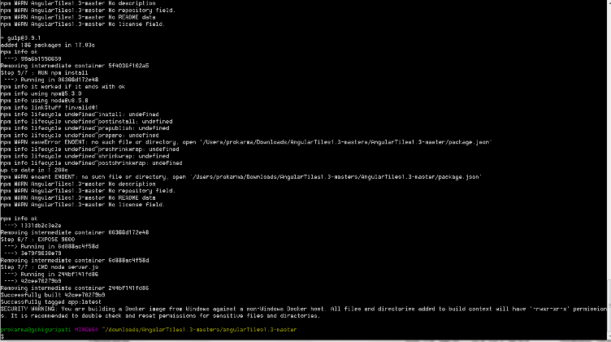

safdsafsafsafsafdsfsfdsa

asfdsafsaffdsa

after successful build you can see the image in kinematic.

Creating container and running the app in browser and useful command to see containers images logs.

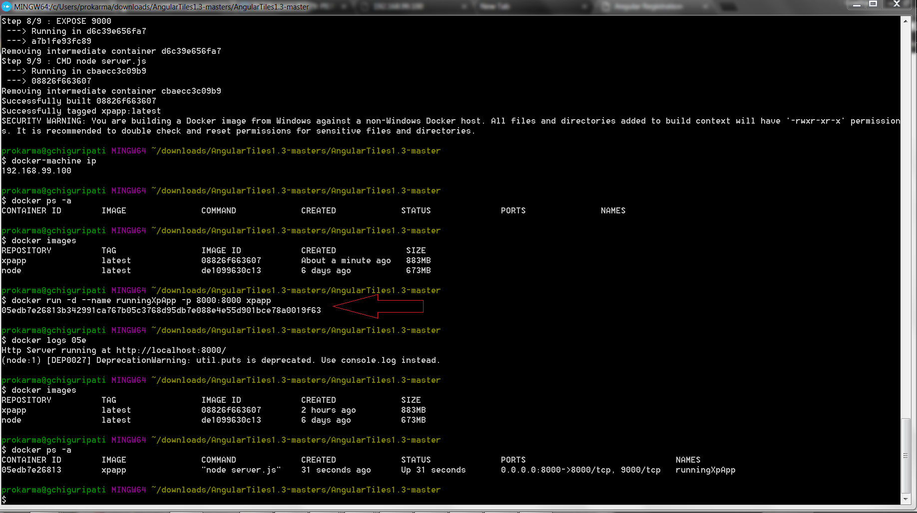

Run the app in web browser . replace localhost with docker-machine ip

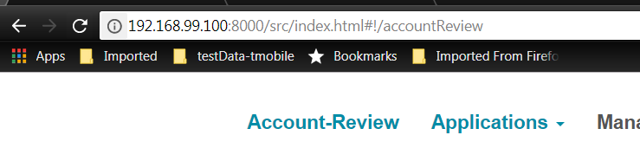

Running multiple applications like tms-api-gateway, auth-server eureka requires compose.