A Mini Project

On

**GIVE BLOOD SAVE LIFE**

*Submitted by*

***Batch No:7***

P Kavya 16121a1281

P Pavan Gowtham 16121a1282

P Priyatha 16121a1283

***Batch No:8***

P V S Meghana 16121a1284

P Divya 16121a1285

P Lavanya 16121a1286

***Batch No:9***

P Ali Abbas 16121a1287

P Ashok kumar 16121a1288

P Prudhvi 16121a1289

Under the Supervision of

**DR.K. K. Baseer** *M.Tech.,Ph.D.*

Associate Professor Department of Information Technology



Department of Information Technology

**SREE VIDYANIKETHAN ENGINEERING COLLEGE**

(AUTONOMOUS)

(Affiliated to JNTUA, Ananthapuramu, Approved by AICTE, Accredited by NBA & NAAC)

Sree Sainath Nagar, Tirupati – 517 102, A.P., INDIA

**2018 -2019**

**CONTENTS**

S.NO TITLE Page No

Abstract 01

1 Introduction 02

2 Modules 03

3 Design 04

4 Implementation 05

5 Concepts 06-10

6 Results 11-15

7 Conclusion 16

8 Future Enhancement 16

References 17

**ABSTRACT**

The main objective of this application is to automate the complete operations of the blood bank. “Blood” one of the most important necessity of our life. The numbers of blood donor is very less when compared with other countries. In our project we propose a new and efficient way to overcome such outline. We will the list of donors with each individual's details like name, phone number, age, weight, date of birth, blood group, address etc. At the time of blood needed a person can login in and can check for blood donor nearby by. Once the user enter the blood group which he/she needed it will automatically show the donor nearby. In case if the donor is not available it will automatically search the next donor which is present in. This Project provider list of donor in your city/area.

**1. INTRODUCTION**

The GIVE BLOOD SAVE LIFE (GBSL)system is designed for successful completion of project on blood bank management system. GBSL is a browser based system that is designed to store, process, retrieve and analyze information concerned with the administrative and inventory management within a blood bank. This project aims at maintaining all the information pertaining to blood donors, different blood groups available in each blood bank and help them manage in a better way. Aim is to provide transparency in this field, make the process of obtaining blood from a blood bank hassle free and corruption free and make the system of GBSL more effective.

The system project report contains information related to blood like

* Blood type
* Donor name
* Available blood group

On the basis of humanity, Everyone is welcome to register as a blood donor. At any point of time the people who are in need can reach the donors through our search facility. Sometimes Doctors and Blood bank project have to face the difficulty in finding the blood group Donors at right time. This project aims at maintaining all the information pertaining to blood donors, different blood groups available in each blood bank and help them manage in a better way.

The main objective of this application is to automate the complete operations of the blood bank. They need maintain hundreds of thousands of records. Also searching should be very faster so they can find required details instantly.

**2. MODULES**

**2.1 Donor Registration**

In this module the users are allowed to register their details like name ,age ,mobile number, email-id, password, age, blood group etc. Those details will be stored in the database.

**2.2 Login**

In this module the website will allow users to login with their earlier registered details i.e., email-id and password.

**2.3 Search**

In this module users can search for the required blood group after their successful login.

**2.4 Results**

In this module the results of above search will be appear according to the blood group they searched for.

**2.5 Database**

In this module all the data related to registration, login, search and results are stored and retrieved.

**2.6 Logout**

In this module users who are logged in are going logout.

**2.7 Payment**

In this module we can purchase the blood of the desired type

**3.DESIGN**

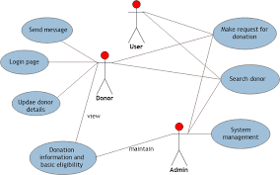

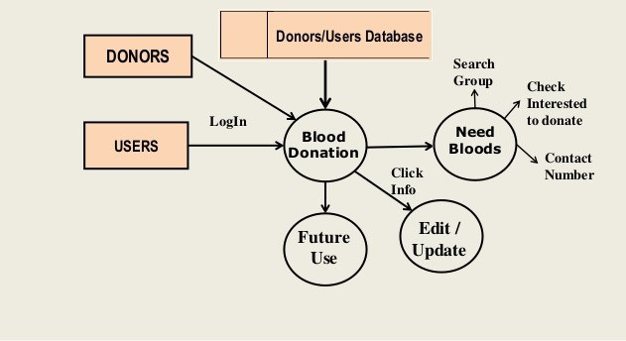

**4. IMPLEMENTATION:**

|  |  |
| --- | --- |
| **HARDWARE** | **MINIMUM SYSTEM REQUIREMENTS** |
| PROCESSOR | Intel core duo 2.0 GHz or more |
| RAM | 1GB or more |
| HARD DISK | 100GB or more |
| KEYBOARD | Normal or multimedia |
| MOUSE | Compatible mouse |

**4.1 HARDWARE REQUIREMENTS**

|  |  |
| --- | --- |
| **SOFTWARE** | **MINIMUM SYSTEM REQUIREMENTS** |
| OPERATING SYSTEM | WINDOWS |
| FRONT-END | HTML, CSS |
| BACK-END | PHP, MYSQL |

**4.2 SOFTWATE REQUIREMENTS**

**5. CODE CONCEPTS**

The various concepts used in this project are

* HTML 5
* CSS
* JScript
* jQuery
* PHP
* MySQL

**5.1 HTML 5**

HTML is written in the form of HTML elements consisting of *tags* enclosed in angle brackets(like <html>). HTML tags most commonly come in pairs like <h1> and </h1>, although some tags represent *empty elements* and so are unpaired, for example <img>. The first tag in a pair is the *start tag*, and the second tag is the *end tag* (they are also called *opening tags* and *closing tags*). The purpose of a web browser is to read HTML documents and compose them into visible or audible web pages. The browser does not display the HTML tags, but uses the tags to interpret the content of the page. HTML describes the structure of a website semantically along with cues for presentation, making it a markup language rather than a programming language.

**Tags used in HTML 5 pages are:**

<html> <head> <title> <body> <form> <img> <input> <a> <link> <style> <textarea> <button>

<script> <div> <span> <center> <marquee> <select>

<option> <label> <ul> <li> <h1> <h3> <br> <p>

**5.2 CSS (Cascading Style Sheet)**

**Cascading Style Sheets** (**CSS**) is a style sheet language used for describing the look and formatting of a document written in a markup language. While most often used to style web pages and user interfaces written in HTML and XHTML, the language can be applied to any kind of XML document, including plain XML, SVG and XUL. CSS is a cornerstone specification of the web and almost all web pages use CSS style sheets to describe their presentation. In the project for every web page we used CSS.

1.Home Page

2.Registration page

3.Login Page

4. Search & Results Page

5.Aboutus page

**Attributes used in CSS files are:**

Display background position opacity filter cursor overflow outline

-webkit-transition moz-transition transition align collapse text-shadow

Alignment text-decoration letter-spacing -webkit-border-radius float

Text-transform padding

**5.3 JAVA SCRIPT**

**JavaScript** (**JS**) is a dynamic computer programming language. It is most commonly used as part of web browsers, whose implementations allow client-side scripts to interact with the user, control the browser, communicate asynchronously, and alter the document content that is displayed. It is also being used in server-side network programming (with Node.js). JavaScript is a prototype-based scripting language with dynamic typing and has first-class functions.

**Methods used in JavaScript files are:**

addToAlbum()

fadeIn()

find()

postResize()

**5.4 JQUERY**

jQuery simplifies HTML document traversing, event handling, animating, and Ajax interactions for rapid web development. jQuery is a JavaScript toolkit designed to simplify various tasks by writing less code. In this we used two jquery files.

**Methods used in jQuery files are:**

ready()

setTimeout()

click()

show()

$("#").val();

appendChild()

**5.5 PHP**

PHP is now officially known as “**PHP: Hypertext Preprocessor**”. It is a server-side scripting language usually written in an HTML context. Unlike an ordinary HTML page, a PHP script is not sent directly to a client by the server; instead, it is parsed by the PHP binary or module, which is server-side installed. HTML elements in the script are left alone, but PHP code is interpreted and executed. PHP code in a script can query databases, create images, read and write files, talk to remote servers – the possibilities is endless. The output from PHP code is combined with the HTML in the script and the result sent to the user’s web-browser, therefore it can never tell the user whether the web-server uses PHP or not, because the entire browser sees is HTML.

**Methods used in php files are:**

$_POST[]

include()

echo

alert()

location.replace(‘#')

isset()

**5.6 MYSQL**

MySQL is a database system used on the web that runs on a server side.

We use the server-side database 127.0.0.1 to store the data, Where the registration details and bloodgroups are stored. We used single database named ‘bb’’.we created two tables in it as follows:

127.0.0.1 Table: donarregistration

Table: bloodgroup

**Methods used in MySQL files are:**

select

insert

mysqli_connect()

mysqli_query()

mysqli_fetch_array()

mysqli_nnum_rows()

mysqli_close()

**6. RESULTS**

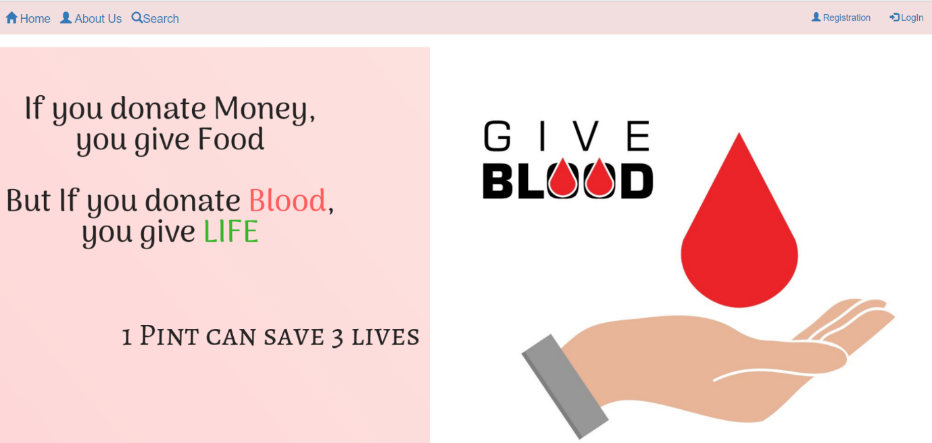

**Fig:6.1 Home Page.**

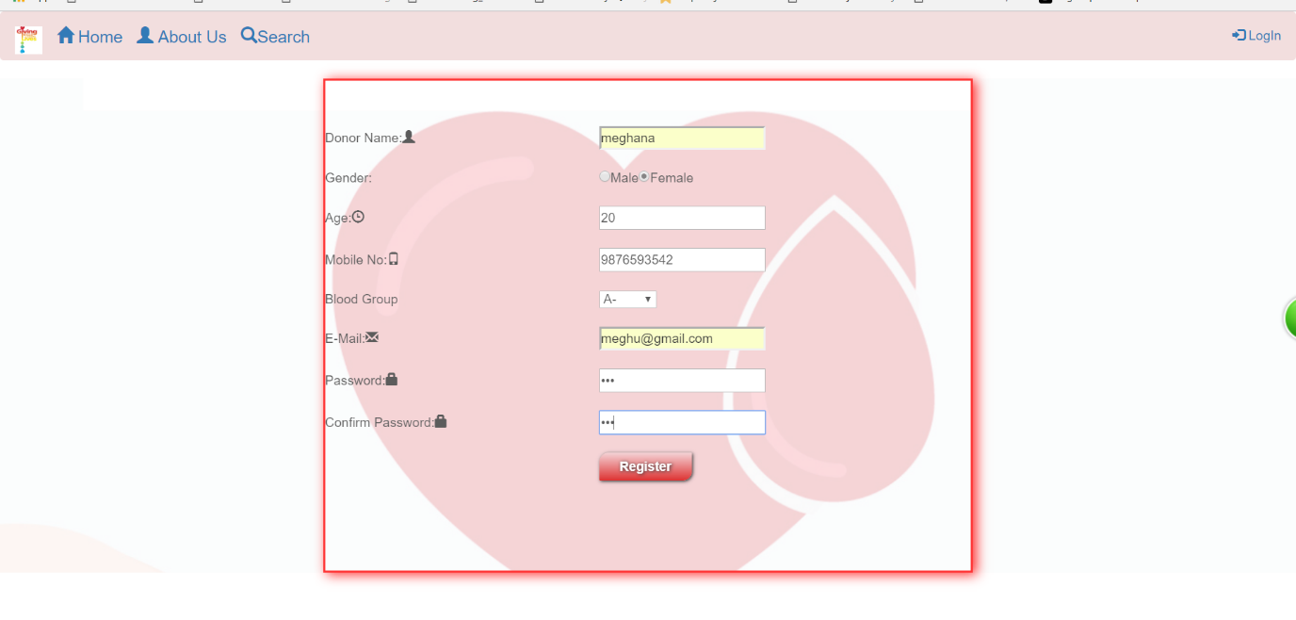

**Fig:6.2 Registration page.**

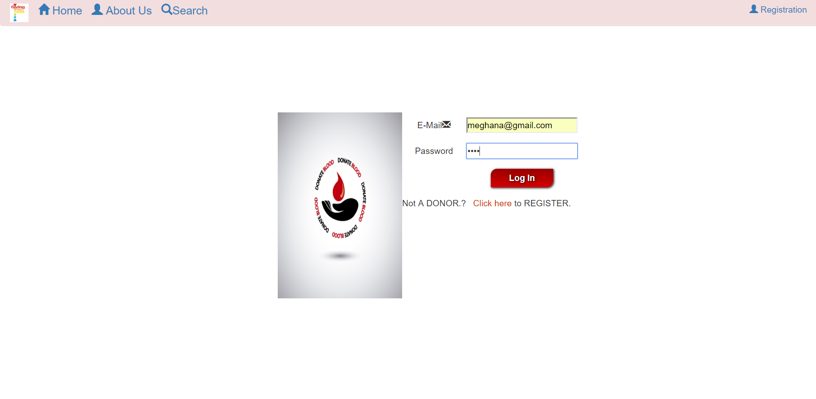

**Fig:6.3 Login page**

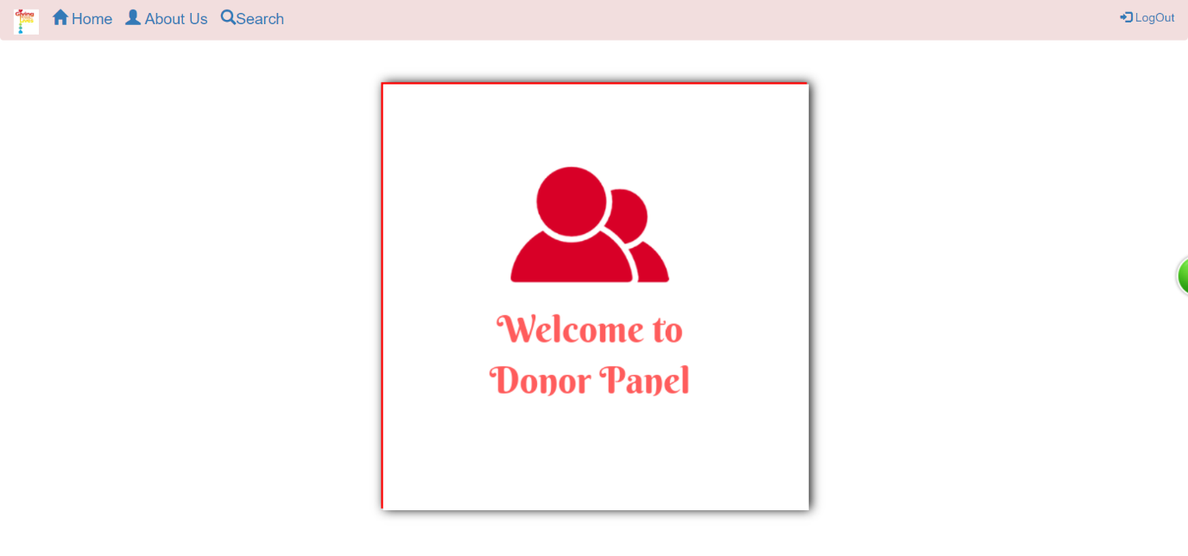

**Fig:6.4 Home page after login.**

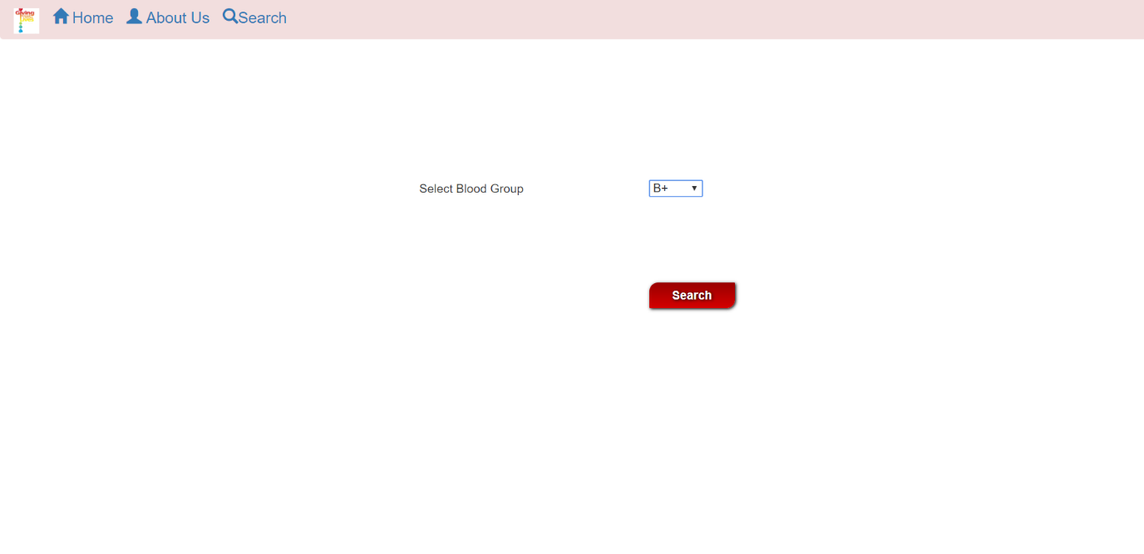

**Fig:6.5 Search page**

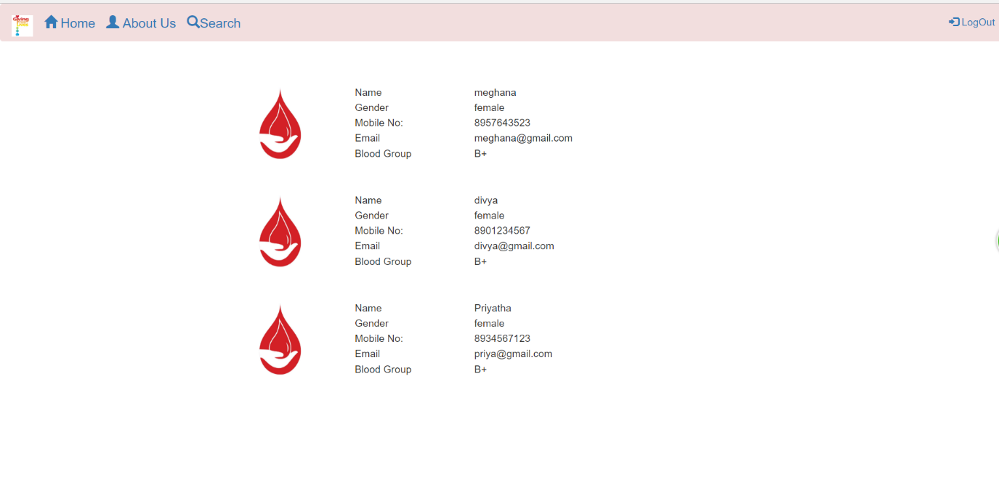

**Fig:6.6 Results page.**

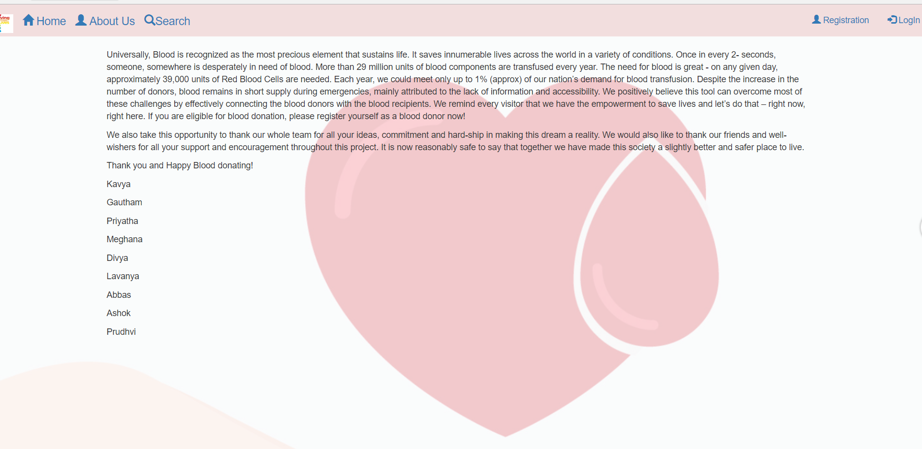

**Fig:6.7 About us page.**



**Fig 6.8 Logout page**

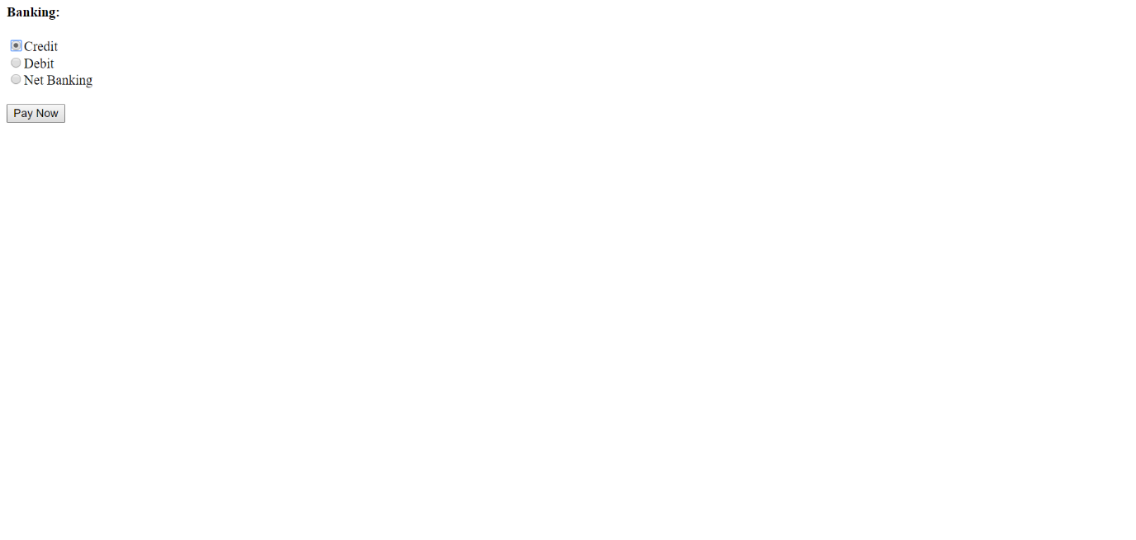

**Fig 6.9.1 Payment page**

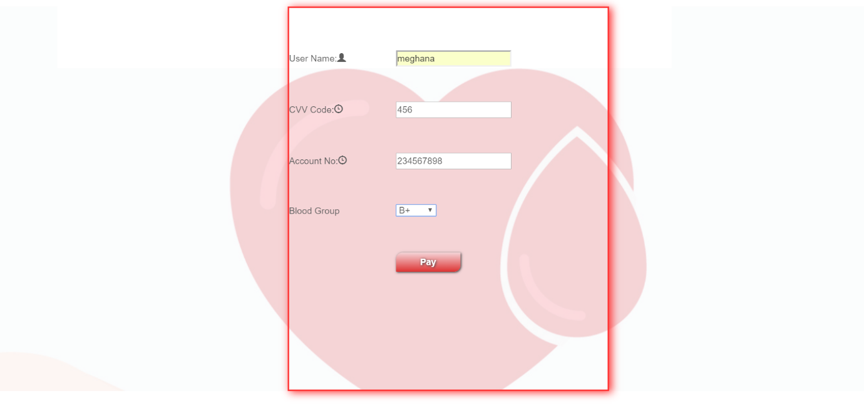

**Fig 6.9.2 Payment page**

**7. CONCLUSION**

With the theoretical inclination of our syllabus it becomes very essential to take the at most advantage of any opportunity of gaining practical experience that comes along. The building blocks of this Major Project “GIVE BLOOD SAVE LIFE” was one of these opportunities. It gave us the requisite practical knowledge to supplement the already taught theoretical concepts thus making us more competent as a computer engineer

Most of the donors in the study group opined that the motivating factors for the recruitment of more donors were, creation of opportunities to donate and the need to be well-informed about the need of blood. A majority of the donors were willing to be regular donors. The donors showed positive effects like a sense of satisfaction after the donation. In our study, most of the donors were knowledgeable about the blood donation and they had a good attitude towards it; however, they felt comfortable in donating blood once a year. If this feel good factor of a once a year donation could be changed into at least twice a year, the gap between the demand and the supply of the country could be narrowed down. Creating opportunities for blood donations by conducting many blood donation camps may provide a solution for our blood demand.

**8. FUTURE ENHANCEMENT**

Providea connection with hospitals where blood request will find all donors and we can get the location of donor

**9.REFERENCES**

[1] Kogent Learning Solutions Inc, “HTML 5 Black Book: Covers CSS3,JavaScript,XML, XHTML, AJAX, PHP and JQuery,” Dreamtech Press, 1st edition, 2011.

[2]W. Jason Gilmore, “Beginning PHP and MySQL,” APress, 4th Edition, 2011.

[3]“for queries”, https://www.stackoverflow.com

[4]“php-concepts”, http://www.phptpoint.com

[5]“basic knowledge “, www.w3schools.com

drafted on 20-04-2018

[6]Universal access to safe blood transfusion. Geneva: WHO; 2008

[http://www​.who.int/worldblooddonorday​/Melbourne Declaration_VNRBD_2009.pdf](http://www​.who.int/worldblooddonorday​/Melbourne%20Declaration_VNRBD_2009.pdf)

[7]

* <https://www.scribd.com/document/.../BLOOD-BANK-MANAGEMENT-SYSTEM-PR>

[8]

* **[www.academia.edu/17573428/Online_Blood_Donation_management_System_report](http://www.academia.edu/17573428/Online_Blood_Donation_management_System_report)**

[9] [http://www​.who.int/bloodsafety​/voluntary_donation​/blood_donor​_selection_counselling/en/](http://www.who.int/bloodsafety/voluntary_donation/blood_donor_selection_counselling/en/)

[10]<http://www​.who.int/bloodsafety​/publications​/bts_screendondbloodtransf/en/index​.html>.

[11]. [http://www​.who.int/bloodsafety​/transfusion_services​/bts_learningmaterials​/en/index.html](http://www.who.int/bloodsafety/transfusion_services/bts_learningmaterials/en/index.html).

[12] [http://www​.who.int/entity​/bloodsafety/global_database​/GDBS_Summary_Report_2011​.pdf](http://www.who.int/entity/bloodsafety/global_database/GDBS_Summary_Report_2011.pdf).

[13]<http://www​.who.int/bloodsafety​/resolutions/en/index.html> & [http://www​.who.int/entity​/bloodsafety/BTS​_ResolutionsAdopted.pdf](http://www.who.int/entity/bloodsafety/BTS_ResolutionsAdopted.pdf).