

|  |  |  |  |  |
| --- | --- | --- | --- | --- |
| **SUBJECTS** | **XII STD** | **WT - 1** | | **NEET QP** |
| **PHYSICS** | **ELECTROSTATICS (S1-S4)** | | | |
| **CHEMISTRY** | **SOLUTIONS (S1-S3)** | | | |
| **BIOLOGY** | **SEXUAL REPRODUCTION IN FLOWERING PLANTS (S1-S3)** | | | |
| ***TOTAL MARKS – 720*** | | | ***DURATION – 3 HRS*** | |
| ***EACH QUESTION CARRIES 4 MARKS. (-1 MARK) FOR WRONG ANSWER.*** | | | | |

**PHYSICS**

1. Among two discs A and B, first have radius 10 cm and charge 10 cm and 10-6 C and second have radius 30 cm and charge 10-5 C. When they are touched, charge on both qA and qB respectively will, be:

a) qA = 2.75 μC, qB = 3.15 μC b) qA = 1.09 μC, qB = 1.53 μC

c) qA = qB = 5.5μC d) None of these

1. A negatively charged object X is repelled by another charged object Y. However an object Z is attracted to object Y. Which of the following is the most possibility for the object Z?  
   a) positively charged only b) negatively charged only  
   c) neutral or positively charged d) neutral or negatively charged
2. Four objects W, X, Y and Z, each with charge +q are held fixed at four points of a square of side d as shown in the figure. Objects X and Z are on the midpoints of the sides of the square. The electrostatic force exerted by object W on object X is F. Then the magnitude of the force exerted by object W on Z is  
   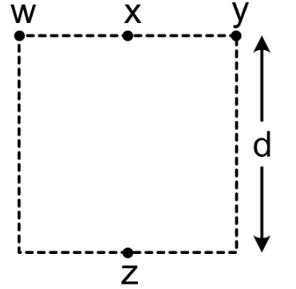  
   a)  b)  c)  d) 
3. An uncharged metal object M is insulated from its surroundings. A positively metal sphere S is then brought near to M. Which diagram best illustrates the resultant distributions of charge on S and M?

a) 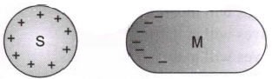 b) 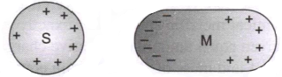

c) 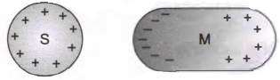 d) 