**CHAPTER 1**

**INTRODUCTION**

**1.1 INTRODUCTION**

The Internet of Things (IoT) imagines to associate billions of sensors to the Internet, so as to give new applications and administrations to savvy urban communities. Internet of Things will permit the development of the Internet of Vehicle from existing Vehicular Ad hoc Networks (VANETs), in which the conveyance of different administrations will be offered to drivers by incorporating sensors, and vehicles, cell phones into a worldwide system. To serve Vehicular ADHOC Networks with computational assets, Vehicular Cloud Computing is as of late imagined with the target of giving traffic answers for improve our day by day driving. These arrangements include applications and administrations to serve Intelligent Transportation Systems, which speak to a significant piece of Internet of Vehicle. Data assortment is a significant viewpoint in Intelligent Transportation Systems, which can adequately serve online travel systems with the guide of Vehicular Cloud.

At last, the objective of Vehicular Cloud Computing is to give on request answers for capricious traffic occasion, where applications can adjust as indicated by the dynamic ecological changes with the guide of a Vehicular Cloud. What separate vehicles from standard hubs in a regular cloud is self-rule and portability. Regardless of the way that the broadband interchanges and remote advancements can give organize network to people in general on the road through roadside Access Points (APs), the high versatility highlight that describe vehicular conditions confines the measure of data that a passing vehicle can download from an Access Point, where shared association can be an elective methodology. Blockage identification and shirking applications can bolster vehicle drivers with productive course arranging dependent on the road condition. A concentrated Intelligent Transportation System will be least to report possible traffic issue and ordinarily doesn't give a moderation arrangements. On the other hand, a Vehicular Cloud can offer the most proper and compelling applications that meet the prerequisites of Intelligent Transportation Systems, by empowering vehicles to talk about their traffic encounters on request. Along these queues, vehicles can distinguish traffic clog and precisely survey the traffic flow condition around situations. Data assortment is a significant viewpoint in Intelligent Transportation System, which can viably serve online travel framework with the guide of a Vehicular Cloud. In this work, we include the new worldview of Vehicular Cloud Computing to propose a force based data assortment to support Intelligent Transportation System.

**1.2 INTELLIGENT TRANSPORTATION SYSTEMS**

An intelligent transportation system (ITS) is a propelled application which plans to give inventive highlights identifying with a few methods of transport and traffic the executives and empower clients to be better educated and make more secure, increasingly planned, and 'more brilliant' utilization of transportation networks. A portion of these innovations incorporate calling for crisis administrations when a mishap happens, utilizing cameras to enroute traffic laws or signs that imprint speed limit changes relying upon conditions. Various types of remote communication innovations have been anticipated. In this section, we include the new worldview of Vehicular Cloud Computing to plan a data assortment model to serve Intelligent Transportation System. We show through recreation results that the interest of least level of vehicles in a powerful Vehicular Cloud is adequate to give significant data assortment.

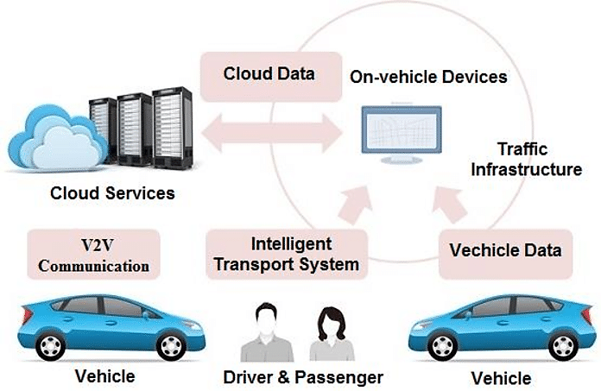

Fig1.1 Intelligent Transportation System

**Uses** **of the** **intelligent transportation system** (ITS).

* Real-time stopping the board.
* Electronic tollgate.
* Emergency vehicle notice systems.
* Automated road speed requirement.

Correspondence collaboration on the road incorporates vehicle to vehicle, vehicle to foundation, and the other way around. Data accessible from vehicles are gotten and transmitted to a server for focal combination and handling. These data can be utilized to distinguish occasions, for example, downpour and clog. The server forms a driving quality devoted to a solitary or a particular gathering of drivers and transmits it remotely to vehicles. The objective of agreeable system is to utilize and design correspondence and sensor foundation to expand road wellbeing. City roads are getting by to the weight of a developing urban populace. One of the principle utilization of an Intelligent Transportation System is brilliant traffic the board.

**Advantages of Intelligent Transportation System**

* Reduction in stops and postponements at crossing points.
* Speed control and improvement.
* Travel time improvement.
* Capacity the board.
* Incident the board

Intelligent Transportation Systems (ITS) advances advance transportation wellbeing and portability and upgrade American efficiency by coordinating advanced interchanges innovations into transportation framework and into vehicles. Intelligent Transportation System includes a broad scope of remote and traditional correspondences based data and electronic advancements. The Intelligent Transportation Systems Joint Program Office (ITS JPO) inside the U.S. Division of Transportation's Research and Innovative Technology Administration is liable for directing exploration in the interest of the U.S. Speck and every single significant mode to advance transportation wellbeing, portability, and natural maintainability through electronic and IT applications, known as Intelligent Transportation System. Intelligent Transportation System applications center around both the foundation and vehicle, just as coordinated advantages between the two, to empower the making of an Intelligent Transportation System. With the origination of keen city transmitting urban areas into computerized social orders, making the life of its residents simple in each feature, “Intelligent Transportation System turns into the fundamental segment among all. In any city portability is a key concern; be it going to class, school and office or for some other reason residents use transport system to go inside the city. Utilizing residents with an Intelligent Transportation System can spare their time and make the city significantly more astute. Intelligent Transportation System means to accomplish traffic proficiency by limiting traffic issues. It advances clients with earlier data about traffic, neighborhood accommodation continuous running data, and seat accessibility and so on which lessens travel time of workers just as upgrades their security and solace. The use of Intelligent Transportation System is generally acknowledged and utilized in numerous nations today. The utilization isn't simply constrained to traffic clog control and data, yet in addition for road security and productive framework use. On account of its unlimited prospects, Intelligent Transportation System has now become a multi-disciplinary conjunctive field of work and in this manner numerous associations around the globe have created answers for giving Intelligent Transportation System advantages to address the issue.

**1.3 VEHICULAR AD HOC NETWORKS (VANETs)**

Vehicular ad hoc networks have been a significant hot examination region over the most recent couple of years. Because of their one of a kind attributes, for example, high unique geography and unsurprising portability, Vehicular ad hoc networks draw in such a great amount of consideration of both academia and industry.” In this section, we give a diagram of the fundamental parts of Vehicular ad hoc networks from an examination. This paradigm begins with the essential engineering of networks, at that point examines three famous examination issues and general exploration strategies, and winds up with the investigation on difficulties and future patterns of Vehicular ad hoc networks.

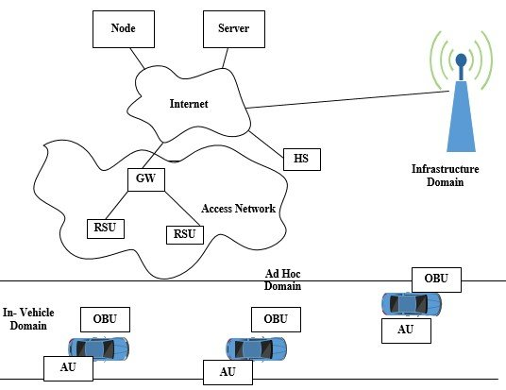

**Fig.1.2 Vehicular ADHOC Networks – VANET**

Vehicular ad hoc networks assume a significant job in giving an elevated level of wellbeing and accommodation to drivers on the road. The fast development of vehicles on the road calls for compelling intends to improve road wellbeing, effective transportation and travelers' solace. Inside the framework space, there are two areas: the roadside foundation space and focal framework area. The roadside foundation area contains roadside unit elements like traffic lights. The focal foundation space contains framework the board places, for example, traffic the executives communities and vehicle the executives habitats. The quantities of associated vehicles are expanding and generally all the introduced associated vehicles are intelligent gadgets that are portable and prepared on-board unit's and different detecting gadgets with incredible calculation ability which helps for detailing the driving data as well as give traffic conditions, road conditions and climate conditions for transportation arranging, road system plan and traffic signal control.

As appeared in Fig 1.2, the in vehicle space is made out of an on-board unit (OBU) and one or numerous application units (AUs). The associations between them are generally wired and some of the time remote. Be that as it may, the ad hoc space is made out of vehicles furnished with on-board units and roadside units (RSUs). An OBU can be viewed as a versatile hub of an ad hoc system and roadside units is a static hub in like manner. A roadside units can be associated with the Internet by means of the passage; roadside units can speak with one another legitimately or through multi-jump also. There are two sorts of framework space get to, roadside units and problem areas. On-board units may speak with Internet by means of roadside unit or problem areas. “Without roadside units and problem areas, on board units can likewise speak with one another by utilizing cell radio networks (GSM, GPRS, UMTS, WiMAX, and 4G). Vehicular clouds in urban territories empower provisioning of various uses, for example, video reconnaissance of open vehicle. In country regions, vehicles team up for a brief timeframe. In this manner, vehicular cloud has short life cycle. In addition to that, vehicular cloud execution is considerably progressively troublesome because of least frequencies of vehicles appearance. The most ideal situation for vehicular cloud stopping usage is part. Portability of the vehicles is irrelevant. The existence pattern of vehicular cloud is fundamentally higher in correlation with country and urban areas. The correspondence and capacity assets of left vehicles can be utilized to shape vehicular cloud covering one of a kind area.

Framework clouds are for the most part started by adjacent road side unit along the road. Vehicles on the road require the entrance to the administrations gave by cloud. Framework Cloud give little geological inclusion around road side unit area. Correspondence between various framework clouds performed through committed neighborhood servers. Considering that both static and versatile elements in this star grouping are engaged with Infrastructure Cloud, specialized multifaceted nature of Infrastructure Cloud advancement changes for various situations of vehicular networks. Urban zones are portrayed by vehicles of generally low versatility and unreasonable adjacent framework. Subsequently, the execution and presence of Infrastructure Cloud is empowered because of the accessibility of various road side unit. Different applications are bolstered by Infrastructure Cloud in urban regions, for example, remote route and traffic the executives. Foundation Cloud organization in country regions is obliged because of absence of adjacent framework and high portability of vehicles. In this situation, just impermanent cloud can be shaped between Road Side Unit and vehicle in brief timeframe period. At the point when vehicles have irrelevant versatility and adjacent framework is accessible, the usage of Infrastructure Cloud in the region of certain Road Side Unit is reachable. Mix of Vehicular Cloud and Infrastructure Cloud brings about high effectiveness and better system exhibitions. Back end cloud alludes to the biggest regular cloud in vehicular condition. This cloud claims assets that can be utilized by vehicles for broad data stockpiling and calculation. Back End Cloud underpins provisioning of high uses transfer speed requesting, for example, in vehicle mixed media.

**1.3.1 Communication Architecture**

Correspondence types in Vehicular Ad hoc Networks can be ordered into four sorts. The class is firmly identified with Vehicular Ad hoc Networks segments as portrayed previously. Fig 1.3 portrays the key elements of every correspondence type. In vehicle correspondence, which is increasingly essential and significant in Vehicular Ad hoc Networks research, alludes to the in-vehicle space. In vehicle correspondence system can identify a vehicle's exhibition and particularly driver's exhaustion and laziness, which is basic for driver and open security.

Vehicle to vehicle (V to V) correspondence can give a data trade stage to the drivers to share data and cautioning messages, in order to extend driver help. Vehicle to road foundation (V to R) correspondence is another helpful exploration field in Vehicular ADHOC Networks.” Vehicle to road foundation correspondence empowers constant traffic/climate refreshes for drivers and gives ecological detecting and checking. Vehicle to broadband cloud (V to B) correspondence implies that vehicles may convey by means of remote broadband instruments, for example, 3G/4G.

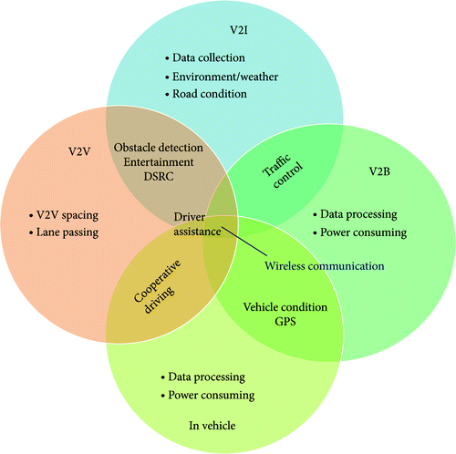

**Fig.1.3 Key process of each Communication Type**

As the broadband cloud may include more traffic information and observing data just as infotainment, this sort of transmission will be valuable for active driver assistance and vehicle tracking.

**1.3.2 Layered Architecture for Vehicular ADHOC Networks**

The open systems interconnection (OSI) model is notable to the greater part of the readers, which bunches same communication functions into one of seven logical layers. The meeting layer and introduction layer are stayed away from here, and a given layer can be additionally parceled into sub layers in this architecture. By and large, the architecture of Vehicular ADHOC Networks may differ from locale to district, and consequently the protocols and interfaces are likewise fluctuate among them. Vehicular applications likewise include security, geo-advertising, and amusement applications to make the vehicle's travelers venture progressively fun and bliss. The European Transport and Telecommunication Information (ETSI) characterizes Cooperative-Intelligent Transport System (C-ITS) applications that give emergency (wellbeing) messages and reduce drastically car accidents. In fact, Cooperative-Intelligent Transport System applications include, for instance, in vehicle speed breaking point or emergency collision. Messages from Cooperative-Intelligent Transport System applications can be produced from different use cases such as an accident and are commonly just one or, in all likelihood two bounces. In addition to this, geo-advertising constitutes a lot of applications for advertising to vehicles inside a particular zone territory and direction. Moreover, amusement based vehicular uses are primarily cloud-based applications which improve wellbeing, comfort, and diversion through the advancement of process taking into consideration

Internet prepared vehicles referred to as the Internet of Vehicles. Internet of Vehicles offers travelers the capacity to get cloud resources whenever and pay as they use them. Thusly, the cloud computing serves to continuously perform different process such as altering, meeting, introduction records or going to a significant group meeting as long as the vehicle is connected to the Internet. In any case, the high portability and incessant handover from serving Road Side Units increase arrange overload because of the quantity of reconnection demands and insufficient vehicle computing resources. Additionally, the issue of backhaul latency affects Quality of service since many cloud based vehicular uses are eager for bandwidth. Along these queues, cloud computing gives considerable resources to empower cloud-based applications including Internet of Vehicles applications.

[

The Vehicular Cloud architecture is in the advancement of converging with the Internet of vehicles as a crucial stage for the Intelligent Transportation System. The cloud architecture for vehicular networks consists of three interacting layers: Vehicular Cloud, Road Side Unit cloud, and central cloud. Moreover, the components of central and Road Side Unit cloud are described as a most virtualized stage that gives the computation, stockpiling, and system resources. In addition to that, Edge Computing is an expansion of a central cloud to give least postpone and better computation performance. A case of a comparable system to Edge computing, the cloudlet, is characterized as cloud computing in box. Cloudlets are created at the Road Side Unit as a little scale operational site that offers cloud services to vehicles in the quick vicinity of the cloudlets. These cloud services are for the most part begun from central/edge cloud infrastructures and moved to the vehicles through portability the board protocols. In any case, the dynamic geography of the vehicular networks and substantial versatility decrease data spread, which keeps an eye on the execution of complex steering protocols. Hence, complex steering protocols limit the execution of new vehicular applications, which would permit everything around the vehicle to communicate with all vehicles. Thusly, developing system technologies were recently offered to address existing issues in vehicular networks. Directly, the Software-Defined Network is among the developing system technologies for Vehicular Ad-hoc Networks and has drawn much consideration from a few academic researchers.

Various protocols are intended to use at the various layers; not many of them are as yet under active improvement now in Vehicular Ad-hoc Networks, remote communication has technology to help the achievement of a few applications and services. In any case, because of the characteristics of Vehicular Ad-hoc Networks such as high dynamic geography and discontinuous connectivity, the current directing calculations in MANETs are not accessible for most application scenarios in Vehicular Ad-hoc Networks. Along these queues, researchers demonstrate no push to improve existing calculations just as plan new ones, with the goal that the communication unwavering quality can be stays same. Contingent upon the quantity of senders just as the receivers in question, steering approaches can be classified into three distinct sorts: Geocast/broadcast, multicast, and unicast approaches. One of the most crucial boundaries in mimicking Vehicular Ad-hoc Networks is the versatility of the hubs.

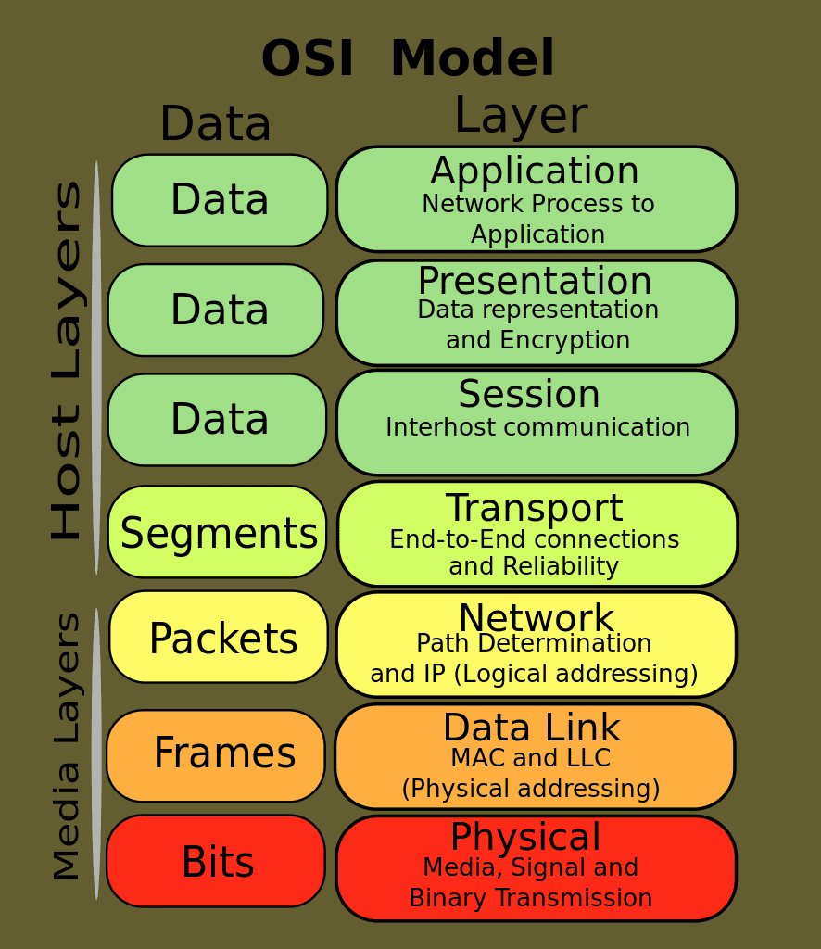

**Fig.1.4 OSI Reference Architecture**

It is essential to utilize realistic versatility model with the goal that the perceptions from the recreation accurately reflect this present reality performance of a Vehicular Ad-hoc Networks. For instance, a vehicle hub is typically restricted to the boulevards which are isolated by structures, shops or different objects. Such obstructions increase the normal distance between hubs as compared to an open field situation with lesser number of obstructions.

Numerous earlier examinations have demonstrated that a realistic versatility model with sufficient degree of subtleties is substantial for accurate system reenactment results. With the increasing applications in the spaces of universal and context-mindful computing, Internet of Things are picking up importance. In Internet of Things, actually anything can be a piece of it, regardless of whether it is sensor hubs or moronic objects, so extremely different sorts of services can be produced.

In such manner, resource the executives, service creation, service the board, service discovery, data stockpiling, and force the executives would require much better infrastructure and sophisticated mechanism. The measure of data Internet of Things will produce would not be feasible for standalone power constrained IoTs to handle.

Cloud computing comes into play. Coordination of Internet of Things with cloud computing, named as Cloud of Things can help achieve the objectives of imagined Internet of Things and future Internet. This Internet of Things and Cloud computing combination isn't straight forward. It includes a few challenges. One of those challenges is data cutting. Because unnecessary computation troubles the core organize, “yet in addition the data center in the cloud. For this reason, data can be pre-processed and cut before sending it to the clouds. This can be done by means of Smart Gateways, accompanied with a Smart Networks. We have discussed this concept in detail and present the architecture of Smart Gateways. We have tried this concept based on Upload Delay, Synchronization Delay, and Jitter, Bulk data Upload Delay, and Bulk data Synchronization Delay.

**1.4 VEHICULAR CLOUD COMPUTING**

VCC for Traffic Management and System gives creative research on the quickly advancing employments of vehicle to vehicle and vehicle to infrastructure communication. It likewise covers the need to completely use vehicular adhoc organize resources to give refreshed and dynamic information about the condition of road traffic with the goal that the quantity of road accident can be limited. Including research on topics such as character administrations, computational architectures, and resource administrations, this book is unmistakably intended for urban organizers, researchers, policy producers, graduate level understudies, transportation specialist, and technology designer looking for current research on vehicle computational structure, architecture, security, and privacy.

Road accidents caused by debilitated and distracted driving just as traffic congestions are on the ascent, with the quantity of increasing dramatically each and consistently. Intelligent transportation systems intend to improve the efficiency and wellbeing of going by consolidating vehicle activity, overseeing transportation traffic, and telling drivers with alarm and security messages progressively. The underutilized resource of vehicles can be imparted to other vehicle over the Vehicle ADHOC Network to deal with the road traffic all the more efficiently. The cloud computing and its capability of incorporating and sharing resources, assumes possible job in the improvement of traffic the board systems.

This presentation surveys the Vehicular Cloud Computing based traffic the executives answers for investigate the job of Vehicular Cloud Computing in road traffic the board. Particularly, an examination of Vehicle ADHOC Network based and Vehicular Cloud Computing based traffic the executives systems is introduced. To investigate, the Vehicle ADHOC Network infrastructure and services, a comparison of Vehicular Cloud Computing based traffic the executives systems is given. A scientific categorization of vehicular clouds is introduced, so as to recognize and recognize the sort of vehicular cloud mix. Expected future challenges and their answer in respect of developing technologies are additionally discussed. The Vehicular Cloud Computing is vision to assume a significant job in further improvement of ITS.

The VCC architecture depends on three layers: inside vehicle, communication and cloud. As dequeueated in Fig.1.4, the primary layer is the inside vehicle layer, which is liable for checking the wellbeing and disposition of the drivers and collecting information’s inside the car such as weight and temperature by utilizing body sensor, natural sensor, cell phone sensor, the vehicle's interior sensor, inertial route sensor (INS), and driver conduct recognition to predict the driver's reflexes and goal. At that point, the information collated through sensor ought to be sent to the cloud for capacity or for use as contribution for various software program in the application layer, for instance, conveys wellbeing and ecological recognition applications.

We expect that each vehicle is furnished with an on board unit that including an implicit route system, with a guide and the location of a Road Side Units. The On Board Units have a broadband remote communication to move data through 3 G else 4 G cellular communication devices, WiFi, WiMAx, Wireless Access in Vehicular Environment or Dedicated Short Range Communication. Vehicular systems administration has become a significant research territory because of its specific component and application such as standardization, efficient traffic the board, road wellbeing and infotainment. Vehicles are expected to carry generally more communication systems, on board computing facilities, stockpiling and increased detecting power. Hence, a few technologies have been conveyed to keep up and advance Intelligent Transportation Systems (ITS). Recently, various arrangements were offered to address the challenges and issues of vehicular networks. Vehicular Cloud Computing (VCC) is one of the arrangements. VCC is another half breed technology that remarkably affects traffic the board and road security by quickly utilizing vehicular resources, such as computing, stockpiling and internet for decision making. This hypothesis presents the cutting edge overview of vehicular cloud computing. Also, we present a scientific categorization for vehicular cloud in which special consideration has been dedicated to the broad applications, cloud arrangements, key administration, bury cloud communication systems, and broad aspects of privacy and security issues. Through a broad survey of the writing, we structure an architecture for VCC, order the properties required in vehicular cloud that help this model.

The V2V architecture permits vehicles to communicate with each other in an ad-hoc design. The systems administration highlights are empowered as long as vehicles are inside a substantial communication go. In this sense, a VCC can be collected dynamically, self-sufficiently, and opportunistically through vehicles by means of their V2V connections. Savvy vehicles participating in VANET have high computing capabilities which lead the demand to help more applications that give wellbeing and effective measures to individuals. The vehicles in VANET are taking the assistance of cloud services for communication, computation and capacity which benefits in economical way and we call that as vehicular cloud computing (VCC). Because of certain confinements in VCC and additionally demand for greater nature of service applications in savvy vehicles another paradigm called vehicular Fog computing (VFC) is offered which assists with overcoming constraints in VCC and offer greater quality types of assistance to clients participating in VANET. A portion of the security challenges and potential attacks in VFC are likewise expressed the speed limit or the occurrence of a major mechanical disappointment in the vehicle, an Emergency Warning Messages (EWMs) will be produced and sent to the cloud stockpiling and encompassing vehicles, which contains the geographical location, speed, acceleration and moving direction of the offender. The second component of the communication layer is vehicle-to infrastructure (V2I), which is answerable for exchanging the operational data among vehicles, infrastructures and the cloud over remote networks such as 3G, satellite or internet. The V2I component is utilized to expand the security level of vehicles on parkways by reducing the percentage of crashes, postponements and congestion improve portability, and give Wireless Roadside Inspection (WRI) to automatically inspect commercial vehicles. For processing all the vehicular applications and giving communication among vehicles VANET requires a lot of capacity, computation and communication resources. Cloud computing offers numerous services like giving communication, computation and storerooms utilizing a central cloud or a gathering of remote servers. With the special highlights like scalability in computation and capacity resources, wherever whenever and anyplace accessing without the difficulty for keeping huge capacity and computation devices in vehicles and all the more significantly pay-as-you-use and increasing [3] demand for computation and communication applications in vehicular networks makes cloud computing to coordinated with VANET so as to shape another sort of paradigm called vehicular cloud computing (VCC).” Remote cloud servers will be sent at different places. The information that the sensors of the vehicles assembled will be sent to these remote cloud servers through the system for processing and be putting away. Fig.1.4 shows the vehicular system in which the vehicles give the information or data that they assembled to VCC to process or sort utilizing RSU's.

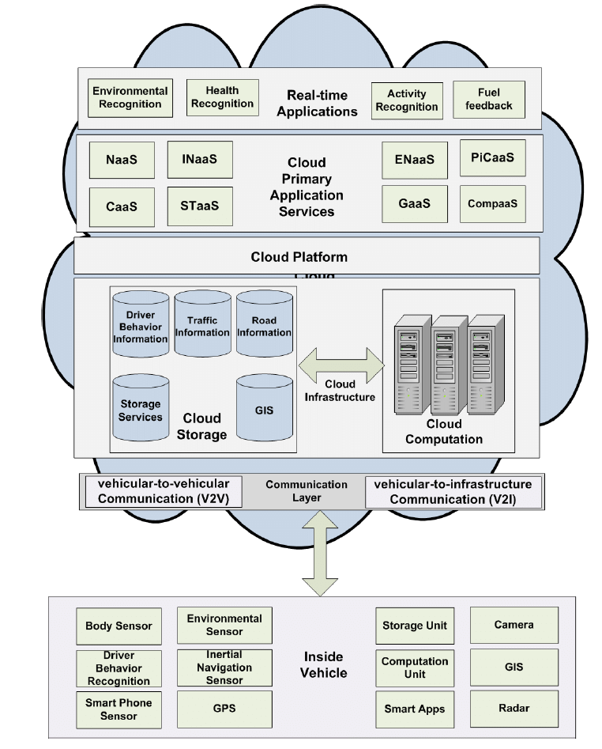

**Fig.1.5 VCC Architecture**

The forward and backward activity between cloud servers and devices in vehicles prompts expanded deferment in handling and reaction to messages. One of the most significant advantages of VCC is data conglomeration by utilizing cloud stockpiling, where different administrative and private agencies, particularly the police or the meteorology division can utilize the put away data in the cloud to perform different examinations. Be that as it may, the cloud which is the last layer of the VCC architecture, can compute the gigantic and complex computations in insignificant time. The cloud layer consists of three inward layers: application, cloud infrastructure, and cloud stage. In the application layer, different applications and services are considered as ongoing services or cloud essential services, which are accessible remotely by drivers, such as fuel feedback, human activity recognition, wellbeing recognition and natural recognition. Human activity recognition is utilized for a computerized investigation (or translation) of progressing occasions and their context of video data. In the essential services, a few services are sent, such as Network as a Service (NaaS), Storage as a Service (SaaS), Cooperation as a Service (CaaS), Information as a Service (IaaS), and Entertainment as a Service (EaaS), which are discussed in the remainder of this section. The cloud infrastructure consists of two gatherings: cloud stockpiling and cloud computation. The data accumulated by the inside-vehicle layer will be put away in the geographic information system (GIS), a road traffic control device or a capacity system dependent on the kind of applications. The computation part is utilized to calculate the computational errands which gives quicker performance, for instance, the wellbeing recognition sensors send data to driver conduct database in cloud stockpiling.

1**.5 FEATURES OF VEHICULAR CLOUD COMPUTING**

Transportation is a necessary infrastructure for our advanced society. The performance of transportation systems is of crucial importance for singular versatility, commerce, and for the economic development everything being equal.

***Table 1.1: Comparative features of CC and VCC***

|  |  |  |
| --- | --- | --- |
| **Feature** | **CC** | **VCC** |
| Self-governing Composition | No | Yes |
| Resource Flexibility | Static | Highly Dynamic |
| Network Architecture | Client-Server | Peer to Peer or Client-Server |
| Physical Resources | Local or Remote Servers | Local Vehicles or Remote Servers |

In recent years current society has been facing more traffic jams, higher fuel prices, and an increase in CO 2 outflows. It is basic to improve the security and efficiency of transportation. Building up a practical intelligent transportation system requires the consistent coordination and interoperability with developing technologies such as connected vehicles, cloud computing, and the Internet of Things. “In this model we introduce and discuss a portion of the coordination challenges that must be addressed to empower an intelligent transportation system to address issues facing the transportation sector such as high fuel prices, significant levels of CO2 outflows, increasing traffic congestion, and improved road security.

**1.5.1 Autonomous Composition**

The underlying perspective on practitioners and researchers was that radio-prepared vehicles could keep the drivers educated about potential dangers and increase their familiarity with road conditions. The view at that point expanded to include access to the Internet and associated services. This position proposes and advances a novel and increasingly comprehensive vision to be specific that advances in vehicular networks, installed devices and cloud computing will empower the arrangement of independent clouds of vehicular computing, communication, detecting, power and physical resources. Hence, we coin the term, Autonomous Vehicular Clouds (AVCs). A key highlights recognizing AVCs from conventional cloud computing is that versatile AVC resources can be pooled dynamically to serve approved clients and to empower self-governance progressively service sharing and the board on earthly, airborne, or aquatic pathways or theaters of tasks. In addition to universally useful AVCs, we likewise imagine the emergence of specialized AVCs such as versatile analytics labs. Besides, we imagine that the mix of AVCs with universal shrewd infrastructures including intelligent transportation systems, savvy cities, and brilliant electric force frameworks, will have a gigantic societal impact empowering omnipresent utility cyber-physical services at the correct place, opportune time, and with right-sized resources.

As technology is drawing nearer and closer to packing sophisticated resources in singular vehicles, numerous manufacturers are directing their concentration toward making the vehicles on our roads more fuel and vitality efficient than any other time in recent memory. It is sufficient to recall that the previous decade has seen the emergence of cross breed vehicles from the car architect's planning phase into production, to where today about six car and truck manufacturers offer half and half vehicles on the American market.

**1.5.2 Resource Flexibility**

A Vehicular Cloud for the most part focuses on a few aspects, which include giving a lot of computational services requiring little to no effort to vehicle drivers; limiting traffic congestion, accidents, travel time, and ecological contamination; and guaranteeing the utilization of low vitality and constant services of software, stages, and infrastructure with QoS to drivers.” The biggest challenge in vehicular portable Clouds consists of creating a mechanism for the board and search resources that doesn't rely upon roadside infrastructure, which consequently requires the unconstrained and dynamic creation of a Cloud through the resources shared by vehicles.

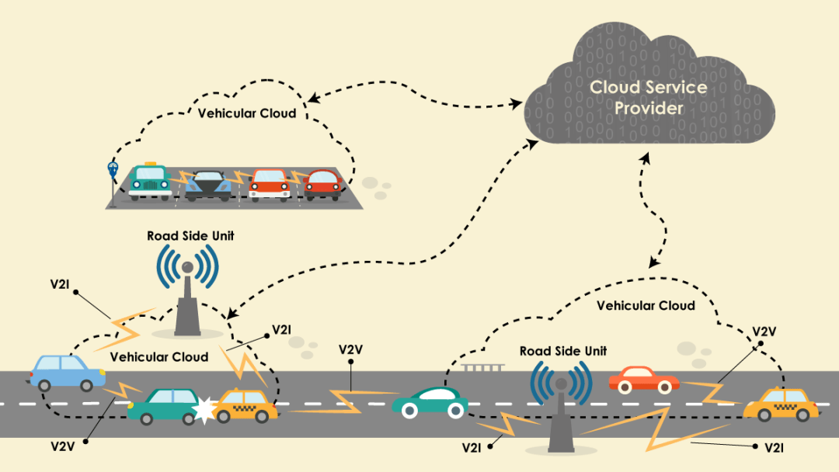

**Fig.1.6 Sample virtual reality frameworks for vehicular cloud computing**

In this way, the system must empower collaboration and co-activity between vehicles so they may set up connections to give resources. To address this challenge, we suggest a distributed protocol to aid the discovery and the executives of resources in a vehicular versatile Cloud without relying upon the help of a roadside infrastructure so that vehicles are expected to sort out themselves and set up collaborations to oversee and share their resources.

Heterogeneous vehicular applications (if not all) are for the most part reliant on Internet or outsider networks. The rising VCC technology ought to be incorporated such that it limits the dependency on the Internet. Completely V2V-misused arrangements are models. VCC and cloud cooperation can be utilized to process more traffic data locally over the cloud. Internet cloud dependency can be limited by abusing cooperative VCC. For instance, if a vehicle needs to know the genuine circumstance at the approaching intersection, this vehicle needs to connect to an Internet-based server over the Internet cloud. In the vehicular cloud, the vehicle requests the necessary information and the cloud controller may satisfy this inquiry from inside the cloud. At that point, the vehicle is refreshed about the current circumstance at the intersection. The vehicular clouds satisfy this undertaking effectively in vicinity without leaving the question alone moved to the inaccessible Internet cloud.

The Intelligent Transportation System (ITS) is instrumental for making the road traffic in keen city more secure, increasingly efficient, and progressively convenient. As the core component of ITS, Vehicular Ad Hoc Network (VANET) can improve the efficiency of the information exchange in road traffic. VANET is a system that vehicles can share the on-road information such as the car crush or the traffic jam on the road ahead. There are two sorts of communicating mechanism for vehicles to exchange their information in VANET: vehicle-to-vehicle (V2V) where vehicles communicate by means of on-board radio device directly and vehicle-to-infrastructure (V2I) where vehicles communicate with each other by existing infrastructure on road side. The hardware beside the road is called RSUs (Road Side Units). It assumes a significant job in the territory of road wellbeing with using the transportation data collected by VANET.

**1.5.3 Network Architecture**

The current VANET organizing model has been gotten principally from traditional wired systems administration protocols. Not with standing, because of the gigantic difference between the Internet and the infrastructure less ad hoc condition, the model shows a few intrinsic confinements. In the first place, the VANET protocol despite everything accept utilizing IP address to speak to a host. Appointing IP addresses to moving hubs isn't paltry in ad-hoc situations. The task often requires infrastructure bolster such as a central DHCP server, which directly conflicts against the way of thinking of ad-hoc networks that work in a self-organized way with no infrastructure. Second, it is difficult to discover the IP address of the distributer of a specific content in an ad-hoc organize. Hubs join and leave the system much of the time, and any hub can become another distributer of the content. Subsequently, the content of intrigue cannot be consistently bound to an interesting IP address. Last, the VANET protocol just performs IP-based start to finish communications. During directing procedure, a switch basically transfers and then erases content. In spite of the fact that the content is famous to such an extent that numerous hubs likewise need it, the switch cannot directly send it to them because the switch doesn't spare it.

[

Our perception of the current VANET is summed up as the VANET applications advance from straightforward data consumers to ones that empower local collaborations with sufficient contents for richer client experience. In any case, hidden systems administration doesn't appear to efficiently bolster the core functions that the developing applications demand. This section introduces recent research endeavors that address the issues under two categories of computing and systems administration.

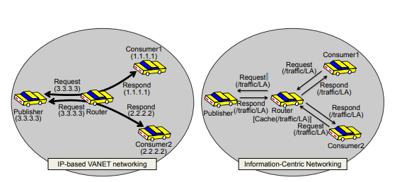

**Fig.1.7 The existing VANET networking vs. Information Centric Networking**

**1.5.4 Physical Resources**

**In a vehicular cloud, a gathering of vehicles share their computation resources, stockpiling resources, and spectrum resources. Each vehicle can access the cloud and use services for its own motivation. Through cooperation in the gathering, the physical resources of vehicles are dynamically scheduled on demand. VANET has been a core organizing technology to give security and comfort to drivers in vehicular situations. Developing applications and services, in any case, require significant changes to its basic computing and systems administration models, which demand new system making arrangements for VANET.**

**This section especially inspects how VANET advances with two developing paradigms: vehicular cloud computing and information-centric systems administration. VCC brings the versatile cloud model to vehicular networks and in this way changes the method of system service provisioning, though ICN changes the idea of data steering and scattering. We imagine another vehicular systems administration system, vehicular cloud organizing, on head of them. This model scrutinizes its architecture and activities, and discusses its structure principles. Vehicular communication develops with new rising paradigms, and this inspected the very subtleties behind the advancement. We investigated rising VANET applications and watched three noticeable characteristics, which cannot be bolstered efficiently by the current VANET technology. To accommodate such characteristics, we introduced another VANET organize arranging, consisting of two recent paradigms - Vehicular Cloud Computing and Information Centric Networking. Developing vehicle applications consume an enormous measure of sensor data in a collaborative way. That is, numerous sensors, introduced on vehicles, record a myriad of physical wonders. Vehicle applications collect such sensor records, even from neighboring vehicles, to produce esteem added services. In Mob Eyes, for instance, vehicles utilize a couple of sensors (including a camcorder) to record all-encompassing occasions such as car accidents while driving. From there on, Internet operators and/or portable specialists search the vehicular system for observers as a major aspect of their examinations. The Car Speak application empowers a vehicle to access sensors on neighboring vehicles, in a similar way as it can access its own.**

**1.6 TAXONOMY OF VEHICULAR CLOUDS**

**Nowadays, most vehicles are furnished with implanted systems, incorporated computers, processing units and sensors. Every one of these upgrades give a decent stage to convey Data as a Service (Daas), in this manner, giving an efficient and ideal data dispersion about such occasions as traffic jams, accidents, and road conditions. In VANETs, the portability of vehicles, distinctive system thickness and the incessant changes in geographies are the most challenges that must be considered. In addition to these challenges, constant applications are strict to defer and data conveyance of these security messages. Up to now, most VANETs have applied IEEE 802.11p as a communication strategy, which frames the conventional path for remote access. IEEE 802.11 p supplies data rate run from 6 to 27 Mb/s at a short transmission distance, 300 m.**

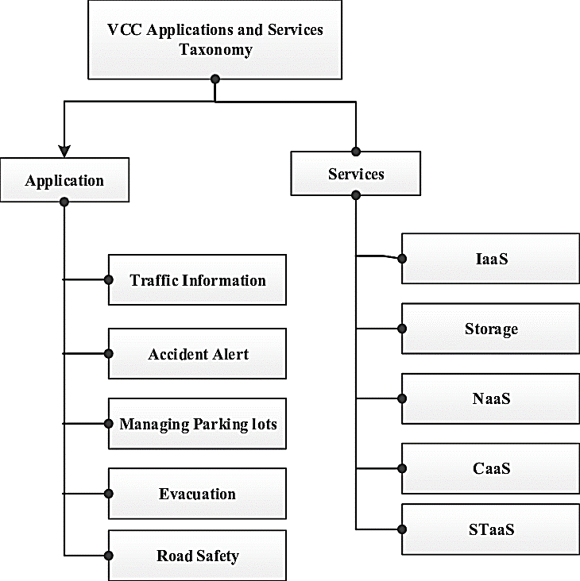

**Fig.1.8 Taxonomy of VCC**

Dissemination security messages over a gigantic territory needs an intelligent multi-jump broadcast techniques managing broadcasting overhead and successive disconnections. With the expansion of car industry, vehicles are enlarged with different types of increasingly incredible computation, communication, stockpiling and detecting resources. A vehicle in this way can be viewed as computer-on-wheels. “With such rich resources, it is of extraordinary significance to efficiently use these resources.

This advances the vision of vehicular cloud computing. In this chapter, we give a broad overview of current vehicular cloud computing research and feature a few key issues of vehicular cloud such as architecture, natural highlights, service scientific categorization and possible applications. The regularly increasing demand for capacity, computation, and communication has vexed researchers, especially with the inception of Internet of Things (IoT)- based cyber-physical systems. In the previous barely any years, the computational force required by various applications has significantly increased. For instance, applications supporting medical sciences, finance, and artificial intelligence are increasingly needy upon high computation systems. Both equal computing and conveyed computing have introduced various arrangements accordingly to overcome the appeal of computational force.

Cloud computing is another arrangement that has advanced from Grid Computing. Basically, cloud computing is empowered by effectively accessible data centers giving exceptionally high computation and capacity capabilities. Notwithstanding, the underlying arrangement cost for software and equipment, just as running cost of infrastructure which includes the maintenance cost, cooling power consumption, and direct hardware power consumption are of significant concern. Vehicular cloud computing gives a cost-effective other option. According to this concept, a cloud can be framed anyplace on the roads utilizing the computational capabilities of the installed hardware in the vehicles or utilizing the cell phone in those vehicles.

Cloud computing has been generally adopted across the IT business because of its scalable, cost-effective, and efficient services. It has numerous applications in territories such as healthcare, versatile cloud computing (MCC), and vehicular ad hoc networks (VANET). Vehicular cloud networks (VCN) is another application of cloud computing which is a combination of cloud and VANET technologies. It is composed of three clouds named vehicular cloud, infrastructure cloud, and traditional IT cloud. In this chapter, the three clouds associated with VCN are introduced utilizing a three-level architecture, and the security issues identified with each level are described in detail. In the wake of describing the definite architecture of VANET, their components, and their significant characteristics, this chapter presents the architecture of VCN. It is trailed by the nitty gritty examination of the dangers to which each level cloud of VCN is powerless. Vehicular Cloud Networking (VCN) where vehicles and adjacent infrastructure converge with traditional internet clouds to offer various applications extending from low estimated applications to extremely complex applications. VCN is composed of three sorts of clouds: Vehicular cloud, Infrastructure cloud and traditional Back-End (IT) cloud. We introduced these clouds through a three level architecture alongside their tasks and characteristics.

We have planned the use cases of each cloud level that clarify how it is practically created and used while taking the vehicular versatility in consideration. Additionally, it is critical to guarantee security, privacy and trust of VCN system and its benefits. Along these queues, to describe the security of VCN, we have given an inside and out examination of various dangers identified with each level of VCN. The dangers identified with vehicular cloud and infrastructure cloud are categorized according to their advantages, i.e., vehicles, adjacent infrastructure, remote communication, vehicular messages, and vehicular cloud dangers. Also, the Back-End cloud dangers are categorized into data and system dangers. Various vehicles and RSU share their resources alongside the conventional BEC in this manner empowering a wide scope of expected applications. VCN bolsters video surveillance in urban territories.” It empowers tracking vehicles or individuals utilizing top notch (HD) video to guarantee security. Considering that HD video continuously requires enormous capacity, vehicular clouds are promising arrangement.

Cloud computing has been broadly adopted across the IT business because of its scalable, cost-effective, and efficient services. It has numerous applications in territories such as healthcare, versatile cloud computing (MCC), and vehicular ad hoc networks (VANET).

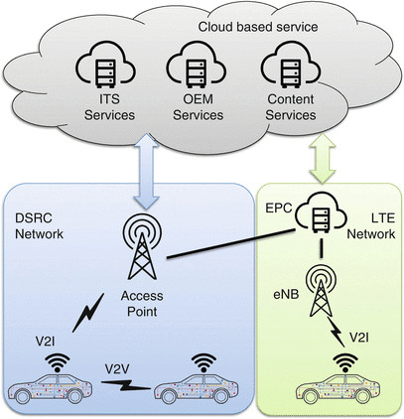

**Fig.1.9 Vehicular Cloud Network**

Vehicular cloud networks (VCN) is another application of cloud computing which is a combination of cloud and VANET technologies. It is composed of three clouds named vehicular cloud, infrastructure cloud, and traditional IT cloud. In this chapter, the three clouds associated with VCN are introduced utilizing a three-level architecture, and the security issues identified with each level are described in detail. In the wake of describing the point by point architecture of VANET, their components, and their significant characteristics, this chapter presents the architecture of VCN. It is trailed by the definite examination of the dangers to which each level cloud of VCN is defenseless. So as to help high bandwidth demanding applications with complex computation, the cooperation among vehicles and adjacent RSU is required. Computational and capacity resources are shared among them which brings about an impermanent cloud with more resources. System efficiency can be additionally enhanced by consolidating conventional clouds with brief clouds. Impermanent clouds are convenient for applications such as traffic the board, wellbeing applications and sharing information about traffic conditions. Conventional clouds may offer complex applications such as giving in-vehicle diversion to the vehicular user. These resources work as a common virtual stage. Each vehicle incorporated in the vehicular cloud has three categories of resources: data stockpiling, sensors and computing. Contents created from vehicle applications, sensors and conventional mixed media documents are put away into data stockpiling. It empowers data sharing among cloud individuals. Sensors can detect occasions in the vicinity of the vehicle. Outer systems can read the sensor data and may have the likelihood to control the sensor. “Computing resources in the vehicle are constrained and speak to a collection of versatile resources. Cloud leader welcomes vehicles and adjacent RSUs in its vicinity by transmitting resource demand messages (RREQs) so as to create a cloud. Part meaning to share its resources reacts to the cloud leader with resource answer message (RREPs) .After informing RREPs, the cloud leader selects cloud individuals and sorts out a cloud. The selection process may will in general limit absolute resource utilization in the cloud alongside the correct activity of the application. Cloud leader is additionally in charge for individuals' ID maintenance and task of various undertakings and application.

The application is appropriated to the cloud individuals relying upon the accessibility and accessibility of their resources. Cloud individuals normally communicate with cloud leader. Individuals can share contents dependent on the cloud leader consent. Maintenance of the cloud is obligation of the cloud leader. Cloud individuals can excuse enrollment in the cloud by requiring the resource leaving message to cloud leader. In that case, cloud leader confirms the discharge and selects a replacement among individuals that at first sent RREPs in the resource discovery stage. New part ought to have enough resources to complete the undertaking alloted to the leaving part. Cloud leader conveys offered assignment to the new cloud part and updates the system geography information. At the point when cloud leader moves out of the cloud go, it broadcasts the cloud discharge message and discharges the resources with the goal that the other cloud individuals can reuse them.

**1.7 OUTLINE OF THESIS**

The First Chapter is an Introduction; Second Chapter explains, cloud computing, service models, VCC security, VANET, and application security threats on the review of literature; Third Chapter explains about research gap, problem statement and objectives; Fourth Chapter illustrates light of vehicular cloud computing and provide a novel framework named VEDA_CIT and it’s design structure; Fifth Chapter describes the profile of the study area and data collection with interpretations Sixth Chapter is an Data analysis and validation, Seventh chapter explains about the analysis Results and discussion and the Last chapter highlights conclusion and future work.

**CHAPTER 2**

**LITERATURE REVIEW**

**2.1 INTRODUCTION**

In VANETs, vehicles can spread significant information in regards to different significant occasions, such as road conditions, traffic congestion, accident notifications, for efficient and circulated traffic the board. Vehicles can get such an information from neighboring vehicles or from the earth so as to detect traffic congestion or collisions. In such a critical circumstance, the presence of malicious and getting into mischief hubs causing adulterated and fabricated information spread in the system can lead to drastic circumstances, in this manner compromising the wellbeing, security, and privacy of expected clients. Significant regions are internet sites, checking of roads, tracking of individual vehicles, observing and the executives of transport process. Composing for the investigation subject may be accumulated from the diverse diary papers appropriated. Vehicular cloud is another concept dependent on the mix of VANET and cloud computing. Numerous vehicular cloud architectures were proposed to profit by the advantages of VANET and cloud computing. They can be classified into three significant categories Hussain et al.,(2012), proposed vehicular cloud (VC) where just vehicles are the substances framing the cloud, and they misuse their resources, vehicles utilizing cloud (VuC) where vehicles access the CC, and cross breed cloud which is a combination of VC and VuC. In spite of the fact that this concept gives better abuse of the vehicular resources and empowers different services by Whaiduzaman et al., (2014), numerous challenges affect its usage by Mekki et al., (2017a). The significant concerns that were dealt with are resource allocation, security, and the administration of the VC.

Existing IoV research focuses on proposing models and structures for different applications and services. Summed up IoT models cannot be directly applied for vehicular networks, because of the specific properties that characterize these conditions. For instance, the detecting as service model proposed by Perara et al., (2014) can be applied in a few IoT scenarios, because of the speculation gave by four conceptual layers. VANET applications by Lebre et al., (2014) research basically concentrates on giving momentary services such as wellbeing informing. Long haul applications inside VANET are as yet challenging since VANET organizing doesn't efficiently bolster their developing demands by Lee et al., (2014). A vehicular cyber-physical system (VCPS) is composed of a physical subsystem, including every physical component and processes, and a computational subsystem that includes the systems administration processes and computational models by Legatiuk et al., (2017).

Datta et al. (2016) have recorded challenges applicable to coordinating connected vehicles into Internet of Things ecosystems, and have proposed a structure that comprises building blocks, software components, and their operational stages and benefits. Likewise, the creators have discussed the execution and interoperability of the proposed structure by planning the semantic based description of system components into standard architectures. Advances in the car business have prompted the plan of vehicles with different computational on-board capabilities, such as ground-breaking computing units, a few sorts of sensors, and distinctive communication devices. Subsequently, vehicles can retain information from nature, perform computational processes, and work accordingly. Thus, all system hubs, including vehicles, can perform decentralized data processing, for example edge computing, to handle time-touchy tasks all the more efficiently, and to record data with local relevance incidentally Atchison et al., ( 2018)

An adjusted rendition of Ad hoc On-Demand Distance Vector (AODV) Perkins et al.,(2018) is utilized to help the steering inside an area. The vehicle that demands the errand execution and the leader vehicle that has relegated the undertakings keeps up a table which includes a rundown of individuals and appointed assignments. The proposed work achieves the benefits of VCC at the cost of communication overhead. Feng et al. (2017) introduced a system for conveyed Autonomous Vehicular Edge (AVE). In the proposed structure, the vehicles can offload computing undertaking to different vehicles. Be that as it may, the vehicles are allocated on requester need. Besides the job as requester and performer, the vehicle can fill in as a hand-off hub to empower multi-jump communication. The proposed AVE for the most part consists of two modules i.e., flow and beaconing. The previous one includes caching demands, discovery of accessible resources, scheduling of occupations, and data transmission. The last is answerable for periodic beaconing to keep up a rundown of vehicles inside the vicinity. At scheduler, occupations are served according to subterranean insect colony flow lining calculation. The applications are introduced on local working systems of vehicles and the accessible inert resources are overseen in a virtualized way.

Guo et al. (2018) proposed a period scaled caching scheme for Adaptive Bit Rate (ABR) video spilling in vehicular networks, in which caching is performed at base station. This scheme deals with the video quality, cache placement, and video transmission. The caching in vehicular networks is not the same as the traditional caching in remote networks because of fast versatility. V2I clouds incorporates vehicles with infrastructural communication networks, for instance WIFI and 3G/LTE. This is the place traffic-checking sensors help structure a cloud, once in a while named as roadside sensor clouds, according to the research hypothesis in Ahmad et al.,(2017). This permits vehicles to have improved cooperative communication and detecting technologies for more prominent transport security.

Sergei Korjagin (2017) introduced the examination that manages intelligent transport security systems. He discussed the utilization of intelligent transport security systems that expected to bring down traffic accidents and dangers, increase the traffic capacity of road organize, reduce the postponements in traffic flow and enhance traffic wellbeing. This present likewise guaranteed continuous progression of land urban traveler transport in Klachek and Korjagin (2015). The investigations of Russian and European experience demonstrated the application of ITS that empowered to reduce roads and traffic authority (RTA) level by 30%. The work presents a bio cybernetic traffic the executives presumptions dependent on ITS. The series of expectations was intended to combine enormous traffic control at road and transport conditions with fine adjustment at the little degree of physiological and intellectual actions taken by driver. Firas Alrawi (2017) proposed whether ITS are identified with air quality improvement. Studies depict that the utilization of such systems in transportation system reduced travel time and frequency. for example variable message signs reduces the interferences by 53% and enhanced travel time by 44% (AL-Jarallah, 2012). SCOOT technique for traffic organize screen the executives in urban territories reduced traffic congestion by 20% (William, 2008). The investigation uncovered the increased dependability of traffic transport and reduced fuel rate consumption which lead to the reduction of emanation rate. The primary point of it was ton spare least of one billion of gas each year and to bring down emanations at any rate in relation to this fuel sparing (ITS America, 2002).

**2.2 CLOUD COMPUTING**

Cloud computing is currently commonly used to describe the conveyance of software, infrastructure and capacity services over the internet. Clients of the cloud can profit by different associations conveying services associated with their data, software and other computing needs for their benefit, without the need to possess or run the typical physical equipment (such as servers) and software (such as email) themselves. Cloud computing is the following stage in the development of the internet, it gives the methods through which everything from computing capacity to computing infrastructure, applications and business processes can be conveyed to you as a service any place and at whatever point you need them. Cloud computing arrangements can flow queue the manner by which your business works, particularly as far as equipment needs.

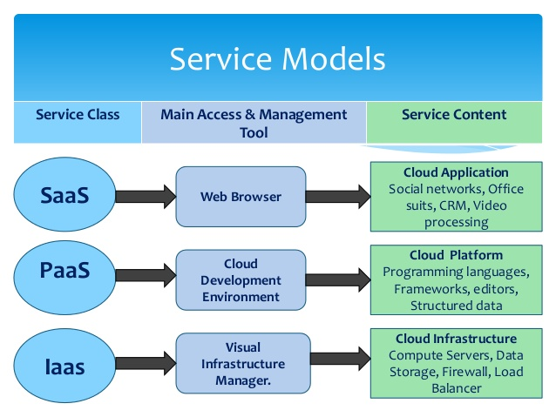

**Fig. 2.1 Cloud computing services delivered over the internet**

Through a cloud arrangement you can connect and access a similar information yet now you can connect from anyplace and appreciate a progressively smoothed out technology establishment, as appeared in the Fig. 2.1. Cloud computing isn't only a technology arrangement or a server put away in another location.

**2.2.1 Layers and Services of Cloud Computing**

Cloud computing data centers are modeled upon a basic plan for-disappointment infrastructure. They utilize minimal effort, purpose built, scalable arrangements, including servers, stockpiling systems and systems administration products, while as yet using standard conveyance models and enormous economies of scale. “Cloud computing data centers, be that as it may, don't purchase off-the-rack systems intended for the traditional mass-IT showcase. These products are excessively costly and include highlights that don't meet the cloud's remarkable data center condition and application prerequisites. These services are broadly isolated into three categories:

* Infrastructure-as-a-Service (IaaS)
* Platform-as-a-Service (PaaS)
* Software-as-a-Service (SaaS)

**Infrastructure-As-A-Service-Infrastructure-as-a-Service**

IaaS gives the infrastructure as a service to its customers. The client doesn't have to purchase the necessary servers, data center or the system resources. Customers can achieve a much quicker service conveyance with less cost. Additionally, customers control and deal with the systems as far as the working systems, applications, stockpiling, and system connectivity, however don't themselves control the cloud infrastructure. The low-level resources cannot be used all alone, and along these queues are typically uncovered as a component of a virtualized domain for example hypervisors. IaaS offers physical or virtual machines just as resources such as document based capacity, firewalls, IP addresses, virtual local region networks (VLANs), and software packs. IaaS cloud suppliers flexibly these resources on demand from their huge pools of resources introduced in data centers. Infrastructure as a Service is additionally alluded to as Hardware as a Service (HaaS).” IaaS gives virtual servers extraordinary IP addresses and blocks of capacity on demand. Customers can pay for exactly the measure of service they use, as for electricity or water, this service is additionally called utility computing.

**Table 2.1 Features of Service Models**

|  |  |  |
| --- | --- | --- |
| **Service**  **Model** | **Who uses it** | **Services** |
| Saas | Business users | * E-mail, blog, wiki * Productivity tools (Office) * CRM * Website testing |
| Paas | Developers and deployers | * Service and application testing * Development * Integration and deployment * Database management |
| IaaS | System Managers | * Virtual Machines * Management * Message Queues * Networks * CPU, Memory, Storage |

**Platform-As-A-Service-Platform-as-a-Service**

PaaS is a lot of software and improvement instruments facilitated on the supplier's servers. Google Apps is one of the most acclaimed Platform-as-a-Service suppliers. This is the possibility that somebody can give the equipment (as in IaaS) in addition to a certain measure of application software - such as incorporation into a common arrangement of programming functions or databases as an establishment whereupon you can assemble your application. Platform as a Service (PaaS) is an application advancement and arrangement platform conveyed as a service to designers over the Web. In the PaaS model, cloud suppliers gracefully customers with a computing platform typically including the working system, execution conditions, database, and web servers. The consumer won't deal with the working system and system, and there may be constraints concerning which applications can be sent into the cloud. Application engineers can create and run their software arrangements on a cloud platform without the cost and complexity of purchasing and dealing with the fundamental equipment and software layers. PaaS automatically scales the basic equipment and capacity resources to match application demand such that cloud clients don't need to allocate resources physically.

**Software-As-A-Service-Software-as-a-Service**

SaaS is the broadest market. In this case the supplier permits the customer just to utilize its applications. The software interacts with the client through a UI. These applications can be anything from online email, to applications like Twitter or Last.fm. Fig 2.2 Evolution of Cloud Storage. SaaS may likewise be alluded to as Application Clouds and is the most basic cloud service model. It gives applications and services utilizing a cloud infrastructure or platform, as opposed to giving the cloud highlights. In the SaaS model consumers pay to access and utilize an application or service that is facilitated in the cloud. The cloud clients don't deal with the cloud infrastructure and platform on which the applications are running. This takes out the requirement for clients to introduce and run applications on their own computers, and along these queues improving the maintenance and backing. Cloud applications vary from different applications in scalability. This is finished by copying undertakings onto numerous virtual machines at run-time to fulfill the changing work need.

**Storage-As-A-Service-Storage as a Service:**

Saas is a plan of action in which an enormous company rents space in their storage infrastructure to a littler company or person. In the endeavor, SaaS sellers are focusing on secondary storage applications by advancing SaaS as a convenient method to oversee backups. The key advantage to SaaS in the venture is in cost investment funds - in faculty, in equipment and in physical storage space.

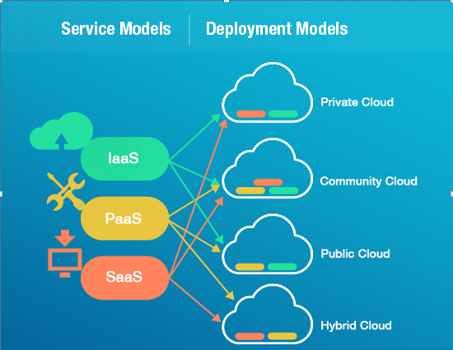

**Fig. 2.2 Service Models of Cloud Computing**

For instance, instead of keeping up an enormous tape library and masterminding to vault (store) tapes offsite, a system administrator that utilized SaaS for backups could specify what data on the system ought to be backed up and how often it ought to be backed up. His company would consent to a service level arrangement (SLA) whereby the SaaS supplier consented to lease storage space on a cost-per gigabyte-put away and cost-per-data-move premise and 2012 seventh International Conference on Telecommunication Systems, Services, and Applications (TSSA) 978-1-4673-4550-7/12/$31.00 ©2012 IEEE 76 the company's data would be automatically moved at the specified time over the storage supplier's exclusive wide zone organize (WAN) or the Internet. On the off chance that the company's data at any point became corrupt or got lost, the system administrator could contact the SaaS supplier and solicitation a copy of the data. The entirety of the service models referenced above are priced on a pay per-use premise.

**2.2.2 Deployment Models**

Sending cloud computing can contrast contingent upon prerequisites, and the accompanying four arrangement models have been distinguished, each with specific characteristics that help the requirements of the services and clients of the clouds in particular manners

**Private Cloud**

Consistent with its name, a private cloud is typically infrastructure utilized by a solitary association. Such infrastructure might be overseen by the association itself to help different client gatherings, or it could be overseen by a service supplier that deals with it either on location or off-site. Private clouds are more costly than public clouds because of the capital use engaged with acquiring and looking after them. Be that as it may, private clouds are better ready to address the security and privacy concerns of associations today. The cloud infrastructure has been conveyed, and is kept up and worked for a specific association. The activity might be in-house or with an outsider on the premises.

**Community Cloud**

This arrangement model backings numerous associations sharing computing resources that are a piece of a community; models include colleges cooperating in certain regions of research, or police divisions inside a county or state sharing computing resources. Access to a community cloud condition is typically restricted to the individuals from the community. This cloud infrastructure is shared among various associations with comparable interests and necessities. This may help limit the capital consumption costs for its foundation as the costs are shared among the associations. The activity might be in-house or with an outsider on the premises.

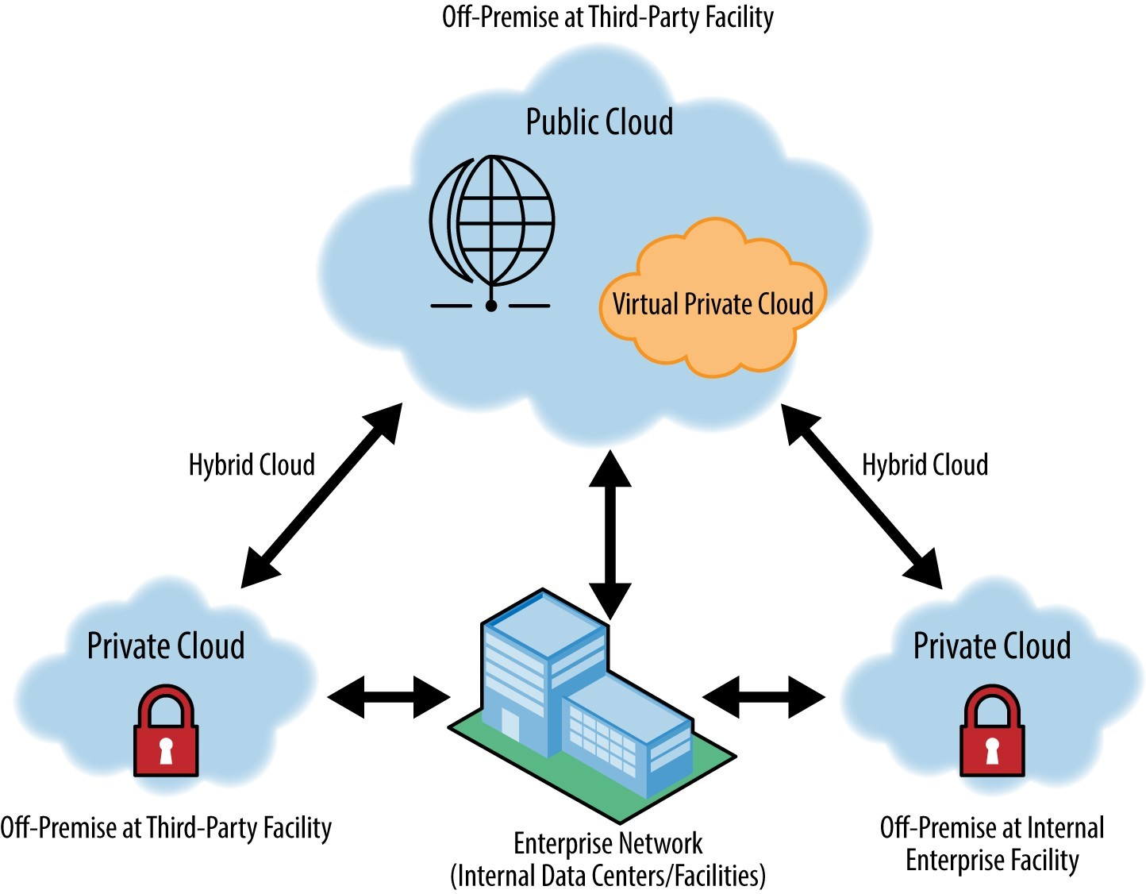

**Fig. 2.3 Cloud Computing Deployment Models**

**Public Cloud**

As the name recommends, this sort of cloud arrangement model backings all clients who need to utilize a computing resource, such as equipment (OS, CPU, memory, storage) or software (application server, database) on a subscription premise. Most common employments of public clouds are for application improvement and testing, non-strategic assignments such as record sharing, and email service. “The cloud infrastructure is accessible to the public on a commercial premise by a cloud service supplier. This empowers a consumer to create and convey a service in the cloud with almost no financial expense compared to the capital consumption prerequisites typically associated with other sending choices.

**Hybrid Cloud**

In a hybrid cloud, an association utilizes interconnected private and public cloud infrastructure. Numerous associations utilize this model when they have to scale up their IT infrastructure quickly, such as when utilizing public clouds to enhance the capacity accessible inside a private cloud. For instance, if an online retailer needs all the more computing resources to run its Web applications during the Christmas season it might achieve those resources by means of public clouds.

The cloud infrastructure consists of various clouds of any sort, however the clouds have the capacity through their interfaces to permit data and/or applications to be moved starting with one cloud then onto the next. This can be a combination of private and public clouds that help the necessity to hold a few data in an association, and additionally the need to offer services in the cloud.

Each cloud sending model fulfills diverse hierarchical needs, so it's significant that you choose a model that will fulfill the requirements of your association. Maybe considerably increasingly significant is the fact that each cloud arrangement model has an alternate offer and various costs associated with it. Subsequently, by and large, your choice of a cloud organization model may basically come down to cash. Regardless, to have the option to settle on an educated decision, you should know about the characteristics of each condition.

With public clouds, the cost is typically low for the end client and there is no capital consumption included. Utilization of private clouds includes capital consumption, yet the use is still lower than the cost of possessing and working the infrastructure because of private clouds' more noteworthy degree of consolidation and resource pooling. Private clouds likewise offer more security and compliance support than public clouds. In that capacity, a few associations may choose to utilize private clouds for their more strategic, secure applications and public clouds for basic errands such as application advancement and testing conditions, and email services.

To exploit cloud computing, legacy applications such as those created utilizing centralized server client/server technologies should be adapted or moved to current dialects and APIs so they can interact with different applications paying little mind to where they are conveyed. Cloud-empowering an application necessitates that the application have the option to interact with databases, middleware, and different applications utilizing standards-based mechanisms such as Web services. Most legacy and client/server applications today don't have this capability locally. Typically, these legacy applications require adapters and covering software to make them accessible by means of Web services.

**2.3 VEHICULAR CLOUD COMPUTING SECURITY**

Vehicular cloud is another concept which is an augmentation of conventional cloud. The possibility of Vehicular cloud (VC), considered so as to improve the utilization of the resources that are inactive in vehicles when they are not being used, these resources are clubbed to frame the cloud. The resources that are included in the vehicle are front camera, back camera, processing unit, GPS system and sensors these resources collaborate with each other to acquire the information in regards to the environmental factors. The information produced need security as it is spread among all the vehicles, the attacker may create a danger to the information which is put away on to the VC and this create a major issue. To address a portion of the issues the mechanism that are utilized in VANET are adopted in VCC. In a VC, vehicular resources included computing force, storage, and Internet connectivity that can be shared between drivers. They are connecting with customers through internet. VC concept is a significant society impact that needs security and privacy gives that ought to be corrected. The principle motivation behind this work is to discover the security challenges and privacy dangers in VCs. Likewise we discussed about some security designs as well.

Vehicular cloud creation: The internet cloud is created by cloud supplier where the services are processed and kept up by him, where as in vehicular cloud, the cloud is created on the fly by utilizing the resources of the vehicle, this can be finished by making the vehicles to interact with each other. Here the locale is isolated into specific lattices and for each piece of a network the virtual machine is allocated which is answerable for giving access to the information just as keeping up the information,” if there is congestion in particular district and if the solicitation cannot be handled the virtual machine solicitation to other virtual machine for the resources.

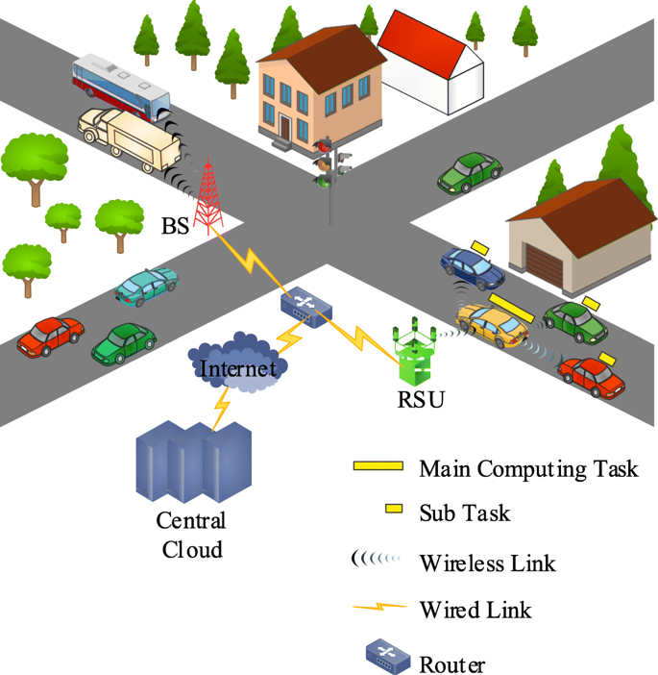

**Fig. 2.4 Security Cooperating in Vehicular Cloud**

**Technology behind security**: In request to give security as far as authentication and confidentiality, geographic location based security mechanism can be utilized which guarantees the physical security, here the messages are encrypted utilizing geographic location key which specifies the decryption district, where actually the hub should exist so as to decrypt the message encrypted with geographic location key.

Nowadays the vehicles are gotten together with piles of workplaces, for instance, web by which customer can refresh him with what's going on far and wide, GPS (Global Positioning System) permit the customer to track the zone, the on-board units which are nowadays sent with limit capacity is utilized to track the status of the vehicle, and moreover the driver. Preceding the vehicle gathering was the bit of mechanical arranging, yet today the considered road prosperity and irrelevant effort of hardware, these vehicles has changed into PC on wheels or PC structure on wheels which has been wrapped up contention for creator to advance a valiant effort and hold the spot in advancing. The vehicular cloud is a blend of both VANET (vehicular offhand system) and cloud computing, by which better usage of advantages is conceivable.

**Conceptual Overview**

**1) Cloud Computing**: In recent years, cloud computing and its myriad applications that guarantee to change the manner in which we consider computing and data storage have received a colossal measure of consideration. Cloud clients don't have to introduce costly equipment and software on their local machine. They can subscribe and utilize both equipment and software as a service when they need to utilize it. In addition, expenses are charged dependent on the utilization of the service. The clients can access these services through Internet programs, and no costly client terminals are required. Service suppliers can utilize excess capabilities on the server side including processors, storage, and sensors that can be utilized to offer types of assistance to clients.

**2) VANET**: In VANETs, the vehicles communicate with each other and/or with the roadside infrastructure utilizing the Federal Communications Commission-mandated DSRC [24], restricting the transmission range to 300–1000 m. There are two sorts of VANET networks: the zero-infrastructure and the infrastructure-based VANET. The zero-infrastructure VANET is created on-the-fly. There are many challenging security and privacy issues because no infrastructure is utilized for authentication and approval. The infrastructure-based VANET can be framed dependent on the roadside infrastructure. The infrastructure can act as remote access focuses for authentication and approval purposes. By a similar token, the vehicles can utilize the infrastructure to report occasions and to exchange information.

**3) VCs**: Similar to VANETs, there are two kinds of VCs. In the primary kind called Infrastructure-based VC, drivers will have the option to access services by arrange communications including the roadside infrastructure. In the second sort called Autonomous VC (AVC), vehicles can be composed on-the fly to frame VC on the side of emergencies and other ad hoc occasions. VCs offer types of assistance at three levels, i.e., application, platform, and infrastructure. Service suppliers utilize the levels diversely dependent on what and how the services are offered. VCs give a cost-efficient approach to offer comprehensive services. “For instance, a cheaper vehicle with arrange access can access a VM with solid computation, communication, detecting capability, and huge storage. Numerous applications such as traffic news, road conditions, or intelligent route systems can be given by a VM.

**2.3.1 Vehicular Cloud Network Application Security Threats**

Vehicular cloud networks security dangers according to the classification are

• Spoofing User Identity: Attackers profess to be another client to acquire unlawful information and benefits. A classic case of this attack man in the center in which attackers profess to be Alice when communicating with Bob and vice versa. Accordingly, both Bob and Alice send decrypted messages to their attackers.

Altering: In this kind of attack, the attacker changes data or creates his/her own data.

• Repudiation: Attacker attempt to imitate new data or control data, activity and activity.

• Information Disclosure: In this danger, attackers attempt to discover and disclosure of distinguishing information such as character, legitimate, finance, politics, accommodation and biological traits and racial and geographic data records included.

• Denial of service attack: The invaders spilled out their attacks as an enormous number of inquiries toward the running system. Therefore, the system resources for the clients will be inaccessible.

• Elevation of Privilege: in this danger, attackers misuse a defect in the system, system spills, structure imperfection or mistake in the configuration of the working system or software application to illicitly raise the benefits and accessibilities” to the protected resources and data.

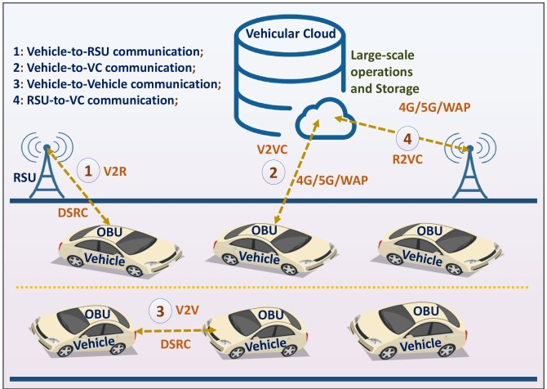

**Fig. 2.5 Secure Message Confirmation based of Vehicular Cloud**

**2.3.2 Securing Vehicular Cloud**

* Trust relationship
* Authentication and confidentiality
* Configuring Security Strategies

**Trust Relationship**

For infrastructure-based VC, trust connections can be worked by infrastructures that are constructed by specialists such as BMV/DMV or other transportation agencies. Infrastructure will be authenticated and doled out with security key sets. Infrastructure stores the key combines in tamperproof devices. As appeared in Fig. 2, vehicles communicate with infrastructure as access point to the VC. The infrastructure is sufficiently capable to handle enormous quantities of accesses in its transmission run. The scalability of trust connections can be achieved because the infrastructure is connected to each other by fixed networks. For AVCs, trust connections can be worked too. A cell leader can be elected to speak to the individuals in the cell to communicate with different cells. For security reasons, the cell leader is checked by its neighbors. At the point when the leader sends and receives accumulated position packets, all the individuals in the cell will compare the situations in the packets dependent on their insight. By staying quiet, they confirm that the packets have not been adjusted. Else, they broadcast challenge the leader.

Different neighbors will put the leader and the protestor vehicle into the inquiry table in the wake of receiving the dissent packet. At that point, the assessment of different neighbors is considered. On the off chance that most of vehicles view the leader as malicious, the record of the leader is moved to the doubt table. A trust model or scale is utilized so a hub can assess the dependability of another element, either being a hub or an infrastructure component so as to distinguish malicious hubs that induce bogus data in the system. There are two sorts of trust models in VANETS that are either element centric, which assess vehicles and attempt to guarantee dependable data conveyance, or data-centric models which assess the reliability of the data sent into the system. These two collaborate with each other.

**Authentication and Confidentiality**

To give authentication and confidentiality, we propose a geographic location based security mechanism to guarantee physical security on head of conventional techniques. Messages are encrypted with a geographic location key that specifies a decryption area. This gives physical security because a vehicle must be physically present in the decryption locale to decrypt cipher text encrypted with this geographic location key. Sender vehicle a specifies the district, creates the location key, encrypts the message, and sends cipher text to vehicles in this.

Authentication techniques in classical VANETs are applicable to Vehicular Clouds, utilizing techniques like Public Key Infrastructure. All together for the vehicle to authenticate in the cloud, it must be first authenticated by the infrastructure. The principle issue is that with the vehicles going at high speeds, the location is quickly changing, hence requiring authentication schemes to be stretched out during handover schemes.

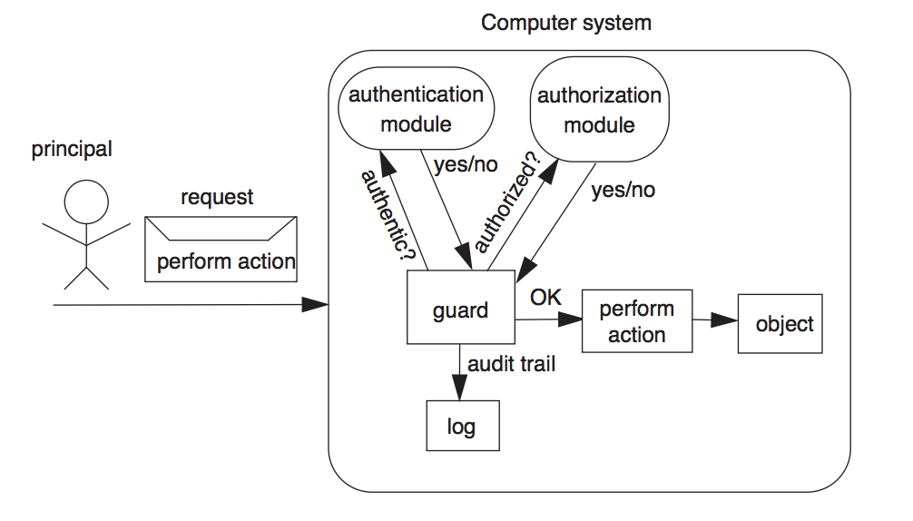

**Fig. 2.6 Confidentiality & Authentication Protocols**

Authority substance, must approach personalities and must be outfitted with capabilities that guarantee that no one can adjust with the information put away there. An advantage of Vehicular Clouds is that the system being virtualized and not having a centralized architecture, on account of the advances of the communication techniques inside the clouds, the authentication stage is simpler to oversee inside the cloud. Security authentication in the Vehicular Clouds must meet a lot of metrics that measure a client's entitlement to enter the system: possession, implying that the hub claims a one of a kind personality; information, implying that the hub knows one of a kind things, similar to a secret key, a key, basically the capacity of a hub to sign and encrypt and decrypt data utilizing secret keys; biometrics, implying that the hub can utilize extraordinary human characteristics, similar to mark, face, or voice recognition or fingerprints so as to access the system.

Configuring Security Strategies: It is essential to permit the VC to dynamically configure the security protocols and to autonomously replace security systems. We will begin with the configuration of security protocols and then describe an intelligent undertaking the executive’s strategy. The cloud will give vehicles a solitary system picture that is straightforward of subtleties of security scheme changes. As vehicles are dynamically moving all through a cell, the security protocols of a cell in its virtual machine should be dynamically adjusted. We watch the fact that the more vehicles are included, the more secure and the stricter a protocol ought to be. Comparative facts can be found in everyday life. Air terminals are often crowded, and security is often stricter than that in numerous different places. Occasions such as football match-ups, auto races, and flying demonstrations often attract more individuals, just as more policemen who watch the region all the more often to guarantee the security of participants. Traditional Cloud Computing, as it was first characterized by the National Institute of Standards and Technology (NIST) is a model for empowering pervasive, convenient, on demand arrange access to a mutual pool of configurable computing resources, attracts clients with its scalability, high resource elasticity and, to wrap things up, bypassing the requirement for own interests in network infrastructure.

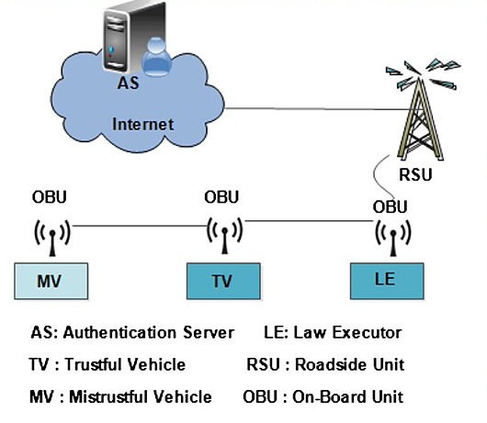

**Fig. 2.7 Secure Real-Time traffic**

One of the fundamental characteristics of a vehicular situation is that it is a multi-client condition which has a high pace of geography changes and high variety of hubs. Public key infrastructure-based access control isn't perhaps the most ideal choice, because it won't guarantee access control in a fine-grained way. Basically, the creators recommend that in a practical scenario, information that is sent through the system can be characterized by traits that are extracted from the scope of the information. Moreover, for each trait a public key component is characterized and utilized for encryption of data. On the client side, client secret keys are additionally arranged and created dependent on the kind of data that is probably going to send across the system. An advantage of this approach is that is shows an improved reduction in computational overhead.

Intelligent Transportation System technology can be characterized as the application of information technology to surface transportation so as to achieve enhanced security and portability while reducing the natural impact of transportation. It expects to facilitate a national multi-modular surface transportation system that includes a connected transportation condition around vehicles of numerous kinds, the infrastructure, and carry-in traveler devices to serve the public great by utilizing technology to augment wellbeing, versatility, and ecological performance. It covers all methods of transport and considers all components of the transportation system-the vehicle, the infrastructure, and the driver or client, interacting together dynamically.

Enthusiasm for the intelligent transportation system comes from issues caused by traffic congestion and a collaboration of new information technology for reproduction constant and communications networks. Traffic congestion has been increasing worldwide therefore or increased mechanization, urbanization, populace development and changes in populace thickness. Congestion reduces efficiency or transportation infrastructure and increases travel time, air contamination and fuel consumption. Presently a day's improvement of roads has created another havoc which lead to the increase in the accident cases the whole way across the world, so as to over-come from such an issue, Intelligent Transport System holds a valid statement. Intelligent Transport System is intended for the urban/state/private road transport association. “The system consists of a backend and an equipment component to give a coordinated answer for the driver console unit, electronic ticking machine traveler information system in the midst of vehicle tracking system. Intelligent Transport System gives a solitary answer for transport companies to schedule and screen transports with the assistance of advance technologies such as GPS, Wi-Fi and GPRS. Intelligent Transport System facilitates better public transport services by considering the transport winning, public wellbeing and security. This chapter basically discusses the impact and the different application fields or Intelligent Transport System for road transportation. Likewise, this presentation set forward the usage or different transportation technologies that will be crucial for homeland security, vehicular surveillance alongside technologies that can make our ride increasingly protected and economical.

The general function of ITS is to improve decision making, often in realtime, by transport organize controllers and different clients, in this way improving the activity of the whole transport system. The definition encompasses a broad exhibit of techniques and approaches that might be achieved through stand alone technological applications or enhancements to ether transportation methodologies. ITS offers scope for combination, and some contend that it is just through mix of its components that ITS will achieve its full impact. ITS includes exhibit of information! Data relying on the necessity of the usage subject, and at the same time coordinating these components together to get a decent Information structure condition for the traffic arranging, control and the board and boosting the system effectiveness.

**2.4 COLLABORATION OF CLOUD COMPUTING AND VANET’S**

The basic thought of VANET (Vehicular Ad Hoc Network) is to take the broadly adopted and modest Wireless Local Area Network (WLAN) technology, with a couple of changes, and introduce it on vehicles. In any case, in spite of the flood in VANET research, security and privacy issues have been the main driver of hindered force in VANET organization. One of the numerous objectives of VANET is to help traffic security and make the driving experience increasingly sheltered and comfortable. In VANET, Vehicles and RSUs (Road-Side Units), for example arrange hubs, will be furnished with on-board computation and communication modules to ensure productive communication conceivable among them. By building up a common data design alongside a semantic data description we imagine both collaboration between VANET applications and between applications from various areas too. Consider a service giving the best parking spot in a certain territory and client context. The decision relies upon information about a client's location and goal, the accessibility of parking spaces, the encompassing traffic circumstance, etc. In this manner, the system needs to inquiry data sources and applications from various associations and spaces (such as a route system, parking garage suppliers, TIS, climate service, etc.). Be that as it may, to utilize data from various spaces and associations, a common, machine-readable and platform-autonomous data portrayal and information about the data's semantics are basic. For both the data portrayal and the specification of semantics open standards ought to be utilized.

**2.4.1 Proposed VANET Cloud Architecture**

Olariu et al. (2011) just because, coined the term Autonomous Vehicular Clouds (AVC) as, A gathering of to a great extent self-ruling vehicles whose corporate computing, detecting, communication, and physical resources can be coordinated and dynamically allocated to approved clients. We step forward to broaden the possibility of VANET clouds by first characterizing a communication paradigm for VANET clouds and then set forth the potential cloud services from VANET stand point. It is, as far as we could possibly know, absolute first approach to take the vision of Olariu and his co-laborers, above and beyond towards VANET based cloud computing.

* Service Architecture in cloud
* VANET cloud scientific classification
* Service Architecture in Cloud

As showed in Fig.2.8, VANET clouds are reasonable for IaaS and SaaS just, though PaaS doesn't appear to be logically suitable for VANET condition. At IaaS level, the potential services gave by VANET clouds may be Network as a Service (NaaS) where a vehicular hub proceeding onward the road may be utilized as a wifi access guide passage toward the internet. The vehicles could lease their resources if the clients expecting to utilize the services, are will to pay.” At SaaS level, constant VANET information could be imparted to the subscribed clients. Additionally, infotainment services and P2P applications are reasonable to be utilized as SaaS.

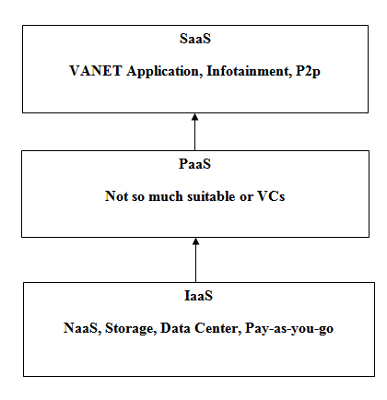

**Fig.2.8 Service Architecture in Cloud**

Vehicular ad hoc organize (VANET) is expected to improve our driving experience through enhanced wellbeing, security, heartiness, and infotainment. All things considered, in spite of considerable measure of research, VANET didn't make it, at any rate not on a full scale, to the sending stage because of numerous issues including security and privacy. Cloud architecture is the means by which all the components and capabilities necessary to construct a cloud are connected so as to convey an online platform on which applications can run.

**VANET Clouds Taxonomy**

Fig. 2.9 out queues the brief VANET clouds scientific classification. We partition VANET clouds into three significant architectures to be specific Vehicular Clouds (VC), Vehicles utilizing Clouds, and Hybrid Clouds (HC). VC is additionally partitioned into two scenarios from development standpoint. Static clouds allude to the fixed vehicles giving cloud services. For instance a virtual super computer shaped by the collaboration of vehicles left in a major association or endeavors parking garage. In case of static VANET clouds, the infrastructure (communication, storage, and process) can be leased to make income too. IaaS and data storages services are doable for such game plans. Then again, dynamic clouds are framed on demand in ad hoc way. VuC connects the VANET to traditional clouds where VANET clients can utilize cloud services progressing such as infotainment, traffic information, and CAA. In HC, vehicular clouds will interact with traditional cloud for services exchange.

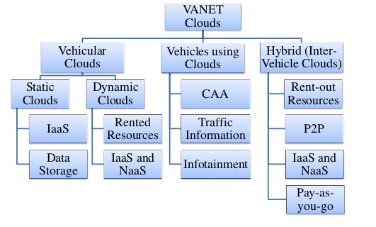

**Fig. 2.9 Taxonomy of VANET Clouds**

**2.4.2 Working Methodology**

**Modules**

1. Intelligent Parking Cloud Service
2. Communication from vanets to cloud
3. Vehicular Data Mining Cloud Service

**(i)Intelligent Parking Cloud Service**

An intelligent leaving cloud service that collects and investigates geographic location information, leaving accessibility information, parking spot reservation and request information, traffic information and vehicle information through sensor detection and the clouds is required.

* Decision Process
* Android Application Service

**Decision Process**:

The Car Parking Area, left via cars, implies it is characterized as - Occupancy. The car leaving territory has a free space implies it is characterized as - Vacancy. This decision refreshed to server part. At last, in decision step, the blended component is compared with pre-characterized limit.

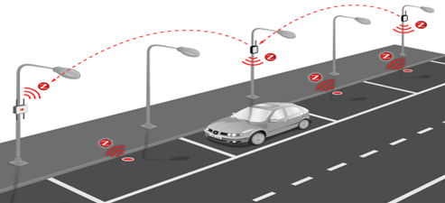

**Fig. 2.10 Intelligent Parking System**

**Android Application Service**

Android application collects all information from server through web server, and it calculates complete no of openings, encaged and free spaces. It shows graphical view for encaged and free openings by means of applications. It approving information's continuously to the web server.

**(ii) Communication from VANETS to cloud**

In this section we are going to produce an enlistment kind for drivers. Registration of jumper is required then exclusively the thought process force will take vehicle from systems administration aspect. Once the enlistment technique is completed and refreshed to cloud, jumper can gives his subtleties to verification. Once the verification forces finished with success, so the thought process force chooses the vehicle complete and model and current location. And for each couple of secs he will be drive forward moving to somewhere else in the middle of this the twitch level for that road. This subtleties we will in general change in to cloud.

**(iii) Vehicular Data Mining Cloud Service**

As conveyance information clouds contain a scope of heterogeneous information and data resources, effective data processing service ought to be created to quickly discover risky road things, issue early admonition messages, and help drivers to create recognizable choices to prevent accidents. In vehicle producing strategy, in some cases, some quality issues are often covered up for an all-encompassing time while not being known. Owing to a scarcity of occasions or motions toward correlate many separate issues, potential issues probably won't be explored even the slightest bit.

IoT-based conveyance information clouds zone unit expected to be the backbone of future ITSs with the final word objective of constructing driving more secure and a ton of pleasurable. A scientific approach and collaboration among academe, the car corporations, enforcement, government specialists, standardization groups, and cloud service providers territory unit required to handle these challenges in spite of the fact that with a few challenges, “IoT and cloud computing offer colossal opportunities for technology advancement inside the business and can function sactionative infrastructures for creating conveyance information clouds. We tend to blessing an extraordinary standard and multilayered conveyance information cloud platform upheld cloud computing and IoT technologies. we tend to conjointly discuss anyway cloud services might be created to create the conveyance information clouds accommodating. This examination makes contributions by proposing a one of a kind computer code plan for the conveyance information clouds inside the IoT environmental factors, that has the capabilities to coordinate fluctuated devices offered inside vehicles and devices inside the road infrastructure. We will in general propose a completely interesting multilayered conveyance information cloud platform vedacitisation existing cloud computing and IoT technologies. Two changed data processing models for the conveyance data processing cloud service, a Naïve Bayes model and a providing Regression model, are conferred well indeed.

**2.4.3 Information scattering in VANET-based clouds**

In a multi-client condition, access control through public key infrastructure certificates technique is definitely not a decent approach because in dynamic vehicular communication circumstance it won't guarantee the access control in a fine-grained way. Yeh et al. (2011) proposed the encryption scheme dependent on fluffy personality and offered the trait situated access control system for emergency information dispersal service in vehicular ad hoc networks. Trait based encryption indicated an improved reduction in computational and communicational overhead as compared to the current public key infrastructure certificates techniques. In any case, these investigations lacking the arrangement of complex policy classification with predicates. Hussain et al. (2015) proposed secure traffic information scattering as a service in VANET-based clouds by using GPS-based location encryption scheme. As GPS coordinates are publicly accessible and effectively accessible to the attackers. L. Nkenyereye et al. (2015) proposed ID-based marks with batch verification for secure vehicle traffic data spread in vehicular clouds. In the wake of, breaking down all the proposed VANETs and cloud-based secure information scattering schemes, we have proposed a novel cloud-based security and privacy-mindful information spread over universal VANETs.

In this research work, we have investigated the security and privacy issues. Moreover, we have adopted ciphertext policy characteristic based encryption (CP-ABE) to actualize the access control systems and effective access policies for both cloud and VANETs. IVs carried out the fine-grained information scattering among cloud system and the vehicular hubs by adopting the batch verification process. We meant to give a cloud-based secure and privacy-mindful information scattering service by empowering cooperation among concerned elements. This research focuses to give fine-grained information to the vehicular hubs by coordinated collaboration between cloud-based infrastructure and the vehicular hubs. The fine-grained information can be comprised of congestion investigates different courses, location-based services, traffic information, emergency traffic services and infotainment. This fine-grained information is rendered to make a very much stretched information see that may take multi-bounce communication resources. The Road Side Units (RSUs) and the vehicular hubs act as Communication Terminals (CTs). RSUs contribute as changeless CTs and vehicular hubs fill in as convenient CTs for efficient information spread. The RSUs as CTs perform to control all the communication between vehicular hubs and the cloud-based infrastructure.” Traffic the board Bureau (TMB) is an expert for giving the security certificate that will be used both at cloud and RSU side for authentication and for guaranteeing the security of the vehicle.

**2.4.4 System Overview**

In this section, we diagram the system review alongside system model and introduced a preview of the calculations produced for our proposed arrangements.

* System Model and Overview
* Traffic Management Bureau (TMB)
* Road Side Unit (RSU)

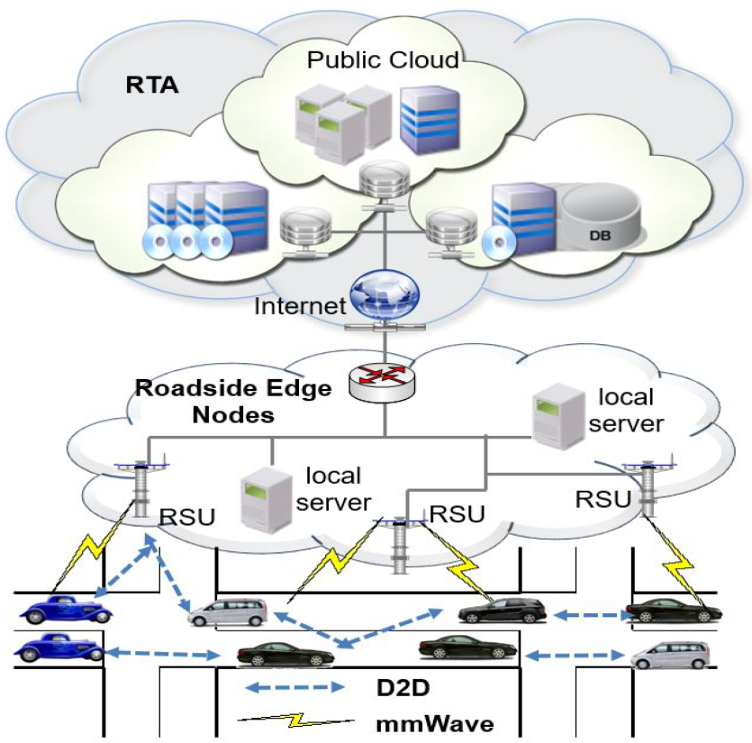

**Fig. 2.11 Cloud-based security and privacy-aware information dissemination model**

**System Model and Overview**

We categorized our proposed scheme into two principle classifications, cloud-based infrastructure alongside TMB and VANET-based infrastructure alongside RSUs. Both VANET and cloud-based infrastructures are all around connected through CTs. Generally speaking, the proposed plan consists upon traffic the executives Bureau (TMB) as a confided in power, roadside infrastructure, and OBUs of the vehicles. “Vehicles on roads fill in as hubs for VANET based communication and RSUs fill in as CTs between cloud infrastructure and vehicles. In a circumstance where there is no connectivity accessible to the close by RSUs, 3G/4G internet capability of the vehicles can be utilized as portable CTs. Along these queues RSUs as CTs, are dependable to concurrently refresh the cloud system through the beaconing of IVs by using the accessible methods for internet connectivity.

**Traffic Management Bureau (TMB)**

TMB is liable for the key age and malicious vehicle detection. Likewise, play out the job of a traffic screen for better traffic the board in handling issues identified with guide queue and controlling of vehicles and courses. It's a believed expert for all the partners of the whole system including principle vehicles, leaving facilities supervisors, traffic police and drivers. TMB can without much of a stretch track the malicious sort of vehicle and watch out for that for security reasons whether the vehicle is left or non-left moving on the roads. TMB approve the enrollment credentials of the vehicle as it demands for a car leave facility and upon approval, the system proceeds for additional allocation of parking spot. TMB likewise have the hands-on information with respect to traffic congestion on different courses and through this, it can all the more likely deal with the traffic issues of the whole urban center. TMB guarantee security through key administration procedures by utilizing encryption and private key task to the vehicle.

**Road Side Unit (RSU)**

RSUs have a wide-extending job of not just filling in as the connectivity point for the two vehicles, PSUs alongside the centralized cloud-based server yet additionally to screen the congestion circumstance on roads. RSUs assemble congestion provides details regarding different courses and send it to the cloud server for better traffic the board. The congestion report isn't just useful for the vehicles to securely and opportune reach to a leaving facility yet additionally accommodating for the Traffic Management Bureau (TMB) for controlling traffic congestion issue on various courses of a city. RSUs can use the current infrastructure of 3G/4G for communication alongside PSUs and the cloud-based stopping server.” RSUs likewise give the hands-on traffic information to the vehicles present in the encompassing zone.

**2.5 SUMMARY**

In this chapter we have given lot of review about the intelligent transportation system and some of the vehicular cloud data items. Most of the recent review of journals are gathered and grouped under the specific suitable headings. These are very needful to get the clear idea about the research topic. Then, useful to acquire the better knowledge particularly in the earlier research area.

**CHAPTER 3**

**PROBLEM DEFINITION**

**3.1 RESEARCH GAP**

A literature gap, or research gap, is an unexplored topic revealed during a literature search that has scope for research or further exploration. To identify literature gaps, you need to do a thorough review of existing literature in both the broad and specific areas of your topic.

We could go through both the Introduction and Discussion sections of existing papers in the subject area to identify such gaps. Apart from a study of the existing literature, you may also be able to identify research gaps based on your own analysis of the problem and existing literature.

Many number of research studies have been undertaken periodically on the VANET problems. But sufficient and in-depth studies are not identified in these matters. There is a wide gap in the matters relating to consumer studies. The present need of the hour, is to find out the areas of intelligent transport system studies, which are not touched. To fill up the gap constructive and suggestive studies are needed.

**3.2 PROBLEM DEFINITION**

A few issues and challenges identified with vehicular clouds should be properly addressed. Security and privacy aspects are of crucial importance. These aspects are increasingly complex in comparison with conventional networks because of high portability of cloud individuals, dynamical characteristics of the earth, heterogeneity of the vehicles and incessant system geography changes. In addition, setting up trust connections among cloud individuals presents a fundamental piece of dependable communication which is necessary in this context. Cloud individuals ought to have more prominent understanding in the process of sharing information. Besides, restricted capacity on cell phones, insufficient battery life, scalability and service accessibility are challenges in vehicular cloud computing, too. VANET communication permits exchange of touchy information among close by vehicles such as condition of climate and road accidents so as to improve vehicle traffic efficiency through Intelligent Transportation Systems (ITS). Numerous technologies have been created to enhance ITS. Recently, vehicular cloud computing (VCC) has been created so as to overcome the drawbacks VANET. VCC technology gives minimal effort services to vehicles and capable of overseeing road traffic efficiently by utilizing the vehicular sources (such as internet) to settle on decisions and for capacity. VCC is considered as the reason for improving and creating intelligent transportation systems.” It assumes a significant job in individuals' carries on with because of its wellbeing, security, trust, and comfort to travelers and drivers. This chapter researches the vehicular cloud computing. The creators first concentrate on architectures. At that point, they feature applications and highlights gave by VCC. Additionally, they clarify the challenges for VCC. At long last, the creators present opportunities and future for VCC.

**3.3 RESEARCH OBJECTIVES**

To frame an intelligent transportation system (ITS), which is designed to provide advanced services to traffic management. This work gathers and describes the most recent approaches and solutions for VC (Vehicular Clouds), featuring applications, services, and traffic models that can enable VC in a more dynamic environment. We have proposed a new framework called VEDA-CIT Vehicular Data Collection for Intelligent Transport, scope of the transportation system, benefiting its management, passengers and drivers. Research on Vehicular cloud computing is very much supporting Intelligent Transportation System (ITS) applications. The concept of VEDA-CIT is new and attaining growing interest from the research community. The objective of the thesis is to studying this emerging paradigm of Vehicular cloud computing. Contributed submissions to this thesis may present novel ideas, models, system design and architecture, security and privacy and performance evaluation techniques etc.

**CHAPTER 4**

**RESEARCH METHODOLOGY**

The primary point of the proposed framework called VEDA-CIT, Vehicular Data Collection for Intelligent Transport, is to give assistance to the administration services of intelligent transport systems and mechanisms for the storage of the information. This permits heterogeneous communication between different devices all the while by dealing with the versatility of vehicles, along with the information flows that are produced. This implies VEDA-CIT can offer help for various sorts of services.

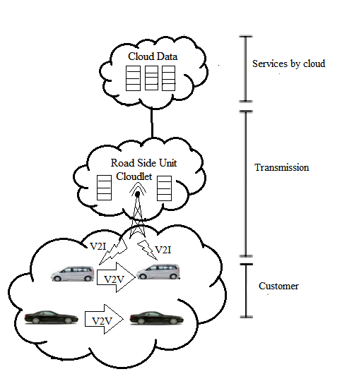

**Fig.4.1 VEDA-CIT Architecture**

For the static vehicular cloud, a research work made an underlying stride towards executing a VC and explored the quantity of cars that are expected to be available in a drawn out parking area of a typical global air terminal. The stochastic process with time-shifting appearance and takeoff rates are utilized to model the quantity of compute hubs at the datacenter which is formed by the additional computing capabilities of those vehicles. In this particular work, it was deduced a closed form for the expected number of vehicles and its variance in a universal air terminal parking structure. The time-subordinate likelihood dispersion function of the parking area occupancy and the restricting conduct of these boundaries as the underlying conditions fade away. With those boundaries, we could have a clear picture of the quantity of vehicles in the parking garage at some random second.

Aside from overcoming the challenges emerging from the highlights of vehicular networks and vehicular clouds, the proposed system is answerable for the accompanying:

1. Management and data storage.
2. Allocation and sharing of resources.
3. Interoperability between various devices.

The system attempts this by checking the best forms of communication and interaction between vehicle networks and different networks to help data flow and the requirements of individuals, just as handling all the resources mentioned by the demand for services.

**4.1 FREE FLOW MODEL**

In the free-flow traffic model, the traffic isn't blocked by any obstacles such as traffic light, stop sign, bifurcations or traffic congestion, and a driver can drive at any speed, if they stay inside road constraints. Therefore, the traffic thickness in this case is bound to be low or medium, as high thickness hinders the traffic because of the road capacity. At the end of the day, vehicles are endlessly disengaged on the road and the landings in the section purpose of the road fragment are freely and identically dispersed. The Poisson process is a common random process for depicting vehicles' appearance.

**4.1.1 Traffic Management**

Traffic the executives applications intend to help the traffic flow of vehicles by forestalling congestion or in any event, keeping away from congested territories. The advancement of such applications imagines continuous constraints on the info data; the restrictions reside on dynamically changing ecological conditions and appropriate reactions to accommodate refreshes in sensible time periods. Suitable recommendations to traffic the board systems or drivers directly influences the effectiveness in improving the progression of vehicles. Table 4.1 immediately records the current known VCC applications for traffic the board

**Table 4.1 Vehicular Cloud Applications for Traffic Management**

|  |  |  |  |
| --- | --- | --- | --- |
| **Application** | **Mobility** | **Major Feature** | **Cloud depend** |
| User driven system | High | Path recommendation | Yes |
| Intellectual Road Infrastructure | High | Cost recommendation | No |
| Context Aware Parking | High | Probability Analysis | No |

Client Driven Cloud Transportation System made utilization of continuous data, which the client (driver) took care of into the application M.Ma et al.,(2012). In this work, a Cloud transportation system was concocted to permit predictions of traffic congestion. The system additionally empowers the construction of traffic maps, expecting to help keen driving, which recommends a way to the driver according to a characterized model. The application utilizes a scheme of client driven crowd-sourcing to acquire driver data for predicting traffic sticks and building an ongoing traffic model. “With respect to a proportion of performance enhancement for the calculations, the application likewise participates in a Map-Reduce computing model and calculation for traffic data processing. The last interface is created and made accessible on an Android-based model application. Another comparative traffic the board application consists of the Intellectual Road Infrastructure, V.Hahanov et al., (2013) which likewise collected and accumulated data progressively to readily decide traffic conditions. Therefore, this work proposed a road infrastructure to screen and control traffic in a constant way. This ongoing coordination is imagined to limit in general transportation costs and improve wellbeing. The proposed system accesses devices and vehicles provided with locally available radio frequency identification (RFID), GPS, and sensors to assemble information about traffic conditions. After data collection completes, the system processes the information in the Cloud and presents significant outcomes by means of an online service.

The third traffic the board application varied from the past two applications because it focused on a particular context, which included recognizing parking spaces continuously. This recommendation system, Context-Aware Dynamic Parking Service J.Wan et al.,(2014), broadened the traditional leaving services in carports by dynamically refreshing the accessible parking spaces for incoming vehicles. In this case, the Vehicular Cloud can help the leaving of vehicles on road portions. The system utilized a technique for likelihood examination to empower important traffic specialists to decide dynamically whether the road can be approved to give context-mindful stopping services. Accordingly, the context information must speak to the expected leaving length of vehicles on the roadside.

Another macroscopic free-stream traffic model is described in M.Khabbaz et al., (2012), which de-fined the accompanying presumptions:

* Density of vehicles on a road portion may be low or medium.
* An autonomous and identically disseminated Poisson process speaks to the appearance of incoming vehicles.
* Traffic lights, stop signs, and different obstacles don't upset the development of vehicles on a road portion.
* Speed shows variety that is regularly circulated in the stretch [Vmin, Vmax], keeping up a similar velocity along the road portion.

These suspicions are basic in characterizing their proposed model, which gives helpful estimations on the residence time of a vehicle and the quantity of vehicles in a road portion. The work described in T.Zhang et al., (2016) and A. Boukerche et al., (2015) proposed a split of the flow model into two well-defined scenarios so that each part of the model can provide a more realistic representation of the behavior of the traffic. Free-flow traffic and queuing -up traffic models comprehend the two typical traffic situations modeled in this approach. Even though both of them attempt to represent the movement of vehicles in a flow abstraction, they make use of stochastic modeling to define the number of vehicles and their residencetime in a road segment for a more precise estimation of available resources in a Vehicular Cloud.

In the Free-flow model, the vehicle arrival is modeled as a Poisson process. This model considers that there is a free-flow of vehicles: there are no obstacles or conditional stops while the nodes are traversing the road segment, and the vehicles can move at any speed within the allowed range. Consequently, the flow of vehicles presents a low to medium density, as well as residence time in the road segment.

**4.1.2 Stochastic Traffic Models**

Stochastic traffic models are typically utilized on attempts to speak to the general aspects of versatility through an easier form, which condition them to adopt restrictive suspicions and make them veer off from the real world. Stochastic traffic models are once in a while utilized by researchers now since it has profoundly restrictive suspicions and often go astray from the real world. Two most common stochastic portability models include Random Walk and Random Direction Mobility Model, where the versatile hubs are allowed to move in any random directions dependent on the road map. Random Direction Mobility and Random Walk models consist of the most famous stochastic versatility models; the significant standard component in both includes the capacity of portable hubs to move unreservedly in any discretionary direction, according to the road geography of an area. The models described in this section adopt various portrayals for the random portability of hubs in traffic. This category of models additionally contains different highlights, which are quickly recorded as follows:

* The association of the roads follows a framework geography, and the vehicles follow a random development inside the scenario;
* Destinations are resolved randomly by vehicles, which push toward them in constant velocity. Consequently, the network geography constricts the development directions to vertical and level;
* There are no interactions among vehicles; the vehicular thickness, speed, and flow rate, which consist of the between correlated boundaries commonly present in macroscopic models and traffic flow models, are not considered.

The accompanying highlights that are commonly found in this kind of model.

* The roadway geography is often spoken to by a lattice. The development of vehicles on the lattice is random.
* Vehicles select a random point as their goal and push toward this goal at constant speed. The route directions are either vertical or flat.
* The interactive conduct among vehicles are not considered and the three between correlated macroscopic boundaries in the traffic flow model are just neglected.

A model dependent on a fixed dispersion was added to the random way-point portability model. In this work, the creators investigated the potential varieties according to the fixed disseminations for both speed and location.” They characterized a delaying boundary to examine the fixed circumstances, so the development of hubs, or vehicles, is spoken to dependent on the measure of respite they introduced in a given development, making some stop memories equivalent to zero. By essence, the free-flow traffic model arrangements with low traffic thickness, with generally high normal speeds and low residence time. Despite the fact that this model speaks to a scenario in which it is impractical to utilize computational resources because of the quickly changing geography and sparcity of the vehicular system, it can give beneficial answers for discontinuously connected vehicular networks. A joining of this model with delay-open minded mechanisms may serve and fit necessities to increase the packet conveyance proportion. The scheduling of assignments and allocation of resources for a Vehicular Cloud, such as capacities, load, accessibility, residence, and thickness, in a given second. For instance, prediction of traffic load oscillations is basic for assessing the measure of time vehicles are accessible to access a service or manufacture a Cloud, utilizing similar vehicles to compute an answer for a potential traffic jam because of current load conditions.

**4.1.3 Transport Model**

The transport model reenacts the interaction between the gracefully sub-system, as far as influence of the flow in the system performances, and travel demand sub-system, regarding influence of the performances in the client's conduct. The gracefully sub-system is reproduced by methods for a system model, with joins, hubs, geography and cost functions. The general formulation of a congested system model consists of a way costs versus interface costs consistency condition and of a way flows versus connect flows consistency. The gracefully model needs the meaning of the connection cost functions. For singular clients, the cost is the total of the cost on the connection and the cost at the junction. A hanging tight time function is utilized for signalized junctions; a hole acceptance model is utilized for non-signalized junctions. For what concerns collective clients, cost functions are equivalent to the ones for singular clients in the mutual connections of the system; the free-flow travel time is considered in the saved connections. In evacuation conditions, travel demand models specified and calibrated for customary conditions cannot be directly applied because of a few reasons: multiplicity of decision-producers (civic chairman and citizen); choice set (which may vary for emergency scenarios and for decision-creators); statistical and probabilistic aspects; and qualities and boundaries. Besides, in evacuation conditions the expert must consider the objectives and constraints characterized by the public decision-creator, so as to reduce the presentation. Comparable to the kind of the calamitous occasion, which can be classified according to its effects in space and in the time, a few emergency scenarios can be characterized and diverse demand models must be specified. A system of static models is adopted to recreate demand in evacuation conditions (trip age appropriation and mode-choice). A dynamic way choice model is adopted to recreate flexibly demand interaction. Beginning from these considerations, a coordinated system of models is proposed, considering an anthropic perilous occasion, which predominantly produces effects on demand, with diffuse effects in space and deferred effects in time [23]. The coordinated system of demand models is partitioned into the accompanying sub-models:

* Generation and takeoff time model gives the degree of demand in the investigation region according to the reference time and client category.
* Modal choice/dissemination model gauges the quantity of clients undertaking a transport mode from a cause to a shelter region, form accessible other options the circulation model mimics client appropriation among various safe focuses, asylum zones, goals and recently characterized or not by a public decision-producer.
* Path choice model gauges the likelihood of choosing a way and the way flow given the flight time, the starting point, the goal and the mode.

The general conditions for the movement demand models, comparative with the initial two focuses, are

h = P(g) d

d = d(se, g)

with h as the path flows vector; P as the path-origin destination probability matrix defined below; d, as the demand vector; d(**.**) as the demand functions vector; se as socio-economic attributes; and g as the path costs vector. A crucial choice of road clients in emergency conditions concerns way choice. Each client needs to choose between his/her ongoing way and not-experienced elective ways. The two clients' experience in common conditions and information acquired during evacuation (for example arrange dependability) influence clients' choices. This model is diversely specified according to the reenactment of individual or collective clients' conduct. The individual client has self-sufficient decision-production on choices concerning way, flight time and goal (constrained by a lot of safe goals). On the contrary, the collective client has no self-governing decision-production on way, takeoff time and goal, as they are characterized by the organizer.

Test data were given by articulated field overviews before and during the evacuation. Before-evacuation field reviews concerned the characteristics of the clients that possibly evacuate (demand study) and the performances of the transport arrange (gracefully overview). The demand review was arranged to know socio-economic characteristics of the evacuation zone and to appraise and check clients' number and eagerness to evacuate, by methods for expressed and uncovered preferences techniques. Evacuation overviews concerned the characteristics of the road arrange (connections and junctions gracefully study) and checked diverse mechanized modes utilized by the evacuees: private vehicles, transports and ambulances (demand study). “The vehicular flow inside the evacuation territory was recorded by a few cameras located on some selected connections of the road organize (demand/gracefully interaction study). The watched traffic factors were: vehicle travel time, vehicle counts and classification (cars, transports, ambulances etc.).

The principle objective of evacuation is to reduce the component of hazard identified with introduction of the evacuation territory. Accordingly, the objective of this present reality experimentation was to calculate the reduction of hazard for the two above decision-production processes. In presence of ICT, chance reduction relies upon the effective improvement of the decision-creators' actions executed before and after each checked (by methods for the ICT system) evacuation. In presence of ITS, hazard reduction relies upon the effect of the process (an) and on the added information received from the DSS that structures performances of the transport system (flexibly plan and/or demand the board).

The free-flow vehicular traffic is characterized under the circumstance that the vehicle thickness is low or medium on the road. In the circumstance of high vehicle thickness, the traffic is best modeled according to a lining up model in which each vehicle basically awaits in a queue for takeoff from the road portion. In the free-flow model, vehicles keep a generally huge distance from each other with the goal that the conduct of a vehicle is autonomous from that of different vehicles. In this scenario, the flow of vehicles, which show up toward the beginning purpose of a specific road section, is generally considered as a Poisson appearance process and the between appearance times of vehicles are free, identically conveyed (i.i.d.) exponential random factors. Therefore, the traffic flow that navigates a decided road portion can be modeled as a lining system, where the road fragment is the server and the vehicles are thought to be customers. In light of lining hypothesis, we can conduct a comprehensive investigation on the expected customers, vehicles, and service time, vehicle residence time on the road section. Following this modeling technique, a work introduced in M. J. Khabbaz et al.,(2012) has proposed a straightforward free-flow model under the aforementioned scenario; the work described in T. Zhang et al., (2015) at that point stretched out the model and continued to carry out investigation on the vehicle computing resources for dynamic Vehicular Clouds. In a similar pattern of thought, we utilize the models characterized in these past functions as a base to show an explicit deduction on our advanced, stretch parting free-flow model.

Two principle scenarios characterize the conditions and restrict the boundaries for forming Vehicular Clouds; these scenarios include the level of versatility of vehicles, which can empower the work of static Vehicular Clouds and dynamic Vehicular Clouds M. Whaiduzzaman et al.,(2014). The static VCC for the most part exploits the inert computing resources in vehicles resting still in a parking area while the dynamic VCC means to total resources among moving vehicles on the road. A large portion of the current instances for VCC are in the static formation scenario, such as the works that watch the resources of left vehicles for characterizing parking area data Clouds. Then again, the arrangement of dynamic VCC is fairly challenging because of the high versatility and the sophisticated communication condition for moving vehicles on the road. In a given area where a dynamic VCC exists, the quantity of accessible compute hubs, specifically the vehicles, shifts over the long haul. Consequently, because of the short residence time of vehicles, the computational errands allocated by the dynamic VCC must be instantly moved from the leaving vehicles to the vehicles still in the scope of the VCC. Hence, the execution of dynamic VCC depends on a comprehensive appraisal and prediction of the dynamically changing vehicle resources on the road, especially the accessible number of vehicles and their expected residence time. The traffic flow model has the capability of giving such information. The vehicular traffic models are broadly utilized in reenacting realistic vehicular traffic conduct for Intelligent Transportation System (ITS). Car-following models, traffic flow models, and stochastic traffic models consist of the three fundamental gatherings of existing vehicular traffic models. The car-following models consider the individual conduct of each vehicle, so these models lie in the category of microscopic models. An enormous number of boundaries, such as acceleration, path changing, and intersection decision are incorporated into the car-following models, so it presents high precision in speaking to subtleties, similar to driver reaction time, road condition, and climate conditions. In any case, these models achieve this high precision with a cost of complexity and concentrated computation. Therefore, the car-following models show generally helpless scalability when evaluating traffic load for profoundly dynamic scenarios where time constraints are significantly restrictive.

The stochastic traffic model, then again, follows a simplistic macroscopic modeling methodology of vehicular traffic. This sort of model makes extremely restrictive suppositions with the goal that the general portability conduct over vehicular networks matches the conditions for accepting random walk models [18] to characterize the development of vehicles. Notwithstanding, a stochastic traffic model typically disregards the truth since it overlooks the correlation between the vehicle speed, vehicle thickness, and traffic flow rate over a road fragment.

**4.2 QUEUEING MODEL**

The queuing-up model endeavors to introduce a progressively realistic perspective on the traffic scenario of huge urban regions, where road fragments become congested with the increase in the quantity of vehicles crossing roads, reaching their most extreme capacity. In this model, obstacles are the cause of a bottleneck that limits the flow out of the road fragment, conditioning a vehicle takeoff rate littler than the appearance rate on the road. Vehicles queuing-up in a road section facilitates many promising applications, because of longer residence times and higher vehicle thickness in a road fragment. For instance, vehicles under these circumstances can self-sufficiently self-sort out and dynamically assemble a vehicular cloud, which can assist with tackling traffic-related issues continuously. Such a cloud can execute traffic the board applications and dynamically and accordingly expand green lights in a provided guidance, for the sole purpose of easing traffic congestion. In this section, we feature the significant issues and challenges in collecting data with the guide of VC. We for the most part focus on the issues correlated with ITS applications such as traffic the executives, congestion detection and route systems.” These issues include Penetration rate, trust the executives, the interoperability of various clouds, and security.

**A. Penetration Rate**

Penetration rate in our proposed VEDA CIT data collection can be characterized as the percentage of vehicles furnished with the required OBUs and subscribed to the mentioned service.

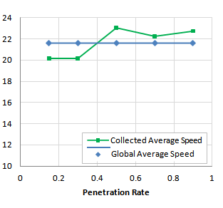

**Fig.4.2 High Traffic Demand (Density = 70 Vehicle/Km)**

Regeneration results are appeared in Fig 4.2. In Fig 4.2, we show the reenactment results under high traffic demand. As the Figure appears, the normal estimation of speed data collected in the VC is closed to the actual normal speed esteem, much under low infiltration rates. This can be clarified by the fact that vehicles going in a similar road typically experience a similar traffic condition, while neglecting different factors that may occasionally create little varieties among participating vehicles. In Fig 4.3, we show the outcomes under medium traffic demand. Like high traffic demand results, it tends to be clearly indicated that the collected normal speed under medium traffic is closed to the worldwide normal under all paces of penetration. Because of the high expected impact of infiltration rate in vehicular situations (especially at early usage stages), we give an assessment of various entrance rates in a data collection scenario inside a vehicular cloud. We show by means of reenactment results that preparing 15% of the voyaging vehicles can be effective continuously data collection scenarios to support ITS. Coined hearty architecture for Vehicular Clouds (VC) lacks virtual relocation among vehicles Poor versatility the executives service drops needs efficient calculations for VCCN, VM is between V2V just and Lacks allocation of physical resources.

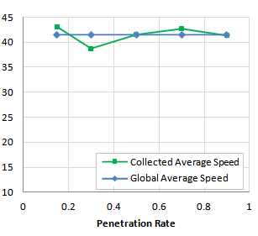

**Fig.4.3 Medium Traffic Demand (Density = 50 Vehicle/Km)**

Uses coalition partion for organize selection leads to high latency LTE demonstrates failure to handle increased system load and 802.11p has lack of coordinated channel access and circulated congestion control. In spite of that the best outcome is demonstrated when 90% of the vehicles participate in data collection we can conclude that vehicular cloud-based approaches can effectively bolster intelligent transportation systems with ongoing data, even with low percentage of participating vehicles.

**B. Trust Management**

In ITS applications, the VC in some cases requires to have local expert for taking actions or settling on decisions instead of a central power. Such local authority can be achieved through trust the board system by means of cooperation between the cloud formation and the central power, so as to computerize the verification of actions. It utilizes static system of RSU with fixed resources utilizing Markov decision process yet not appropriate for profoundly dynamic road traffic substances and slacks in handling system scalability. In light of admission control with various client SLA yet doesn't handle memory conflict efficiently , proposed workflow errands on heterogeneous cloud resources to limit time however cost is increased Domain-Specific Language (DSL)- based RPM specifying QoS constraints and functional prerequisites yet neglects to handle queues at run time.

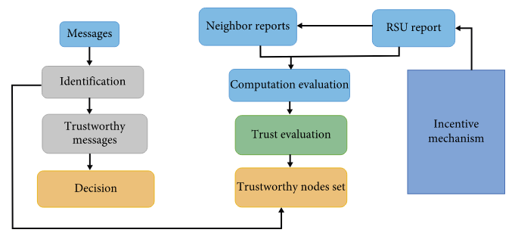

**Fig.4.4 Trust Management Schemes in VANET’s**

To overcome the challenges of trust the board in the VANET, we discuss the attractive properties for the trust the executives which ought to be incorporated in the VANETs system.

(i)Decentralized trust foundation: it is suitable for VANETs because of its dynamic condition. A key infrastructure is utilized to confirm the jobs of each vehicle drivers in a conveyed manner. The unwavering quality of vehicle is assessed by utilizing V2V interaction or depending on the actual driver's condition.

(ii)Scalability: it is an indispensable piece of the trust the board; during the pinnacle hours, an enormous number of vehicles going through the system might be higher. In case of emergency circumstances, a companion needs to take the decision quick. To satisfy this necessity, each companion can just accept information from reliable friends, and set up trust in the VANET ought to be scalable.

(iii)Privacy: it is a challenging part for the trust the executives, uncovering a vehicle proprietor ID, such as proprietor place of residence, may cause any malicious client to attack and create the harm. The trust the executives can utilize public key infrastructure which can permit hubs to authenticate each other.

(iv)Robustness: the trust the board can improve peers collaboration and detect malicious hubs. In any case, once in a while the trust the executives becomes the objective of attacks and compromised. “The trust mutilation can deceive the confided in arrange tasks by misleading the dependable computation, and likewise, the unwavering quality of another hub perhaps misshaped

(v)Information sparsity: in the trust the executives, the information sparsity is ruled in VANETs and the data may be named important. The information which is received directly has a significant worth, and the weightage of this information must be increased in trust calculation mechanism

**C. The Interoperability of Different Clouds**

Various kinds of clouds are anticipated to develop sooner rather than later. These clouds may interact with each other and connect on demand to the Internet cloud progressively scenarios. Therefore, issues identified with communication, dependability, synchronization and efficiency are required to be addressed to help the interoperability of various clouds. Addresses about scalability utilizing bandwidth bottleneck utilizing very good quality switches to incurs cost factor however doesn’t approves the proposed work under commodity switches. Discusses execution of specialist daemon, virtualization operator, resource administrator and undertaking scheduler however doesn’t have adaptation to non-critical failure and load balancer, Bandwidth misfortunes because of collision.

**D. Security**

VC experiences a similar security challenges of Cloud Computing, as anticipated. Since a large portion of vehicular systems depend on location information, it is basic to guarantee the secure location and localization. In addition, the high versatility of vehicles requires confirming the authentication of clients and the trustworthiness of messages. For the put away data, it is required to give secure data access to protect touchy data against unapproved access. Data detachment mechanisms can guarantee the security of data put away in the cloud. Propounded k-secrecy schemes for gathering of VANETs just uses a multi-bounce informing utilizing PN forces connecting issues for new dynamic vehicle passages and resource service conditions, Discusses on data centric schemes which detects bogus vehicle by information isn't appropriate with VClouds

**4.2.1 Data Collection Technology –queuing Model**

Significant advances in communication and computing technologies have thusly yielded advancements in ITS data collection technologies. The applicable data come from numerous sources. ITS data sources can be categorized into four broad gatherings:

1. Roadway data
2. Vehicle-based data
3. Traveler-based data
4. Wide region data.

Thus, data collection technologies are assembled into four categories:

1. Roadway data collection technology
2. Vehicle-based data collection technology
3. Traveler-based data collection technology
4. Wide region data collection technology

Roadway data collection technologies have been utilized for decades to collect data from fixed locations along a parkway. Sensors utilized on roadways can be aloof in nature, collecting data without disturbance to ordinary traffic activities. One of the most generally sent roadway data collection technologies is the circle detector. Various circle detector-based applications are presently being used such as intersection traffic observing, incident detection, vehicle classification and vehicle re identification applications. A few sorts of circle detectors can give data that include the count or detection of vehicles at a location. Another kind of roadway data collector is microwave radar, which can detect vehicle flow, speed, and presence. Infrared sensors can be utilized to gauge the reflected vitality from a vehicle, which might be utilized to deduce characteristics about the sort or conduct of the vehicle. Ultrasonic sensors can recognize vehicle count, presence, and path occupancy. Another generally utilized roadway data collection technology is the CCTV camera. Machine learning techniques can be applied to the video to detect characteristics of traffic. Once these pictures are digitized, they are processed and converted into pertinent traffic data. Distinctive machine vision calculations are utilized to break down the recorded traffic pictures for constant traffic checking, incident detection and verification, and vehicle classification.

Drivers utilizing cell telephone applications give a third data collection source for ITS. These broadly utilized communication and cell telephone applications and online social media have been utilized by explorers to intentionally give refreshed traffic information. For instance, the Waze cell telephone application, presently worked by Google, utilizes location information of voyagers to construe traffic log jam and the possible location of traffic incidents. In any case, such data from drivers that is determined through online social media platforms is semi-structured and questionable in that the driver doesn't give the specific location information of any traffic occasion. For instance, just 1.6% of Twitter clients have their geo location functionality activated.

Wide region data collection technology, which screens traffic flow by means of different sensor networks, is the fourth data collection source. Photogrammetry and video recording from unmanned aircraft and space-based radar are additionally accessible as data collection technologies. Data collected from these technologies include vehicle spacing, speed, and thickness, which thusly are utilized for different purposes such as traffic observing and incident administration.

A synopsis of the distinctive transportation data collection technologies. Aside from the data collected by the four classical data collection sources, transportation-related data is additionally created from such sources as the news media and climate stations. The inclusion of both constant and archived data collected by both public and private agencies utilizing various technologies in the distinctive transportation decision-production activities has assumed an amazing job in the fast usage of various ITS applications.

Understanding the structure of ITS applications is an essential to perceiving the various data system components of ITS. An ITS architecture offers a common system to:

* Plan
* Define
* Implement

are various ITS applications. An ITS architecture additionally characterizes the information and data flow through the system and associated standards to give particular ITS services. For instance, the United States National ITS Architecture offers general guidance to guarantee interoperability of systems, products, and services. A key objective is to guarantee interoperability through standardization while guaranteeing that the architecture will lead to the organization of ITS projects even as information and telecommunications technology advances. USDOT started the assignment of characterizing and building up the US national ITS architecture in 1993, and this scheme should now be utilized in the entirety of ITS projects so as to receive any government financing.” A coordinated ITS architecture created for a district that follows the national ITS architecture can use national standards and shared data sources. Thusly, costs are reduced for collecting, processing, and spreading of data, and duplication of effort is reduced while executing numerous ITS applications. The national ITS architecture offers systematic rules to plan, structure and actualize ITS applications to guarantee the compatibility and interoperability of various ITS components.

For the ITS architecture, client services can be considered as the principal building block, and these characterize what the system is required to do. Client services are described from the perspective of the clients or partners. At first, the client services were characterized by the joint effort of USDOT and ITS America, with the contribution of different partner gatherings. Client services bolster the foundation of elevated level transportation services that address distinguished transportation issues. From the start, 29 client services were characterized dependent on the consensus of industry. Until this point, the complete number of client services is 33, and they are assembled into the accompanying client service zones:

1. Travel and traffic the board
2. Public transportation the board
3. Electronic installment
4. Commercial vehicle tasks
5. Emergency administration
6. Advanced vehicle security systems
7. Information administration
8. Maintenance and construction tasks.

It is necessary to characterize a lot of functions to accomplish these client services. For instance, to characterize the speed of a roadway dependent on the traffic condition, the traffic should be observed and then data collected by checking the traffic flow will be utilized to predict the speed for the roadway section. A lot of functional proclamations, which is utilized to characterize these various functions of each of the client services, is called client service prerequisites. Each client service prerequisite contains a will proclamation. Another client service prerequisite is required to be characterized, if an agency needs to perform a function and it isn't planned to the current client service necessities. These client service necessities give a direction to create functional processes and information flows of the ITS services instead of acting as mandates to the system/architecture implementers.

**4.2.2 Queue Length Sensing Model**

The queue length detecting technique proposed in this model needs to meet some after basic conditions:

1. Connected vehicles must be outfitted with GPS and remote transmission hardware.
2. It is expected that roadside units (such as sign controller) can accurately acquire information such as connected vehicle's ID and location.
3. The motorcade in each entrance path must contain at any rate one connected vehicle;
4. This model accept that every single participating vehicle (including connected vehicles and unconnected vehicles) are standard vehicles.

The principal condition requires the GPS to accurately locate the path of a vehicle, and it requires the remote transmission device to formulate an emergency treatment intend to guarantee the opportune transmission of information to the roadside unit in case of gear disappointment. The second condition requires the roadside unit to receive information sent by connected vehicles continuously and to accurately process the data effectively and criticism to vehicles in time. The third condition requires each motorcade to include at any rate one connected vehicle, because the technique concentrated in this model is applicable to the vehicle infrastructure cooperative condition. This introduction doesn't consider the queue detecting of every unconnected vehicle. Some writing alludes to the utilization of traditional detection strategies (such as circle detector) to manage this circumstance and the utilization of information combination technology to achieve the detecting work. The fourth condition expect that all vehicles are standard vehicles, which implies a vehicle's sort isn't considered. Nonetheless, in the actual circumstance, diverse vehicle types should be converted according to the vehicle conversion coefficient.

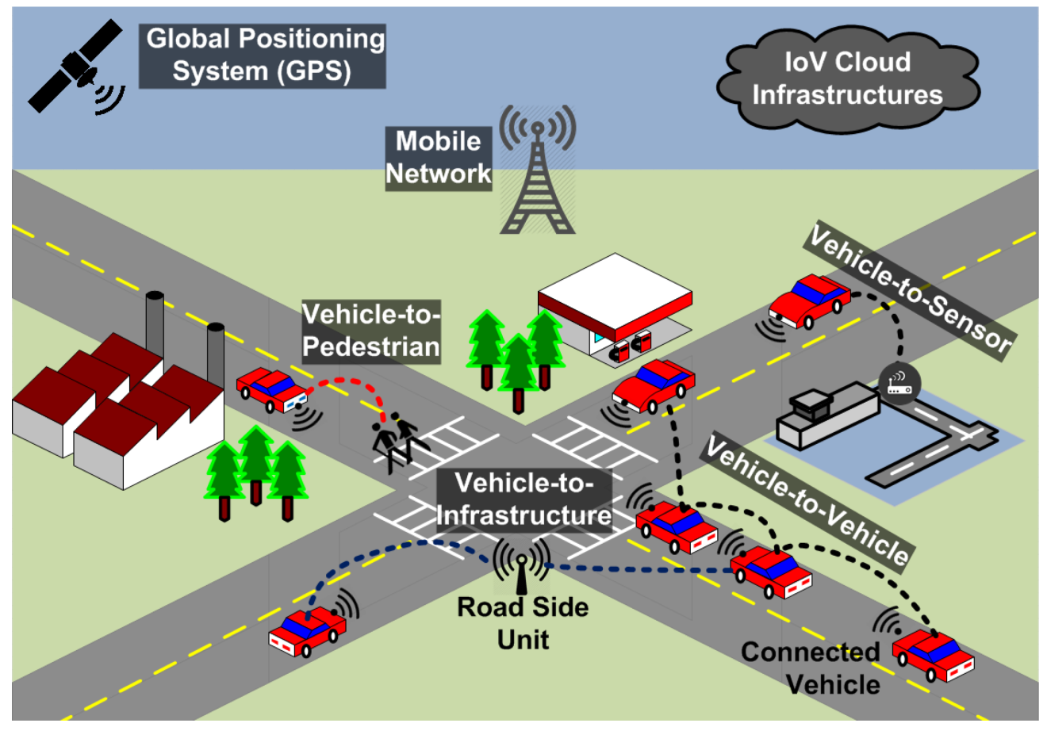

**Fig. 4.5 Structure of Sensing Model**

The above basic conditions can reduce difficulty and complexity of issue research to a huge degree. Later on, we would like to reduce the constraint of theory conditions and expand this technique to a bigger scope of application. The four basic conditions above infer that the queue length detecting model has a few restrictions. Right off the bat, the detecting scene must be the signalized intersections. Secondly, the model is just applicable to blended traffic situations, where both connected and unconnected vehicles exist in the motorcade, or traffic conditions where every single connected vehicle exist. At long last, because the model accept that vehicles go through the intersection as waves, the model is reasonable for predicting the length of the queue formed in the entrance path. In view of the above preconditions and constraints, this introduction proposes an ongoing detecting model for queue length. “The general structure of this model is appeared in fig 4.4. The shockwave-based detecting and the BP neural system based detecting respectively gauge the queue length and combine the advantages of two sub-models in various entrance rates to construct the combined detecting model, which has higher accuracy.

**4.2.3 Traffic Prediction**

Traffic congestion impacts congested roads as well as close by boulevards and roadways which are elective ways to drivers keeping away from it. An answer for keep away from these circumstances is tracing increasingly efficient courses, which rely upon refreshed traffic information. Since acquiring constant traffic condition of all roads in a city is a hard assignment, elective methods of detecting such aspect were created.

Lippi et al. (2013) introduced a comparison between numerous transient traffic pre-diction systems. Predicting traffic state in shorter windows of time is a simpler undertaking and increasingly effective, given that courses will be traced thinking about later information. Tostes et al. (2013) and Abadi et al. (2015) created predic-pinnacles of traffic levels in urban regions dependent on statistical instruments. Relapse models are especially helpful in predicting momentary traffic because they capture the typical conduct of congestion levels and adapt in face of abnormal circumstances, similar to accidents and roadblocks. Brilliant Traffic Management is where centrally-controlled traffic signs and sensors direct the flow of traffic through the city in light of demand.

Upgrading and incorporating all the signs on the primary roads in the city will:

* Reduce regular congestion extraordinarily, by smoothing traffic flows and organizing traffic in light of demand progressively.
* Reduce contamination all through the city: stop-begin driving is inefficient and dirtying.
* Give need to transports approaching junctions, staging lights to give traffic flowing with transports a 'green wave' through the city.
* Enable a much progressively effective reaction to traffic incidents, especially on the A14 and M11.” The system can be pre-modified to handle an unexpected increase in traffic on any of the ten radials.
* Enable Inbound Flow Control.

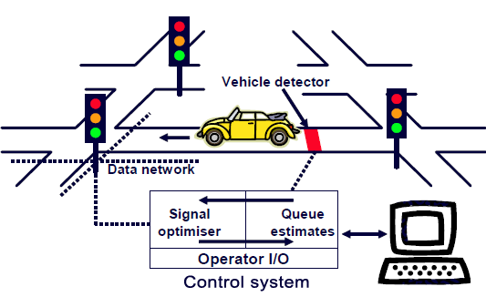

**Fig. 4.6 Traffic Control System**

It will likewise give a perfect opportunity to introduce checking hardware to collect much more nitty gritty traffic and excursion data than we have now. Each arrangement of traffic lights will have communication gear that can be utilized to transmit (unknown) vehicle data, either from ANPR cameras or Bluetooth detectors, and CCTV takes care of (where appropriate).Not knowing the condition of the current traffic control center, it may be that speculation is expected to upgrade or create another best in class suite for checking and controlling traffic. Because it would not require extensive consultation, land purchases or access understandings, conveyance could begin inside a year, on a turning program more than a few years. Disturbance at each junction would keep going for only days or, probably, weeks. Benefits would be experienced inside long stretches of beginning the program.

There are three components: traffic lights, queue detectors covered in the road and/or cameras, and a central control system. The queue detectors tell the control system the condition of traffic flow on all the principle roads in the city. The system thusly controls the lights to keep up a free flow of traffic inside the city. At regular intervals the system utilizes a model of genuine conditions to decide whether there would be an advantage in changing the staging of any of the lights. What the system software considers an 'advantage' might be characterized as punctual transports, lower contamination at a particular location, or less vehicles lining on a motorway slip slope. On the off chance that Inbound Flow Control is utilized, the furthest arrangements of traffic lights on blood vessel or radial roads serve a special function and are referred to technically as 'entryways' or 'control focuses'. These control the flow of vehicles entering the city. You may already have experienced gating in Cambridge, on New market Road or Trumping ton Road, where lights toward the finish of the transport paths keep down traffic to give transports need. You may likewise have experienced in queue metering, where traffic is kept down on a slip slope onto a motorway, smoothing the rate at which traffic joins, and in this manner forestalling congestion.

The software (SCOOT) has been created over decades, and is utilized in many cities all through Europe, including Cambridge, to co-ordinate traffic signals, typically to offer need to transports. There are in any event three cities where the system is utilized to control all traffic into the city, much as we are proposing for Cambridge: Zurich, Braunschweig and Potsdam. The software would be set up with 'information on' the road system and prepared to react suitably to a wide scope of scenarios, including significant disturbance caused, state, by an accident on the A14. Be that as it may, it can likewise be physically abrogated if necessary.

Recent communication technology advances have empowered vehicles to communicate among themselves and with a city's basic infrastructure. Having the option to communicate, vehicles can share sensor data which contains reflexes of traffic state. Wan et al. (2016) and Pan et al. (2013) present strategies to total sensor data from various people and extract traffic information to trace less crowded courses in a city. “Probably the greatest challenge consists of planning new communication arrangements in this heterogeneous arrangement of accessible technologies. Since an intelligent system works in a collaborative way, it is necessary to characterize standards to empower the combination everything being equal. . Also, because of the high versatility, the infrastructure sending becomes an issue besides postponement and adaptation to non-critical failure, inborn in such systems.

**4.2.4 Emerging Supplications of VCCN**

**1) Need for a novel architecture**

VCCN needs an all-inclusive standardized architecture model and API‟s to empower same software infrastructure to interact with public and private clouds at hence needs adaptability in SaaS level to abstain from moderating data lock-in issues keeping SLA considerations and necessities an efficient VM movement between vehicle to cloud infrastructure and its vulnerabilities ought to be addressed to satisfy client demands on demand and ought to have auto reconfiguration upon workload varieties.

**2) Data center interconnection networks**

Thousands of concurrent users utilizes internet searches and client driven web Supplications moving planning a data center in VCCN plays a significant job coming up next are the challenges should be addressed.

* To bolster measured development of increasing servers which makes huge scale data centers.
* To give high throughput computation by upgrading to rapid system based computing to meet the system prerequisites like low latency, minimal effort high bandwidth and adaptation to internal failure by giving multipath by replicating mechanism and repetitive servers.
* To bolster Map and reduce functions at fast to help different traffic designs demanded by clients Supplications.
* Datacenter with vehicle cloud arrange geography ought to be intended to help load balancing and data development among servers.

**3) Network Scalability and interoperability**

In today’s time the quantity of vehicle number is increasing drastically organizing scaling is a major issue currently there is no worldwide standardization for the system hence requires administering position to have a decent scope of communication.

**4) Resource provisioning**

Resource provisioning assumes a significant job when client demands for complex computing service an all-around structured resource scaling mechanism and to handle off loaded data efficient calculations for Virtual resource movement is required.

**4.2.5 Model Phases**

In the accompanying, we describe each period of our proposed model for data collection, until an answer is received by the mentioning vehicle. These phases are summed up in Fig 4.7

**Stage I: Request Message Data Delivery**

An intriguing vehicle expresses its preferences for a data collection service in advance, such that it can demand for traffic information on demand. A vehicle looking for traffic information decides it’s ideal goal and creates a course demand (RREQ) message. Wanted goal can be alluded to as the Region of Interest (ROI), which can be expanded to an itemized road guide, or restricted to a solitary road fragment.

The mentioning vehicle broadcasts the created RREQ to its one-jump neighbors. RREQ is then directed to vehicles at the ideal goal so as to get services utilizing negligible infrastructure. The advantage of abusing the advantages of vehicular cloud computing in directing is that the system can be separated into clusters for an improved efficiency. In the event that no infrastructure exists, the solicitation will be directed through the ad hoc arrange by using VANET steering protocols. These protocols ordinarily intend to overcome the challenge of high versatility of vehicles that causes exceptionally dynamic geography and continuous disconnections, by following directed broadcasting paradigm or geographic steering.

**Stage II: Cloud Computing**

At the point when the RREQ is received by vehicles at the ideal ROI, vehicles subscribed to a similar service will cooperate in giving a response to the mentioning vehicle by announcing the necessary sensor data to the system. Sensor data may include condition data and/or inside detected vehicular data such as speed, distance, acceleration or fuel consumption. We allude to receiving vehicles at the goal road which are subscribed to the mentioned service as cooperating vehicles.

CVs at the goal road attempt to form a dynamic vehicular cloud to distribute their sensor data. Each vehicle in the arrangement of CVs competes to be elected as an intermediary. Like different kinds of Wireless Sensor Networks (WSNs), a solitary hub is elected to assume the job of a merchant, which is liable for collecting data and communicating with the infrastructure. A close by Roadside Unit (RSU) deals with the process of dealer election dependent on the connectivity criteria. Once elected, the representative will attempt to form a vehicular cloud, and the remainder of CVs will cooperate in the dynamic cloud formation process. Once the representative announces the VC formation, the VC accumulates computing resources to serve the solicitation. Cloud resources consist of data sensors, storage and computing resources of CVs, which are shared among the vehicles to create a common virtual platform.

**Stage III: Reply Message Data Delivery**

On account of complex demands that are sent to the Internet cloud, a reaction is sent from the allocated server in the Internet cloud to the VC specialist. This reaction contains the mentioned information extracted from processing detected data, such as course arranging other options or route recommendation to maintain a strategic distance from congestion focuses. Then again, basic demands that are completely processed by the dynamic VC ordinarily contain straightforward data to signify traffic conditions or travel circumstances. Once the reaction is ready, a course answer message (RREP) is created by the representative and then steered to the mentioning vehicle, either by means of another VC or through VANET.

Our proposed model is proper for ITS applications in which data is collected upon demand. Congestion detection is a delegate scenario where vehicles share their sensor data with the guide of a dynamic vehicular cloud, so as to report traffic condition. Speed data is sufficient to indicate traffic conditions much of the time. At the point when the cloud is dynamically formatted, data can be collected and then sent to the Internet cloud for additional processing, so as to help the mentioning vehicle with course arranging choices dependent on the driver's convenience.

The specialist demands different CVs to send the necessary sensor data. Received data are collected by means of the vehicular cloud, put away in a hash table, and then sent by the specialist to a server in the Internet cloud if further processing is required. On account of straightforward solicitation, VC resources might be sufficient to give a reaction. In complex cases where the VC computing resources can't serve the solicitation, the representative communicates with the Internet cloud so as to allocate the necessary computing resources. At whatever point an internet access is required, vehicles with no systems administration services can obtain these services from vehicles with an internet access, which can be given through cell phones or fixed access focuses. When modeling the natural impact of road traffic, we can recognize both a static and dynamic impact of infrastructures and vehicles on discharges and waste. From one perspective, roads can be considered as a visual interruption. In addition, they may cause harm to characteristic watercourses or compromise the regular natural surroundings of untamed life. Vehicles thus consume normal resources and force a strain on the earth toward an amazing finish cycle. As traffic flows occupy a central situation in the appraisal of road traffic outflows, a powerful traffic flow model is required

From the modeling process of system model, the model depends on the Monte Carlo technique statistical mathematical reenactment model, which is made in the language of mathematics, this strategy is comparative for depicting actual vehicles in urban traffic intersection and their lining issues at the Jiangdong Road and the Hunan Road intersection in Maanshan City. Where the primary highlights, are the info yield relationship abstracted into a mathematical articulation so as to examine it. Because transportation systems are non-engineering systems, so utilization of data collection and statistical strategies are expected to sum up the model suppositions. In this case, utilizing the possibility of the system reenactment and MATLAB language programming, recreation calculates the reproduced estimation of the system of indicators.

Lining system is a typical discrete dynamic system, which necessarily includes reproduction introduction time and occasion driven portrayal. Here, we utilize the possibility of a static recreation to achieve lining model of the vehicles for computer reenactment. The condition of the lining system in each car can be reflected by the three amounts: The past timespan to reach the car, holding up time in lining to enter the intersection and through the intersection before the time.” The service time and appearance time is exponentially appropriated, with no other factors' impact. Holding up time before the start of the service will have be subjected to change by the front vehicle. The model just presents multi-intersection theoretical calculations and reproductions, and haven't had broad certifiable applications, there are some potential issues which should be settled and improved. Likewise, taking care of the intersection vehicles lining issue isn't the main a traffic issue at hand. There are additionally various issues identified with economics, social, government, populace, condition and technology.

**4.2.6 Vehicular Network Applications**

Monstrous intrigue and efforts to investigate Vehicular Networks in traffic situations have created various applications for an immense arrangement of purposes. Such applications fit into three primary classes.

* Applications for road wellbeing
* Applications for traffic efficiency
* Applications for traveler comfort

**Applications for road wellbeing**

The context of these applications focuses on utilizing the communication capabilities that Vehicular Networking introduces as an empowering agent to give critical messages. These messages can bolster peril notifications, collision avoidance, and admonitions, which can give information about cruel climate conditions for the purpose of road wellbeing and traffic accident reduction.

**Applications for traffic efficiency**

The plan of these applications intends to help drivers and the transportation the board system. They give intends to better working with the road, helping decision-production during driving, and complementing decision processes with additional information. For instance, applications can help with notice about the chance of traffic jams, detecting vehicles that are queuing up, or overtaking other vehicles.

**Applications for traveler comfort**

These worth added applications organize the comfort of driver and travelers. They are intended to make vehicular outings progressively lovely by giving locally available services, such as Internet access, informing, and infotainment.

**4.2.7 Vehicular Cloud Services**

Vehicular Cloud can empower a broad assortment of services. This broad scope of services is assembled in a few service type categories, the most significant of which are Computation as a Service, Network as a Service (NaaS), Storage as a Service (STaaS), and Cooperation as a Service (CaaS).

**Computation as a Service**

Computation-as-a-Service has comparative objectives as STaaS; it addresses the total of accessible, unused computation resources of vehicles, making them accessible through a service to approved clients. Vehicular Cloud Computing consists of a recent concept that manages a delicate and complex context: the investigation of computational resources in profoundly versatile situations. The examination conducted can serve to assess conceivable computing capabilities inside a parking area, where vehicles rest still for a predictable measure of time. The challenge in this circumstance is the way to characterize an appropriate model that permits effective movement of errands in and from left vehicles, redistributing assignments when vehicles leave or show up in the parking garage. In this case, the model needs to consider the movement trouble, which includes suspending errands, sparing their execution status, distinguishing new has, and moving employments; every one of these factors are fundamental in deciding the practicality of assignment offloading in such dynamic scenarios.

**System as a Service**

Giving connectivity consists of a significant and complex challenge in urban conditions. Vehicular Networks moderate the issue by the utilization of fixed roadside access focuses (APs) and portable vehicular clients. Recent activities towards NaaS have focused on utilizing V2V and V2I communication to empower connectivity and move data to and from the Cloud. An examination has been created in this context to explore the expected performance of downloading content from the Vehicular Cloud. The work formulated and tackled the issue through direct programming, investigating the condition and accessibility of each communication medium. The various data move paradigms broke down in the formulation consisted of direct exchanges, connected forwarding, and carry-and-forward. The direct communication access a friend has with the Cloud characterizes direct moves, implying that it can directly download content from an AP. Then again, connected forwarding comprehends the data move through multi-jump ways set up among vehicles. Carry-and-forward is comprised of vehicles putting away data until it very well may be forwarded to the goal when the way between the AP and the downloader shows discontinuous connections.

**Storage as a Service**

Each cutting edge vehicle is thought to be furnished with enormous storage capacity as technology has permitted storage media to achieve convenient sizes and reduced costs. Such advancements have persuaded work deciding the boundaries that condition the plan and execution of a data center in the parking area of a worldwide air terminal. The data center exploits the accessibility of locally available resources of left vehicles. This work expect that vehicles are connected to control sources so that there is no restriction in power consumption and battery self-governance. The work additionally considers a plan of action for encouraging air go ers to contribute through benefits on free leaving or car services; in this case, this approach expect that vehicle proprietors are inspired to share unused resources for working up the Cloud.

**Cooperation as a Service**

Coordinated collaboration among vehicles introduces a wide scope of benefits to system and applications. The collaboration advances data collection and errand processing in an on-demand, managed form. For instance, a Navigator Assisted Vehicular course Optimizer (NAVOPT), created in, focused on composing an installed route server. The server depends on the traditional Cloud and the cooperation of vehicles that participate in a Vehicular Cloud. Each vehicle in the proposed system is liable for detecting its geographical situation through its GPS device and announcing this information to the route server through remote communication. The server totals the data from a few vehicles and constructs a traffic load map for a given territory; it additionally decides ideal courses for each vehicle, restoring this upgraded way to its respective vehicle.

In view of queuing hypothesis we analytically constructed the notable speed own thickness out queues. Utilizing a few queuing models, speed is resolved, in view of various appearance and service processes. “The exact state of the distinctive speed own thickness out queues is to a great extent controlled by the model boundaries. Therefore we accept that a decent choice of boundaries can help to adequately describe reality. We dequeueated this with a model, utilizing the most broad models (including a state subordinate model) for a roadway. Because of the fact that speeds affect vehicle emanations, our models can be effectively used to evaluate the natural impact of road traffic.

**CHAPTER 5**

**EXPERIMENTATION**

**5.1 MATHEMATICAL MODEL**

Vehicular Cloud Computing completely depends on the accessibility of vehicular resources, and forming and keeping up a VCC relies upon the presence of close by, reachable vehicles. In the transportation context, vehicles may either be left or in development. The former case introduces a static scenario in which takeoff and appearance rates can be derived from a history, consisting of a basic condition for deciding the quantity of vehicles and their plausible time of accessibility. The last case builds up a dynamic, intricate scenario where the reachability of vehicles quickly changes. Consequently, characterizing models that can speak to the conduct of vehicles is crucial for creating estimations and supporting the administration of resources inside the VCC.

A model consists of a straightforward depiction of this present reality; it engages reproductions, considering a set number of accepted factors. Utilizing simplification and significant speculations, a model is capable of addressing authentic scenarios, which contain a countless number of components. The context of traffic flows includes various factors that influence traffic load, such as road geometry, traffic signs, road conditions, climate, and driver conduct. Besides that, a precise mathematical model of the traffic is exceptionally complex, similarly as unfeasible, because of a ton of random occasions that occur.

Model is a simplification and reenactment of the real world, which has practically unbounded factors and, therefore, is incredibly complex. Model improves the truth by making appropriate predefined presumptions. For the traffic flow, there are such a large number of compelling factors such as climate, traffic signs, road geometry, road conditions, driver’s conduct and countless random occasions that make it difficult to precisely model the traffic by mathematical apparatuses, so traffic flow model additionally needs suppositions. Numerous VANETs, just as VC related examinations, need to incorporate different traffic models that copy the realistic vehicular traffic conduct so as to assess the performance of their proposition such as another directing protocol, data dispersal in VANET, accessible on-board resources prediction. Therefore, traffic flow models additionally need suppositions.

A few works have incorporated traffic models for supporting arrangements of Vehicular Networks and Clouds. These models speak to realistic traffic conduct in expressways and urban centers, filling in as a mechanism for breaking down the performance of novel approaches, such as data spread schemes, directing protocols, and prediction of accessible installed resources. Three distinct categories classify such models, giving various degrees of abstraction and detail in their portrayal Those traffic models can be categorized into three 3 sorts:

* Car-following models
* Traffic flow models
* Stochastic traffic models.

**5.1.1 Car-following Model**

Car-following model Zeng et al., (2016) is the category of microscopic models, which describe the individual conduct of each vehicle in the traffic flow. There are a few basic presumptions in the car-following model R.X.Zhong et al., (2016)

* Drivers just react to the status of the vehicles ahead and don't react to any of the accompanying vehicles.
* The vehicle follows behind the preceding vehicles in a similar path and doesn't overwhelm.
* The road conditions are perfect and each vehicle has a similar performance, and drivers carry on typically and have a similar degree of driving aptitudes.

Car-following model is currently most commonly used to analytically describe the dynamics of vehicular traffic flow since it has less restrictive suppositions and accounts for an enormous number of such boundaries that close to reality as limited driver's reaction time, climate conditions, road conditions and vehicle technical subtleties, bringing about a great level of accuracy. In most of car-following models, a vehicle's speed is communicated as one of the accompanying four modes.

* Free-driving mode, when the vehicles are scantily conveyed and they are no obstacles for the vehicle. A driver can drive any speed they need as long as the speed is inside the speed furthest reaches of the road.
* Approaching mode, where the vehicle's speed is quicker than the preceding vehicle while keeping up the sheltered headway.
* Following mode, where the headway between two consecutive vehicles permits the adherent vehicle to have the option to accelerate or decelerate as per the vehicle ahead.
* Braking mode, when the driver understands the headway between vehicles is underneath the ideal wellbeing distance.

As a rule, microscopic models like car-following models are greater conformity with genuine traffic. Be that as it may, they are exceptionally computationally costly, especially when the quantity of vehicles becomes enormous in a territory. In addition, it is incredibly complex to get closed-form results inside the analytical system.” Car-following models comprehend the class of microscopic models. Consequently, they separately characterize the conduct of each vehicle in the traffic flow. A few other vehicles models have been choose to speak to the driving conduct in a road section.

**Table 5.1 Notation of the traffic flow models**

|  |  |
| --- | --- |
| **Variable** | **Description** |
| bn | maximum acceleration of vehicle n |
| δ | the acceleration index |
| c | the reasonable deceleration |
| U | reaction delay time |
| ∆ wn (u) | speed between the current and following vehicles (wn+1(u)−wn (u)) |
| w0 | the ideal speed |
| S | coefficient that determines the different of velocity |
| W(n,u) | speed of vehicle n at time u |
| W ∗(n) | aimed speed of vehicle n |
| ∆ yn (t) | distance between current and following vehicles (yn +1(u)− yn (u)) |
| Tb | the expected headway |
| t0 | the still safe distance between vehicles |
| Yi | Z = h(Y1 , ..., Yn ) - abstract model parameters |
| bn (u) | acceleration of vehicle n at time t |

Such models introduce a progressively adaptive approach to the conduct modeling of vehicles instead of streamlining perspectives on the traffic flow, when all is said in done. Table 5.1 sums up the documentations utilized in models described in this section. ID model consists of a portrayal of an intelligent driver model, requiring a base number of pertinent boundaries. The model is proposed to improve calibration through a uniform description of the stage transformation in the traffic flow, which would occasionally occur from a free-flow to an altogether queued up, congested flow. Formula 1 sum up the model.

bn(u) = bn(0)Σ1 − (wn(u)/wo)δ − ((Tn∗ (wn(u), −∆wn(u)))/ta)2Σ (5.1)

A full velocity difference model was intended to accommodate realistic be-havior of acceleration and deceleration of vehicles. The model, as described in Formula 5.2, depends on a general force model and characterizes the flow beginning velocity that reacts quicker to the velocity wave.

bn(v) = bΣW (∆yn(v)) − wn(v)Σ + r∆wn(v) (5.2)

The plan of achievable, realistic car-following models must follow a few basic presumptions:

* Drivers act just upon the status or condition of the vehicles ahead; they don't consider any of the vehicles tailing them.
* A vehicle moves trailing the vehicles before it and in a similar path; it doesn't overwhelm the vehicles ahead.
* Road conditions are ideal; vehicles show same moving performance; drivers consistently act commonly and with the equivalent predictable driving conducts.

Such suspicions manage the current models and have be utilized to produce a relative entropy-based probabilistic affectability investigation. This examination is expected to all the more likely gauge the estimations of important microscopic traffic model boundaries.

The recorded development designs are varieties of an increasingly simplistic car-following model, which concerns the current speed of a vehicle and its acceleration to achieve an ideal normal speed. Accordingly, it merits noticing that this model may be deciphered as an expansion of the Gipps model.

Car-following models, just as microscopic models, are generally progressively realistic with traffic conduct. This Cloud-based middleware structure works in the scope of helping media conveyance for vehicular applications. Be that as it may, they are profoundly computation-escalated, especially in scenarios where urban territories may contain an enormous number of vehicles. In addition, the analytical car-following system forced high complexity for acquiring closed-form results.

**5.1.2 Traffic Flow Model**

Dissimilar to car-following models, traffic flow models don't focus on the behavior of an individual vehicle. These models instead speak to vehicles collectively, as in vehicular flows. As a consequence, the flow models are classified as macroscopic models because they decipher a vehicular traffic flow as a hydrodynamic flow. Traffic flow rate, vehicular thickness, and speed of vehicles consist of the principle macroscopic boundaries for speaking to the vehicular traffic flow. This improved approach shows that these models contain fewer factors, which makes traffic flows less complex, facilitating their implementation. This lower complexity causes flow models to be well-known than microscopic models for the plan of data communication methodologies in Vehicular Ad Hoc Networks. In any case, the macroscopic traffic models utilized in open research works contain suppositions that are not consistent, concerning case-specific aspects. Table 5.2 records the primary documentation components utilized in the traffic flow models described in this section.

Analytical tests have been conducted over roadways in genuine, huge urban conditions: Madrid, Spain M.Gramaglia et al., (2011); and Beijing, China D.Chena (2004). These examinations empowered the collection of a significant measure of data through sensors placed along thruways. These works have applied notable data processing instruments, similar to principal component investigation (PCA) and expectation-expansion based calculation. These instruments permitted them to draw the general dissemination of the traffic for a period. In any case, the work is constrained by the applicability of the models since they are firmly attached to the scenarios where the examinations have been conducted, conditioning the fluctuation of the data. In work described in D.Chena et al., (2004), a model was proposed utilizing principal curves (PC) as a paradigm expansion from PCA to accommodate the varieties in the info data curves. A calculation is utilized to adjust the curves following an introduction that leads to an iterative execution that characterizes projections, expectations (recalculations), and a stop condition. The model is fundamentally determined by the arc-length of the curve towards the traffic flow data, as spoke to in Formula 5.3, while the model applies the PC smoothing on the curve when f (ψ) is consistent, as described in Formula (5.4)

*l* =||f j(z)|| =i=1||*f* (ψi+1) − f (ψi)|| (5.3)

f (ψ) = E(X|ψf (X) = ψ), ∀ψ ∈ R1 (5.4)

### The work described in M. Gramaglia et al., (2011), investigated the between appearance times of vehicles in a road fragment to characterize the general conveyance of traffic and characterize a free-flow model. The work considered the dependence between finishing vehicles the utilization of correlation investigation to recognize their development speed.

**Table 5.2 Notation of the traffic flow models**

|  |  |
| --- | --- |
| Variables | Description |
| f t(ψ) | Tangent to the curve f(.) at ψ |
| ψ1 and ψn | the curves where arc-length is calculated |
| f (ψ) | principal curve where it does not intersect itself, has ftnite length in a bounded |
| γ | mean of the Gaussian random variable |
| µ | mean vehicle flow rate (vehicles/minute) |
| σ | standard deviation of the Gaussian random variable |
| φ | rate of the exponential random variable |
| m | shift of the exponential random variable |
| wG | weight of the normal distribution |
| wE | weight of the exponential distribution |
| Pn | probability of number of vehicles within [SD] |
| Pn | Pn (t) for t → ∞ |
| R | average residence time |
| E(T ) | expected residence time in [SD] |

### The work additionally watched the explosion of vehicles, where the short distance among them and their nearly constant relative speed directly delimited it. In this way, a model was described in this work to speak to the time between voyaging vehicles that followed a Gaussian-exponential model to recognize the between appearance times, as plot in the meaning of the random variable.

### The traffic model in A. Abdrabou et. al.,(2011) considered vehicles moving in one direction on a straight road portion. Two random factors, V and T, are utilized to characterize the development of a vehicle. V consists of the speed level of a vehicle. The speed level contains two likely qualities: fast (VH) and low speed (VL). “Boundary T conditions the switch of the speed level into these two qualities; these boundaries comprehended an exponentially circulated random variable with boundary φ. The model introduced in this work expect that a vehicle shows a chance of keeping up a speed level VH (VL) for a certain measure of time T before switching to VL (VH ).

### Another macroscopic free-flow traffic model is described in [96], which de-fined the accompanying presumptions:

### Density of vehicles on a road portion may be low or medium.

### An free and identically disseminated Poisson process speaks to the appearance of incoming vehicles. Traffic lights, stop signs, and different obstacles don't upset the development of vehicles on a road fragment.

### Speed shows variety that is typically circulated in the stretch [VminVmax], keeping up a similar velocity along the road portion.

### These suspicions are fundamental in characterizing their proposed model, which gives valuable estimations on the residence time of a vehicle and the quantity of vehicles in a road portion.

### 5.1.3 Stochastic Traffic Models

### Stochastic traffic models are normally utilized on attempts to speak to the general aspects of versatility through a more straightforward form, which condition them to adopt restrictive suppositions and make them go amiss from the real world. Random Direction Mobility and Random Walk models consist of the most well-known stochastic mobility models, the significant standard element in both includes the capacity of portable hubs to move uninhibitedly in any self-assertive direction, according to the road geography of an area. The models described in this section adopt distinctive representations for the random portability of hubs in traffic. This category of models likewise contains different highlights, which are quickly recorded as follows:

### The association of the roads follows a matrix geography, and the vehicles follow a random development inside the scenario;

### Destinations are resolved randomly by vehicles, which advance toward them in constant velocity. Consequently, the network geography constricts the development directions to vertical and level.

### There are no interactions among vehicles; the vehicular thickness, speed, and flow rate, which consist of the between correlated boundaries commonly present in macroscopic models and traffic flow models, are not considered.

### The stochastic process with time-differing appearance and flight rates are utilized to model the quantity of compute hubs at the datacenter which is formed by the additional computing capabilities of those vehicles. In this particular work, it was deduced a closed form for the expected number of vehicles and its variance in a worldwide air terminal parking structure. This model is reasonable for enormous scale mimicked conditions where each element, hub, or vehicle, acts freely. The time-subordinate likelihood circulation function of the parking garage occupancy and the constraining conduct of these boundaries as the underlying conditions fade away.

### We have investigated the recent structures to give computing, storage, and system services through VCC. Additionally, the issues and challenges of existing work have likewise been discussed toward the finish of each section.” The vast majority of the current systems are intended to help a particular scenario with their own abstractions; therefore, because of lack of standards, various VCC unites cannot communicate with others. Different regions that need further investigations are security, privacy, nature of services, and client experience. The vehicular networks are appropriate for the content conveyance system.

### Table 5.3 Strengths and Weaknesses of Existing Traffic Models

|  |  |  |
| --- | --- | --- |
| Traffic Model | Strengths | Weaknesses |
| Car Following Model | Consider a large number of realistic parameters and the interactive behavior among individual vehicles. Have relatively high degree of accuracy. | Highly computationally expensive and extremely complex.Very hard, most likely impracticable to get the analytical results. |
| Traffic Flow Model | Focus on the collective behavior of vehicle flows.  Easy to get the analytical results and useful for high-level traffic behavior studies | Some of these models have un realistic assumptions. |
| Stochastic Traffic Model | Based on stochastic theory and very simplistic. | Have highly restrictive assumptions and often deviate from reality. |

At this stage, supposedly, most works in the writing about vehicular cloud are about scientific classification definition and concept proposition. A few works focus on the execution of vehicular clouds in a fairly steady condition, such as the parking garage of a universal air terminal or the carport of a huge shopping center the primary concepts identified with intelligent transportation systems. Issues identified with existing architectures, communication arrange standards, and reconciliation of systems with various sorts of communication were brought up and discussed, indicating the demand for the standardization and joining of these systems.

Additionally, it is introduced the principle kinds of ITS applications, to show the works found in the writing that already utilizes these concepts, giving a few directions of new works. At long last, it brings up the principle topics of current research and the challenges that are found in ITS to manage future research in the region. We accept that there are new challenges that can emerge as these systems develop and new clients join.

ITS utilization data, communication, and processing to offer types of assistance and applications to take care of different transportation issues. These systems, in addition to offering types of assistance to oversee and improve security for individuals in travel, likewise can empower comfort services for drivers and travelers, such as access to social networks and video flow services while voyaging. These applications depend on collaboration between the components that incorporate the system such as vehicles, sensors and other cell phones. Each of these components assumes a significant job, collaborating and detecting data that will be assessed by the system. This collaboration of components is made conceivable by the communication between them. For this, components such as recieving wires and control stations can halfway this communication.

In the context of the direct communication between the vehicles, vehicular networks emerge, a sort of system that has been applying a significant influence on the scene of the ITS. Intelligent Transportation Systems (ITS) intends to improve transport wellbeing and mobility, just as to increase individuals' productivity and reducing the hurtful effects of traffic. This improvement is achieved through the reconciliation of communication technologies in vehicles and infrastructure. ITS isn't just proposed to improve vehicle traffic conditions yet additionally means to make the transportation more secure, progressively maintainable, and efficient, staying away from the inconvenience caused by traffic congestion and the effects of climate issues on traffic. To this end, the focus is on improving the administration of cities' resources and increasing the convenience of individuals utilizing information and ready services. This improvement, therefore, assists with facilitating the flow in the city, reducing the time spent on congestion and consequently reducing fuel consumption, CO2 outflows and money related misfortunes. In the accompanying sections, the central concepts identified with ITS will be introduced. “The National ITS Architecture, characterized by the US Department of Transportation, describes how communication between its components and subsystems occurs, with a precise meaning of the job of each one of them. This architecture is separated into four classes: Center, Fields, Vehicles, and Travelers. Center characterizes the center of control and the executives of the entire system, in which the services are executed. Field encompasses all the infrastructure of the earth (RSU, observing sensors, cameras). Vehicles, which are vehicles and inserted sensors, and Travelers that are characterized by the devices individuals use during the outing.

The services and applications gave by ITS have their characteristics and peculiarities, which varies to other traditional applications. They are services that generate and consume a shifted measure of data, utilize distinctive communication technologies with various bandwidths, reach, and latency. Besides, vehicles have high portability, in addition, speed limits and directions dictated by public roads become communication a challenging assignment in this scenario. For this explanation, structuring a service some portion of these systems becomes a significant challenge. In this chapter, we discuss ITS and present a diagram of the zone, characterizing its central concepts, coordination, the job of VANETS to give communication, and the cooperation with different networks. Additionally, we describe challenges of the infrastructure to advance the services and the open issues about data and security.

Vehicular networks are a kind of rising system that has attracted the enthusiasm of many research gatherings. These networks are made up of vehicles with processing capacity and remote communication, going on roads and parkways, sending and receiving information from different vehicles. They vary from traditional networks from multiple points of view. The first of these is the idea of the hubs that form them, such as vehicles, trucks, transports, etc., which have remote communication interfaces, and gear attached to the roads. Additionally, these hubs have high versatility, and their trajectory follows the limits and direction characterized by public roads. Vehicles participating in the system are outfitted with a locally available system with computing capability, communication interfaces, sensors, and UIs. The system underpins a scope of applications to improve transport security and additionally offer types of assistance to clients. A system infrastructure along roadsides and lanes called the Roadside Unit (RSU) is additionally part of VANETs and facilitates the communication of system hubs to the Internet. Additionally, traveler handhelds and the vehicle system can connect to the Internet through the RSU infrastructure. An administration system can be adapted to control and authenticate the entrance of vehicles in the system, for the most part in the aspect of computer security, such as the appropriation of cryptographic keys, authentication servers, etc. The system can likewise offer types of assistance and oversee hub versatility during system exchanges.

In vehicle networks, information ought to for the most part be conveyed inside vehicles in a locale of enthusiasm, considering the geographical situation of the hub and the relevance of the information to the hub. One challenge in this context is the way to convey information to vehicles efficiently, considering the dynamics and portability of vehicles on the system and even the urgency of conveying information to maintain a strategic distance from a collision. For this, a significant device to be considered is the steering protocol, which must be efficient, solid, support multi-jump communication, and defer narrow minded. In addition, it is significant that the vehicle receives the admonition of the conceivable obstacle, regardless of whether they are not in a similar scope of communication.

Remote technologies are becoming pervasive. It gives arrange access to an assortment of standards, such as IEEE 802.11, 3G/4G, LTE and Bluetooth, which can be utilized to prepare sensor networks, unmanned vehicle networks, and vehicular networks. Hence, cellular networks (4G/LTE) may give significant distance communication and Internet access for vehicles, and, in short distance, DSRC (Dedicated short-extend communications) ad hoc ought to be progressively reasonable. Hence, ITSs must offer types of assistance to drivers and travelers whenever and place. And the success and accessibility of this service will rely upon the mix of various technologies and networks.

It present a performance examination of the two communication designs in vehicular networks for various scenarios, densities, and speeds of vehicles. It very well may be seen that the DSRC scores great outcomes in scattered networks. But since of its communication radius impediments, its help for vehicle portability is constrained. Then again, the LTE standard introduced a decent performance with respect to scalability, unwavering quality, and portability support. Be that as it may, it presents a few challenges in managing the postpone constraints in certain applications.

As to collection, ITSs should utilize a combination with sensor networks (WSN) and unmanned vehicle networks (FANET). Tangible data can be combined with other data collected by the vehicles to, for instance, induce the positioning of a system hub (vehicle, RSU, portable client device), give vehicle thickness in roads, call attention to the presence of purposes of floods and obstacles, etc. Considering the unmanned vehicles, they can be applied in special occasions like floods, to help in the collection and scattering of data. In such cases, they would aid the dissemination of ready messages by building up communication joins in places where RSU infrastructure is in activity or inaccessible.

Considering different aspects of data transmission technology, these standards can likewise be utilized to set up communication among ITSs and all intelligent traffic infrastructure. For instance, reinventing traffic lights, reading data from cameras and sensors introduced on public roads, communication with radars, etc., every single such device must have the option to communicate with traffic checking centers to furnish data that can help with the administration of all traffic.

**5.1.4 ITS Infrastructure**

The dynamic scenario of a transportation system has as fundamental characteristic the high portability of its components in a urban domain. In spite of the fact that individuals and products' portability are available for some years, it has never reached such a high scale as now a-days. Therefore, issues faced along those years, such as accidents, congestions, and risky circumstances have likewise compounded with the portability increasing.

With the technology advancement, the communication developed from radio, signs, and cautions from own drivers to locally available computers, sensors, cell phones, and different devices that receive ongoing notifications through remote communication. New technologies empowered a progressively dynamic and moment communication.

ITSs have an adaptable hybrid architecture, permitting the activity inside Internet connectivity, either by infrastructure or taking full self-sufficiency of the system, in an ad hoc way. This architecture has benefits such as scalability and defer reduction, however it faces a few challenges to perform efficiently and ensures quality and wellbeing, besides speaking to an additional cost that isn't generally possible.

Numerous devices compose such architecture, including sensors, OBUs (locally available units), RSUs (roadside units), GPS (worldwide situating system), intelligent traffic lights, access focuses, convenient devices (cell phones, tablets, PCs), satellites, specialized servers, and the Internet. To permit communication among those components, differing technologies can be adopted, such as Wi-Fi, WiMAX, LTE, GSM, 3G, 4G, satellite, and Bluetooth, among others.

Perhaps the greatest challenge consists of structuring new communication solutions in this heterogeneous arrangement of accessible technologies. Since an intelligent system works in a collaborative way, it is necessary to characterize standards to empower the coordination all things considered. Additionally, because of the high versatility, the infrastructure organization becomes an issue (for instance, consider access focuses or RSUs location), besides postponement and adaptation to non-critical failure, characteristic in such systems.” The components of ITS can be furnished with numerous sorts of remote transceivers and can communicate over more than one remote data channel.

The IEEE 802.11p protocol, a variation of Wi-Fi technology, gives the allocation of bandwidth for specific V2V and V2I communication. Communication can happen in short range, empowering V2V and V2I communication, through GPS and DSRC radios or long range, fundamentally for V2I and I2I, utilizing cellular data transceivers, GSM-based, GPRS, UMTS.

The work [16] features the importance and the pretended by the Internet infrastructure in the context of vehicular networks. Being universal and accessible in different urban conditions, the wired Internet infrastructure can offer help to an assortment of applications. For instance, the downloading of advertisements and amusement or the storage of data assembled and sent by the vehicles. Additionally, content that is already in the ownership of some vehicle may likewise be shared by opportunistic P2P connections among vehicles and different devices. The creators conclude that a major pattern for the Future Internet is the interaction between remote P2P communication side by side with a help infrastructure for the adequate provisioning of applications and services. Among them, we have route wellbeing, route efficiency, diversion, vehicle checking, urban detecting, participatory detecting, and emergencies. In the accompanying, we feature a few takes a shot at incorporating infrastructure and ad hoc networks to show how ITS can become complete and efficient by utilizing a hybrid architecture.

The issue of RSUs sending for V2I communication through IEEE 802.11p is contemplated. The fundamental objective consists of breaking down urban highlights' impacts, alongside an appropriate RSU sending and communication configurations to ensure a successful V2I communication. Results introduced for an enormous arrangement of investigations con-ducted in the city of Bologna show that the nature of V2I communication through IEEE 802.11p is emphatically affected by road format, landscape height, trees and vegetation, traffic thickness, and presence of overwhelming vehicles. Subsequently, it is necessary to think about such factors in the best possible organization of RSUs and radio configuration. The creators propose rules to be followed for an efficient organization in the plan of vehicular networks.

The I2V data conveyance issue is researched. It consists of accurately assessing the goal position, considering the transient and spatial encounter of the packet and goal vehicle. The proposed arrangement, named Trajectory-based Statistical Forwarding (TSF), utilizes a packet postpone conveyance and a vehicle defer dispersion to select an objective point intending to limit packet conveyance delay while fulfilling the packet conveyance likelihood mentioned by the client. They consider the establishment of RSUs as infrastructure, vehicles outfitted with OBUs and DSRC communication, GPS present in the two vehicles and fixed hubs and information on the trajectory of the vehicle, which is shared on the Internet periodically through access focuses. Infrastructure on the plan of ITS is investigated in numerous works of the writing. The work of RSUs can be found. The coordination of VANETs and cloud computing is dealt with.

Nowadays, present day vehicles have high-technology implanted systems that intend to improve driving security, performance, and fuel consumption. To achieve these objectives, manufacturers have put both in the amount and nature of sensors that vehicles. Currently, a vehicle collects information from several sensors that are connected to the Engine Control Unit (ECU) through an interior wired sensor arrange and the Output data is accessible by means of an Onboard Diagnostic (OBD) interface.

The control system of current vehicles depends on data collected from inserted sensors. These systems permit to control vehicle's solidness and contribute to more secure driving. Sensor data is accessible through the OBD interface, which has been introduced for administrative and maintenance issues yet has been misused for different purposes due to the data it provides. “A portion of the data collected from vehicle's sensors don't speak to significant information for drivers since the greater part of this data is utilized by the ECU and doesn't have a clear importance for the driver (for example oxygen and fuel pressure sensors). Besides, sensors that indicate important information to the driver are shown by indicators in vehicles such as pivot every moment, speed, and temperature of the motor.

### In this way, the challenge is to extract helpful information from vehicle's sensors to correlate them with inside and outside factors, empowering customized services for drivers and a transportation system. To more readily represent this subject, data were collected from Bluetooth adapters connected to the OBD interface and cell phones. A few dangers come from insertion, cancellation, or modification of misleading messages. On the message addition case, an attacker forges a message and embeds it into the system to advance malicious effects, for instance, in a DoS, the attacker can open a main part of TCP connections with the vedacit to deplete memory resources and deny the service quickly. On message cancellation cases, messages are dropped from the system. A model is the black opening attack, where a misconfigured switch has zero cost to any goal, and then all traffic loads are forwarded to this switch. Consequently, the switch doesn't bolster the weight and fizzles. At long last, on the modification case, the attacker expels a message from the system, alters it, and then reinserts the adjusted message again into the ITS system. Consider an ITS cheap food service, where a client does a request to the service. An attacker needs to attack the request and receives the food. The attacker doesn't have a clue about the VEDA_CIT acknowledgment card number. Along these queues, the attacker waits for the VEDA_CIT to perform a request, at that point he intercepts the messages request, alters them by replacing a few properties (such as address, merchandise, and request description) and put the messages again to the system. Because of developing cloud Supplications vehicles and internet computing services Vehicles can utilize equipment and software resources for substantial web based computing undertakings utilizing public cloud for nothing and private infrastructure relying on their Service level understandings (SLA) through dynamic provisioning mechanism either in single-jump or multi-bounce vogue depending on their whereabouts during motile or fixed. This architecture includes between vehicular information. Propounded three unique precisions via vehicular clouds, vehicles utilizing clouds and hybrid vehicular clouds. Right off the bat Vehicular clouds are additionally classified into static and Supplications like storage as giving fixed infrastructure acting as a datacenters and dynamic Supplications includes which have certain Supplications like video on demand and dynamic traffic light scheduling however needs a worldwide standard for formation of vehicle clouds and efficient versatility the executives to conquer the heterogeneous geographies, secondly vehicles utilizing cloud proposes it very well may be utilized for remote configuration, large traffic data investigation and locality based Supplications it requires solid data center internetworks and dynamic resource provisioning schemes for better administration Thirdly hybrid vehicular clouds propounds Supplications utilizing distributed communication for leasing the client resources which needs encouragement and inspiration as incentives and pricing policies for resources. [16] propounded Virtual Migration (VM) to use resources forming interactive clouds by for all intents and purposes processing the queues of solicitation with maximum velocity versatility should be addressed propounded certain VM approaches between vehicles just utilizing problem areas with shorter period meetings. Executes in his paper work converges numerous radio access networks with heterogeneous networks with high band connectivity yet this concept creates latency in Vehi-Clouds. Scrutinizes the execution of two remote accesses via, LTE and IEEE 802.11p, long haul development somewhat blocks when number of vehicle thickness or system load increases where as other one gives best effort services with inadequate networks.

### Accepting static Road side Unit (RSU) for examinations with fixed resource pools utilizing MDP gives better outcomes however under exceptionally dynamic road traffic elements is the significant concern. Propounds pooling the resources with admission control for each client having own SLA creates continuous summoning among datacenter and clients makes powerless condition to memory conflicts. Actualizes cloud resource with converging different networks efficiently with least an ideal opportunity to allocate resources without arranging the cost factor.

### 5.2 SUMMARY

### In this chapter, we fundamentally introduced the technical upheaval of vehicular cloud computing dependent on a broad survey of the writing. A lot of research works have contributed to this paradigm move from vehicular networks to vehicular clouds. Different services and applications that can be executed on the vehicular cloud have been classified and discussed here. Toward the end, since our work depends on the traffic modeling, we additionally did a study on the current traffic models. This chapter gives a broad understanding into the vehicular cloud applications and their usage. We have looked into the recent research contributions in the developing area of Vehicular Cloud Computing. The VCC is a combination of keen vehicles, ad hoc networks, and omnipresent detecting. The concept is to utilize the under-used computing and storage resources accessible in vehicles by offering these resources to different vehicles or customers. These resources can be efficiently provisioned whenever overseen through a very much characterized comprehensive structure created through standards.

### The VANETs becomes well known in the traffic the board system, which plans to guarantee the security of human lives in the city and give comfort to explorers by broadcasting wellbeing messages among vehicles. As these wellbeing messages are broadcasted in an open-access condition that makes VANETs progressively powerless against the attacks, a vigorous security calculation must be intended for tackling security dangers and attacks which could guarantee the secure communication in the VANETs and VCC. The future research direction for VANETs focuses on the security and privacy issues such as trust model and cryptography-based technique to authentication security messages. In light of these techniques, researchers could structure a vigorous security system, which can have the option to forestall VANETs from various types of security dangers and attacks. In addition to VANETs, the VCC is still in the early phase and expected to give an ideal answer for protect the system from various types of dangers and improve the efficiency of the traffic the board system.

### As we would see it, in view of the current VCC calculations, architectures, and protocols, an improved calculation could be intended to reduce the trust and privacy issues in VCC. The VCC is considered as the mix of numerous technologies and this technology could be utilized to perform the activity. It is necessary to select the best technology, which can perform a specific undertaking.” For instance, cell phones, implanted devices, and other handheld devices expect to leave their accessible resources that could reduce their traffic. Sending traffic to the conventional cloud can be considered as a challenging issue. Likewise, the restricted bandwidth resources and bad sign outcome in countless packets drop and additionally introduces the packet delay. Therefore, the RSUs could perform tasks as a cloudlet to overcome these issues. Be that as it may, there are still a few challenges that should be considered such as the cloudlet security and the technique to convey and deal with its resources. Besides, radio channel technology is considered as a challenging issue in VCC, in which the significant increase in remote traffic often leads to the emergence of cognitive radio technology.

**CHAPTER 6**

**DATA ANALYSIS AND VALIDATION**

In this chapter we present a comprehensive discussion of the outcomes got from our investigation on the two traffic scenarios: free-flow and queuing-up traffic. The examination of the models consider various metrics and factors that may condition or restrict vehicle traffic flows. So as to watch the models conditioned under various circumstances, the models' boundaries have been configured according to the worth extents described in Table 6.1.

In this investigation, traffic load and vehicles' residence times are the central point we see in our scenarios since the scope of this work concentrates on the use of excessive, under-used resources of vehicles in a road portion. Traffic load consists of the amount of resources that can be collected from vehicles, while residence time decides the period of time resources are accessible.

**Table 6.1 Summary of Experimental Parameters**

|  |  |  |
| --- | --- | --- |
| **NAME** | **SYMBOL & UNITS** | **DEFAULT VALUES** |
| Traffic Density | ρ (veh/meter) | 0.07 |
| Max Traffic Density | ρmax (veh/meter) | 0.25 |
| Road Segment Length | LSD (meter) | 200 |
| Maximum Speed | Vmax (m/s) | 50 |

**6.1 DATA ANALYSIS**

The utilization of a one-dimensional perspective on ITS will probably rearrange a few aspects of the system. Notwithstanding, the complexity of ITS requires utilizing numerous perspectives. One method of review ITS is as a data-escalated application in which the data are facilitated by, and circulate through, an interconnected system of computers, communication infrastructure, and transportation infrastructure.

This system is characterized by

* Data producers and consumers
* Data storage systems
* Intelligent decision bolster components.

Communication is upheld through both wired and remote technologies. Through the interconnection organize, intelligent decision bolster applications extract significant data that are produced by billions of sources, specifically from roadway sensors and ITS devices. “The data are then used to offer specific types of assistance to road clients, transportation organizers, and policy producers. A second method to understand it includes considering the different layers of the architecture, like the Open Systems Interconnection organize model. For this system, the establishment layer contains the physical transportation components, computer networks, computers, and storage devices. These computing components might be commodity off-the-rack, or might be specifically structured appropriateness devices that are utilized by a little community or a solitary company.

The system is additionally characterized by a progression of characterized standards that permits networks to connect to computers and storage devices. Over the central physical layer is the data interface layer, which is characterized by a progression of increasingly sophisticated standards that characterize communication protocols for specific system technologies, such as remote or wired networks. The internet protocol (IP), which is the standard protocol for connecting various networks together, works over the individual system protocols to permit vehicular communication through cellular telephone to a data center that is interconnected with wired system technologies such as 10G Ethernet. Transport layer protocols above IP such as transmission control protocol (TCP) and others guarantee a start to finish dependability of communication in any event, when the various sources are moving and changing. The meeting, introduction, and application layer protocols over the transport layer describe the data formats expected by the applications, at that point deal with the various kinds of messages communicated among clients and systems and between various self-sufficient systems. Another perspective on ITS is that of the Three Is instrumented, interconnected, and intelligent G.Rucks et al.,(2016). This is an instrumentation concept that includes advanced devices and sensors that are increasingly shifted in the sum and sort of data collected. For instance, sensors may quantify location information, screen and measure vibration, or capture video utilizing various kinds of cameras. Test vehicles on the interstate might be conveyed to empower the continuous collection of traffic data. In spite of the fact that sensors require a source of intensity such as a battery or electrical connection, technology advances are empowering the conceivable widespread arrangement of reasonable sensors onto the transportation infrastructure that can work without a battery or outer force source. Here, sophisticated wired and remote communication systems transmit the data from sensors to intelligent decision bolster applications.

**6.2 TRAFFIC LOAD – FREE FLOW MODEL**

The connection between the examination boundaries and normal number of vehicles inside a street portion [SD] has been researched as described to give an investigation on traffic load. The normal number of vehicles inside a road fragment, increases with the vehicular thickness development. This conduct is conditioned through the normal vehicle speed (V), which decreases as ρv increases; consequently, the flow of vehicles likewise increases relatively. Therefore, the appearance of vehicles in a road portion creates with developing frequency under such conditions.

Fig. 6.1 gives analytical qualities that compare the normal number of vehicles in a given road portion with its length. The chances of discovering more vehicles in a road fragment are directly relative to the component of the section.” The figure shows that there is a straight association in the model that connects the amount of vehicles and the portion length. From the examination, the normal with the more extended time required to cross the road fragment, the normal number of vehicles inside the portion increases relatively, according to Little's law. Fig.6.2 presents an examination of the free-flow model on vehicle speed.

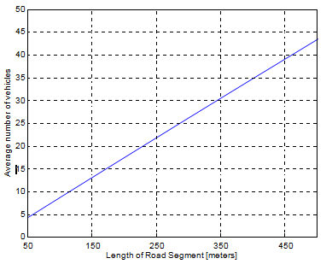

**Fig. 6.1 Average Number of Vehicles versus Road Length of [SD]**

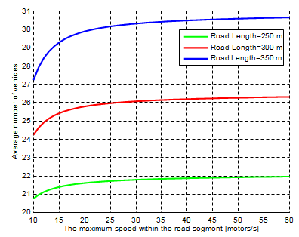

**Fig.6.2 Average Number of Vehicles versus Max Speed Limit within [SD]**

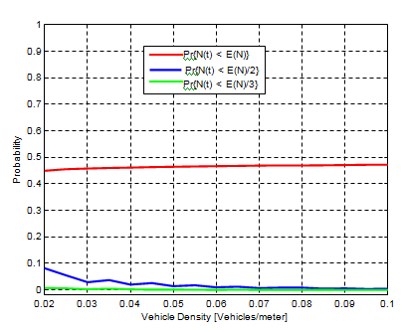

Pr(A(t)<A(V)

Pr(A(t)<A(V)/2

Pr(A(t)<A(V)/3

**Fig. 6.3 The Probablity *P* [*A(T)*]**

At last, the decrease of normal resident time kills the increase of the vehicle appearance rate. At the point when the vehicle thickness in the road portion increases, the likelihood Pr[A(T)< A(V)] converges to 0.5. This conduct is appeared in Fig 6.3, which depicts that this likelihood tendency is expected, since both VAR(N ) and A(V) ) equivalent µA(T ) for the characterized Poisson process. Give vehicle thickness access a road portion of ρ = 0.02 (vehicles/meter ); the likelihood of containing various vehicles inside [SD] not exactly 50% of the expected worth is 0.08. Accepting an increase in vehicle thickness (ρ), the expected worth quickly watches out for 0. For instance, the likelihood Pr[A(T) < 6] is equivalent to 0.02 if the expected estimation of A(T) is characterized as 12 with a vehicle thickness of ρ = 0.04. These conditions guarantee that there are in excess of 5 vehicles in the road portion [SD] with a likelihood of 0.98. The estimation of likelihood Pr[A(T) < A(V)/3] stands close to zero for any vehicle thickness in the road portion, indicating that the likelihood of occurring at any rate A(V)/3 vehicles in the fragment is 100%. This guarantees us that there are in any event A(V)/3 vehicles inside [SD] whenever for use of any application.

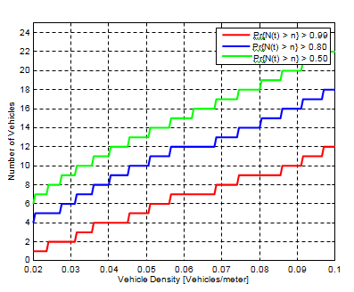

Pr(A(t)<A(V)

Pr(A(t)<A(V)/2

Pr(A(t)<A(V)/3

**Fig.6.4 Number of Vehicles Distribution versus Vehicular Density**

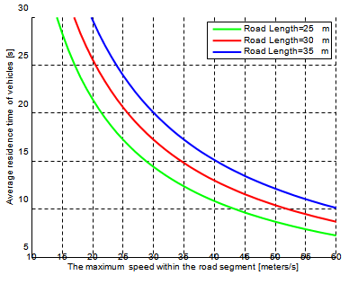

**Fig.6.5 Average Residence Time versus Max Speed Limit within [SD]**

The investigation of the quantity of vehicles in a road fragment [SD] is depicted in Fig 6.4. For instance, there is a likelihood of Pr[A(T)> 7] > 1.99 in encountering at any rate 7 vehicles in the portion, as the vehicle thickness rises to ρ = 1.06. Moreover, increasing the likelihood to 1.80, it is conceivable to discover in any event 12 vehicles in the fragment. With a likelihood of 1.5 on the occasions, in excess of 15 vehicles are in road section [SD].

The residence time contains important information for vehicular clouds, since it assesses the time accessibility of a vehicle, just as its computational resources, in a road section. Assessing the accessibility of resources is fundamental for appropriately scheduling cloud errands. “In the context of free-flow traffic, the fixed road length and an increasing most extreme speed causes the normal residence time A(T) to decrease, as described in Fig 6.5. As the normal residence time decreases, the normal number of vehicles in the road section decreases; this conduct is depicted in Fig 6.2.

**CHAPTER 7**

**RESULTS & DISCUSSION**

**7.1 TRAFFIC LOAD – QUEUEING-UP MODEL**

The normal number of vehicles in a road section increases as per the power of the traffic. This conduct follows the queuing -up model appeared in Fig 7.1. The normal number of vehicles increases to a huge incentive if the traffic power is close to 1, speaking to an extraordinary traffic jam in the section. For instance, the normal number of vehicles in the queue is E(Q) = 0.82/(1 − 0.8) = 3.2 when the leaving time is exponentially conveyed and with ρ = 0.8. Following this connection, ρ = 0.88 leads to a normal number of vehicles of E(Q) = 6.4. Consequently, an increase of 0.08/0.8 = 10% in the appearance rate leads to a 100% increase in the mean number of queuing vehicles.” Formula 7.1 gives PMF of the quantity of vehicles in the queue, considering that the leaving time is exponentially conveyed, and including the withdrawing time vehicle in the fragment.

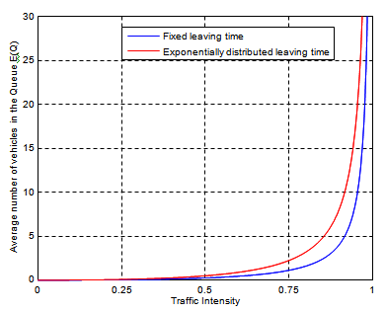

**Fig.7.1 Mean No. of Vehicles in a Roadway Segment Versus Traffic Intensity**

PMF of the number of vehicles *N* (*t*) in the queue is

pn = (1 − ρ)ρn (n ≥ 0) …….. (7.1)

Fig 7.2 depicts the conduct of the PMF in the queuing -up model, in which we focus on achieving a harmony scenario that fulfills the condition ρ = λ < 1. As described in the figure, the traffic queue shows a lower chance to occur, close to 0, as the flight pace of vehicles is twice the size of the appearance rate, spoke to by ρ = 1.5.

The PMF likewise shows a uniform appropriation, as the appearance rate is close to the takeoff rate (ρ = 1.99). This shows the quantity of vehicles can become enormous in the presence of likelihood such as a circumstance with a low number of queued vehicles. Fig 4.8 indicates that the likelihood of the quantity of queuing vehicles is conditioned by a given number. This exhibits it is improbable that in excess of 5 vehicles will be queued with ρ = 1.5. A similar close-to-zero chance is seen with 13 vehicles, P [N (t) > 13], with ρ = 1.75. Be that as it may, encountering in excess of 20 vehicles in the queue occurs with a likelihood of 1.82 with ρ = 1.99. This shows a high chance of forming a queue in the road fragment, increasing the chances that resources may be used.

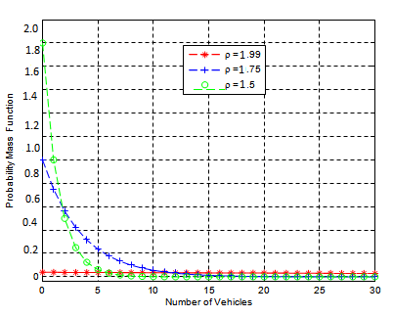

**Fig.7.2 Probability Mass Function**

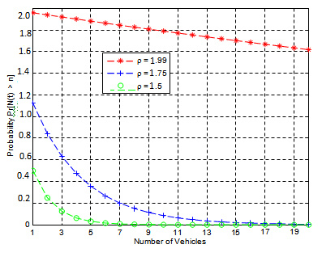

**Fig.7.3 Number of Vehicles with Exponential Leaving Time**

In the scenario in which the leaving time of vehicles is constant, various dispersions are gotten, as depicted in Fig 7.4 and 7.5. Compared with a scenario that shows the exponentially appropriated leaving time of vehicles, the fixed leaving time matches a few aspects; for instance, with low ρ, the PMF and likelihood curves follow a similar example, demonstrating comparative qualities.

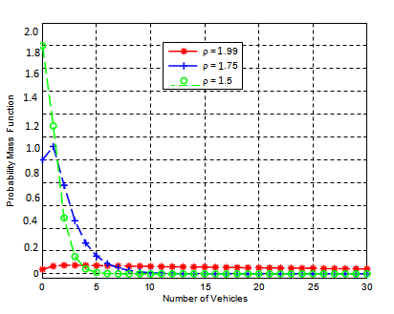

**Fig.7.4 Probability Mass Function**

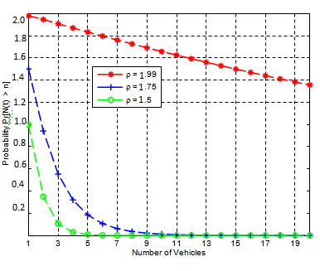

**Fig.7.5 Number of Vehicles with Fixed Leaving Time**

The difference resides on ρ = 1.99; in this case, the likelihood of encountering in excess of 20 vehicles in the road section is 68% for a fixed leaving time. This presents a lower esteem when compared with the exponentially dispersed leaving time scenario, which shows a chance of 82% under similar conditions.

This difference is legitimized in Fig 7.1, which shows that an exponentially disseminated leaving time scenario presents a bigger number of vehicles in the fragment than a fixed leaving time scenario does.

The residence time is a significant metric that gives a methods for deciding the measure of time computing resources are accessible in the road section, so as to schedule and move applications and assignments. Fig 7.6 presents the normal holding up times of vehicles in a traffic queue of our exponentially circulated and fixed leaving time scenarios with ρ = 0.8, 0.9. Fig 7.7 depicts the PDF of the holding up times of vehicles in a queue with an appearance pace of µ = 1, and the leaving time of vehicles follows a random variable with exponential appropriation. The analytical results totally match the behavior of the PMF shown in Fig 7.2 with *ρ* = 0*.*5, which means that 50% of the vehicles traverse the road segment without waiting in the queue**.**

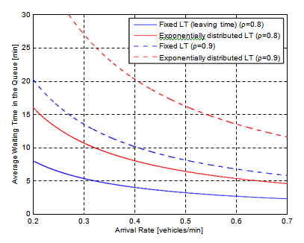

**Fig.7.6 Mean Waiting Time in the Queue Arrival Rate**

With ρ = 0.02, it is seen that the holding up time of vehicles is uniformly disseminated over quite a while outqueue. Bigger hold up times occur because of appearance rates close closeness to flight rates.. The occasions are better described in Fig 7.8, which contains probabilities of holding up times according to various appearance rates. For a ρ = 0.25, it is improbable that any vehicle will sit tight in the queue for more than 8 seconds.

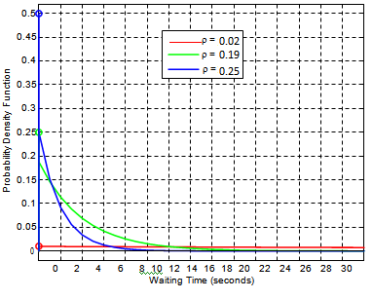

**Fig.7.7 PDF of Waiting Time in the Queue with Exponential Leaving Time**

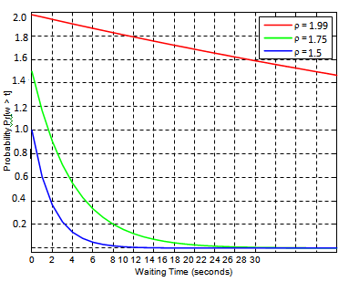

**Fig. 7.8 Pr[W(w)*>* t] with Exponential Leaving Time**

Then again, with ρ = 1.99, there is a likelihood of 1.75 that it will take longer than 30 seconds for vehicles to cross the road portion.

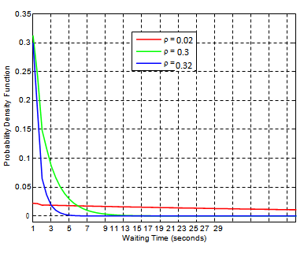

**Fig. 7.9 PDF of Waiting Time in the Queue with Fixed Leaving Time**

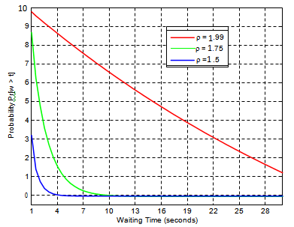

**Fig. 7.10 Pr[W(w)*>*t] with Fixed Leaving Time**

At long last, holding up times in the line according to the fixed leaving time scenario are depicted by Fig 7.9 and 7.10. Consistent with the outcomes introduced in Fig 7.6, the fixed leaving time scenario describes shorter leaving times when compared with the exponentially disseminated leaving time scenario. VEDA-CIT, a Vehicular Data Collection Intelligent Transport system for the intelligent transport the board of enormous cities. “These gave mechanisms are to carrying out the storage of information and empowering heterogeneous communication between various devices while simultaneously handling the versatility of vehicles and information flows created. This included recreated model administration and resource allocation, in which the module exhibited a steady conduct, since even with the increase in vehicles or increased utilization of resources, the protocol didn't show an unexpected variety and held its steadiness. In addition, the arrangement proposed demonstrated a high pace of service accessibility reaching about 85% accessibility in the most dire outcome imaginable (500 vehicles with 60 s of service allocation time). In future work, we intend to adapt the administration and search resource module to work in urban scenarios and conduct tests that consider the architecture all in all.

At the point when a vehicle needs some resource of the vehicular cloud, at that point the requester checks among its neighbors if any vehicle meets the solicitation. On the off chance that yes the requester will store this piece of information and send a question message to the vehicle mentioning the resource. After receiving the inquiry, the vehicle checks whether the service is actually inactive or not and reacts with a query_hit. At the point when the requester receives a query_hit it checks if the allocation occurred or not and refreshes the information in the vehicle. On the off chance that the allocation was successful, the service is begun. Something else, the requester selects the controllers from both the front and the back and sends a question to these controllers. Controllers receive a question to store all the information of the requester and then perform the process of checking if any of the vehicles connected to it meet the prerequisites; if so it sends another inquiry for these vehicles. After receiving the inquiry check, the vehicle is actually the service or not and reacts with a query_hit. At the point when controllers receive a query_hit they store the whole information of the vehicle and send it to the requester, informing the allocation of required resources. Nonetheless if the controller figured out how to allocate resource to any of the vehicles connected to it, the controller will initially check its situation comparable to the requester and then retransmit the solicitation to another controller, which will be the vehicle uttermost to the front or the vehicle farthest to the back, contingent upon its situation according to the vehicle that mentioned the resource.

The vehicular portable cloud consists of a lot of versatile computing resources and vehicles, which are not utilized by traditional cloud computing. These resources are interconnected through the vehicular system. The vehicular portable cloud can be either fixed or versatile. On account of the former, vehicles, RSUs, and/or travelers can lease their computing resources from different consumers that are in off-state (e.g., cars in parking garages or travelers sitting tight for a transport). On account of the last mentioned, the vehicular versatile cloud consists of vehicles that share their inactive resources with the vehicles around them. This sort of vehicular versatile cloud is commonly utilized when vehicles don't have communication with the RSU. It is one of the extraordinary challenges of this system to build up a mechanism for the board and search resources just between vehicles. There will be an assessment and assessment of this mechanism in this investigation.

At the point when a vehicle needs some resource of the vehicular cloud, at that point the requester checks among its neighbors if any vehicle meets the solicitation. In the event that yes the requester will store this piece of information and send an inquiry message to the vehicle mentioning the resource. After receiving the inquiry, the vehicle checks whether the service is actually inert or not and reacts with a question hit. At the point when the requester receives a question hit it checks if the allocation occurred or not and refreshes the information in the vehicle. In the event that the allocation was successful, the service is begun. Something else, the requester selects the controllers from both the front and the back and sends a question to these controllers. Controllers receive a question to store all the information of the requester and then perform the process of checking if any of the vehicles connected to it meet the necessities; if so it sends another inquiry for these vehicles. After receiving the inquiry check, the vehicle is actually the service or not and reacts with a question hit. At the point when controllers receive an inquiry hit they store the whole information of the vehicle and send it to the requester, informing the allocation of required resources.” Notwithstanding if the controller figured out how to allocate resource to any of the vehicles connected to it, the controller will initially check its situation corresponding to the requester and then retransmit the solicitation to another controller, which will be the vehicle farthest to the front or the vehicle uttermost to the back, contingent upon its situation according to the vehicle that mentioned the resource. This system has additionally changed the procedure of message transmission, because of the characteristics of the vehicular system.

**CHAPTER 8**

**CONCLUSION AND FUTURE WORK**

**8.1 CONCLUSION**

In this novel framework, we discuss a lot of benefits and also a few key research challenges and a possible direction for ITS. We introduce and give an original thought of VEDA-CIT Vehicular Data Collection for Intelligent Transport and cloud computing empowered system for vehicles. The offered services include however are not restricted to healthcare, traffic route and tracking, infotainment etc. This novel framework is a three-layered Vehicular Cloud architecture with definite description of each sub-layer. In the circumstance when driver isn't solid and comfortable enough to drive, our system can offer cloud computing based ongoing services so as to improve driver's security and comfort degree. Vehicles can exchange traffic information among each other to find out about issues inside a couple of blocks and react accordingly. The information on a malfunctioning traffic light, or a twofold left truck can be helpful to settle on quick alternate route decisions, more efficiently than trusting that the Navigator Server will find out about them and reflect them in its course instructions. There have been proposition for completely circulated traffic the executives.

We have described two traffic flow models to speak to the conduct of vehicles in a road section. The models give the analytical way to dynamically evaluating the profit capacity of computational resources in the traffic organize, and can coordinate a vehicular cloud. The proposed models reflect two common scenarios: free-flow and queuing-up traffic. Unique in relation to the past works that investigate such resources in a static environment, similar to the long haul resting of vehicles in an air terminal parking garage, this work watches a somewhat dynamic condition. The evaluations permit the structure of models to decide the attainability and potential scenarios for allotting computational undertakings to vehicles, just as relocating errands from leaving vehicles to those showing up in a road section. Cluster computing with versatile hubs and message passing interface are approaches for settling task issues.

**8.2 FUTURE WORK**

Our future work consists of actualizing our free-flow traffic model and assessing it through test systems, such as NS2 or OMNeT++, to watch the circulation of computational assignments on vehicles in a road fragment and the effect of load movements among vehicles. The work in Mohammad Pasha et al.,(2016) could be our progression stone to investigate this direction. In a less dynamic scenario, the queuing-up traffic circumstance, we expect to couple our model with scheduling techniques to decide the best errand task for profiting applications. In the context of unexpected critical traffic issues, it is perfect that processing dead queues are matched with the time range of an on-demand collected vehicular cloud. Subsequently, critical applications brought forth for settling critical issues can conclude their execution, bringing about a significant answer. Also, our work investigated the traffic flow in single-path road sections in which a harmony is achieved. This scenario is expected to be reached out into multi-path road sections, including non-harmony lines.

**REFERENCES**

1. Whaiduzzaman, Md., Sookhak, M., Gani, A. and Buyya, R. (2014) ‘A survey on vehicular cloud computing’*, Journal of Network and Computer Applications*, Vol. 40, No. 1, pp.325–344.
2. Mekki, T., Jabri, I., Rachedi, A. and Ben Jemaa, M. (2017a) ‘Vehicular cloud networks: challenges, architectures, and future directions’, Vehicular Communications, Vol. 9, pp.268–280.
3. Hussain, R., Son, J., Eun, H., Kim, S. and Oh, H. (2012) ‘Rethinking vehicular communications: Merging vanet with cloud computing’, in 2012 IEEE 4th International Conference on Cloud Computing Technology and Science (CloudCom), IEEE, pp.606–609.
4. Perera, Charith, Arkady Zaslavsky, Peter Christen, and Dimitrios Georgakopoulos. "Sensing as a service model for smart cities supported by internet of things." Transactions on Emerging Telecommunications Technologies 25, no. 1 (2014): 81-93
5. Lee, Euisin, Eun-Kyu Lee, Mario Gerla, and Seong Y. Oh. "Vehicular cloud networking: architecture and design principles." Communications Magazine, IEEE 52, no. 2 (2014): 148-155.
6. Lèbre, Marie-Ange, Frédéric Le Mouël, Eric Ménard, Julien Dillschneider, and Richard Denis. "VANET Applications: Hot Use Cases." arXiv preprint arXiv:1407.4088 (2014).
7. Legatiuk, D., Theiler, M., Dragos, K. and Smarsly, K. (2017). A categorical approach towards metamodeling cyber-physical systems. In: Proc. of the 11th International Workshop on Structural Health Monitoring. Stanford, CA, USA, September 12, 2017
8. Datta, S.K., Costa, R.P., Haerri, J. and Bonnet, C. (2016). Integrating connected vehicles in Internet of Things ecosystems: Challenges and solutions. In: Proc. of the 2016 IEEE 17th International Symposium on A World of Wireless, Mobile and Multimedia Networks, Coimbra, Portugal, June 21, 2016.
9. Atchison, L. (2018). Edge Computing vs. Cloud Computing: Which One Is Right for Your Application?. [online] New Relic Blog. Available at: https://blog.newrelic.com/technology/edge-computing-vs-cloud-computingcomparison/ [Accessed: February 2, 2019].
10. Xu Li, Xuegang Yu, Aditya Wagh and Chunming Qiao, Human Factors-aware Service Scheduling in Vehicular Cyber-Physical Systems, IEEE Infocom 2011.
11. Willlaim Milam “Automobiles as Cyber-Physical Systems” Workshop on Architectures for Cyber-Physical Sytems, Chicago IL, at CPSWeek2011
12. C. Perkins, E. Belding-Royer, S. Das, Ad hoc on-demand distance vector (aodv) routing. RFC 3561, RFC Editor (2003). [http://www.rfc-editor.org/rfc/rfc3561.txt. Accessed 15 May 2018](http://www.rfc-editor.org/rfc/rfc3561.txt.%20Accessed%2015%20May%202018).
13. J. Feng, Z. Liu, C. Wu, Y. Ji, Ave: Autonomous vehicular edge computing framework with aco-based scheduling. IEEE Trans. Veh. Technol. 66:, 10660–10675 (2017).
14. Y. Guo, Q. Yang, F. R. Yu, V. C. Leung, Cache-enabled adaptive video flowing over vehicular networks: a dynamic approach. IEEE Trans. Veh. Technol. 67:, 5445–5459 (2018).
15. Sergei Korjagin, Pavel Klachek. Innovative development of intelligent transport systems based on biocybernetical vehicle control systems 2017.
16. Ahmad, I., Noor, R., Ali, I., Imran, M. and Vasilakos, A. (2017). Characterizing the role of vehicular cloud computing in road traffic management. [ebook] Wei Yu.Availableat:https://journals.sagepub.com/doi/full/10.1177/1550147717708728 [Accessed 2 Feb. 2019]
17. Z. Pang, L. Zheng, J. Tian, S. Kao-Walter, E. Dubrova, and Q. Chen,―Design of a terminal solution for integration of in-home health care devices and services towards the internet-of-things,ǁ Enterprise Inf.Syst., to be published, 2014.
18. H.Abid,L.T.T.Phuong,J.Wang,S.Lee,andS. Qaisar,―V-Cloud:Vehicular cyber-physical systems and cloud computing,ǁ in Proc. 4th Int. Symp.Appl. Sci. Biomed. Commun. Technol., Barcelona, Spain, 2011, p. 165.
19. S. Olariu, I. Khalil, and M. Abuelela, ―Taking VANETto the clouds,ǁ Int. J.Pervasive Comput. Commun., vol. 7, no. 1, pp. 7–21, 2011.
20. Y. Leng and L. Zhao, ―Novel design of intelligent internet-of-vehicles management system based on cloud-computing and internetof-things,ǁin Proc. Int. Conf. Electron. Mech. Eng. Inf. Technol., Harbin, Heilongjiang,China, 2011, vol. 6, pp. 3190–3193.
21. R. Hussain, J. Son, H. Eun, S. Kim, and H. Oh, ―Rethinking vehicular communications: Merging VANET with cloud computing,ǁ in Proc. IEEE 4th Int. Conf. Cloud Comput. Technol. Sci., Taipei, Taiwan, 2012, pp. 606–609.
22. R. Mietzner, F. Leymann, and T. Unger, ―Horizontal and vertical combination of multi-tenancy patterns in service-oriented application,ǁ Enterprise Inf. Syst., vol. 5, no. 1, pp. 59–77, 2011.
23. H. Panetto and J. Cecil, ―Information systems for enterprise integration, interoperability and networking: Theory and applications,ǁ Enterprise Inf.Syst., vol. 7, no. 1, pp. 1–6, 2013.
24. S. Hachani, L. Gzara, and H. Verjus, ―A service-oriented approach for flexible process support within enterprises: Application on PLM systems,ǁEnterprise Inf. Syst., vol. 7, no. 1, pp. 79–99, 2013.
25. F. Tao, H. Guo, L. Zhang, and Y. Cheng, ―Modelling of combinable relationship-based composition service network and the theoretical proof of its scale-free characteristics,ǁ Enterprise Inf. Syst., vol. 6, no. 4,pp. 373–404, 2012.
26. D. Paulraj, S. Swamynathan, and M. Madhaiyan, ―Process model-basedatomic service discovery and composition of composite semantic web services using web ontology language for services (OWL-S),ǁ Enterprise Inf. Syst., vol. 6, no. 4, pp. 445–471, 2012.
27. J. Wang, J. Cho, S. Lee, and T. Ma, ―Real time services for future cloud computing enabled vehicle networks,ǁ in Proc. Int. Conf. WirelessCommun. Signal Process., Nanjing, China, 2011, pp. 1–5.
28. Y. Qin, D. Huang, and X. Zhang, ―VehiCloud: Cloud computing facilitating routing in vehicular networks,ǁ in Proc. IEEE 11th Int.Conf. Trust Secur. Privacy Comput. Commun., Liverpool, U.K., 2012,pp. 1438–1445.
29. H. Wang, W. He, and F. K. Wang, ―Enterprise cloud service architectures,ǁInf. Technol. Manag., vol. 13, no. 4, pp. 445–454, 2012.
30. Q. Li, Z. Y. Wang, W. H. Li, J. Li, C. Wang, and R. Y. Du, ―Applications integration in a hybrid cloud computing environment: Modeling and platform,ǁ Enterprise Inf. Syst., vol. 7, no. 3, pp. 237–271, 2012.
31. L. Ren, L. Zhang, F. Tao, X. Zhang, Y. L. Luo, and Y. Zhang,―A methodology towards virtualization-based high performance simulationplatform supporting multidisciplinary design of complex products,ǁEnterprise Inf. Syst., vol. 6, no. 3, pp. 267–290, 2012.
32. European Commission Information Society, Internet of Things in 2020: A Roadmap for the Future [Online]. Available: [www.iotvisitthefuture.eu](http://www.iotvisitthefuture.eu).
33. L. Atzori, A. Iera, and G. Morabito, ―The internet of things: A survey,ǁComput. Netw., vol. 54, no. 15, pp. 2787– 2805, 2010.
34. C. Speed and D. Shingleton, ―An internet of cars: Connecting the flow of things to people, artefacts, environments and businesses,ǁ in Proc. 6thACM Workshop Next Gener. Mobile Comput. Dynam. Personalised Travel Plann. ACM, Ambleside, U.K., 2012, pp. 11–12.
35. E. Qin, Y. Long, C. Zhang, and L. Huang, ―Cloud computing and the internet of things: Technology innovation in automobile service,ǁ in Human Interface and the Management of Information. Information and Interaction for Health, Safety, Mobility and Complex Environments. Berlin, Germany: Springer-Verlag, 2013, pp. 173–180.
36. Firas Alrawi. The importance of intelligent transport systems in the preservation of the environment and reduction of harmful gases 2017.
37. S. Olariu, M. Eltoweissy and M. Younis, “Towards Autonomous Vehicular Clouds,” ICST Transactions on Mobile Communications and Applications, vol. 11, no. 7-9, 2011, pp. 1-11
38. L. Y. Yeh, Y. C. Chen. and J.-L. Huang; ABACS: An Attribute-Based Access Control System for emergency services over vehicular ad-hoc networks, IEEE Journal on Selected Areas in Communications, 29 (3) (2011): pp. 630–643
39. R. Hussain, Z. Rezaeifar, Y. H. Lee and H. Oh; Secure and privacy-aware traffic information as a service in VANET-based clouds: Pervasive and Mobile Computing (2015), <http://10.1016/j.pmcj.2015.07.007>
40. L. Nkenyereye, B. A. Tama, Y. Park and K. H. Rhee; A fine-grained privacy-preserving protocol over attribute-based access control for VANETs. Journal of Wireless Mobile Networks Ubiquitous Computing Dependable Applications 6.2 (2015): pp. 98-112.
41. W. Lumpkins, ―The internet of things meets cloud computing,ǁ IEEE Consum. Electron. Mag., vol. 2, no. 2, pp. 47–51, Apr. 2013.
42. Y. Zhang, B. Chen, and X. Lu, ―Intelligent monitoring system on refrigeratortrucks based on the internet of things,ǁ Wireless Communications and Applications. Berlin, Germany: Springer-Verlag, 2012, pp. 201–206.
43. Yu R, Huang X, Kang J, Ding J, Maharjan S, Gjessing S, et al Cooperative resource management in cloud-enabled vehicular networks. IEEE Transactions on Industrial Electronics, 2016 Sep. 24, 62(12): 7938–7951.
44. Refaat TK, Kantarci B, Mouftah HT. Virtual machine migration and management for vehicular clouds. Vehicular Communications. 2016 Apr. 5, 4: 47–56.
45. Wei W, Fan X, Song H, Fan X, Yang J. Imperfect Information Dynamic Stackelberg Game Based Resource Allocation Using Hidden Markov for Cloud Computing. IEEE Transactions on Services Computing. 2016 Feb. 29: 1–1
46. S. A. Soleymani, A. H. Abdullah, M. Zareei et al., “A secure trust model based on fuzzy logic in vehicular Ad Hoc networks with fog computing,” IEEE Access, vol. 5, pp. 15619–15629, 2017.
47. X. Huang, R. Yu, J. Kang, and Y. Zhang, “Distributed reputation management for secure and efficient vehicular edge computing and networks,” IEEE Access, vol. 5, pp. 25408–25420, 2017.
48. V. Hahanov, W. Gharibi, B. A. A. Abbas, S.Chumachenko, O.Guz,E.Litvinova, Cloud traffic monitoring and control, in: Proceedings of the IEEE 7th International Conference on Intelligent Data Acquisition and Advanced Computing Systems, Vol. 01, 2013, pp. 244–248.
49. J. Wan, D. Zhang, S. Zhao, L. Yang, J. Lloret, Context-aware vehicular cyber-physical systems with cloud support: architecture, challenges, and solutions, IEEE Communications Magazine 52 (8) (2014) 106–113.
50. M. Ma, Y. Huang, C. H. Chu, P. Wang, User-driven cloud transportation system for smart driving, in: Proceedings of the IEEE 4th International Conference on Cloud Computing Technology and Science, 2012, pp. 658– 665
51. M. Khabbaz, W. Fawaz, C. Assi, A simple free-flow traffic model for vehic- ular intermittently connected networks, IEEE Transactions on Intelligent Transportation Systems 13 (3) (2012)
52. T. Zhang, R. E. De Grande, A. Boukerche, Urban traffic characteriza- tion for enabling vehicular clouds, in: Proceedings of the IEEE Wireless Communications and Networking Conference, 2016, pp. 1–6
53. T. Zhang, R. E. De Grande, A. Boukerche, Design and analysis of stochas- tic traffic flow models for vehicular clouds, Ad Hoc Networks 52 (2016) 39–49.
54. T. Zhang, R. E. De Grande, A. Boukerche, Vehicular cloud: Stochastic analysis of computing resources in a road segment, in: Proceedings of the 12th ACM Symposium on Performance Evaluation of Wireless Ad Hoc, Sensor, & Ubiquitous Networks, 2015
55. R.X. Zhong, K.Y. Fu, A. Sumalee, D. Ngoduy, and W.H.K. Lam. A cross-entropy method and probabilistic sensitivity analysis framework for calibrating microscopic traffic models. Transportation Research Part C: Emerging Technologies, 63:147 – 169, 2016
56. M. Gramaglia, P. Serrano, J. Hernandez, M. Calderon, C. J. Bernardos, New insights from the analysis of free flow vehicular traffic in highways, in: Proceedings of the IEEE International Symposium on a World of Wireless, Mobile and Multimedia Networks, 2011, pp. 1–9
57. D. Chen, J. Zhang, S. Tang, J. Wang, Freeway traffic flow modeling based on principal curves and its analysis, IEEE Transactions on Intelli- gent Transportation Systems 5 (4) (2004) 246–258.
58. A. Abdrabou, W. Zhuang, Probabilistic delay control and road side unit placement for vehicular ad hoc networks with disrupted connectivity, IEEE Journal on Selected Areas in Communications 29 (1) (2011) 129– 139.
59. G. Rucks, A. Kuzma, How Big Data Drives Intelligent Transportation? hhttps://www.greenbiz.com/blog/ 2012/08/15/how-big-data-drives-intelligent-transportationi, 2016 (accessed 15.06.16)
60. Roman, R.; Lopez, J.; Mambo, M. Mobile edge computing, fog et al.: A survey and analysis of security threats and challenges. Future Gener. Comput. Syst. 2018, 78, 680–698.
61. Chaqfeh, M.; Mohamed, N.; Jawhar, I.; Wu, J. Vehicular Cloud data collection for Intelligent Transportation Systems. In Proceedings of the Smart Cloud Networks & Systems (SCNS), Dubai, UAE, 19–21 December 2016; pp. 1–6
62. Akabane, A.T.; Villas, L.A.; Madeira, E.R.M. An adaptive solution for data dissemination under diverse road traffic conditions in urban scenarios. In Proceedings of the IEEE Wireless Communications and Networking Conference (WCNC), New Orleans, LA, USA, 9–12 March 2015; pp. 1654–1659.
63. Tian, B.; Hou, K.M.; Zhou, H. The Traffic Adaptive Data Dissemination (TrAD) protocol for both urban and highway scenarios. Sensors 2016, 16, 920
64. Villas, L.A.; Boukerche, A.; Maia, G.; Pazzi, R.W.; Loureiro, A.A. DRIVE: An efficient and robust data dissemination protocol for highway and urban vehicular Ad Hoc networks. Comput. Netw. 2014, 75, 381–394.
65. Schwartz, R.S.; Scholten, H.; Havinga, P. A scalable data dissemination protocol for both highway and urban vehicular environments. EURASIP J. Wirel. Commun. Netw. 2013, 2013, 1–19
66. Maia, G.; Boukerche, A.; Aquino, A.L.; Viana, A.C.; Loureiro, A.A. A data dissemination protocol for urban vehicular Ad Hoc networks with extreme traffic conditions. In Proceedings of the IEEE International Conference on Communications (ICC), Budapest, Hungary, 9–13 June 2013; pp. 5997–6001
67. Akamatsu, R.; Suzuki, M.; Okamoto, T.; Hara, K.; Shigeno, H. Adaptive delay-based geocast protocol for data dissemination in urban VANET. In Proceedings of the Seventh International Conference on Mobile Computing and Ubiquitous Networking (ICMU), Singapore, 6–8 January 2014; pp. 141–146.
68. Bi, Y.; Shan, H.; Shen, X.S.; Wang, N.; Zhao, H. A multi-hop broadcast protocol for emergency message dissemination in urban vehicular Ad Hoc networks. IEEE Trans. Intell. Transp. Syst. 2016,
69. Zemouri, S.; Djahel, S.; Murphy, J. Short novel: Road-Casting: A new distributed dissemination protocol for safety messages in urban areas. In Proceedings of the IEEE Vehicular Networking Conference, Boston, MA, USA, 16–18 December 2013; pp. 234–237
70. Loo, J.; Mauri, J.L.; Ortiz, J.H. (Eds.) Mobile Ad Hoc Networks: Current Status and Future Trends; CRC Press: Boca Raton, FL, USA, 2016
71. Shi, W.; Cao, J.; Zhang, Q.; Li, Y.; Xu, L. Edge computing: Vision and challenges. IEEE Internet Things J. 2016, 3, 637–646
72. Feng, J.; Liu, Z.; Wu, C.; Ji, Y. AVE: Autonomous vehicular edge computing framework with ACO-based scheduling. IEEE Trans. Veh. Technol. 2017, 66, 10660–10675
73. Truong, N.B.; Lee, G.M.; Ghamri-Doudane, Y. Software defined networking-based vehicular ad hoc network with fog computing. In Proceedings of the 2015 IFIP/IEEE International Symposium on Integrated Network Management (IM), Ottawa, ON, Canada, 11–15 May 2015; pp. 1202–1207.
74. Wang, K.; Yin, H.; Quan, W.; Min, G. Enabling collaborative edge computing for software defined vehicular networks. IEEE Netw. 2018
75. Luo, G.; Yuan, Q.; Zhou, H.; Cheng, N.; Liu, Z.; Yang, F.; Shen, X.S. Cooperative vehicular content distribution in edge computing assisted 5G-VANET. China Commun. 2018, 15, 1–17.
76. Menouar, H.; Guvenc, I.; Akkaya, K.; Uluagac, A.S.; Kadri, A.; Tuncer, A. UAV-Enabled Intelligent Transportation Systems for the Smart City: Applications and Challenges. IEEE Commun. Mag. 2017, 55, 22–28
77. Garcia Lopez, P.; Montresor, A.; Epema, D.; Datta, A.; Higashino, T.; Iamnitchi, A.; Barcellos, M.; Felber, P.; Riviere, E. Edge-centric computing: Vision and challenges. ACM SIGCOMM Comput. Commun. Rev. 2015, 45, 37–42.
78. Tsai, P.W.; Li, J.P.; Shih, J.S.; Chen, Y.J.; Lee, T.Y.; Cheng, S.T. Mixed broadcast techniques of leisure information in vehicular Ad-Hoc networks. Telecommun. Syst. 2016, 1–14
79. Chaqfeh, M.; Lakas, A. A novel approach for scalable multi-hop data dissemination in vehicular Ad Hoc networks. Ad Hoc Netw. 2016, 37, 228–239
80. M. J. Khabbaz, W. F. Fawaz, and C. M. Assi, “A simple free-flow traffic model for vehicular intermittently connected networks,” IEEE Transactions on Intelligent Transportation Systems, vol. 13, no. 3, pp. 1312–1326, Sept 2012.
81. T. Zhang, R. E. De Grande, and A. Boukerche, “Vehicular cloud: Stochastic analysis of computing resources in a road segment,” in Proceedings of the 12th ACM Symposium on Performance Evaluation of Wireless Ad Hoc, Sensor, and Ubiquitous Networks. ACM, 2015
82. M. Whaiduzzaman, M. Sookhak, A. Gani, and R. Buyya, “A survey on vehicular cloud computing,” Journal of Network and Computer Applications, vol. 40, pp. 325 – 344, 2014.
83. Ku, Y.J.; Chiang, P.H.; Dey, S. Quality of Service Optimization for Vehicular Edge Computing with Solar-Powered Road Side Units. In Proceedings of the 27th International Conference on Computer Communication and Networks (ICCCN), Hangzhou, China, 30 July–2 August 2018; pp. 1–10.
84. Amazon Elastic Compute Cloud. http://aws.amazon.com/ec2/ (accessed on March 28, 2012)
85. Google App Engine. http://code.google.com/appengine/ (accessed on March 28, 2012).
86. B. Furht, and A. Escalante, “Handbook of cloud computing,” Cloud computing fondamentals chapter writen by B. Furht, Springer, 2010.
87. S. Bitam, and A. Mellouk, “Bee life-based multi constraints multicast routing optimization for vehicular Ad hoc networks,” Journal of Networks and Computer Applications (JNCA), Elsevier, 2012.
88. H. Abid, L.T.T. Phuong, J. Wang, S. Lee, and S. Qaisar, “V-Cloud: Vehicular Cyber-Physical Systems and Cloud Computing,” 4th International Symposium on Applied Sciences in Biomedical and Communication Technologies (ISABEL), Barcelona, Spain, 2011.
89. D. Bernstein, N. Vidovic, and S. Modi, “A Cloud PAAS for High Scale, Function, and Velocity Mobile Applications - With Reference Application as the Fully Connected Car,” 5th International Conference on Systems and Networks Communications (ICSNC), Nice, France, 2010.
90. K. Tsubouchi, H. Yamato, and K. Hiekata, “Innovative on-demand bus system in Japan,” Journal. IET. Intelligent Transport Systems, Volume 4, Issue 4, pp. 270-279, 2010.
91. Z. Alazawi, S. Altowaijri, and R. Mehmood, “Intelligent disaster management system based on cloud-enabled vehicular networks,” 11th IEEE International Conference on ITS Telecommunications (ITST), St. Petersburg, Russia, 2011.
92. S. Olariu, T. Hristov, and G. Yan, “The Next Paradigm Shift: From Vehicular Networks to Vehicular Clouds,” chapter of book: Developments in Wireless Network Prototyping, Design and deployment: Future Generations.Eds, IGI Global, 2012.
93. W. Kim and M. Gerla, NAVOPT: Navigator Assisted Vehicular route OPTimizer, IMIS’07, Seoul, S.Korea, June 2011
94. I. Leontiadis and et al., On the Effectiveness of an Opportunistic Traffic Management System for Vehicular Networks. IEEE Trans on Intelligent Transport Systems, Dec., 2011
95. F. Bonomi et al., “Fog Computing and Its Role in the Internet of Things,” Proc. ACM 1st Wksp. on Mobile Cloud Comp., 2012, pp. 13–16.
96. S. Bitam and A. Mellouk, “QoS Swarm Bee Routing Protocol for Vehicular Ad Hoc Networks,” Proc. IEEE ICC, 2011, pp. 1–5.
97. S. Zeadally et al., “Vehicular Ad Hoc Networks (VANETS): Status, Results, and Challenges,” Telecommun. Sys., vol. 50, no. 4, 2012, pp. 217–41.
98. M. A. Salahuddin et al., “RSU Cloud and Its Resource Management in Support of Enhanced Vehicular Applications,” Proc. IEEE GLOBECOM, 2014.
99. S. Olariu, T. Hristov, and G. Yan, “The Next Paradigm Shift: From Vehicular Networks to Vehicular Clouds,” Developments in Mobile Ad Hoc Networking: The Cutting Edge Directions, Wiley, 2012.
100. K. Mershad and H. Artail, “Finding a STAR in a Vehicular Cloud,” IEEE Intelligent Transportation Systems, vol. 5, no. 2, 2013, pp. 55–68.
101. D. Baby et al., “VCR: Vehicular Cloud for Road Side Scenarios,” Advances in Comp. and Info. Tech., 2013, pp. 541–52.
102. N. Zingirian and C. Valenti, “Sensor Clouds for Intelligent Truck Monitoring,” Proc. IEEE Intell. Veh. Symp., 2012, pp. 999–1004.
103. R. Hussain et al., “Rethinking Vehicular Communications: Merging VANET with Cloud Computing,” Proc. 4th IEEE CloudCom, 2012, pp. 606–09.
104. S. Rangarajan et al., “V2C: A Secure Vehicle to Cloud Framework for Virtualized and On-Demand Service Provisioning,” Proc. ACM Int’l. Conf. Advances in Comp., Commun. and Informatics, 2012, pp. 148–54.
105. S. Kumar, S. Gollakota, and D. Katabi, “A Cloud-Assisted Design for Autonomous Driving,” Proc. 1st ACM Wksp. on Mobile Cloud Comp., 2012, pp. 41–46.
106. Euisin Lee, Eun-Kyu Lee, Soon Y. Oh, and Mario Gerla, “Vehicular Cloud Networking: Architecture and Design Principle”, [IEEE Communications Magazine,](http://ieeexplore.ieee.org/xpl/RecentIssue.jsp?punumber=35) Los Angeles, Volume: 52, [Issue: 2,](http://ieeexplore.ieee.org/xpl/tocresult.jsp?isnumber=6736727) February 2014.
107. S. Kumar, L. Shi, N. Ahmed, S. Gil, D. Katabi, and
108. D. Rus, “CarSpeak: A Content- Centric Network for Autonomous Driving”, ACM SIGCOMM, Helsinki, Finland ACM 978-1-4503-1419-0/12/08, August 13– 17, 2012.
109. Ashwin Ashok, Peter Steenkiste, Fan Bai Enabling “Vehicular Supplications using Cloud Services through Adaptive Computation Offloading”, MCS’15, ACM. ISBN 978-1-4503-3545-4/15/09. September 2015.
110. Cisco Visual Networking Index: Global Mobile Data Traffic Forecast White Novel, @ Cisco Systems Inc., February 3, 2016.
111. S. Wang, L.Sun, Q. Sun, J. Li, F. Yang, “Efficient service selection in mobile information systems, Mobile Information Systems”, whitenovel 2014, DoI: 10.3233/MIS-140203.
112. F. Rebecchi, M. Dias de Amorim, V. Conan, A. Passarella, R. Bruno, and M. Conti, “Data Offloading Techniques in Cellular Networks: A Survey”, IEEE Communications Surveys & Tutorials, [Volume: 17 Issue: 2,](http://ieeexplore.ieee.org/xpl/tocresult.jsp?isnumber=7110413) Pages 580 - 603 Secondquarter 2015.
113. U. Lee, E. Magistretti, B. Zhou, M. Gerla, P. Bellavista, and A. Corradi, “MobEyes: Smart Mobs for Urban Monitoring with a Vehicular Sensor Network”, IEEE Communications Magazine, vol. 13(6), pp. 52 – 57, Oct. 2006.
114. Abuelela, M., & Olariu, (2010). “Taking VANET to the clouds. In Proceedings of the 8th international conference on advances in mobile computing and multimedia”, MoMM’10” Paris, page 6–13, November 08 - 10, 2010 .
115. Oanh Tran Thi Kim, Nguyen Dang Tri, “Addressing Virtual Machine Migration Problems in Cloud Based Vehicular Networks” *Department of Computer Engineering, Kyung Hee University, 2015*.
116. Benjamin Baron, Miguel Campista,Spathis, Henrique M. K. Costa, Marcelo Dias de Amorim, “Virtualizing vehicular node resources: Feasibility study of virtual machine migration”, Vehicular Communications, [Volume 4,](http://www.sciencedirect.com/science/journal/22142096/4/supp/C) April 2016, Pages 39– 46,
117. S. Abdel Hamid, G. Takahara and H. S. Hassanein, "On the Recruitment of Smart Vehicles for Urban Sensing," IEEE Global Communications Conference (GLOBECOM’13), Atlanta, GA, USA, Dec. 2013, pp. 58-63.
118. Xu, Ke, "Cloud-based Strategies for Robust Connectivity and Efficient Transmission in Vehicular Networks" (2015). All Dissertations. [http://tigerprints.clemson.edu/all_dissertations/1507,](http://tigerprints.clemson.edu/all_dissertations/1507) Novel 1507.
119. Hameed Mir and Filali, “LTE and IEEE 802.11p for vehicular networking: a performance evaluation EURASIP”, Journal *on Wireless Communications Networking,* DOI**:** 10.1186/1687-1499-2014-830, May 2014.
120. Mohammad A. Salahuddin “Reinforcement Learning for Resource Provisioning in Vehicular Cloud”*, IEEE Wireless Communications*, vol.23, no.4, pp.128-135, August2016.
121. Garg SK, Gopalaiyengar SK, Buyya, “SLA-based resource provisioning for heterogeneous workloads in a virtualized Cloud datacenter”, *Journal of Computer applications, Vol 45,Issue C, pages 108- 120, Oct 2014.*
122. Poola D, Garg SK, Buyya R, Yang Y ” Robust scheduling of scientific workflows with deadqueue and budget constraints in Clouds*”, The 28th IEEE international conference on advanced information networking and Applications*, ISSN**:** 1550-445X 13- 16 May 2014
123. Rosenberg F, Celikovic P, Michlmayr A, ”An end- to-end approach for QoSaware service composition*”, IEEE international enterprise distributed object computing conference*, IEEE EDOC‟09, pp 151–160.
124. Fekri M. Abduljalil,”Video Capture Service in the Intelligent Transportation System based on Cloud Computing*”, International Journal of Computer Applications (0975 – 8887)*, Volume 97– No.5, July 2014.
125. Al-Fares Alexander Loukissas, Mohammad, “A Scalable, Commodity Data Center Network Architecture*”, SIGCOMM’08*, Seattle, Washington,
126. Olariu, S., Eltoweissy, M., & Younis, M, “Towards autonomous Vehi-Clouds. ICST Transactions on Mobile Communications and Applications”, 11(7–9), 1–11.
127. Rasheed Hussain, Z & Oh,” A Paradigm Shift from Vehicular Ad Hoc Networks to VANET- Based Clouds”, USA, ACM, Wireless personal Communication Journal, Volume 83, Issue 2, Pages 1131-1158, July 2015.
128. Li, C.-T., Hwang, M.-S., & Chu, “ A secure and efficient communication scheme with authenticated key establishment and privacy preserving for vehicular ad hoc networks”, Computer Communications”, 31(12), 2803–2814, Elsevier 2008.
129. Singh S, Chana I, “Q-aware: quality of service based cloud resource provisioning”, Computers and Electrical Engineering Journal, Volume 47, Issue C, Pages 138-160, October 2015.
130. Singh S, Chana I, “QoS-aware autonomic cloud computing: A systematic review”, Journal of ACM computing surveys, Volume 48 Issue 3, Article No. 32, February 2016,
131. Arif S, Olariu S, Wang J, Yan G, Yang W, Khalil “Datacenter at the airport: reasoning about time- dependent parking lot occupancy”,IEEE Transactions on Parallel and Distributed Systems, Volume: 23, [Issue: 11,](http://ieeexplore.ieee.org/xpl/tocresult.jsp?isnumber=6311386) pages 2067 – 2080, Nov. 2012.
132. H. Abid et al., “V-Cloud: Vehicular Cyber-Physical Systems and Cloud Computing,” Proc. 4th Int’l. Symp. on Applied Sciences in Biomedical and Commun. Tech., Spain, 2011.
133. Hou, X.; Li, Y.; Chen, M.; Wu, D.; Jin, D.; Chen, S. Vehicular fog computing: A viewpoint of vehicles as the infrastructures. IEEE Trans. Veh. Technol. 2016, 65, 3860–3873.
134. Mohammad Pasha, Mohd Umar Farooq, and Khaleel-Ur-Rahman Khan. Inno- vations in Computer Science and Engineering: Proceedings of the Third ICICSE,

2015, chapter A Proof-of-Concept Model for Vehicular Cloud Computing Using OMNeT++ and SUMo, pages 193–198. Springer Singapore, Singapore, 2016.

1. Zeng You-zhi and Zhang Ning. Proceedings of the 6th International Asia Con- ference on Industrial Engineering and Management Innovation: Core Theory andApplications of Industrial Engineering (volume 1), chapter Review and New In-sights of the Car-Following Model for Road Vehicle Traffic Flow, pages 87–96. Atlantis Press, Paris, 2016.
2. Miorandi, Daniele, Sabrina Sicari, Francesco De Pellegrini, and Imrich Chlamtac. "Internet of things: Vision, applications and research challenges." Ad Hoc Networks 10, no. 7 (2012): 1497-1516.
3. Al-Fuqaha, Ala, Mohsen Guizani, Mehdi Mohammadi, Mohammed Aledhari, and Moussa Ayyash. "Internet of things: A survey on enabling technologies, protocols, and applications." Communications Surveys & Tutorials, IEEE 17, no. 4 (2015): 2347-2376.
4. Schaffers, Hans, Nicos Komninos, Marc Pallot, Brigitte Trousse, Michael Nilsson, and Alvaro Oliveira. "Smart Cities and the Future Internet: Towards Cooperation Frameworks for Open Innovation." Future Internet Assembly 6656 (2011): 431-446.
5. Reina, Daniel G., Sergio L. Toral, Federico Barrero, Nik Bessis, and Eleana Asimakopoulou. "The Role of Ad Hoc Networks in the Internet of Things: A Case Scenario for Smart Environments." In Internet of Things and Inter- cooperative Computational Technologies for Collective Intelligence, pp. 89-113. Springer Berlin Heidelberg, 2013.
6. Lu, Ning, Nan Cheng, Ning Zhang, Xuemin Shen, and Jon W. Mark. "Connected vehicles: Solutions and challenges." Internet of Things Journal, IEEE 1, no. 4 (2014): 289-299.
7. Gerla, Mario. "Vehicular cloud computing." In Ad Hoc Networking Workshop (Med-Hoc-Net), 2012 The 11th Annual Mediterranean, pp. 152-155. IEEE, 2012.
8. Whaiduzzaman, Md, Mehdi Sookhak, Abdullah Gani, and Rajkumar Buyya. "A survey on vehicular cloud computing." Journal of Network and Computer Applications 40 (2014): 325-344.
9. Gerla, Mario, Eun-Kyu Lee, Giovanni Pau, and Uichin Lee. "Internet of vehicles: From intelligent grid to autonomous cars and vehicular clouds." In Internet of Things (WF-IoT), 2014 IEEE World Forum on, pp. 241-246. IEEE, 2014.
10. Eltoweissy, Mohamed, Stephan Olariu, and Mohamed Younis. "Towards autonomous vehicular clouds." In Ad hoc networks, pp. 1-16. Springer Berlin Heidelberg, 2010.
11. Fangchun, Yang, Wang Shangguang, Li Jinglin, Liu Zhihan, and Sun Qibo. "An overview of Internet of Vehicles." Communications, China 11, no. 10 (2014): 1- 15.
12. Dressler, Falko, Philipp Handle, and Christoph Sommer. "Towards a vehicular cloud-using parked vehicles as a temporary network and storage infrastructure." In Proceedings of the 2014 ACM international workshop on Wireless and mobile technologies for smart cities, pp. 11- 18. ACM, 2014.
13. Lèbre, Marie-Ange, Frédéric Le Mouël, Eric Ménard, Julien Dillschneider, and Richard Denis. "VANET Applications: Hot Use Cases." arXiv preprint arXiv:1407.4088 (2014).
14. Dinh, Hoang T., Chonho Lee, Dusit Niyato, and Ping Wang. "A survey of mobile cloud computing: architecture, applications, and approaches." Wireless communications and mobile computing 13, no. 18 (2013): 1587-1611.
15. Mousannif H,KhalilI, Al Moatassime H. Cooperation as a Service in VANETs. Journal of Universal Computer Science 2011; 17:1202–18.
16. Allal, Salim, and Saadi Boudjit. "Geocast routing protocols for VANETs: survey and geometry-driven scheme proposal." Journal of Internet Services and Information Security (JISIS) 3, no. 1/2 (2013): 20-36.
17. "What is OMNeT++?." OMNet++ Discrete Event Simulator. OpenSim Ltd. Web. 10 April 2015.
18. Behrisch, Michael, Laura Bieker, Jakob Erdmann, and Daniel Krajzewicz. "Sumo-simulation of urban mobility- an overview." The Third International Conference on Advances in System Simulation (SIMUL). 2011.
19. C. Sommer, R. German and F. Dressler, "Bidirectionally Coupled Network and Road Traffic Simulation for Improved IVC Analysis," IEEE Transactions on Mobile Computing, vol. 10 (1), pp. 3-15, January 2011.