Screenshot:

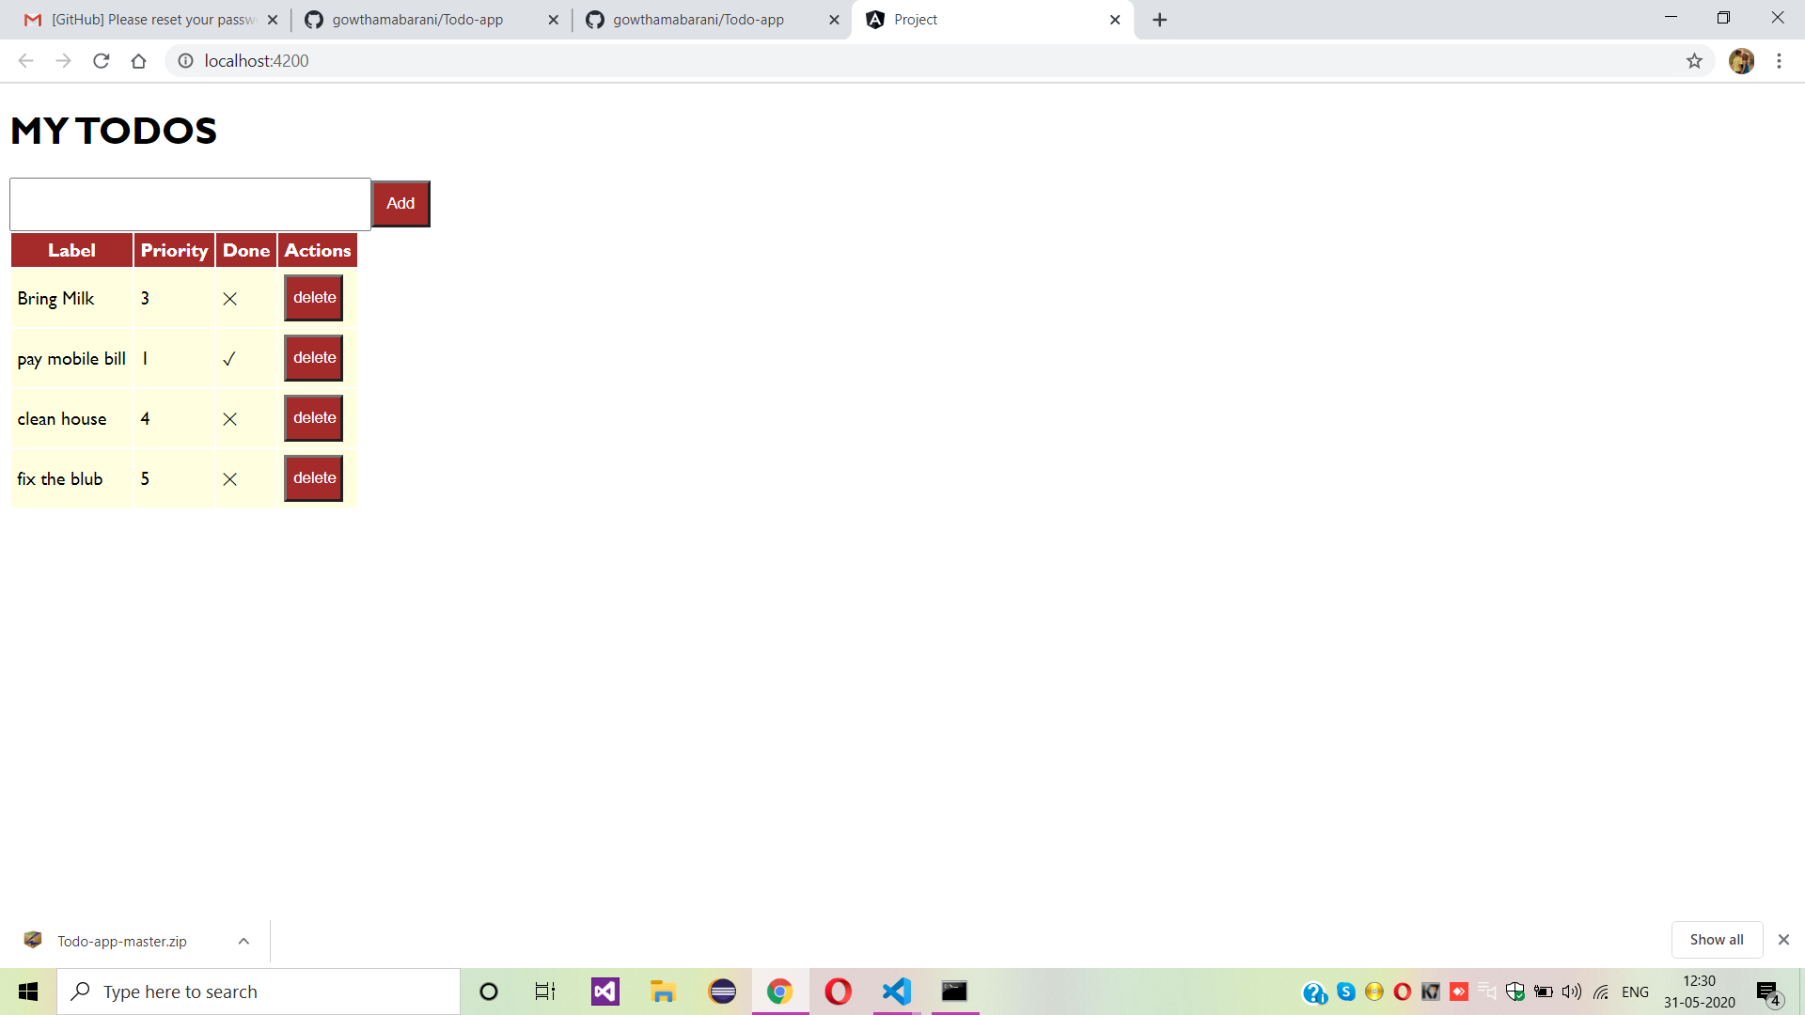

S.gowthamabarani

Mca

App name:todos app