**Day: 1**

**MVC: (Model View Controller)**

ASP.NET is a framework for creating web application while MVC is a great architecture to organize and arrange our code in a better way.

**Why we use ASP.NET MVC?**

1. Response time: - How fast the server responds to request?.
2. Bandwidth consumption: - How much data is sent ?.

**In Asp.Net MVC request flow in general moves as follows:-**

Step 1:- The first hit comes to the controller.

Step 2:- Depending on the action controller creates the object of the model. Model in turn calls the data access layer which fetches data in the model.

Step 3:- This data filled model is then passed to the view for display purpose.

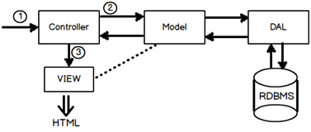

Note: DAL: Data Access Layer (DataBase)

**ASP.NET Controller:**

**User interaction Logic?**

When end user hits a URL on a browser.

Browser sends request to server and server sends a response.

By means of such request, client is trying to interact with server. Server is able to respond back because some logic is written at server end to fulfil this request.

**Simple MVC program 1**

**Step 1: open Microsoft visual studio 2012 (ultimate) or any. (or_) run->devenv->ok.**

**Step 2: Select General development settings (first time only – otherwise ignore step2)**

**Step 3: file 🡪new 🡪 project 🡪template🡪web 🡪 ASP.NET MVC 4 Application 🡪**

**Template 🡪empty or mvc 🡪 view engine 🡪Razor🡪 ok.**

**Step 4:**

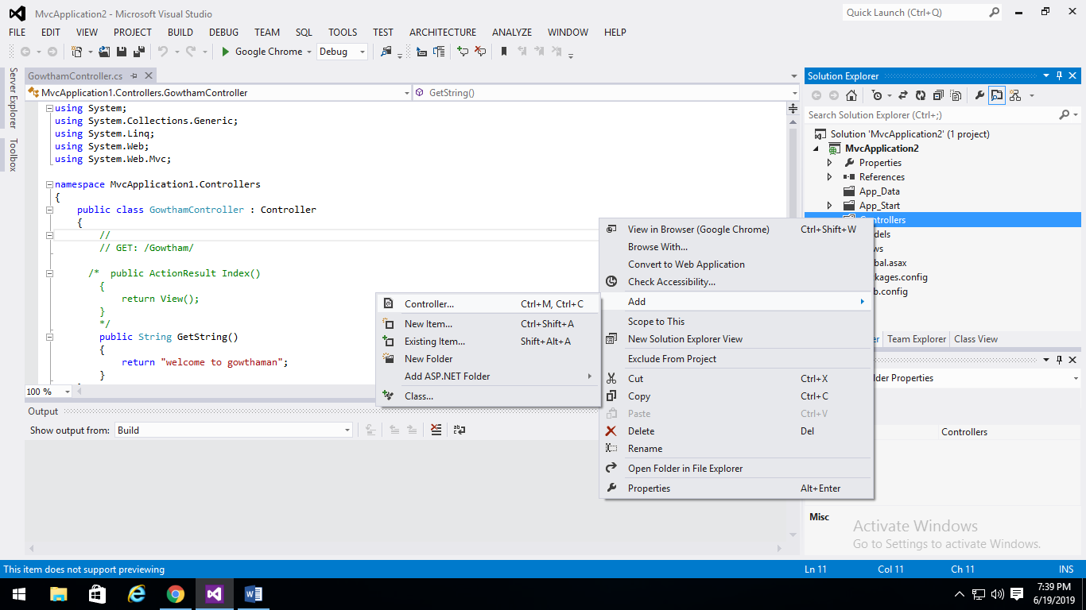

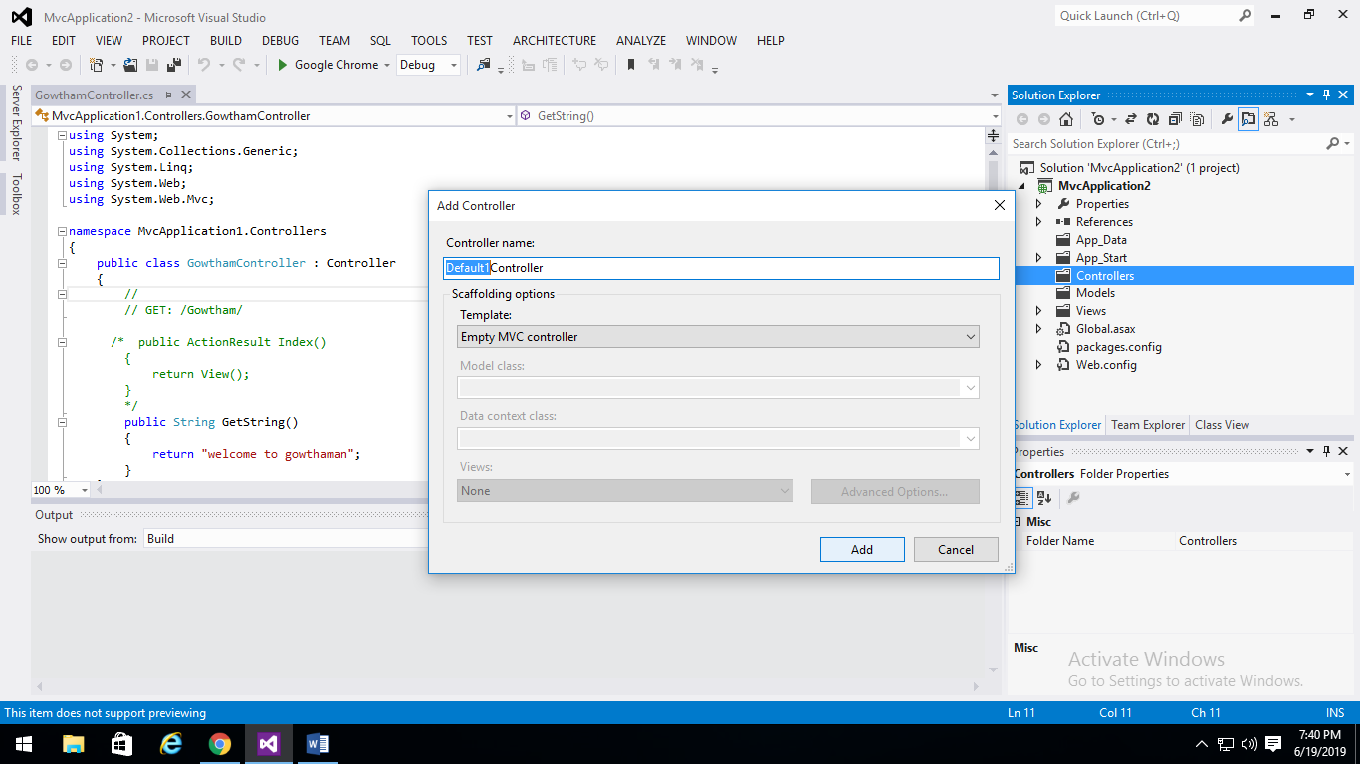

**Step 5:**

**Execute and Test**

Press F5. In the address bar put “ControllerName/ActionName” as follows. Please note do not type the word “Controller” just type “Gowtham”.

