Create folder, type cmd in address bar, code .

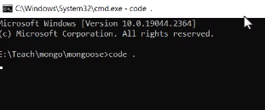

npm init : Initialize a new project and create a package. json file. npm install <package-name> : Install a package and add it to the dependencies object in your package. json file.

Y meaning : Yes  
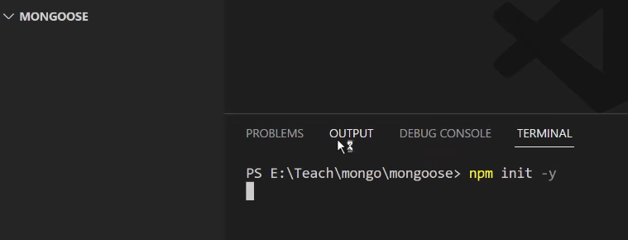

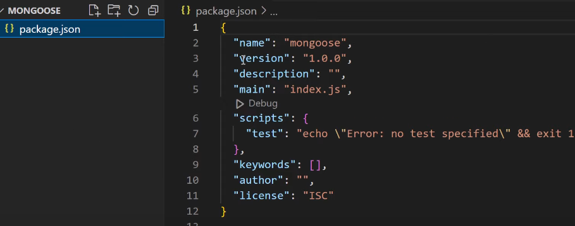

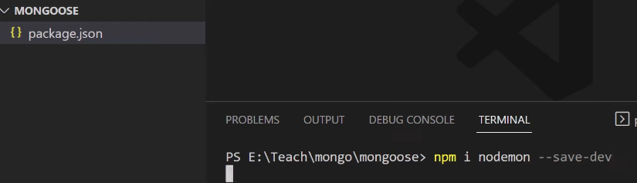

--save is default use (npm install, it will work after clone in github)

--save-dev is for development

When you use the --save-dev flag, the package is added to your devDependencies object.

if you download a repo from github and type npm install, the devDependencies are ignored

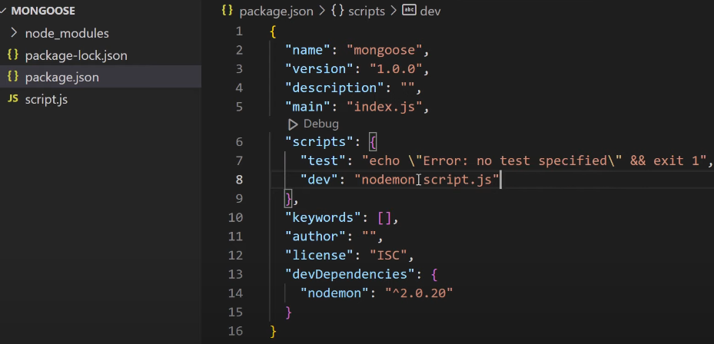

Don’t run every time: node script.js

Run only one time : npm run dev (it will take automatically refresh when saved)

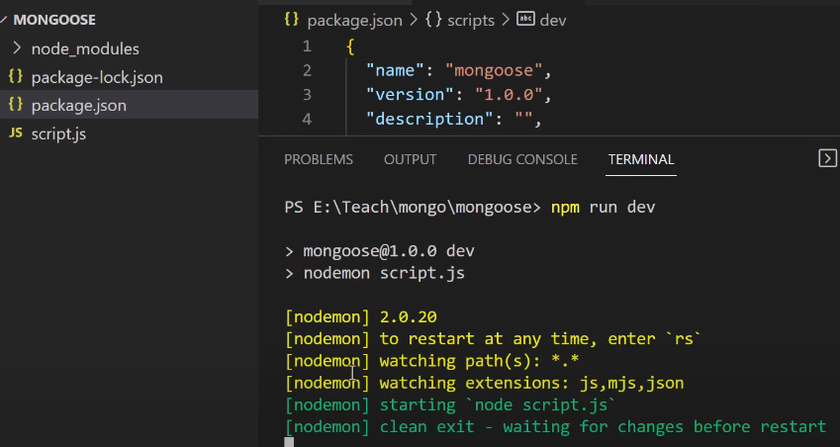

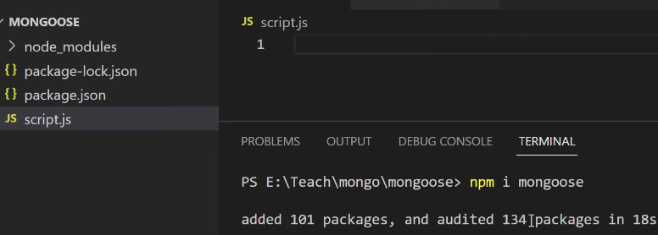

Terminal hide/show shortcut :ctrl +~

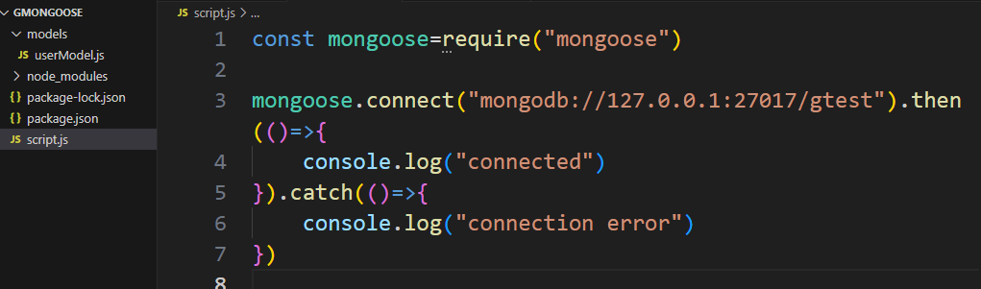

Schema : inbuilt class of mongoose

Use: only allow to store schema defined keys and datatype.

userSchemea: userDefined object.

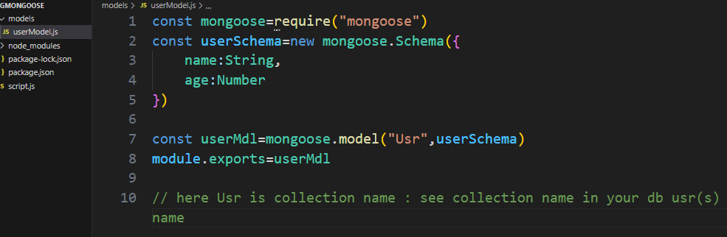

Insert method 1: (with out using async await)

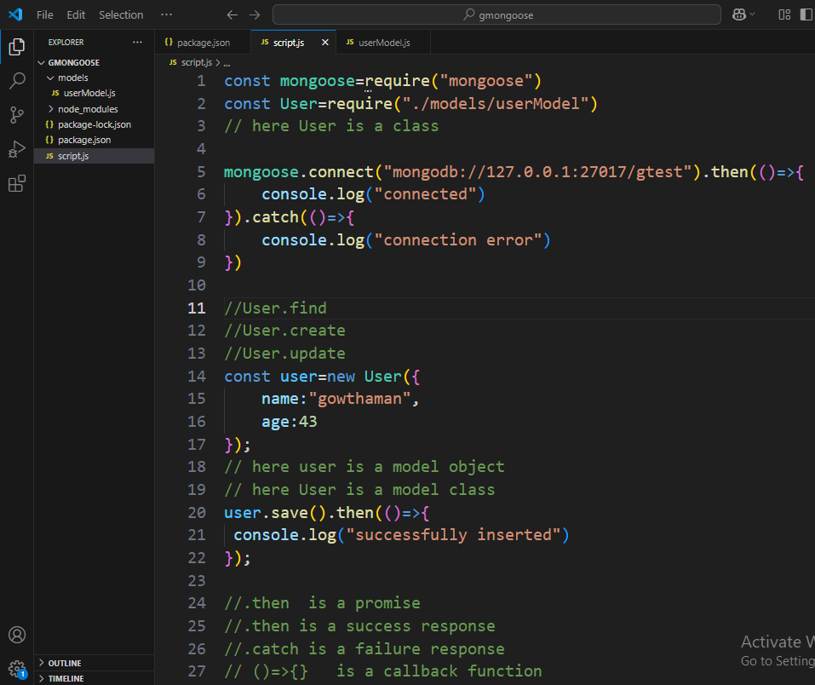

Do not change name & age key. because schema defined.

Do not add extra field. Only name and age accept

Same insert method using async function because promise return (.then)

Method 2: insertion using save with async function

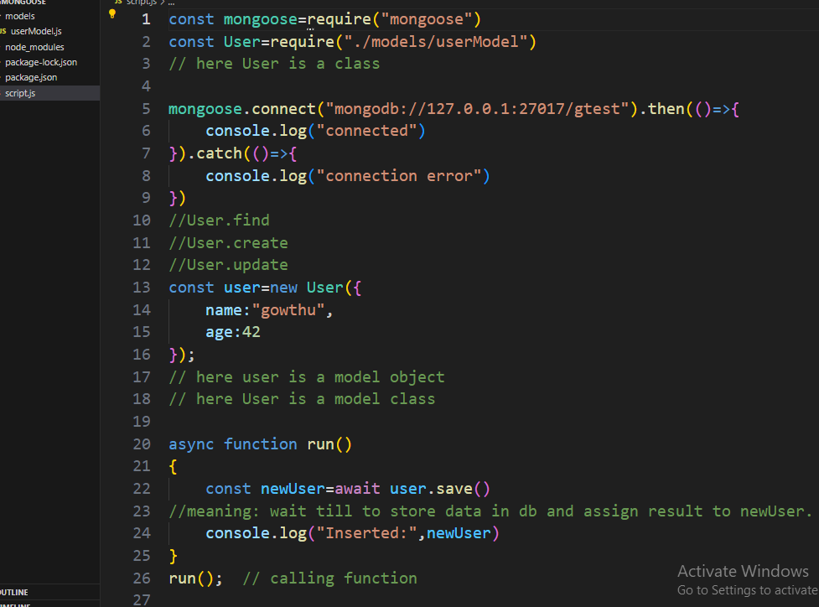

Method:3 insertion (without using save method)

Only using create

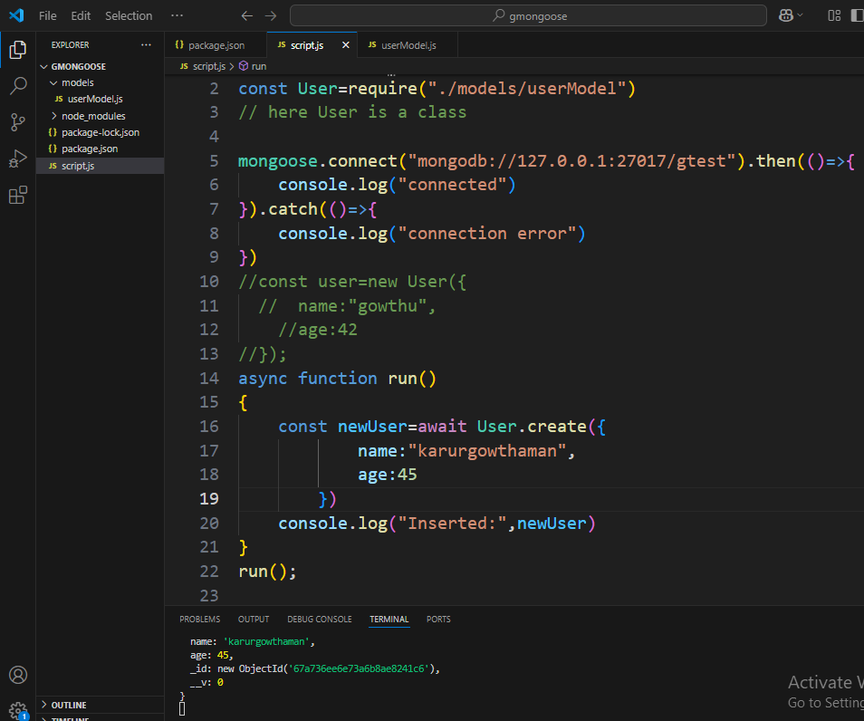

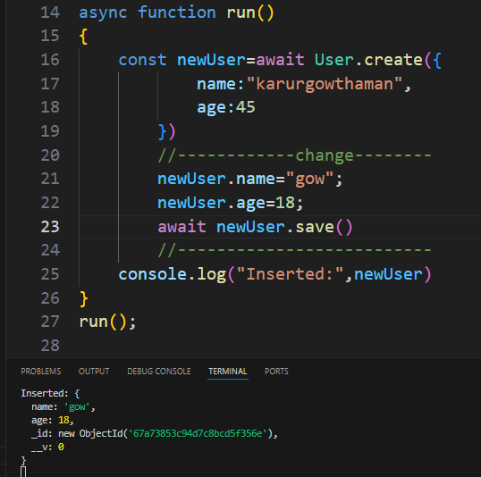

**Schema types:**

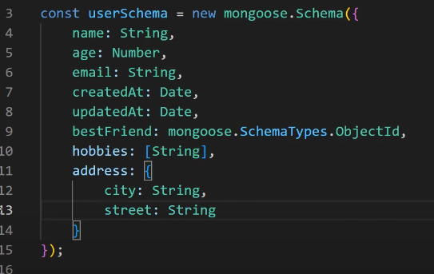

Nested schema:

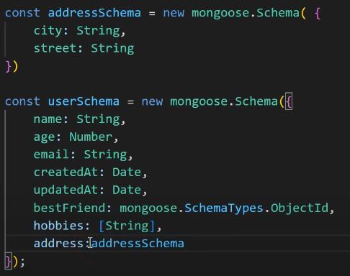

Before error handle :

Age only accept integer types

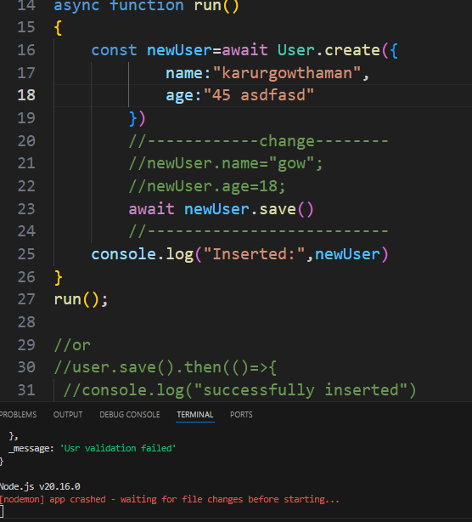

Error handle using try catch block.

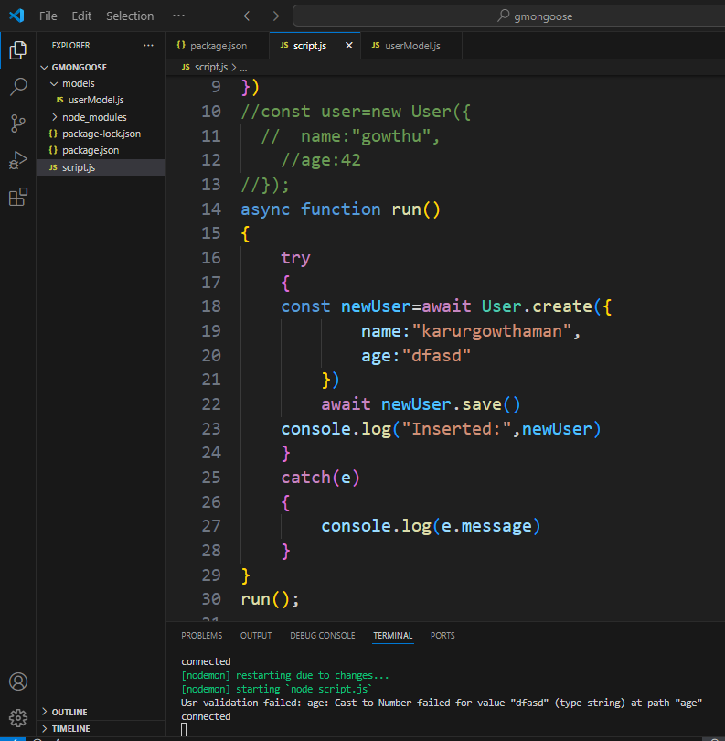

Use: console.log(e.errors)

**SCHEMA VALIDATAION:**

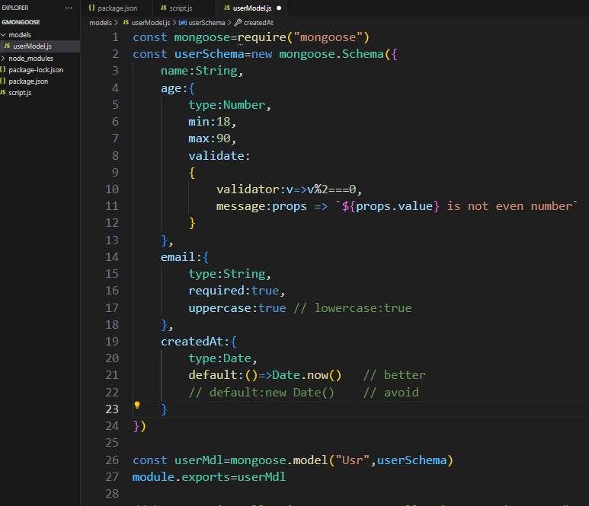

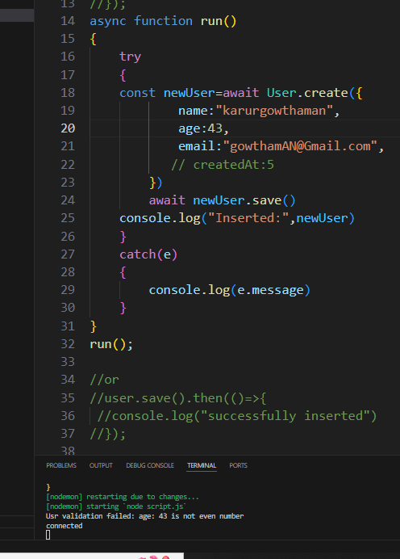

Note: age only accept even numbers (validation)

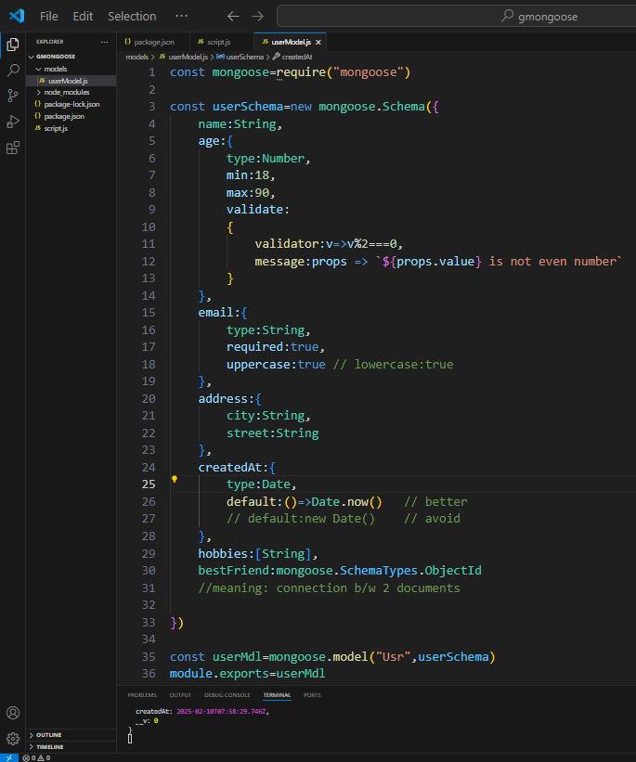

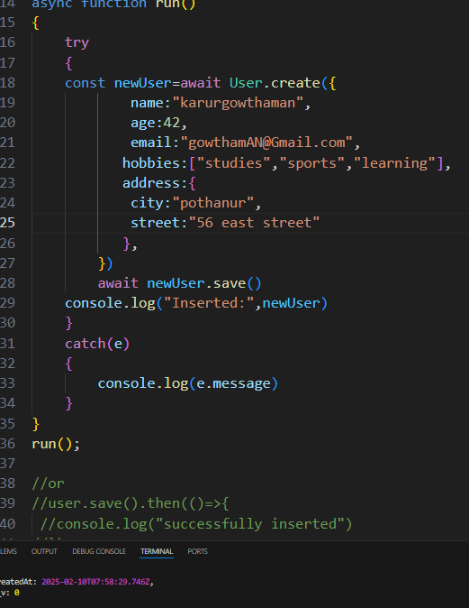

**Query methods:**

**findById**

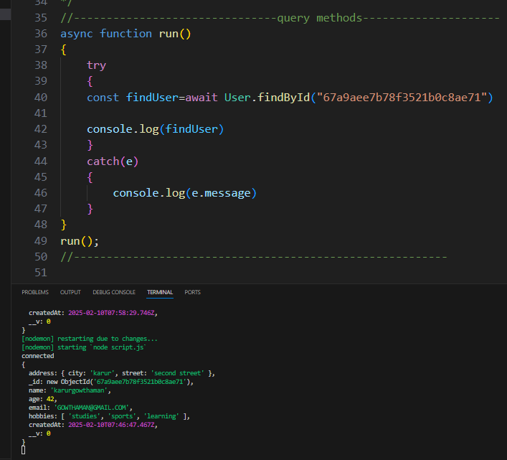

**find query methods:**

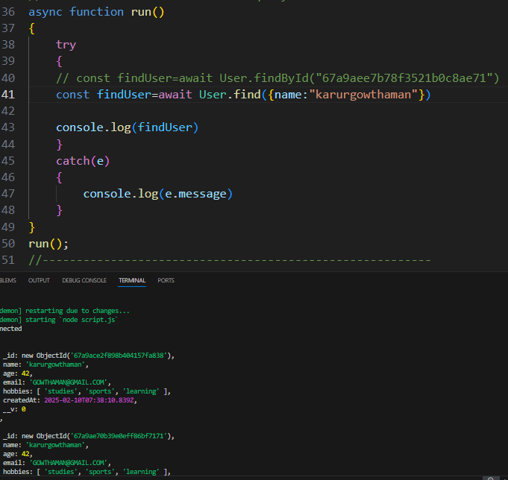

**task: findOne query methods (first one only appear)**

**use: exists query methods only show object id**

**ex: //const findUser=await User.findOne({name:"karurgowthaman"})**

**const findUser=await User.exists({name:"karurgowthaman"})**

**where function query methods:**

**use: avoid deleteOne,deleteMany,updateOne,updateMany**

const findAllUsers=await User.where('name').equals("karurgowthaman")

const findUser=await User.where('age').gt("43")

const findUser=await User.where('age').gt("40").lt('50')

const findUser=await User.where('age').gt("40").lt('50').limit(1)

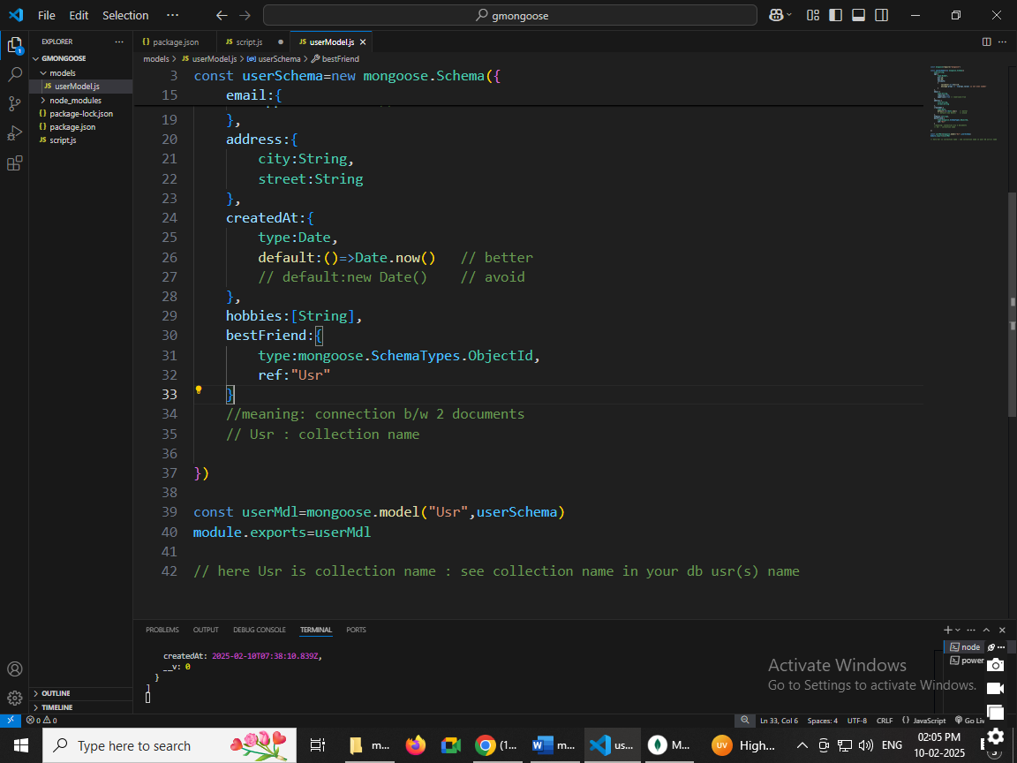

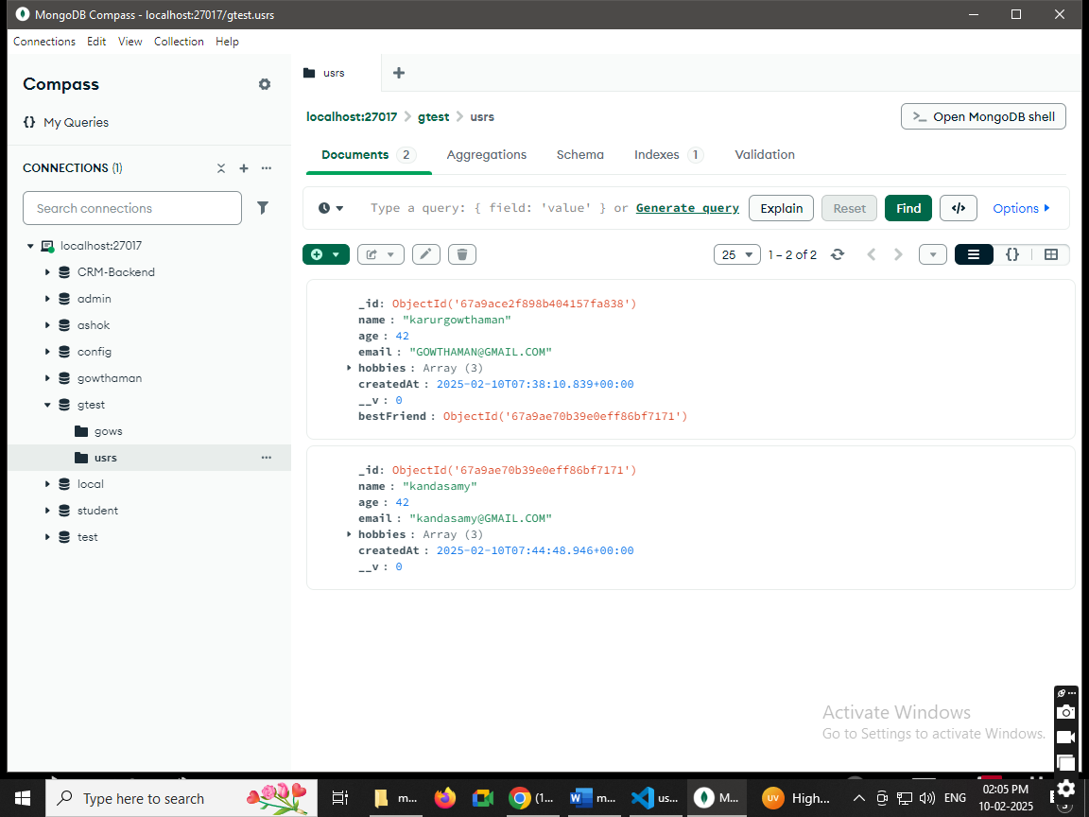

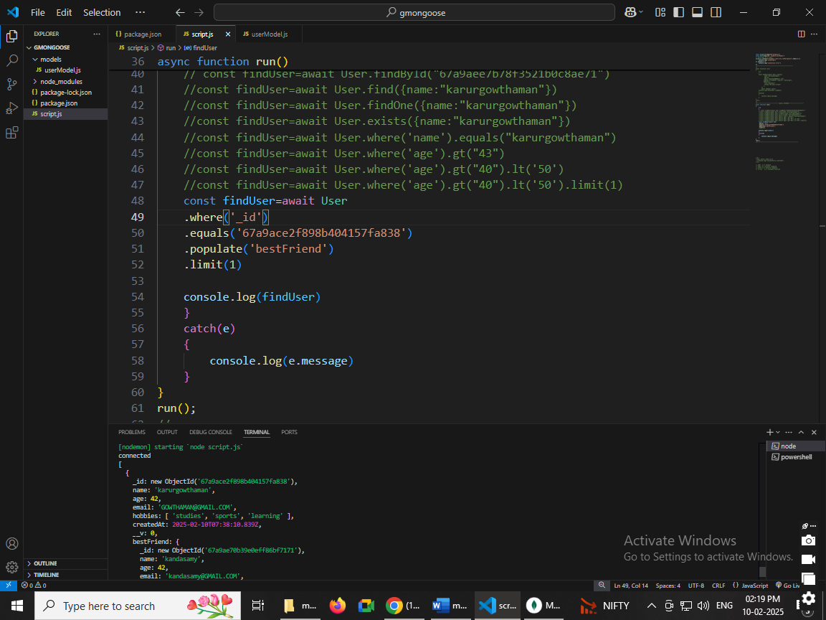

**Schema Methods:**

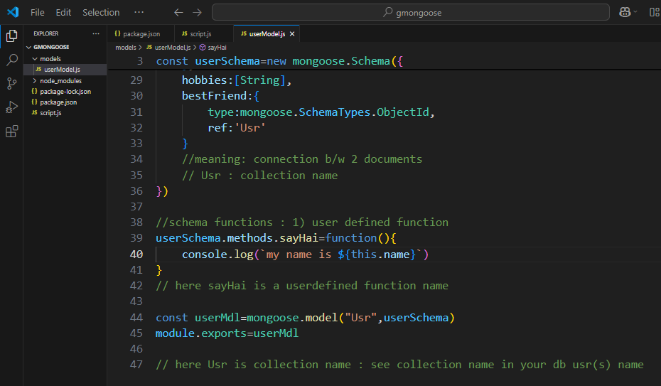

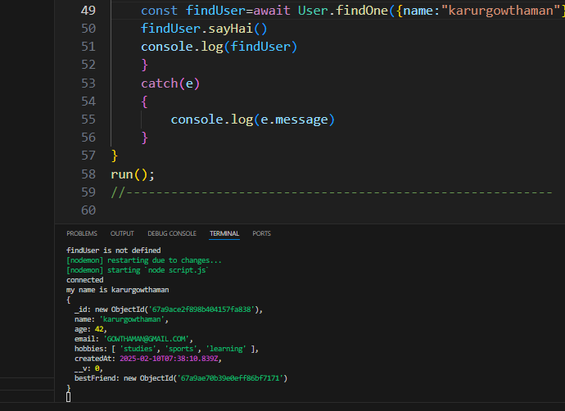

Line no. 50 sayHai() userdefined function call to line no 39

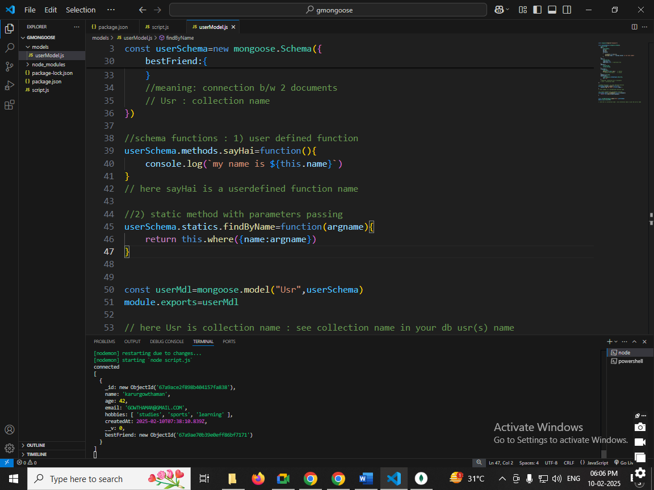

Lineno:46 use find keyword

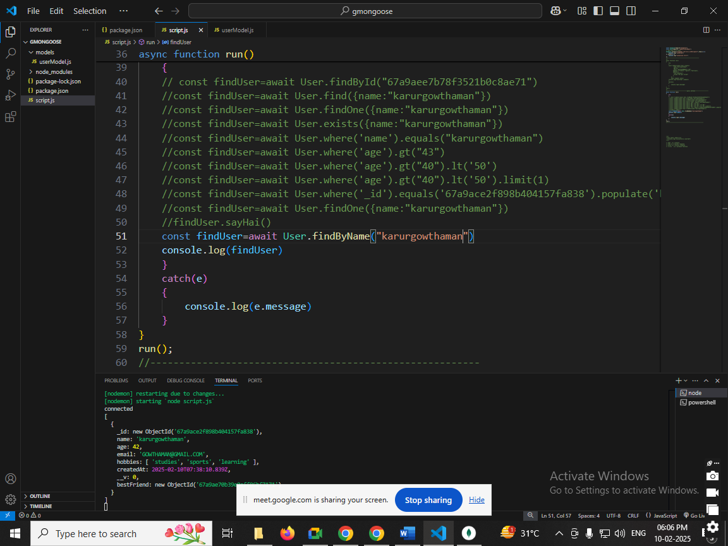

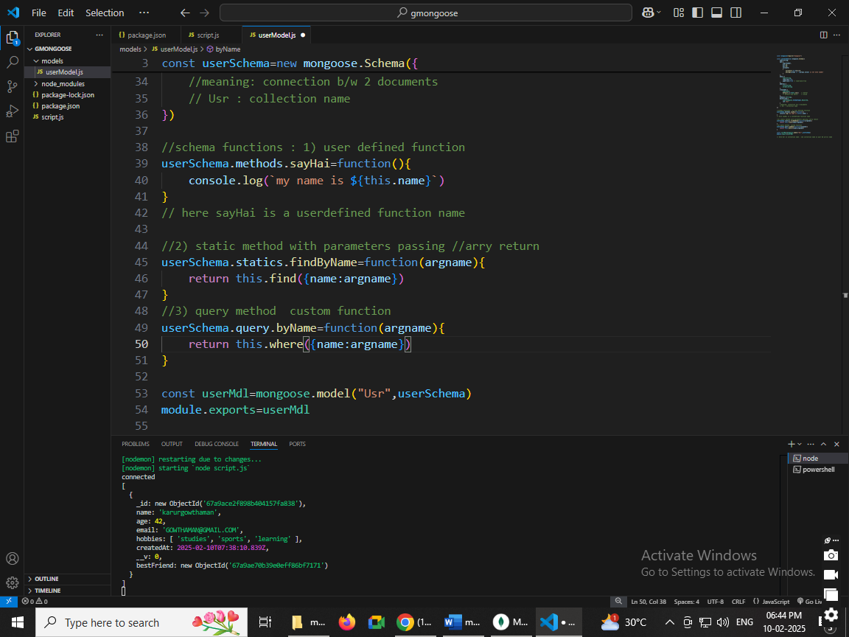

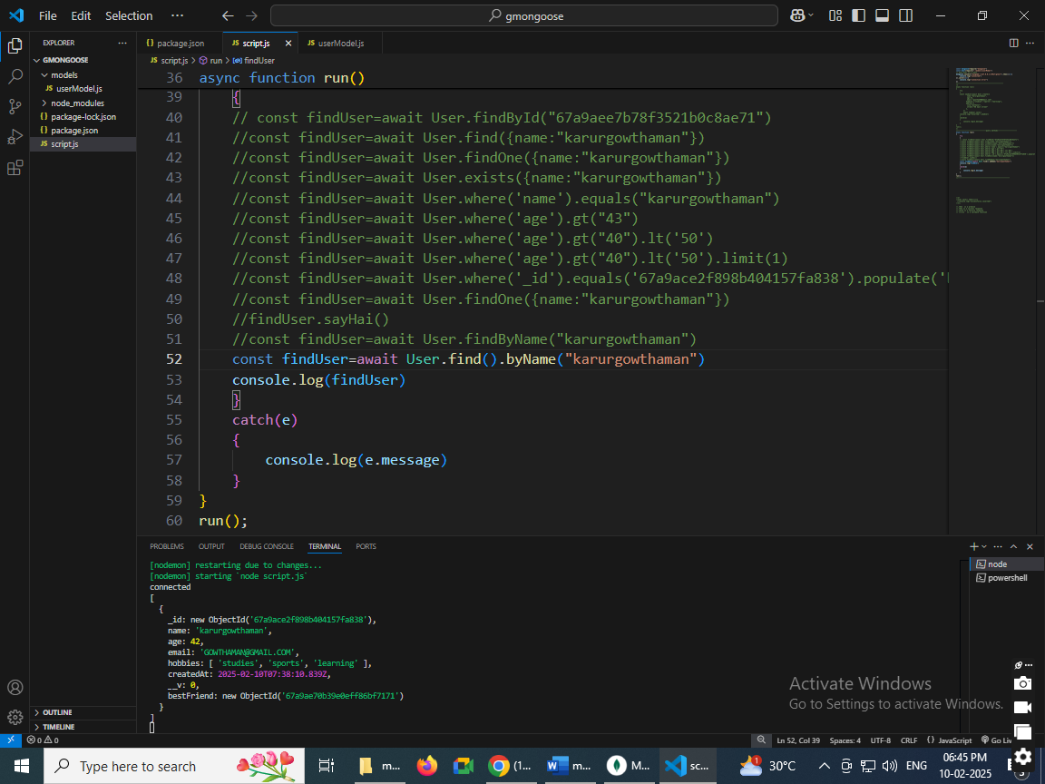

**Schema Virtuals:**

Meaning : Adding new field

Ex: {namedEmail:”gowthaman@gmail.com”}

But this email not visible. But we can see virtually using code.

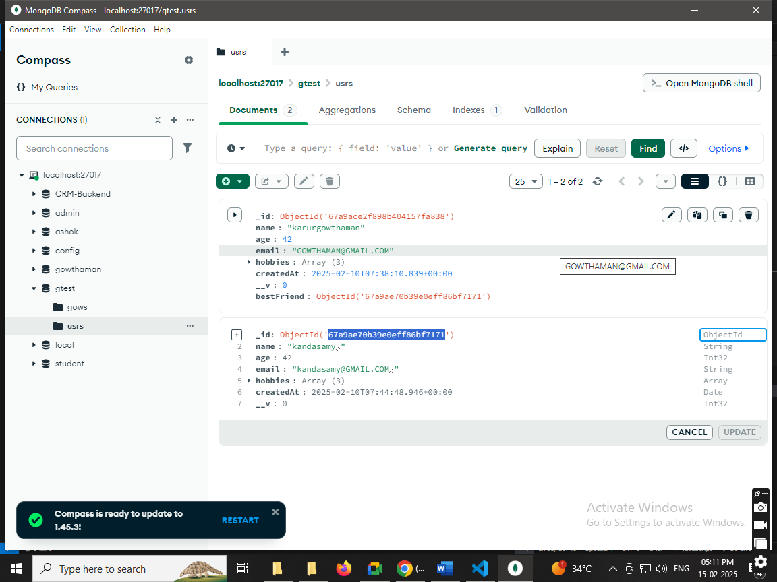

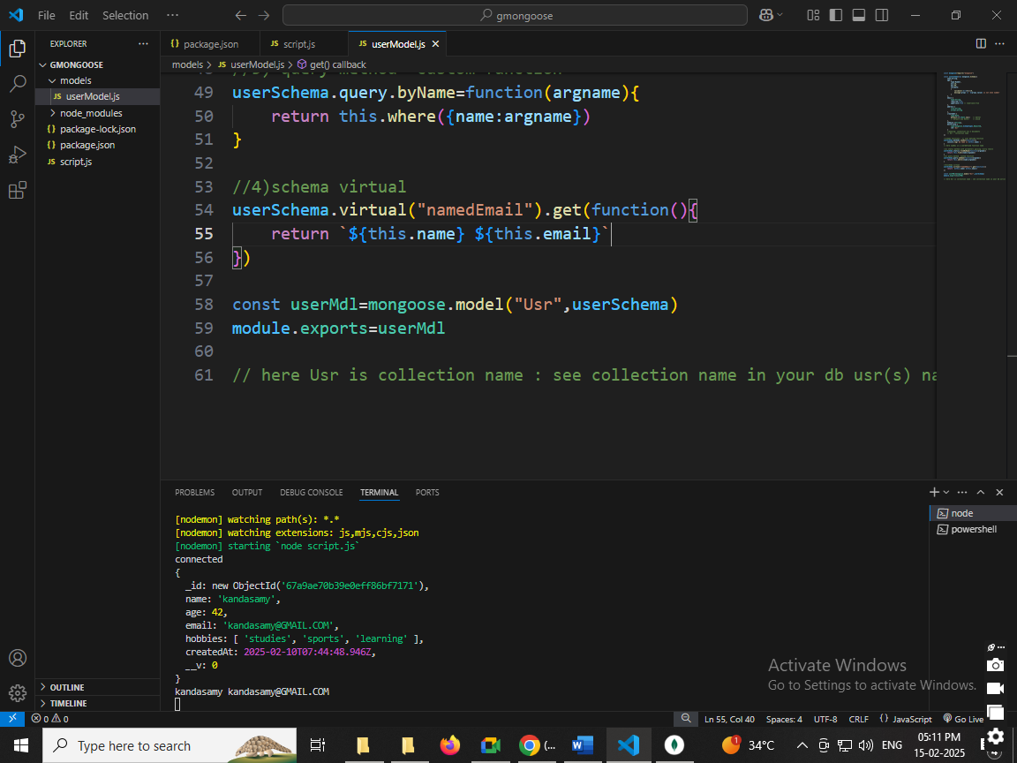

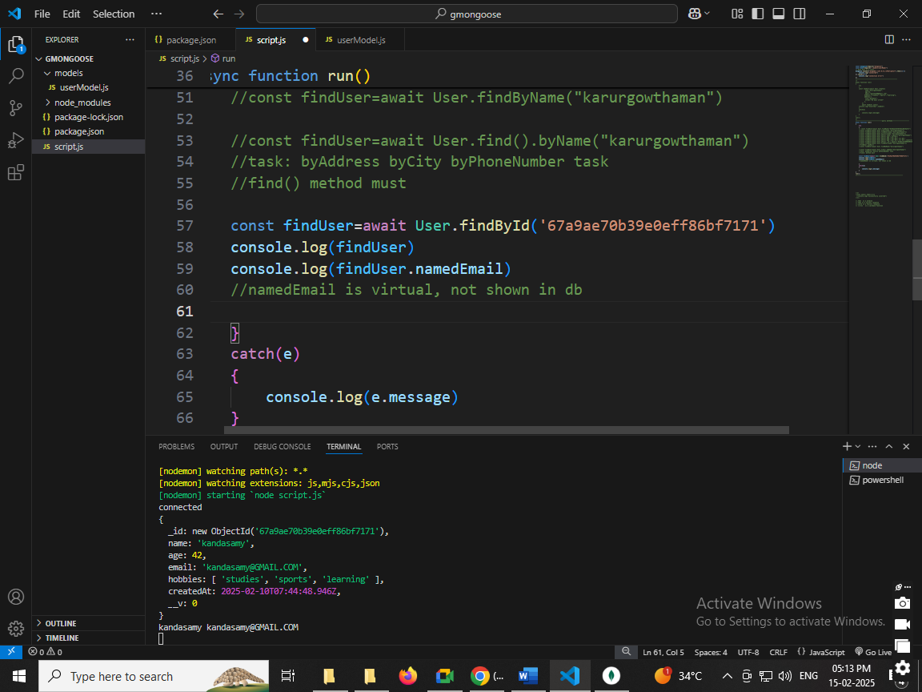

Schema Middlewares:

Meaning: before insert / after insert some changes

Ex: Mr. yourname(add Mr. before insert)

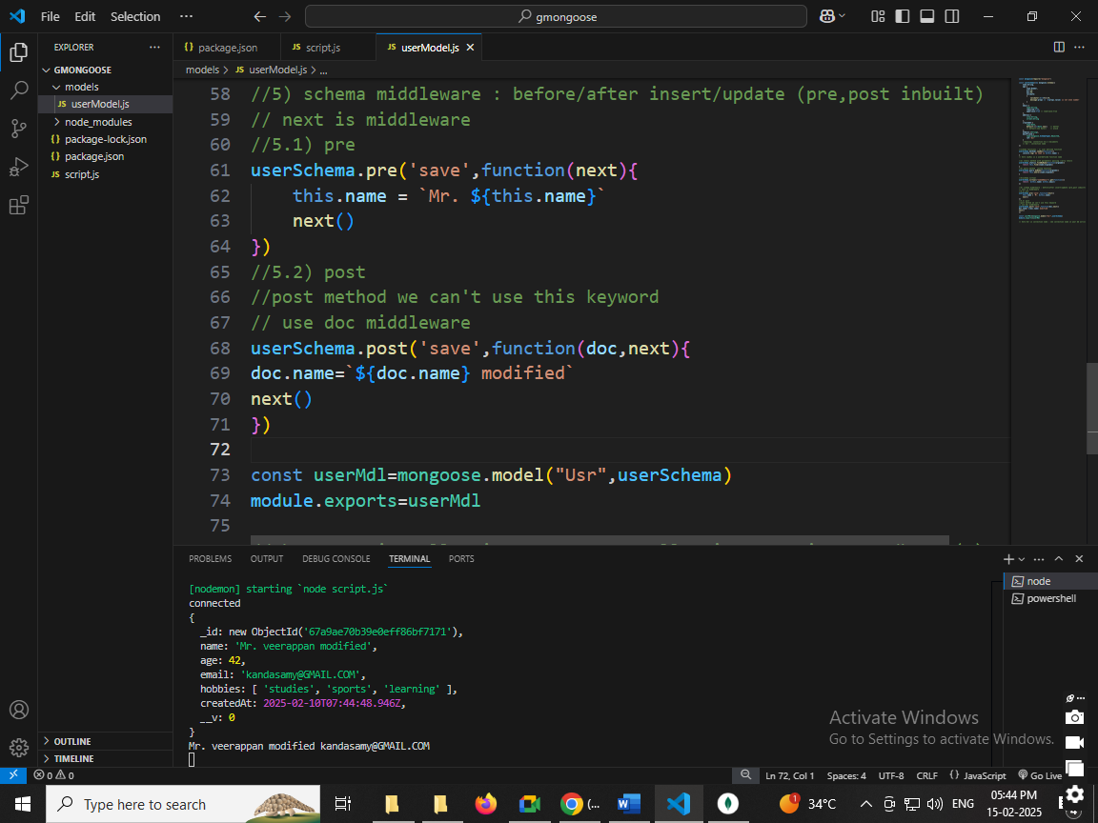

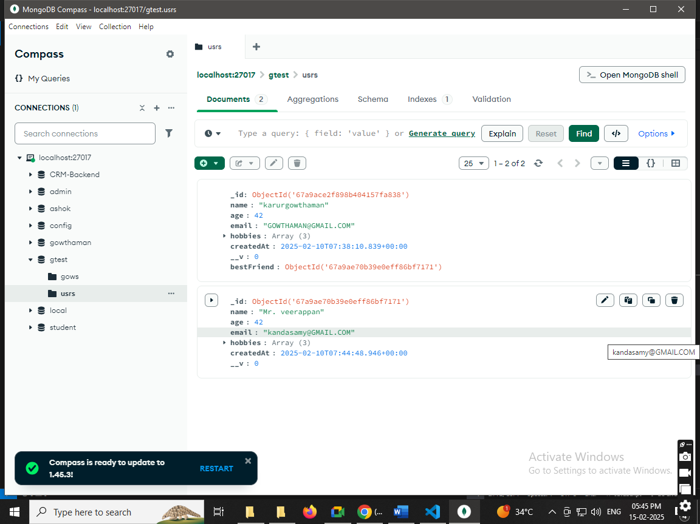

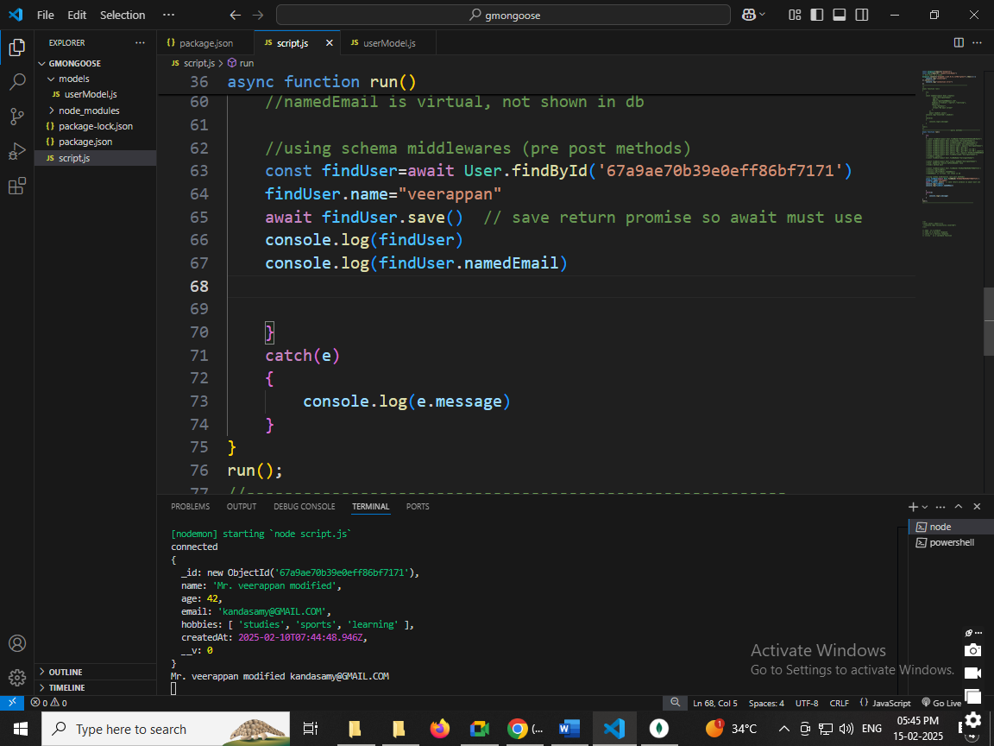

=================end thanks jvl code==============