FORM DESIGN:
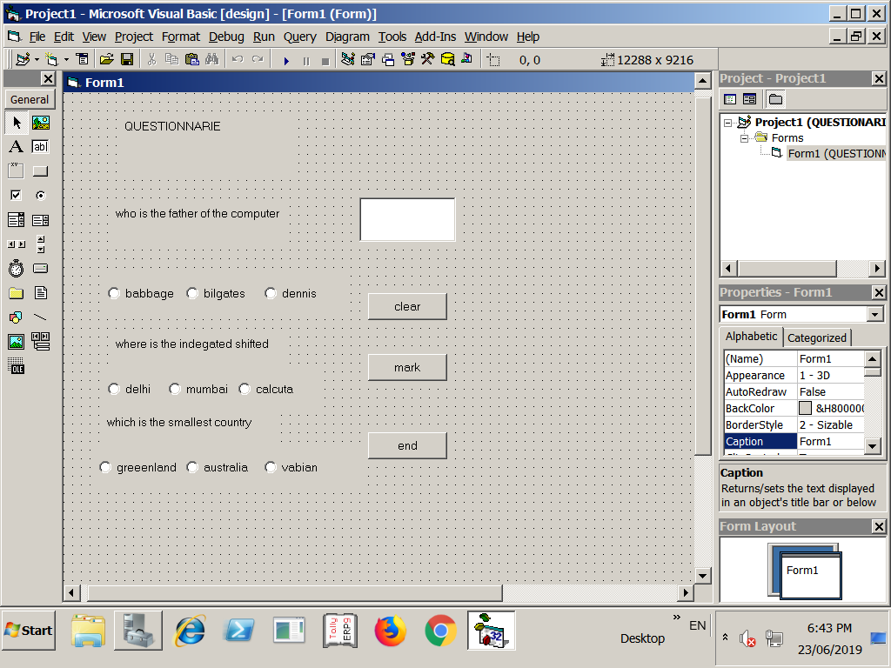
CODING:(QUESTIONNARIE)
Dim i As Integer
Private Sub Command1_Click()
Text1.Text = ""
End Sub
Private Sub Command2_Click()
Text1.Text = i
End Sub
Private Sub Command3_Click()
End
End Sub
Private Sub Form_Load()
i = 0
Option1.Value = False
Option2.Value = False
Option3.Value = False
Option4.Value = False
Option5.Value = False
Option6.Value = False
Option7.Value = False
Option8.Value = False
Option9.Value = False
Option10.Value = False
Option11.Value = False
Option12.Value = False
End Sub

Private Sub Option10_Click()
i = i + 10
End Sub

Private Sub Option12_Click()
i = i + 10
End Sub

Private Sub Option9_Click()
i = i + 10
End Sub

OUTPUT:

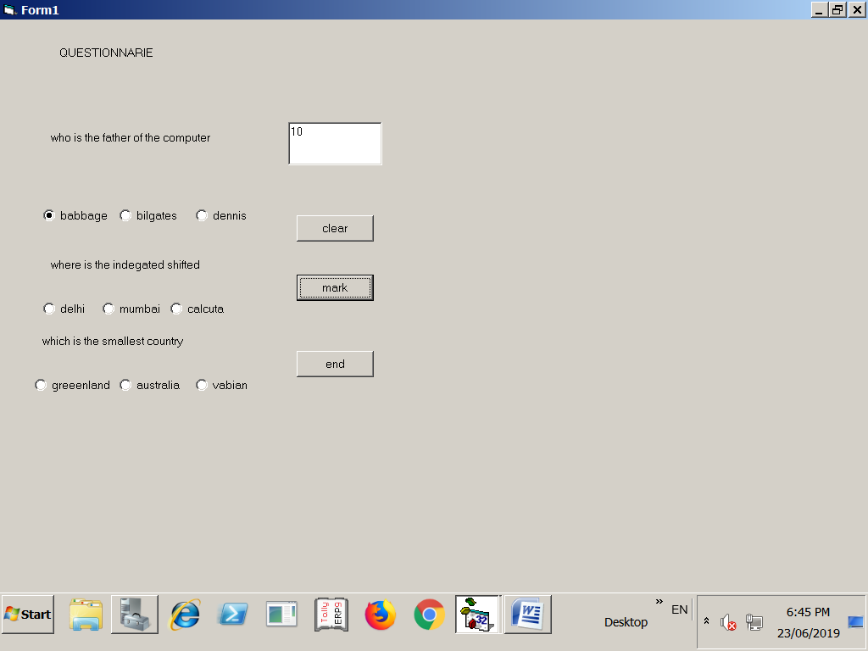
FORM DESIGN:
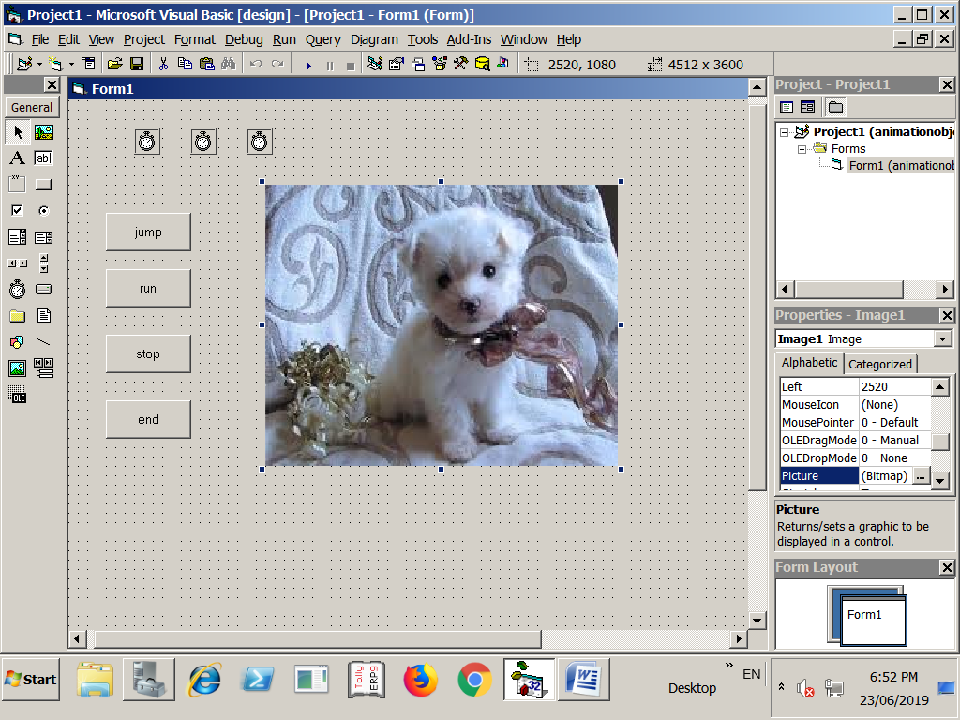
CODING:(ANIMATION AN OBJECT)
Private Sub Command1_Click()
Timer2.Interval = 1
Timer1.Enabled = False
Timer3.Enabled = False
End Sub
Private Sub Command2_Click()
Timer1.Interval = 1
Timer1.Enabled = True
Timer2.Enabled = False
Timer3.Enabled = False
End Sub
Private Sub Command3_Click()
Timer1.Enabled = False
Timer2.Enabled = False
Timer3.Enabled = False
End Sub
Private Sub Command4_Click()
End
End Sub
Private Sub Timer1_Timer()
Image1.Left = Image1.Left + 20
End Sub
Private Sub Timer2_Timer()
Image1.Top = Image1.Top - 50
Image1.Left = Image1.Left + 10
If Image1.Top < 10 Then
Timer1.Enabled = False
Timer2.Enabled = False
Timer3.Enabled = True
End Sub
Private Sub Timer3_Timer()
Image1.Left = Image1.Top + 20
Image1.Top = Image1.Left + 50
If Image1.Top > 40 Then
Timer2.Enabled = True
Timer3.Enabled = False
End If
End Sub
OUTPUT:

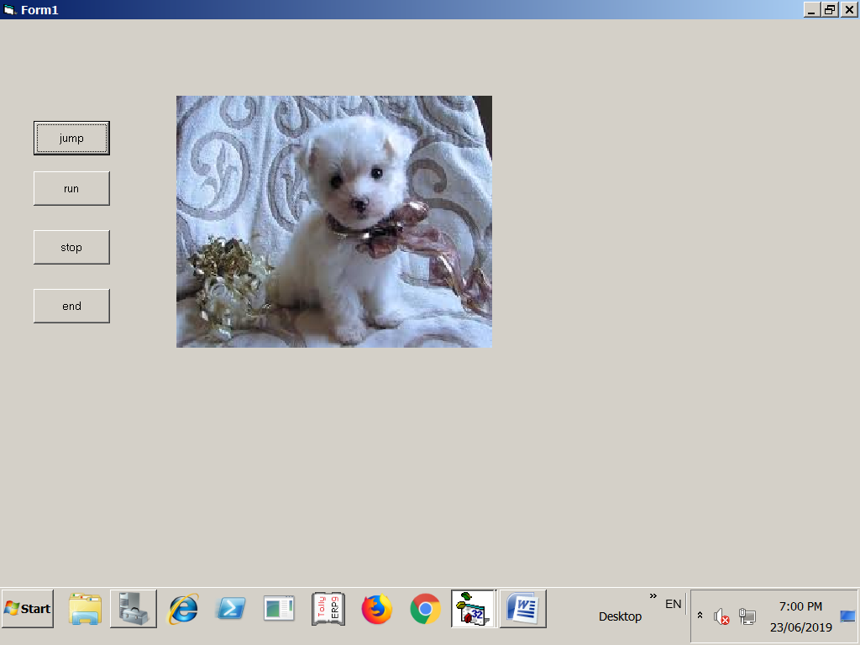
FORM DESIGN:

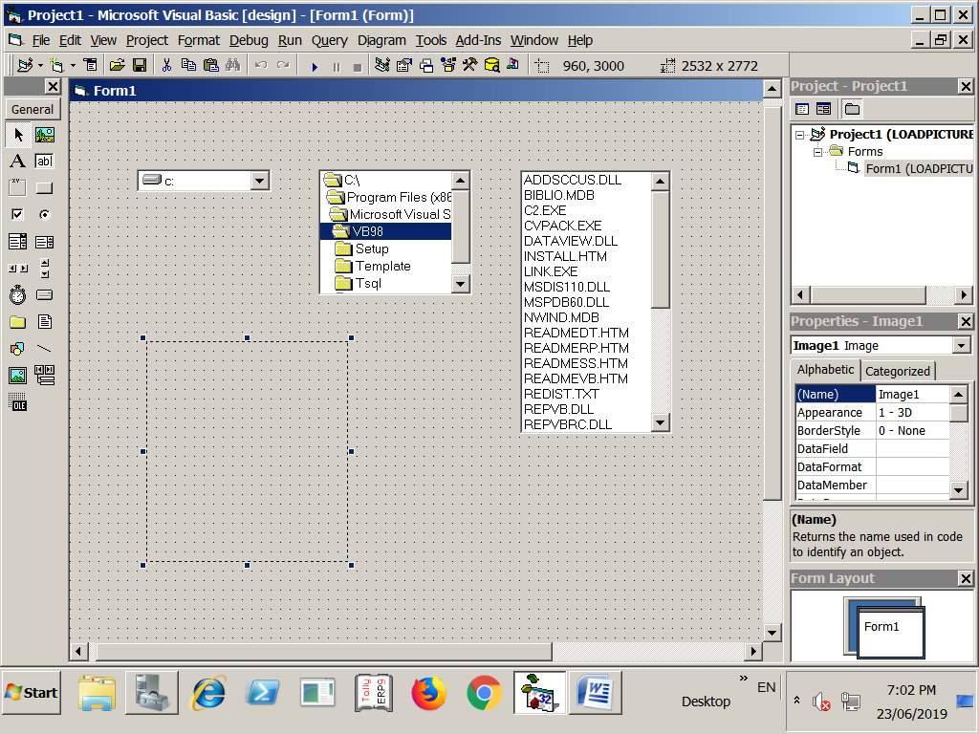
CODING (LOAD A PICTURE)

Private Sub Dir1_Change()
File1.Path = Dir1.Path
End Sub
Private Sub Drive1_Change()
Dir1.Path = Drive1.Drive
End Sub
Private Sub File1_Click()
Image1.Picture = LoadPicture(Dir1.Path + "\" + File1.FileName)
End Sub

OUTPUT:

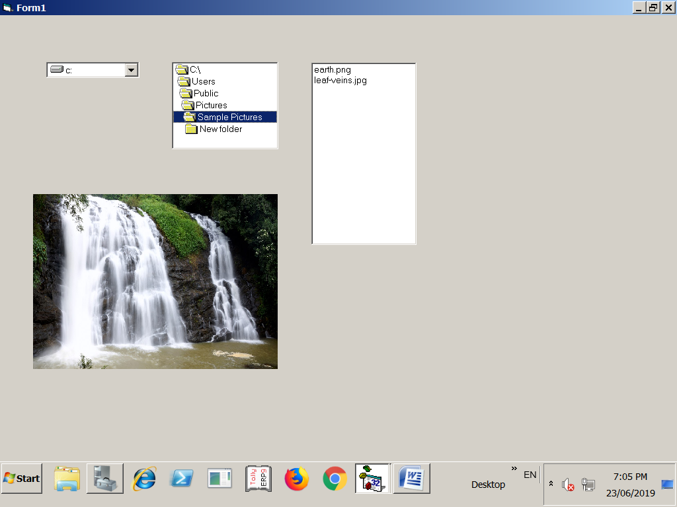
FORM DESIGN:

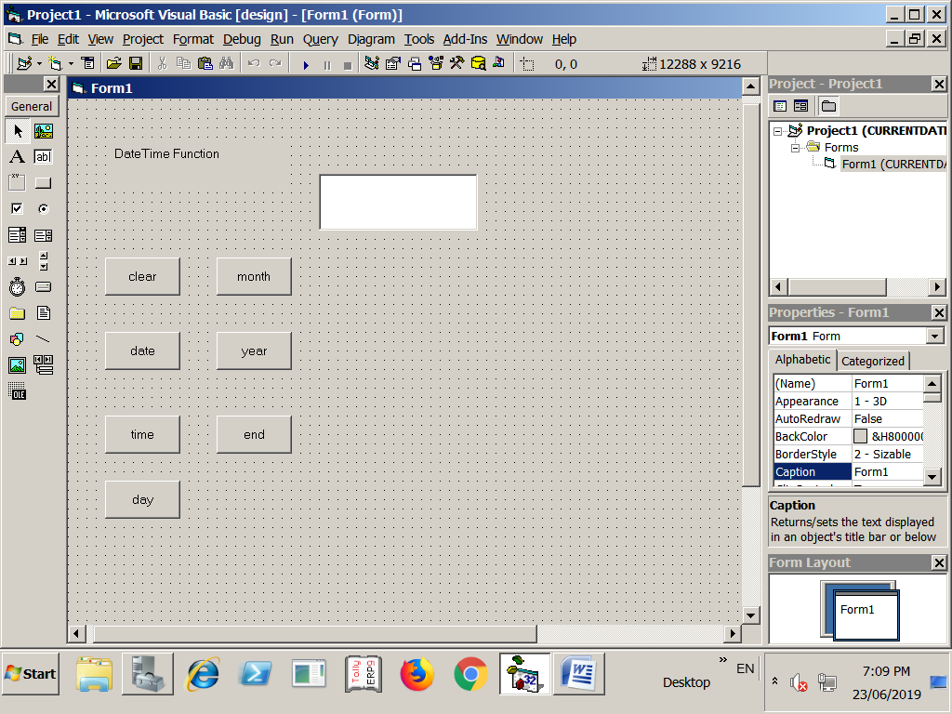
CODING :( DISPLAY CURRENT DATE AND TIME)
Private Sub Command1_Click()
Text1.Text = ""
End Sub
Private Sub Command2_Click()
Text1.Text = Date
End Sub
Private Sub Command3_Click()
Text1.Text = Time
End Sub
Private Sub Command4_Click()
Text1.Text = Weekday(Date)
If (Text1.Text = 1) Then
Text1.Text = "sunday"
ElseIf (Text1.Text = 2) Then
Text1.Text = "monday"
ElseIf (Text1.Text = 3) Then
Text1.Text = "tuesday"
ElseIf (Text1.Text = 4) Then
Text1.Text = "wednesda"
ElseIf (Text1.Text = 5) Then
Text1.Text = "thursday"
ElseIf (Text1.Text = 6) Then
Text1.Text = "friday"
Else
Text1.Text = "saturday"
End Sub
Private Sub Command5_Click()
Text1.Text = Month(Date)
If (Text1.Text = 1) Then
Text1.Text = "january"
ElseIf (Text1.Text = 2) Then
Text1.Text = "February"
ElseIf (Text1.Text = 3) Then
Text1.Text = "march"
ElseIf (Text1.Text = 4) Then
Text1.Text = "april"
ElseIf (Text1.Text = 5) Then
Text1.Text = "may"
ElseIf (Text1.Text = 6) Then
Text1.Text = "june"
ElseIf (Text1.Text = 7) Then
Text1.Text = "july"
ElseIf (Text1.Text = 8) Then
Text1.Text = "august"
ElseIf (Text1.Text = 9) Then
Text1.Text = "september"
ElseIf (Text1.Text = 10) Then
Text1.Text = "october"
ElseIf (Text1.Text = 11) Then
Text1.Text = "novermber"
Else
Text1.Text = "december"
End Sub
Private Sub Command6_Click()
Text1.Text = Year(Date)
End Sub
Private Sub Command7_Click()
End
End Sub
OUTPUT:
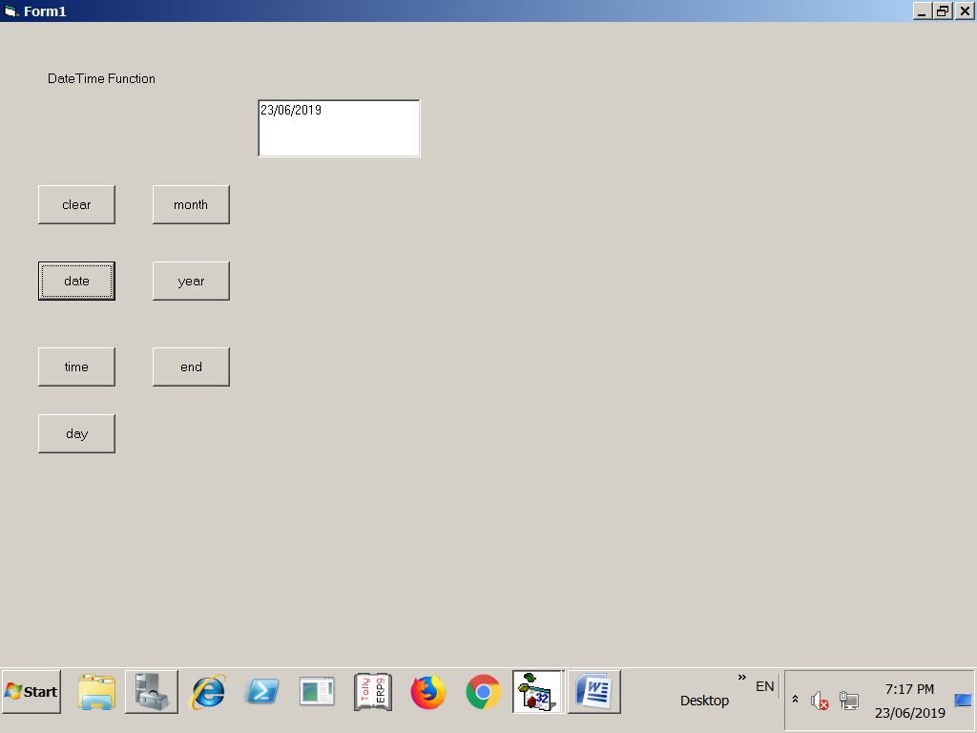
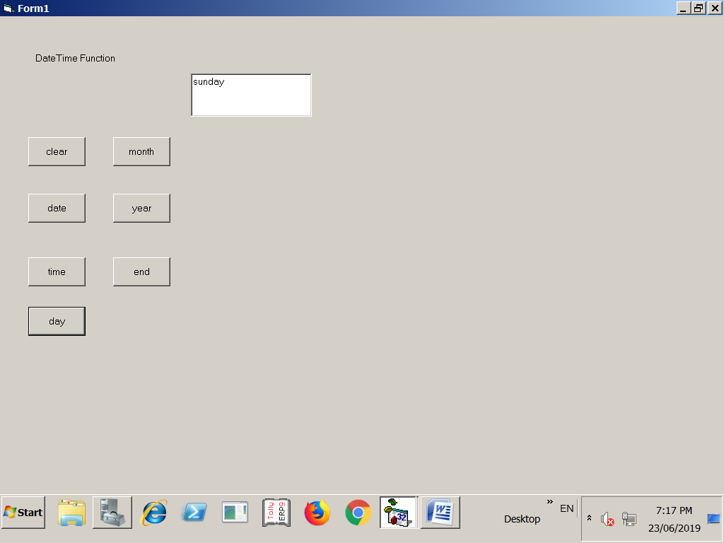
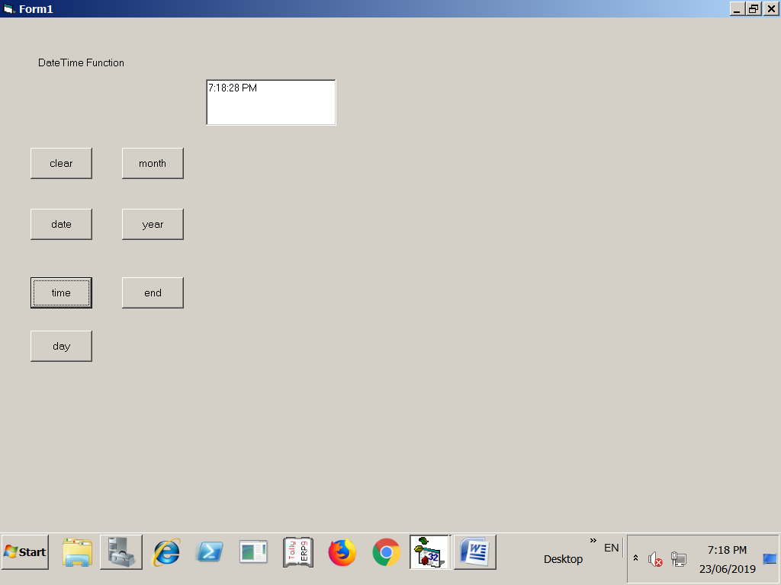
FORM DESIGN:

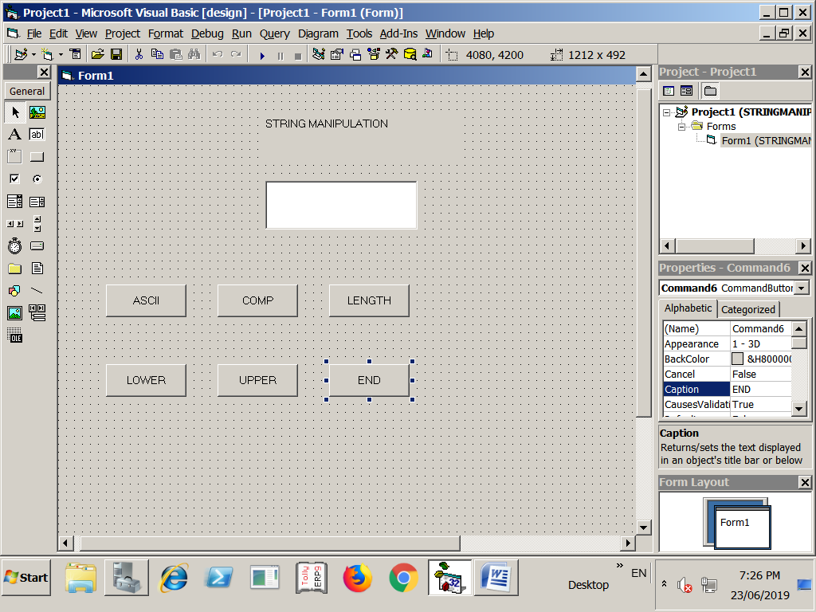
CODING :( STRING MANIPULATION)

Dim s1, s2, s3 As Integer
Dim st1 As Integer
Private Sub Command1_Click()
s1 = InputBox("enter the string")
Text1.Text = Asc(s1)
End Sub
Private Sub Command2_Click()
s1 = InputBox("enter first string")
s2 = InputBox("enter second string")
st1 = StrComp(s1, s2)
If (st1 = 1) Then
Text1.Text = "first string greater than (>) second string"
ElseIf (st1 = -1) Then
Text1.Text = "first string less than (>) second string"
Else
Text1.Text = "both are equal"
End
End Sub
Private Sub Command3_Click()
s1 = InputBox("enter the string")
Text1.Text = Len(s1)
End Sub
Private Sub Command4_Click()
s1 = InputBox("enter the string")
Text1.Text = LCase(s1)
End Sub
Private Sub Command5_Click()
s1 = InputBox("enter the string")
Text1.Text = UCase(s1)
End Sub
Private Sub Command6_Click()
End
End Sub
OUTPUT:
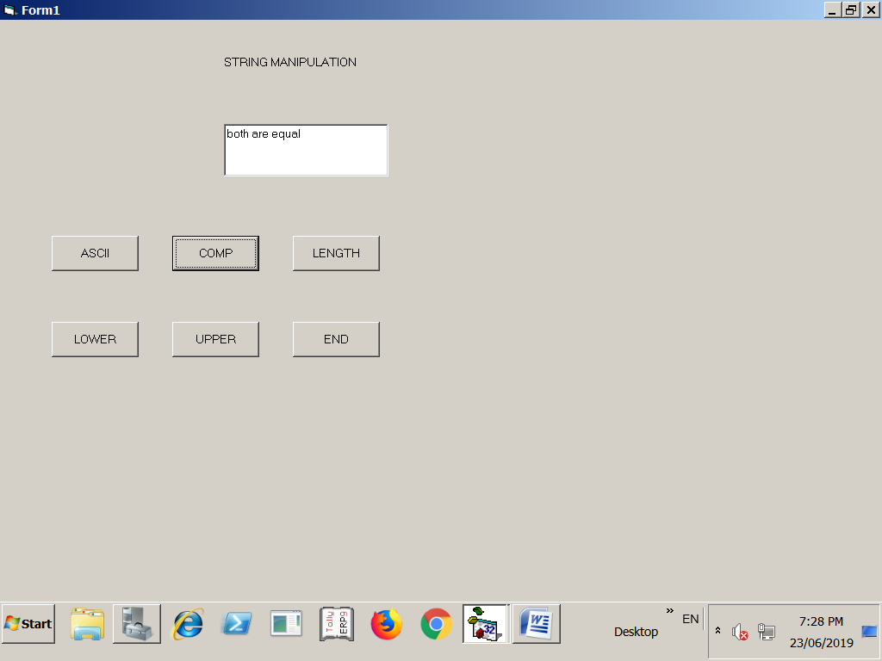
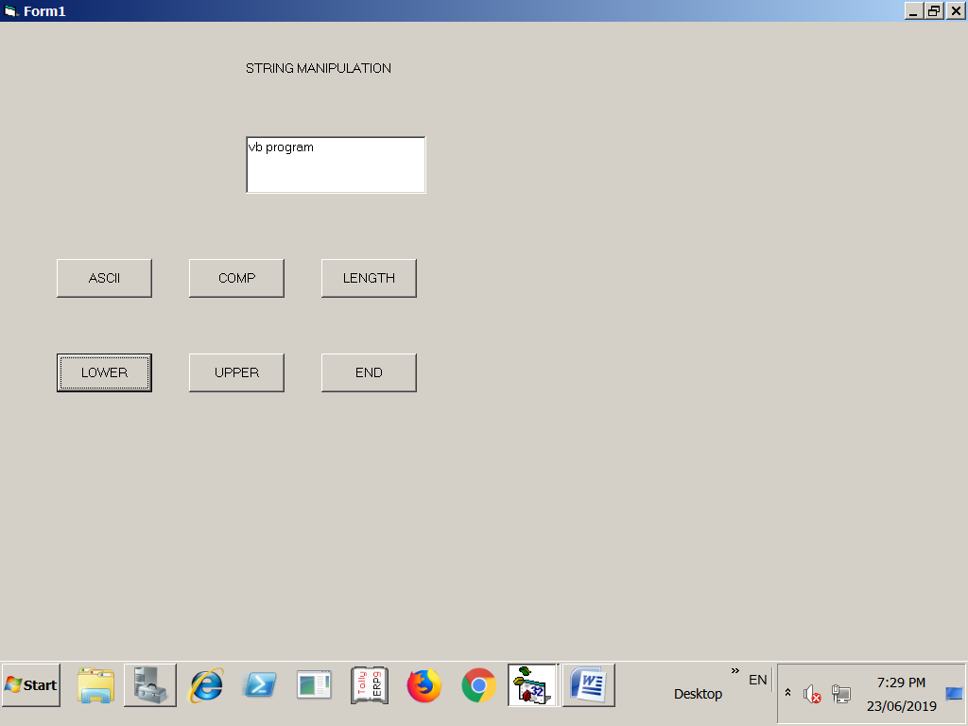
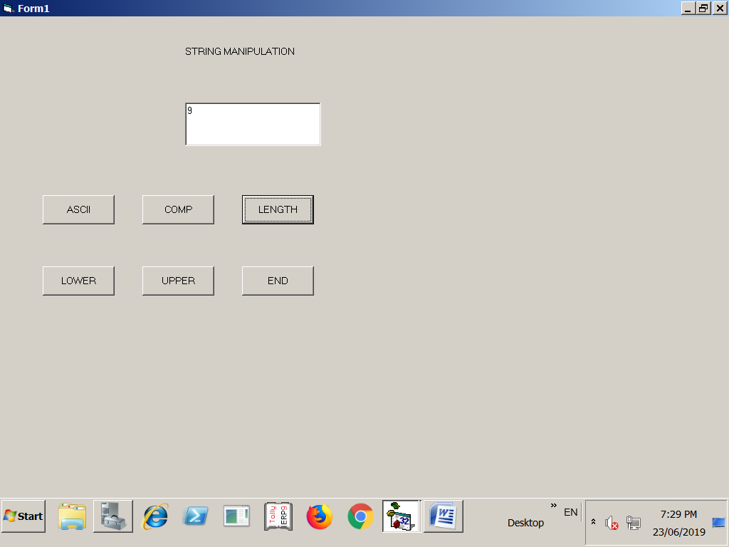
FORM DESIGN:

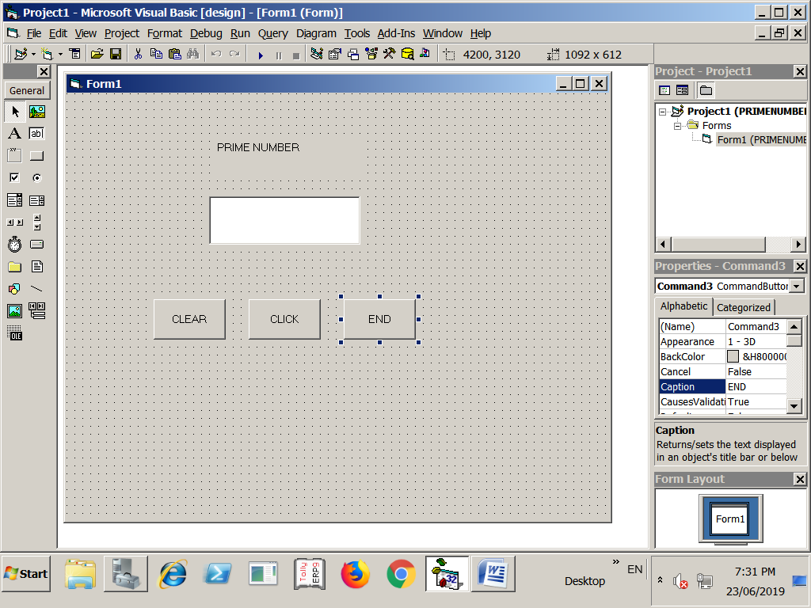
CODING : (PRIME NUMBER)

Private Sub Command1_Click()
Text1.Text = ""
End Sub
Private Sub Command2_Click()
Dim a, b, i As Integer
a = Val(Text1.Text)
i = 1
b = 0
While (i <= a)
If ((a Mod i) = 0) Then
b = b + 1
End If
i = i + 1
Wend
If (b = 2) Then
MsgBox "prime"
Else
MsgBox "not prime"
End If
End Sub
Private Sub Command3_Click()
End
End Sub
OUTPUT:

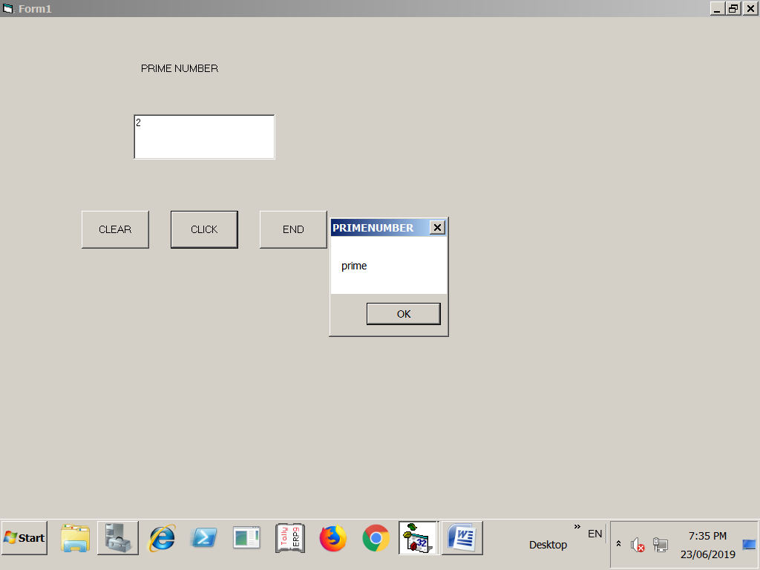
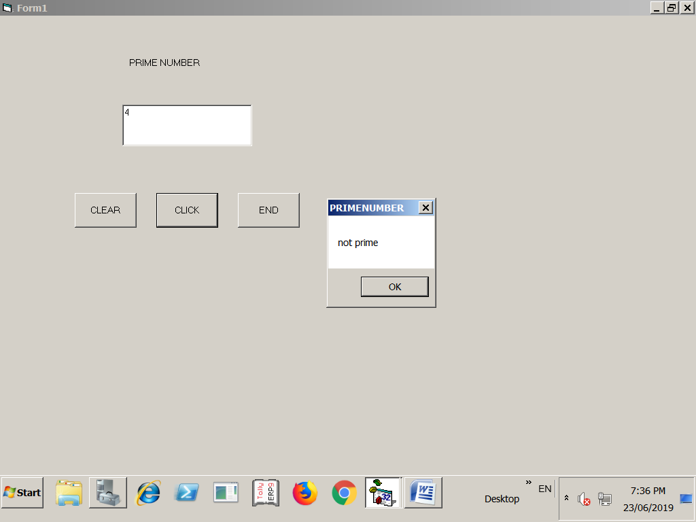
FORM DESIGN:

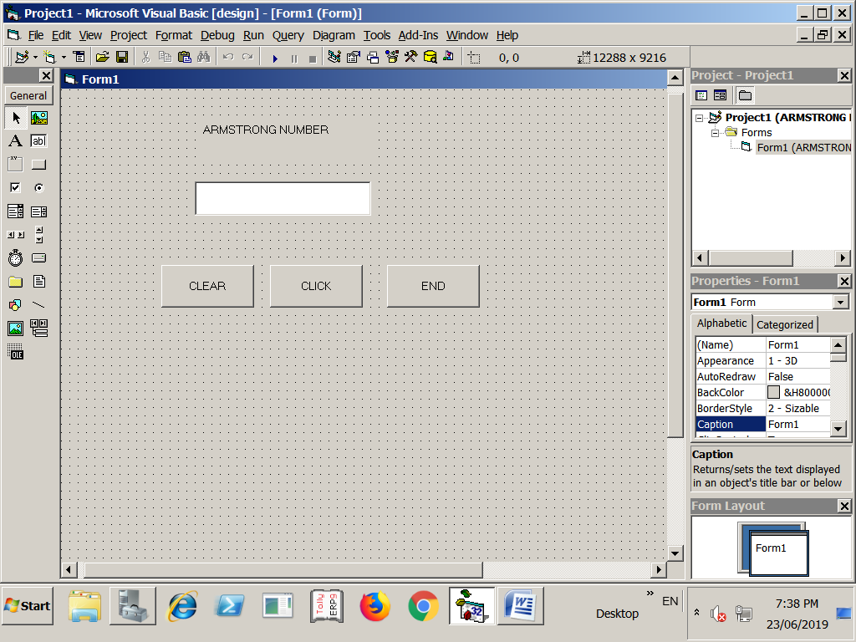
CODING :( ARMSTRONG NUMBER)

Private Sub Command1_Click()
Text1.Text = ""
End Sub

Private Sub Command2_Click()
Dim s, r, n, n1 As Integer
n = Val(Text1.Text)
n1 = n
s = 0
Do While (n > 0)
r = n Mod 10
s = s + (r * r * r)
n = n / 10
Loop
If (n1 = s) Then
MsgBox "amstrong "
Else
MsgBox "not amstrong"
End If
End Sub

Private Sub Command3_Click()
End
End Sub
OUTPUT:

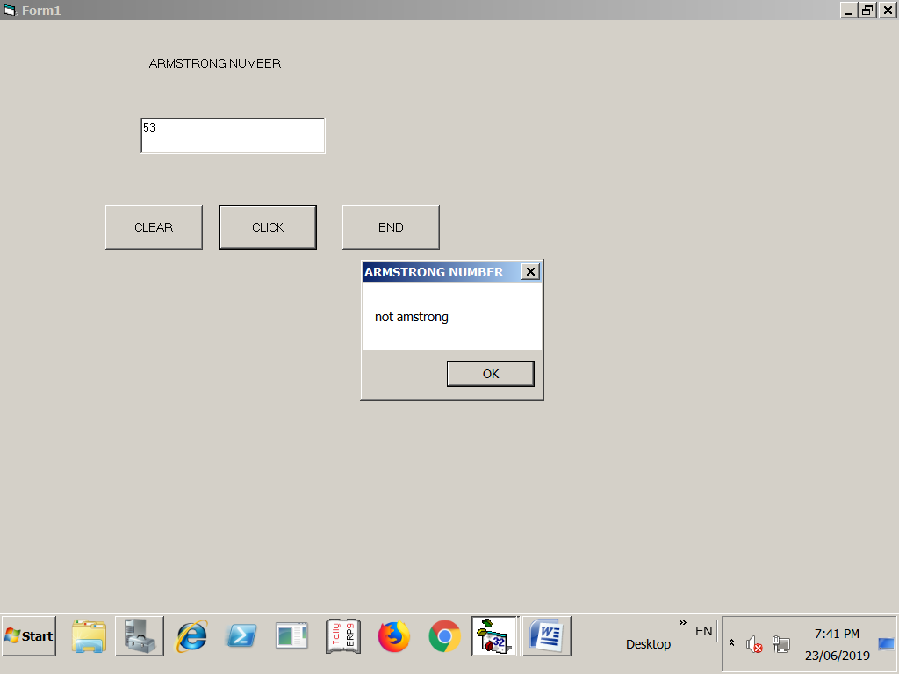
FORM DESIGN:

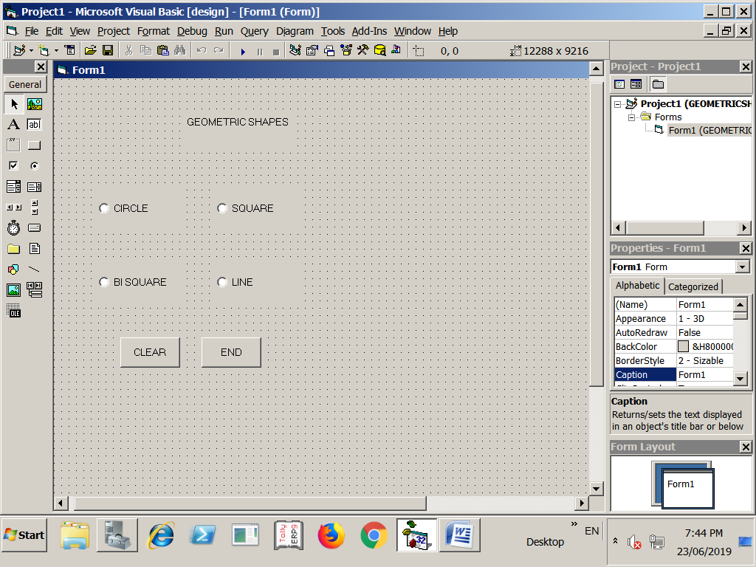
CODING : (GEOMETRIC SHAPES)
Private Sub Command1_Click()
Me.Cls
End Sub
Private Sub Command2_Click()
End
End Sub
Private Sub Form_Load()
Me.AutoRedraw = True
Me.WindowState = 2
Me.Width = Screen.Width
Me.Height = Screen.Height
Option1.Value = False
Option3.Value = False
Option4.Value = False
End Sub
Private Sub Option1_Click()
Me.Cls
Option1.Value = True
x = Screen.Width / 2
y = Screen.Height / 2
Me.Circle (x, y), (Rnd * 300), QBColor(Rnd * 15)
End Sub
Private Sub Option2_Click()
Me.Cls
Option2.Value = True
x = Screen.Width / 2
y = Screen.Height / 2
Me.Line (5000, 4000)-(10000, 8000), QBColor(Rnd * 15), B
End Sub
Private Sub Option3_Click()
Me.Cls
Option3.Value = True
x = Screen.Width / 2
y = Screen.Height / 2
Me.Line (5000, 4000)-(10000, 8000), QBColor(Rnd * 15), BF
End Sub
Private Sub Option4_Click()
Me.Cls
Option4.Value = True
Me.Line (5000, 4000)-(10000, 8000), QBColor(Rndnn * 15)
End Sub
OUTPUT:

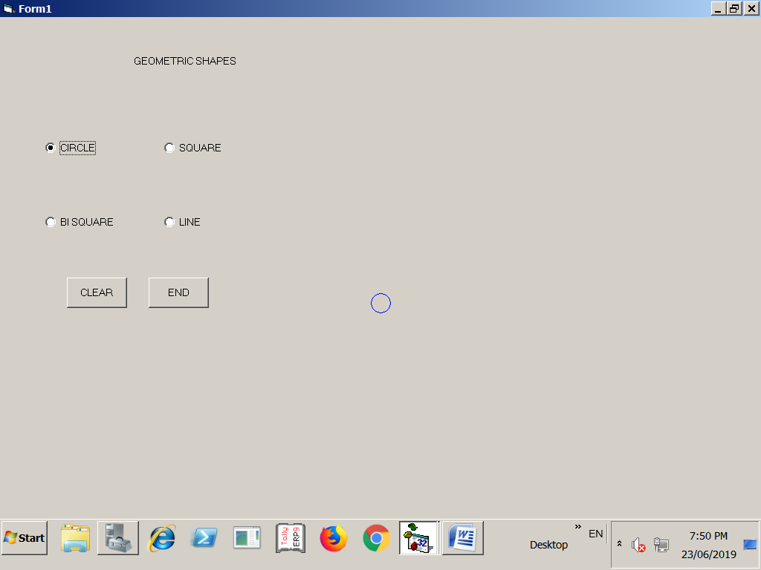
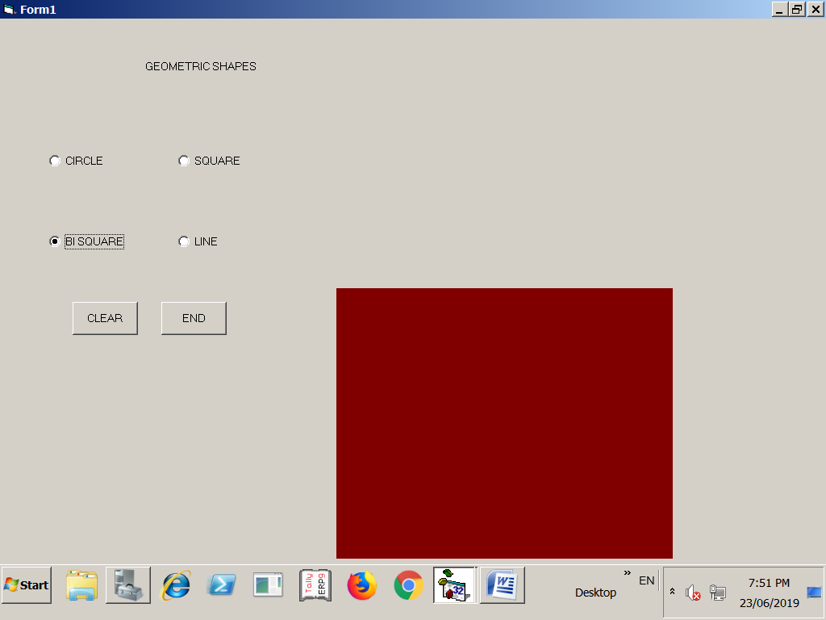
FORM DESIGN:

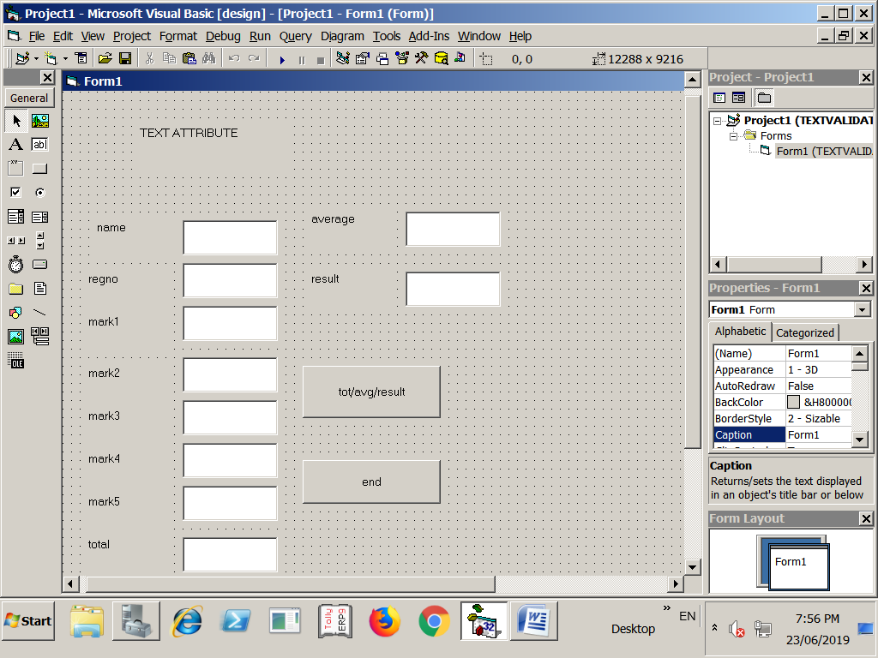
CODING: (TEXT VALIDATION)

Private Sub Command1_Click()
Dim a, b As String
Dim c, d, e, f, g, h, i, j, k As Integer
a = Val(Text1.Text)
b = Val(Text2.Text)
c = Val(Text3.Text)
d = Val(Text4.Text)
e = Val(Text5.Text)
f = Val(Text6.Text)
g = Val(Text7.Text)
h = Val(Text8.Text)
i = Val(Text9.Text)
j = Val(Text10.Text)
k = Val(c) + Val(e) + Val(f) + Val(g)
Text8.Text = Val(k)
Text9.Text = Val(i)
If (c > 35 And d > 35 And e > 35 And f > 35 And g > 35) Then
Text10.Text = "PASS"
Else
Text10.Text = "FAIL"
End If
End Sub
Private Sub Command2_Click()
End
End Sub
OUTPUT:
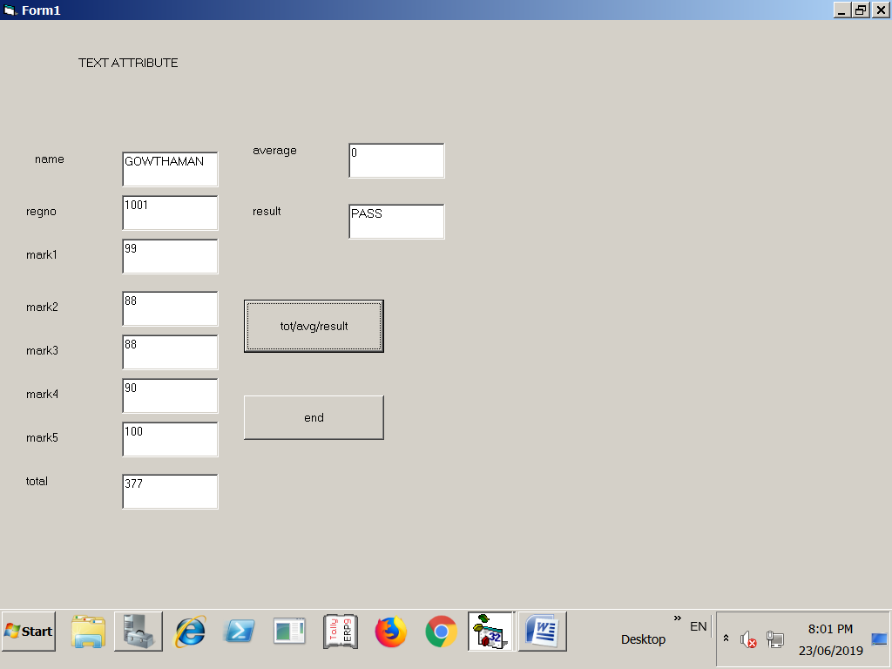
FORM DESIGN:

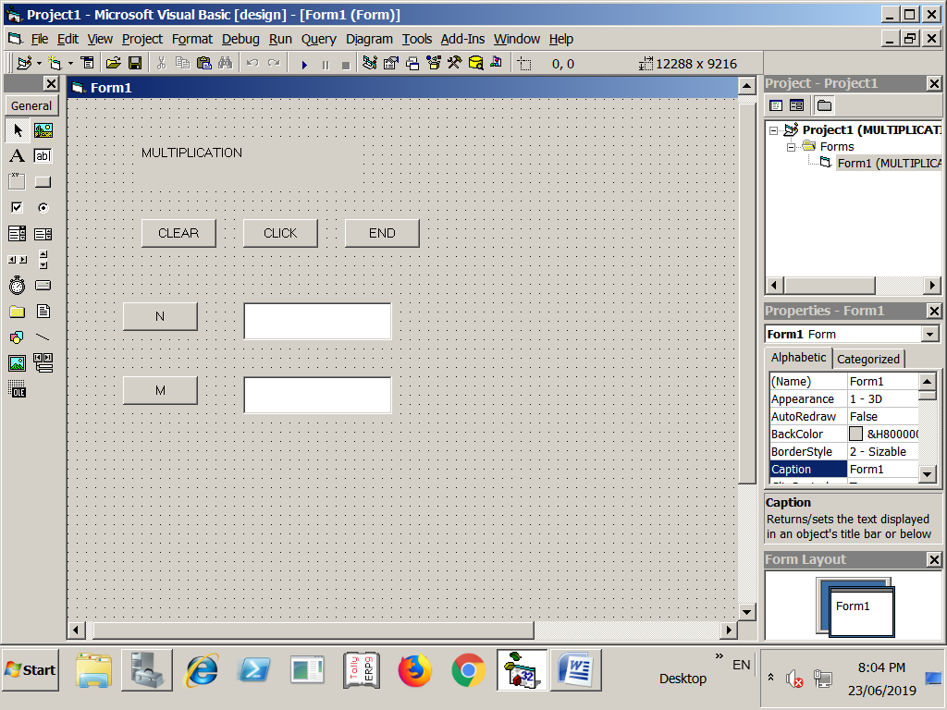
CODING : (MULTIPLICATION TABLE)

Private Sub Command1_Click()
Text1.Text = ""
Text2.Text = ""
Me.Cls
End Sub
Private Sub Command2_Click()
Dim n, m As Integer
n = Val(Text1.Text)
m = Val(Text2.Text)
For i = 1 To n
n = i * m
Print
Print i; "*"; "="; n
Print
Next i
End Sub
Private Sub Command3_Click()
End
End Sub
OUTPUT:

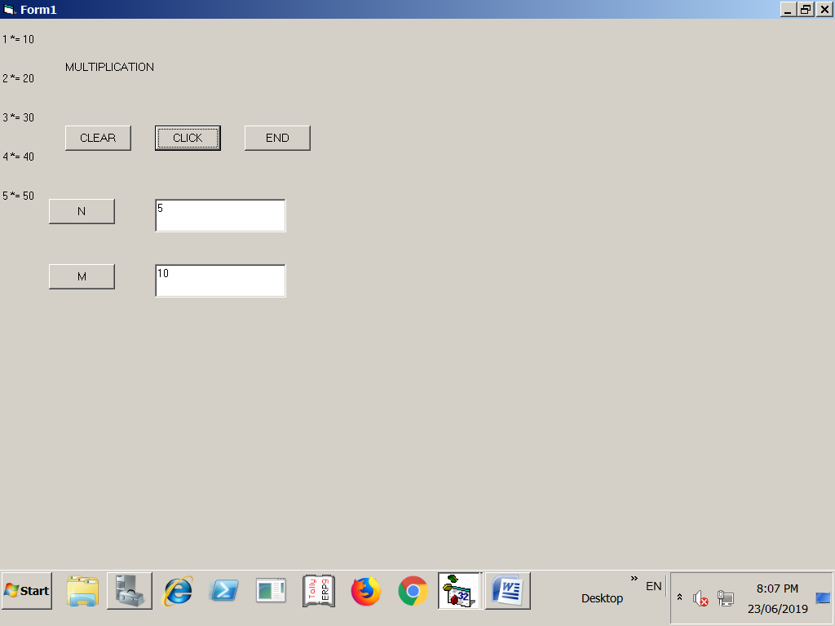
FORM DESIGN :

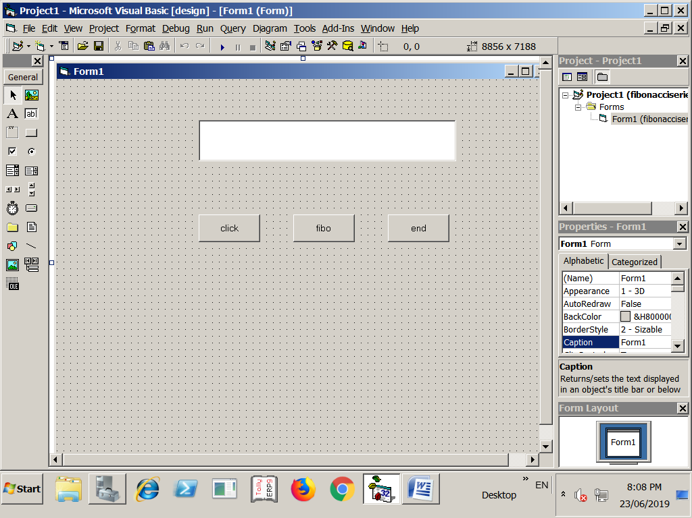
CODING: ( FIBONACCI)

Private Sub Command1_Click()
Me.Cls
Text1.Text = ""
End Sub
Private Sub Command2_Click()
Dim a, n, j As Integer
n = Text1.Text
For j = 0 To n - 1
a = fibo(j)
Print a
Next
End Sub
Private Sub Command3_Click()
End
End Sub
Public Function fibo(m As Integer)
If (m = 0) Then
fibo = 0
Else
If (m = 1) Then
fibo = 1
Else
fibo = fibo(m - 1) + fibo(m - 2)
End If
End If
End Function
OUTPUT:
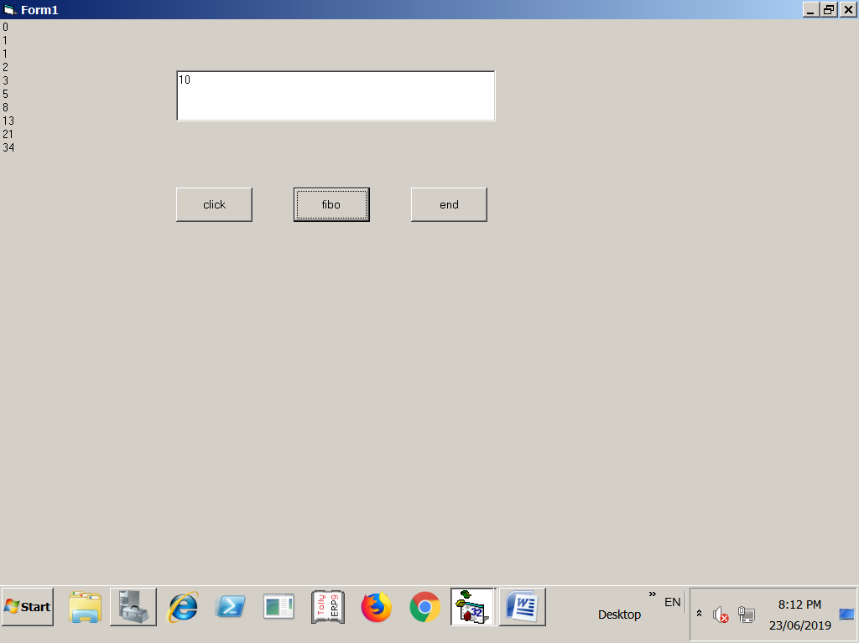
FORM DESIGN (CALCULATOR):

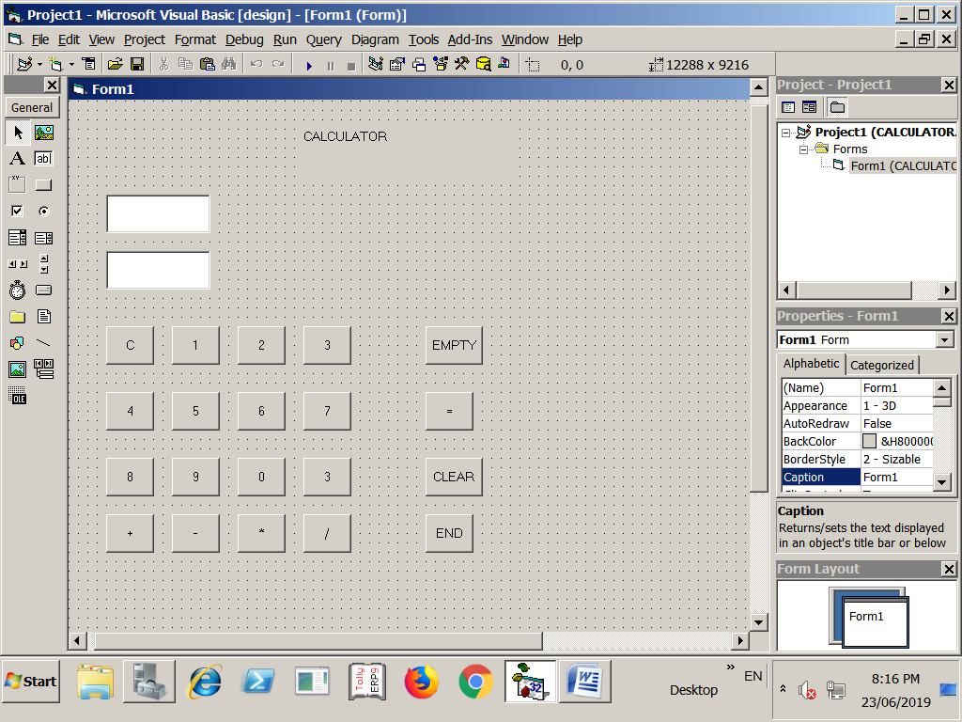
CODING (CALCULATOR):
Dim a, b As Integer
Dim s As String
Private Sub Command1_Click()
Text1.Text = Command1(Index).Caption
End Sub
Private Sub Command18_Click()
Text2.Text = Text1.Text
Text1.Text = ""
Command3.Caption = Command2(Index).Caption
c = Command3.Caption
Select Case (c)
Case "%"
Text1.Text = b / 10
End Select
End Sub
Private Sub Command19_Click()
a = Val(Text2.Text)
b = Val(Text2.Text)
c = Command3.Caption
Select Case (c)
Case "+"
Text2.Text = ""
Text1.Text = a + b
Case "-"
Text2.Text = ""
Text1.Text = a - b
Case "*"
Text2.Text = ""
Text1.Text = a * b
Case "/"
Text2.Text = ""
Text1.Text = a / b
End Select
End Sub
Private Sub Command2_Click()
Text1.Text = ""
Text2.Text = ""
End Sub
Private Sub Command20_Click()
End
End Sub
OUTPUT:

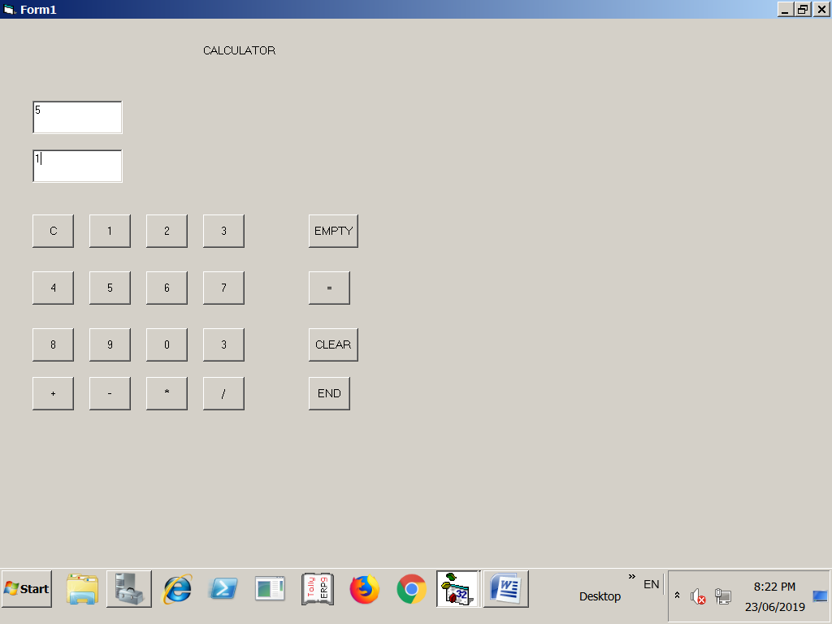
FORM DESIGN:

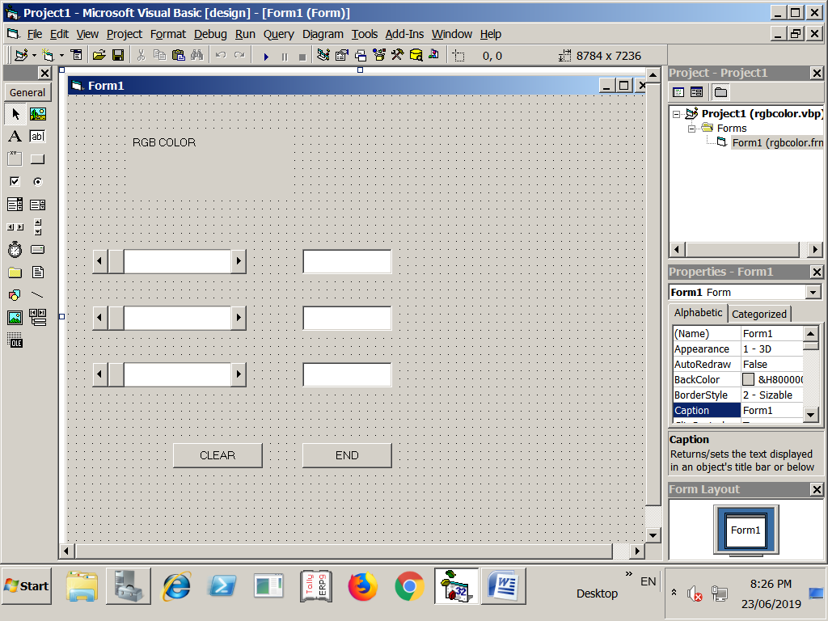
CODING:( RGB COLOR)

Private Sub Command1_Click()
Text1.Text = ""
Text2.Text = ""
Text3.Text = ""
End Sub
Private Sub Command2_Click()
End
End Sub
Private Sub Form_Load()
HScroll1.Min = 0
HScroll1.Max = 255
HScroll2.Min = 0
HScroll2.Max = 255
HScroll3.Min = 0
HScroll3.Max = 255
End Sub
Private Sub HScroll1_Change()
Form1.BackColor = RGB(HScroll1.Value, HScroll2.Value, HScroll3.Value)
Text1.Text = Val(HScroll1.Value)
End Sub
Private Sub HScroll2_Change()
Form1.BackColor = RGB(HScroll1.Value, HScroll2.Value, HScroll3.Value)
Text2.Text = Val(HScroll2.Value)
End Sub
Private Sub HScroll3_Change()
Form1.BackColor = RGB(HScroll1.Value, HScroll2.Value, HScroll3.Value)
Text3.Text = Val(HScroll3.Value)
End Sub
Private Sub Text1_Change()
HScroll1.Value = Val(Text1.Text)
End Sub
Private Sub Text2_Change()
HScroll2.Value = Val(Text2.Text)
End Sub
Private Sub Text3_Change()
HScroll3.Value = Val(Text3.Text)
End Sub
OUTPUT:

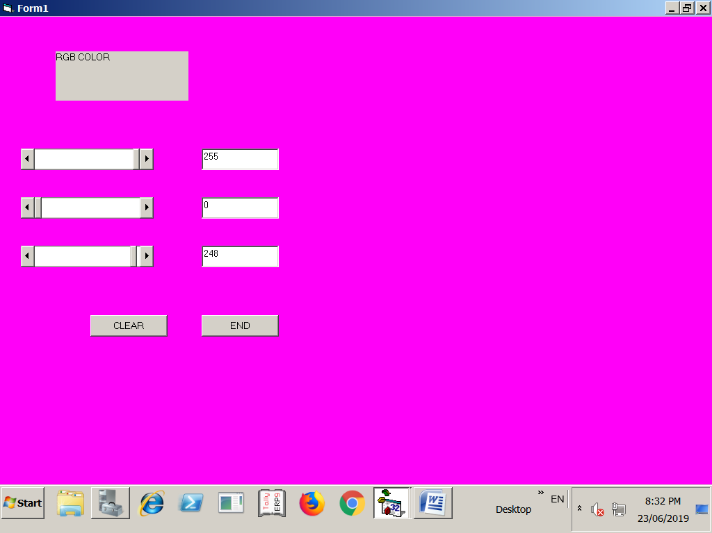
FORM DESIGN:

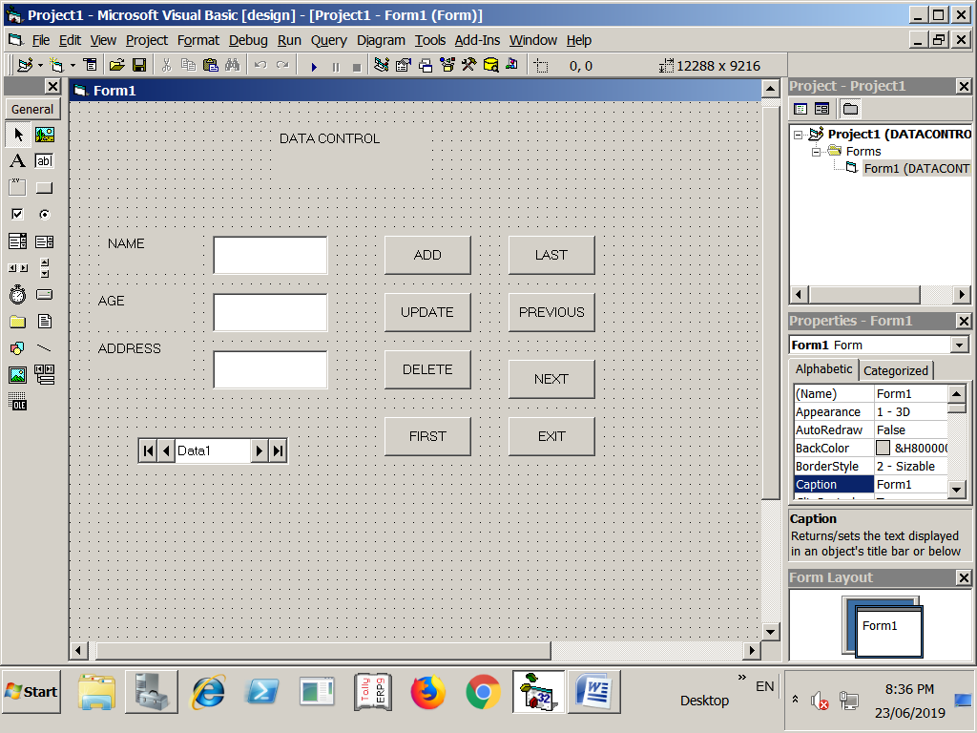
CODING : (DATA CONTROL)
Dim db As Database
Dim rs As Recordset
Private Sub Command1_Click()
Text1.Text = ""
Text2.Text = ""
Text3.Text = ""
Text1.SetFocus
rs.AddNew
End Sub
Private Sub Command2_Click()
rs.Fields(0).Value = Text1.Text
rs.Fields(1).Value = Text2.Text
rs.Fields(2).Value = Text3.Text
rs.Update
MsgBox ("record updated")
End Sub
Private Sub Command3_Click()
Dim n As Integer
n = InputBox("enter the student no to deleted")
rs = MoveFirst
Do While Not rs.EOF
If rs.Fields(1).Value = n Then
rs.Delete
MsgBox ("record deleted")
Exit Sub
End If
rs.MoveLast
Loop
MsgBox ("record not found")
End Sub

Public Function display()
Text1.Text = rs.Fields(0).Value
Text2.Text = rs.Fields(1).Value
Text3.Text = rs.Fields(2).Value
End Function
Private Sub Command4_Click()
rs.MovePrevious
If rs.EOF Then
rs.MoveFirst
End If
Call display
End Sub
Private Sub Command5_Click()
Dim n As Integer
n = InputBox("Enter to selected")
rs.MoveFirst
Do While Not rs.EOF
If rs.Fields(1).Value = n Then
Call display
Exit Sub
End If
rs.MoveNext
Loop
MsgBox ("record not found")
End Sub
Private Sub Command6_Click()
rs.MoveFirst
Call display
End Sub
Private Sub Command7_Click()
rs.MoveLast
Call display
End Sub
Private Sub Command8_Click()
rs.MoveNext
If (rs.EOF) Then
rs.MoveLast
End If
Call display
End Sub
Private Sub Form_Load()
Set db = OpenDatabase("d:\gfolder\DAO.mdb")
Set rs = db.OpenRecordset("stu")
End Sub
OUTPUT:

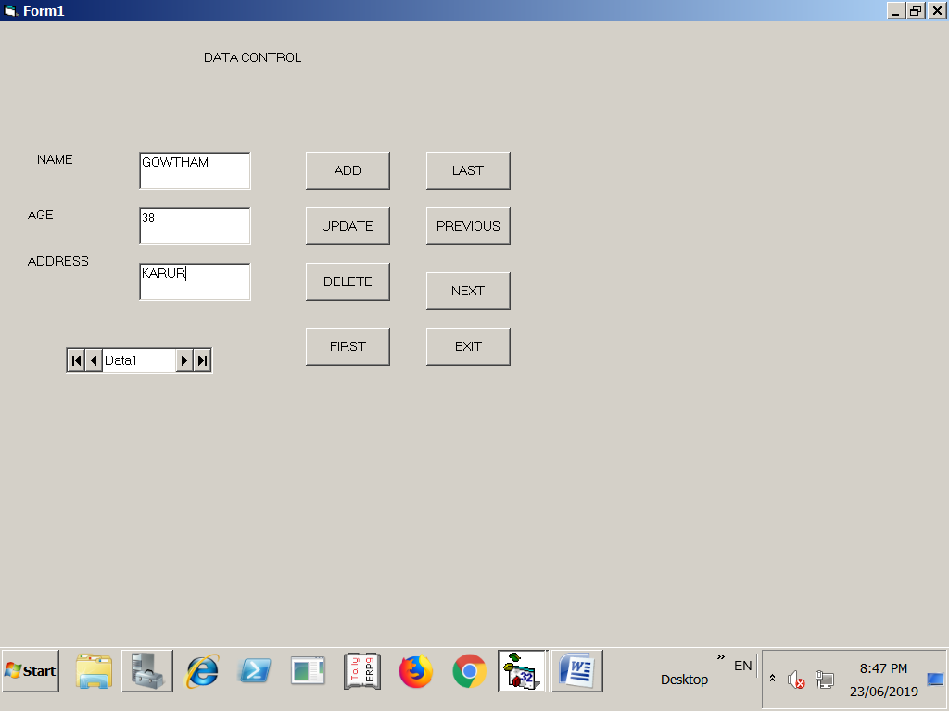
FORM DESIGN:
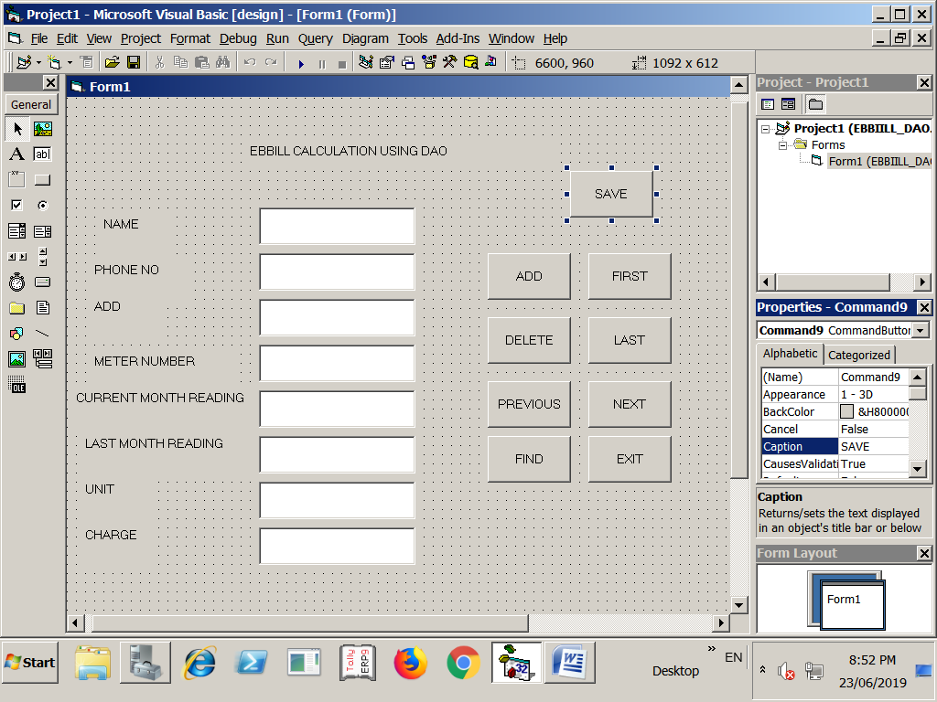
EBBILL(CODING):

Dim db As Database
Dim rs As Recordset
Private Sub Command1_Click()
Text1.Text = ""
Text2.Text = ""
Text3.Text = ""
Text4.Text = ""
Text5.Text = ""
Text6.Text = ""
Text7.Text = ""
Text8.Text = ""
rs.addnew
End Sub
Private Sub Command2_Click()
Dim n As Integer
n = InputBox("Enter the meter no. to be deleted")
rs.MoveFirst
Do While Not rs.EOF
If rs.Fields(3).Value = n Then
rs.Delete
MsgBox ("record deleted")
Exit Sub
End If
rs.MoveLast
Loop
MsgBox ("record not found")
End Sub
Private Sub Command3_Click()
rs.MovePrevious
If (rs.EOF) Then
rs.MoveFirst
End If
Call display
End Sub
Private Sub Command4_Click()
Dim n As Integer
n = InputBox("Enter to seleted")
rs.MoveFirst
Do While Not rs.EOF
If rs.Fields(3).Value = n Then
Call display
Exit Sub
End If
rs.MoveNext
Loop
MsgBox ("record not found")
End Sub

Private Sub Command5_Click()
rs.MoveFirst
Call display
End Sub

Private Sub Command6_Click()
rs.MoveLast
Call display
End Sub

Private Sub Command7_Click()
rs.MoveNext
If (rs.EOF) Then
rs.MoveLast
End If
Call display
End Sub

Private Sub Command8_Click()
Dim a As Integer
a = MsgBox("do you want to exit", vbQuestion - vbYesNo, "exit")
If a = vbYes Then
End
Else
MsgBox ("exit cancelled")
End If
End Sub

Private Sub Command9_Click()
Dim a As Integer
a = MsgBox("saved document?", vbQuestion + vbYesNo, "save")
If a = vbYes Then
rs.Fields(0).Value = Text1.Text
rs.Fields(1).Value = Text2.Text
rs.Fields(2).Value = Text3.Text
rs.Fields(3).Value = Text4.Text
rs.Fields(4).Value = Text5.Text
rs.Fields(5).Value = Text6.Text
rs.Update
MsgBox ("saved")
Else
MsgBox ("cancelled")
End If
End Sub
Public Function display()
Text1.Text = rs.Fields(0).Value
Text2.Text = rs.Fields(1).Value
Text3.Text = rs.Fields(2).Value
Text4.Text = rs.Fields(3).Value
Text5.Text = rs.Fields(4).Value
Text6.Text = rs.Fields(5).Value
End Function

Private Sub Form_Load()
Set db = OpenDatabase("e:/gfolder/eb.mdb")
Set rs = db.OpenRecordset("ebb")
End Sub

Public Function calculate()
Text7.Text = Val(Text5.Text) - Val(Text6.Text)
Text8.Text = Val(Text7.Text) * 0.075
End Function

Private Sub Text5_Change()
Call calculate
End Sub

Private Sub Text6_Change()
Call calculate
End Sub
OUTPUT:

