Online Crime Investigation System

The project report submitted in partial fulfillment of
the requirements for the award of

BACHELOR OF TECHNOLOGY
IN
COMPUTER SCIENCE & INFORMATION TECHNOLOGY

By

Student Name
(Regd. No.)

UNDER THE ESTEEMED GUIDANCE OF

CERTIFICATE

This is to certify that this Project work entitled “ONLINE CRIME INVESTIGATION SYSTEM” is an original work carried out by ************** in partial fulfillment of the requirements for the Award of the Degree in Bachelor of Technology during the year ****– **.

Head of the Department: Guide:

Associate Professor. Associate Professor.

ACKNOWLEDGEMENTS

Project completion fetches any individual fair amount of happiness, while cannot be expressed in words. Likewise I felt the same way after the successful completion of my project. It happened only because of some auxiliary co-operation from some people.

On successful completion of my project work I am bound to convey my sincere thanks to Mr.P.Rajesh M.Sc., project coordinator, Millennium Software Solutions, training division Visakhapatnam, for his valuable guidance through out my project.

I also wish to thank Sri *********. Guide & H.O.D. (I.T./M.C.A.), for giving support and guidance with valuable advises during the whole project.

My sincere thanks to Sri ***********. Principal of ****** Institute of Technology & Management for being a source inspiration and constantly encouraging me through out the course to pursue new goals and ideas.

I am thankful to my friends for the cooperation in my work and grateful thanks to my parents for giving me moral support in this work.

INDEX
CONTENTS

- Abstract 1
- Introduction 2
- Feasibility Study 4
3.1. Technical Feasibility 4
3.2. Operational Feasibility 5
3.3. Economical Feasibility 6
4. Platform Overview 7
4.1. Introduction to JDBC 7
4.2. Introduction to JSP 8
4.3. Introduction to H.T.M.L. 27
4.4. Introduction to ORACLE 29
5. Requirement Analysis 37
5.1.1. Purpose 38
5.1.2. Developers Responsibilities Overview 38
5.2. Current System 39
5.3. Proposed System 40
5.3.1. General Description 40
5.3.1.1. Product Function Overview 40
5.3.1.2. User Characteristics 40
5.3.2. Functional Requirement 41
5.3.3. Non-Functional Requirement 46
6. Design 49
6.1. System Design 49
6.1.1. Design Goals 50
6.1.2. Subsystem Composition 51
6.1.3. Subsystem Services 53
6.1.4. Access Control Security 55
6.1.5. Boundary Conditions 56
6.2. Database Design 56
6.2.1. Introduction to Normalization 59
6.2.2. Table Design 60
7. Project Dictionary. 65
8. Sample Coding. 73
9 Testing. 85
10. Output Forms 96
11. Hardware & Software 119
12. Conclusion. 120
13. Scope 121
14. Bibliography 122

ABSTRACT

1. ABSTRACT

The aim of ONLINE CRIME INVISTIGATION SYSTEM is to marinating the proper customer complaints of different police department. by Using this application people who are afraid to go to police station for complaint about different issues they can give their complaint through online to register any type of complaint they need to register his personal details along with login details. Once he/she registers in the application he/she can post their complaints.

This software comprises of following modules

Administration Module

Department Module

Customer Module

Administration Module: Administrator is responsible to carry out the whole process of registration of different police departments, updating the existed police departments, registering the criminal information along with photo uploading, updating the criminal information. Displaying all available criminal information and police department details.

Department Module: In this module, each department SI will login into this module checks the complaints, which are posted by the customer of his department area. Updates the criminal information and updates the complaint status. the status will be Pending, Process, closed, reopen.

Customer Module: In this module, Customer can register in the application. Updates the Personal information. Registration of new Complaints and checking the posted complaint status. Viewing the all-criminal information category wise. Changing the login details.

INTRODUCTION
2. INTRODUCTION

The objective of the proposed system is to build that provides the facility to the customer to post their complaints about the particular crime or criminal.

The system should keep track of complaints and within no time, the customer should get the solution for his problem.

The proposed system should provide the facilities for the following modules.

- Administrator Module
- Customer Module
- Department Module

Only the authorized persons can login to their respective modules using their username and password.

In administrator module, once an administrator logs on to the system he/she can register the departments and criminals.

The Administrator can update the details of anyone on their demand. He analyzes the performance of each individual .

In customer module, once a customer logs on to the system, he can post a complaint to the department. The customer can view the status to the complaint posted by
him. They can edit their personnel details.

In department module, when department person logs on to the system, he can view the complaints posted by the customers. The department person can then change the status of the cime.

3. FEASIBILITY STUDY

This phase of the analysis is based on the feasibility study of the proposed system. Any system is feasible when given infinite time and resources. The problem is whether the proposed system achieves the goal by using available resources and pre-specified time.

For this to start any project, we have to study the system so that the requirements and goals should be matched. This feasibility study involves:
- Technical feasibility
- Operational feasibility
- Economical feasibility

3.1 Technical feasibility

The proposed system needs the data in an efficient manner i.e., it needs protection of data and authorized access to the data. This is done when we use the software, which supports console-oriented methodology and database methodology.

Therefore technical feasibility determines whether the organization has the technology and skills necessary to carry out the project and how this is obtained. The system is technically feasible on the following grounds:
- All necessary technology is available those that are required to develop the system.
- The existing resource is capable and can hold all the necessary data in an efficient way.
- The system is too flexible and can expanded further.
- The system can give guarantee of accuracy, ease of use , reliability and data-security.
- The system can give instant responses.

The following are the activities that are undertaken during this study:

Development Risks

Determining whether the system can be designed so that the necessary function and performance are achieved within the constraints uncovered during the analysis.

Resource Availability

It specifies whether the hardware and software resources necessary to develop the system are available. Connecting to Oracle is very suitable to accomplish the task. The organization has bought the required hardware and software, these efforts from the organization made the proposed system technically feasible.

Technology:
Whether the relevant technology progressed to such a state that it could support the system. So we can conclude that the project is technically feasible.

3.2 Operational Feasibility

This determines if the proposed system has satisfied user objectives and can be fit into the current system operation. The present system is operationally feasible on the following grounds:

- The method of processing and presentation are completely accepted to the clients since they can meet all the requirements.
- The clients have been involved in the planning and development of the system.
- The proposed system will not cause any problem under any circumstances.

The proposed system will certainly satisfy the user requirements and will also enhance their capabilities. It can be best fit into current operations. Also the maintenance of the system is very easy and requires minimal persons. Therefore, the system is operationally feasible.

3.3 Economical Feasibility

It determines whether the project goal can be within the resource limits allocated to it. It must determine whether it is worthwhile to process with the project or whether the benefit obtained from the new system is not worth the costs. After conducting the cost benefit analysis, it reveals that the objectives of the proposed system can be achieved within the allocated resources. The proposed system requires no extra man-power. Also the cash investment to implement the proposed system can be easily recovered.

4. PLATFORM OVERVIEW.

4.1 INTRODUCTION TO JDBC

JDBC is a java API for executing SQL statements. JDBC is often thought of as standing for Java Database Connectivity. It consists of a set of classes and interfaces written in the Java programming language. JDBC provides standard API tool/database developers and makes it possible to write database application using a pure Java API. Using JDBC, it is easy to send SQL statements to virtually any relation database.

One can write a single program using the JDBC API, and the program will be able to send SQL statements to the appropriate database. The combination of Java and JDBC lets a programmer to write it once and run it anywhere.

Java being robust, secure, easy to understand and automatically downloadable on a network, is an excellent language basis for database applications. A programmer can write or update once, put it on the server, and everybody has access to the latest version.

JDBC makes it possible to do three things:

- Establishes a connection with a database.
- Send SQL statements.
- Process the results.

4.2 INTRODUCTION TO JSP

Java Server Pages (JSP) lets you separate the dynamic part of your pages from the static HTML. You simply write the regular HTML in the normal manner, using whatever Web-page-building tools you normally use. You then enclose the code or the dynamic parts in special tags, most of which start with "<%" and end with %>".

We normally give the file a .jsp extension, and typically install it in any place you could place a normal Web page. Although what you write often looks more like a regular HTML file than a servlet, behind the scenes, the JSP page just gets converted to a normal servlet, with the static HTML simply being printed to the output stream associated with the servlet's service method. This is normally done the first time the page is requested, and developers can simply request the page themselves when first installing it if they want to be sure that the first real user doesn't get a momentary delay when the JSP page is translated to a servlet and the servlet is compiled and loaded. Note also that many Web servers let you define aliases that so that a URL that appears to reference an HTML file really points to a servlet or JSP page.

Aside from the regular HTML, there are three main types of JSP constructs that you embed in a page: scripting elements, directives, and actions. Scripting elements let you specify Java code that will become part of the resultant servlet, directives let you control the overall structure of the servlet, and actions let you specify existing components that should be used, and otherwise control the behavior of the JSP engine.

Syntax Summary
JSP Element | Syntax | Interpretation | Notes
JSP Expression | <%= expression %> | Expression is evaluated and placed in output. | </jsp:expression>. Predefined variables are request, response, out, session, application, config, and page Context
JSP Scriptlet | <% code %> | Code is inserted in service method. | Code  </jsp:scriptlet>.
Declaration | <%! code %> | Code is inserted in body of servlet class, outside of service method. | Code  </jsp: declaration>.
JSP page Directive | <%@ Page att="val" %> | Directions to the servlet engine about general setup. | Legal attributes, with default values in bold, are:  - import="package.class"  - contentType="MIME-Type"  - isThreadSafe="true|false"  - session="true|false"  - buffer="sizekb|none"  - autoflush="true|false"  - extends="package.class"  - info="message"  - errorPage="url"  - isErrorPage="true|false"  - language="java"
JSP include Directive | <%@ include file="url" %> | A file on the local system to be included when the JSP page is translated into a servlet. | The URL must be a relative one. Use the jsp:include action to include a file at request time instead of translation time.
The jsp:include Action | <jsp:include  page="relative URL"  flush="true"/> | Includes a file at the time the page is requested. | If you want to include the file at the time the page is translated, use the page directive with the include attribute instead. Warning: on some servers, the included file must be an HTML file or JSP file, as determined by the server (usually based on the file extension).
The jsp:useBean Action | <jsp:useBean att=val*/> or  <jsp:useBean att=val*>  ...  </jsp:useBean> | Find or build a Java Bean. | Possible attributes are:  - id="name"  - scope="page|request|session|application"  - class="package.class"  - type="package.class"  - beanName="package.class"
The jsp:setProperty Action | <jsp:setProperty att=val*/> | Set bean properties, either explicitly or by designating that value comes from a request parameter. | Legal attributes are  - name="beanName"  - property="propertyName|*"  - param="parameterName"  - value="val"
The jsp:getProperty Action | <jsp:getProperty  name="propertyName"  value="val"/> | Retrieve and output bean properties.
The jsp:forward Action | <jsp:forward  page="relative URL"/> | Forwards request to another page.

Template Text: Static HTML

In many cases, a large percent of your JSP page just consists of static HTML, known as template text. In all respects except one, this HTML looks just like normal HTML, follows all the same syntax rules, and is simply "passed through" to the client by the servlet created to handle the page. Not only does the HTML look normal, whatever tools can create it you already are using for building Web pages.

JSP Scripting Elements

JSP scripting elements let you insert Java code into the servlet that will be generated from the current JSP page. There are three forms:
- Expressions of the form <%= expression %> that are evaluated and inserted into the output,
- Scriptlets of the form <% code %> that are inserted into the servlet's service method, and
- Declarations of the form <%! code %> that are inserted into the body of the servlet class, outside of any existing methods.
Each of these is described in more detail below.

JSP Expressions

A JSP expression is used to insert Java values directly into the output. It has the following form:
<%= Java Expression %>
The Java expression is evaluated, converted to a string, and inserted in the page. This evaluation is performed at run-time (when the page is requested), and thus has full access to information about the request.

JSP Scriptlets

If you want to do something more complex than insert a simple expression, JSP scriptlets let you insert arbitrary code into the servlet method that will be built to generate the page. Scriptlets have the following form:
<% Java Code %>
Scriptlets have access to the same automatically defined variables as expressions.

JSP Declarations

A JSP declaration lets you define methods or fields that get inserted into the main body of the servlet class (outside of the service method processing the request). It has the following form:
<%! Java Code %>
Since declarations do not generate any output, they are normally used in conjunction with JSP expressions or scriptlets.

JSP Directives

A JSP directive affects the overall structure of the servlet class. It usually has the following form:
<%@ directive attribute="value" %>
However, you can also combine multiple attribute settings for a single directive, as follows:
<%@ directive attribute1="value1"
attribute2="value2"
attributeN="valueN" %>
There are two main types of directive: page, which lets you do things like import classes, customize the servlet superclass, and the like; and include, which lets you insert a file into the servlet class at the time the JSP file is translated into a servlet.

The JSP page Directive

The page directive lets you define one or more of the following case-sensitive attributes:
- import="package.class" or import="package.class1,...,package.classN". This lets you specify what packages should be imported. For example:
<%@ page import="java.util.*" %>
The import attribute is the only one that is allowed to appear multiple times.
- contentType="MIME-Type" or
contentType="MIME-Type; charset=Character-Set"
This specifies the MIME type of the output. The default is text/html. For example, the directive
<%@ page contentType="text/plain" %>
has the same effect as the scriptlet
<% response.setContentType("text/plain"); %>
- session="true|false". A value of true (the default) indicates that the predefined variable session (of type HttpSession) should be bound to the existing session if one exists, otherwise a new session should be created and bound to it. A value of false indicates that no sessions will be used, and attempts to access the variable session will result in errors at the time the JSP page is translated into a servlet.
- buffer="sizekb|none". This specifies the buffer size for the JspWriter out. The default is server-specific, but must be at least 8kb.
- autoflush="true|false". A value of true, the default, indicates that the buffer should be flushed when it is full. A value of false, rarely used, indicates that an exception should be thrown when the buffer overflows. A value of false is illegal when also using buffer="none".
- extends="package.class". This indicates the superclass of servlet that will be generated. Use this with extreme caution, since the server may be using a custom superclass already.
- errorPage="url". This specifies a JSP page that should process any Throwables thrown but not caught in the current page.
- isErrorPage="true|false". This indicates whether or not the current page can act as the error page for another JSP page. The default is false.
- language="java". At some point, this is intended to specify the underlying language being used. For now, don't bother with this since java is both the default and the only legal choice.
The XML syntax for defining directives is
<jsp:directive.directiveType attribute=value />

The JSP include Directive

This directive lets you include files at the time the JSP page is translated into a servlet. The directive looks like this:
<%@ include file="relative url" %>
The URL specified is normally interpreted relative to the JSP page that refers to it, but, as with relative URLs in general, you can tell the system to interpret the URL relative to the home directory of the Web server by starting the URL with a forward slash. The contents of the included file are parsed as regular JSP text, and thus can include static HTML, scripting elements, directives, and actions.

Note that since the include directive inserts the files at the time the page is translated, if the navigation bar changes, you need to re-translate all the JSP pages that refer to it. This is a good compromise in a situation like this, since the navigation bar probably changes infrequently, and you want the inclusion process to be as efficient as possible. If, however, the included files changed more often, you could use the jsp:include action instead.

Predefined Variables

To simplify code in JSP expressions and scriptlets, you are supplied with eight automatically defined variables, sometimes called implicit objects. The available variables are request, response, out, session, application, config, pageContext, and page. Details for each are given below.

request
This is the HttpServletRequest associated with the request, and lets you look at the request parameters (via get Parameter), the request type (GET, POST, HEAD, etc.), and the incoming HTTP headers (cookies, Referrer, etc.). Strictly speaking, request is allowed to be a subclass of ServletRequest other than HttpServletRequest, if the protocol in the request is something other than HTTP. This is almost never done in practice.

response
This is the HttpServletResponse associated with the response to the client. Note that, since the output stream (see out below) is buffered, it is legal to set HTTP status codes and response headers, even though this is not permitted in regular servlets once any output has been sent to the client.

out
This is the PrintWriter used to send output to the client. However, in order to make the response object useful, this is a buffered version of PrintWriter called JspWriter. Note that you can adjust the buffer size, or even turn buffering off, through use of the buffer attribute of the page directive.

session
This is the HttpSession object associated with the request. Recall that sessions are created automatically, so this variable is bound even if there was no incoming session reference. The one exception is if you use the session attribute of the page directive to turn sessions off, in which case attempts to reference the session variable cause errors at the time the JSP page is translated into a servlet.

application
This is the ServletContext as obtained via getServletConfig().getContext().

config
This is the ServletConfig object for this page.

pageContext
JSP introduced a new class called PageContext to encapsulate use of server-specific features like higher performance JspWriters. The idea is that, if you access them through this class rather than directly, your code will still run on "regular" servlet/JSP engines.

page
This is simply a synonym for this, and is not very useful in Java. It was created as a placeholder for the time when the scripting language could be something other than Java.

Actions
JSP actions use constructs in XML syntax to control the behavior of the servlet engine. You can dynamically insert a file, reuse JavaBeans components, forward the user to another page, or generate HTML for the Java plugin. Available actions include:
- jsp:include - Include a file at the time the page is requested.
- jsp:useBean - Find or instantiate a JavaBean.
- jsp:setProperty - Set the property of a JavaBean.
- jsp:getProperty - Insert the property of a JavaBean into the output.
- jsp:forward - Forward the requester to a new page.

The jsp:include Action
This action lets you insert files into the page being generated. The syntax looks like this:
<jsp:include page="relative URL" flush="true" />
Unlike the include directive, which inserts the file at the time the JSP page is translated into a servlet, this action inserts the file at the time the page is requested. This pays a small penalty in efficiency, and precludes the included page from containing general JSP code (it cannot set HTTP headers, for example), but it gains significantly in flexibility. For example, here is a JSP page that inserts four different snippets into a "What's New?" Web page. Each time the headlines change, authors only need to update the four files, but can leave the main JSP page unchanged.

The jsp:useBean Action

This action lets you load in a JavaBean to be used in the JSP page. This is a a very useful capability because it lets you exploit the reusability of Java classes without sacrificing the convenience that JSP adds over servlets alone. The simplest syntax for specifying that a bean should be used is:
<jsp:useBean id="name" class="package.class" />

Jsp: useBean
The simplest way to use a bean is to use
<jsp:useBean id="name" class="package.class" />
to load the bean, then use jsp:setProperty and jsp:getProperty to modify and retrieve bean properties. However, there are two other options. First, you can use the container format, namely
<jsp:useBean ...>
Body
</jsp:useBean>
to indicate that the Body portion should be executed only when the bean is first instantiated, not when an existing bean is found and used. As discussed below, beans can be shared, so not all jsp:useBean statements result in a new bean being instantiated. Second, in addition to id and class, there are three other attributes that you can use: scope, type, and beanName. These attributes are summarized in the following table.

Atribute | Usage
Id | Gives a name to the variable that will reference the bean. A previous bean object is used instead of instantiating a new one if one can be found with the same id and scope.
Class | Designates the full package name of the bean.
scope | Indicates the context in which the bean should be made available. There are four possible values: page, request, session, and application. The default, page, indicates that the bean is only available on the current page (stored in the PageContext of the current page). A value of request indicates that the bean is only available for the current client request (stored in the ServletRequest object). A value of session indicates that the object is available to all pages during the life of the current HttpSession. Finally, a value of application indicates that it is available to all pages that share the same ServletContext. The reason that the scope matters is that a jsp:useBean entry will only result in a new object being instantiated if there is no previous object with the same id and scope. Otherwise the previously existing object is used, and any jsp:setParameter elements or other entries between the jsp:useBean start and end tags will be ignored.
Type | Specifies the type of the variable that will refer to the object. This must match the classname or be a superclass or an interface that the class implements. Remember that the name of the variable is designated via the id attribute.
beanName | Gives the name of the bean, as you would supply it to the instantiate method of Beans. It is permissible to supply a type and a beanName, and omit the class attribute.

jsp:setProperty

You use jsp:setProperty to give values to properties of beans that have been referenced earlier. You can do this in two contexts.First, you can use jsp:setProperty after, but outside of, a jsp:useBean element, as below:
<jsp:useBean id="myName" ... />
...
<jsp:setProperty name="myName"
property="someProperty" ... />
There are four possible attributes of jsp:setProperty:

Attribute | Usage
Name | This required attribute designates the bean whose property will be set. The jsp:useBean element must appear before the jsp:setProperty element.
Property | This required attribute indicates the property you want to set. However, there is one special case: a value of "*" means that all request parameters whose names match bean property names will be passed to the appropriate setter methods.
Value | This optional attribute specifies the value for the property. String values are automatically converted to numbers, boolean, Boolean, byte, Byte, char, and Character via the standard valueOf method in the target or wrapper class. For example, a value of "true" for a boolean or Boolean property will be converted via Boolean.valueOf, and a value of "42" for an int or Integer property will be converted via Integer.valueOf. You can't use both value and param, but it is permissible to use neither. See the discussion of param below.
Param | This optional attribute designates the request parameter from which the property should be derived. If the current request has no such parameter, nothing is done: the system does not pass null to the setter method of the property. Thus, you can let the bean itself supply default values, overriding them only when the request parameters say to do so. Param, it is the same as if you supplied a param name that matches the property name. You can take this idea of automatically using the request property whose name matches the property one step further by supplying a property name of "*" and omitting both value and param. In this case, the server iterates through available properties and request parameters, matching up ones with identical names.

jsp:getProperty

This element retrieves the value of a bean property, converts it to a string, and inserts it into the output. The two required attributes are name, the name of a bean previously referenced via jsp:useBean, and property, the property whose value should be inserted.

Here's an example; for more examples,
<jsp:useBean id="itemBean" ... />
...
<UL>
<LI>Number of items:
<jsp:getProperty name="itemBean" property="numItems" />
<LI>Cost of each:
<jsp:getProperty name="itemBean" property="unitCost" />
</UL>

jsp:forward

This action lets you forward the request to another page. It has a single attribute, page, which should consist of a relative URL. This could be a static value, or could be computed at request time, as in the two examples below.
<jsp:forward page="/utils/errorReporter.jsp" />
<jsp:forward page="<%= someJavaExpression %>" />

4.3 HYPER-TEXT MARKUP LANGUAGE

Introduction
Hyper Text Markup Language is a structural markup language used to create and format a web document. A markup language such as HTML is simply a collection of codes, called Elements that are used to indicate the structure and format of a document. A user agent, usually a web browser that renders the document, interprets the meaning of these codes to figure how to structure or display a document. HTML is not invention but it is an improved version of Standard Generalized Markup Language (SGML).

HTML in the following four stages:
- Level-0 included only the basic structural elements and assured that all browsers supported all features.
- Level-1 advanced features included highlighted text and graphics that were supported depending on the browser capability.
- Level –2 introduced the World Wide Web as an interactive medium and the feature of fill out forms on the Internet.
- Level-3 introduced frames, inline, video, sound, etc.

Importance of HTML
- HTML can be used to display any type of document on the host computer, which can be geographical at a different location.
- It is a versatile language and can be used on any platform or desktop.
- The appearance of a Web page is important, and HTML provides tags to make the document look attractive. Using graphics, fonts, different sizes, color, etc. can enhance the presentation of the document.

Functionality of HTML in the project:

As we know this is purely web-based project. This helps to embed Java Server Pages within the page using some simple tags.
- Used to design the forms.
- User can communicate easily with server.

4.4 INTRODUCTION TO ORACLE
A modern Relational Database Management System can perform a wide array of tasks. It acts as a transparent interface between the physical storage and the logical presentation of data .In practice; it provides a set of more or less flexible and sophisticated tools for handling information.
Because it gives you so much control over the Relational DBMS can also serve as the foundation for products that generate applications and extract data. Which of these abilities you considered most important depends upon the job that you need to do. How might be in charge of creating and maintaining a Database. You might be a casual user who primarily works with existing applications to accomplish specific tasks or you might be a system developer who creates such application. A DBMS must also be secure from unauthorized access and provide efficient solutions for failure recovery. The ORACLE server provides efficient solutions for the database features.

Large Databases And Space Management Control

Oracle supports the largest of database, potentially hundreds of gigabytes in size. To make efficient use of expensive hardware devices, it allows full control of space usage.

Many Concurrent Database Users
Oracle support large number of concurrent users executing a variety of database applications operating on the same data. It minimizes data contention and guarantees data concurrency.

High Transaction Processing Performance
Oracle maintains the preceding features with a high degree of overall system performance. Data users do not suffer from slow processing performance.

High Availability
At some sites, Oracle works 24 hours per day with no down time to limit the database through put. Normal systems operations such as database backup and partial computer system failures do not interrupt database users.

Controlled Availability
Oracle can selectively control the availability of data, at the database level and sub database level. For example, an administrator can disallow, without affecting other applications.

Manageable Security
Disaster recovery can be extremely problematic. Oracle has several features that ensure the integrity of your database. If an interruption occurs in processing, a rollback can reset the database a point before a disaster. If a restore is necessary, Oracle has a role forward command for recreating our database to its most recent safe point. Oracle provide users with several functions for securing data, grant and revoke commands limit, access to information down to the row and column levels. Views are valuable feature for limiting access to the primary tables in the database. As you can see, there are many ways to control access to an Oracle database.

Data Enforced Integrity
Oracle enforces data integrity. “Business Rules” that dictate the standards for acceptable data. As a result, the costs of coding and managing checks in many database applications are eliminated.

Client/Server Environment
To take full advantage of a given computer system or network, Oracle allows processing to be split between the database server and the client application programs. The oracle is processed all responsibilities of shared data management system.

Distributed Database Systems
For computing environments that are connected via networks, Oracle combines the data physically located on different computers into one logical database that can be accessed by all network users. Distributed systems have the same degree of user transparency and data consistency as non-distributed systems; yet receive the advantage of local database management.

Portability
Oracle software is ported to work under different operating systems and is the same on all the systems. Applications developed for oracle can be ported any operating systems with little or no modifications.

Compatibility
Oracle software is compatible with industry standard operating systems. Applications developed for oracle can be used on virtually any systems with little or no modifications.

Connect ability
Oracle software allows different types of computers and operating systems to share information across networks.

Oracle Performs Competitively
Through years of experience in the mini and mainframe markets, Oracle has been constantly improved to perform competitively on largest database. Because relational database systems have been humped by a reputation for slow access times oracle has to provide its continuity.

The Object-Relational Model for Database Management
Database management systems have evolved from hierarchical to network to relational models. The most widely accepted database model is the relational model. Oracle extends the relational model to an object-relational model, which makes it possible to store complex business models in a relational database.

The Relational Model
The relational model has three major aspects:
Structures
Structures are well-defined objects (such as tables, views, indexes, and so on) that store or access the data of a database. Structures and the data contained within them can be manipulated by operations.
Operations
Operations are clearly defined actions that allow users to manipulate the data and structures of a database. The operations on a database must adhere to a predefined set of integrity rules.
Integrity Rules
Integrity rules are the laws that govern which operations are allowed on the data and structures of a database. Integrity rules protect the data and the structure of a database.
Relational database management systems offer benefits such as:
1. Independence of physical data storage and logical database structure.
2. Variable and easy access to all data
3. Complete flexibility in database design
4. Reduced data storage and redundancy

The Object-Relational Model
The object-relational model allows users to define object types, specifying both the structure of the data and the methods of operating on the data, and to use these data types within the relational model. Object types are abstractions of the real-world entities--for example, purchase orders--that application programs deal with. An object type has three kinds of components:
      - A name, which serves to identify the object type uniquely.
      - Attributes, which are built-in data types or other user-defined types. Attributes model the structure of the real world entity.
      - Methods, which are functions or procedures written in PL/SQL and stored in the database, or written in a language like C, are stored externally. Methods implement specific operations that an application can perform on the data. Every object type has a constructor method that makes a new object according to the data type’s specification.

Structured Query Language (SQL)
SQL (pronounced SEQUEL) is the programming language that defines and manipulates the database. SQL databases are relational

FEATURES OF ORACLE
- Oracle provides a good security by providing the capability to make users with their own passwords with different privileges.
- It includes the provision to define table level or column level constraints
- (Primary key, Not Null, Unique) and some referential constraints such as foreign key.
- It is easy to retrieve data needed by giving proper SQL commands.
- We can bunch the SQL commands and make the bunch executed once by means of PL/SQL (procedures).
- It provides to store our procedures as a library functions by means of Stored Procedures.
- It includes the facility for corresponding updates by means of triggers.
- It gives the capability to access record by means of Cursors.
- It provides a facility to create views and synonyms that hide the original table and also have many more advantages.
- It can able to store data more than 1 GB by using data types like Long, BLOB, CLOB etc.
- It has the capability to store the references of files that resides outside the database by means of the data type BFILE.
- It supports client handler, which is a section of code written specifically to deal with errors.
It supports large database and space management control, concurrent database users; manageable enforces integrity, client/server environment, distributed database systems, portability, compatibility, connectivity.

SOFTWARE REQUIREMENT SPECIFICATION

5. REQUIREMENT ANALYSIS
Requirements analysis is done in order to understand the problem the software system is to solve. The problem could be automating an existing manual process, developing a new automated system, or a combination of the two. For large systems that have many features, and that need to perform many different tasks, understanding the requirements of the system is a major task.

The emphasis in requirements analysis is on identifying what is needed from the system, not how the system will achieve its goals. This task is complicated by the fact that there are often at least two parties involved in software development-a client and a developer. The developer usually does not understand the client’s problem domain and the client does not understand the issues involved in the system software systems developed by the developers. Hence causes a communication gap between them.

This communication gap is bridged during the analysis. This analysis phase ends with a document describing all the requirements called as SRS (Software Requirements Specification).

There are two major activities involved in this phase. Problem understanding or analysis and requirement specification. In problem analysis, the analyst has to understand the problem and its context. Such analysis typically requires through understanding of the existing system, parts which have to be automated. A clear understanding is needed of the important data entities in the system, major centers where action is taken, the purpose of the different actions that are performed and the inputs and outputs.
5.1.1 Purpose:
The purpose of “ONLINE CRIME INVESTIGATION SYSTEM” is to provide the solution for the bug posted by the customer within no time. The manager should be able to organize the entire bug efficiently and assign the bug to the concerned technical person. The system should provide the solution to the customer in possible proposed date.
5.1.2 Developers Responsibilities Overview
- Developing the System
- Testing the product at developers and users place
- Installing the software
- Conducting the users training
- Maintaining the System
- Listening the Clients periodically to know the status of the product
- Any changes thereafter should be followed by testing and implementation

5.2 CURRENT SYSTEM
Now a days, almost everyone is using computers. Some people use it for writing letters, sending mails etc. Few people use it for developing applications and few people use it for entertainment purpose. Like this computers are useful for almost everyone in something or the other way.
When people are working with computers, they may or may not be aware of computers and more importantly when they are using the software products of different vendors, they may face some problems. If such is the case, the users may not get a proper solution immediately and sometimes it would also take a very long time to get a solution for his/her problem.
For getting proper solutions, the users have to contact the concerned organization that has provided the software and tell their problem. The concerned organization will then provide a solution for his/her problem within a period of time.

Problems with the Current System
- There is a communication gap between the customer and department.
- People generally don’t know the sites of all the departments to post their complaints.
- Customer face problem while posting their complaints
As they have to post their complaints to different departments individually.
- There is no surety of quick response from the department.
- Few departments may not be interested in responding to the customers.
So in order to overcome all these limitations and to meet all their requirements the current process is replaced with this application.

5.3 PROPOSED SYSTEM

5.3.1 General Description
5.3.1.1 Product Function Overview:
This product interacts with mainly three entities i.e. Customer, Administrator and Department person.

5.3.1.2 User Characteristics:
The main user of the system is the Administrator uses it. So to use the system, the Administrator should have the knowledge of the following topics:
      - The Administrator should have working knowledge on computers.
      - The Administrator should know how to use an operating system for running applications.
5.3.2 Functional Requirements
The functional requirements describe the interactions between the system and its environment independent of its implementation.
Administration Module:
The system should accept the following as input from Administration of organization for successful login.
Valid username
Password
After successful login, the administrator is provided with the following options, which require some data entry
To add new department
To add new criminal
To update criminal information
To update department information

The administrator has to register the details of department and criminal . For every complaint posted by the customer will be checked by the department .

Department Registration: This takes the following as Input

Department Name
SI Name
DepartmentAddress
Police Station Area
Contact No
Login Name
Password
After submitting all the details, a unique ID is generated to uniquely identify that particular Department.
Criminal Registration: This takes the following as Input

Criminal Name
Criminal Location
Wanted Since
Type Of Crime
Criminal Photo

After submitting all the details, a unique ID is generated to uniquely identify that particular criminal.
Customer Module
Customer Registration- This module takes the following details as Input

Customer Name
CustomerAddress
Contact No
Login Name
Password

After submitting all the details, a unique ID is generated to uniquely identify that particular customer.

Customer Login- This module takes the following details as Input
Customer name
Password
It validates all the above fields and if the input given is valid then the customer is allowed to enter to its main page.

Complaint registration- This module takes the following details as Input

Problem Description
Area
Complaint Type
After submitting all the details, a unique ID is generated to uniquely identify that particular customer complaint.

Department Module: The system should accept the following as input from department person for successful login.
Valid username
Password
After successful login, the department person is provided with the following options, which require some data entry

5.3.3 Non-Functional Requirements
Non-functional requirements describe user-visible aspects of the system that are not directly related to functionality of the system.
User Interface
A menu interface has been provided to the client to be user friendly.

Documentation
The client is provided with an introductory help about the client interface and the user documentation has been developed through help hyperlink.

Performance Constraints
- Requests should be processed within no time.
- Users should be authenticated for accessing the requested data

Error Handling and Extreme Conditions
In case of User Error, the System should display a meaningful error message to the user, such that the user can correct his Error.
The high level components in proposed system should handle exceptions that occur while connecting to database server, IOExceptions etc.

Quality Issues
Quality issues refer to how reliable, available and robust should the system be? While developing the proposed system the developer must be able to guarantee the reliability transactions so that they will be processed completely and accurately.
The ability of system to detect failures and recovery from those failures refers to the availability of system.
Robustness of system refers to the capability of system providing information when concurrent users requesting for information.

Security
Security and confidentiality are the top most concerns of the client. The proposed system should provide the following
- Each customer should also be provided with ID and password for controlled access.
- Access to database should also be restricted to the managing department only.

Acceptance Criteria
The developer will have to demonstrate and show to the user that the system works by testing with suitable test cases so that all conditions are satisfied.

SYSTEM DESIGN
6. DESIGN

6.1 SYSTEM DESIGN
System design is the process, which involves conceiving planning and carrying out the plan by generating the necessary reports and inputs. In other words design phase acts as a bridge between the software requirement specification and implementation phase, which satisfies those requirements. System Design is the transformation of the analysis model into a system design model.
The design of a system is correct if a system built precisely according to the requirements of that system. Design should be clearly verifiable, complete and traceable. The goal is to divide the problem into manageably small modules that can be solved separately. The different modules have to cooperate and communicate together to solve the problem. The complete project is broken down into different identifiable modules. Each module can be understood separately. All the modules at last are combined to get the solution of the complete system.

6.1.1 Design Goals
The definition of design goals is the first step of system design. In our proposed system the goals identified are reliability, fault tolerance, security and modifiability. “Online Technical Support” should be reliable; fault tolerant to loss of connectivity of server as well as it should be secure and can be modified later by any software developers.
Performance criteria
The proposed system “Online Technical Support” should have fast response while customers are posting their bugs, managers should be able to handle the bugs in an efficient manner and provide the response as quickly as possible. There should be no loss of information given by the customer regarding their bugs.
Dependency criteria
The proposed system must handle both low level and high-level exceptions with appropriate alert messages.
Cost criteria:
It includes development cost, deployment cost, maintenance cost and administration cost. As the proposed system will be developed using software, which is free ware, hence it can be developed with minimum costs. As the proposed system is “Online Technical Support”, deployment of it requires certain amount. Maintenance costs required performing enhancements to the system. Administration costs are required to administrate the system.

Maintenance criteria
The proposed system is extensible i.e., new features can be added to the system and also it is easily modifiable and portable i.e. it is possible to adapt software developed for this system to different platforms.
End User criteria
The proposed system supports the work of all the customers throughout the world. Hence it should be kept into the consideration that every customer can easily interact with the system.

6.1.2 SUBSYSTEM DECOMPOSITION
The developed system can be divided into following modules
Customers:
- Customers Registration
- Customer Login
- Posting their complaints
- Viewing status of complaints
- Viewing department information
- Viewing Criminal information

Department:
- Department Registration
- Department Login
- Viewing Posted complaints
- Viewing customer information
- Viewing criminal information.

6.1.3 Subsystem Services
Customers
Customer Registration - The aim of this module is to provide all the details of the customers so that by providing all the details, he can get registered with this web site. After registering, the customer will be getting a unique id. Using that unique id the customer can logon to this web site.
Customer Login - The aim of this module is that the customers with their login ID and password can now logon to the Systems and use the service.
Posting Complaints - The aim of this module is to provide all the details of the complaint by the customer and post the complete details to the manager.
Viewing Complaint Status - The aim of this module is to provide an interface to the customer to view the status of his posted complaints.
Viewing department information - The aim of this module is to provide an interface to the customer to view the department information.
Viewing criminal information - The aim of this module is to provide an interface to the customer to view the criminal information
Department
Department Registration - The aim of this module is to provide all the details of the managers so that by providing all the details, the Administrator can register the manager and after registering each manager provided with a unique ID.
Department Login - The aim of this module is that the department persons with their login ID and password can now logon to the System and use the services provided to him.
Viewing complaints - The aim of this module is to provide an interface to the manager to view the complaints along with the details posted by the customers.
Viewing customer information - The aim of this module is to provide an interface to the department to View the complaints posted by the customers specific.
Viewing criminal information - The aim of this module is to provide an interface to the department to View the criminal information.

6.1.4 Access Control and Security
The proposed system should perform the required authentication mechanisms and also provide security by using server side validations for login and also by handling exceptions.
6.1.5 Boundary Conditions
To decide how the system is started, initialized, and shut down and we need to define how we deal with major failures, such as data corruption, whether they are caused by a software error or a power outage we need to examine the boundary conditions.

6.2 DATABASE DESIGN

DATABASE
A database is a collection of data with some inherent meaning, designed, built and populated with data for a specific purpose.
A database management system provides flexibility in the storage and retrieval of data. The DBMS is a bridge between the application program, which determines what data are needed and how they are processed, and the operating system of the computer, which is responsible for placing data on the magnetic storage devices. A schema defines the database and a subschema defines the portion of the database that a specific program will use.
Characteristics
- Represents complex relationships between data.
- Keeps control on data redundancy.
- Keeps a centralized data dictionary for the storage of information retaining to data and its manipulation.
- Enforces data access authorization.
- Has automatic intelligent backup and recovery Procedure for data.

Database Administrator
A database administrator is a block of code loaded into memory, which organizes all information (database) between the users.
The DBA takes care of the following things:
- Updating database
- Retrieving the data
- Accepting the queries
- Enforces security
- Enforces data integrity specifications
- Managing data sharing
- Optimizing queries
- Managing system catalogs

Representing of null values
The database management system has a consistent method for representing null values. For example, null values for numeric data must be distinct from the zero or any other numeric value for character data it must be different from string of blanks or any other character value.
Catalog Facility
A logical description of a relational database represented in the same manner as pre ordinary data. This is done so that facilities of the relational management system itself can be used to maintain database description.
Data language
A relational database management may support many types of languages for describing data and accessing the database. However there must be at least one language that was ordinary character strings to support the definition of data, the definition of views, the manipulation of data, constraints of data integrity information concerning authorization and the boundaries for recovery of units.
View Updatability
Any view that can be defined using combination of base tables that are theoretically updateable is capable being updated by the relational database management system.

Insert, Update, Delete
Any operand that describes the results of a single retrieval operation is capable of being changes to be made to application program.
Logical Data Independency
Changes made to table the so not modify and data stored in the table do not require changes to be made to application program.

6.2.1 INTRODUCTION TO NORMALIZATION
NORMAL FORMS:
First Normal Form
A relation R is in first normal form if and only if all underlying domains contains atomic values only.
Second Normal Form
A relation R is in second normal form if and only if it is in first normal form and every non-key attribute is fully dependent on primary key.
Third Normal Form
A relation R is in third normal form if and only if t is in second normal form and every non-key attribute is non-transitively dependent on primary key.

Boyce-Codd Normal Form
A relation R is in Boyce-Codd form if and only if every determinate is a candidate key.

Normalization reduces redundancy. Redundancy is the unnecessary reputation of data. It can cause problems with storage and retrieval of data. Full-normalized record consists of a primary key, which identifies the entity and empty set of attribute.
DATA DICTIONARY
A Data Dictionary is a collection of metadata, that is data about data. In addition to storing catalog information about schemas and constraints, the data dictionary stores other information, such as design decisions, usage standards, application program descriptions, and user information.

6.2.2 TABLE DESIGN

CUSTOMER_MASTER
Name | Null? | Type
CUSTOMER_ID | NOT NULL | NUMBER(4)
CUSTOMER_NAME | NOT NULL | VARCHAR2(30)
ADDRESS | NOT NULL | VARCHAR2(100)
CODE | NOT NULL | VARCHAR2(5)
CNO | NOT NULL | VARCHAR2(13)
2.CAUTIONS

Name | Null? | Type
CAUTION |  | VARCHAR2(500)

3. COMPLAINT_REG

Name | Null? | Type
COMPLAINT_ID | NOT NULL | NUMBER(3)
PROB_DESC | NOT NULL | VARCHAR2(400)
STATUS | NOT NULL | VARCHAR2(15)
CUSTOMER_ID |  | NUMBER(4)
DEPARTMENT_ID |  | NUMBER(3)
CTYPE |  | VARCHAR2(20)
CDATE |  | DATE

4. LOGIN_MASTER

Name | Null? | Type
USER_ID | NOT NULL | VARCHAR2(20)
USER_PWD | NOT NULL | VARCHAR2(20)
LOGIN_TYPE |  | CHAR(1)
REG_ID |  | NUMBER(4)

5. POLICE_DEPARTMENT

Name | Null? | Type
DEPARTMENT_ID | NOT NULL | NUMBER(3)
DEPARTMENT_NAME | NOT NULL | VARCHAR2(20)
SINAME | NOT NULL | VARCHAR2(20)
ADDRESS | NOT NULL | VARCHAR2(100)
AREA | NOT NULL | VARCHAR2(20)
CODE | NOT NULL | VARCHAR2(5)
CNO | NOT NULL | VARCHAR2(13)

6. THIEVES

Name | Null? | Type
THIEVE_ID | NOT NULL | NUMBER(3)
TH_NAME | NOT NULL | VARCHAR2(20)
LOCATION | NOT NULL | VARCHAR2(30)
NO_OF_YEARS | NOT NULL | VARCHAR2(20)
TYPE_TH | NOT NULL | VARCHAR2(20)
PHOTO | NOT NULL | LONG RAW

7.PROJECT DICTIONARY

A COMPLETE STRUCTURE OF OBJECT

DATA FLOW DIAGRAMS

CONTEXT LEVEL DIAGRAM
LEVEL 0 :

OCR
CUSTOMER
DEPARTMENT
ADMINISTRATOR
Update customer details,,complaint status,thieves info,dept.info.
Dept details,Criminal details
New dept details,new thieve details,update criminal info,cautions
Complaint info,customer info,criminals info
Update personal info,Add Customer details,New complaint

Update thieves info.,update complaint status

TTOPLEVEL DFD

ADMIN

Registering
Department

Register new criminal details

Cautions
Police_department
Thieves
Cautions
Update criminal info

Customer

Registering complaint

Registering customer
Complaint_reg
Customer_master
Update customer details

Department
Update criminal info.
Update complaint status
Thieves
Complaint_reg

USE CASE DIAGRAMS:
UML provides the use case diagram to facilitate the process of requirements gathering. The use case diagram models the interactions between the system’s external clients and the use cases of the system. Each use case represents a different capability that the system provides the client.

Kinds of classifiers
Classifier Function Notation

Actor An outside user of the
system

Class A concept from modeled

system
Interface A named set of operations that
characterize behavior

Node A computational resource

Use case A specification of the behavior of
an entity in its interaction with
outside agents

CUSTOMER USECASE DIAGRAM
New criminal registration
New dept registration
Cautions
Update criminal information
Update dept. information
New criminal registration
New dept registration
Cautions
Update criminal information
Update dept. information
Customer

DEPARTMENT USECASE DIAGRAM

Update criminal information
Update complaint status
View complaints
View customer information
Department

ADMINISTRATOR USECASE DIAGRAM

New criminal registration
New dept registration
Cautions
Update criminal information
Update dept. information
New criminal registration
New dept registration
Cautions
Update criminal information
Update dept. information

Component Diagram
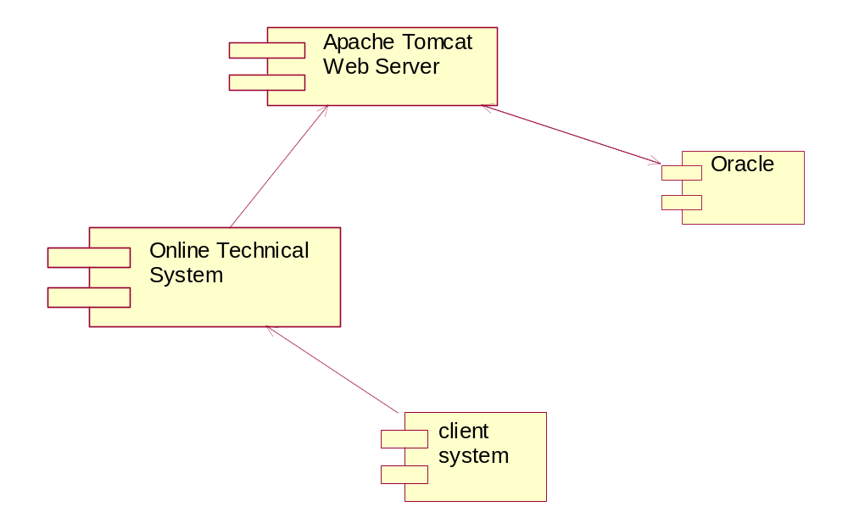

Deployment View
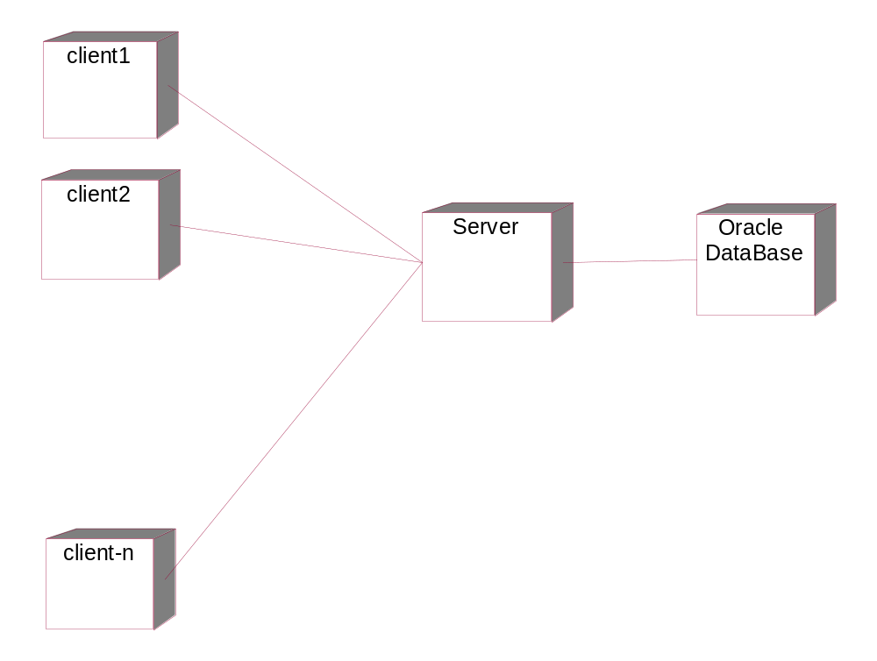

8. Sample Coding
Sample Code For Connection Bean Class

package CMST;
import java.sql.*;
public class ConnectionBean
{
private Connection connection;
private Statement statement;
private static final String driver="sun.jdbc.odbc.JdbcOdbcDriver";
private static final String dbURL="jdbc:odbc:ocr";
private static final String login="ocr";
private static final String password="ocr";
public ConnectionBean()
{
try
{
Class.forName(driver);
System.out.println("ok");
connection=DriverManager.getConnection(dbURL,login,password);
System.out.println("ok");
statement=connection.createStatement();
}
catch (ClassNotFoundException e)
{
System.err.println("ConnectionBean: driver unavailable");
connection = null;
}
catch (SQLException e)
{
System.err.println("ConnectionBean: driver not loaded");
connection = null;
}

}
public Connection getConnection()
{
return connection;
}
public void commit() throws SQLException
{
connection.commit();
}
public void rollback() throws SQLException
{
connection.rollback();
}

public void setAutoCommit(boolean autoCommit) throws SQLException
{
connection.setAutoCommit(autoCommit );
}

public ResultSet executeQuery(String sql) throws SQLException
{
return statement.executeQuery(sql);
}
public int executeUpdate(String sql) throws SQLException
{
return statement.executeUpdate(sql);
}
public boolean execute(String sql) throws SQLException
{
return statement.execute(sql);
}
protected void finalize()
{
try
{
connection.close();
}
catch (SQLException e)
{
}
}
}

Sample JSP Code For Customer Registration Form

<title>Registration Form</title>

<script>
function Check(obj)
{
len=obj.value;
var colors=new Array("`","~","!","@","#","$","%","^","&","*","(",")","_","+","<",">","/","?","}","{","[","]","'",";","=","-","|",",","a","b","c","d","e","f","g","h","i","j","k","l","m","n","o","p","q","r","s","t","u","v","w","x","y","z","A","B","C","D","E","F","G","H","I","J","K","L","M","N","O","P","Q","R","S","T","U","V","W","X","Y","Z");
for(j=0;j<=len.length-1;j++)
{
var char=len.substring(j,j+1);
for(i=0;i<=colors.length-1;i++)
{
var sNumber=colors[i];
if(sNumber==char)
{
obj.value="";
obj.focus();

return false;
}
}
}
if(obj.value.length==0)
{
return false;
}
string_value=obj.value;
var whitespace = " \n\r\t\."
var existed="No";
var Valid="No";
for (var counter = 0; counter < string_value.length; counter++)
{
// Get the current character
current_char = string_value.charAt(counter)
// If it's not in the whitespace characters string,
// return false because we found a non-whitespace character
if(whitespace.indexOf(current_char) =="")
{
var existed="Yes";
}else if(whitespace.indexOf(current_char) ==-1)
{
existed="No";
Valid="Yes";
break;
}
}
if(existed=="No" && Valid=="Yes")
{
existed="Yes";
Valid="No";
return false;
}else
{
obj.value="";
existed="Yes";
Valid="No";
obj.focus();
return false;

}

}

function its_whitespace2(obj)
{

if(obj.value.length==0)
{

return false;

}
// These are the whitespace characters

var whitespace = " \n\r\t"
var existed="No";
var Valid="No";
len=obj.value;

var string_value=obj.value;

var char=len.substring(len.length,len.length-1);
// Run through each character in the string
for (var counter = 0; counter < string_value.length; counter++)
{
// Get the current character
current_char = string_value.charAt(counter)
// If it's not in the whitespace characters string,
// return false because we found a non-whitespace character
if(whitespace.indexOf(current_char) =="")
{
var existed="Yes";
}else if(whitespace.indexOf(current_char) ==-1)
{
existed="No";
Valid="Yes";
break;
}
}
if(existed=="No" && Valid=="Yes")
{
existed="Yes";
Valid="No";
return false;
}else
{
obj.value="";
existed="Yes";
Valid="No";
obj.focus();

return false;

}

// Otherwise, the string has nothing but
// whitespace characters, so return true

}

function its_whitespace(obj)
{
len=obj.value;
var colors=new Array("~","`","!","@","#","$","%","^","&","*","(",")","_","+","<",">","/","?","}","{","[","]","'",";","=","-","|",",","1","2","3","4","5","6","7","8","9","0");
for(j=0;j<=len.length-1;j++)
{
var char=len.substring(j,j+1);
for(i=0;i<=colors.length-1;i++)
{
var sNumber=colors[i];
if(sNumber==char)
{

obj.value="";
obj.focus();
return false;
}
}

}

if(obj.value.length==0)
{

return false;

}

string_value=obj.value;

// These are the whitespace characters
var whitespace = " \n\r\t\."
var existed="No";
var Valid="No";

// Run through each character in the string
for (var counter = 0; counter < string_value.length; counter++)
{
// Get the current character
current_char = string_value.charAt(counter)
// If it's not in the whitespace characters string,
// return false because we found a non-whitespace character
if(whitespace.indexOf(current_char) =="")
{
var existed="Yes";
}else if(whitespace.indexOf(current_char) ==-1)
{
existed="No";
Valid="Yes";
break;
}
}
if(existed=="No" && Valid=="Yes")
{
existed="Yes";
Valid="No";
return false;
}else
{
obj.value="";
existed="Yes";
Valid="No";
obj.focus();
return false;

}

}

function its_whitespace1(obj)
{
len=obj.value;
var colors=new Array("`","~","!","@","#","$","%","^","&","*","(",")","_","+","<",">","/","?","}","{","[","]","'",";","=","-","|",",");
for(j=0;j<=len.length-1;j++)
{
var char=len.substring(j,j+1);
for(i=0;i<=colors.length-1;i++)
{
var sNumber=colors[i];
if(sNumber==char)
{

obj.value="";
obj.focus();
return false;
}
}

}

if(obj.value.length==0)
{

return false;

}

string_value=obj.value;

// These are the whitespace characters
var whitespace = " \n\r\t\."
var existed="No";
var Valid="No";

// Run through each character in the string
for (var counter = 0; counter < string_value.length; counter++)
{
// Get the current character
current_char = string_value.charAt(counter)
// If it's not in the whitespace characters string,
// return false because we found a non-whitespace character
if(whitespace.indexOf(current_char) =="")
{
var existed="Yes";
}else if(whitespace.indexOf(current_char) ==-1)
{
existed="No";
Valid="Yes";
break;
}
}
if(existed=="No" && Valid=="Yes")
{
existed="Yes";
Valid="No";
return false;
}else
{
obj.value="";
existed="Yes";
Valid="No";
obj.focus();
return false;

}

}

function NoCheck(obj)
{
n=event.keyCode;
len=obj.value;
if((n<=57 && n>=48) || n==8 || (n<=105 && n>=96) || n==46 ||(n>=33 && n<=36) || (n==37) || (n==18) ||(n==92) ||(n==93) ||(n==17) ||(n==145) ||(n==19) ||(n==144) ||(n==35)|| (n==46)||(n==45)||(n==40)|| (n==38) || (n==39) || (n==9))
{

}else
{
obj.value="";

}

}

function NoCheck1(obj)
{
n=event.keyCode;
len=obj.value;

if(n==32)
{
obj.value="";

}

}

function setfocus()
{

f1.CustName.focus();

}

function CharCheck(obj)
{
len=obj.value;

len=obj.value;

if(len.charAt(0)==" " || len.charAt(0)=="." )
{
var oldvalue=len.substring(1,len.length);
obj.value=oldvalue;
}

n = event.keyCode;

len=obj.value;

if((n>=65 && n<=90)|| (n>=33 && n<=36) || (n==37) || (n==18) ||(n==92) ||(n==93) ||(n==17) ||(n==145) ||(n==19) ||(n==144) ||(n==35)|| (n==46)||(n==45)||(n==40)|| (n==38) || (n==39)||(n==32) || (n==8) || (n==110) || (n==190) || (n==20) || (n==9) || (n==16) || n==36)
{

}else
{
obj.value="";
return false;
}
}

function validateuserid(obj)
{

var string_value=obj.value;
var user=obj.value;

its_whitespace1(obj);

var oXMLHTTP = new ActiveXObject( "Microsoft.XMLHTTP" );
var sURL = "./CheckUser?user=" + user
oXMLHTTP.open( "POST", sURL, false );
oXMLHTTP.send();
var status=oXMLHTTP.responseText;
var s=status;

var str="a";

if(s.charAt(0)==str)
{
alert(s);

f1.txtlogin.value="";

f1.txtlogin.focus();
}

}

function CheckInput()
{

if(f1.CustName.value=="" || f1.CustName.value==null)
{
alert("Please Enter Customer name");
f1.CustName.focus();
return false;
}else if(f1.CustName.value==" ")
{
alert("Please Enter Customer name");
f1.CustName.focus();
return false;
}else if(f1.CustAdd.value=="")
{
alert("Please Enter Customer Address");

f1.CustAdd.focus();
return false;
}else if(f1.CustAdd.value.length<5)
{
alert("Customer Address should not be less than the 5 Characters");
f1.CustAdd.focus();
return false;
}else if(f1.CustAdd.value.length>100)
{

alert("Customer Address should not be greater than the 100 Characters");
f1.CustAdd.focus();
return false;

}else if(f1.Code.value=="")
{
alert("Please Enter Code No");
f1.Code.focus();

return false;

}else if(f1.CustCno.value=="")
{
alert("Please Enter Contact No");
f1.CustCno.focus();

return false;
}else if(f1.txtlogin.value=="")
{
alert("Please Enter User Id");

f1.txtlogin.focus();
return false;
}else if(f1.txtpwd.value=="")
{
alert("Please Enter User Password");
f1.txtpwd.focus();

return false;
}else if(f1.CustName.value.length<3)
{

alert("Customer Name Should Be Minimum 3 Characters");
f1.CustName.focus();
return false;

}else if(f1.Code.value.length<3)
{
alert("Code Number Should Be Minimum 3 Digits");
f1.Code.focus();
return false;
}else if(f1.CustCno.value.length<6)
{
alert("Phone Number Should Be Minimum 6 Digits");
f1.CustCno.focus();
return false;

}else if(f1.txtlogin.value.length<4)
{

alert("User Id Should Be Minimum 4 Characters");
f1.txtlogin.focus();
return false;
}else if(f1.txtpwd.value.length<4)
{
alert("User Password Should Be Minimum 4 Characters");
f1.txtpwd.focus();
return false;

}else if(f1.txtlogin.value==f1.txtpwd.value)
{
alert("User Id and Password Both Are Same");

f1.txtlogin.value="";
f1.txtpwd.value="";
f1.txtlogin.focus();

return false;

}
}

</script>

<%@page import="java.sql.*,CMST.*" %>
<style>

a
{
color:"Black";
text-decoration:none;
}
a:hover
{
color:Gray;
text-decoration:underline;

}
</style>

<jsp:include page="RegHeader.jsp" />

<HTML><HEAD><TITLE>Home Page</TITLE>

<BODY onload="setfocus()">

<TABLE class=tabformat width="20%" border=0>
<TBODY>

<%
try
{
Connection con=null;
ResultSet cust_rs=null;
ConnectionBean CBean=new ConnectionBean();
con=CBean.getConnection();
cust_rs=CBean.executeQuery("select nvl(max(customer_id),0)+1 from customer_master");
cust_rs.next();
String cust_no=cust_rs.getString(1);
System.out.println(cust_no);
cust_rs.close();

%>
<h3>Customer Registration Form</h3>
<form name="f1" action="Register" ">
<table border="0" >
<tr>
<td class=tabhead2><b>Customer Id</b>
<td class=tabhead2><input type="text" name="regno" readonly value=<%=cust_no%>></td></tr>
<td class=tabhead2><b>Customer Name</b></td>
<td class=tabhead2><input type="text" name="CustName" maxlength=30 onkeyup="CharCheck(this)" onblur="its_whitespace(this)" ></td></tr>
<td class=tabhead2><b>CustomerAddress</b>
<td class=tabhead2>

<textarea name=CustAdd rows=5 onblur="its_whitespace2(this)"></textarea></td></tr>

<td class=tabhead2><b>Contact No</b></td>

<td class=tabhead2><input name="Code" type="text" onkeyup="NoCheck(this)" onblur="Check(this)" maxlength=5 size=5>-
<input name="CustCno" type="text" onkeyup="NoCheck(this)" onblur="Check(this)" maxlength=13></td>
</tr>
<td class=tabhead2 bgcolor="#FFFFCC"><b><font color="#000033" size="5" >Login
Details</font></b></td>
</tr>
<td class=tabhead2><b>Login Name</b>

<td class=tabhead2><input type=text name="txtlogin" onblur="validateuserid(this);" onkeyup="NoCheck1(this)" size=20 maxlength=20 class="pwdstyle" ></td></tr>
<td class=tabhead2><b>Password</b></td>

<td class=tabhead2><input type=password name=txtpwd onblur="its_whitespace2(this)" size=20 maxlength=20 class="pwdstyle" ></td></tr>

<%
}catch(Exception ex)
{
out.println("Error At " + ex);
}
%>

</tr>
</td>
<tr>
<td>&nbsp;&nbsp;&nbsp;&nbsp;&nbsp;&nbsp;&nbsp;&nbsp;&nbsp;&nbsp;&nbsp;&nbsp;&nbsp;&nbsp;&nbsp;&nbsp;&nbsp;&nbsp;&nbsp;&nbsp;&nbsp;&nbsp;&nbsp;&nbsp;&nbsp;&nbsp;&nbsp;&nbsp;&nbsp;&nbsp;&nbsp;&nbsp;&nbsp;&nbsp;<input type=submit value="Register" onclick="return CheckInput()">&nbsp;&nbsp;&nbsp;&nbsp;<input type=reset value=Clear ></td>
</tr>
</table>

<jsp:include page="Footer.htm" />

</form>
</body>
</html>

9.TESTING
INTRODUCTION
Testing is the process of finding differences between the expected behavior specified by system models and the observed behavior of the system.

TESTING CONCEPTS:

- A component is a part of the system that can be isolated for testing. A component can be an object, a group of objects, or one or more subsystems.
- A fault, also called bug or defect, is a design or coding mistake that may cause abnormal component behavior.
- An error is a manifestation of a fault during the execution of the system.
- A failure is a deviation between the specification of a component and its behavior. A failure is triggered by one or more errors.
- A test case is a set of inputs and expected results that exercise a component with the purpose of causing failures and detecting faults.

TESTING ACTIVITIES:

- Inspecting a component, which finds faults in an individual component through the manual inspection of its source code.
- Unit testing, which finds faults by isolating an individual component using test stubs and drivers and by exercising the components using a test case.
- Integration testing, which finds faults by integrating several components together.
- System testing, which focuses on the complete system, its functional and nonfunctional requirements and its target environment.

Testing is the phase where the errors remaining from all the previous phases must be detected. Hence, testing performs a very critical role for quality assurance and for ensuring the reliability of software.Testing of designed software consists of providing the software wit a set of test outputs and observing if the software behaves as expected .if the software fails to behaves as expected, then the conditions under which a failure occurs are needed for debugging and correction .
The following terms are some commonly used terms associated with testing.

Error
The term error is used in two different ways. It refers to the discrepancy between a computed, observed, or measured value and true, specified, or theoretically correct value. Error is also used to refer to human action that results in software containing a defect or fault. This definition is quite general and encompasses all the phases.

Fault:
Fault is a condition that causes a system to fail in performing its required function. In other words a fault is an incorrect intermediate state that may have been entered during program execution.

Failure:
Failure is the inability of the system or component to perform a required function according to its specifications. In other words a failure is a manifestation of error. But the mere presence of an error may not cause a failure.

Presence of an error implies that a failure must have occurred, and the observation of a failure implies that a fault must be present in the system. However, the presence of a fault does not imply that a failure must occur.

A test case is the triplet [i, s, o], where i stands for the data input to the system, s is the state of the system at which the data is input, and o is the expected output of the system .a test suite is the set of all test cases with which a given software product is to be tested.

Verification and Validation

Verification is the process of determining whether one phase of the software product confirms to its previous phase. Verification is concerned with phase containment of errors.

Validation is the process of determining whether a fully developed system confirms to its required specification. The aim is to make the final product error free.

Types of testing:

1. White box testing.
2. Black box testing.

White box testing:

- In the white box testing the designer can derive test cases that guarantee that all independent paths within a module have been exercised at least once.
- Exercise all logical decision on their true and false sides.
- Exercise all loops at their boundaries and within their operational bounds.
- Exercise internal data structures to ensure their validity.

There are several methods used in the white box testing in the software design.

Statement coverage
In this, each statement in a program is executed at least once. This is done by checking the program in debug mode and by verifying each statement.

Branch coverage
In this, each and every branch is tested whether the different branch conditions are true or false. It is a stronger test criterion over statement coverage testing.

Condition coverage
In this, each component of a condition of a composite conditional expression is given both true and false values. It is a stronger test criterion over branch coverage testing.

Path coverage:
In this testing, all the linearly independent paths in the program are executed once. A linearly independent path is defined in terms of the control flow graph of a program. The control flow graph describes how the flow of control passes through the program.

Data-flow based testing
In this method, selects the test paths of a program according to the locations of the definitions and use of different variables in program. Data-flow based testing strategies are useful for selecting tested paths of a program containing nested if and loop statements.

Mutation testing
In this method, the software is first tested by the above methods after the initial testing. In the mutation testing few small changes to program at a time such as, changing a conditional operator or changing the type of variable each time the program is changed, is called a mutated program and the change effected is called mutant. Then it is tested if it gives an error, then the mutant is said to be dead, if it is working properly then the test data is enhanced to kill the mutant.

Black box testing
The black box testing focuses on the functional requirement of the software. That is for a swinger the black box testing will give the desired results for what it is meant for, it means that he has to exercise all functional requirements for a program. The black box testing is done after the software is developed.
Black box testing attempts to find errors in the following:

1. Incorrect or missing functions.
2. Interface errors.
3. Errors in data structures or external database access.
4. Performance errors.
5. Initialization and termination errors.

Testing object oriented programs are different from testing functional oriented programs. As the test cases in black box testing are selected independently of the internal structure of the code, it does not matter whether the software is object oriented or function oriented however, if the testing is white box, then the test cases are determined based on the structure of the program. Testing classes is fundamentally different from testing functions as a function has a clearly defined input-output behavior while a class does not have an input-output behavior specification. Further a class cannot be tested directly; only an instance of class can be tested. This means that, we test a class indirectly by testing its instance. Further there is no sequential control flow with in a class like in functions. In a function, arguments, passed to the function with global data determine the path of execution within the procedure, but in an object, the state associated with object also influences the path of execution, and methods of a class can communicate each other among themselves through this state, because this state is persistent across invocation of methods. Hence, state of an object plays a major role in testing objects.

System testing:
System tests are designed to validate a fully developed system with a view to assuring that it meets requirements.There are three kinds of system testing.

Alpha testing
Alpha testing refers to the system testing that it’s carried out by the customer with in the organization along with the developer. The alpha tests are conducted in a controlled manner.

Beta testing
Beta testing is the system testing performed by a select group customer’s .The developer is not present at the site and the user will inform the problems that are encountered. As a result of problems reported during the Beta test, the software developer makes the modifications and then prepares for release of the software to the customer.

Acceptance Testing
Acceptance Testing is the system testing performed by the customer to whether or not of accept the delivery of the system.

TEST CASES

A test case is a set of input data and expected results that exercises the component with the purpose of causing failures and detecting faults.Test cases are classified into black box test and white box test. Black box test focus on input/output behavior of the component. White box test focus on internal structure of the components.

TEST CASE EXECUTION AND ANALYSIS:
Customer Module:
Test Case | Condition Being Checked | Expected Output
Form submission | Checking connection | Displays oracle error message
Invalid user name | Read Password | Redirect to Login page
Valid Password | Read Password | Redirect to home page
Invalid Password | Check the validity of the password | Redirect to Login page
Password length >8 | Read Password | Displays error message
Any compulsory field not selected | When submitting details | Displays message to select particular field

Department Module:

Test Case | Condition Being Checked | Expected Output
Form submission | Checking connection | Displays oracle error message
Invalid user name | Read Password | Redirect to Login page
Valid Password | Read Password | Redirect to his home page
Invalid Password | Check the validity of the password | Redirect to Login page
Password length >8 | Read Password | Displays error message
Any compulsory field not selected | When submitting details | Displays message to select particular field

Administrator:

Test Case | Condition Being Checked | Expected Output
Form submission | Checking connection | Displays oracle error message
Invalid user name | Read Password | Redirect to Login page
Valid Password | Read Password | Connected to home page
Invalid Password | Check the validity of the password | Redirect to Login page
Password length >8 | Read Password | Displays error message
Any compulsory field not selected | When submitting details | Displays message to select particular field

SCREENS
HOME PAGE
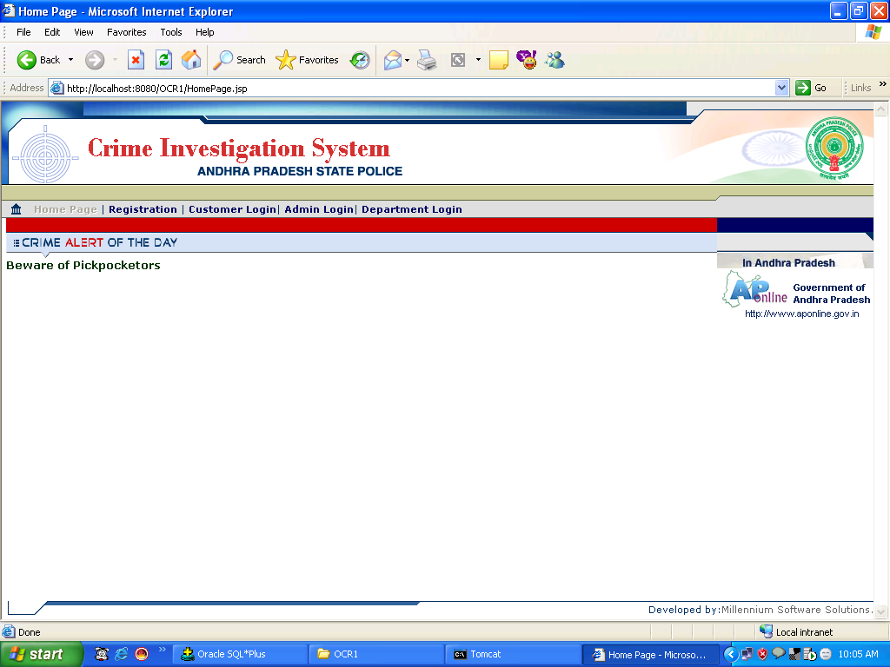

ADMINISTRATION MODULE

ADMIN LOGIN FORM

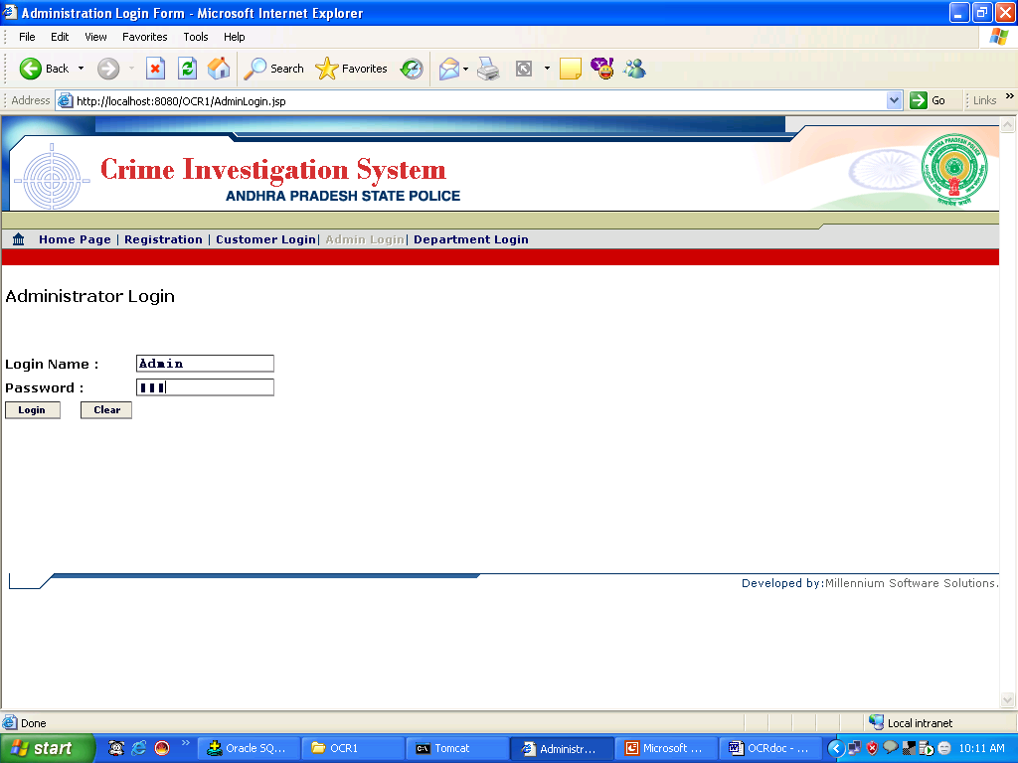

ADMIN HOME PAGE

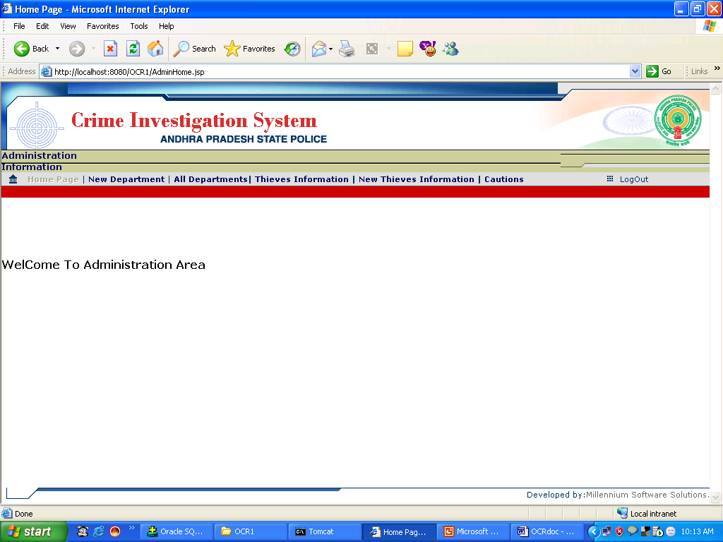

New Department Registration Screen

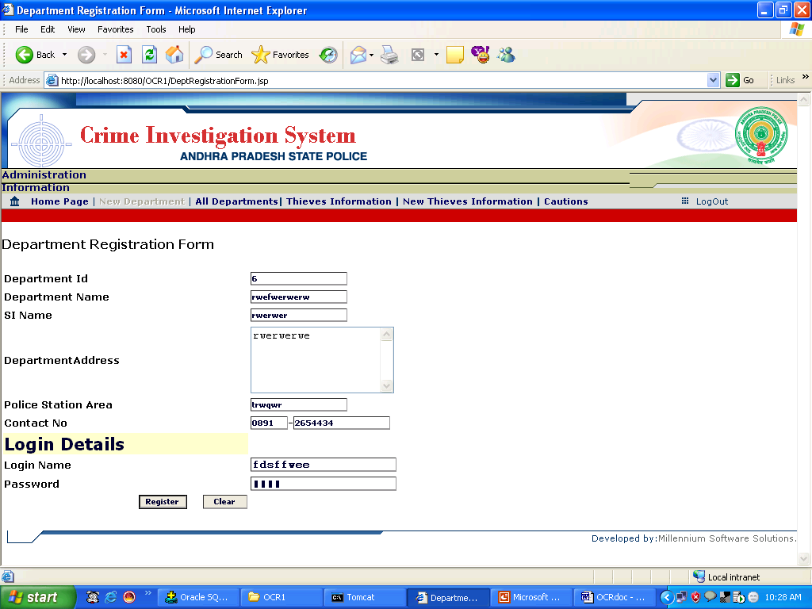

Updating Department Details

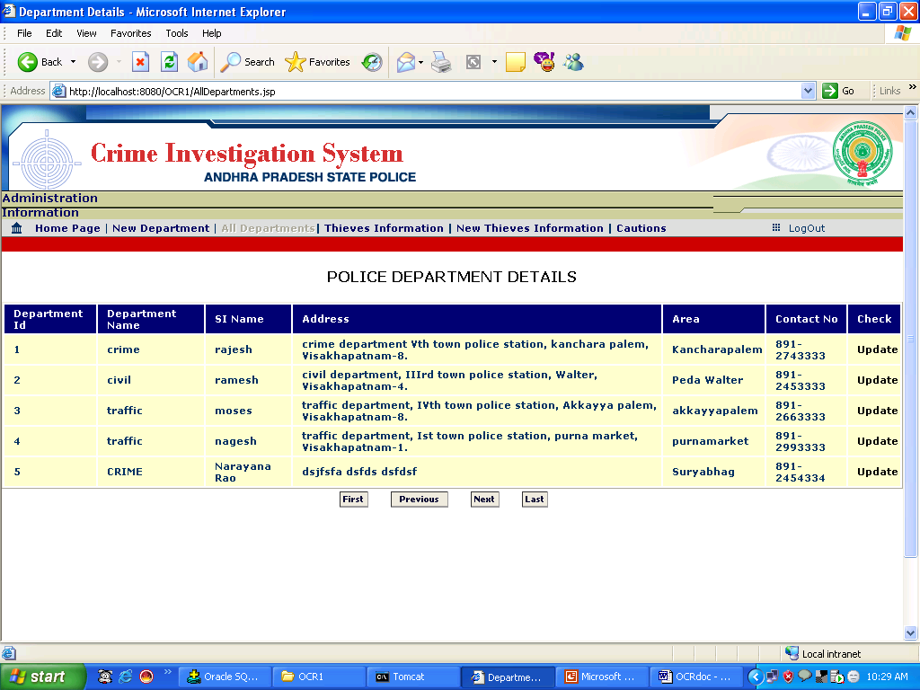

SCREEN2
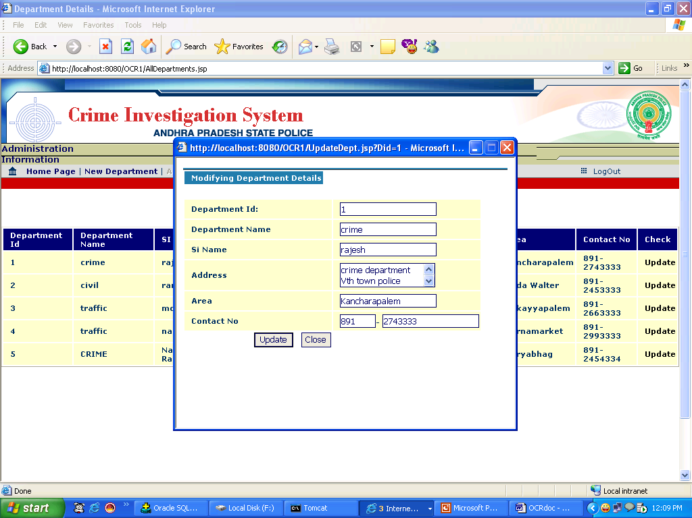

Thieve Registration Screen

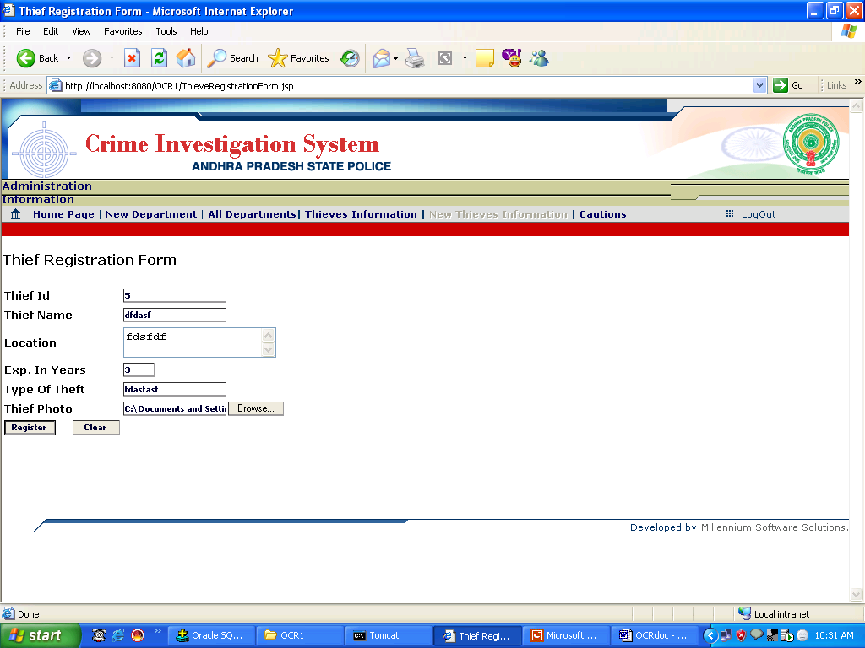

Updating Thief Registration Screen

SCREEN1
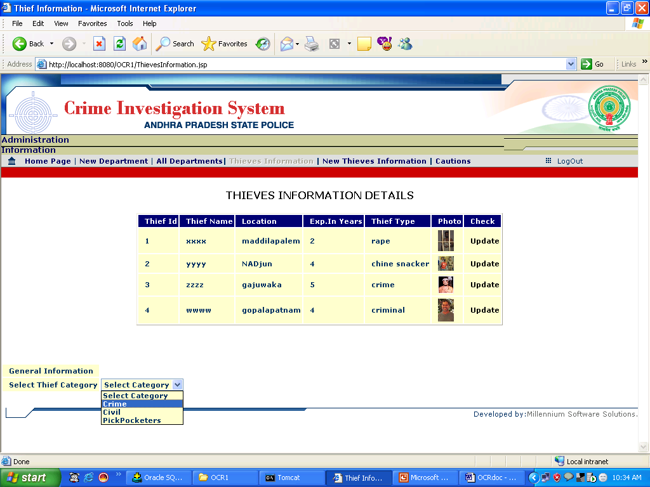

SCREEN2
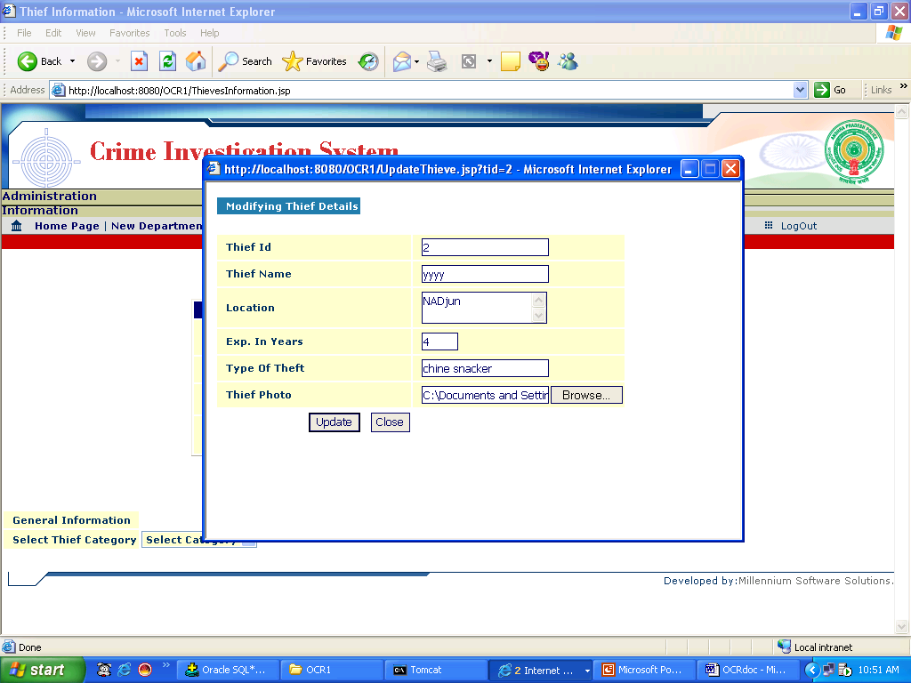

SCREEN3
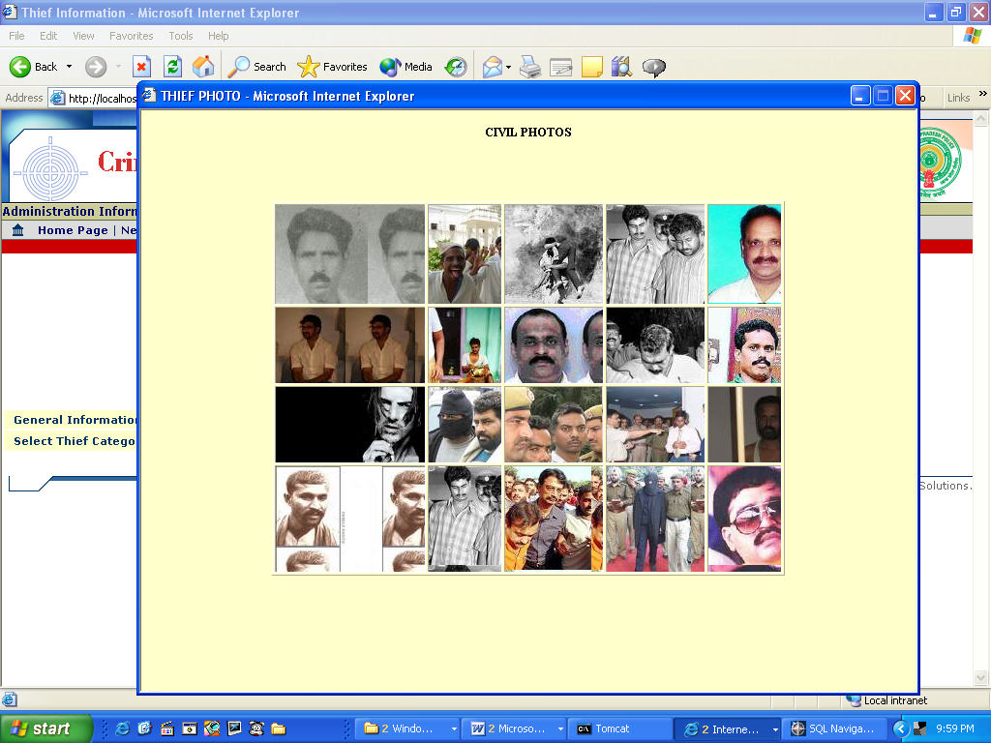

Caution Registration Form

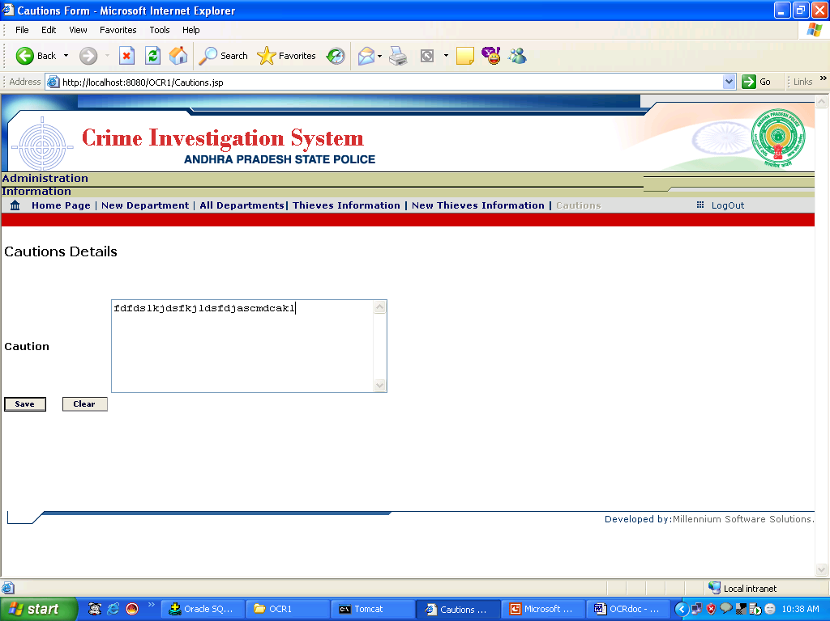

Department Login screen

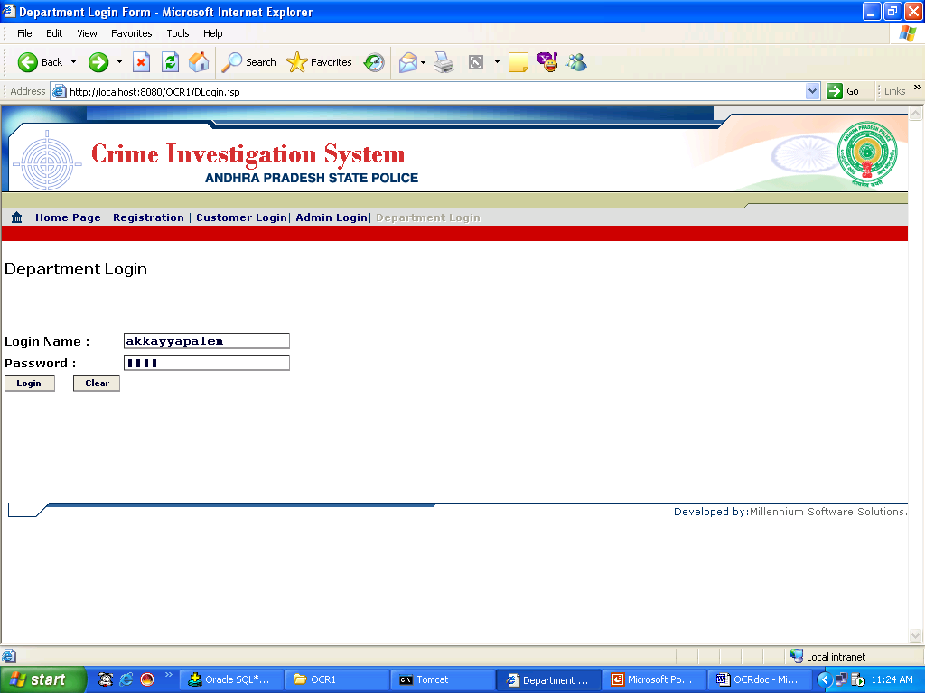

Department Home Page

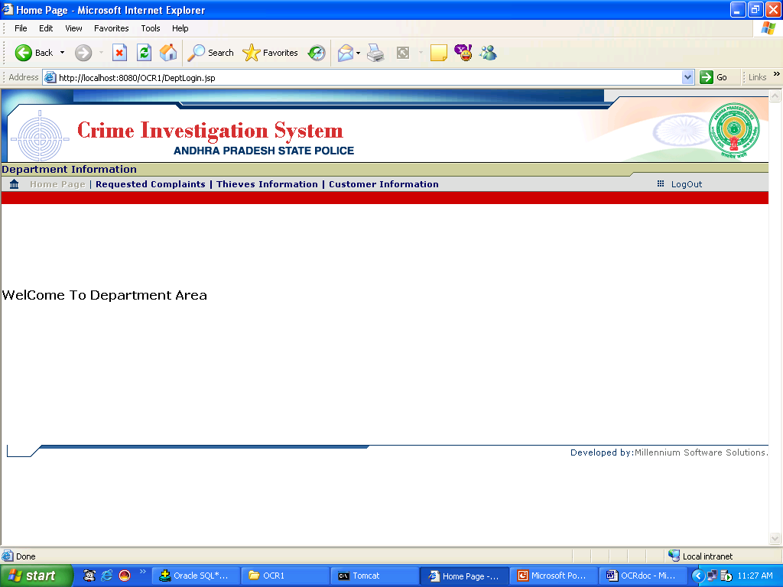

Requested Complaints

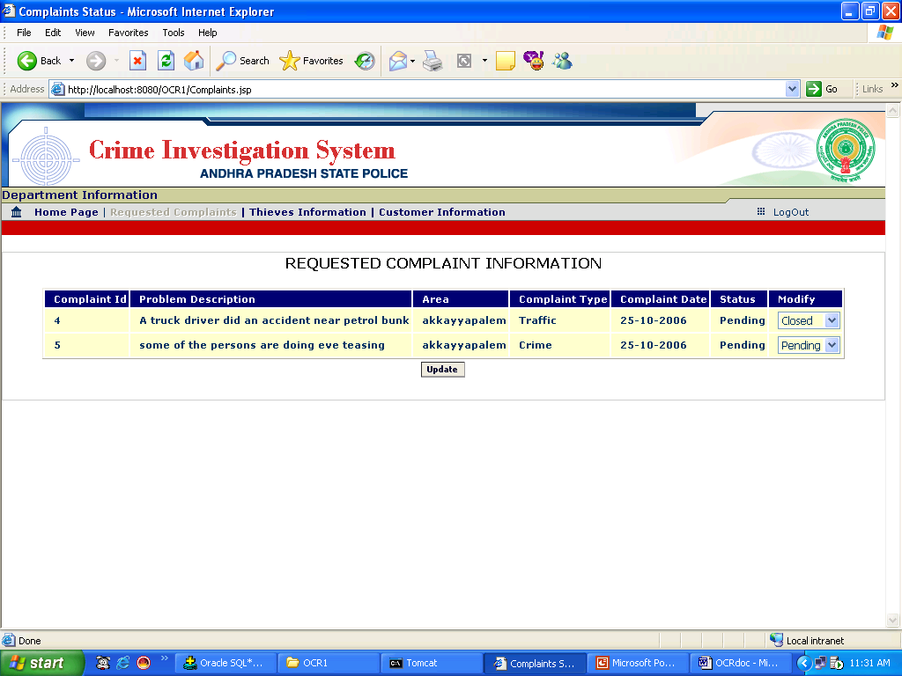

Thief Details screen

Screen1
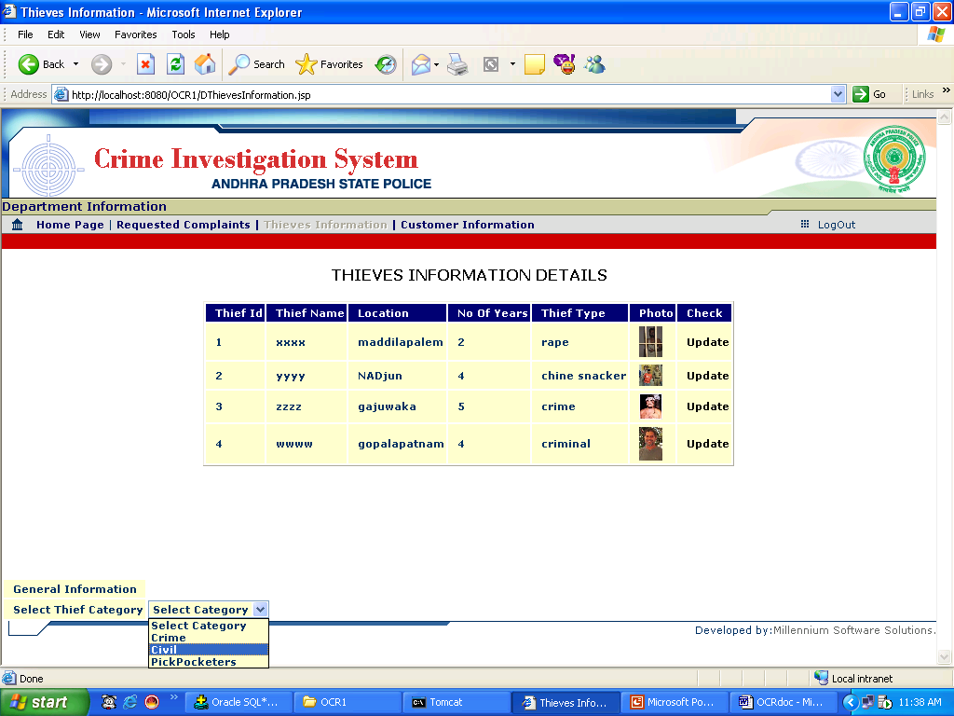

SCREEN2

SCREEN3

Customer Information Screen

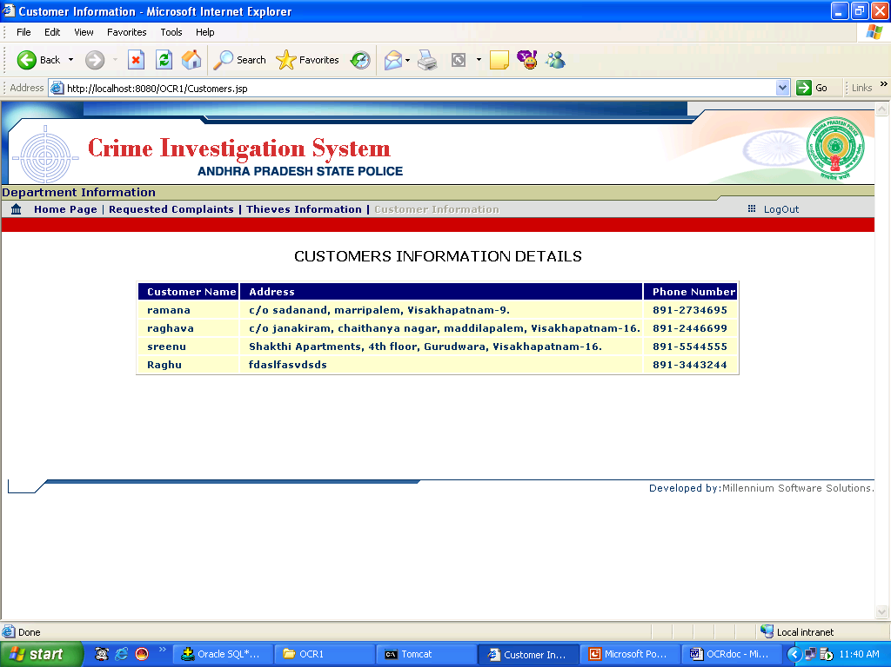

Customer Registration Screen

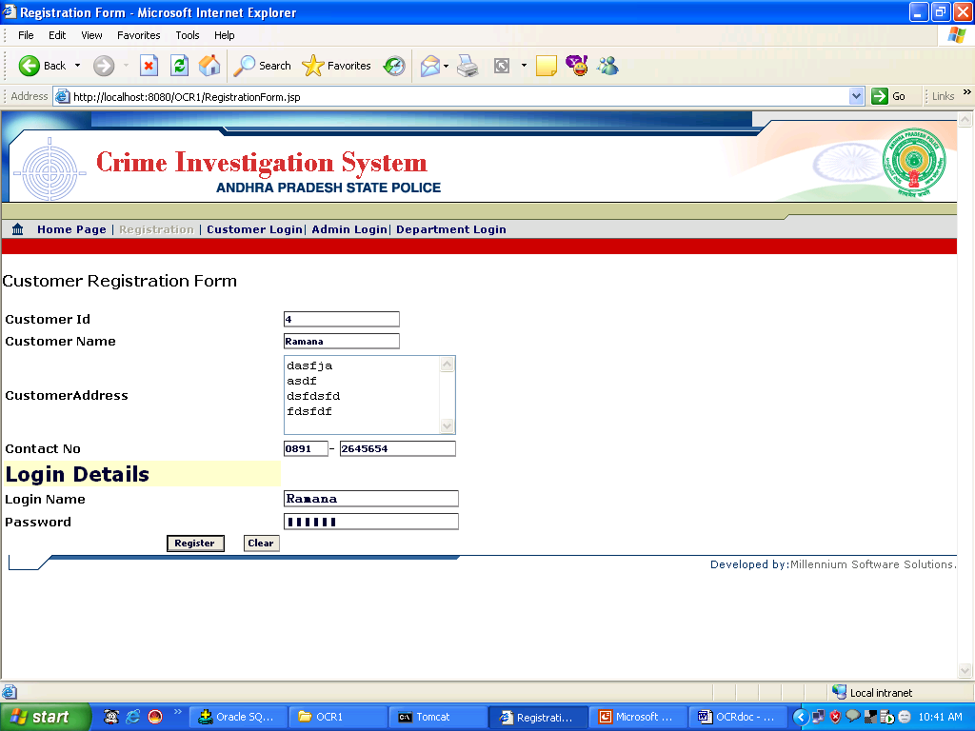

Customer Login Screen

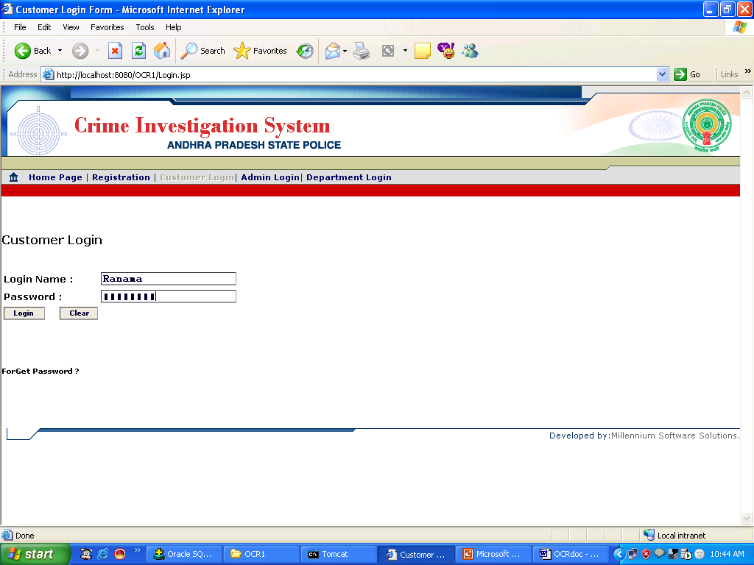

Customer Home Page

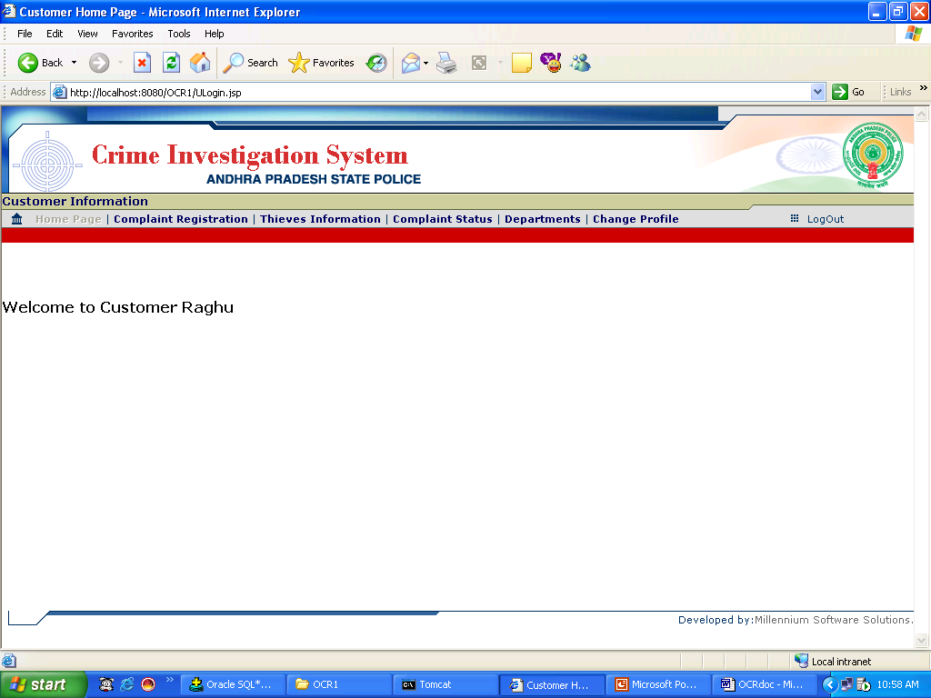

Complaint Registration Screen

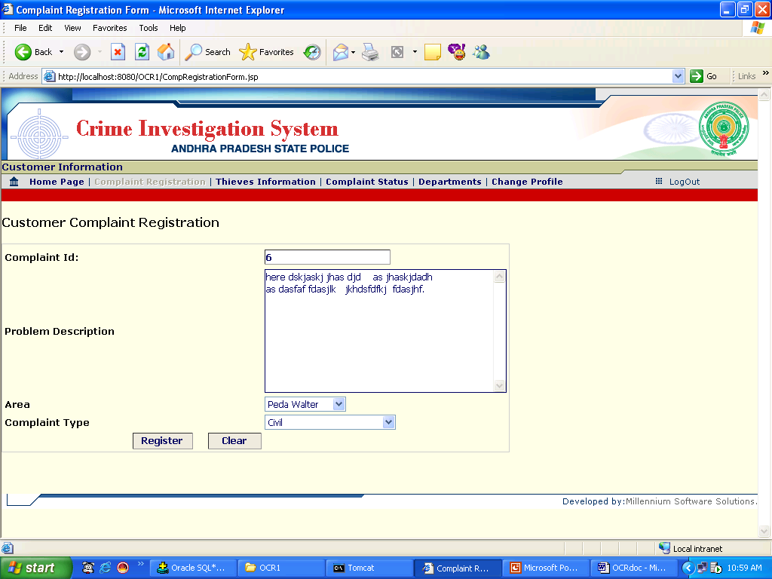

Thief Details Screen

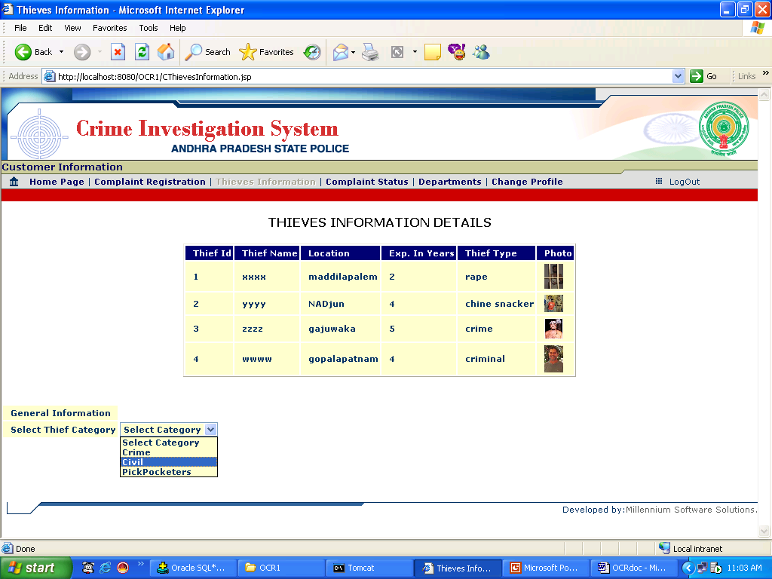

Department Details Screen

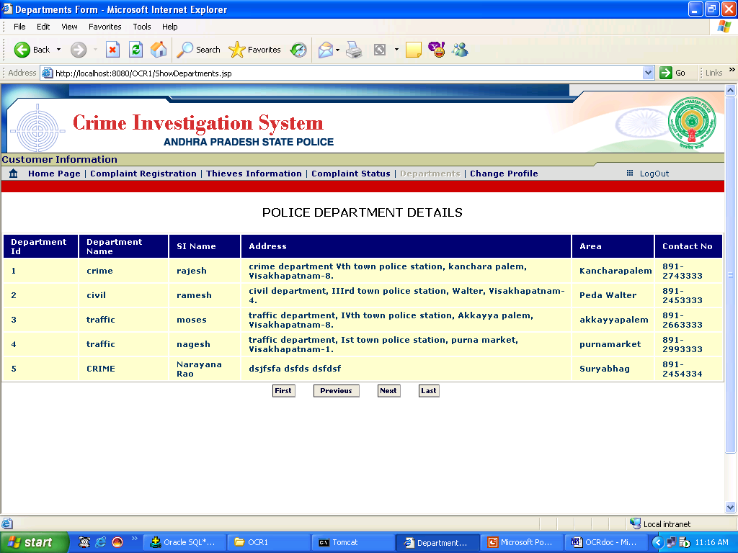

Changing Customer profile Screen

SCREEN1

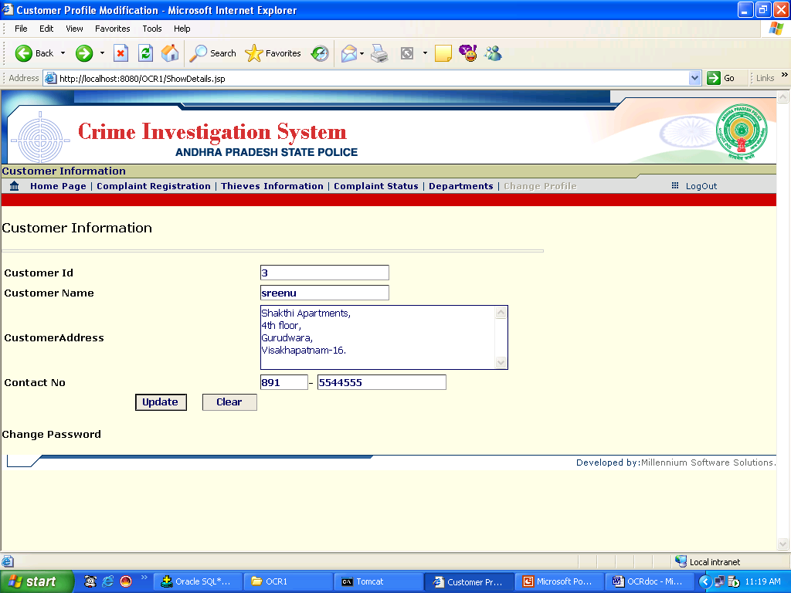

SCREEN2
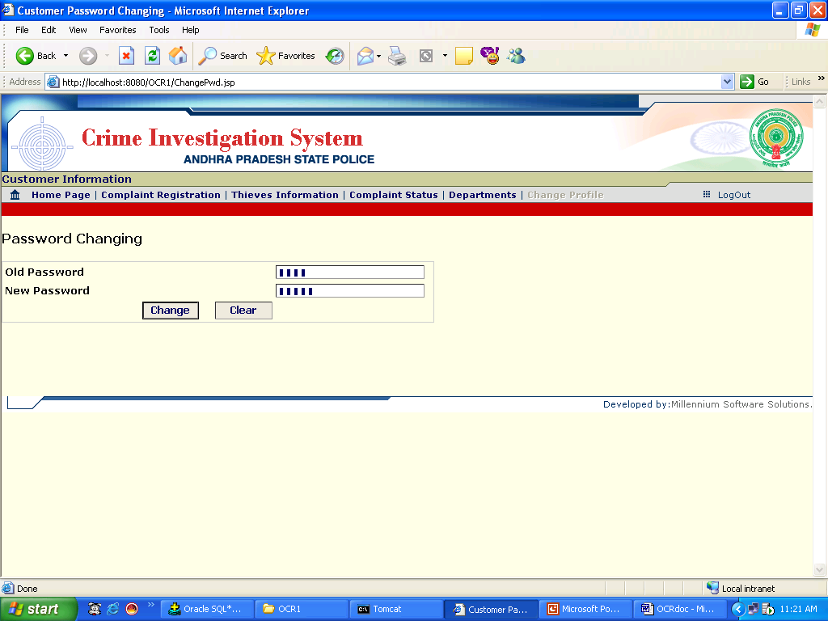

Complaint Status Details Screen

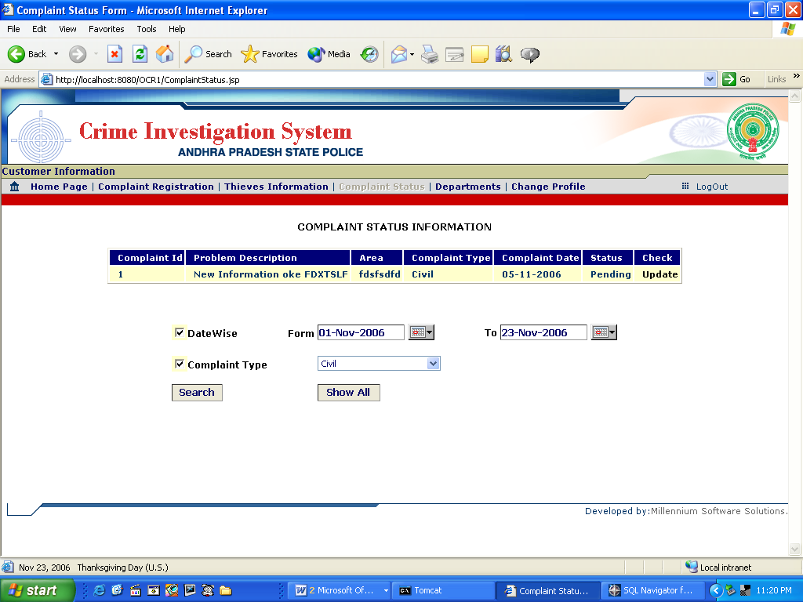

SOFTWARE
&
HARDWARE

11.SOFTWARE & HARDWARE

Software Environment
Operating System - Microsoft Windows 2000/XP
Front End Tool - Servlets and Java Server Pages
Scripting language - HTML, JavaScript
RDBMS - Oracle 8i
Application Server - Apache Tomcat Web Server

Hardware Environment
RAM - 64 MB
Hard Disk - 20 GB
Processor - Intel Pentium 500MHz
Floppy Disk - 1.44 MB
Monitor - Color Monitor (256 colors)

Mouse -3 button scroll mouse
Keyboard -Multimedia Keyboard

CONCLUSION

12.CONCLUSION

This software presents the part of an organization work as per the requirments , specifications and conditions mentioned in the user manual . This application s/w has been developed and completed successfully and also tests successfully by taking “Test Cases”It is user friendly and has all the needed menu options , which can be utilized by the user to perform the desired operations .Moreover help messages are provided which will help any authorized user from using the system without trouble.

SCOPE

13.SCOPE
This document is meant for use by the developers and will be the basis for developing the final delivered system. The requirement changes to the document can be made due to changes in the client needs, change in technology etc.
The proposed system is not limited presently. Presently we have to login to the system online and post the complaints. We can further develop the system by using “Voice Recognition System”. So this project has got scope to get developed in the near future. The scope of the project exists throughout the life of the product development, testing and implementation.

BIBLIOGRAPHY

14. BIBILIOGRAPHY

1. SOFTWARE ENGINEERING An Engineering Approach
By Peters Pedrycz
Wiely Publications
2. COMPLETE REFERENCE - JAVA
Herbert Schield
3. PROGRAMMING IN JDBC
O’really publications
4. AN INTRODUCTION TO DATABASE MANAGEMENT SYSTEM
C.J.Date
Manual, Microsoft Press
5. MASTERING JAVASCRIPT & JSCRIPT
James Jaworski
6. DEVELOPING JAVA SERVLETS
James GoodWill
7. SOFTWARE ENGINEERING
Rogger S. Pressman

Web Sites:
www.sunmicrosystems.com
www.google.com
www.newprojects.com
www.advancedjava.com

