1. **Vibration analysis** - each vibration will have a signature along with it. Hence, we match the vibration with the signature we already have. The rotating elements of these machines generate vibrations at specific frequencies that identify the rotating elements. The amplitude of the vibration indicates the performance or quality of machine. An increase in the vibration amplitude is a direct result of failing rotational elements such as bearings or gears. Based on the machine speed, the rotational frequencies can be calculated and compared to the measurements to identify the failure mode.

*different vibration sensors (accelerometers, velocity transducers, or displacement probes).*

-for rotating devices

- Bearings

- Typical machines include motors, pumps, fans, gear boxes, compressors, turbines, conveyors, rollers, engines, and machine tools that have rotational elements.

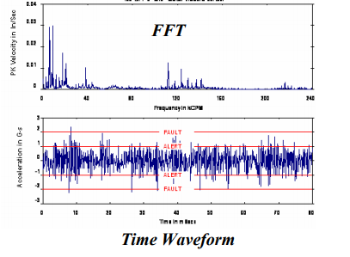

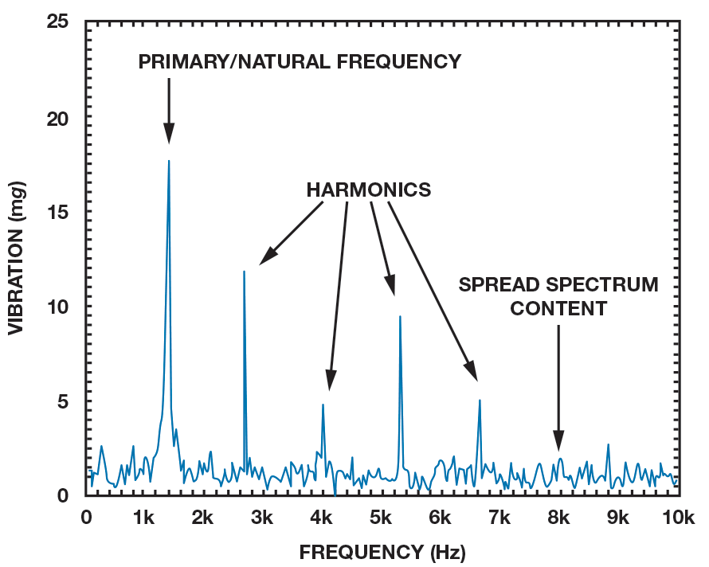

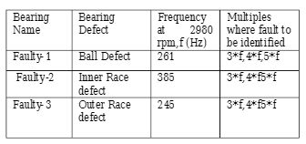

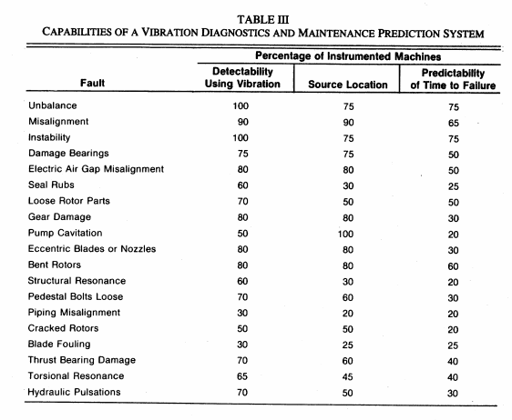

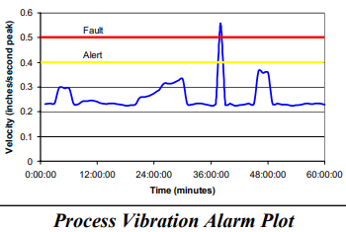

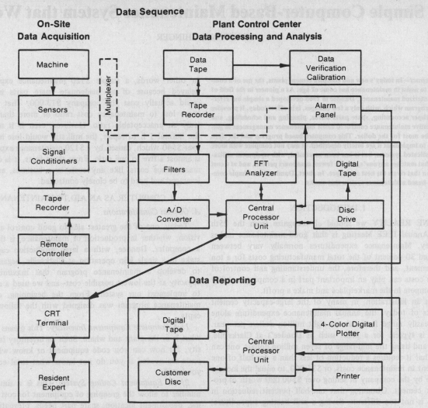

<https://www.researchgate.net/publication/236330286_VIBRATION_ANALYSIS_OF_MACHINE_FAULT_SIGNATURE>

<https://www.ctconline.com/pdf/pubTechPapers/21-Industrial%20Vibration%20Analysis.pdf>

**considering a typical Electromotor with 1.5 Kw Power**

<https://scialert.net/fulltext/?doi=jas.2008.1268.1273>

-three faults in our electromotor; there were misalignment, looseness and bad bearing.

Vibration characteristics can be distinctively divided into two types:

* forced vibration

mass unbalance, misalignment and excitation of electrical or mechanical nature.

* free vibration.

dependent on the geometry, mass and damping of the system and typically caused by structural, acoustic resonance and by aerodynamic or hydrodynamic excitation.

Vibration analysis in particular has been used as a predictive maintenance procedure for some time and as a support for machinery maintenance decisions (Barron, 1996). As a general rule, machines do not break down or fail without some form of warning, which is indicated by an increased vibration level. By measuring and analysing the vibration of a machine, it is possible to determine both the nature and severity of the defect and hence predict the machine's failure. The overall vibration signal from a machine is contributed from many components and structures to which it may be coupled.

The critical overall vibration recommended value in ISO 10816-1 for this electromotor is 2.8 mm sec–1 and measurement values and mean of them were lower than standard value. The critical overall vibration recommended value in ISO 10816-1 for this electromotor is 2.8 mm sec–1 and measurement values and mean of them were lower than standard value.

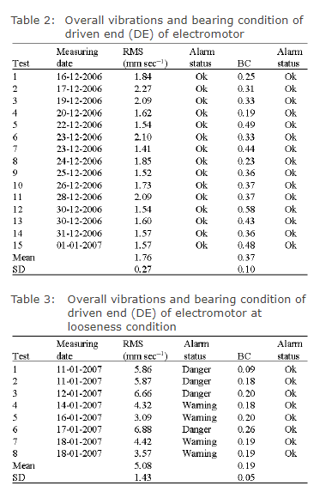

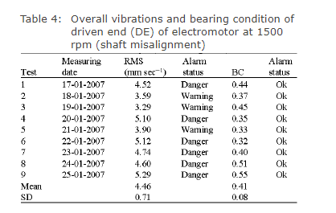

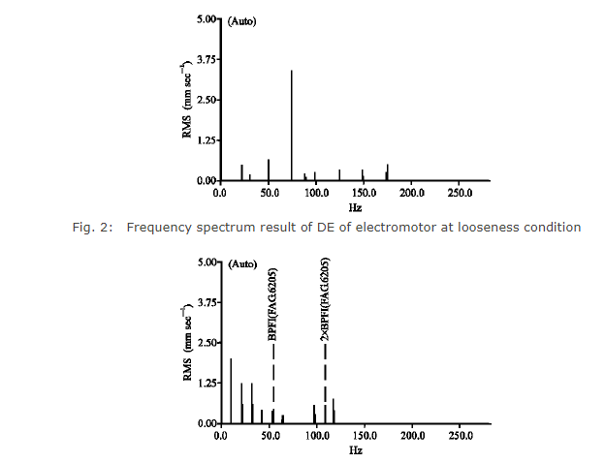

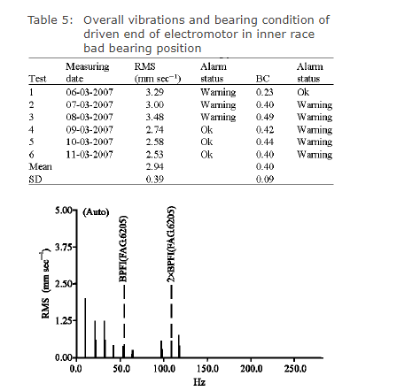

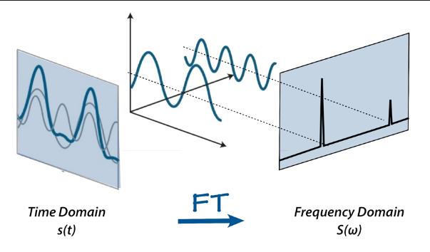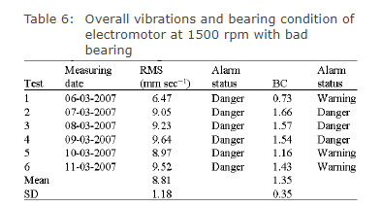

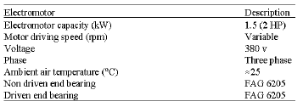

2.**sound**/**Noise** - the concept of vibration can also be used for monitoring faults using sound.

<https://www.researchgate.net/publication/317401564_Automated_Noise_Analysis_for_Fault_Detection>

In this context proposes a fault detection system basedon a noise signal which is obtained through microphone from aelectrical machinery. The noise signal of rotating machinery isutilized for early fault diagnostic. Fault detection system withautomated noise signal processing consist of: a measured data isdivided down by short time duration parts. Fault carrying fre-quencies are extracted from digitalized signal. Envelope detectorand demodulation were utilized for identifying fault frequencieswith their harmonics and sidebands. Automated noise analysis isdedicated to detect and report a machinery abnormal condition.Implementation was conducted with noise signals which wereobtained from an electric motors, turbine generators and bearingfault motors

