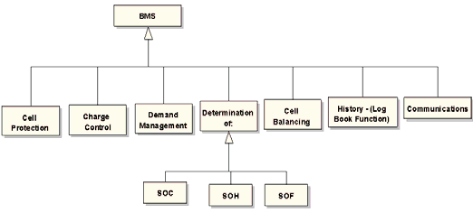

<https://www.researchgate.net/figure/Main-functions-of-a-BMS-system_fig7_224190844>

* Arduino Uno or compatible.
* Male pins (we need four pins only).
* Two same value resistors (here I use 12K).
* Two pin female connector. Photo shows three pin because that is what I have. Here I use power switch connector to motherboard instead :)
* A battery
* indicate low battery at your desired voltage level.
* A mini breadboard is optional for testing phase.

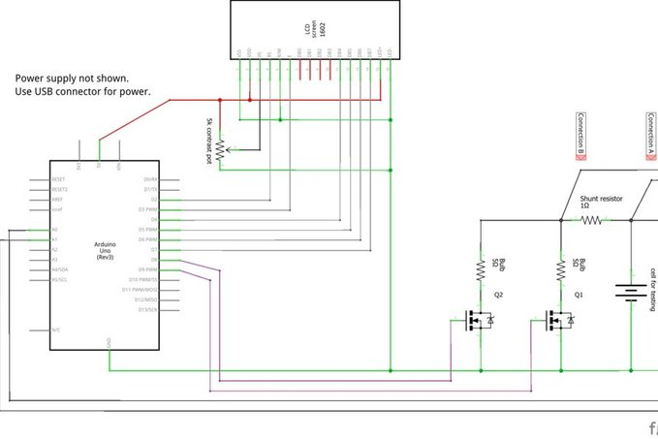

<https://www.instructables.com/id/Arduino-cell-capacity-meter/>

