In all our recent client deployments, IoT (internet of things) has been a topic of priority for the Security team. The Mirai and Dyn DDoS focused botnet attacks and a recent FBI bulletin have provided a wakeup call for the industry - IoT devices are actively being used as a conduit for bad as well as good. Popular tactics these days for attackers include repurposing IoT devices as proxies via which they can anonymously funnel their illegitimate traffic, and even using them directly for crypto mining.
The harsh reality is that IoT still tends to be an afterthought when it comes to security monitoring and this is only going to become more acute as a barrier to adoption. Gartner predicts that through 2020, the biggest inhibitor to growth for IoT security will come from a lack of prioritization and implementation of security best practices and tools in IoT initiative planning.

WHAT IOT DEVICES ARE ON MY NETWORK?
Watches,
smart TVs,
cameras,
digital video recorders,
audio conferencing equipment,
HVAC,
coffee machines

WHAT ATTACK SURFACE DO THESE IOT DEVICES INTRODUCE?
Unfortunately, IoT devices still tend to have a lower bar when it comes to how diligently their default security is configured, and in most cases, they are not actively patching themselves so as new vulnerabilities arise, so in turn does increased attack surface. Attackers know that the more traditional endpoints (e.g. Windows based), these days, are more likely to be more effectively patch managed, hardened and protected so they need to look elsewhere on the network for entry points and points of pivot - IoT devices make for a very attractive target.

DETECTION
Continuously analyzing the network traffic generated by IoT devices can help to identify potential compromise and misuse. Here are some examples of traffic characteristics that can be monitored for:
- Repeated login attempts to IoT devices, which are using factory default credentials (e.g. admin/admin). This may indicate an attacker or malicious process is attempting to gain access via brute force.
- If IoT devices are moved to their own dedicated network segment / VLAN, monitor for unexpected traffic between the IoT devices and your other internal hosts on the main internal network.
- Outbound SOCKS proxy traffic from IoT devices.
- Communication from IoT devices to public IPs / Domains known to be associated with botnets, command and control, proxy usage, crypto mining, etc.
- The SSL/TLS certificates used to establish secure connections to public servers.
- Dynamically generated domains being looked up from IoT devices
- Changes in traffic rates and patterns from an established baseline
Functionalities
1-Bidirectional Communication
2-Cross-platform
3-Monitor Devices
4-Intelligent data analysis
5-Device upgrade checking
6-Network analysis
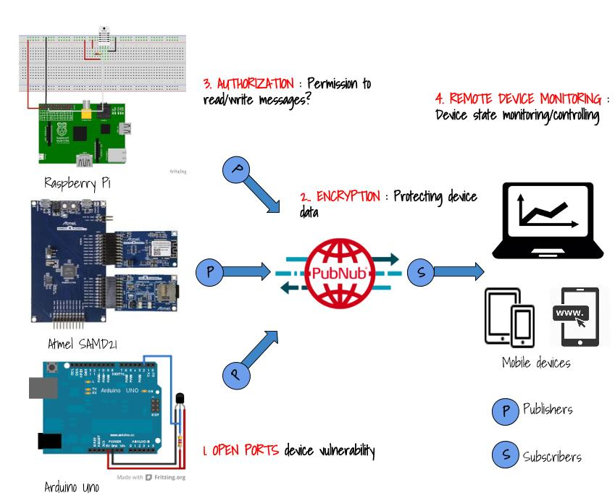
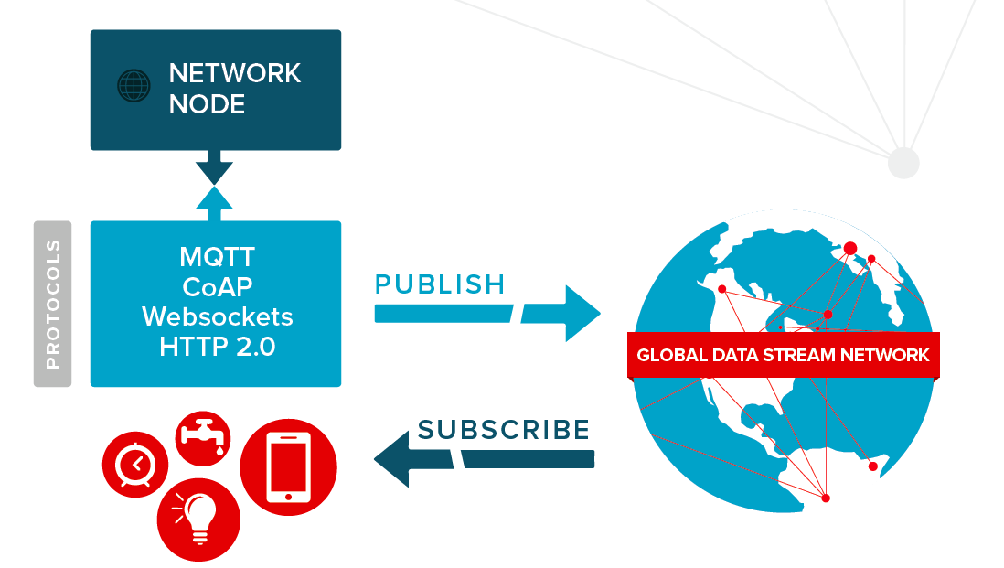
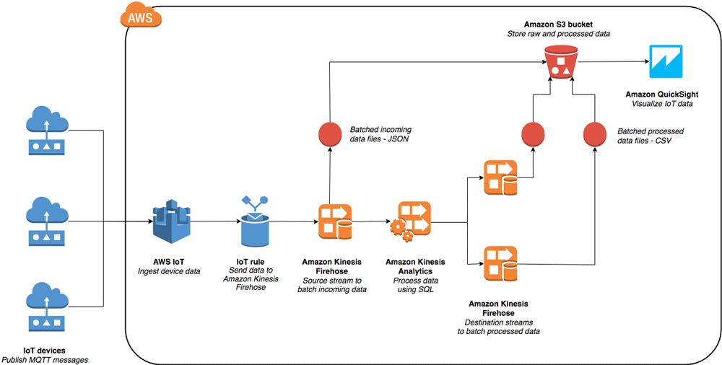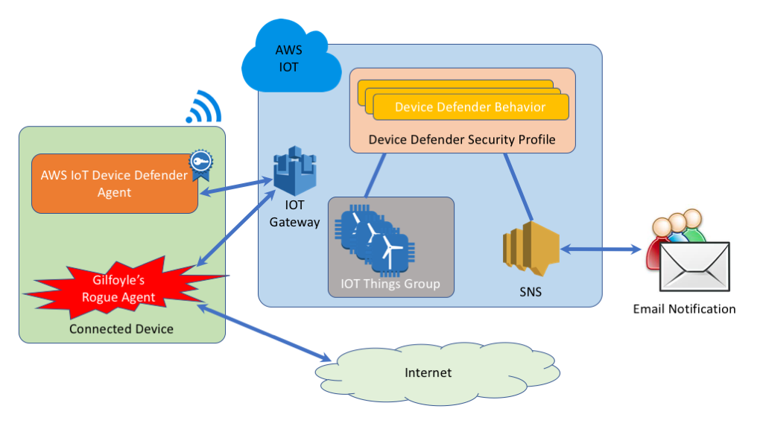
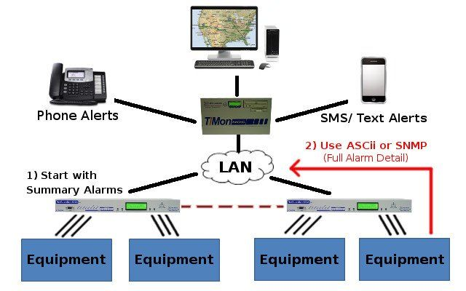

Research paper
1-Comparison with HTTP and MQTT on Required Network Resources for IoT
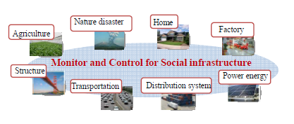
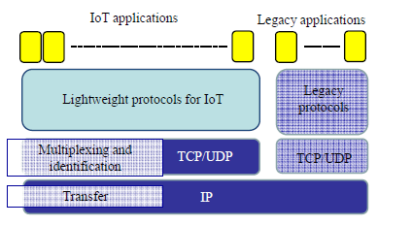
This paper has summarized the data transfer protocols used in IoT. IoT is expected to be applied to various applications as a social infrastructure. However, to deploy IoT widely, lightweight communication protocols are required. This paper has clarified that ICN architecture is the promising candidate for this purpose. A comparison has been made between the performance of HTTP in the category of legacy protocols and MQTT in the category of protocols based on ICN architecture. The paper concludes that MQTT performs better that HTTP. Additionally, this paper has proposed an approach to enhance MQTT.

2-HACKING IoT: A Case Study on Baby Monitor Exposures and Vulnerabilities
This last distinction is often the most dangerous one to make when it comes to deploying IoT devices. In his keynote address to the Chaos Computer Club, Lockdown: the coming war on general- purpose computing2, Cory Doctorow makes the case that with today’s technology and current computer science thinking, we cannot yet create a computer that is anything other than a general purpose computer. End users may have devices that are nominally prohibited from performing certain actions according to the manufacturer, and those manufacturers sometimes go to great lengths to foil modification efforts. In the end, though, it is not possible to build and sell a computing device that cannot be coerced into rebelling against a manufacturer’s intentions.
The absence of a fast, reliable, and safe patch pipeline is a serious and ongoing deployment failure for the IoT. A sub-one hundred dollar video baby monitor, a five hundred dollar smart phone, a thirty-five thousand dollar connected car, and a four hundred million dollar jet airliner are all difficult to patch, even when vulnerabilities are identified, known, and a fix is in hand. This situation is due to a confluence of factors, ranging from the design of these devices, through the regulatory environment (or lack thereof) in which these components and devices exist. Today, a commonly accepted (or truly acceptable) way to effect a rapid rollout of patches simply does not exist.
Compounding these patching problems is the fact that the use of commodity, third-party hardware, software, and cloud-based resources is prevalent in the IoT industry. While reusing off-theshelf technologies is critical in keeping costs of production low, it introduces an ambiguity of ownership for developing and deploying patches and other upgrades.
Another concern is the raw computing power available to attackers in the form of millions to billions of IoT devices. In total, the teraflops of processing power may be effectively harnessed by malicious actors to launch powerful distributed denial of service (DDoS) attacks against arbitrary Internet targets.
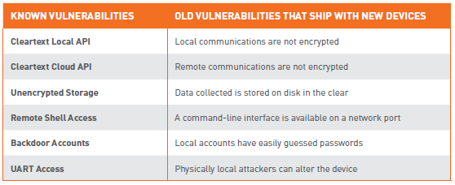
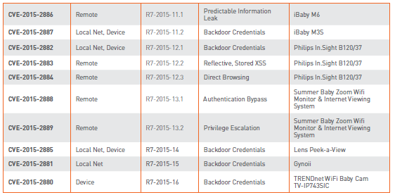
3-Security Issues in Internet of Things (IoT): A Survey
The major challenges while building IoT involve:
(i) Devices heterogeneity: As IoT is about connecting several smart devices, connecting heterogeneous devices is major challenge while building IoT. Such devices run on different platforms, they uses different protocols to communicate. So it is necessary to do unification of such devices.
(ii) Scalability: Another major challenge is the scalability of the IoT, as everyday new devices/objects are getting connected with the network. It involves issues like addressing/naming conventions, information management, service management etc.
(iii) Ubiquitous data exchange through wireless technologies: In IoT, wireless technologies are used to connect smart devices. It involves issues like availability, network delays, congestion etc.
(iv) Energy-optimized solutions: This is major constraint of IoT. As many devices are connected via networks, energy spent for data communication will be high. The challenge is to optimize the use of energy required for communication between different devices.
(v) Localization and tracking capabilities: The smart objects must be identified and tracking of them is necessary.
(vi) Self-organization capabilities: In IoT, it is required that the smart objects should sense the environment and autonomously react to real world situations, without much human intervention.
(vii) Semantic interoperability and data management: IoT exchange data among different smart objects, it is required that there should be a standardized format for data exchange in order to ensure the interoperability among applications.
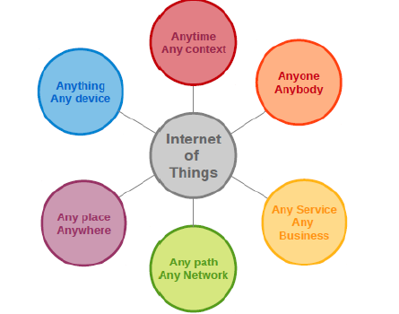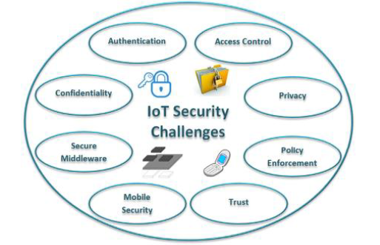
With many different technologies are in place within the IoT bench mark, numerous types of middleware layer are also engaged to effect the integration and the security of devices and data within the identical information network. Within alike middlewares, data required to have exact protection constraints. Additionally, in middleware design and development, the different communication mediums for wide scale IoT deployments need to be considered. While many smart devices can natively support IPv6 communications [18, 19], continuing deployments might not acknowledge the IP protocol within the local area scope. So ad hoc gateways are used along with middlewares [20]. Additionally, middlewares immediately lack an accomplished inspection, adopt to arguing to all the IoT conditions, coupled in terms of security and privacy and network behavior. Also, interoperability is becoming an elementary challenge, in order to allocate an individual construction of separated elements, able to co-act and collaborate with each other and as well as to deal data on the basis of standards. IoT includes not only individual data provided by devices/machines, but also by consumers, adjoining the interactions are machine-to-machine and furthermore among consumers and machines additionally among users and users. Therefore, the design and establishment of a middleware adhere an impact on the system composition (i.e., scalability, coupling among components).

3-Proposed Security Model and Threat Taxonomy for the Internet of Things (IoT)
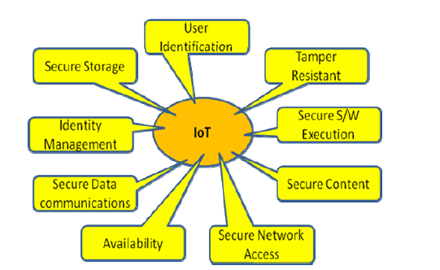
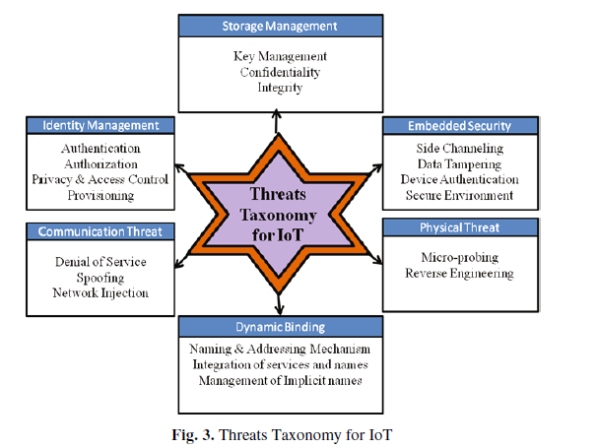
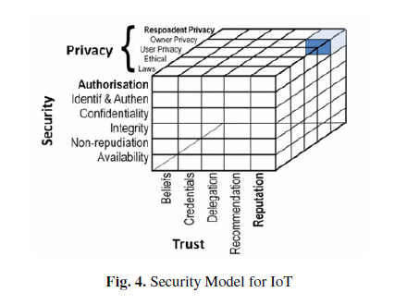
The incremental deployment of the technologies that will make up the IoT must not fail what the Internet has failed to do: provide adequate security and privacy mechanisms from the start. We must be sure that adequate security and privacy is available before the technology gets deployed and becomes part of our daily live. Security requirement and threat taxonomy insist to go for Trusted Platform Module which offers facilities for the secure generation of cryptographic keys, and limitation of their use, in addition to a hardware pseudo-random number generator. It also includes capabilities such as remote attestation and sealed storage. "Remote attestation" creates a nearly unforgeable hash key summary of the hardware and software configuration. The extent of the summary of the software is decided by the program encrypting the data. This allows a third party to verify that the software has not been changed. "Binding" encrypts data using the TPM endorsement key, a unique RSA key burned into the chip during its production, or another trusted key descended from it. In this paper we presented a categorization of topics and technologies in the IoT with analysis of sensitivity and state in research to different security and privacy properties. We see this (1) as a basis for coming up with an integrated systems approach for security and privacy in the Internet of Things, and (2) as stimulator for discussion on the categorization and sensitivity rating in the IoT. Furthermore, we presented key challenges like identity management, embedded security and authentication in the IoT.
4-Security of the Internet of Things: perspectives and challenges
We will divide IoT into three layers: perception layer, transportation layer and application layer. In order to analyze the security issues of IoT in more detail, according to the data transmission in the IoT Phases, we divide perception layer into perception nodes and perception network, divide transportation layer into access network, core network, and LAN, and divide application layer into application support layer and IoT applications. Each layer has a corresponding technical support, these technologies at all levels play irreplaceable roles, but these techniques are more or less related to the existence of the range problems that can cause insecurity, privacy and other security issues of data. Security architecture of IoT is shown in Fig. 1.
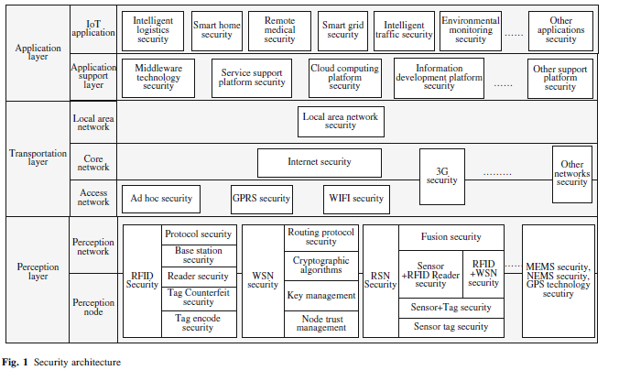
we compared security issues between IoT and traditional network, and concluded that IoT system lives in a more dangerous environment with limited resources and less network guards, thus lightweight solutions would always be our first choices for IoT security. We also discussed opening security issues of IoT as an indivisible entity, and give some potential directions for these issues: overall security architecture for the entire IoT system, lightweight security solutions and efficient solutions for massive heterogeneous data.
6. Cyber and Physical Security Vulnerability Assessment for IoT-Based Smart Homes
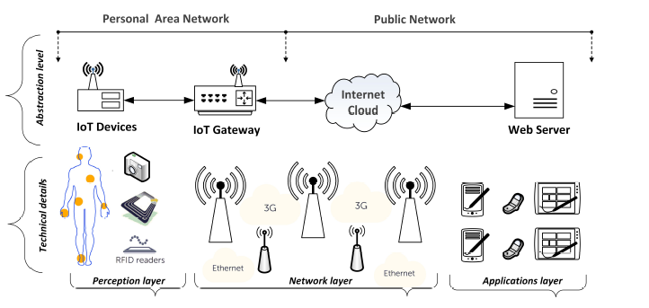
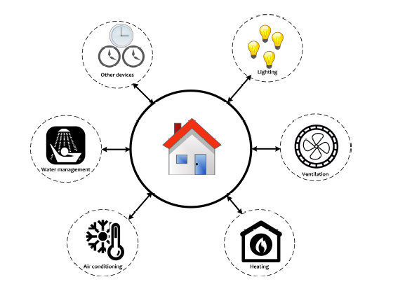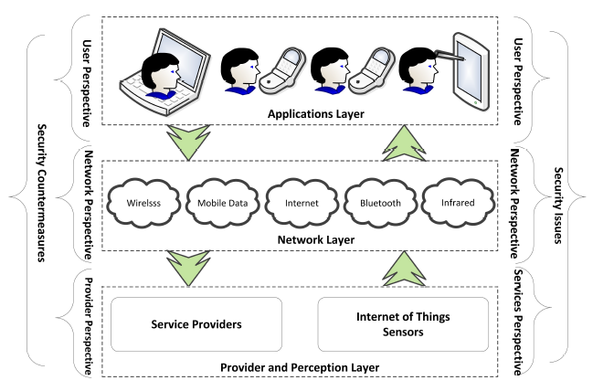
The types of security vulnerabilities include hacking of the home device, a virus attack, an information leak, content fabrication and privacy violation.
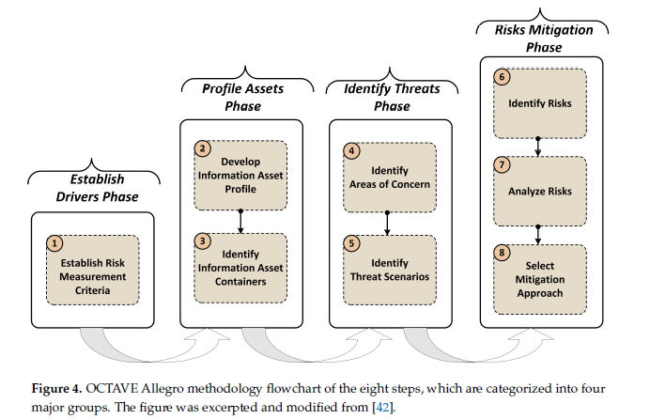
The aim of this section is to first collect all security threats found by conducting the information security risk assessment using the OCTAVE Allegro methodology. The results of this research are presented in Tables 1 and 2, which give a better overview of the identified security threats and the potential risks in an IoT-based smart home environment. The two tables show the information assets that were identified and used in the risk assessment process, the threats associated with them, and the consequences or potential impacts in the form of specific risks and risk scores.
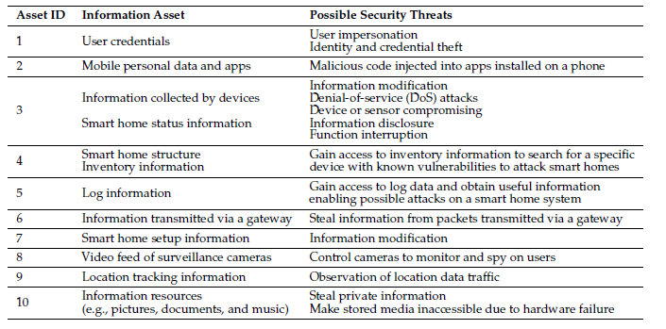
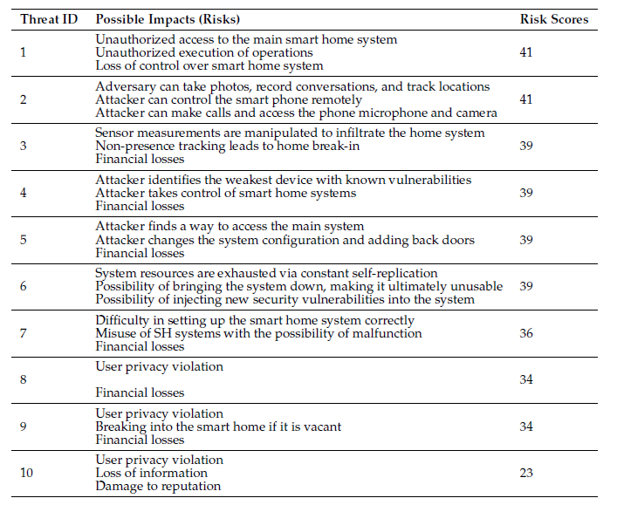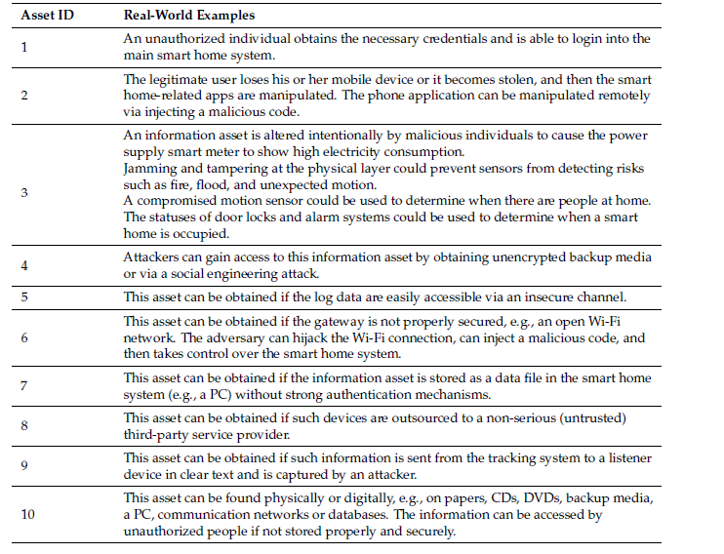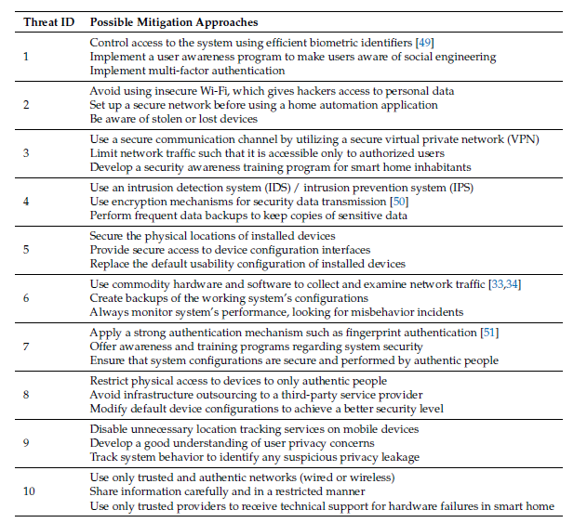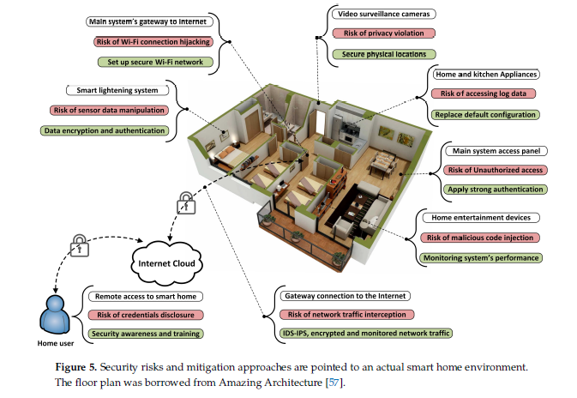
IoT devices installed in smart homes lack high computational power, large storage space, and large memory size. Therefore, implementing intensive security solutions may not be an available option. To offer a secure connection between the IoT devices and the gateway inside the smart home environment, a distributed encryption mechanism [1] or an energy-efficient data encryption approached like a triangle based security algorithm that uses efficient key generation [58] should be taken into consideration. At the edge of network layer, the IoT gateway works as an intermediary between IoT devices and the external network. The IoT gateway is susceptible to different security exploits such as man-in-the-middle attack and possibility to collect data from IoT devices. Therefore, gateway security is a crucial need for protecting the data flow inside and outside smart home environments. A secure gateway can be built by implementing efficient security algorithms like elliptic curve cryptography (ECC) [59] and using strong user authentication approaches [60].
This study has conducted a comprehensive security risk assessment using OCTAVE Allegro and identified 10 critical information assets. Via a risk assessment, approximately 15 security risks from the cyber and physical perspectives, as reported in Table 1, originating from both inside and outside smart homes, have been identified. Intuitively, there are other risks that have not been stated due to time limitations and the increased number of worksheets in the OCTAVE Allegro method. The impacts of security risks are described in Table 2. Suitable countermeasures for mitigating the risks to an acceptable level (since 100% security is never attainable) are proposed in Table 4. The risk assessment aims to identify the most severe potential dangers with a given risk score, as shown in Table 2. Physical security risks correspond to devices and sensors, i.e., the perception layer in Figures 1 and 3. The risks to hardware concern the theft, defect, manipulation, and sabotage of the various devices inside or outside a smart home environment. The highest risk score, which is 41, is related to cyber or information assets such as user credentials, mobile personal data, and user applications. Within network communication, represented by the network layer in Figures 1 and 3, the core risks come from inadequate authentication mechanisms, a lack of secure communication channels, and a lack of appropriate data encryption mechanisms [62].

7-Choice of Effective Messaging Protocols for IoT Systems: MQTT, CoAP, AMQP and HTTP
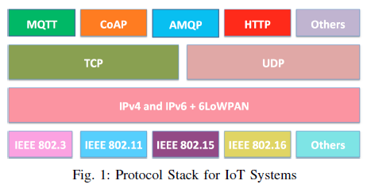
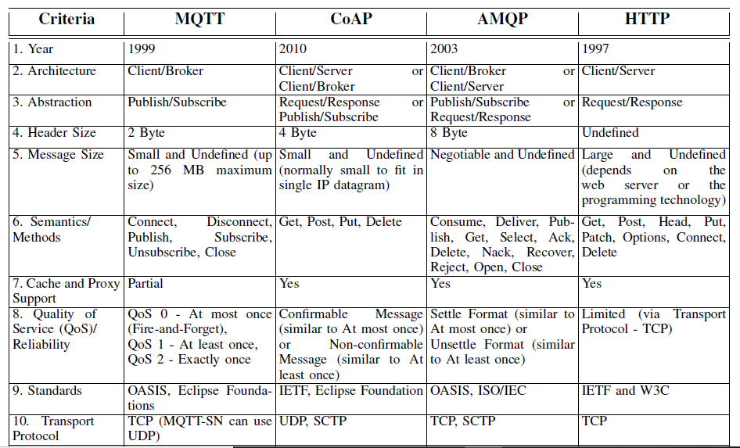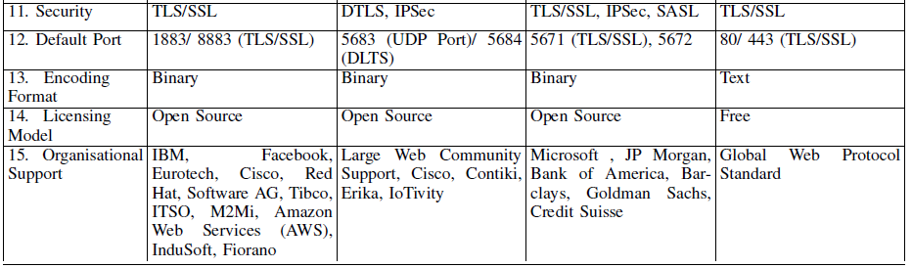
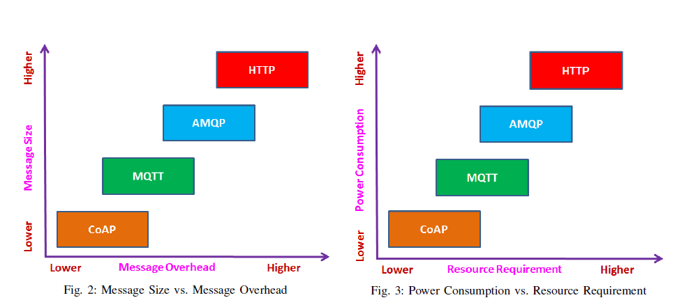
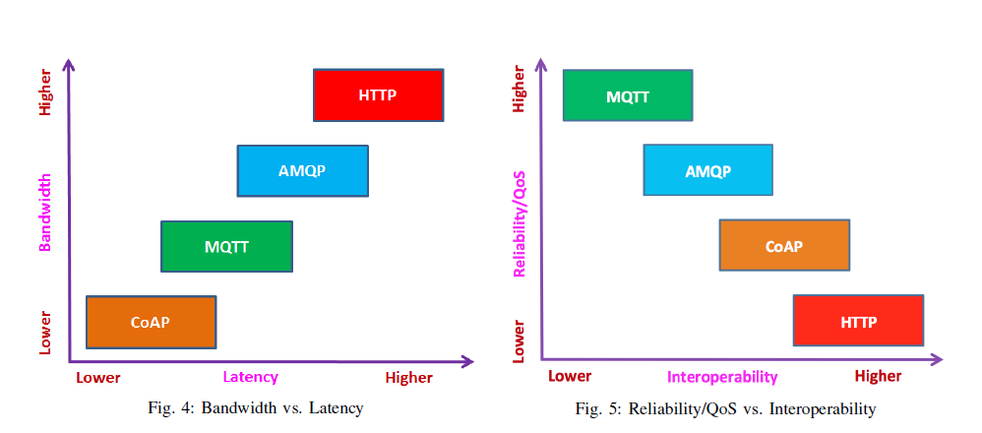
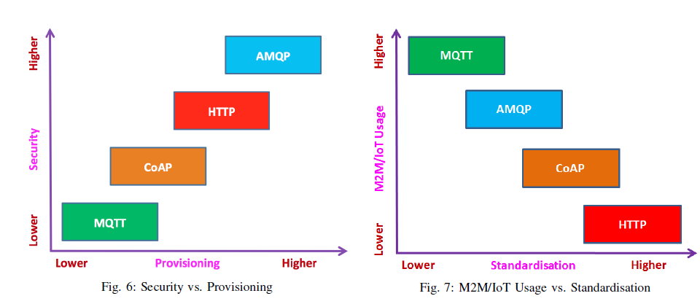

8-ProfilIoT: A Machine Learning Approach for IoT Device Identification Based on Network Traffic Analysis
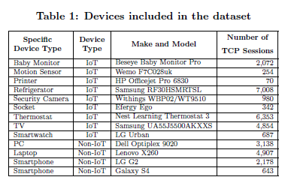
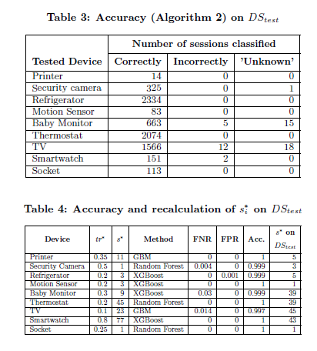
IoT device can be accurately identi ed based on characteristics of the network tra
c it generates. Our method can classify an IoT de- vice, including by brand and model, with 99.281% accuracy which makes our method feasible for real organizations. We believe that our novel approach can be used to automati- cally and accurately recognize (possibly unauthorized) con- nections of IoT devices to an enterprise's computer network, and thus mitigate violations of operational policies. In fu- ture research, we plan to explore applications and adapt our technology to additional scenarios, possibly including di er- ent network protocols and various data capturing points, to better understand how our approach scales and generalizes.

9-Machine Learning DDoS Detection for Consumer Internet of Things Devices
Given the lack of public datasets of consumer IoT attack traffic, we generate classifier training data by simulating a consumer IoT device network. We set up a local network comprised of a router, some popular consumer IoT devices for benign traffic, and some adversarial devices performing DoS attacks. Our classifiers successfully identify attack traffic with an accuracy higher than 0.999. We found that random forest, K-nearest neighbors, and neural net classifiers were particularly effective. We expect that deep learning classifiers will continue to be effective with additional data from real-world deployments.

