(day-16 assignment, below 3 questions)

1. Write a program to take an integer array from the user and give the user a choice to sort using bubble sort (or) selection sort. Sort the array elements according to the selected algorithm of the user and display the sorted array.

package SBA_4;

import java.util.Scanner;

public class Q1 {

//*****BUBBLE SORT************

void bubbleSort(int arr[])

{

int n = arr.length;

for (int i = 0; i < n-1; i++)

for (int j = 0; j < n-i-1; j++)

{

if (arr[j] > arr[j+1])

{

// swap arr[j+1] and arr[j]

int temp = arr[j];

arr[j] = arr[j+1];

arr[j+1] = temp;

}

//for debugging every move made by the algorithm

/*for (int k=0; k<n; ++k)

{

System.out.print(arr[k]+",");

}

System.out.println("");*/

}//inner for closes

}

/* Prints the array */

void printArray(int arr[])

{

int n = arr.length;

for (int i=0; i<n; ++i)

System.out.print(arr[i] + " ");

System.out.println();

}

//********SELECTION SORT**************

void Selectionsort(int arr[])

{

int n = arr.length; //6

for (int i = 0; i < n-1; i++)

{

int min_idx = i;//

for (int j = i+1; j < n; j++)

{

if (arr[min_idx] > arr[j])

min_idx = j;//5

}

int temp = arr[min_idx];

arr[min_idx] = arr[i];

arr[i] = temp;

/*for (int k=0; k<n; ++k)

{

System.out.print(arr[k]+" ");

}

System.out.println(); */

}

}

// Prints the array

void printArray2(int arr[])

{

int n = arr.length;

for (int i=0; i<n; ++i)

System.out.print(arr[i]+" ");

System.out.println();

}

//****MAIN CLASS*********

public static void main(String[] args) {

//int arr[] = {64, 34, 25, 12, 22, 11, 90};

int[] arr=new int[5];

System.out.println("Enter 5 integer values");

Scanner sc=new Scanner(System.in);

for(int i=0;i<5;i++)

{

arr[i]=sc.nextInt();

}

System.out.print("Unsorted Array is : [");

for(int i=0;i<5;i++)

{

System.out.print(arr[i]+",");

}

System.out.println("]");

Q1 ob = new Q1();

System.out.println("Enter 1:Bubble Sort 2:Selection Sort");

int n=sc.nextInt();

switch(n)

{

case 1:{

ob.bubbleSort(arr);

System.out.println("Sorted array");

ob.printArray(arr);

break;

}

case 2:{

ob.Selectionsort(arr);

System.out.println("Sorted array");

ob.printArray2(arr);

break;

}

}

}

}

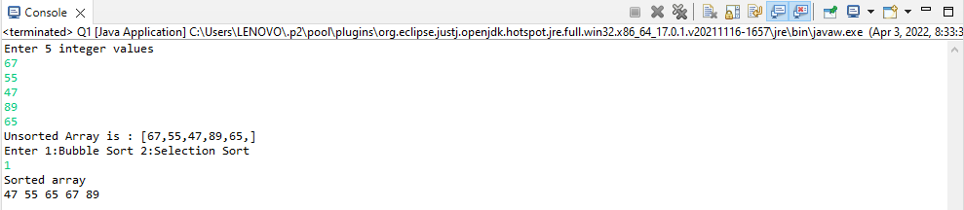

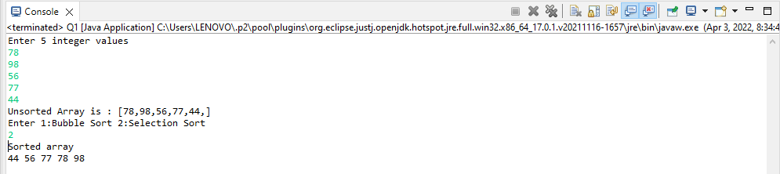

1. Write a program to implement insertion sort.

//Write a program to implement insertion sort.

**package** SBA_4;

**public** **class** Q2 {

**void** sort(**int** arr[])

{

**int** n = arr.length;

**for** (**int** i = 1; i < n; ++i) {

**int** key = arr[i];

**int** j = i - 1;

/* Move elements of arr[0..i-1], that are

greater than key, to one position ahead

of their current position */

**while** (j >= 0 && arr[j] > key) {

arr[j + 1] = arr[j];

j = j - 1;

}

arr[j + 1] = key;

}

}

/* A utility function to print array of size n*/

**static** **void** printArray(**int** arr[])

{

**int** n = arr.length;

**for** (**int** i = 0; i < n; ++i)

System.***out***.print(arr[i] + " ");

System.***out***.println();

}

// Driver method

**public** **static** **void** main(String args[])

{

**int** arr[] = { 12, 11, 13, 5, 6 };

Q2 ob = **new** Q2();

ob.sort(arr);

*printArray*(arr);

}

}



1. Write a program to implement Hashtable and add atleast 4 values into it, implement the putIfAbsent() method.

//Write a program to implement Hashtable and add atleast 4 values into it, implement the putIfAbsent() method.

**package** SBA_4;

**import** java.util.*;

**class** Q3{

**public** **static** **void** main(String args[]){

Hashtable<Integer,String> map=**new** Hashtable<Integer,String>();

map.put(100,"Amit");

map.put(102,"Ravi");

map.put(101,"Vijay");

map.put(103,"Rahul");

System.***out***.println("Initial Map: "+map);

//Inserts, as the specified pair is unique

map.putIfAbsent(104,"Gaurav");

System.***out***.println("Updated Map: "+map);

//Returns the current value, as the specified pair already exist

map.putIfAbsent(101,"Vijay");

System.***out***.println("Updated Map: "+map);

}

}

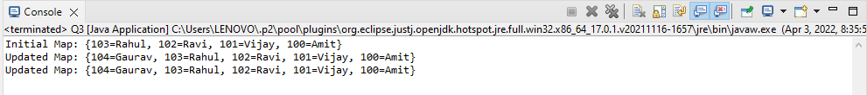

1. Create a class of Books with attributes:

a)id

b)name

c)author

d)publisher

e)quantity sold.

Implement a Hashtable to implement the objects of Books type. Print all the details of books by traversing through the Hashtable.

package SBA_4;

import java.util.Hashtable;

import java.util.Map;

class Book {

int id;

String name,author,publisher;

int quantity;

public Book(int id, String name, String author, String publisher, int quantity) {

this.id = id;

this.name = name;

this.author = author;

this.publisher = publisher;

this.quantity = quantity;

}

}

public class Q4 {

public static void main(String[] args) {

//Creating map of Books

Map<Integer,Book> map=new Hashtable<Integer,Book>();

//Creating Books

Book b1=new Book(101,"Let us C","Yashwant Kanetkar","BPB",8);

Book b2=new Book(102,"Data Communications & Networking","Forouzan","Mc Graw Hill",4);

Book b3=new Book(103,"Operating System","Galvin","Wiley",6);

//Adding Books to map

map.put(1,b1);

map.put(2,b2);

map.put(3,b3);

//Traversing map

for(Map.Entry<Integer, Book> entry:map.entrySet()){

int key=entry.getKey();

Book b=entry.getValue();

System.out.println(key+" Details:");

System.out.println(b.id+" "+b.name+" "+b.author+" "+b.publisher+" "+b.quantity);

}

}

}

