**Wanderlust**

**Introduction:**

The website designed provides details about the places visitors would like to visit. Users could use this website to add information about the places they have already visited and to get information about places they would plan to visit soon. Information is provided categorically to ease the navigation experience between the categories.

1. **Screenshot the Home page of the website:**

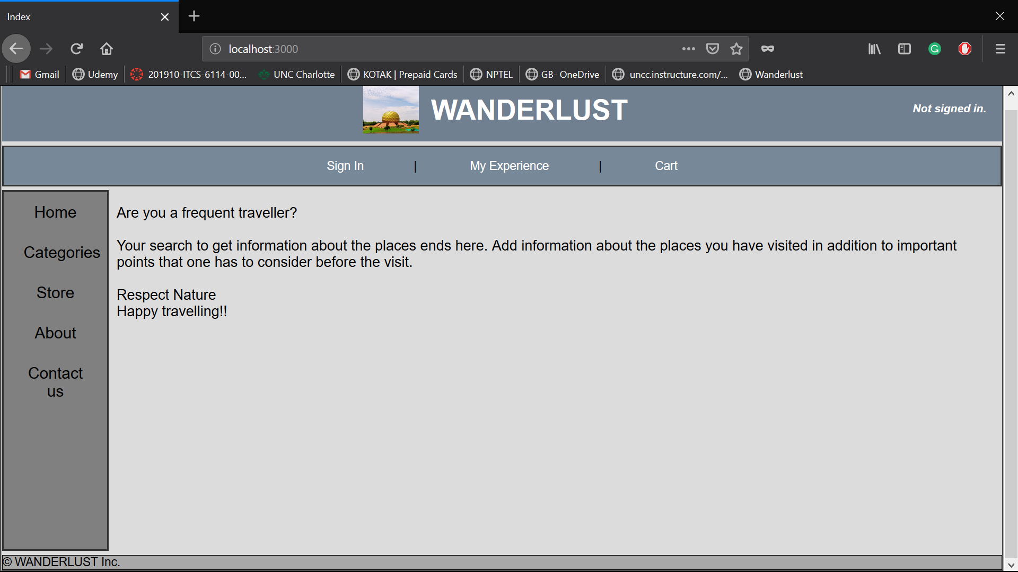

1. **Additional features:** There are no additional features at this point.
2. **Status of the web application:** The web application has been developed so far as per the requirements provided to us. It works well for all the functionalities developed so far.

The feedback.ejs page that was not dynamic in the previous assignment has been made dynamic in this assignment. Complete data and its operations are being carried out on database.

1. **Development experience:** Integrating various concepts that we had separately learned so far has been quite challenging and it would take more time to accomplish the same. Implementing various individual modules has been the hardest part so far. The database part is very interesting. I did have a good learning experience.