**Q4) PUBLIC URL LINK:** <https://gowtham-api.onrender.com/calculate>

**Chosen Question1 and created REST endpoint.**

**Question1:**

Given numbers x,y and z write a generator function for the output as follows.

hello

x

If x^y is greater than z, return 'higher than expected'. Else print x^y

done

Eg:

Input: 6 2 50

Output:

hello

6

36

done

Input: 3 4 50

Output:

hello

3

higher than expected

done

**Node.js code:**

const express = require('express');

const bodyParser = require('body-parser');

const app = express();

app.use(bodyParser.json());

app.post('/calculate', (req, res) => {

  const { x, y, z } = req.body;

  const result = generateOutput(x, y, z);

  res.json(result);

});

function generateOutput(x, y, z) {

  const output = ['hello'];

  output.push(x);

  if (x ** y > z) {

    output.push('higher than expected');

  } else {

    output.push(x ** y);

  }

  output.push('done');

  return output;

}

app.listen(port, () => {

  console.log(`Listening at http://localhost:5000`);

});

**Test using Postman:**

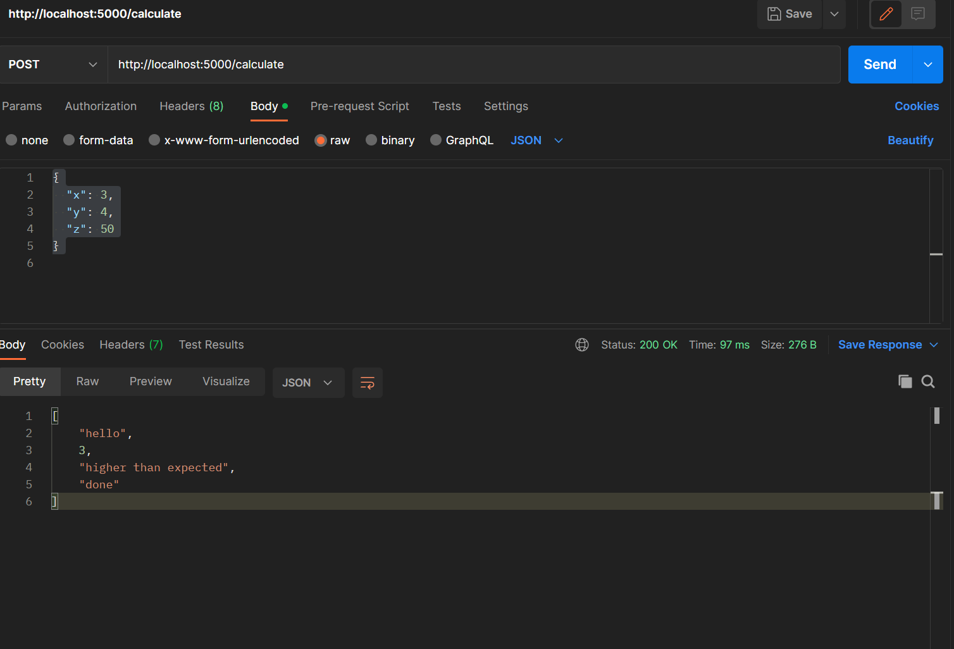

**Deployed as public URL in Render:**

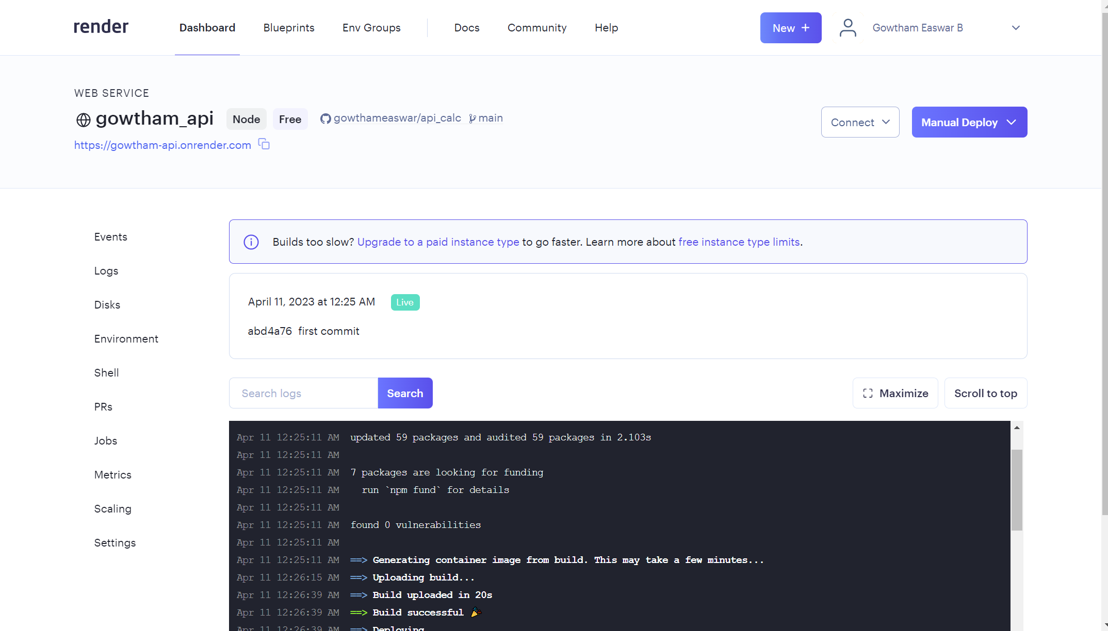

**Test using Postman:**

