 Project Report

**INTRODUCTION**

OVERVIEW

THIS PROJECT HELPS YOU TO MAINTAIN AND MANAGE THE SCHOOL RELATED PROBLEMS WHICH FURTHER CAN BE MODIFIED BASED ON THE REQUIREMENTS.

**PURPOSE**

This project helps us to maintain and manage the school related informations that are clearly maintained one by one that is easily to find one persons information very easily.

**DATA MODEL:**

|  |  |
| --- | --- |
| **Object name** | **Fields in the Object** |
| Student object | |  |  | | --- | --- | | Field label | Data type | | Phone number | Phone | | School | Master detail relationship | |
| Parent object | |  |  | | --- | --- | | Field label | Data type | | Parent Address | Area | | Parent number | Phone | |

**ACTIVITY & SCREENSHOT:**

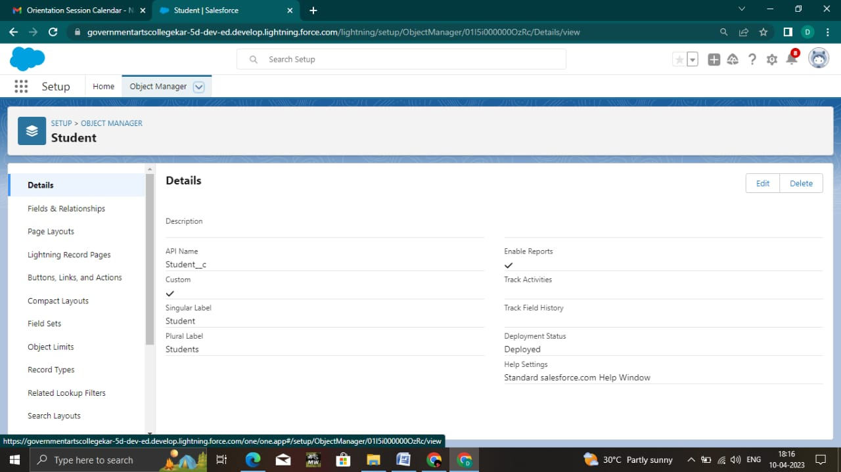

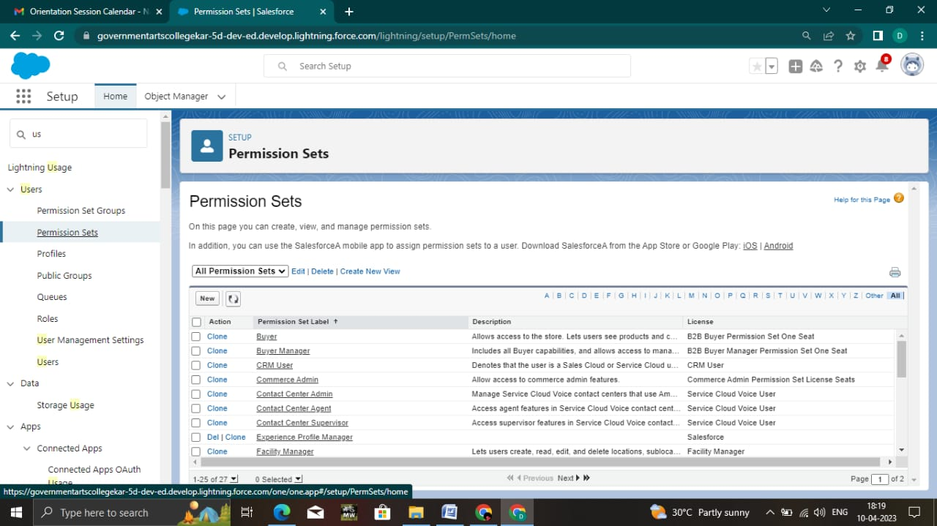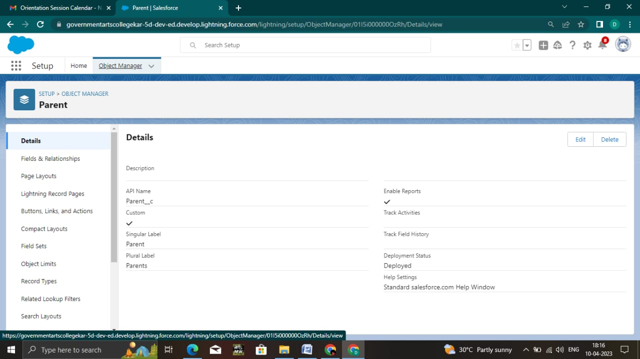

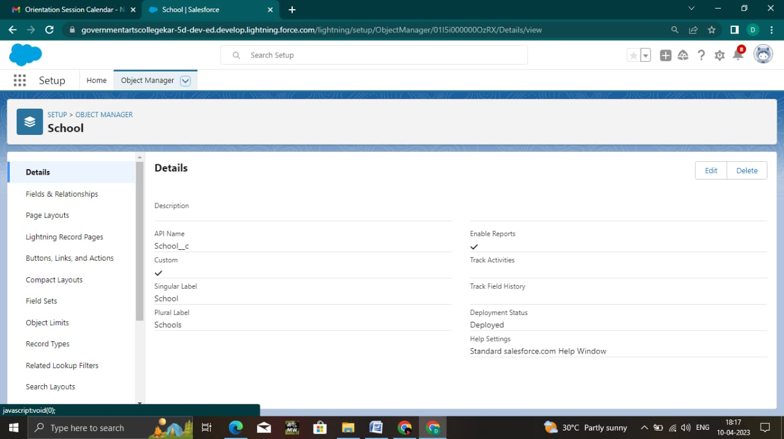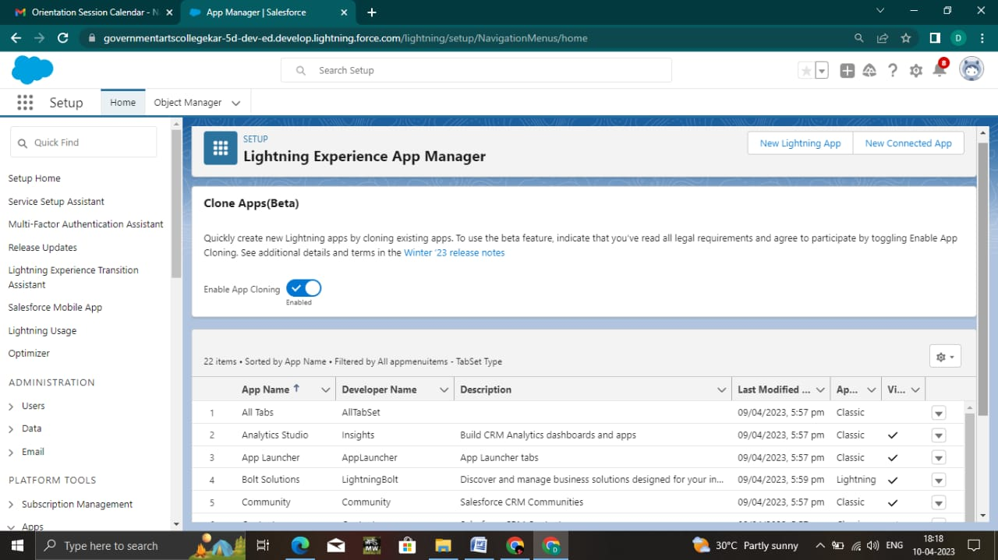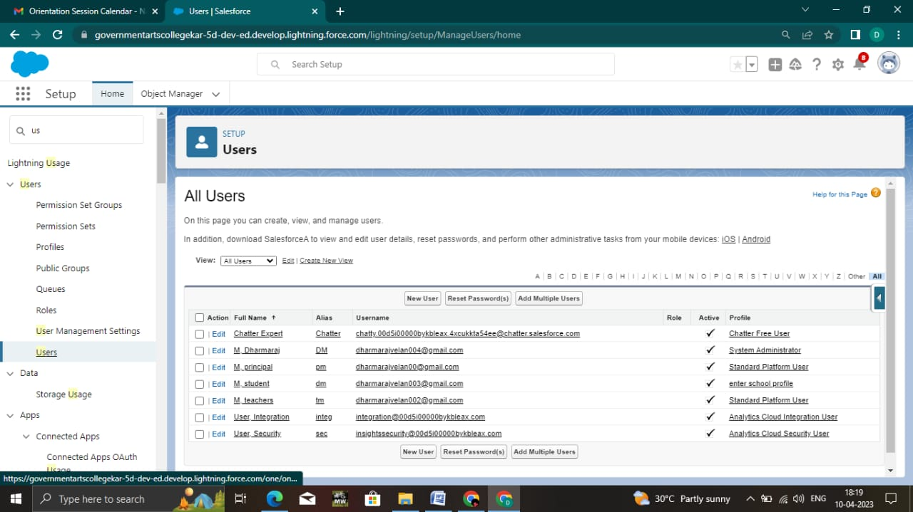

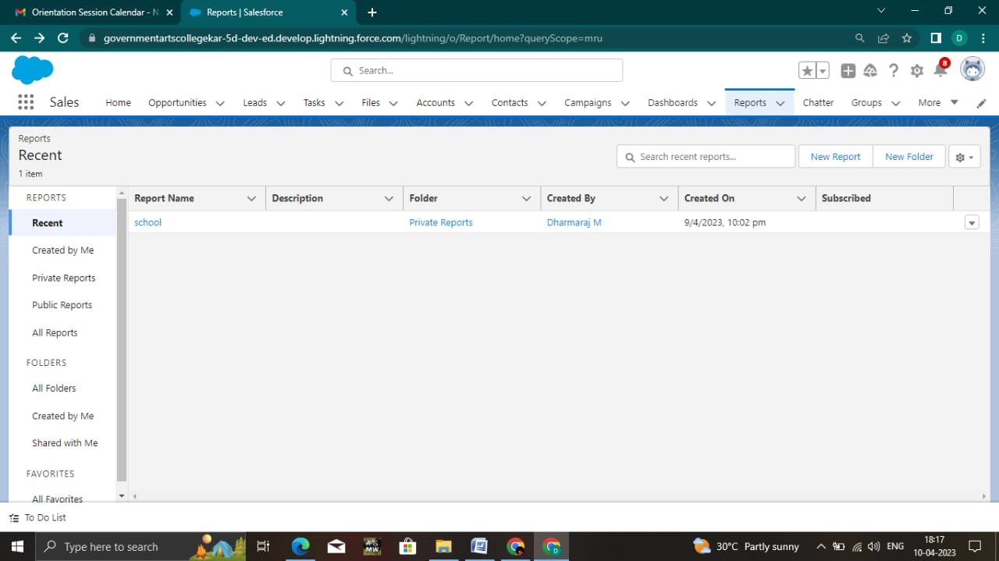

**Trailhead Profile Public URL**

**DHARMARAJ.M: https://trailblazer.me/id/dharm300**

**GAYATHRI.S: https://trailblazer.me/id/hgahlot3**

**GOWTHAMARAJ.K: https://trailblazer.me/id/g-ggggggg3**

**HARIPRABAKARAN.P: https://trailblazer.me/id/hprabha59**



**ADVANTAGES & DISADVANTAGE**

**\***Here we get the informations of the students very fastly and easily.

**\***It gives us a space to make our informations safe and saves high no of in informations in low space

**\***Here there is no disadvantage in my teams point of view.

**APPLICATIONS**

**\*** In schools and colleges this program is very helpful to store the students informations clearly as well.

**CONCLUSION**

**\*** We worked well on this project.

**\***Here we noted How hard to store the informations of students in schools. So there our project is very helpful to them.

**FUTURE SCOPE**

**\***In future our project gets more importance because storing of informations is very essential.So we think our project makes an impact in future.

**\*\*\*\*\*\*\*\*\*\*\*\*\*\*\*\*\*\*\*\*\*\*\*\*\***