MACHINE LEARNING PROJECT PHASE 1 DATA PREPROCESSING

# Graduate Admission Prediction

Submitted By:

Vanguru Vekata Varun Kumar Reddy AM.EN.U4CSE20172

Chinthakuntla Purushottam Reddy AM.EN.U4CSE20120

S N V V S Gowtham Tadavarthy AM.EN.U4CSE20160

Balasani Dheeraj Redddy AM.EN.U4CSE20115

Joshua Wilson Philip AM.EN.U4CSE20135

Maddipati Umesh Chandra AM.EN.U4CSE20142

Data Pre-processing :

* Numerical data
  + Normalization

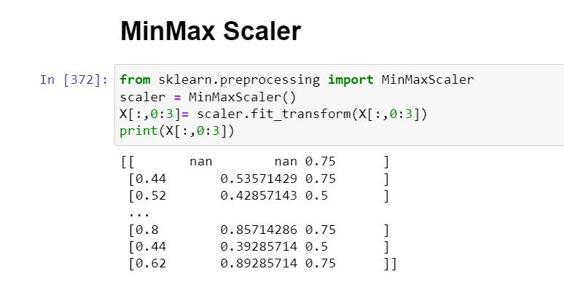

* + Standardization

* + Imputing Missing values

* Data Summarization: o Use statistical methods to understand the data and apply the required methods

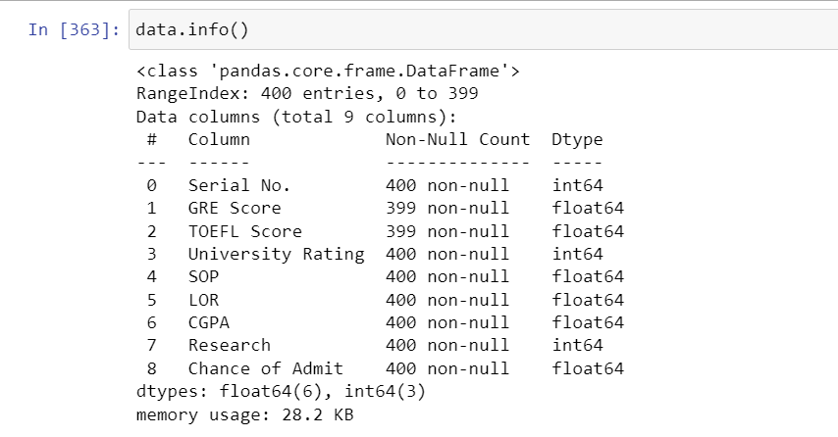

* Data Visualization: o Visualize the data using various plots like scatterplot, histograms, box plot etc and record your interpretations with varying values

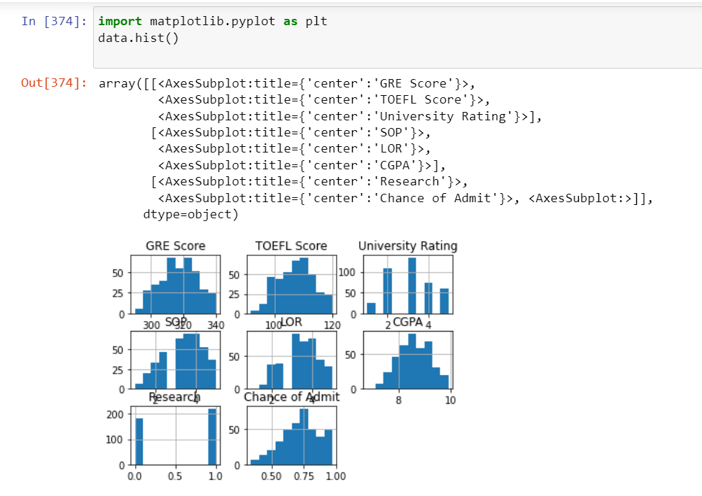

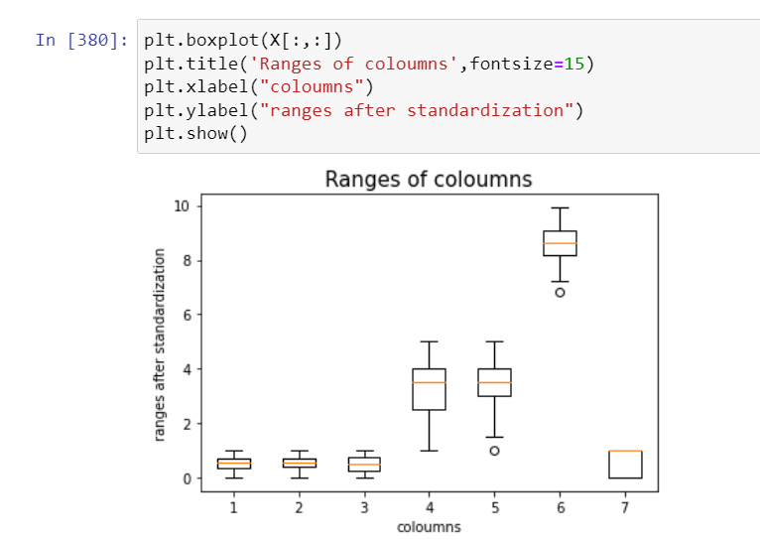

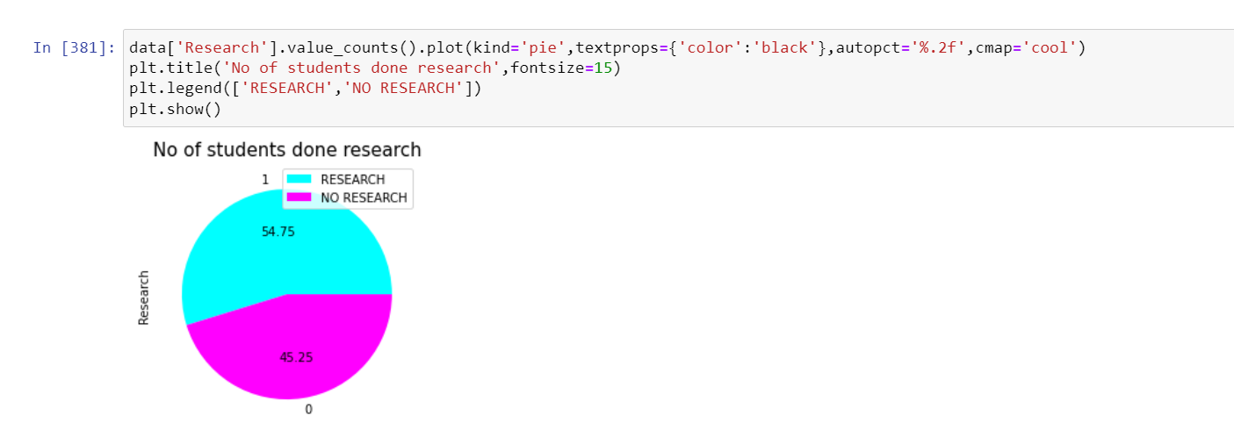

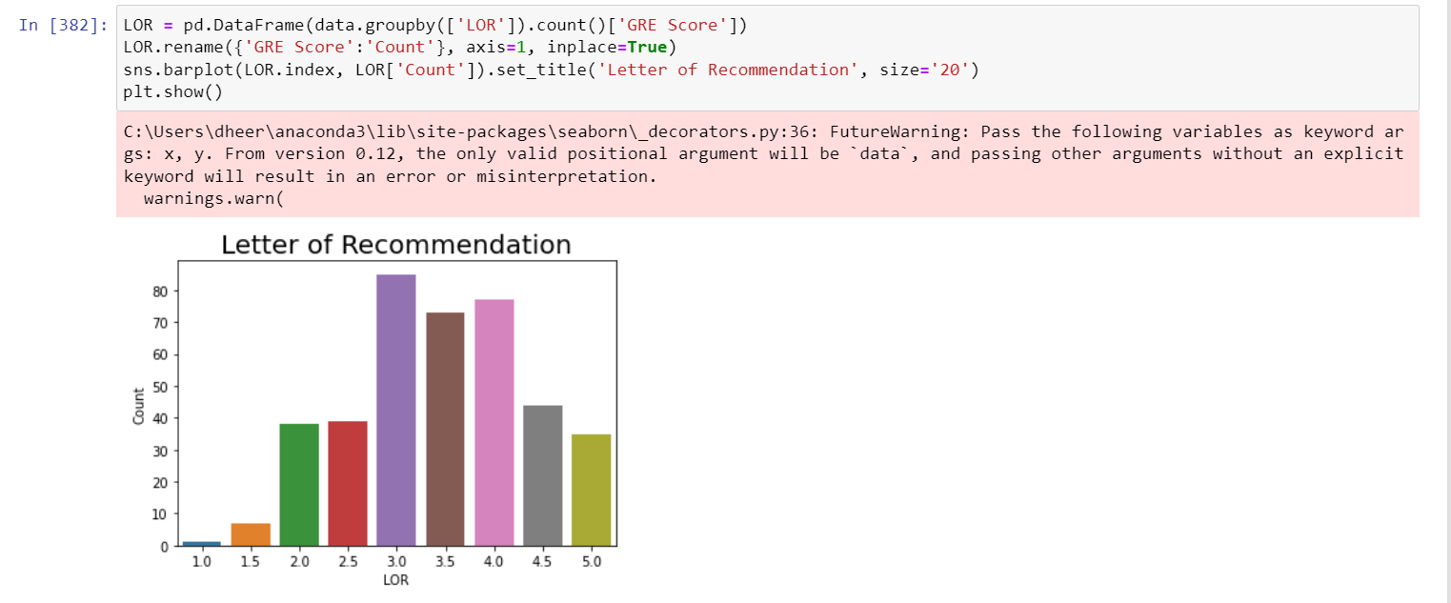

* Data Interpretation:

o Record all your findings and summary about data o Document all the results with relevant screenshots. o Upload the original as well as the cleaned data.