Guideleines:

<http://build.fhir.org/ig/HL7/carin-bb/toc.html>

**Important** : Guidance for patient access:

<https://www.cms.gov/Regulations-and-Guidance/Guidance/Interoperability/index>

IG/Profiles:

<http://hl7.org/fhir/us/carin-bb/>

<http://hl7.org/fhir/us/davinci-pdex/STU1/>

Important: (used for data mapping )

<http://hl7.org/fhir/us/carin-bb/Common_Payer_Consumer_Data_Set.html>

Capability statement for Explanation of Benefits by CARIN:

<http://build.fhir.org/ig/HL7/carin-bb/CapabilityStatement-c4bb.html>

artifact

<http://build.fhir.org/ig/HL7/carin-bb/artifacts.html>

Mulesoft Implementation:

<https://anypoint.mulesoft.com/exchange/org.mule.examples/hc-accelerator-sfdc-carin-explanationofbenefits-sys-api/minor/1.0/pages/Use%20case/>

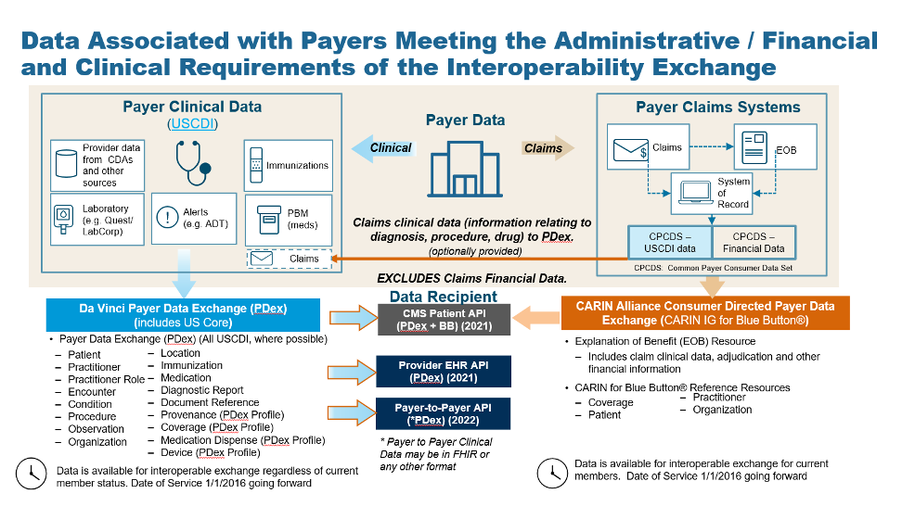

Background

Consumer-directed exchange occurs when a consumer or an authorized caregiver invokes their HIPAA Individual Right of Access (45 CFR 164.524) and requests their digital health information from a HIPAA covered entity (CE) via an application or other third-party data steward.

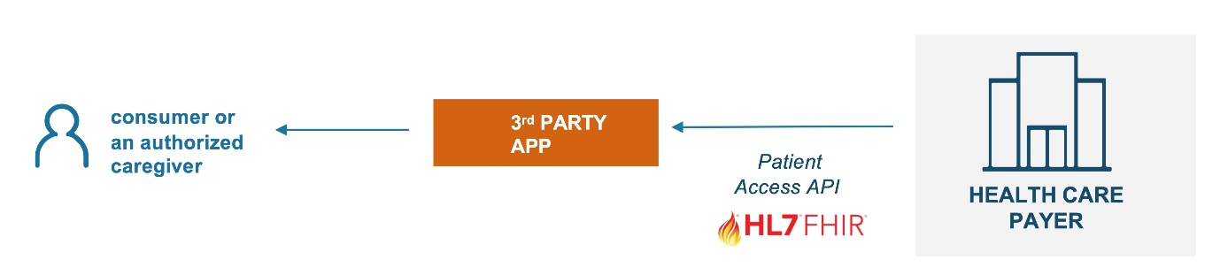

Technical Workflow

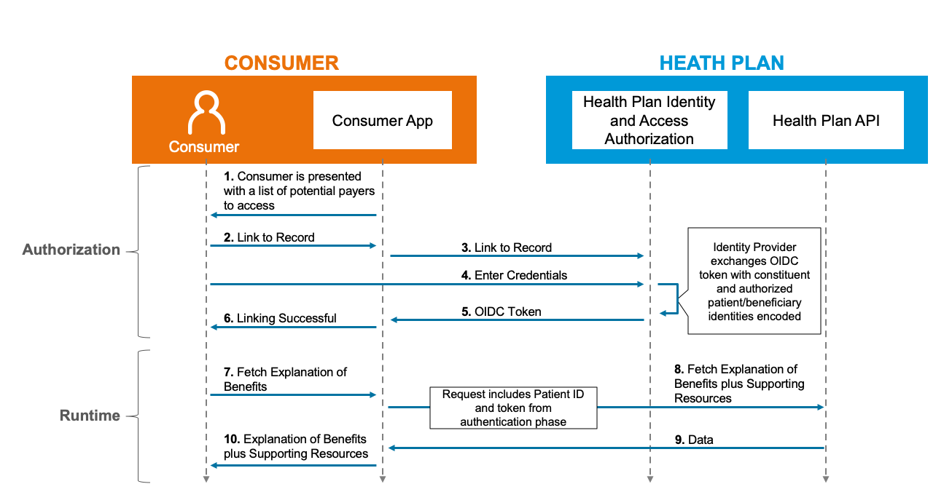

 Actors:

* + Consumer (aka Subscriber, Beneficiary, Patient, or Personal Representative)
  + Consumer App (aka digital third-party application selected by and primarily for the Consumer with a consumer-facing user interface)
  + Health Plan API (aka Payer, Covered Entity)
  + Health Plan’s Identity and Access Authorization server

Flow:

* + Consumer App presents a list of potential Payers / Health Plans that can be accessed by the Consumer.
  + Consumer selects the Payer / Health Plan.
  + Consumer App opens the link to the Health Plan's Identity and Access Authorization server.
  + Consumer enters the credentials.
  + Health Plan's Identity and Access Authorization server validates the credentials, generates and returns to the Consumer App an OIDC token with Consumer and authorized patient/beneficiary identities encoded.
  + Consumer App successfully links the user to the Payer / Health Plan and notifies the Consumer.
  + Consumer requests the Consumer App to fetch Explanation Of Benefit records.
  + Consumer App generates and sends to the Health Plan's CARIN IG for Blue Button® enabled FHIR API a request (which includes Patient ID, and token from the step #5) to fetch the Explanation Of Benefit (EOB) and supporting reference FHIR resources.
  + Health Plan's CARIN IG for Blue Button® enabled FHIR API responds with a bundle of the requested EOB and supporting reference FHIR resources.
  + Consumer App presents the EOB and supporting reference FHIR resources to the Consumer.

*From <*[*http://build.fhir.org/ig/HL7/carin-bb/Use_Case.html*](http://build.fhir.org/ig/HL7/carin-bb/Use_Case.html)*>*

Mulesoft Implementation:

<https://anypoint.mulesoft.com/exchange/org.mule.examples/hc-accelerator-sfdc-carin-explanationofbenefits-sys-api/minor/1.0/pages/Use%20case/>

