# Introduction to FHIR

**F**ast

**H**ealthcare

**I**nteroperability

**R**esources

Introduction

HL7 is a standards development organization.

FHIR is a standard (V2 and CDA are also separate standards)

Versions of FHIR

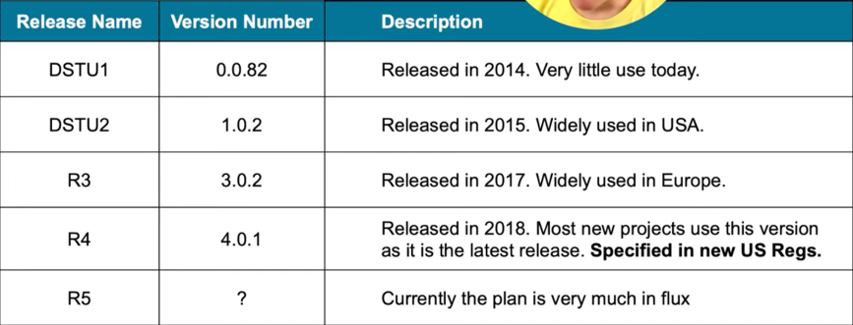

* The basics: resources and references
* Structured Data
* Profiling
* Paradigms of Exchange
* Ecosystem
* Health information sharing is becoming increasingly important
  + Individuals involved in delivering care to consumers now expect the information they require to be available at the point of care
* Data collected in multiple places
  + Realistically need to move information around
* Interfaces are expensive
  + Especially if not standards based
* HL7 defines Interoperability Standards
* In 2011, the Board of HL7 noted:
  + Interoperability requirements are increasing
  + Need for real time access (API) – Mobile
  + Vast increase in the amount, type and source of data
    - e.g. Devices, Genomics
  + Analytics, population health
  + Implementer expectations
* Existing standards were lacking, a fresh look was needed…

# Benefits of FHIR

#### Benefits to Implementers and Vendors

* Familiar tooling and technologies
  + XML/JSON, HTTP, REST, SSL, OAuth
* Predefined resources and APIs
  + With built in extensibility
  + Allows implementer to focus on the core application functionality
* Extensive documentation, samples and reference server implementations
* Validation services
* Active and supportive community
* Open Source code libraries
  + HAPI (Java) and Furore (.Net)
* Mobile friendly
* Increases commercial viability of app development as FHIR compliant apps will work with different FHIR Servers (EMRs, HIEs)
* Clinicians can get involved in system design
* Tooling available
* Improved access to more complete, higher quality patient information incl. genomics
* Greater choice and variety of applications and devices to support clinical workflow
* Increased IT development speed – solving business problems faster in innovative ways
* Improving Decision Support
  + E.g. Immunization protocol
* Saving time
* Prospect of improved patient engagement apps, enabled through FHIR APIs to clinical systems
  + Can engage more deeply
* Clinician has access to a more complete patient record and improved decision making tools, leading to:
  + Better decision making
  + More efficient diagnosis and treatment
  + Higher quality care
* Overall improved patient experience – reducing wasted time

Benefits to Health Care Organisations

* Most vendors are committed to FHIR
* Should lead to:
  + faster deployments
  + lower cost interoperability
  + reduced vendor lock in as FHIR is adopted by source systems
* Standards based APIs to support internal application development
* Capture data for
  + Analytics and Decision Support
  + Population Management

# Basics of FHIR

### The goals of FHIR (FHIR manifesto)

* Implementer Focus
* Target the 80% (common stuff)
* Use today’s web technologies
  + Spec & artifacts
* Support human readability
* Paradigm & architecturally agnostic
* Open Source

Overview of FHIR

* Fast Healthcare Interoperability Resources (FHIR)
* Consistent, simple to use content model (resources)
  + Controlled extensibility
* Supports all paradigms of exchange
  + Real-time APIs
  + Documents, Messages & Operations
* Designed with implementers in mind
* Freely available
* Detailed on-line, hyperlinked specification
* Freely available tooling, servers, libraries
* Strong endorsement and support from vendors, providers and regulatory community (e.g. NHS, INTEROpen, Project Argonaut)
* Massive supporting community

#### Related to other Healthcare Standards

* HL7
  + Version 2
  + Version 3
  + CDA
* openEHR
* CIMI
* IHE
* DICOM
* Terminologies
  + SNOMED
  + ICD

V2

1987

Start V3

1995

V3 CDA

2005

Fresh Look

2011

FHIR STU 3

2016

FHIR

CDA

V3

V2

1980

1990

2000

2010 2020

* Implementer focus
* Community involvement
* Tested at Connectathons
* Based on other standards
* Test servers available
* Open Source Libraries
* Free tooling
  + clinFHIR
  + forge

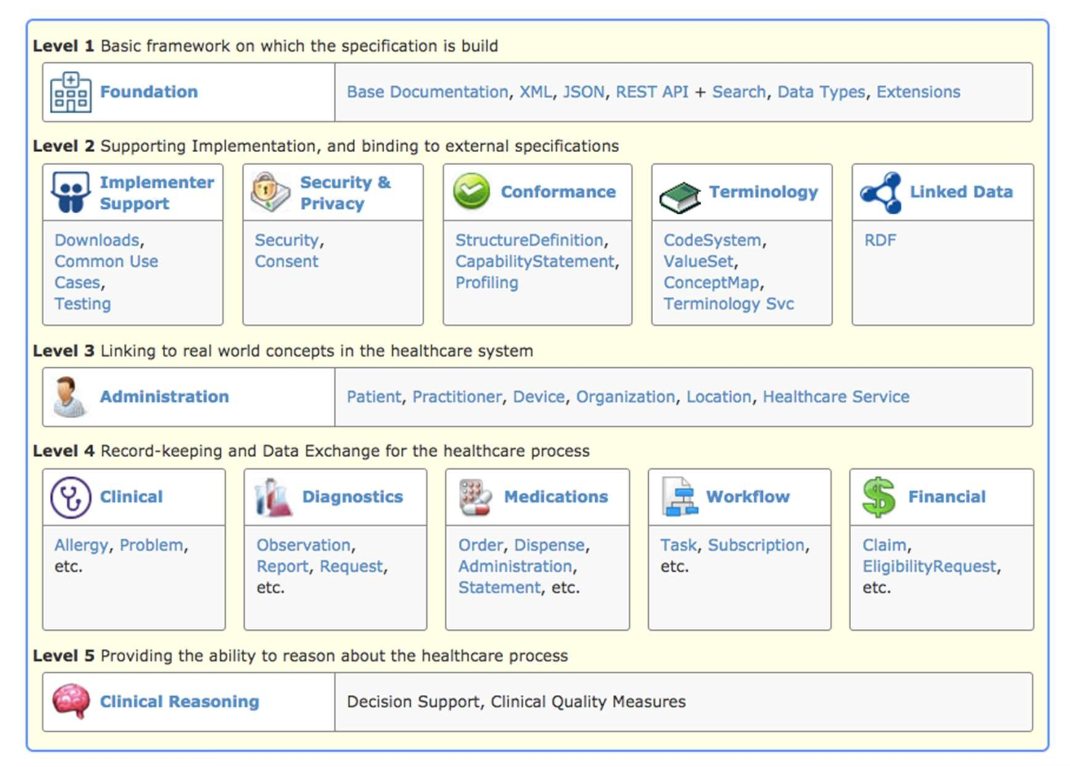<http://hl7.org/fhir/index.html>

* The Content model
* The Thing that is exchanged
  + Via REST ( FHIR Restful API), Messages, Documents
* Informed by much past work inside & outside of HL7
  + HL7: version 2, version 3 (RIM), CDA
  + Other SDO: openEHR, CIMI, ISO 13606, IHE, DICOM

   

**General:** AllergyIntolerance Condition (Problem) Procedure ClinicalImpression FamilyMemberHistory RiskAssessment DetectedIssue

**Care Provision:** CarePlan CareTeam

Goal ReferralRequest ProcedureRequest NutritionOrder VisionPrescription

**Medication & Immunization:**

Medication MedicationOrder MedicationAdministration MedicationDispense MedicationStatement Immunization

ImmunizationRecommendation

**Diagnostics:** Observation DiagnosticReport DiagnosticOrder Specimen BodySite ImagingStudy

ImagingObjectSelection

Maturity Model

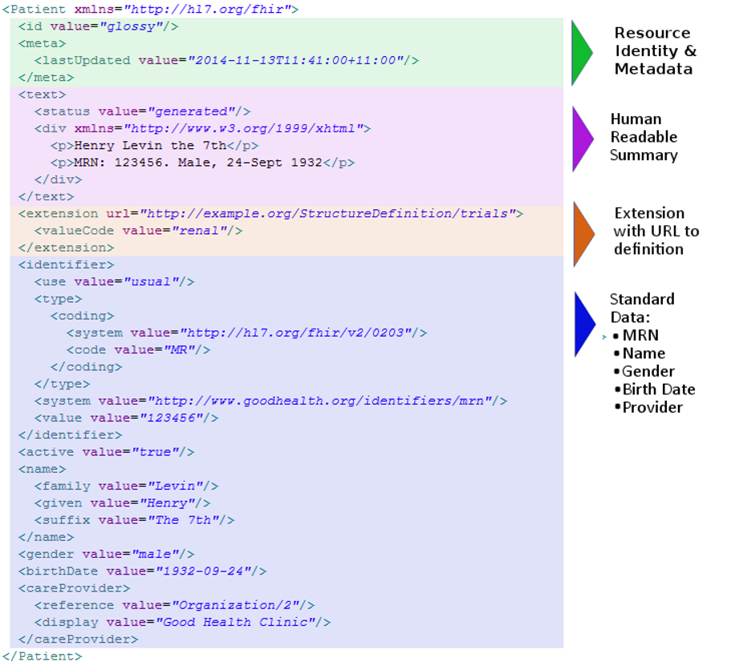

## between resources

**Coded Properties**

type bodySuite indication performer.role complication

relatedItem.type

**Other Properties**

identifier (Identifier) outcome (String)



PATIENT

Subject

Related Item

Report

CONDITION PROCEDURE DIAGNOSTIC REPORT

Encounter

Performer

ENCOUNTER

PRACTITIONER

consultation

**12-year-old-boy**

Patient Encounter Condition Observation Medication

Allergy Intolerance

**First consultation**

Complaining of **pain in the right ear for 3 days** with **an elevated temperature**. On examination, temperature **38°C** and an **inflamed right eardrum** with no perforation. Diagnosis **Otitis Media**, and prescribed **Amoxicillin 250mg 3 times per day for 7 days.**

**Follow up consultation**

2 days later returned with an **itchy skin rash**. No **breathing difficulties**. On examination, **urticarial rash** on both arms. No evidence meningitis. Diagnosis of penicillin **allergy**. Antibiotics changes to **Erythromycin 250mg 4 times per day for 10 days.**

## As linked resources…

Asserter

Pain right ear 3 days

Patient

Performer

Encounter

Elevated temperature

Performer

Temperature 38°C

Practitioner

Performer

Inflamed right drum

Asserter

Otitis media

Prescriber

Amoxicillin 250mg

Asserter

Itchy skin rash

Asserter

Encounter

No breathing difficulties

Performer

Urticarial Rash

Performer

Penicillin Allergy

Performer

Erythromycin 250mg

**STRUCTURED AND CODED DATA**

## Why have structured / coded data

* Structured vs Coded
* Coded:
  + Improves UI possibilities
  + Improves exchange
  + ‘Secondary’ uses
    - Allows Decision Support
    - Population health

## FHIR the basics | Resource example



## Resource structure

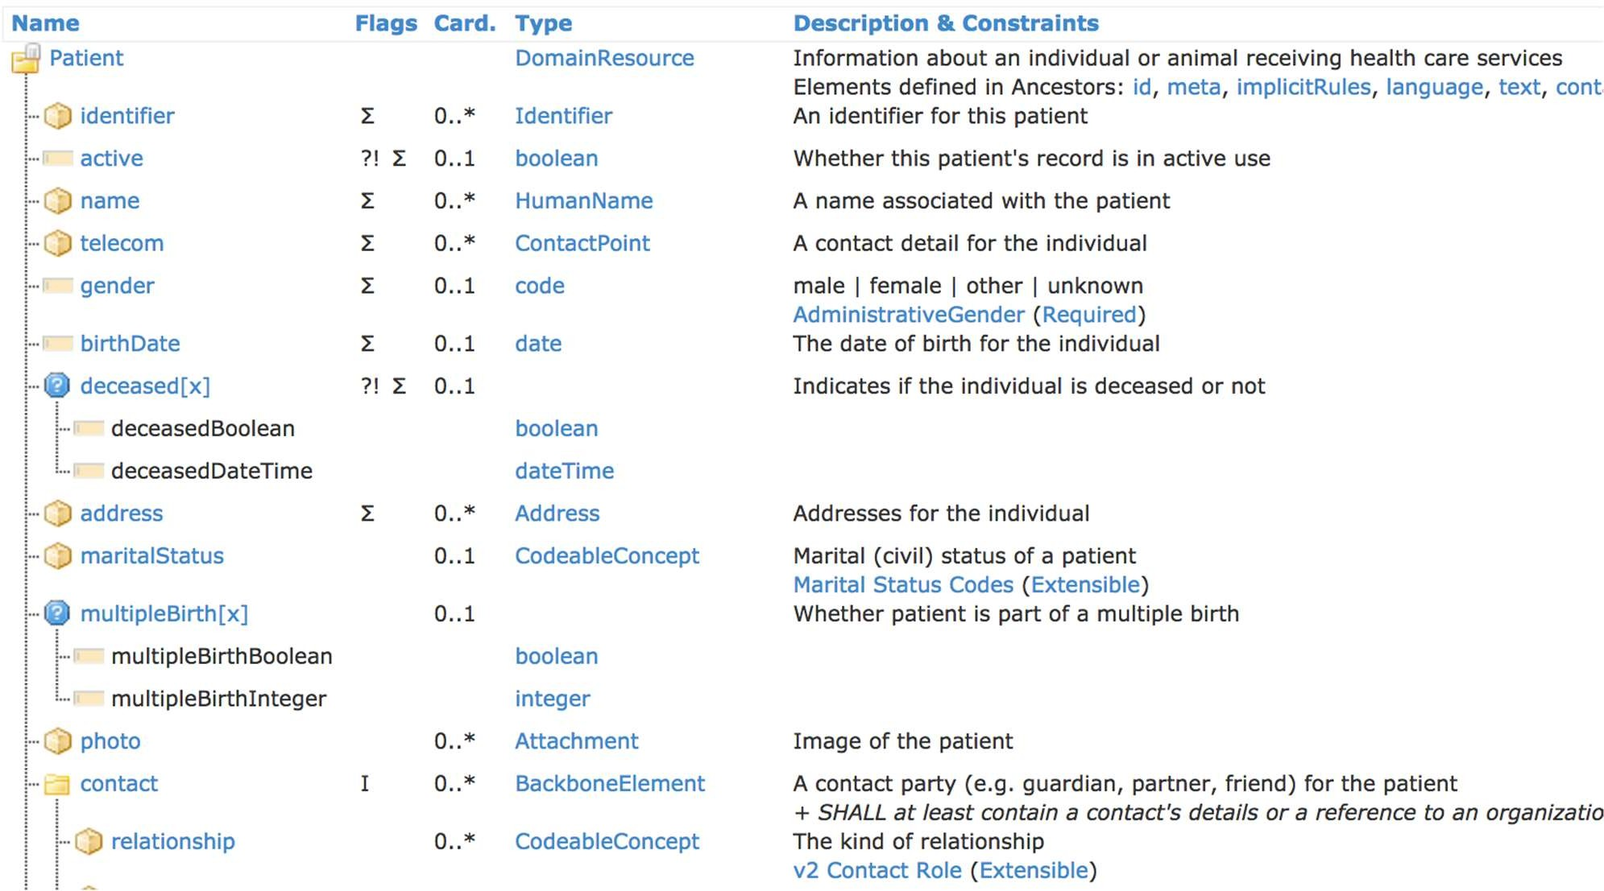

Data types: Primitive

* Based on w3c schema and ISO data types

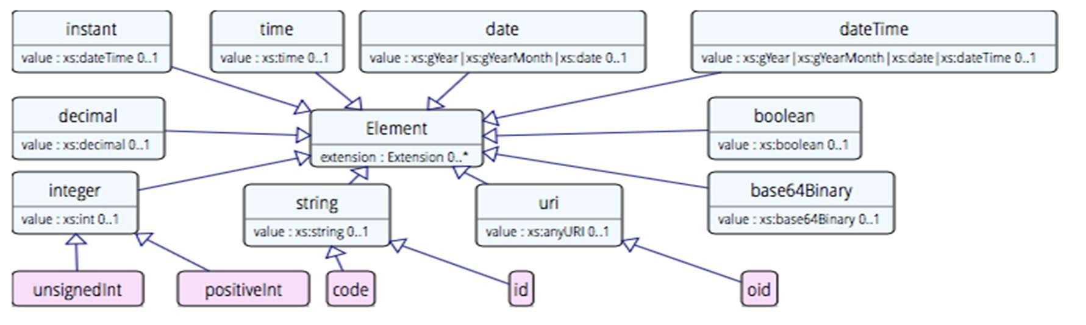•

Stick to the “80% rule” – only expose what most will use

* Simplified

## Data types: Complex

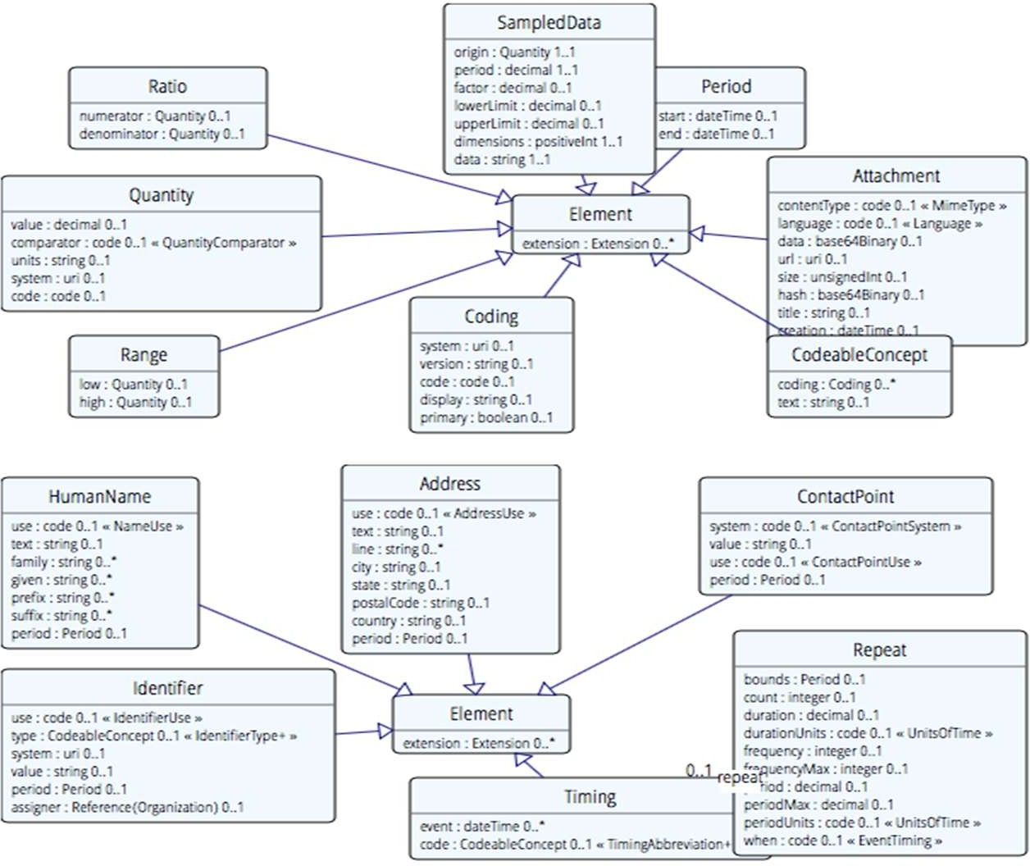

* Review datatypes in spec
  + Start from resource
* Datatypes in resource definition
  + Backbone element
  + ‘choice’ data types
* Identifiers
* Review coded data
  + ValueSet binding
* Code: "status" : "confirmed"
* Coding: {

"system": "<http://www.nlm.nih.gov/research/umls/rxnorm>", "code": "C3214954",

"display": "cashew nut allergenic extract Injectable"

}

* CodeableConcept: { "coding": [{

"system": "<http://snomed.info/sct>", "code": "39579001",

"display": "Anaphylactic reaction“

}],

"text" : "Anaphylaxis"

}

* SNOMED CT / LOINC / RxNORM
* ICPC, MIMS + 100s more
* ICD-X+
* A drug formulary
* Custom

Code System:

Defines a set of concepts with a coherent meaning

Code

Display Definition

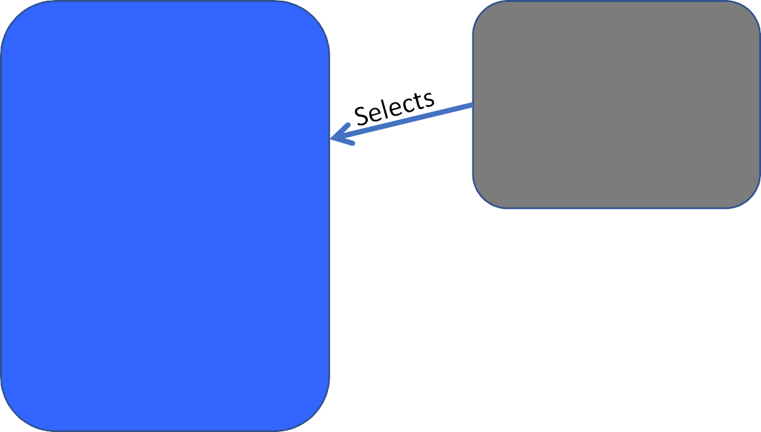

Code System:

Defines a set of concepts with a coherent meaning

Value Set:

A selection of a set of codes for use in a particular context

Code

Display Definition

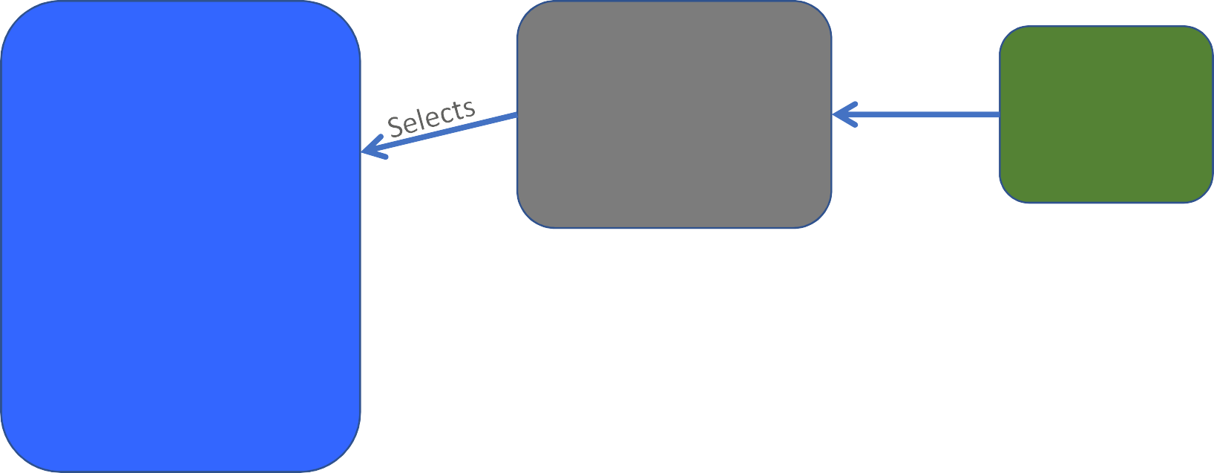

Code System:

Defines a set of concepts with a coherent meaning

Value Set:

A selection of a set of codes for use in a particular context

Binds

Element

Definition: Type and Value set reference

Code

Display Definition

Code System: Defines a set of concepts with a coherent meaning

Code Display Definition

Value Set:

A selection of a set of codes for use in a particular context

Binds

Element: code/ Coding/

CodeableConcept

Element Definition: Type and Value set reference

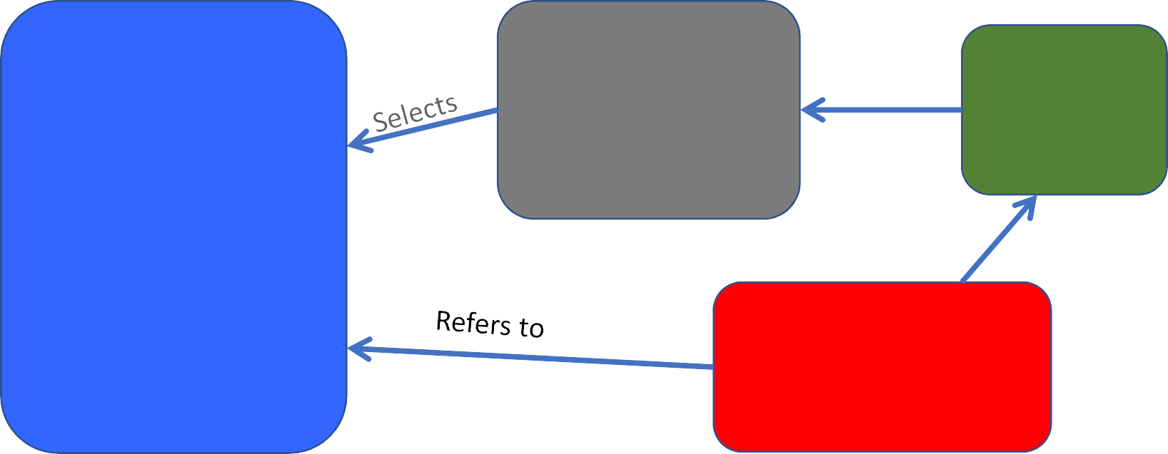Conforms

Adapting FHIR to your needs: Profiling

* Many different contexts in healthcare, but want a single set of Resources
* Need to be able to describe ‘usage of FHIR’ based on context
* Allow for these usage statements to:
  + Authored in a structured manner
  + Published in a registry & Discoverable
  + Used as the basis for validation, code, report and UI generation.
* 3 main aspects:
  + Constraining a resource - remove element, change multiplicity fix values
  + Change coded element binding
  + Adding a new element (an extension)
* Profiling adapts FHIR for specific scenarios

Limit names to just 1 (instead of 0..*)

Change maritalStatus to another set of codes that extends the one from HL7 international

Require that the identifier uses the NHS number – and is required

Don’t support photo

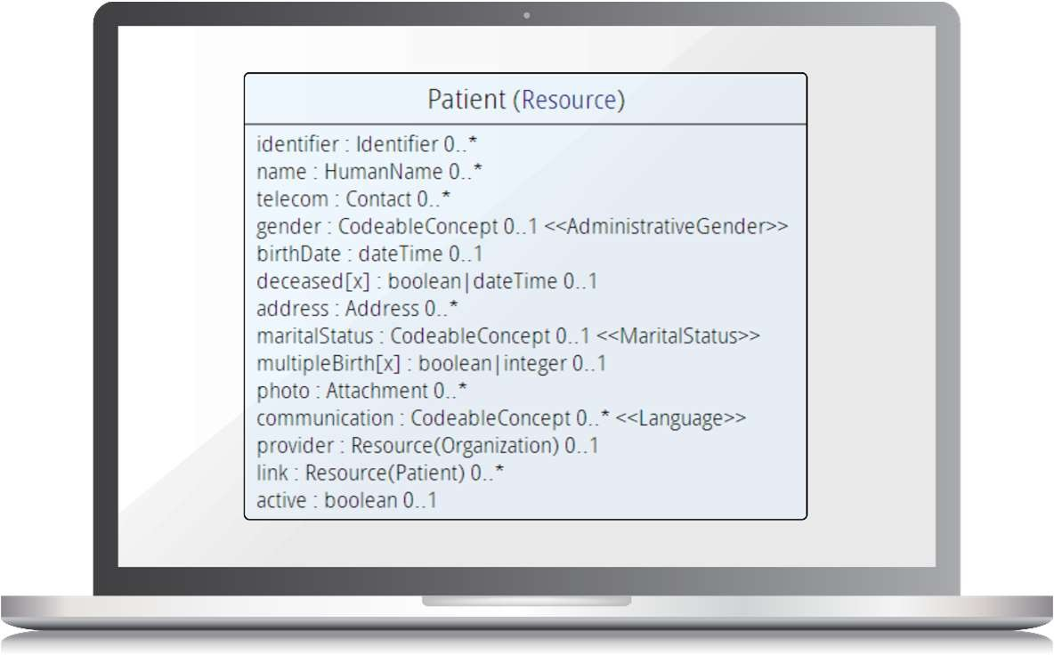

Add an extension to support ethnicity

*Note: Limited mandatory elements in the core spec*

* Defined by StructureDefinition resource
  + Same as used for core resources
* Defines each element
  + Path, name, dataType, binding, multiplicity. mapping & much more
  + Including allowable extension points
* Can use Forge tooling to build
  + clinFHIR (and others) for learning/viewing
* US Core (was DAF)
  + <http://hl7.org/fhir/us/core/index.html>
* Also a StructureDefinition
  + Defines the content of a single extension
* Simple or Complex
* Definition:
  + Available on the web
  + Canonical Url
    - Resolvable or Registry
* In resource instance:
  + Reference to Url
  + Extension or ModifierExtension

REST

Documents

Messages

Services (Operations)

* Container resource
* Types of Bundle

Bundle Resource

Observation Resource Device Resource

List Resource Condition Resource

* + Searchset
  + Transaction
  + Document
  + Message
  + …
* “Representational State Transfer” – an architecture for how to connect systems in real time
* Uses HTTP/S
* Simple to use
* Very commonly used outside of healthcare – especially mobile
* For simple interactions
  + Create
  + Read (& Query)
  + Update
  + Delete
* A lot of tooling / experience available

<Bundle>



Composition Resource Metadata

Section

Observation Resource

Device Resource

List Resource

Condition Resource

44

Section

Section

Attester

<entry>

<**Composition** />

</entry>

<entry>

<Observation />

</entry>

<entry>

<Device />

</entry>

<entry>

<List/>

</entry>

<entry>

<Condition/>

</entry>

</Bundle>

<Bundle>



MessageHeader Resource

Observation Resource

Device Resource

Patient Resource

event

destination

source

<entry>

<**MessageHeader** />

</entry>

<entry>

<Observation />

</entry>

<entry>

<Patient />

</entry>

<entry>

<Device />

</entry>

</Bundle>

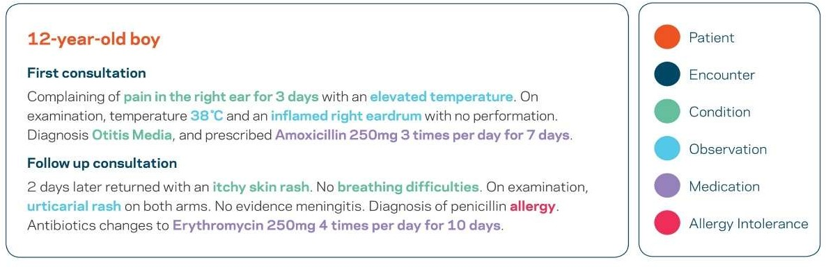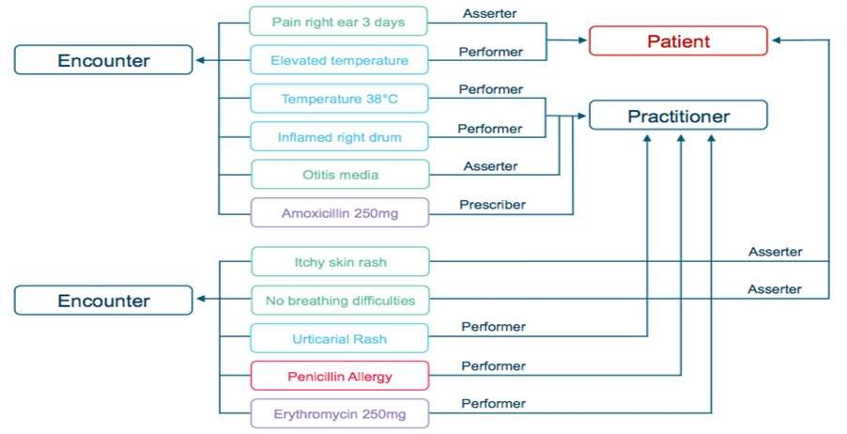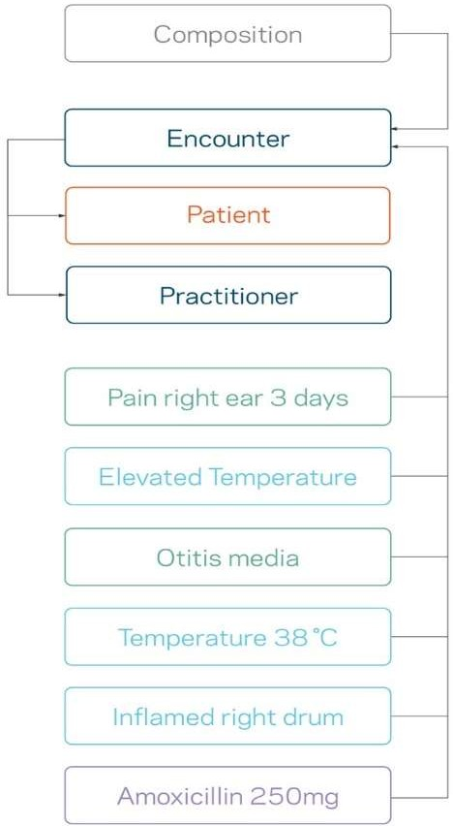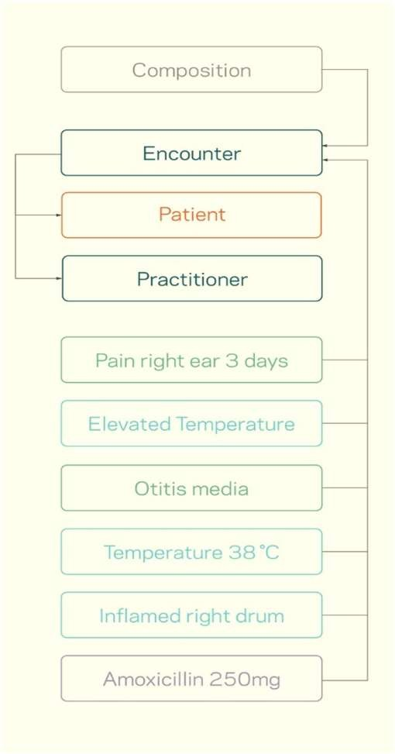

* When more complex server logic required than simple CRUD
  + Midway between REST & SOAP
* Some defined in spec. e.g.:
  + Get all data for a patient
  + Expand/filter terminology
  + CDS services
* Can define custom services
  + Still using FHIR resources
  + Resources to define / inputs

▸ From HL7

* + <http://hl7.org/fhir/index.html>
  + wiki.hl7.org/index.php?title=FHIR
  + <http://www.fhir.org/>

▸ Community

* + https://chat.fhir.org/
  + List server [(fhir@lists.hl7.org](mailto:(fhir@lists.hl7.org) )
  + Stack Overflow (tag FHIR)

▸ Blogs

* + [www.healthintersections.com.au/](http://www.healthintersections.com.au/)
  + https://fhirblog.com/
  + https://thefhirplace.com/
  + https://brianpos.com

▸ Libraries

* + Java (<http://hapifhir.io/)>
  + C# (NuGet HL7.FHIR)

▸ Tooling

* + Forge (<http://fhir.furore.com/Forge)>
  + <http://clinfhir.com/>

▸ Test servers

* + <http://wiki.hl7.org/index.php?title=P> ublicly_Available_FHIR_Servers_for_t esting
  + https://fhirblog.com/2016/10/19/set ting-up-your-own-fhir-server-for- profiling/