Name G.Gowthami

Sec:04

ID NO:2100030164

**DAA SKILL-03**

**1)Sherlock and Array:**

**Code:**

import java.io.*;

import java.util.*;

import java.text.*;

import java.math.*;

import java.util.regex.*;

public class Solution {

public static void main(String[] args) {

Scanner in = new Scanner(System.in);

int k = in.nextInt();

for(int i=0; i<k; i++){

int n = in.nextInt();

int[] arr = new int[n];

for(int j=0; j<n; j++){

arr[j] = in.nextInt();

}

System.out.println(decision(arr));

}

}

public static String decision(int[] arr){

int sum = 0;

for(int i=0; i<arr.length; i++){

sum += arr[i]; }

int curr = 0;

for(int j=0; j<arr.length; j++){

if(curr == sum - arr[j]-curr){

return "YES";

}

curr += arr[j];

}

return "NO"; }}

**OUTPUT:**

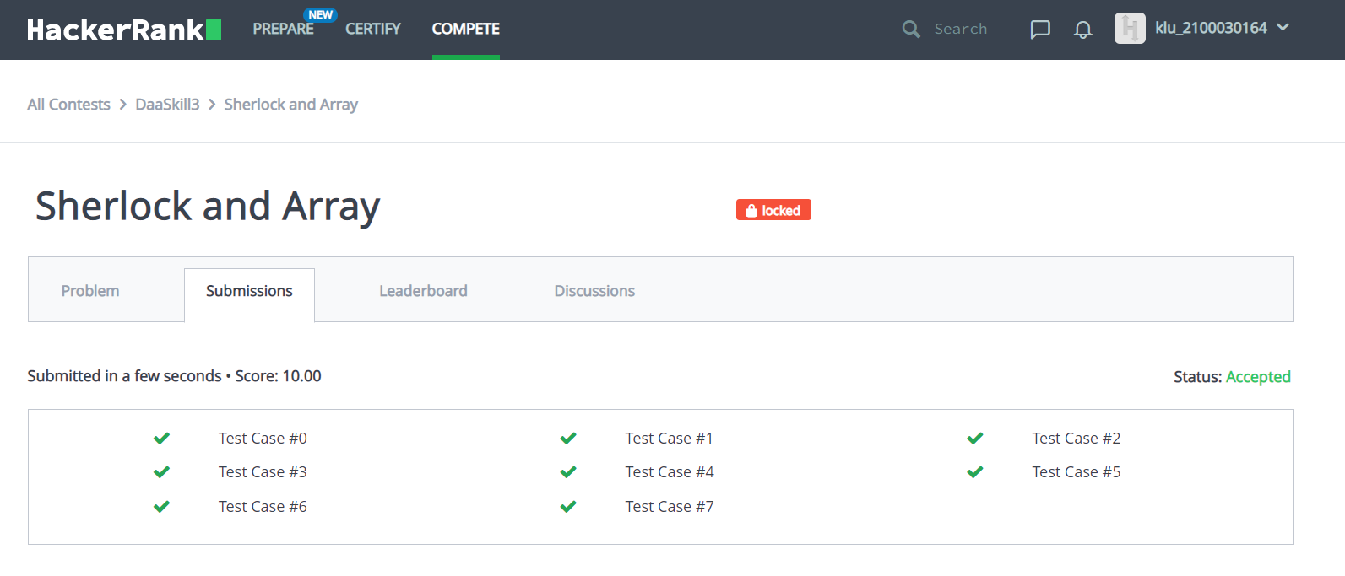

**2)**