**PROJECT: Validation of the User Login**

**Developer Name:** GOWTHAMI V

**This document contains contents for:**

* Project Description.
* Flow of the Application.
* Core concepts used in project.
* Conclusions.

1. **Project Description:**

* Creating a servlet-based web application that shows a login page and validates it.
* The correct values are hard-coded.
* On successful login, a dashboard page is shown.
* The dashboard will provide a link for logging out. Incorrect logins need to be handled by showing an error message page.

1. **Application Flow:**

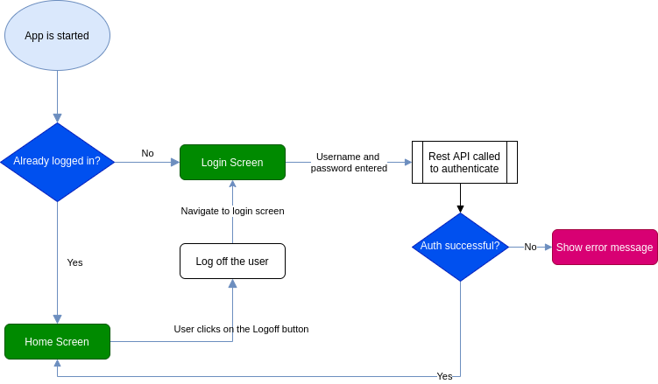

1. **Core concepts used in project:**

* Eclipse as the IDE.
* Apache Tomcat as the web server.
* HTML pages for the front end.
* Servlets for backend processing.

1. **Conclusion:**

This project is designed for displaying the validation of user login.