TEAM ID: SWTID-2026-4310
TEAM SIZE: 4

TEAM LEADER: GOWTHAMI A
EMAIL ID: hs0373411@gmail.com

TEAM MEMBER: SOPNA A
EMAIL ID: sopnaarjun3@gmail.com

TEAM MEMBER: DIVIYA J
EMAIL ID: nathanjekan61@gmail.com

TEAM MEMBER: KANISHKA P
EMAIL ID: kanishkaprakash03@gmail.com

Replace and modernize legacy VPN architectures with a cloud-native Zscaler Zero
Trust solution to reduce attack surface and lateral movement.
Abstract:
This project details the strategic migration from a legacy Virtual Private Network (VPN) infrastructure to a cloud-native Zero Trust Network Access (ZTNA) solution provided by Zscaler. The primary driver for this initiative is the fundamental inadequacy of traditional VPNs in the modern threat landscape. Legacy architectures operate on a "connect first, verify later" model, granting users broad access to the corporate network and, consequently, creating a significant risk of lateral movement by malicious actors. This expansive attack surface, combined with the operational overhead of managing physical appliances and the poor user experience associated with hair-pinned traffic, renders the existing model both insecure and inefficient for today's hybrid workforce.
The proposed solution leverages the Zscaler Zero Trust Exchange, a global, cloudnative platform that shifts connectivity from a network-centric to an identity and application-centric model. By making corporate applications invisible to the internet and establishing direct, secure connections between verified users and specific applications, the new architecture eliminates the concept of network-based privileges. This approach ensures that users connect to the applications they need, not the underlying network, thereby completely neutralizing the threat of lateral movement. Furthermore, it improves performance by steering traffic directly to Zscaler’s edge nodes, optimizing the user experience regardless of their location.
The expected outcomes of this modernization project are multifaceted. We anticipate a drastic reduction in the organization's attack surface and the complete elimination of lateral movement risks. This will be coupled with a simplified, scalable security posture managed from a unified cloud console, reducing operational costs and complexity. Ultimately, this transition will not only fortify our cyber defenses against sophisticated threats but also enable a secure, highperformance, and agile work environment, future-proofing the organization's security architecture.

Use Case Scenarios:
Scenario 1: Third-Party Vendor Access to Finance Application
An external auditor needs temporary access to the university's finance application for end-ofyear reconciliation. Instead of provisioning a VPN account, ZPA grants time-bound, applicationspecific access. The vendor authenticates via identity provider and is micro-segmented away from all other internal resources.
Output:
- User identity verified (External_Auditor_Group)
- Time-bound access policy enforced (7-day validity)
- Connection restricted to Finance Application only
- No lateral movement possible to other systems

Scenario 2: Research Assistant Access to High-Performance Computing Cluster
A graduate student requires SSH access to an on-premises research computing cluster to run data analysis scripts. Using ZPA, they connect directly to the cluster without exposing SSH ports to the internet or requiring a full network-level VPN tunnel.
Output:
- User identity verified (Research_Assistant_Group)
- Protocol-specific access granted (SSH only)
- Direct micro-tunnel established to HPC Cluster
- All other network segments remain inaccessible

Scenario 3: Administrative Staff Access to Internal File Server
An administrative assistant working from a campus satellite office needs to access a sensitive file server containing student records. ZPA verifies their device compliance and routes them exclusively to the file server application, with all traffic inspected inline for data loss prevention.
Output:
- User identity verified (Admin_Staff_Group)
- Device posture compliant (Disk encryption enabled, patch level current)
- Granular file access policies enforced (Read/Write permissions) • Data Loss Prevention (DLP) policies active

Scenario 4: IT Administrator Secure Access to Server Management Interfaces
A systems administrator requires RDP access to manage critical Windows servers in the data center. Using ZPA, they connect directly to the target servers without exposing RDP to the internet, while all administrative sessions are recorded for audit compliance.
Output:
- User identity verified (IT_Admin_Group)
- Privileged access workflow triggered (Approval required)
- Session recording and monitoring active
- Micro-tunnel established to specific server IP and port only

Scenario 5: Visiting Professor Access to Library Resources
A visiting professor from a partner institution needs temporary access to digitized archives stored on an internal library application server. ZPA provides just-in-time access without placing the visiting scholar on the internal network, ensuring separation from administrative systems.
Output:
- User identity verified (Visiting_Faculty_Group)
- Just-in-time access provisioned (8-hour session limit)
- Connection restricted to Library Application Server
- Full network segmentation maintained

Stage-1

Title Of the Project: -

Replace and modernize legacy VPN architectures with a cloud-native Zscaler Zero Trust solution to reduce attack surface and lateral movement.

Overview: -

This project is a strategic initiative to fundamentally transform the organization's remote access and network security architecture by decommissioning the existing legacy Virtual Private Network (VPN) infrastructure and replacing it with a cloud-native Zero Trust solution from Zscaler. The current VPN model, based on a perimeter-centric "castle-and-moat" approach, inherently trusts users once they are connected, granting them broad access to the internal network. This expansive access creates a significant attack surface and leaves the organization vulnerable to lateral movement, where a single compromised credential can lead to a widespread breach. The operational challenges of managing, scaling, and patching legacy VPN appliances, coupled with the poor user experience of backhauled traffic, further underscore the urgent need for modernization. This project directly addresses these critical security and operational deficiencies. The core of the new architecture is Zscaler Private Access (ZPA), which operates on a Zero Trust principle of "never trust, always verify" and "connect the user to applications, not the network." By making internal applications completely invisible to the internet and the public DNS, ZPA eliminates the attack surface associated with exposed ports and IP addresses. When a user requests access, ZPA verifies their identity and context—through integrations with identity providers like Azure AD and device posture checks—before establishing a secure, encrypted micro-tunnel. Crucially, this tunnel connects the user only to the specific application they are authorized to use, not to the underlying network. This effectively renders the network invisible to the end-user and eliminates any possibility of lateral movement, as threat actors cannot scan, discover, or pivot to other internal resources.
The anticipated outcomes of this modernization are profound and multi-faceted. The organization will achieve a drastically reduced attack surface and a complete eradication of lateral movement risks, significantly strengthening its security posture against advanced cyber threats. Operationally, the shift to a cloud-native, globally distributed edge removes the need for traffic hair-pinning, thereby optimizing performance and user experience for a hybrid workforce. This transition also simplifies IT operations by replacing complex, hardware-dependent VPN infrastructure with a unified, scalable, and agile cloud management console. Ultimately, this project will not only fortify the organization's defenses but also create a secure, high-performance, and future-ready access framework that supports evolving business needs.

This expansive access creates a significant attack surface and leaves the organization vulnerable to lateral movement, where a single compromised credential can lead to a widespread breach. The operational challenges of managing, scaling, and patching legacy VPN appliances, coupled with the poor user experience of backhauled traffic, further underscore the urgent need for modernization. This project directly addresses these critical security and operational deficiencies. The core of the new architecture is Zscaler Private Access (ZPA), which operates on a Zero Trust principle of "never trust, always verify" and "connect the user to applications, not the network." By making internal applications completely invisible to the internet and the public DNS, ZPA eliminates the attack surface associated with exposed ports and IP addresses. When a user requests access, ZPA verifies their identity and context—through integrations with identity providers like Azure AD and device posture checks—before establishing a secure, encrypted micro-tunnel. Crucially, this tunnel connects the user only to the specific application they are authorized to use, not to the underlying network. This effectively renders the network invisible to the end-user and eliminates any possibility of lateral movement, as threat actors cannot scan, discover, or pivot to other internal resources.

List of Vulnerability Table:

Practice Website:

S.no | Vulnerability Name | CWE - No
1 | Improper Sanitization of File Paths | CWE- 284: Improper Access  Control
2 | Invalid Certificate | CWE-395: Improper  Certificate Validation
3 | Missing X-Frame-Options Header | CWE-1021: Design  Improper Restriction of  Rendered UI Layers or  Frames
4 | X-Content-Type Options Header Missing | CWE -918: Server-Side  Request Forgery (SSRF)
5 | Drupal Ajax API shows JSONP not disabled by default | CWE-937,1035: OWASP  Top Ten 2013,2017 Category A9 - Using Components with  Known Vulnerabilities

6 | Drupal Api Vulnerability | CWE-20: Improper Input  Validation
7 | Improper API Filtration | CWE-79: Improper  Neutralisation of Input  During Web Page Generation  ('Cross-site Scripting')
8 | Denial of Service | CWE -400: Uncontrolled  Resource Consumption
9 | TLS Version 1.0 Protocol Detection | CWE-327: Use of a Broken or Risky Cryptographic  Algorithm
10 | web.config File Information Disclosure | CWE-497: Exposure of Sensitive System Information to an Unauthorised Control  Sphere

REPORT: -
Practice Website: http://www.itsecgames.com/

1) Vulnerability Name: Improper Sanitization of File Paths CWE- 284: Improper Access Control

OWASP Category: A01:2021-Broken Access Control

Description: The product does not restrict or incorrectly restricts access to a resource from an unauthorized actor.
Business Impact: This vulnerability is significant, as it can lead to unauthorized access to sensitive data or files, potentially causing data breaches, privacy violations, and loss of user trust.
Affected sites may also require configuration changes after applying a security release.
Steps to Reproduce: https://www.shodan.io/host/31.3.96.40

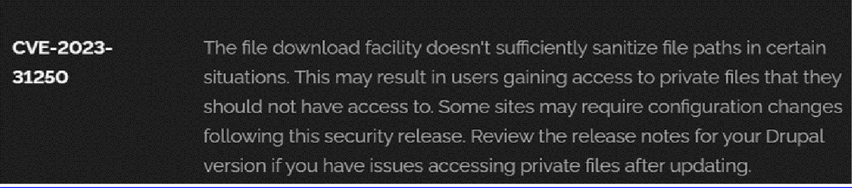

Recommendation:

- Apply Security Updates: The primary recommendation is to apply the security update provided by Drupal as soon as it becomes available. Security updates typically include fixes for known vulnerabilities like this one.
- Review Configuration: After applying the update, review your Drupal site's configuration to ensure that private files remain protected as intended. Make any necessary adjustments to your site's file permissions or access controls.
- Regular Audits: Conduct regular security audits and vulnerability assessments to identify and address potential security issues in your Drupal site.
- Access Control: Implement strong access controls to ensure that only authorized users can access private files. Review and restrict file access permissions as needed.
- Data Minimization: Minimize the amount of sensitive data stored on your Drupal site. Only store data that is necessary for your site's functionality.

2) Vulnerability Name: Invalid Certificate
CWE-395: Improper Certificate Validation

OWASP Category: A07:2021 – Identification and Authentication Failures

Description: When a certificate is invalid or malicious, it might allow an attacker to spoof a trusted entity by interfering in the communication path between the host and client. The product might connect to a malicious host while believing it is a trusted host, or the product might be deceived into accepting spoofed data that appears to originate from a trusted host.
Business Impact: Improper certificate validation can lead to a range of security threats which includes Man-in-the-middle attacks(Attackers can intercept communication between two parties and read or modify the data exchanged between them),Data breaches:(Attackers can gain unauthorized access to sensitive information or sensitive systems, leading to data breaches),Malware distribution(Attackers can use fake digital certificates to distribute malicious software or infect systems with malware)
Steps to Reproduce: https://www.ssllabs.com/ssltest/analyze?d=www.itsecgames.com

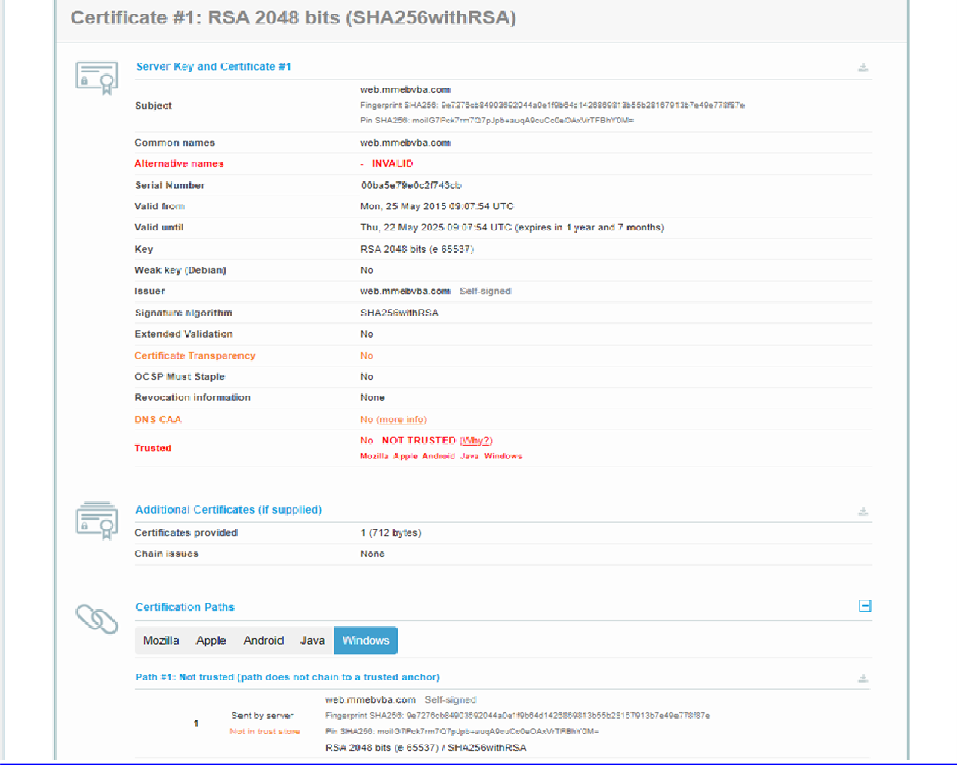
Recommendation:

- Use trusted certificate authorities: Only trust digital certificates issued by well-known and trusted certificate authorities.
- Verify certificate chains: Verify that the certificate presented by the remote party is valid and issued by a trusted certificate authority. Verify the entire certificate chain, including intermediate certificates.
- Check certificate revocation status: Check the revocation status of the certificate presented by the remote party to ensure that it has not been revoked.
- Use certificate pinning: Implement certificate pinning to ensure that the communication only occurs with the exact certificate or certificate authority specified.
- Keep software up to date: Keep software and security protocols up to date, as new vulnerabilities and security patches are regularly released.

3) Vulnerability Name: Missing X-Frame-Options Header

CWE-1021: Design Improper Restriction of Rendered UI Layers or Frames

OWASP Category: A04:2021-Insecure Design

Description: A web application is expected to place restrictions on whether it is allowed to be rendered within frames, iframes, objects, embed or applet elements. Without the restrictions, users can be tricked into interacting with the application when they were not intending to.
Business Impact: This enables path to the attackers to manipulate or gain unauthorized access to user interface elements, potentially leading to deceptive or malicious user interactions. This can result in data leakage, fraud, user distrust, and reputational damage, undermining the integrity and trustworthiness of the application and causing financial losses.
Vulnerability Path: http://www.itsecgames.com/

Steps to Reproduce:

- Open the practice website to inspect
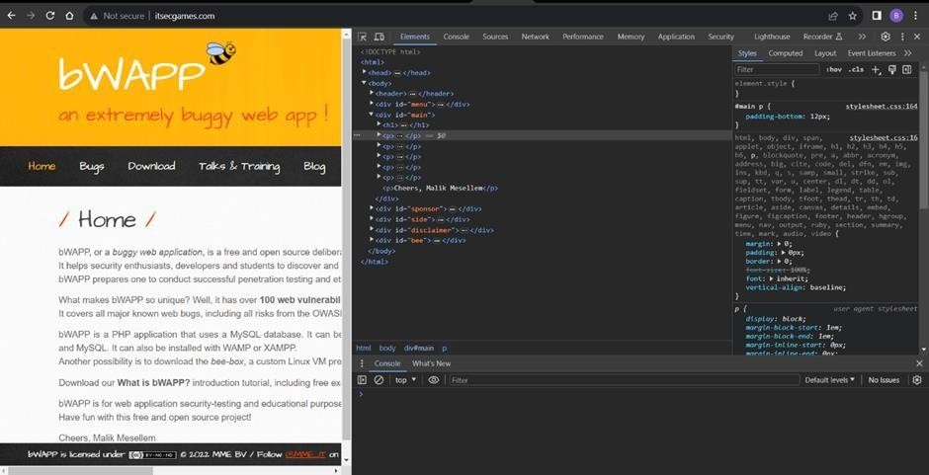

- Go to network and start capturing using F5 or Ctrl+R

- Go to html document and see if x-frame-options present in response headers or not

- If not the absence of this header indicates that the website may not have protection against embedding its content within an iframe on other domains, potentially leaving it vulnerable to clickjacking attacks.

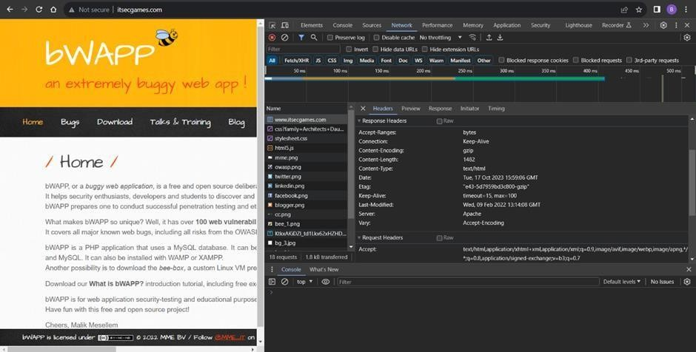
Recommendation:

- Implement Proper UI Layer Access Controls: Enforce access controls to restrict access to UI layers or frames based on user privileges.
- Use Session and Authentication Management: Ensure robust session management and user authentication mechanisms to prevent unauthorized access.
- Implement Content Security Policies (CSP): Use CSP headers to control where resources can be loaded from and mitigate against frame-based attacks.
- Keep Software and Libraries Updated: Stay current with software updates and patches to address known security issues.

4) Vulnerability Name: X-Content-Type Options Header Missing CWE -918: Server-Side Request Forgery (SSRF)
OWASP Category: A10:2021 – Server-Side Request Forgery (SSRF)

Description: The web server receives a URL or similar request from an upstream component and retrieves the contents of this URL, but it does not sufficiently ensure that the request is being sent to the expected destination.

Business Impact: The header missing impact Data Exposure(Attackers might force the server to render sensitive data as HTML, leading to data exposure),Security Risks(Content type manipulation can increase security risks, potentially leading to breaches, data leaks, and unauthorized access), Brand and Reputation Damage(Successful attacks that exploit SSRF vulnerabilities can harm the organization's reputation and trustworthiness)
Vulnerability Path :
https://securityheaders.com/?q=http%3A%2F%2Fwww.itsecgames.com%2F&followRedirects= on
Steps to Reproduce:
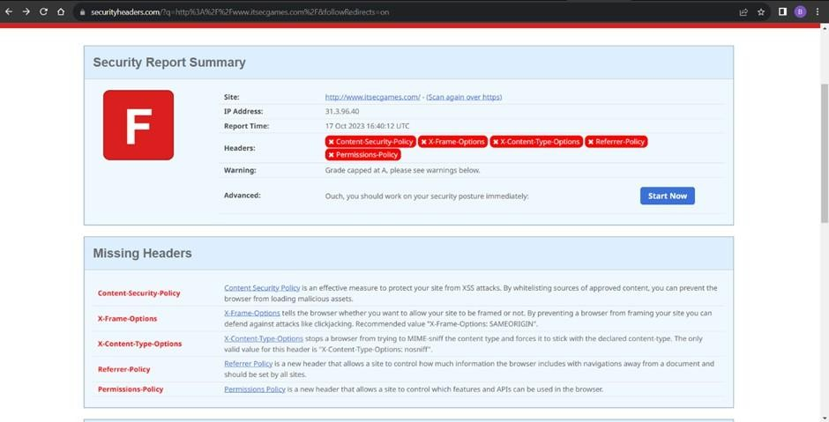

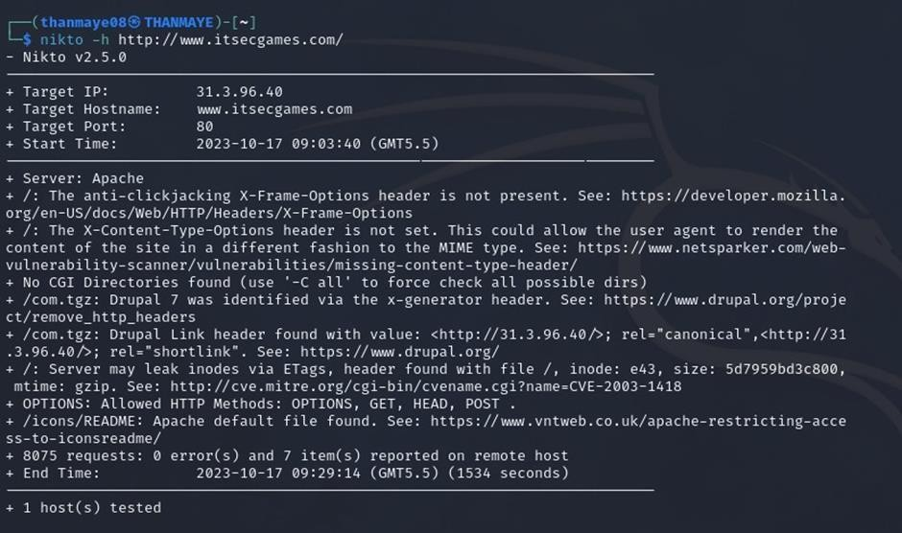
Recommendation:

- Implement "X-Content-Type-Options" Header: Configure the "X-Content-Type-Options" header with the value "nosniff" in your web server or application to prevent content type sniffing.
- Secure SSRF: To directly mitigate SSRF vulnerabilities, ensure proper input validation, access controls, and allow-list-based URL validation to prevent attackers from making unauthorized requests to internal resources.
- Security Headers: Implement other security headers like "X-Frame-Options" and "Content-Security-Policy" to further enhance security and mitigate various types of web-based attacks.
While the "X-Content-Type-Options" header may not be a direct countermeasure to SSRF, it is a valuable security control that, when configured correctly, can help protect against content type- based attacks that may be exploited in SSRF scenarios.

5) Vulnerability Name: Drupal Ajax API shows JSONP not disabled by default

CWE-937,1035: OWASP Top Ten 2013,2017 Category A9 - Using Components with Known
Vulnerabilities
OWASP Category: A06:2021-Vulnerable and Outdated Components

Description: Vulnerable and outdated components refer to using software libraries, modules, or dependencies within a web application that have known security issues or are not updated to the latest secure versions. This can include plugins, frameworks, or APIs that are no longer maintained or have publicly documented vulnerabilities.
Business Impact: The presence of vulnerable and outdated components in a web application poses significant security risks. Attackers can exploit these weaknesses to gain unauthorized access, inject malicious code, steal sensitive data, or disrupt the system's operation. The potential business impacts include compromised user data, damaged reputation, legal consequences, and financial losses due to breach recovery and remediation efforts.
Vulnerability Path: https://www.shodan.io/host/31.3.96.40

Steps to Reproduce:

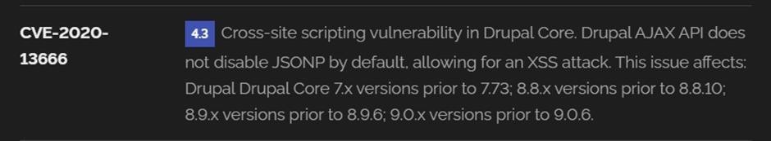

Recommendation:
- Regular Updates: Keep all components, libraries, and dependencies up to date by applying security patches and upgrades.
- Vulnerability Scanning: Conduct periodic vulnerability assessments to identify and address potential issues.
- Dependency Management: Implement a strategy for managing third-party dependencies, including continuous monitoring of their security status.
- Security Testing: Perform regular security testing, including penetration testing and code review, to identify and remediate vulnerabilities.
- Change Control: Maintain a change management process to assess the impact of new components and ensure they don't introduce new vulnerabilities.

6) Vulnerability Name: Drupal Api Vulnerability
CWE-20: Improper Input Validation
OWASP Category: A03:2021 – Injection

Description: The product receives input or data, but it does not validate or incorrectly validates that the input has the properties that are required to process the data safely and correctly.
Business Impact: The impact of a successful SQL injection attack can be devastating for businesses. It can result in unauthorized access to sensitive information, data theft, financial losses, damage to reputation, and legal consequences. Depending on the nature of the application and data involved, SQL injection can lead to compliance violations, customer trust erosion, and operational disruption.
Vulnerability Path: https://www.shodan.io/host/31.3.96.40

Steps to Reproduce:

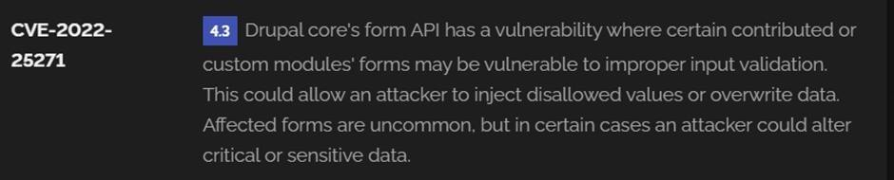

Recommendation:
- Input Validation: Implement rigorous input validation on all user inputs and ensure that only safe, sanitized data is passed to the database.
- Parameterized Queries: Use parameterized queries or prepared statements to separate SQL code from user input, preventing malicious injections.
- Escaping User Input: If parameterized queries are not feasible, escape user input before incorporating it into SQL queries to neutralize special characters.
- Least Privilege Principle: Limit the permissions and access rights of database accounts to the minimum required for specific tasks to minimize the potential damage of an attack.
- Web Application Firewalls (WAF): Employ WAFs to filter and block malicious SQL injection attempts.
- Regular Security Testing: Conduct regular security assessments, including penetration testing, to identify and address vulnerabilities.

7) Vulnerability Name: Improper API Filtration

CWE-79: Improper Neutralization of Input During Web Page Generation ('Cross-site Scripting')

OWASP Category: A07-2017: Cross-site Scripting (XSS)

Description: The product does not neutralize or incorrectly neutralizes user-controllable input before it is placed in output that is used as a web page that is served to other users.
Business Impact: If exploited, this vulnerability allows attackers to inject malicious scripts into web pages, which can be viewed by other users. The potential business impacts include data theft, unauthorized access, compromised user accounts, damaged reputation, and financial losses. Attackers can use XSS to steal sensitive information, such as user credentials, personal data, or financial details, leading to regulatory compliance violations and legal liabilities. Additionally, defacement or manipulation of website content can erode customer trust and result in lost revenue.
Vulnerability Path: https://www.shodan.io/host/31.3.96.40 Steps to Reproduce:
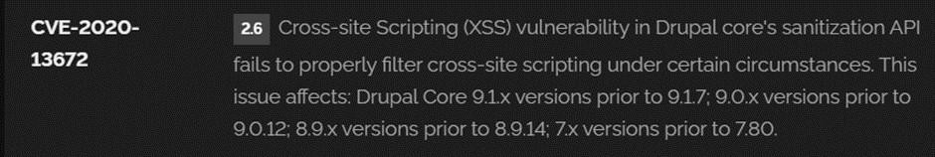

Recommendation:

- Update and Patch: Ensure that Drupal and all related modules and components are up to date with the latest security patches to mitigate known vulnerabilities.
- Input Validation: Implement strong input validation and output encoding to sanitize user inputs and prevent the injection of malicious scripts.
- Content Security Policy (CSP): Implement CSP headers to restrict the sources from which content can be loaded, reducing the risk of XSS.
- Secure Coding Practices: Train developers in secure coding practices, emphasizing the importance of validating and escaping user inputs.
- Security Scanning: Conduct regular security scans and penetration tests to identify and address XSS vulnerabilities.

8) Vulnerability Name: Denial of Service

CWE -400: Uncontrolled Resource Consumption

OWASP Category:

Description: The Denial of Service (DoS) attack is focused on making a resource (site, application, server) unavailable for the purpose it was designed. There are many ways to make a service unavailable for legitimate users by manipulating network packets, programming, logical, or resources handling vulnerabilities, among others. If a service receives a very large number of requests, it may cease to be available to legitimate users. In the same way, a service may stop if a programming vulnerability is exploited, or the way the service handles resources it uses.
Sometimes the attacker can inject and execute arbitrary code while performing a DoS attack in order to access critical information or execute commands on the server. Denial-of-service attacks significantly degrade the service quality experienced by legitimate users. These attacks introduce large response delays, excessive losses, and service interruptions, resulting in direct impact on availability.
Business Impact: If successfully exploited, it involves overwhelming a system or application with excessive demands on its resources. This can lead to a range of disruptive consequences. The targeted system may experience significant slowdowns, or even complete unresponsiveness, making it difficult or impossible for legitimate users to access. Critical resources like CPU, memory, and network bandwidth can become depleted, causing further degradation in performance. In severe cases, the exploited vulnerability may lead to system crashes or failures, potentially resulting in data loss. This disruption not only impacts business productivity and financial stability but also risks reputational damage, eroding customer trust and confidence. Additionally, organizations may face regulatory compliance issues if the uncontrolled resource consumption leads to violations of service level agreements or industry standards. Mitigating this vulnerability requires proactive resource management practices and a well-prepared incident response plan to minimize the potential impacts on business operations and customer satisfaction.
Steps to Reproduce: exploit open ports 80 to perform SQL injections, cross-site request forgeries and DDoS attacks.
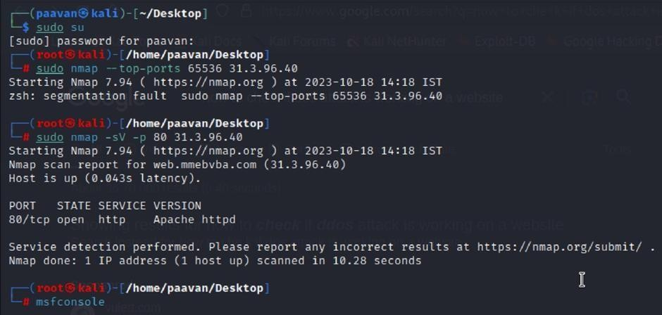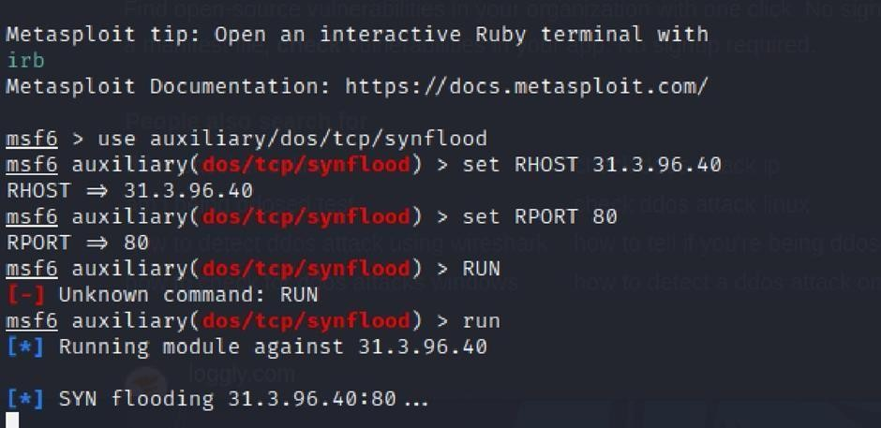
Recommendation: Employ a robust Web Application Firewall (WAF) capable of filtering and mitigating suspicious traffic targeting port 80. Configure it to block excessive requests or patterns indicative of an attack. Utilise load balancing techniques to distribute traffic across multiple servers, ensuring no single server becomes overwhelmed. Additionally, implement rate limiting and throttling mechanisms to restrict the number of requests a single IP address can make within a defined time frame. Regularly monitor traffic patterns and set up alerts to detect unusual spikes in activity, enabling rapid response to potential attacks. Finally, keep software and systems up-to-date with the latest security patches to address known vulnerabilities that attackers may exploit.

9) Vulnerability Name: TLS Version 1.0 Protocol Detection
CWE-327: Use of a Broken or Risky Cryptographic Algorithm
OWASP Category: A02:2021-Cryptographic Failures
Description: The product uses a broken or risky cryptographic algorithm or protocol.

Business Impact: TLS 1.0 is an outdated and vulnerable encryption protocol, and its use can expose sensitive data to potential security threats. This not only jeopardizes the integrity of customer information and payment details but also tarnishes the company's reputation. The business may face legal consequences, loss of customer trust, and decreased revenue as security- conscious users avoid the site due to its security vulnerabilities. Immediate action is necessary to upgrade to a more secure TLS version to safeguard data, ensure compliance, and maintain customer confidence.
Steps to Reproduce:

- Open a terminal or command prompt

- Type the Command: openssl s_client -connect 31.3.96.40:443 -tls1

- The connection is successfully means the server supports TLS 1.0
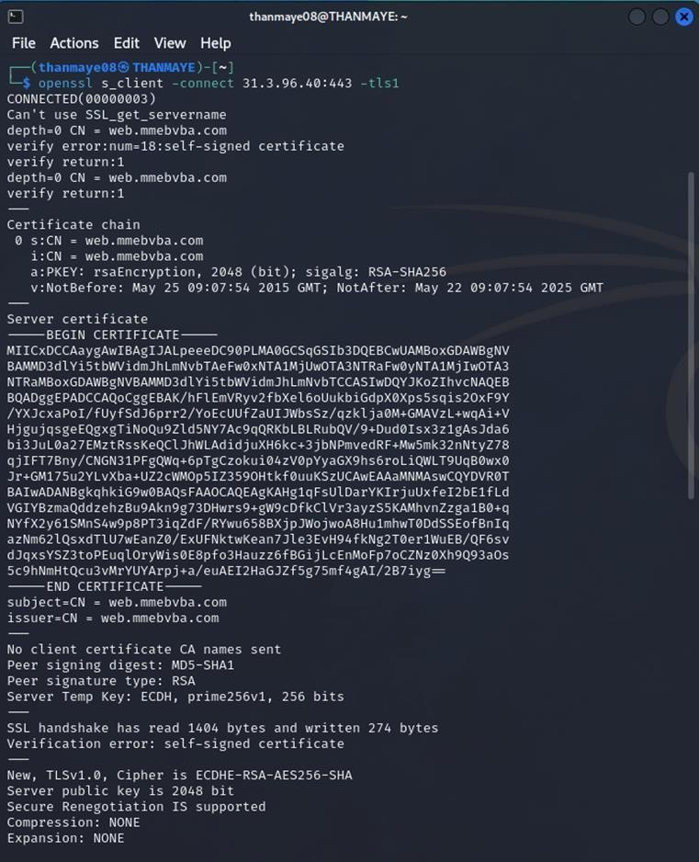
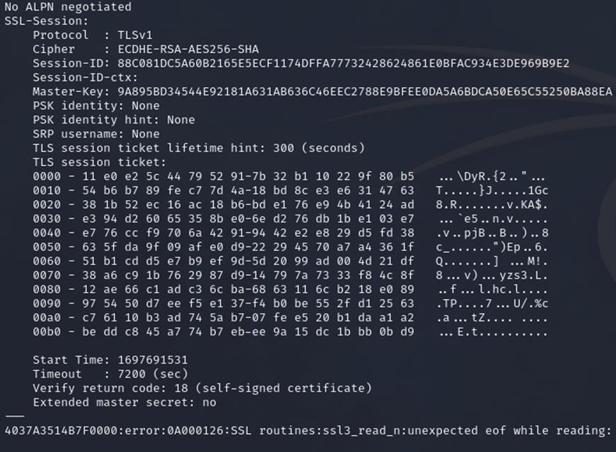

Recommendation:

- Upgrade to a Secure TLS Version: Transition to a more secure TLS version, such as TLS 1.2 or TLS 1.3. This will provide stronger encryption and improved security against modern threats.
- Regularly Update SSL/TLS Configuration: Keep your SSL/TLS configuration up to date to ensure it aligns with the latest security best practices and vulnerabilities.
- Implement a Strong Cryptographic Suite: Use strong cipher suites and secure configurations to further enhance security. Disable weak ciphers and outdated protocols.
- Compliance Checks: Ensure that your website complies with relevant data protection regulations and industry standards (e.g., GDPR, PCI DSS) to avoid legal issues.

10) Vulnerability Name: web.config File Information Disclosure

CWE-497: Exposure of Sensitive System Information to an Unauthorized Control Sphere

OWASP Category: A3:2017-Sensitive Data Exposure
Description: An information disclosure vulnerability exists in the remote web server due to the disclosure of the web.config file. An unauthenticated, remote attacker can exploit this, via a simple GET request, to disclose potentially sensitive configuration information.
Business Impact: It exposes sensitive configuration details, including database connection strings and encryption keys, to potential attackers. This could lead to unauthorized access, data breaches, and system compromise. The impact includes financial losses, damage to reputation, and legal liabilities as the organization's security and customer trust are compromised.
Steps to Reproduce:

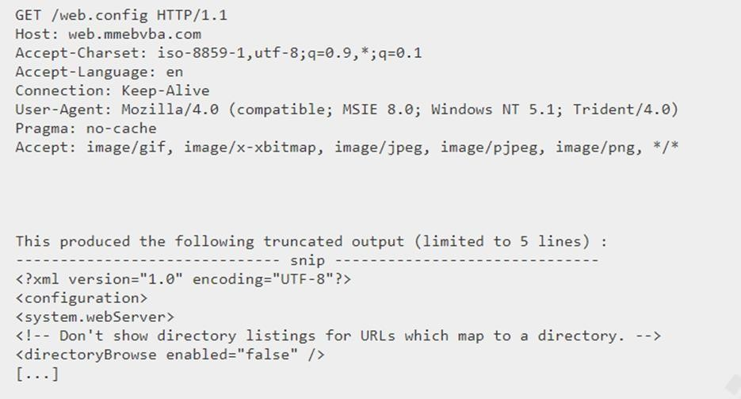

Recommendation:

- Implement proper access controls to restrict access to the web.config file.
- Prevent directory traversal and ensure the web.config file cannot be directly accessed through the web server.
- Encrypt sensitive data within the configuration file.
- Regularly review and update the web.config file, removing any unnecessary sensitive information.
- Ensure that the web.config file is properly secured and not accessible to unauthorized users.
Main Website: vtop.vit.ac.in

1) Vulnerability Name: SL Medium Strength Cipher Suites Supported (SWEET32)
CWE-200: Exposure of Sensitive Information to an Unauthorised Actor
OWASP Category: Broken access control

Description: The remote host supports the use of SSL ciphers that offer medium strength encryption. Nessus regards medium strength as any encryption that uses key lengths at least 64 bits and less than 112 bits, or else that uses the 3DES encryption suite.
Note that it is considerably easier to circumvent medium strength encryption if the attacker is on the same physical network.
Business Impact: The vulnerability known as SWEET32 (Short for Sweet 32 Birthday Attack) relates to the continued use of legacy cryptographic cipher suites with 64-bit block sizes in TLS and SSL protocols. These suites are susceptible to birthday attacks, which exploit the probability of two blocks colliding after a certain number of transactions. If an organisation's systems are vulnerable to SWEET32, it means they're potentially at risk of having encrypted communications intercepted or manipulated. This could lead to unauthorised access, data theft, or even the injection of malicious code. As a result, businesses face a significant risk to the confidentiality and integrity of their sensitive information. Remediation involves updating systems to support more secure cipher suites with larger block sizes, which would effectively mitigate this vulnerability and enhance the overall security posture. Failure to address SWEET32 could leave an organisation exposed to increasingly sophisticated attacks and legal consequences due to potential data breaches.
Vulnerability Path : The Sweet32 vulnerability when detected with a vulnerability scanner will report it as a CVSS 7.5.
Steps to Reproduce:
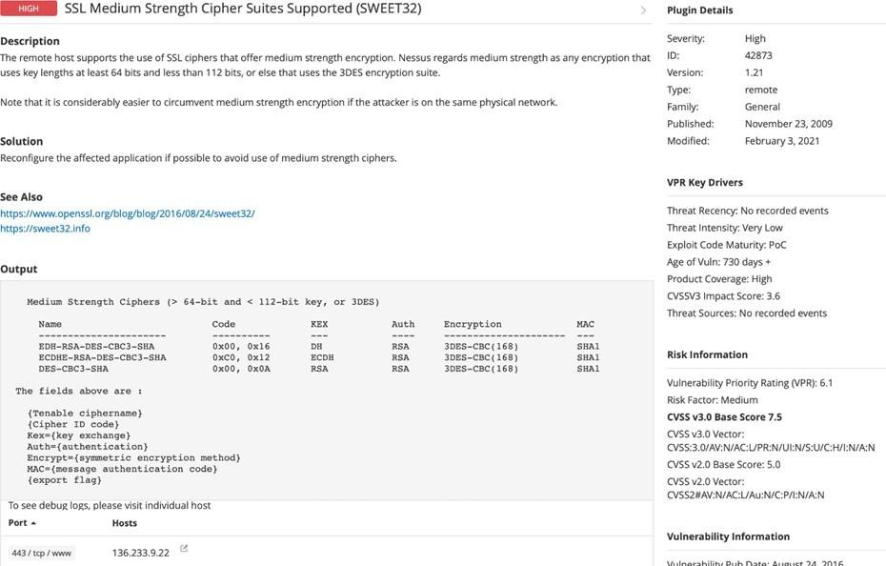
Recommendation: organisations should take several proactive steps. Firstly, it is crucial to update and configure cryptographic libraries, web servers, and any network devices to disable support for cipher suites with 64-bit block sizes. This can be achieved by ensuring that only modern and secure cipher suites are enabled in the TLS/SSL configurations. Additionally, organizations should regularly monitor and assess their systems for any outdated or vulnerable protocols and promptly apply security patches and updates. Implementing strong, unique encryption keys and employing forward secrecy protocols can further bolster security. It's also recommended to utilize intrusion detection systems and perform regular security audits to identify and address any potential vulnerabilities promptly. Lastly, organizations should stay informed about emerging security threats and best practices in cryptographic protocols to proactively adapt their security measures. By taking these measures, businesses can significantly reduce the risk of falling victim to SWEET32 attacks and enhance the overall security of their digital infrastructure.

2) Vulnerability Name: Cookie SERVERID created without secue flag
CWE-79: Improper Neutralization of Input During Web Page Generation
OWASP Category: A07-2017: Cross-site Scripting
Description: The vulnerability allows an attacker to inject malicious code into a WordPress website, which can then be executed by visitors to the website.
To exploit this vulnerability, an attacker would simply need to trick a user into clicking on a malicious link or opening a malicious attachment. Once the user clicks on the link or opens the attachment, the attacker's code would be executed, giving the attacker control over the user's account and potentially the entire WordPress website.
Business Impact: The business consequences of XSS can be severe, ranging from reputational damage due to compromised customer trust, to legal repercussions in cases of data breaches. Moreover, it can lead to financial losses through fraud or the cost of remediation efforts. Beyond the immediate impacts, long-term harm may occur if customers abandon the platform due to security concerns. To mitigate CWE-79, businesses must implement rigorous input validation and output encoding practices, as well as stay vigilant for emerging threats in web application security. Failure to address XSS vulnerabilities could result in significant harm to both the business's reputation and its bottom line.

Vulnerability Path: https://securityheaders.com/

q=http%3A%2F%2Fvtop.vit.ac.in%2F&followRedirects=on

Steps to Reproduce:

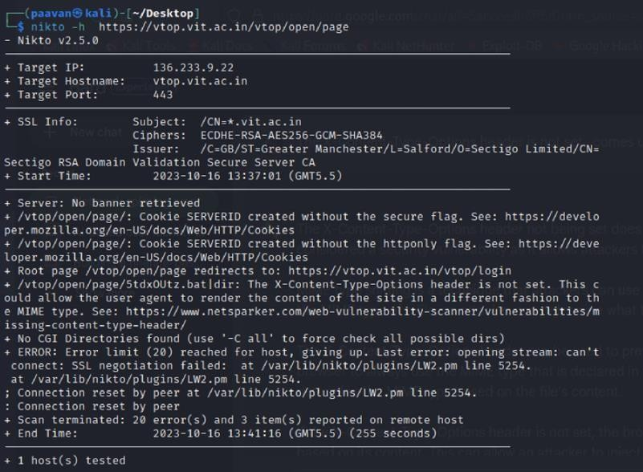
Recommendation:

- Update and Patch: Ensure that Drupal and all related modules and components are up to date with the latest security patches to mitigate known vulnerabilities.
- Input Validation: Implement strong input validation and output encoding to sanitize user inputs and prevent the injection of malicious scripts.
- Content Security Policy (CSP): Implement CSP headers to restrict the sources from which content can be loaded, reducing the risk of XSS.
- Secure Coding Practices: Train developers in secure coding practices, emphasizing the importance of validating and escaping user inputs.
- Security Scanning: Conduct regular security scans and penetration tests to identify and address XSS vulnerabilities.

3) Vulnerability Name: X-Content-Type Options Header Missing
CWE-918: Server-Side Request Forgery (SSRF)
OWASP Category: A10:2021 – Server-Side Request Forgery (SSRF)

Description: The absence of the "X-Content-Type-Options" header poses a notable security risk for web applications. This header is a crucial security feature that instructs the browser to interpret files with a MIME type as declared in the Content-Type header, rather than trying to guess the type. When this header is missing, the browser may attempt to infer the content type, leaving room for potential misinterpretation and security vulnerabilities like MIME-sniffing attacks. This could enable attackers to disguise malicious content, such as scripts or executable files, as benign content, leading to Cross-Site Scripting (XSS) or other types of attacks. Implementing the "X-Content-Type-Options" header with the value "nosniff" is a fundamental security measure that helps prevent these risks. It ensures that browsers strictly adhere to the declared content type, enhancing the overall security posture of the web application and safeguarding against potential exploitation stemming from content misinterpretation.
Business Impact: The header missing impact Data Exposure(Attackers might force the server to render sensitive data as HTML, leading to data exposure),Security Risks(Content type manipulation can increase security risks, potentially leading to breaches, data leaks, and unauthorized access), Brand and Reputation Damage(Successful attacks that exploit SSRF vulnerabilities can harm the organization's reputation and trustworthiness)
Vulnerability Path :
https://securityheaders.com/?q=http%3A%2F%2Fvtop.vit.ac.in%2F&followRedirects=on

Steps to Reproduce:
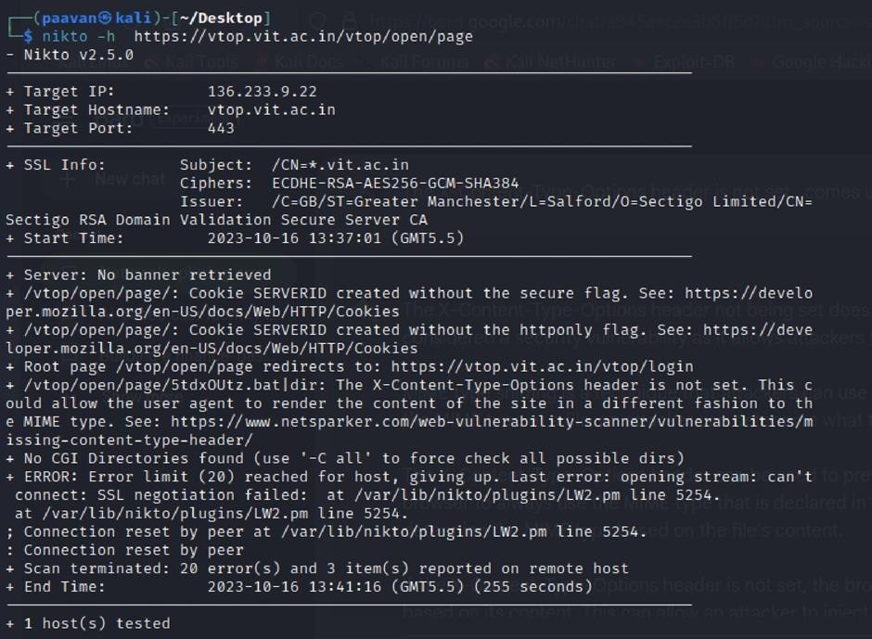

Recommendation:

- Implement "X-Content-Type-Options" Header: Configure the "X-Content-Type-Options" header with the value "nosniff" in your web server or application to prevent content type sniffing.
- Secure SSRF: To directly mitigate SSRF vulnerabilities, ensure proper input validation, access controls, and allow-list-based URL validation to prevent attackers from making unauthorized requests to internal resources.
- Security Headers: Implement other security headers like "X-Frame-Options" and "Content-Security-Policy" to further enhance security and mitigate various types of web-based attacks.
While the "X-Content-Type-Options" header may not be a direct countermeasure to SSRF, it is a valuable security control that, when configured correctly, can help protect against content type- based attacks that may be exploited in SSRF scenarios.

Description: The Denial of Service (DoS) attack is focused on making a resource (site, application, server) unavailable for the purpose it was designed. There are many ways to make a service unavailable for legitimate users by manipulating network packets, programming, logical, or resources handling vulnerabilities, among others. If a service receives a very large number of requests, it may cease to be available to legitimate users. In the same way, a service may stop if a programming vulnerability is exploited, or the way the service handles resources it uses.
Sometimes the attacker can inject and execute arbitrary code while performing a DoS attack in order to access critical information or execute commands on the server. Denial-of-service attacks significantly degrade the service quality experienced by legitimate users. These attacks introduce large response delays, excessive losses, and service interruptions, resulting in direct impact on availability.
Business Impact: If successfully exploited, it involves overwhelming a system or application with excessive demands on its resources. This can lead to a range of disruptive consequences. The targeted system may experience significant slowdowns, or even complete unresponsiveness, making it difficult or impossible for legitimate users to access. Critical resources like CPU, memory, and network bandwidth can become depleted, causing further degradation in performance. In severe cases, the exploited vulnerability may lead to system crashes or failures, potentially resulting in data loss. This disruption not only impacts business productivity and financial stability but also risks reputational damage, eroding customer trust and confidence. Additionally, organizations may face regulatory compliance issues if the uncontrolled resource consumption leads to violations of service level agreements or industry standards. Mitigating this vulnerability requires proactive resource management practices and a well-prepared incident response plan to minimize the potential impacts on business operations and customer satisfaction.
