**STREAMLIT APP**

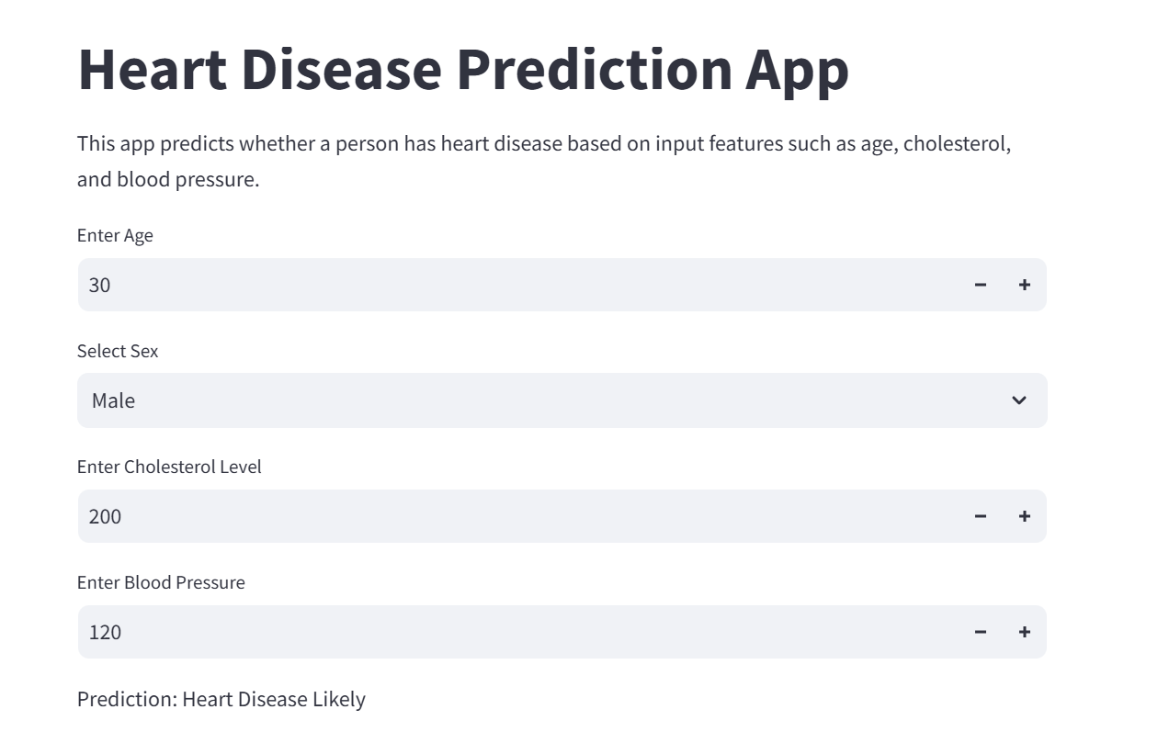

Based on user input, the Streamlit app makes predictions about heart disease. Users can choose their gender using buttons and modify sliders for blood pressure, cholesterol, and age. When "Predict" is clicked, immediate results are shown below. Predictions are simple to understand thanks to the app's responsiveness, visual appeal, and ease of use.

PANEL APP

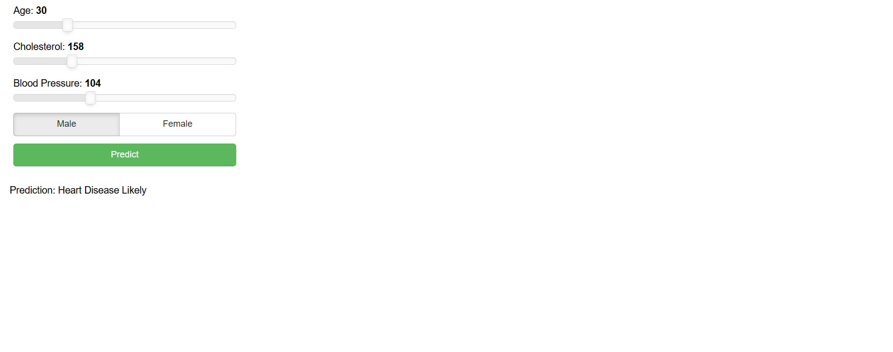The Panel app uses an interactive dashboard to anticipate heart problems. Age, blood pressure, and cholesterol numbers can be entered using sliders, and the input can be refined by a gender toggle. The result display is triggered by a "Predict" button. With its simple design and frequent upgrades, the app guarantees flawless usability.