**Objectives**

* Demonstrate code change in solution mapped to DevOps project will trigger CI pipeline
  + navigate to the repository of the Web application created in the previous step, modify code, check if the CICD pipeline trigger gets initiated, verify that in the application

1. **DevOps project code modification and automatic CI and CD deployment**

Logon to the Azure portal. Click on ‘Resource groups’ link on the top.

Navigate to the DevOps project created under the resource group, that starts with Vsts

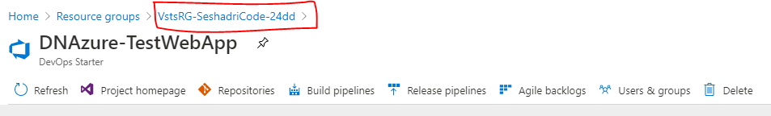

On the resource group load, click the ‘Repositories’ link. It opens dev.azure.com which has details on the code repository, pipelines etc.

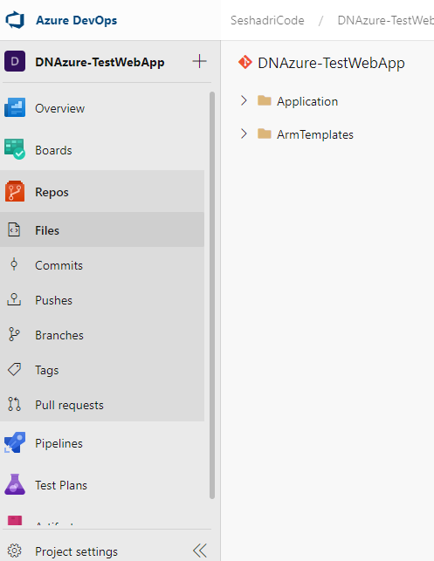

DevOps project creates a code repository automatically.

The application details are shown in the right pane.

Click the application -> SampleWebApplication. This has the MVC code.

Modify code in Views -> Home -> Index.cshtml

Click the ‘Edit’ link on the top right to edit the code. Click ‘Commit’ link, to open pop-up to provide details on the commit.

This triggers a build and deployment AUTOMATICALLY.

Click the ‘Pipelines’ link to view the build. This is the CI pipeline.

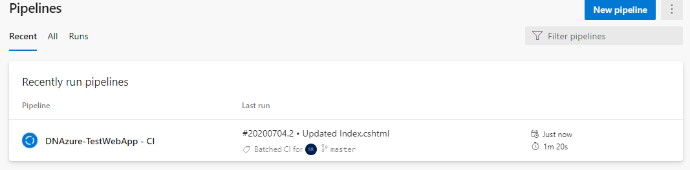

Click the Build pipeline name -> latest build -> Build link to view the steps in it.

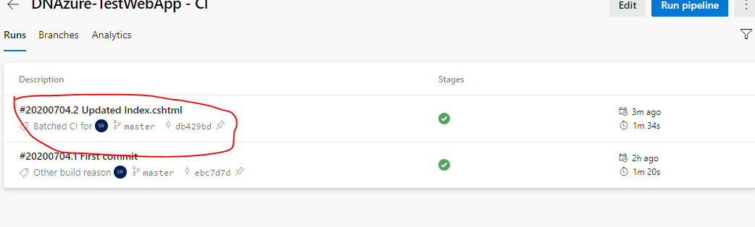

Post this, CD will be automatically triggered.

The releases will be listed in descending order of trigger.

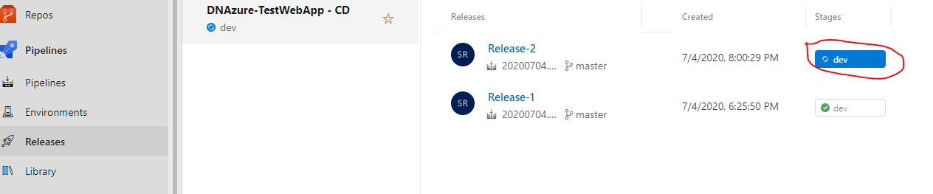

By default, the deployment will be on the ‘Dev’ stage. Click the ‘dev’ button to view the deployment logs.

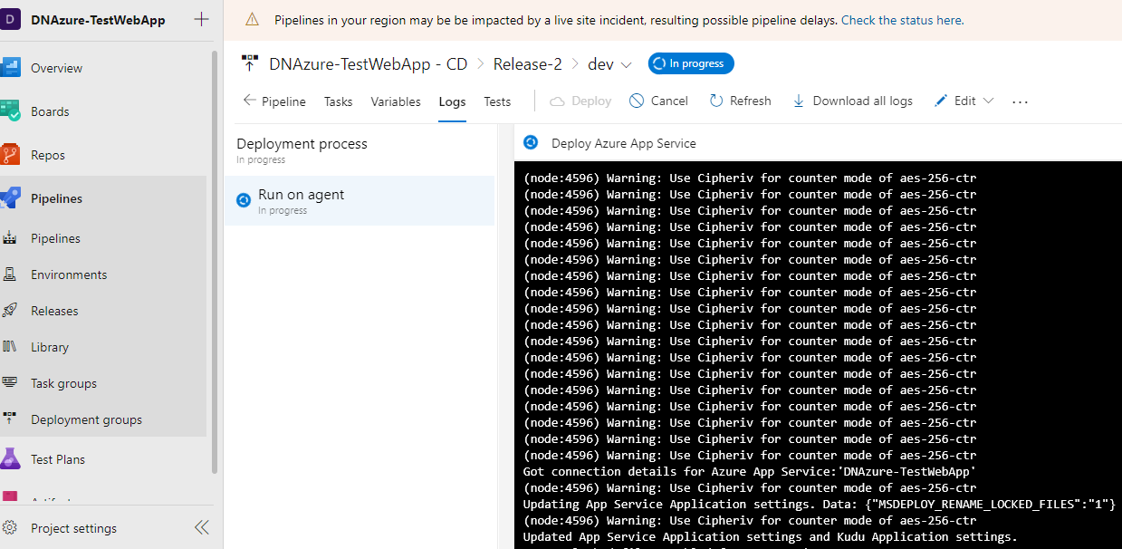

**VERY IMPORTANT:**

Once verified, delete the resource group ‘**[dnazure-testwebapp-rg](https://portal.azure.com/" \l "@seshadrimrgmail.onmicrosoft.com/asset/HubsExtension/ResourceGroups/subscriptions/9797246c-15ce-48a2-baf7-2dfade7b7a9b/resourceGroups/dnazure-testwebapp-rg)**’ and the newly created resource group that starts with VstsRG which contains the DevOps project.

Navigate to Home page. Click ‘Resource groups’

Click on resource group that contains the DevOps project, if not there in the ‘**[dnazure-testwebapp-rg](https://portal.azure.com/" \l "@seshadrimrgmail.onmicrosoft.com/asset/HubsExtension/ResourceGroups/subscriptions/9797246c-15ce-48a2-baf7-2dfade7b7a9b/resourceGroups/dnazure-testwebapp-rg)**’. There will be resource group that starts with ‘VstsRG’. Delete that too.

**Output>>**

