

UID ASSIGNMENT

SUBMITTED BY
NAME | KANDULA GOWTHAM KOUSHIK
ROLL NO | AV.SC.U4CSE25119
YEAR/SEM/SECTION | 1ST YEAR/ SEM-2/CSE-B
CREDITS | 03

SUBMITTED TO
NAME | DR. RAJ KUMAR BATCHU
DESIGNATION | ASST.PROFFESSOR (Sl. Grade)
DEPARTMENT | SCHOOL OF COMPUTING

AIM :
Create a responsive frontend clone of VIVO OFFICIAL WEBSITE (https://www.vivo.com/in) using the concepts with separate index.html, style.css, and script.js,product.html,product.js files

CODE :

Index.html Code :
<!DOCTYPE html>
<html lang="en">

<head>

<meta charset="UTF-8">
<meta name="viewport" content="width=device-width, initial-scale=1.0">

<title>vivo Clone</title>

<link rel="stylesheet" href="css/style.css">

<link href="https://fonts.googleapis.com/css2?family=Outfit:wght@300;400;500;600;700;800&display=swap"
rel="stylesheet">

</head>

<body>

<!-- NAVBAR -->

<nav id="navbar">

<a href="#" class="nav-logo">
vi<span>v</span>o
</a>

<ul class="nav-links">

<li><a href="#products">Phones</a></li>
<li><a href="#camera">Camera</a></li>
<li><a href="#technology">Technology</a></li>
<li><a href="#accessories">Accessories</a></li>

</ul>

<div class="nav-actions">

<button class="btn-nav">
Buy Now
</button>

<button class="hamburger" onclick="toggleMenu()">
☰
</button>

</div>

</nav>

<!-- HERO -->

<section class="hero">

<div class="hero-content">

<div class="hero-badge">
New Arrival 2025
</div>

<h1>
Capture Life's
<span class="highlight">
Finest Moments
</span>
</h1>

<p>
Experience photography reimagined with vivo AI-powered camera technology.
</p>

<div class="hero-btns">

<a href="#products" class="btn-primary">
Explore Phones
</a>

<a href="#camera" class="btn-outline">
Camera Features
</a>

</div>

</div>

</section>

<!-- STATS -->

<section class="stats-section">

<div class="stat-box">
<h2>500M+</h2>
<p>Global Users</p>
</div>

<div class="stat-box">
<h2>50+</h2>
<p>Countries</p>
</div>

<div class="stat-box">
<h2>3200+</h2>
<p>Camera Patents</p>
</div>

<div class="stat-box">
<h2>14+</h2>
<p>Years Innovation</p>
</div>

</section>

<!-- PRODUCTS -->

<section class="products" id="products">

<div class="section-heading">

<h2>
Find Your Perfect Phone
</h2>

<p>
Premium smartphones crafted for innovation.
</p>

</div>

<div class="products-grid">

<!-- CARD 1 -->

<div class="product-card">

<div class="product-img blue-bg">
<img src="assets/x200-pro.jpeg" class="phone-image">
</div>

<div class="product-body">

<h3>vivo X200 Pro</h3>

<p>200MP Zeiss Camera</p>

<div class="product-price">
₹89,999
</div>

<a href="product.html?phone=x200" class="btn-card">
Buy Now
</a>

</div>

</div>

<!-- CARD 2 -->

<div class="product-card">

<div class="product-img purple-bg">
<img src="assets/v40.jpeg" class="phone-image">
</div>

<div class="product-body">

<h3>vivo V40 Pro</h3>

<p>50MP Portrait Camera</p>

<div class="product-price">
₹49,999
</div>
<a href="product.html?phone=v40" class="btn-card">
Buy Now
</a>

</div>

</div>

<!-- CARD 3 -->

<div class="product-card">

<div class="product-img green-bg">
<img src="assets/y300.jpeg" class="phone-image">
</div>

<div class="product-body">

<h3>vivo Y300 Pro</h3>

<p>6000mAh Battery</p>

<div class="product-price">
₹29,999
</div>

<a href="product.html?phone=y300" class="btn-card">
Buy Now
</a>

</div>

</div>

<!-- CARD 4 -->

<div class="product-card">

<div class="product-img blue-bg">
<img src="assets/x100.jpg" class="phone-image">
</div>

<div class="product-body">

<h3>vivo X100 Ultra</h3>

<p>100X Periscope Zoom</p>

<div class="product-price">
₹79,999
</div>
<a href="product.html?phone=x100" class="btn-card">
Buy Now
</a>

</div>

</div>

<!-- CARD 5 -->

<div class="product-card">

<div class="product-img purple-bg">
<img src="assets/v30-pro.jpeg" class="phone-image">
</div>

<div class="product-body">

<h3>vivo V30 Pro</h3>

<p>50MP Aura Portrait</p>

<div class="product-price">
₹42,999
</div>

<a href="product.html?phone=v30" class="btn-card">
Buy Now
</a>
</div>

</div>

<!-- CARD 6 -->

<div class="product-card">

<div class="product-img green-bg">
<img src="assets/y200.webp" class="phone-image">
</div>

<div class="product-body">

<h3>vivo Y200 5G</h3>

<p>Smart Performance Edition</p>

<div class="product-price">
₹24,999
</div>
<a href="product.html?phone=y200" class="btn-card">
Buy Now
</a>

</div>

</div>

</div>

</section>

<!-- CAMERA -->

<section class="camera-section" id="camera">

<div class="section-heading">

<h2>
Camera Beyond Limits
</h2>

<p>
Co-engineered with Zeiss for cinematic photography.
</p>

</div>

<div class="camera-features">

<div class="cam-feature">
<img src="assets/90W FlashCharge.webp" class="phone-image">
<h3>90W FlashCharge</h3>
<p>Charge from 0 to 50% in just 15 minutes.</p>
</div>

<div class="cam-feature">
<img src="assets/AI Processor.jpg" class="phone-image">
<h3>AI Processor</h3>
<p>Advanced Snapdragon chipset with AI optimization.</p>
</div>

<div class="cam-feature">
<img src="assets/5G Connectivity.jpeg" class="phone-image">
<h3>5G Connectivity</h3>
<p>Ultra-fast download and streaming experience.</p>
</div>

<div class="cam-feature">
<img src="assets/200mp.png" class="phone-image">

<h3>200MP Ultra Sensor</h3>
<p>Capture stunning ultra-high resolution details.</p>
</div>

<div class="cam-feature">
<img src="assets/True Color Engine.jpeg" class="phone-image">
<h3>True Color Engine</h3>
<p>Natural colors powered by vivo imaging AI.</p>
</div>

<div class="cam-feature">
<img src="assets/Periscope Zoom.avif" class="phone-image">

<h3>Periscope Zoom</h3>
<p>Zoom distant objects with crystal clear quality.</p>
</div>

<div class="cam-feature">
<img src="assets/Cinematic Video.jpeg" class="phone-image">
<h3>Cinematic Video</h3>
<p>Professional movie-style recording experience.</p>
</div>

<div class="cam-feature">
<img src="assets/Night Vision.jpeg" class="phone-image">

<h3>Night Vision</h3>
<p>Crystal clear low-light photography experience.</p>
</div>

</div>

</section>
<!-- TECHNOLOGY SECTION -->

<section class="technology-section" id="technology">

<div class="section-heading">

<h2>
Advanced Technology
</h2>

<p>
Powerful performance engineered for the future.
</p>

</div>

<div class="technology-grid">

<div class="tech-card">
<div class="tech-icon">⚡</div>
<h3>90W FlashCharge</h3>
<p>Charge from 0 to 50% in just 15 minutes.</p>
</div>

<div class="tech-card">
<div class="tech-icon">🧠</div>
<h3>AI Processor</h3>
<p>Advanced Snapdragon chipset with AI optimization.</p>
</div>

<div class="tech-card">
<div class="tech-icon">📡</div>
<h3>5G Connectivity</h3>
<p>Ultra-fast download and streaming experience.</p>
</div>

<div class="tech-card">
<div class="tech-icon">🔋</div>
<h3>6000mAh Battery</h3>
<p>Long-lasting battery with smart power efficiency.</p>
</div>

<div class="tech-card">
<div class="tech-icon">🛡️</div>
<h3>IP68 Protection</h3>
<p>Dust and water resistance for extreme durability.</p>
</div>

<div class="tech-card">
<div class="tech-icon">🎮</div>
<h3>Gaming Mode</h3>
<p>Ultra-smooth gaming experience with AI optimization.</p>
</div>

<div class="tech-card">
<div class="tech-icon">☁️</div>
<h3>Cloud Sync</h3>
<p>Seamless backup and device synchronization.</p>
</div>

<div class="tech-card">
<div class="tech-icon">📶</div>
<h3>WiFi 7</h3>
<p>Next generation wireless speed and stability.</p>
</div>

</div>

</section>

<!-- ACCESSORIES SECTION -->

<section class="accessories-section" id="accessories">

<div class="section-heading">

<h2>
vivo Accessories
</h2>

<p>
Complete your premium ecosystem.
</p>

</div>

<div class="accessories-grid">

<div class="acc-card">
<img src="assets/TWS Earbuds.webp" class="phone-image">
<h3>TWS Earbuds</h3>
<p>₹3,999</p>
</div>

<div class="acc-card">
<img src="assets/vivo Watch.webp" class="phone-image">
<h3>vivo Watch</h3>
<p>₹12,999</p>
</div>

<div class="acc-card">
<img src="assets/powerbank.jpg" class="phone-image">
<h3>Power Bank</h3>
<p>₹2,499</p>
</div>

<div class="acc-card">
<img src="assets/vivo pad air.jpg" class="phone-image">
<h3>vivo Pad Air</h3>
<p>₹39,999</p>
</div>

<div class="acc-card">
<img src="assets/protective case.jpg" class="phone-image">

<h3>Protective Case</h3>
<p>₹999</p>
</div>

<div class="acc-card">
<img src="assets/charger.jpeg" class="phone-image">

<h3>120W Charger</h3>
<p>₹2,999</p>
</div>

<div class="acc-card">
<img src="assets/gaming kit.webp" class="phone-image">
<h3>Gaming Trigger Kit</h3>
<p>₹1,499</p>
</div>

<div class="acc-card">
<img src="assets/backpack.jpg" class="phone-image">
<h3>Premium Backpack</h3>
<p>₹4,999</p>
</div>

</div>

</section>

<!-- NEWSLETTER -->

<section class="newsletter-section">

<div class="newsletter-content">

<span class="newsletter-label">
STAY CONNECTED
</span>

<h2>
Be First to Know
</h2>

<p>
Subscribe to get exclusive launch offers,
camera tips and latest vivo news.
</p>

<div class="newsletter-form">

<input type="email" id="emailInput" placeholder="Enter your email address">

<button type="button" onclick="subscribeUser()">
Subscribe
</button>

</div>

<!-- POPUP -->

<div class="popup" id="popup">

<div class="popup-content">

<div class="popup-icon">
✓
</div>

<h2>
Thank You!
</h2>

<p>
You have successfully subscribed.
</p>

<button onclick="closePopup()">
Close
</button>

</div>

</div>

</div>

<!-- FOOTER -->

<footer class="footer">

<div class="footer-grid">

<!-- BRAND -->

<div class="footer-brand">

<h2>vivo</h2>

<p>
Extraordinary Camera. Extraordinary Phone.
vivo is committed to building premium
smartphones that integrate technology
with artistry.
</p>

<div class="social-icons">

<a href="https://www.facebook.com/vivoIndia" target="_blank">f</a>

<a href="https://x.com/Vivo_India" target="_blank">𝕏</a>

<a href="https://www.linkedin.com/company/vivo-india/" target="_blank">in</a>

<a href="https://www.youtube.com/@VivoIndiaOfficial" target="_blank">▶</a>

<a href="https://www.vivo.com/in" target="_blank">📸</a>

</div>

</div>

<!-- PRODUCTS -->

<div class="footer-column">

<h3>PRODUCTS</h3>

<a href="#">X Series</a>
<a href="#">V Series</a>
<a href="#">Y Series</a>
<a href="#">iQOO</a>
<a href="#">Accessories</a>
<a href="#">Tablets</a>

</div>

<!-- SUPPORT -->

<div class="footer-column">

<h3>SUPPORT</h3>

<a href="#">Service Centre</a>
<a href="#">Warranty</a>
<a href="#">Software Update</a>
<a href="#">User Manual</a>
<a href="#">FAQ</a>
<a href="#">Track Repair</a>
<a href="#">Live Chat</a>

</div>

<!-- COMPANY -->

<div class="footer-column">

<h3>COMPANY</h3>

<a href="#">About vivo</a>
<a href="#">Zeiss Partnership</a>
<a href="#">Careers</a>
<a href="#">Press</a>
<a href="#">Sustainability</a>
<a href="#">Contact Us</a>

</div>

</div>

<!-- FOOTER BOTTOM -->

<div class="footer-bottom">

<p>
© 2025 vivo Mobile India Pvt. Ltd.
All Rights Reserved.
</p>

<div class="footer-bottom-links">

<a href="#">Privacy Policy</a>
<a href="#">Terms of Use</a>
<a href="#">Cookie Settings</a>

</div>

</div>

</footer>
<script src="js/script.js"></script>

</body>

</html>

Style.css code:
*{
margin:0;
padding:0;
box-sizing:border-box;
}

html{
scroll-behavior:smooth;
}

:root{
--blue:#2563eb;
--dark:#050816;
--dark2:#111118;
--card:#1a1a24;
--white:#ffffff;
--gray:#94a3b8;
}

body{
font-family:'Outfit',sans-serif;
background:var(--dark);
color:var(--white);
overflow-x:hidden;
}

/* =========================
NAVBAR
========================= */

nav{
position:fixed;
top:0;
left:0;
right:0;
height:70px;
background:rgba(0,0,0,0.8);
backdrop-filter:blur(12px);
display:flex;
align-items:center;
justify-content:space-between;
padding:0 5%;
z-index:1000;
box-shadow:0 5px 20px rgba(0,0,0,0.3);
}

.nav-logo{
font-size:2rem;
font-weight:800;
text-decoration:none;
color:white;
}

.nav-logo span{
color:var(--blue);
}

.nav-links{
display:flex;
gap:30px;
list-style:none;
}

.nav-links a{
color:white;
text-decoration:none;
transition:0.3s;
}

.nav-links a:hover{
color:var(--blue);
}

.nav-actions{
display:flex;
align-items:center;
gap:15px;
}

.btn-nav{
background:var(--blue);
border:none;
padding:10px 22px;
border-radius:30px;
color:white;
cursor:pointer;
font-weight:600;
transition:0.3s;
}

.btn-nav:hover{
background:#1d4ed8;
}

.hamburger{
display:none;
background:none;
border:none;
color:white;
font-size:1.5rem;
cursor:pointer;
}

/* =========================
HERO SECTION
========================= */

.hero{
min-height:100vh;
display:flex;
justify-content:center;
align-items:center;
text-align:center;
padding:120px 5%;
background:
radial-gradient(circle at center,
#0d2a6e 0%,
#050816 70%);
}

.hero-content{
max-width:800px;
}

.hero-badge{
display:inline-block;
padding:10px 22px;
border-radius:30px;
background:rgba(37,99,235,0.2);
border:1px solid rgba(37,99,235,0.4);
margin-bottom:25px;
}

.hero h1{
font-size:5rem;
line-height:1.1;
margin-bottom:25px;
}

.highlight{
color:var(--blue);
}

.hero p{
color:var(--gray);
font-size:1.1rem;
line-height:1.8;
margin-bottom:40px;
}

.hero-btns{
display:flex;
justify-content:center;
gap:20px;
flex-wrap:wrap;
}

.btn-primary,
.btn-outline{
padding:15px 35px;
border-radius:40px;
text-decoration:none;
font-weight:600;
transition:0.3s;
}

.btn-primary{
background:var(--blue);
color:white;
}

.btn-primary:hover{
background:#1d4ed8;
}

.btn-outline{
border:1px solid rgba(255,255,255,0.2);
color:white;
}

.btn-outline:hover{
background:rgba(255,255,255,0.08);
}

/* =========================
STATS SECTION
========================= */

.stats-section{
padding:80px 5%;
background:var(--blue);
display:grid;
grid-template-columns:repeat(4,1fr);
text-align:center;
gap:30px;
}

.stat-box h2{
font-size:3rem;
margin-bottom:10px;
}

.stat-box p{
font-size:1rem;
}

/* =========================
COMMON SECTION
========================= */

section{
padding:120px 5%;
}

.section-heading{
text-align:center;
margin-bottom:60px;
}

.section-heading h2{
font-size:3rem;
margin-bottom:15px;
}

.section-heading p{
color:var(--gray);
font-size:1.1rem;
}

/* =========================
PRODUCTS SECTION
========================= */

.products{
background:var(--dark);
}

.products-grid{
display:grid;
grid-template-columns:repeat(3,1fr);
gap:30px;
}

/* PRODUCT CARD */

.product-card{
background:var(--card);
border-radius:24px;
overflow:hidden;
transition:0.4s;
position:relative;
border:1px solid rgba(255,255,255,0.05);
}

.product-card:hover{

transform:
translateY(-12px)
scale(1.01);

box-shadow:
0 25px 45px rgba(0,0,0,0.45);
}

/* PRODUCT IMAGE AREA */

/* PRODUCT IMAGE AREA */

.product-img{

height:320px;

display:flex;
justify-content:center;
align-items:center;

overflow:hidden;

position:relative;

padding:25px;
}

/* PHONE IMAGE */

/* PHONE IMAGE */

.phone-image{

width:100%;
height:260px;

object-fit:contain;
object-position:center;

border-radius:18px;

transition:0.5s ease;

filter:
drop-shadow(0 15px 30px rgba(0,0,0,0.45));
}

.product-card:hover .phone-image{
transform:
scale(1.05)
rotate(-2deg);
}

/* PRODUCT BACKGROUNDS */

.blue-bg{
background:
linear-gradient(
135deg,
#0d1a40,
#0a2060
);
}

.purple-bg{
background:
linear-gradient(
135deg,
#2d1050,
#1a0d2e
);
}

.green-bg{
background:
linear-gradient(
135deg,
#103d25,
#0d2a1a
);
}

.product-body{
padding:25px;
}
.product-body{

display:flex;
flex-direction:column;
justify-content:space-between;

height:260px;
}

.product-body h3{
margin-bottom:12px;
font-size:1.5rem;
}

.product-body p{
color:var(--gray);
margin-bottom:20px;
}

.product-price{
font-size:1.5rem;
font-weight:700;
margin-bottom:20px;
}

.btn-card{
width:100%;
padding:14px;
border:none;
border-radius:30px;
background:var(--blue);
color:white;
cursor:pointer;
font-weight:600;
transition:0.3s;
position:relative;
overflow:hidden;
}

.btn-card:hover{
background:#1d4ed8;
}
.btn-card::before{

content:"";

position:absolute;

top:0;
left:-100%;

width:100%;
height:100%;

background:
linear-gradient(
90deg,
transparent,
rgba(255,255,255,0.2),
transparent
);

transition:0.5s;
}

.btn-card:hover::before{
left:100%;
}

/* =========================
CAMERA SECTION
========================= */

.camera-section{
background:var(--dark2);
}

.camera-features{
display:grid;
grid-template-columns:repeat(4,1fr);
gap:30px;
margin-top:60px;
}

.cam-feature{
background:var(--card);
border-radius:20px;
padding:40px 25px;
text-align:center;
min-height:240px;

display:flex;
flex-direction:column;
justify-content:center;
align-items:center;

transition:0.4s;
}

.cam-feature:hover{
transform:translateY(-10px);

box-shadow:
0 20px 40px rgba(0,0,0,0.4);
}

.cam-icon{
font-size:3rem;
margin-bottom:20px;
}

.cam-feature h3{
margin-bottom:12px;
font-size:1.2rem;
}

.cam-feature p{
color:var(--gray);
line-height:1.6;
}

/* =========================
TECHNOLOGY SECTION
========================= */

.technology-section{
background:#0f0f18;
}

.technology-grid{
display:grid;
grid-template-columns:repeat(4,1fr);
gap:30px;
}

.tech-card{
background:var(--card);
border-radius:20px;
padding:40px 25px;
text-align:center;
transition:0.4s;
}

.tech-card:hover{
transform:translateY(-10px);

box-shadow:
0 20px 40px rgba(0,0,0,0.4);
}

.tech-icon{
font-size:3rem;
margin-bottom:20px;
}

/* =========================
ACCESSORIES SECTION
========================= */

.accessories-section{
background:var(--dark2);
}

.accessories-grid{
display:grid;
grid-template-columns:repeat(4,1fr);
gap:30px;
}

.acc-card{
background:var(--card);
border-radius:20px;
padding:40px 25px;
text-align:center;
transition:0.4s;
}

.acc-card:hover{
transform:translateY(-10px);

box-shadow:
0 20px 40px rgba(0,0,0,0.4);
}

.acc-icon{
font-size:3rem;
margin-bottom:20px;
}

/* =========================
NEWSLETTER SECTION
========================= */

.newsletter-section{
padding:120px 5%;
text-align:center;

background:
radial-gradient(circle at center,
#0d2a6e 0%,
#020617 70%);
}

.newsletter-label{
color:var(--blue);
letter-spacing:4px;
font-size:0.8rem;
font-weight:700;
}

.newsletter-content h2{
font-size:4rem;
margin:20px 0;
}

.newsletter-content p{
color:var(--gray);
margin-bottom:40px;
font-size:1.1rem;
}

.newsletter-form{
display:flex;
justify-content:center;
gap:20px;
flex-wrap:wrap;
}

.newsletter-form input{
width:360px;
padding:18px 25px;
border-radius:40px;
border:none;
background:rgba(255,255,255,0.08);
color:white;
outline:none;
}

.newsletter-form button{
padding:18px 40px;
border:none;
border-radius:40px;
background:var(--blue);
color:white;
cursor:pointer;
font-weight:600;
}

/* =========================
FOOTER
========================= */

.footer{
background:#050816;
padding:80px 5% 30px;
}

.footer-grid{
display:grid;
grid-template-columns:2fr 1fr 1fr 1fr;
gap:60px;
margin-bottom:60px;
}

.footer-brand h2{
font-size:3rem;
margin-bottom:20px;
}

.footer-brand p{
color:var(--gray);
line-height:2;
max-width:350px;
}

.social-icons{
display:flex;
gap:15px;
margin-top:30px;
}

.social-icons a{
width:45px;
height:45px;
border-radius:12px;
background:rgba(255,255,255,0.05);

display:flex;
justify-content:center;
align-items:center;

text-decoration:none;
color:white;

transition:0.3s;
}

.social-icons a:hover{
background:var(--blue);
}

.footer-column{
display:flex;
flex-direction:column;
gap:18px;
}

.footer-column h3{
margin-bottom:10px;
}

.footer-column a{
color:var(--gray);
text-decoration:none;
transition:0.3s;
}

.footer-column a:hover{
color:white;
}

.footer-bottom{
border-top:1px solid rgba(255,255,255,0.08);

padding-top:30px;

display:flex;
justify-content:space-between;
flex-wrap:wrap;
gap:20px;
}

.footer-bottom p{
color:var(--gray);
}

.footer-bottom-links{
display:flex;
gap:25px;
}

.footer-bottom-links a{
color:var(--gray);
text-decoration:none;
}

/* =========================
RESPONSIVE
========================= */

@media(max-width:1200px){

.products-grid,
.camera-features,
.technology-grid,
.accessories-grid{
grid-template-columns:repeat(2,1fr);
}

}

@media(max-width:900px){

.footer-grid{
grid-template-columns:1fr 1fr;
}

}

@media(max-width:768px){

.nav-links{
display:none;
}

.hamburger{
display:block;
}

.hero h1{
font-size:3rem;
}

.stats-section{
grid-template-columns:repeat(2,1fr);
}

.products-grid,
.camera-features,
.technology-grid,
.accessories-grid{
grid-template-columns:1fr;
}

.phone-image{
width:100%;
height:220px;
object-fit:contain;
}

.product-img{
height:260px;
}

}

@media(max-width:600px){

.footer-grid{
grid-template-columns:1fr;
}

.newsletter-content h2{
font-size:2.5rem;
}

.newsletter-form input{
width:100%;
}

}

/* =========================
POPUP
========================= */

.popup{

position:fixed;

top:0;
left:0;

width:100%;
height:100%;

background:rgba(0,0,0,0.7);

display:none;

justify-content:center;
align-items:center;

z-index:9999;
}

.popup-content{

background:#111827;

padding:50px 35px;

border-radius:24px;

text-align:center;

width:90%;
max-width:420px;
}

.popup-icon{

width:80px;
height:80px;

border-radius:50%;

background:#2563eb;

display:flex;
justify-content:center;
align-items:center;

margin:0 auto 25px;

font-size:2rem;
font-weight:bold;
}

.popup-content h2{
margin-bottom:15px;
}

.popup-content p{
color:#94a3b8;
margin-bottom:30px;
}

.popup-content button{

padding:14px 35px;

border:none;

border-radius:30px;

background:#2563eb;

color:white;

cursor:pointer;
}
/* =========================
PRODUCT PAGE
========================= */

.product-page{

min-height:100vh;

padding:140px 5% 80px;

display:grid;

grid-template-columns:1fr 1fr;

gap:60px;

align-items:center;
}

/* LEFT */

.product-image-box{

background:
linear-gradient(
135deg,
#0d1a40,
#0a2060
);

border-radius:30px;

padding:40px;

display:flex;
justify-content:center;
align-items:center;
}

.product-page-image{

width:100%;
max-width:450px;

object-fit:contain;

filter:
drop-shadow(
0 25px 40px rgba(0,0,0,0.5)
);
}

/* RIGHT */

.product-tag{

display:inline-block;

padding:10px 20px;

border-radius:30px;

background:
rgba(37,99,235,0.2);

border:
1px solid rgba(37,99,235,0.3);

margin-bottom:25px;
}

.product-right h1{

font-size:4rem;

margin-bottom:25px;
}

.product-description{

color:var(--gray);

line-height:1.8;

margin-bottom:35px;

font-size:1.1rem;
}

.product-price-page{

font-size:3rem;

font-weight:800;

margin-bottom:40px;
}

/* SPECS */

.specs{

display:grid;

grid-template-columns:repeat(2,1fr);

gap:20px;

margin-bottom:40px;
}

.spec-box{

background:var(--card);

padding:25px;

border-radius:20px;

text-align:center;
}

.spec-box h3{

font-size:1.5rem;

margin-bottom:10px;
}

.spec-box p{
color:var(--gray);
}

/* BUTTONS */

.product-buttons{

display:flex;

gap:20px;

flex-wrap:wrap;
}

.buy-btn,
.cart-btn{

padding:16px 35px;

border:none;

border-radius:40px;

font-size:1rem;

font-weight:600;

cursor:pointer;

transition:0.3s;
}

.buy-btn{

background:var(--blue);

color:white;
}

.buy-btn:hover{
background:#1d4ed8;
}

.cart-btn{

background:transparent;

border:1px solid rgba(255,255,255,0.2);

color:white;
}

.cart-btn:hover{

background:
rgba(255,255,255,0.08);
}

/* RESPONSIVE */

@media(max-width:900px){

.product-page{

grid-template-columns:1fr;
}

.product-right h1{

font-size:3rem;
}

}

Script.js Code:
// =========================
// MOBILE MENU
// =========================

function toggleMenu(){

const navLinks =
document.querySelector(".nav-links");

if(navLinks.style.display === "flex"){

navLinks.style.display = "none";

}

else{

navLinks.style.display = "flex";

navLinks.style.flexDirection = "column";

navLinks.style.position = "absolute";

navLinks.style.top = "70px";

navLinks.style.left = "0";

navLinks.style.right = "0";

navLinks.style.background = "#111";

navLinks.style.padding = "20px";

}

}

// =========================
// NEWSLETTER POPUP
// =========================

function subscribeUser(){

const emailInput =
document.getElementById("emailInput");

const popup =
document.getElementById("popup");

const email =
emailInput.value.trim();

// EMAIL VALIDATION

const emailPattern =
/^[^ ]+@[^ ]+\.[a-z]{2,3}$/;

if(email === ""){

alert("Please enter your email.");
return;

}

if(!email.match(emailPattern)){

alert("Please enter valid email.");
return;

}

// SHOW POPUP

popup.style.display = "flex";

// CLEAR INPUT

emailInput.value = "";

}

// =========================
// CLOSE POPUP
// =========================

function closePopup(){

document.getElementById("popup")
.style.display = "none";

}

Product.html Code:
<!DOCTYPE html>
<html lang="en">

<head>

<meta charset="UTF-8">

<meta
name="viewport"
content="width=device-width, initial-scale=1.0"
>

<title>vivo Product</title>

<link
rel="stylesheet"
href="css/style.css"
>

<link href="https://fonts.googleapis.com/css2?family=Outfit:wght@300;400;500;600;700;800&display=swap" rel="stylesheet">

</head>

<body>

<!-- NAVBAR -->

<nav>

<a href="index.html" class="nav-logo">
vi<span>v</span>o
</a>

<ul class="nav-links">

<li><a href="index.html">Home</a></li>
<li><a href="index.html#products">Phones</a></li>
<li><a href="index.html#footer">Support</a></li>

</ul>

</nav>

<!-- PRODUCT PAGE -->

<section class="product-page">

<!-- LEFT SIDE -->

<div class="product-left">

<div class="product-image-box">

<img
id="productImage"
class="product-page-image"
alt="vivo Phone"
>

</div>

</div>

<!-- RIGHT SIDE -->

<div class="product-right">

<span class="product-tag">
Flagship Smartphone
</span>

<h1 id="productName">
vivo Phone
</h1>

<p
class="product-description"
id="productDescription"
>
Premium smartphone experience.
</p>

<div
class="product-price-page"
id="productPrice"
>
₹00,000
</div>

<!-- SPECS -->

<div class="specs">

<div class="spec-box">

<h3 id="spec1">
200MP
</h3>

<p>Camera</p>

</div>

<div class="spec-box">

<h3 id="spec2">
6000mAh
</h3>

<p>Battery</p>

</div>

<div class="spec-box">

<h3 id="spec3">
120Hz
</h3>

<p>Display</p>

</div>

<div class="spec-box">

<h3 id="spec4">
16GB
</h3>

<p>RAM</p>

</div>

</div>

<!-- BUTTONS -->

<div class="product-buttons">

<button class="buy-btn">
Buy Now
</button>

<button class="cart-btn">
Add to Cart
</button>

</div>

</div>

</section>

<!-- JS -->

<script src="js/product.js"></script>

</body>

</html>

Script.js Code:
// =========================
// MOBILE MENU
// =========================

function toggleMenu(){

const navLinks =
document.querySelector(".nav-links");

if(navLinks.style.display === "flex"){

navLinks.style.display = "none";

}

else{

navLinks.style.display = "flex";

navLinks.style.flexDirection = "column";

navLinks.style.position = "absolute";

navLinks.style.top = "70px";

navLinks.style.left = "0";

navLinks.style.right = "0";

navLinks.style.background = "#111";

navLinks.style.padding = "20px";

}

}

// =========================
// NEWSLETTER POPUP
// =========================

function subscribeUser(){

const emailInput =
document.getElementById("emailInput");

const popup =
document.getElementById("popup");

const email =
emailInput.value.trim();

// EMAIL VALIDATION

const emailPattern =
/^[^ ]+@[^ ]+\.[a-z]{2,3}$/;

if(email === ""){

alert("Please enter your email.");
return;

}

if(!email.match(emailPattern)){

alert("Please enter valid email.");
return;

}

// SHOW POPUP

popup.style.display = "flex";

// CLEAR INPUT

emailInput.value = "";

}

// =========================
// CLOSE POPUP
// =========================

function closePopup(){

document.getElementById("popup")
.style.display = "none";

}

OUTPUT:
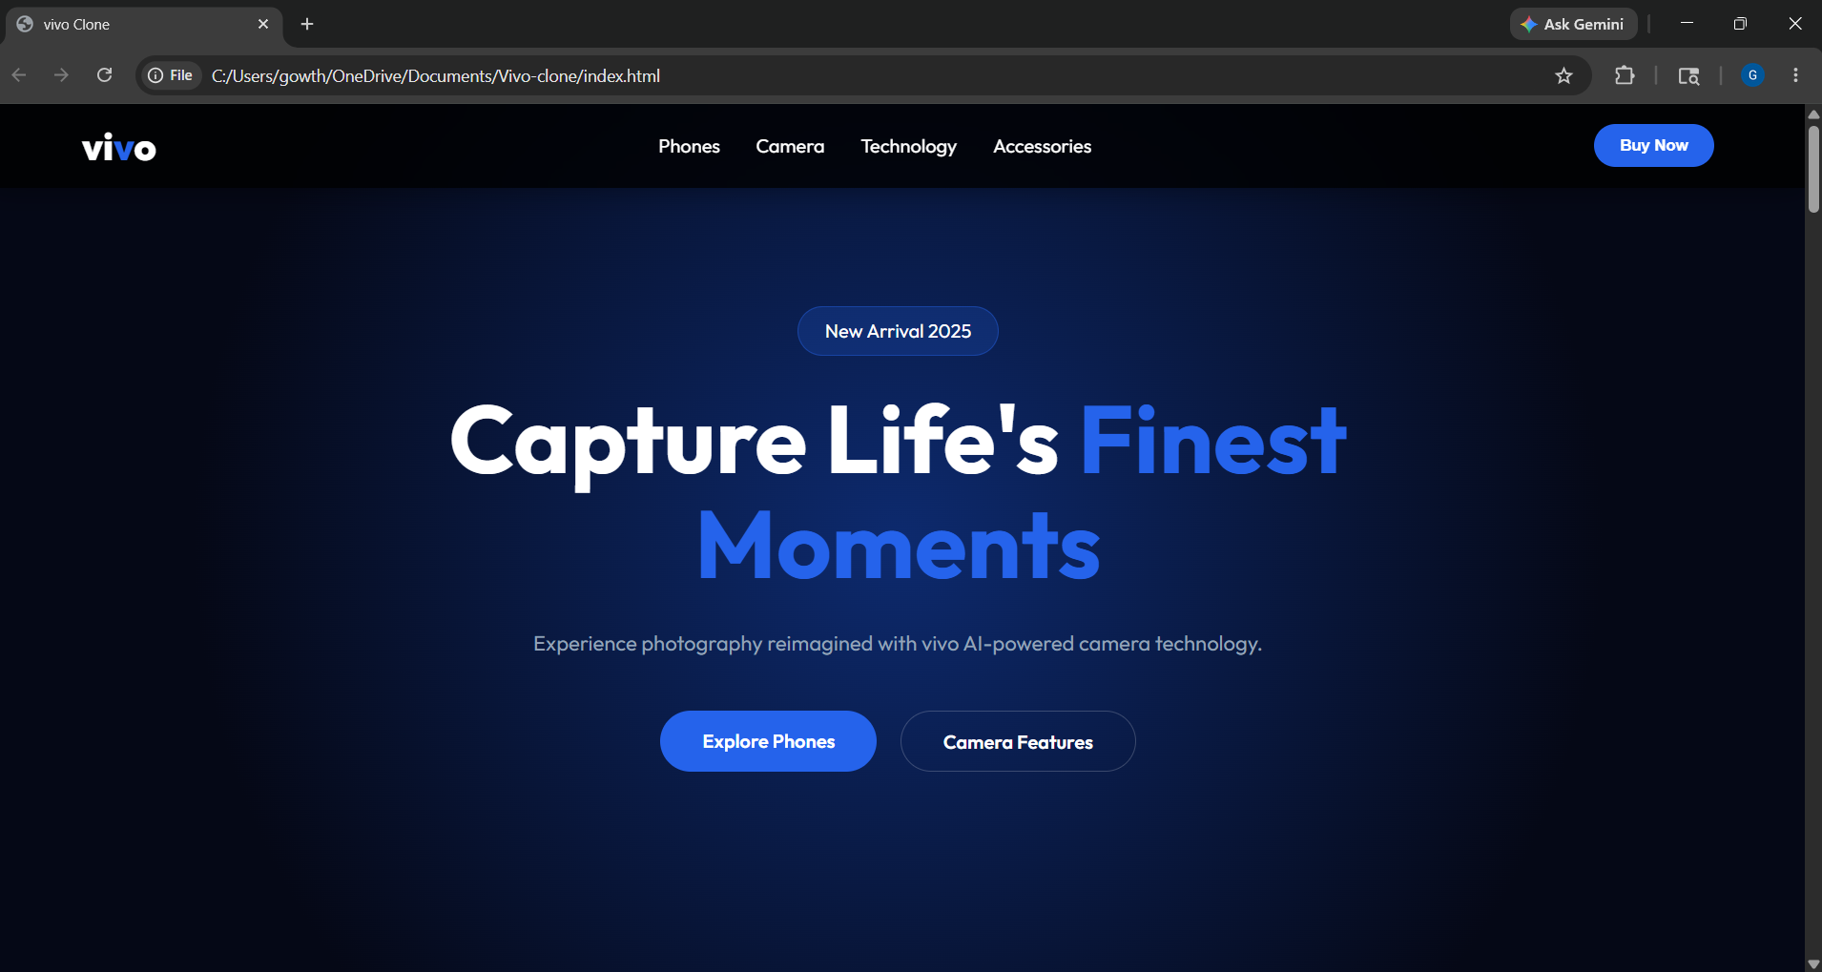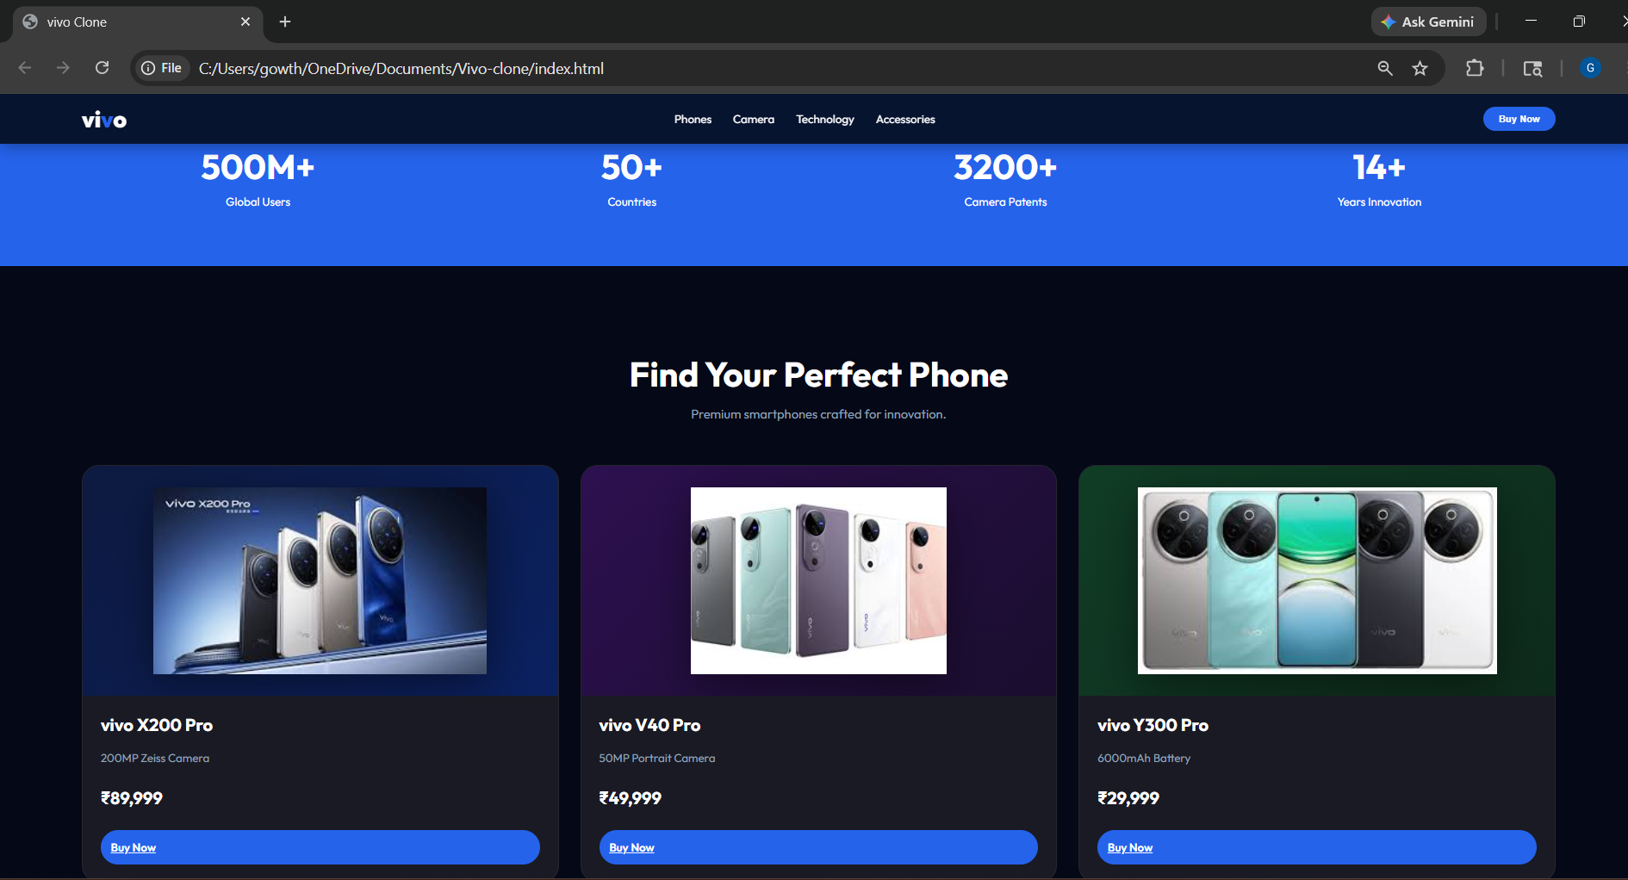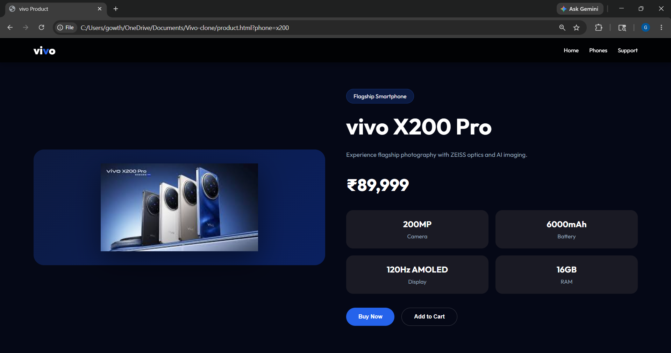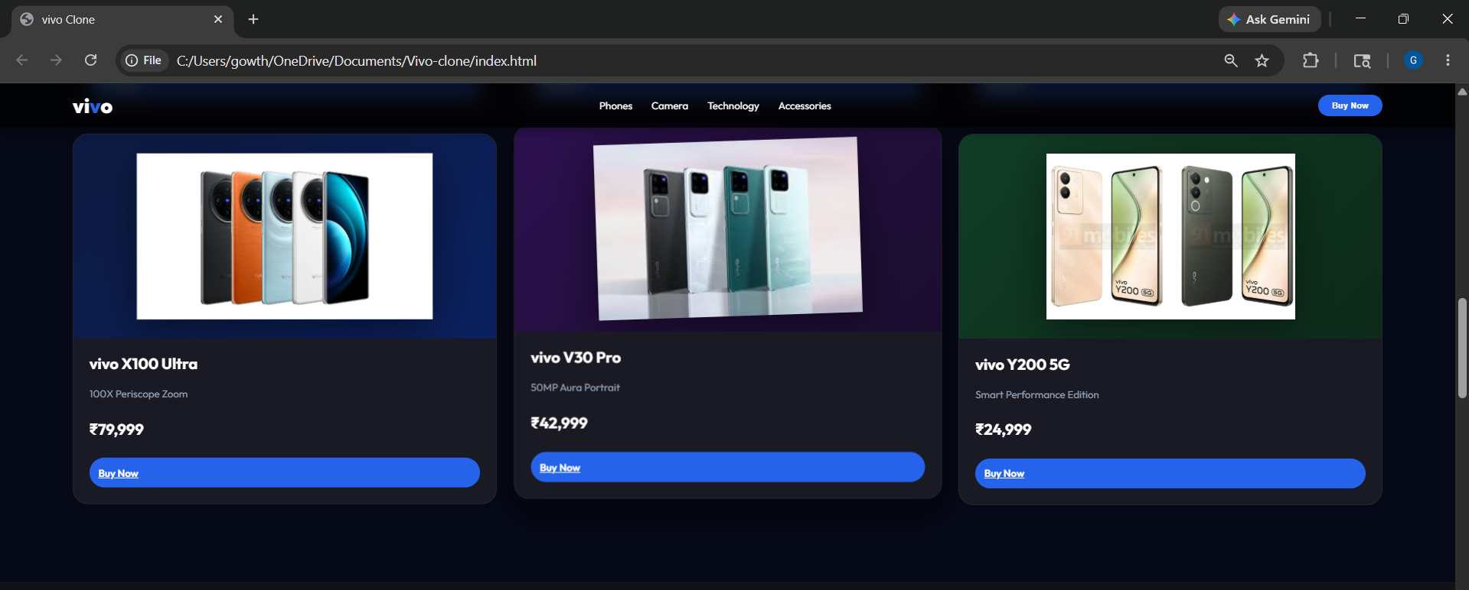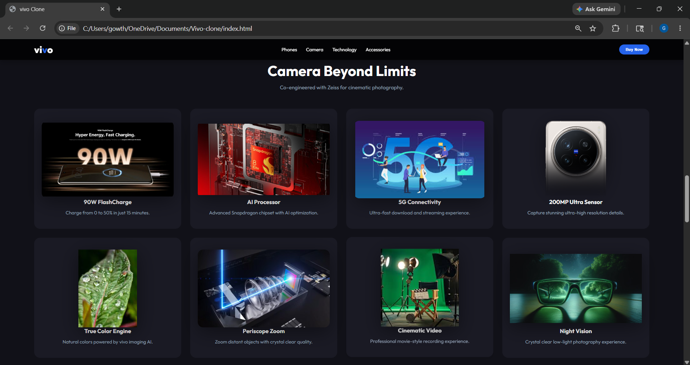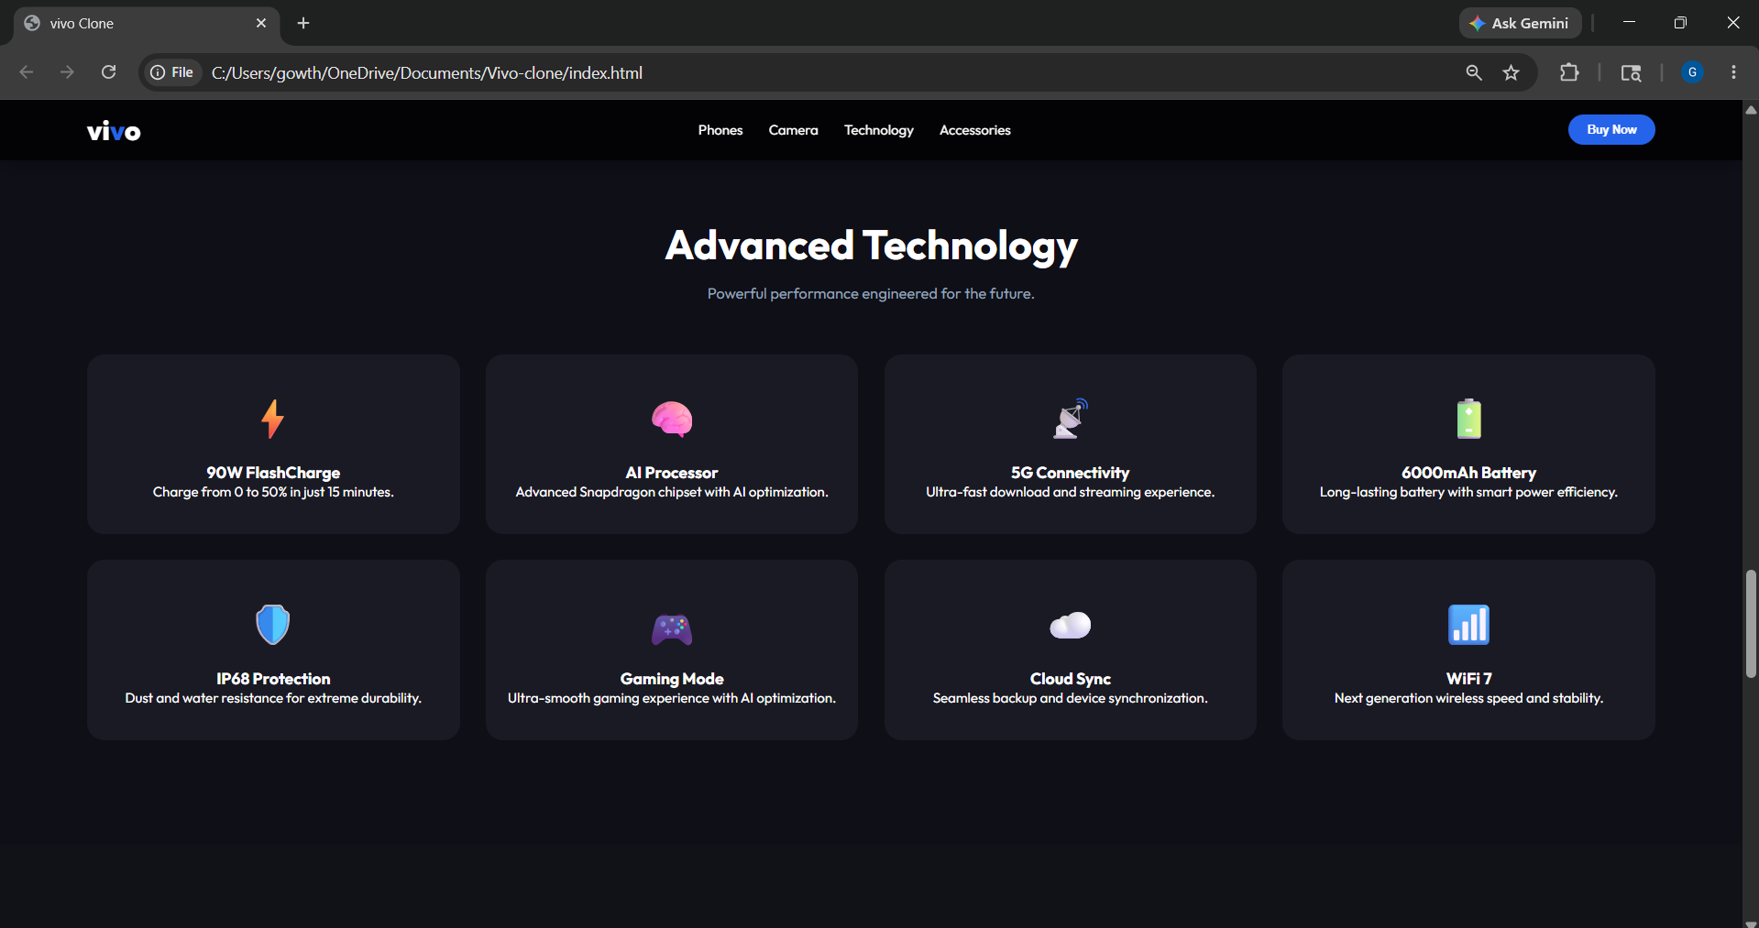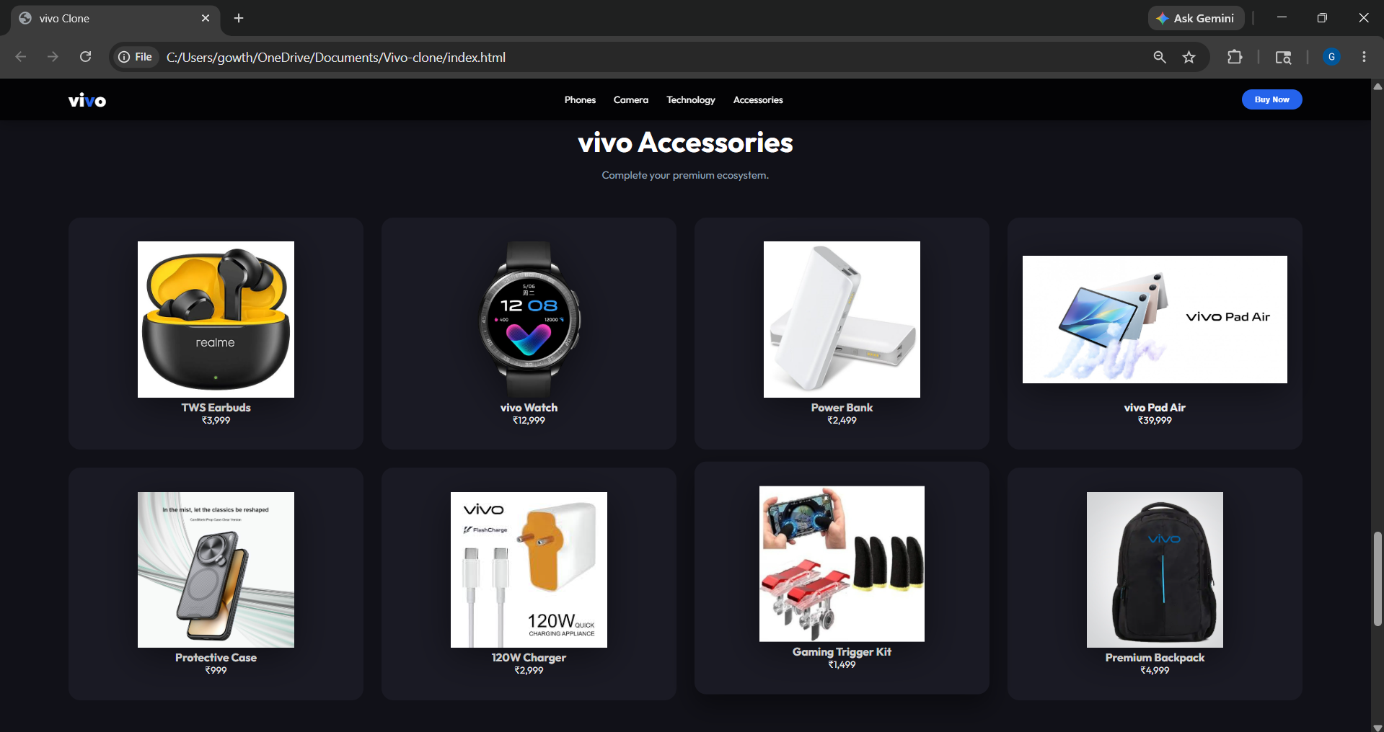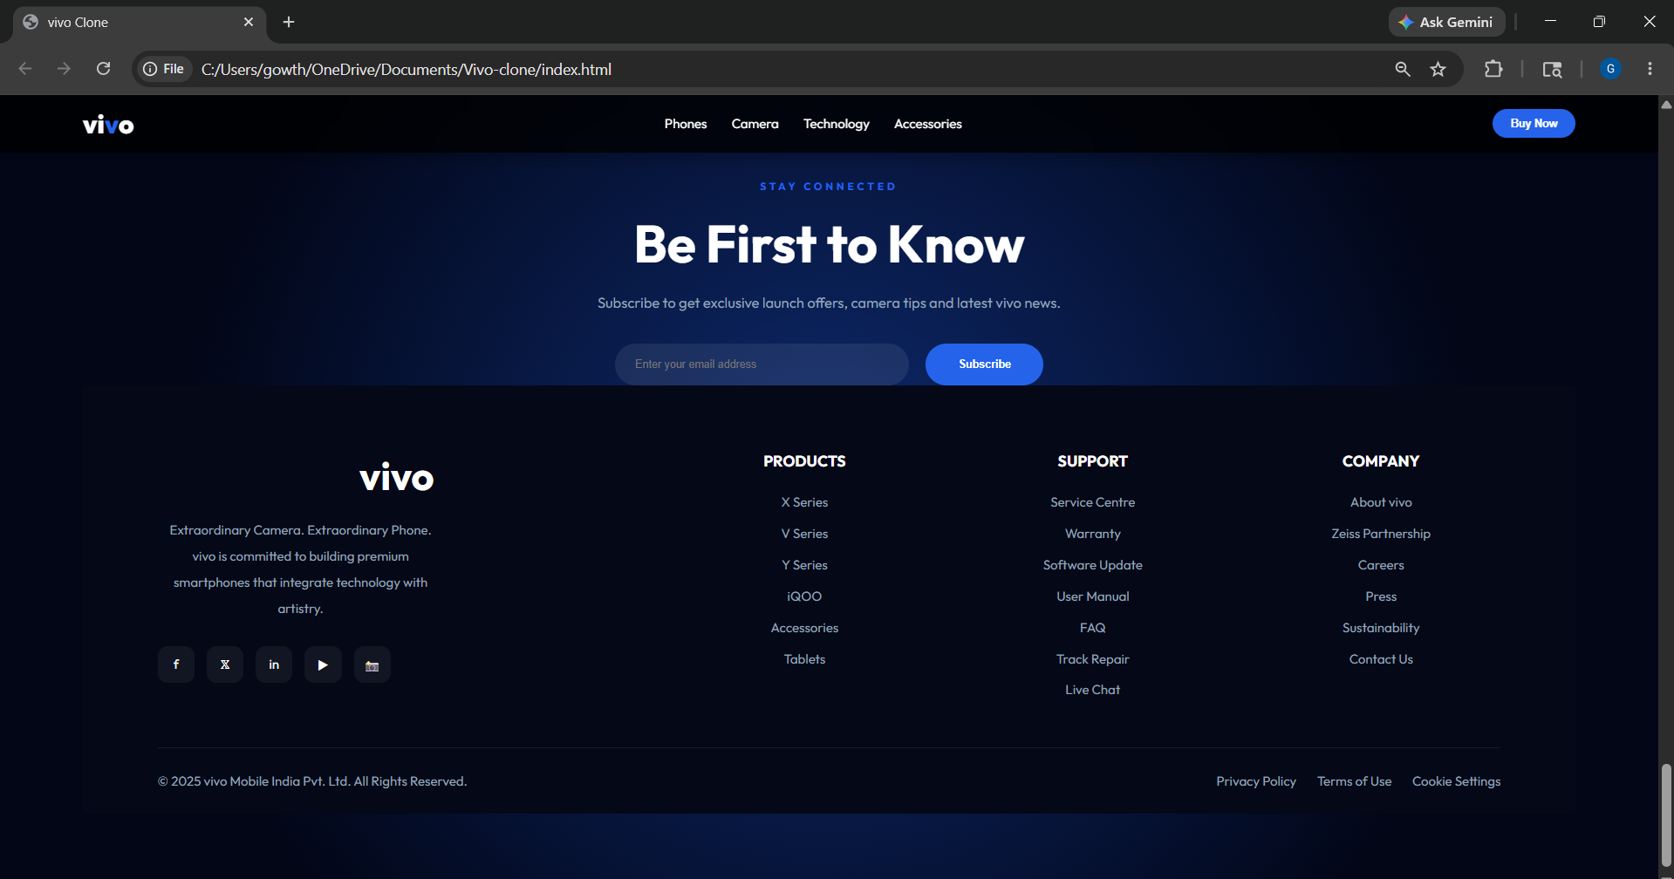
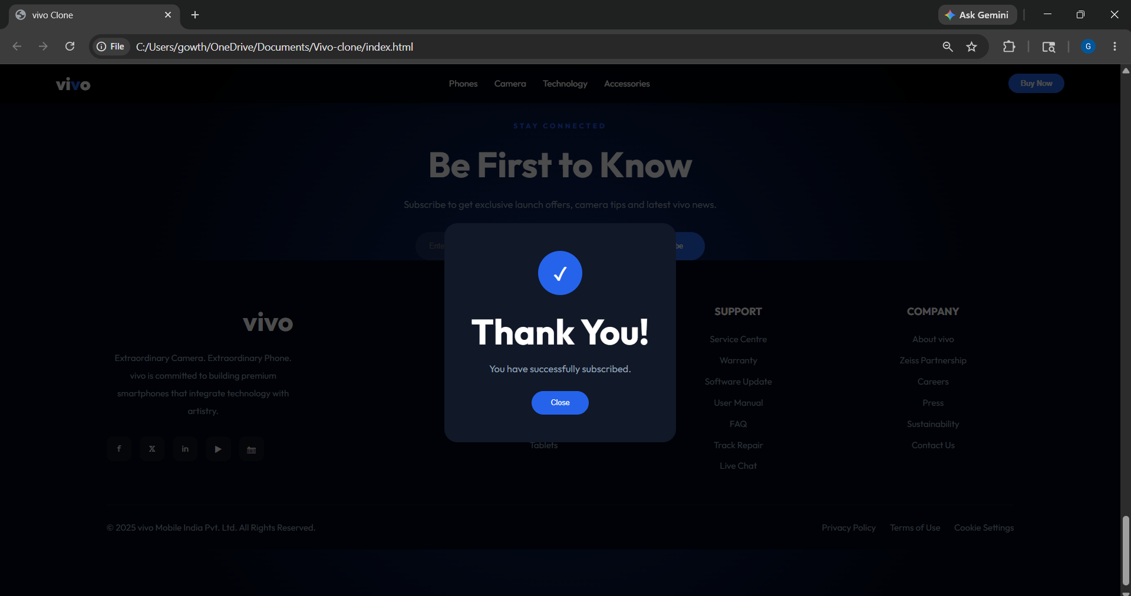

EXPLANATION:

VIVO Website Project Explanation :
Introduction
- This project is a responsive vivo smartphone website.
- The website is created using HTML, CSS, and JavaScript.
- It displays vivo smartphones, accessories, camera features, and technology sections.
- The project contains separate product pages for each phone.
- The website is designed with a modern and attractive user interface.

index.html
- index.html is the main homepage of the website.
- It contains all the major sections of the website.
- It provides navigation between different sections.
- It is connected with external CSS and JavaScript files.
- Google Fonts are used for better typography.
Main Sections in index.html
- Navigation Bar
- Hero Section
- Statistics Section
- Products Section
- Camera Section
- Technology Section
- Accessories Section
- Newsletter Section
- Footer Section
Navigation Bar
- Contains vivo logo.
- Contains menu links.
- Includes Buy Now button.
- Includes hamburger menu for mobile devices.
Hero Section
- Displays the main heading of the website.
- Highlights vivo camera technology.
- Contains call-to-action buttons.
Products Section
- Displays different vivo smartphones.
- Each product is shown using product cards.
- Product card contains:
  - Phone image
  - Phone name
  - Features
  - Price
  - Buy Now button
Camera Section
- Displays vivo camera technologies.
- Shows features like:
  - 200MP Sensor
  - Periscope Zoom
  - Night Vision
  - Cinematic Video
Technology Section
- Displays advanced technologies used in vivo phones.
- Includes:
  - FlashCharge
  - AI Processor
  - Gaming Mode
  - WiFi 7
  - IP68 Protection
Accessories Section
- Displays vivo accessories.
- Includes:
  - Earbuds
  - Smart Watch
  - Power Bank
  - Charger
  - Backpack
Newsletter Section
- Allows users to subscribe using email.
- Uses popup confirmation after successful subscription.
Footer Section
- Contains company information.
- Contains support links.
- Contains social media links.

product.html
- product.html displays complete details of selected smartphones.
- Product information changes dynamically using JavaScript.
- URL parameters are used to identify selected phones.
Features in product.html
- Product image
- Product name
- Product description
- Product price
- Specifications
- Buy Now button
- Add to Cart button
Specifications Displayed
- Camera
- Battery
- Display
- RAM

style.css
- style.css is used for website styling and design.
- It controls:
  - Colors
  - Fonts
  - Layouts
  - Animations
  - Responsiveness
CSS Features Used
- CSS Variables
- Flexbox
- Grid Layout
- Hover Effects
- Media Queries
- Transitions
- Gradients
Responsive Design
- Website works properly on:
  - Desktop
  - Tablet
  - Mobile
Hover Effects
- Product cards move slightly upward on hover.
- Buttons change color on hover.
- Images zoom slightly on hover.
Popup Styling
- Popup is hidden initially.
- Popup appears after successful subscription.

script.js
- script.js handles homepage interactivity.
- It controls:
  - Mobile menu
  - Newsletter popup
  - Email validation
Mobile Menu Function
- Opens and closes navigation menu on mobile devices.
- Uses JavaScript function:
  - toggleMenu()
Newsletter Subscription Function
- Checks if email is entered correctly.
- Uses regular expression for email validation.
- Shows popup after successful validation.
Popup Close Function
- Closes popup window when user clicks close button.

product.js
- product.js handles dynamic product loading.
- Product details are stored inside JavaScript objects.
Product Information Stored
- Name
- Image
- Price
- Description
- Specifications
URL Parameter Usage
- URL parameter identifies selected phone.
- Example:
  - product.html?phone=x200
Dynamic Content Loading
- JavaScript changes:
  - Product name
  - Product image
  - Product price
  - Product specifications

Features of the Website
- Responsive design
- Modern user interface
- Dynamic product pages
- Product cards with hover effects
- Newsletter popup
- Email validation
- Mobile-friendly navigation
- Stylish footer section

Technologies Used
HTML
- Used for website structure.
CSS
- Used for styling and responsiveness.
JavaScript
- Used for interactivity and dynamic content.

Conclusion
- This project demonstrates front-end web development skills.
- It combines HTML, CSS, and JavaScript effectively.
- The website provides a modern e-commerce style experience.
- Dynamic product pages improve user interaction.
- Responsive design ensures compatibility across devices.

