USER INTERFACE DESIGN PROJECT

Vivo Clone Website Frontend
A responsive recreation of the Vivo smartphone product website using HTML5, CSS3, and JavaScript.

https://github.com/gowthamkandula2008-gk/Vivo-Clone-Frontend--UID
Repository
https://resplendent-blini-2d23eb.netlify.app/

Live Demo
KANDULA GOWTHAM KOUSHIK| AV.SC.U4CSE25119
Submitted By
User Interface Design (23CSE113), SEM-2
Course
Dr. Rajkumar Batchu, Assistant Professor, CSE
Submitted To
29 May 2026
Document Date
Project Summary
The Vivo Clone Website is a responsive frontend web application designed to replicate the appearance and functionality of Vivo's product showcase website. The project focuses on modern UI design, responsive layouts, interactive product displays, navigation systems, and an attractive user experience using HTML, CSS, and JavaScript

Figure 1
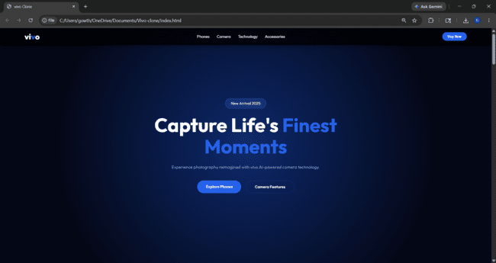.

Introduction
Vivo Clone Website is a frontend project developed as part of the User Interface Design course. The website recreates the visual design and product presentation style of Vivo's official smartphone website.
The application provides product listings, detailed product pages, responsive navigation, shopping cart interaction, and social media integration while maintaining a clean and professional interface.

Objectives
• Design a modern Vivo-inspired website interface.
• Create responsive layouts for mobile, tablet, and desktop devices.
• Implement product showcase sections with images and specifications.
• Develop product detail pages with interactive elements.
• Practice UI/UX design principles including typography, spacing, colors, and visual hierarchy.
• Enhance frontend development skills using HTML, CSS, and JavaScript.

- Technology Stack

Technology | Role in Project | Evidence in Repository
HTML5 | Defines page structure, navigation, hero, feature sections, CTA area, footer, and mobile drawer. | index.html
CSS3 | Handles layout, custom properties, gradients, responsive breakpoints, animations, and visual styling. | style.css
JavaScript | Adds dropdowns, scroll reactions, mobile menu behavior, parallax movement, and footer accordions. | script.js
Media Assets | Provides artwork, icons, webp images, PNG images, and MP4 feature previews. | assets/ folder

- Project Structure

Main homepage containing:
- Hero Section
- Navigation Bar
- Product Showcase
- Featured Phones
- Footer

index.html
- Responsive layouts
- Colors and typography
- Animations
- Hover effects
- Mobile responsiveness
style.css
Handles:
- Product loading
- Cart popup notifications
- User interactions
- Dynamic content display

product.js
Stores:
- Phone images
- Logos
- Icons
- Background images

assets/
 | Project overview, live demo link, technology stack, setup steps, contribution note, contact information, and assignment metadata.
README.md
Product.html | product.html  Contains:  - Individual product information  - Product images  - Specifications  - Add to Cart button  - Product descriptions

- Main Features

Responsive Navigation
- Fully responsive navigation bar.
- Mobile-friendly menu system.
- Smooth navigation between pages.
Product Showcase
- Displays Vivo smartphones attractively.
- Product cards with images and specifications.
- Hover animations for better user experience.
Product Details Page
- Detailed information about each smartphone.
- Product specifications and descriptions.
- High-quality product images.
Add to Cart Functionality
- Interactive "Add to Cart" button.
- Popup notification displaying "Added to Cart Successfully".
- Improved user engagement.
Social Media Integration
- Quick access buttons for:
  - Instagram
  - Facebook
  - Twitter/X
  - YouTube

Design Approach

The website follows Vivo's clean and modern design language.
Typography
- Uses Outfit font family.
- Clear headings and readable content.
Color Scheme
- White backgrounds
- Blue accent colors
- Soft shadows and gradients
Layout
- Flexbox and Grid layouts
- Card-based design
- Responsive sections
User Experience
- Simple navigation
- Interactive buttons
- Smooth hover transitions

Setup and Usage
• Download or clone the project files.
• Open the project folder in Visual Studio Code.
• Ensure all images and assets are properly linked.
• Open index.html using a browser.
• Navigate through products and test responsiveness.
• Click "Add to Cart" to verify popup functionality.

Learning Outcomes
- Understanding of responsive web design.
- Practical experience with HTML5, CSS3, and JavaScript.
- Knowledge of UI/UX design principles.
- Experience in creating product showcase websites.
- Improved frontend development skills.

Limitations
• Frontend-only implementation.
• No backend database integration.
• Cart data is not permanently stored.
• No payment gateway integration.
• Limited product filtering options.

Conclusion
The Vivo Clone Website successfully demonstrates modern frontend web development techniques through a visually appealing and responsive smartphone product website. The project showcases skills in HTML, CSS, JavaScript, UI design, responsiveness, and interactive web development. Future enhancements such as backend integration, authentication, and e-commerce functionality can transform it into a complete online shopping platform.

Submitted By:KANDULA GOWTHAM KOUSHIK
Roll Number: AV.SC.U4CSE25119
Course: User Interface Design (23CSE113)
Institution: Amrita Vishwa Vidyapeetham, Amaravati Campus.

