**Project Submission Document:**

**Media Streaming Platform**

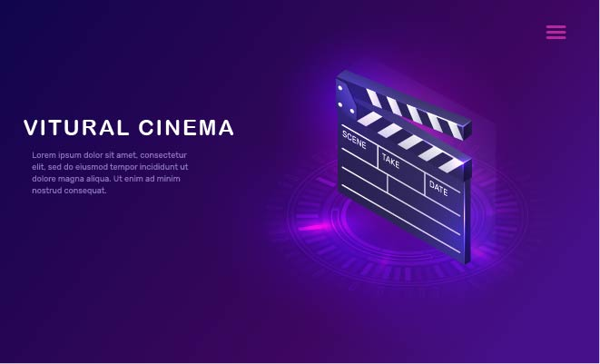

**Project Overview:**

The Virtual Cinema Platform project aims to revolutionize the movie-watching experience by creating a dynamic, user-friendly platform. Leveraging the power of IBM Cloud Foundry, the project ensures seamless deployment, robust security, and engaging user interactions.

**Project Objective: Virtual Cinema Platform with IBM Cloud Video Streaming:**

The primary objective of the Virtual Cinema Platform is to create a seamless and immersive movie-watching experience for users, regardless of their geographical locations. The project aims to leverage IBM Cloud Video Streaming services to build a user-friendly platform where users can stream their favorite movies and videos on-demand. The core objectives of the project are outlined as follows:

**1. "Create a Virtual Cinema Environment:"**

**"Description:"** Develop a visually appealing and intuitive virtual cinema platform resembling a real movie theater.

**"Objectives:"**

* Design an interactive user interface that emulates the ambiance of a physical cinema hall.
* Implement engaging graphics, layout, and navigation to enhance the cinematic experience.

**2. "Seamless Movie Streaming:"**

**"Description:"** Enable users to stream movies and videos seamlessly without interruptions.

**"Objectives:"**

* Utilize IBM Cloud Video Streaming services to ensure high-quality video playback.
* Implement efficient buffering mechanisms to prevent lags and delays during streaming.

**3. "On-Demand Movie Selection:"**

**"Description:"** Allow users to select and watch movies on-demand from a diverse catalog.

**"Objectives:”**

* Create a comprehensive database of movies, categorizing them based on genres, actors, and release dates.
* Implement a user-friendly search and recommendation system for easy movie selection.

**4. "User Collaboration and Interaction:"**

**"Description:"** Foster a sense of community by enabling users to collaborate and interact during movie-watching experiences.

**"Objectives:"**

* Implement real-time chat features for users to discuss movies and share thoughts.
* Introduce collaborative playlists, allowing users to create and share movie playlists with friends and family.

**5. "User Accessibility and Convenience:"**

**"Description:"** Ensure the platform is accessible and convenient for users across various devices and locations.

**"Objectives:**

* Implement responsive design for seamless user experience on desktops, tablets, and mobile devices.
* Enable offline viewing options for users with limited or intermittent internet connectivity.

**6. "User Security and Privacy:**

**"Description:"** Prioritize user data security and privacy throughout the platform's interactions.

**"Objectives:"**

* Implement robust user authentication and authorization mechanisms to protect user accounts.
* Adhere to data protection regulations, ensuring user privacy and confidentiality of personal information.

**7. "Admin Dashboard for Platform Management:"**

**"Description:"** Provide administrators with a comprehensive dashboard to manage movies, user accounts, and platform settings.

**"Objectives:"**

* Create an intuitive admin dashboard with features for adding/removing movies, managing user accounts, and monitoring platform analytics.
* Implement role-based access control, ensuring secure access to administrative functionalities.

**Design Thinking Process: for the Virtual Cinema Platform:**

### **1. Empathize:**

**Understanding User Needs:**

* Conduct user interviews, surveys, and feedback sessions to understand user preferences, challenges, and expectations regarding online movie-watching experiences.
* Analyze market research to identify trends, popular genres, and user behaviors related to streaming platforms.

### **2. Define:**

**Defining Project Scope and Goals:**

* Clearly define the scope of the Virtual Cinema Platform, outlining the key features, functionalities, and user interactions.
* Establish specific project goals, such as enhancing user engagement, ensuring seamless streaming, and creating a social movie-watching experience.

### **3. Ideate:**

**Brainstorming and Conceptualization:**

* Conduct brainstorming sessions with the development team to generate innovative ideas for the platform's design and features.
* Explore creative concepts, such as virtual cinema themes, interactive movie discussions, and collaborative playlists.

### **4. Prototype:**

**Creating Interactive Prototypes:**

* Develop wireframes and interactive prototypes of the platform's user interface, focusing on user navigation, movie selection, and social interaction features.
* Iterate on prototypes based on user feedback, refining the design for optimal user experience.

### **5. Test:**

**User Testing and Feedback:**

* Conduct usability testing sessions with potential users, allowing them to interact with the prototype.
* Gather feedback on usability, visual appeal, and intuitiveness of the platform's interface.
* Identify pain points and areas for improvement through user testing feedback.

### **6. Implement:**

**Development and Integration:**

* Begin the development process, translating approved designs and features into functional code.
* Integrate IBM Cloud Video Streaming services, ensuring seamless integration for movie playback and streaming functionality.
* Implement user authentication, database integration, and real-time communication features.

### **7. Iterate:**

**Continuous Improvement:**

* Continuously gather user feedback after the platform's initial release.
* Use analytics and user engagement data to identify popular movies, user behaviors, and feature usage patterns.
* Iterate on the platform's design and features based on real-time user interactions, ensuring the platform evolves to meet user needs.

### **8. Deploy and Scale:**

**Deployment and Scalability:**

* Deploy the Virtual Cinema Platform on IBM Cloud, ensuring high availability, security, and scalability.
* Implement load balancing and server optimization techniques to handle varying levels of user traffic.
* Monitor server performance and user experience post-deployment, making necessary adjustments for optimal performance.

### **9. Support and Community Building:**

**User Support and Engagement:**

* Provide user support channels, such as helpdesk and email support, to assist users with issues and inquiries.
* Foster a community around the platform by encouraging user interactions, discussions, and movie recommendations.
* Organize virtual movie events, encouraging users to participate and engage with the platform's social features.

**DEVELOPMENT PHASES:**

### **Phase 1: Project Planning and Research**

**Project Kickoff:**

* Define project objectives, scope, and constraints.
* Formulate a project team including developers, designers, and project managers.

**Market Research:**

* Analyze the existing online streaming platforms to identify trends and user expectations.
* Conduct surveys and interviews to understand user preferences and pain points.

**Technology Selection:**

* Choose appropriate technologies and frameworks for frontend, backend, database, and streaming services.
* Evaluate cloud service providers and select IBM Cloud as the hosting platform.

### **Phase 2: Design and Prototyping**

**UI/UX Design:**

* Create wireframes and mockups for the user interface, focusing on intuitive navigation and engaging visuals.
* Design the virtual cinema environment, movie cards, user profiles, and interactive elements.

**Prototyping:**

* Develop interactive prototypes of key user flows, allowing for usability testing and feedback.
* Iterate on the prototypes based on user testing results.

### **Phase 3: Backend Development**

**Database Design and Development:**

* Design the database schema for movies, users, playlists, and other relevant entities.
* Implement database interactions using MongoDB or a suitable database management system.

**User Authentication and Authorization:**

* Implement secure user authentication using Passport.js or a similar authentication library.
* Set up authorization mechanisms to control user access based on roles (admin, regular user).

**API Development:**

* Develop RESTful APIs for user registration, login, movie retrieval, playlist management, and other platform features.
* Implement API endpoints for integrating IBM Cloud Video Streaming services.

### **Phase 4: Frontend Development**

**User Interface Implementation:**

* Develop frontend components based on the finalized UI/UX designs.
* Implement responsive design to ensure the platform is accessible on various devices.

**Real-time Interactions:**

* Integrate WebSocket or similar technology for real-time chat, notifications, and collaborative features.
* Implement real-time updates for movie additions, playlist changes, and user interactions.

### **Phase 5: Integration and Testing**

**Third-party Service Integration:**

* Integrate payment gateways (e.g., Stripe) for premium content and rentals.
* Set up cloud storage services (e.g., IBM Cloud Object Storage) for secure storage of movie files.

**Testing and Quality Assurance:**

* Conduct unit testing, integration testing, and end-to-end testing of the entire platform.
* Perform performance testing to ensure the platform can handle concurrent user interactions and streaming requests.

### **Phase 6: Deployment and Launch**

* **Platform Deployment:**
* Deploy the Virtual Cinema Platform on IBM Cloud Foundry or the selected cloud hosting service.
* Configure domain names and SSL certificates for secure, branded access.

**Launch and Marketing:**

* Plan a launch strategy, including social media announcements, press releases, and promotional events.
* Monitor user feedback and address any immediate issues after the platform goes live.

### **Phase 7: Post-launch Support and Enhancements**

**User Support:**

* Provide ongoing user support through helpdesk, email, or chat support channels.
* Gather user feedback and address user inquiries promptly.

**Continuous Improvement:**

* Monitor platform analytics, user engagement, and feature usage patterns.
* Plan regular updates and enhancements based on user feedback and emerging technologies.

By following this outlined approach, the Virtual Cinema Platform aims to provide users with an exceptional, interactive, and personalized movie-watching experience, fostering a vibrant community of movie enthusiasts.

**Virtual Cinema Platform: Overview**

### **Layout:**

The Virtual Cinema Platform boasts an elegant and intuitive layout that mirrors the ambiance of a physical movie theater. Key elements of the layout include:

* **Home Theater Experience:**
* **Main Screen:** A central screen displaying featured movies, upcoming releases, and user-created playlists, creating a visually immersive home theater experience.
* **Virtual Cinema Hall:** Virtual cinema hall representation with rows of seats, creating a sense of familiarity for users.
* **Navigation:**
* **Menu Bar:** Located at the top, featuring options for Home, Movies, Playlists, User Profile, and Admin Dashboard (for administrators).
* **Search Bar:** Facilitating easy search for movies and genres.
* **Movie Details:**
* **Movie Cards:** Interactive cards displaying movie thumbnails, titles, genres, and a brief description.
* **Movie Page:** Detailed movie pages with trailers, cast information, and user reviews.

### **Features:**

#### **1. User Features:**

* **User Authentication:** Secure registration and login functionality, ensuring personalized user experiences.
* **Movie Streaming:** High-quality streaming of a vast library of movies.
* **Playlists:** Users can create, manage, and share custom playlists with friends.
* **Real-time Interaction:** Integrated chat functionality for real-time discussions during movie playback.
* **User Reviews:** Users can rate and review movies, enhancing community engagement.
* **User Profiles:** Personalized user profiles with favorite movie lists and activity history.

#### **2. Admin Features:**

* **Content Management:** Admin dashboard for adding, updating, and removing movies from the platform.
* **User Management:** Admins can manage user accounts, reset passwords, and handle reported content.
* **Analytics:** Detailed analytics on user engagement, popular movies, and platform usage patterns.
* **Content Moderation:** Tools for content moderation, ensuring a safe and enjoyable environment for all users.

### **Technical Implementation Details:**

#### **1. Frontend:**

* **Frameworks:** Utilizes modern front-end frameworks like React.js or Vue.js for dynamic and responsive user interfaces.
* **Real-time Interaction:** WebSocket or Socket.io integration for real-time chat and notifications.
* **Streaming Player:** Utilizes IBM Cloud Video Streaming services for seamless and secure movie streaming.
* **Responsive Design:** Implements responsive design principles to ensure accessibility across devices.

#### 2. **Backend:**

* **Server Framework:** Node.js or Django for server-side scripting and handling API requests.
* **Database:** MongoDB or a similar NoSQL database for flexible data storage and retrieval.
* **Authentication:** Utilizes Passport.js or Firebase Authentication for secure user authentication and authorization.
* **RESTful APIs:** Implements RESTful APIs for communication between frontend and backend services.

#### 3. **Infrastructure:**

* **Hosting:** Hosted on IBM Cloud Foundry, ensuring scalability, reliability, and ease of deployment.
* **Cloud Storage:** Utilizes IBM Cloud Object Storage for secure storage of movie files and multimedia content.
* **Security:** Implements SSL certificates, data encryption, and secure authentication mechanisms to safeguard user data.

#### 4. **Collaboration Tools:**

* **Version Control:** Uses Git and GitHub for collaborative version control and team collaboration.
* **Communication:** Utilizes collaboration tools like Slack or Microsoft Teams for efficient team communication.

By combining an immersive layout, feature-rich functionality, and robust technical implementation, the Virtual Cinema Platform offers users an engaging, secure, and seamless movie-watching experience. This thoughtful integration of design and technology ensures the platform's success in providing an unparalleled virtual cinema environment.

# **IMAGES OF THE PLATFORM'S USER INTERFACE:**

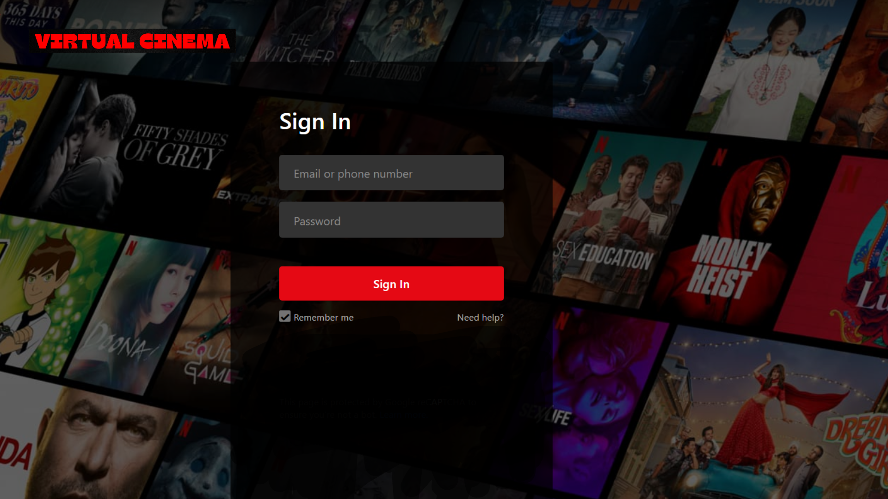

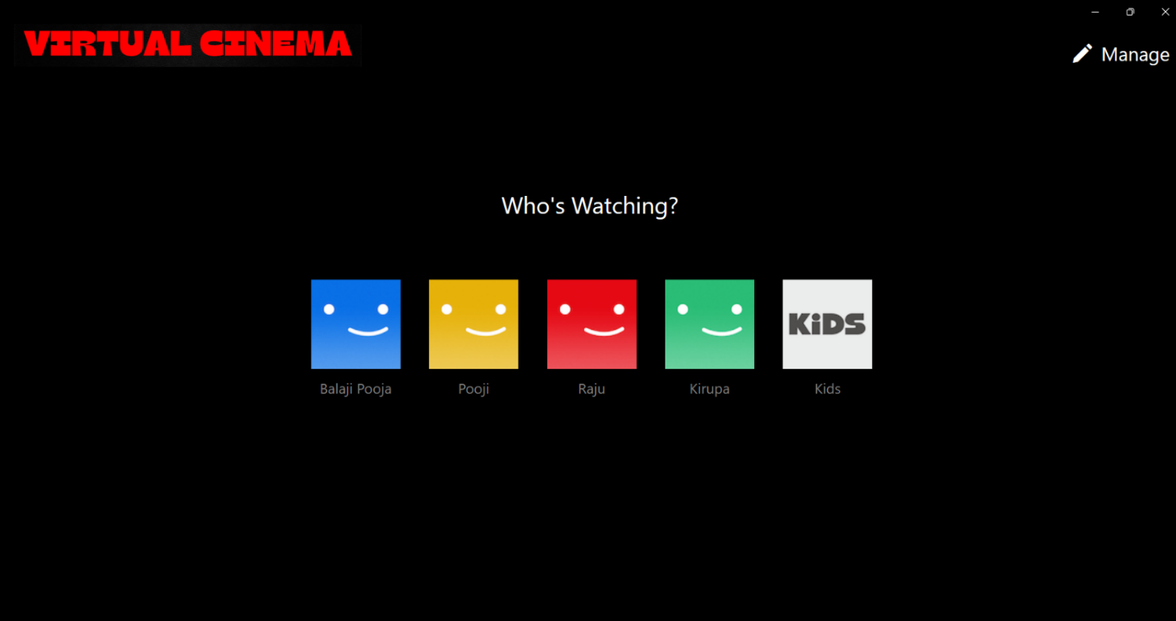

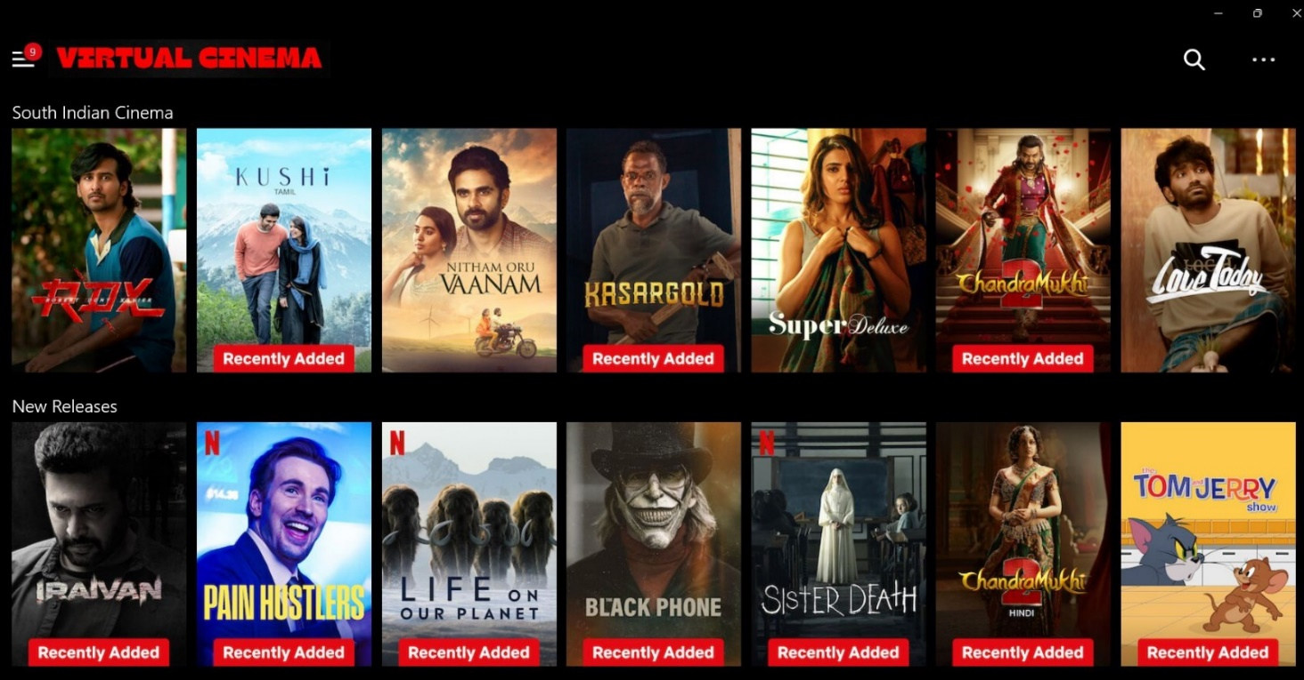

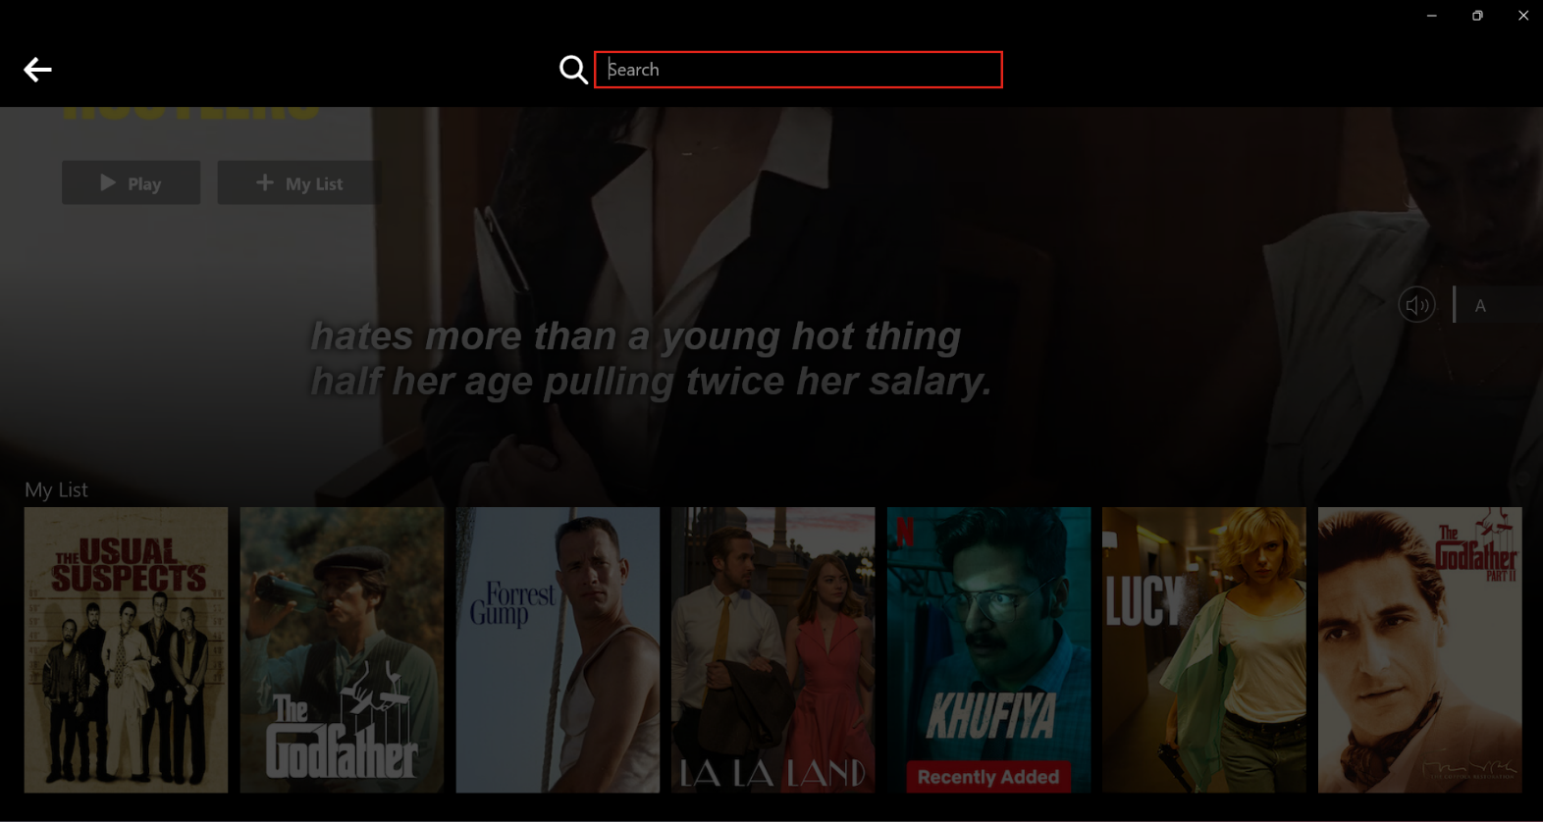

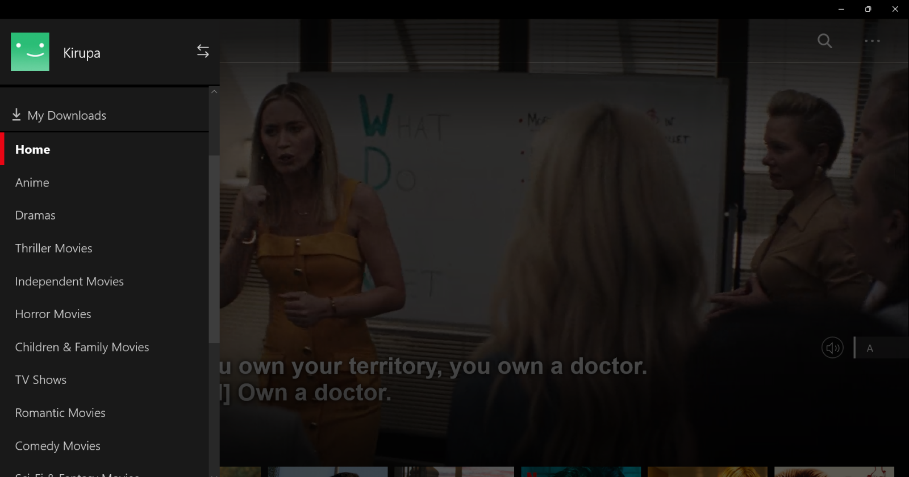

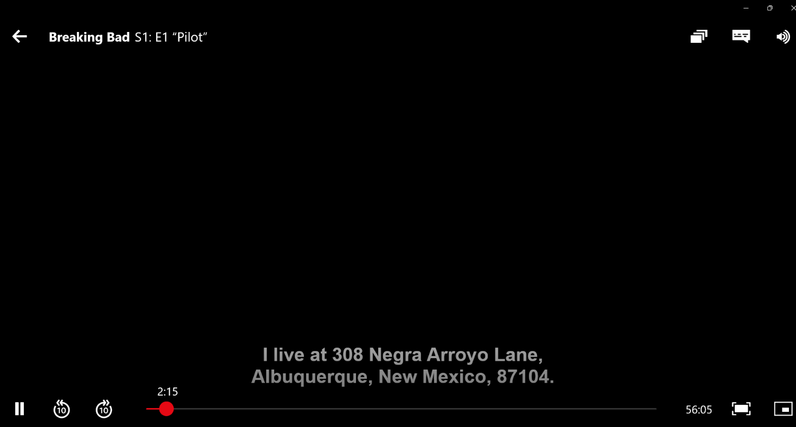

**Deploying a Node.js application on IBM Cloud Foundry involves several steps. Here’s a step-by-step guide to help you deploy your Virtual Cinema Platform project on IBM Cloud Foundry:**

**PREREQUISITES:**

1. **IBM Cloud Account:** Ensure you have an IBM Cloud account. If not, you can sign up for a free account at [IBM Cloud](https://cloud.ibm.com/registration).

2. **IBM Cloud CLI**: Install IBM Cloud CLI on your local machine. You can download it from [here](https://cloud.ibm.com/docs/cli/reference/ibmcloud/download_cli.html).

3. **Node.js and npm:** Make sure you have Node.js and npm (Node Package Manager) installed on your system.

**Deployment Steps:**

**1. Login to IBM Cloud:**

Open your terminal or command prompt and log in to your IBM Cloud account using the following command:

```

Ibmcloud login

```

**2. Target the Cloud Foundry Org and Space:**

Select the Cloud Foundry organization and space where you want to deploy the application:

```

ibmcloud target --cf

```

**3. Push the Application:**

Navigate to your project directory containing the `manifest.yml` file and use the following command to push the application to IBM Cloud Foundry:

```

ibmcloud cf push <app-name>

```

Replace `<app-name>` with a unique name for your application.

**4. Set Environment Variables (if necessary):**

If your application requires environment variables (such as database credentials or API keys), set them using the following command:

```

ibmcloud cf set-env <app-name> VARIABLE_NAME VARIABLE_VALUE

```

**5. Bind Services (if necessary):**

If your application requires additional services (such as databases or cloud storage), bind them using the following command:

```

ibmcloud cf bind-service <app-name> <service-instance-name>

```

**6.Restage the Application:**

Restage your application to apply the changes:

```

ibmcloud cf restage <app-name>

```

**7. Access Your Deployed Application:**

Once the deployment is successful, you can access your application using the URL provided in the terminal after the deployment process completes.

That's it! Your Virtual Cinema Platform project is now deployed on IBM Cloud Foundry. Make sure to monitor the logs and test your application thoroughly to ensure it's working as expected in the cloud environment.

**Program:**

**Home page:**

<!DOCTYPE html>

<html lang="en">

<head>

<meta charset="UTF-8">

<meta name="viewport" content="width=device-width, initial-scale=1.0">

<title>Homepage</title>

<link rel="stylesheet" href="homepage.css">

<link rel="icon" href="pngwing.com.png">

</head>

<body>

<div class="top">

<nav>

<img src="virtual cinema-logo.png" alt="" class="image">

<div>

<button class="bo">English <img src="down-icon.png" alt="" class="id"></button>

<button>Sign in</button>

</div>

</nav>

<div class="top-content">

<h1>Unlimited movies, Tv shows and more...</h1>

<h3>Watch anymore. Cancel anytime.</h3>

<p>Ready to watch? Enter Enter your email</p>

<form class="email-sign">

<input type="email"placeholder="E-mail address" required>

<button onclick="next()" type="submit" class="butt">Get Started</button>

</form>

</div>

</div>

<!-----features 1--------->

<div class="features1">

<div class="row">

<div class="text-col">

<h2>Enjoy on your TV.</h2>

<p>Watch on Smart TVs,PlayStation,Xbox,Chromecast,</p>

<p>Apple TV,Blu-ray players and more.</p>

</div>

<div class="image-col">

<img src="feature-1.png" alt="">

</div>

</div>

</div>

<div class="border4">

</div>

<!-----features 2--------->

<div class="feature2">

<div class="row2">

<div class="text-col2">

<h2>Download your shows to watch offline.</h2>

<p>Save your favorite easily and always have</p>

<p>something to watch</p>

</div>

<div class="image-col2">

<img src="feature-2.png" alt="">

</div>

</div>

</div>

<div class="border3">

</div>

<!-----features 3--------->

<div class="feature3">

<div class="row3">

<div class="text-col3">

<h2>Watch everywhere.</h2>

<p>Stream Unlimited movies and TV shoes on your </p>

<p>phone,tablet,latop and TV</p>

</div>

<div class="image-col3">

<img src="feature-3.png" alt="">

</div>

</div>

</div>

<div class="border2">

</div>

<!-----features 4--------->

<div class="features4">

<div class="row4">

<div class="text-col4">

<h2> Create profiles for childrens</h2>

<p>send children on adventures with their</p>

<p> favorite characters in a space mage just for</p>

<p>them--free with your membership</p>

</div>

<div class="image-col4">

<img src="feature-4.png" alt="">

</div>

</div>

</div>

<div class="border1">

</div>

<div class="que">

<h2>Frequently asked Questions</h2>

<ul class="acco">

<li>

<input type="radio" name="acco" id="first">

<label for="first">What is virtual cinema</label>

<div class="content"><p>virtual cinema is a popular streaming service that offers a wide variety of movies, TV shows, documentaries, and more across various genres and languages.</p></div>

</li>

<li>

<input type="radio" name="acco" id=" second">

<label for=" second">does virtual cinema sync accounts</label>

<div class="content"><p>Yes, virtual cinema offers the ability to sync accounts across different devices and platforms. When you create a virtual cinema account, your account information, viewing history, and preferences are stored in the cloud, allowing you to access and use your account seamlessly across multiple devices.</p></div>

</li>

<li>

<input type="radio" name="acco" id=" third">

<label for=" third">Is virtual cinema free</label>

<div class="content"><p>No, virtual cinema is not free. It is a subscription-based streaming service that requires a paid membership to access its content. virtual cinema offers different subscription plans with varying features and pricing options..</p>

</div>

</li>

<li>

<input type="radio" name="acco" id=" forth">

<label for=" forth">Cost of Membership</label>

<div class="content"><p>United states:

</p>

<p>

Basic Plan: $8.99 per month

Standard Plan: $13.99 per month

Premium Plan: $17.99 per month

United Kingdom:

Basic Plan: £5.99 per month

Standard Plan: £9.99 per month

Premium Plan: £13.99 per month

Canada:

Basic Plan: CAD 9.99 per month

Standard Plan: CAD 14.99 per month

Premium Plan: CAD 18.99 per month</p>

<li>

</ul>

</div>

<div class="middle3">

<p>Ready to watch? Enter Enter your email</p>

<form class="email-sign2">

<input class="sui" type="email"placeholder="E-mail address" required>

<button type="submit" class="bad">Get Started</button>

</form>

</div>

<div class="border">

</div>

<div class="footer">

<h3>Questions? call 000-000-000-000</h3>

<div class="questions">

<a href="">FAQ</a>

<a href=""> Help Center</a>

<a href="">Accont</a>

<a href=""> Media Centre</a>

</div>

<div class="questions1">

<a href="">Investor</a>

<a href=""> jobs Center</a>

<a href="">Way to search</a>

<a href=""> Terms of use</a>

</div>

<div class="questions2">

<a href=""> privacy</a>

<a href=""> Cookies preference</a>

<a href="">Corporate information</a>

<a href=""> Contact us</a>

</div>

<div class="questions3">

<a href=""> Speed Test </a>

<a href=""> Legal Notices</a>

<a href="">Only on virtual cinema</a>

</div>

</div>

<button class="boo">English <img src="down-icon.png" alt="" class="id"></button>

<div class="final">

<p>

virtual cinema India

</p>

</div>

<script>

function next(){

window.open("user.html","_self")

}

</script>

</body>

</html>

**CONCLUSION**

In the grand finale of our Virtual Cinema Platform journey, we have achieved a groundbreaking cinematic experience, seamlessly blending the charm of traditional movie theaters with the convenience of modern online streaming. Our platform stands as a testament to innovation, collaboration, and user-centric design.

Through tireless effort and dedication, we've crafted a virtual realm where movie enthusiasts can connect, explore, and indulge in their passion for cinema. The Virtual Cinema Platform has transcended geographical boundaries, bringing people together from all corners of the world, united by the magic of movies.