**LINUX ASSIGNMENT DAY 5**

1. 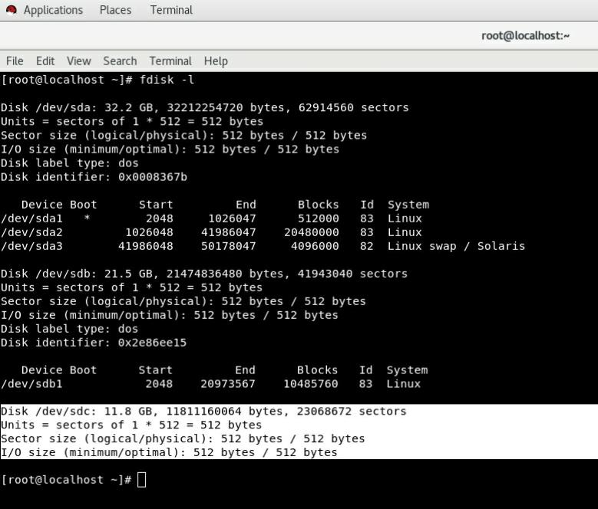 **Add a 10GB disk to the CentOS.**
2. 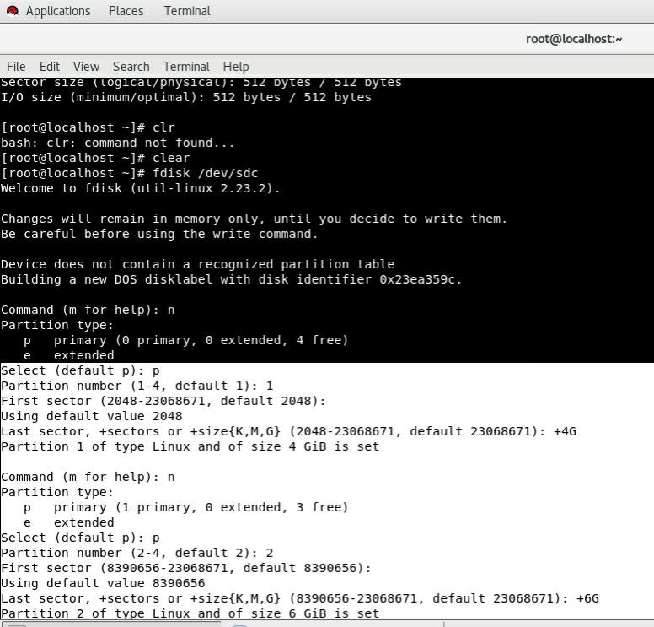**Create 2 Partitions 4GB and 6GB of Space respectively.**
3. **Format 4GB with xfs and 6GB with ext4 file system.**

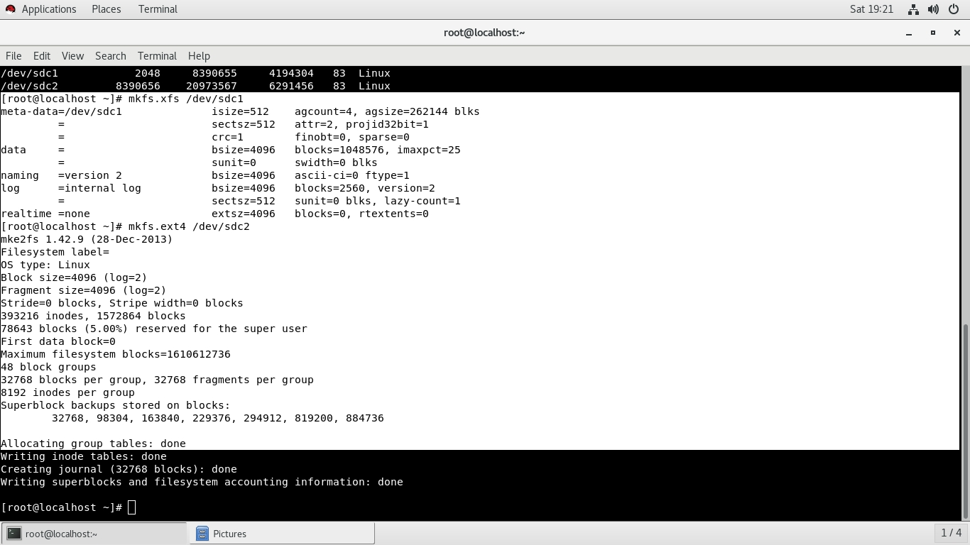

1. **Mount 4GB and 6GB in /data and /music directory respectively.**

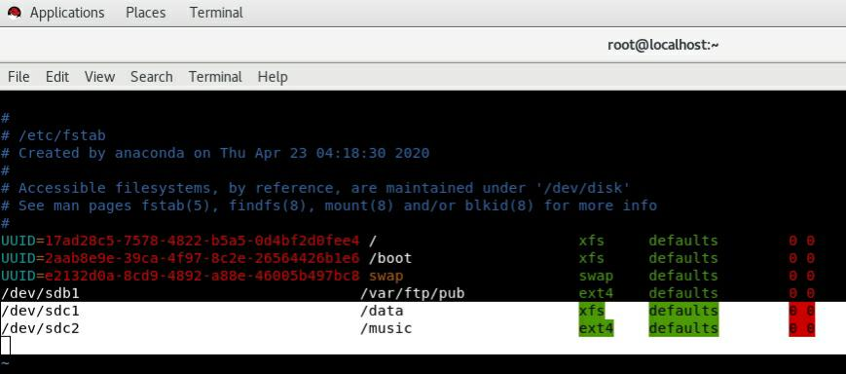

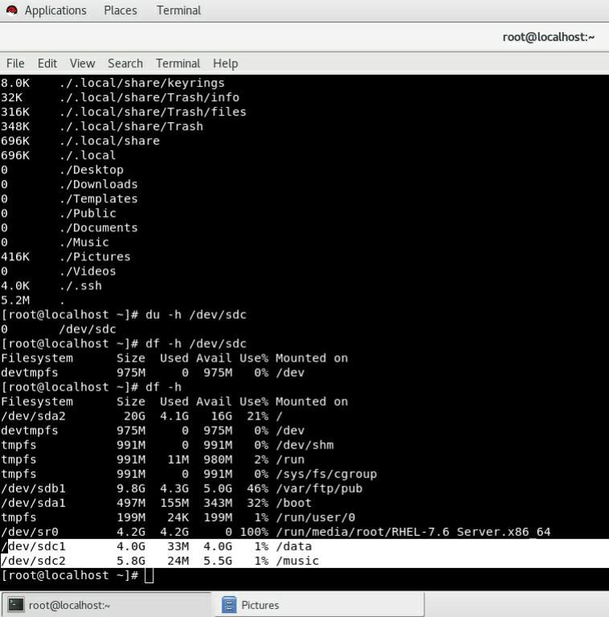

1. **Create one file of 1GB in each of the mount point created above.**

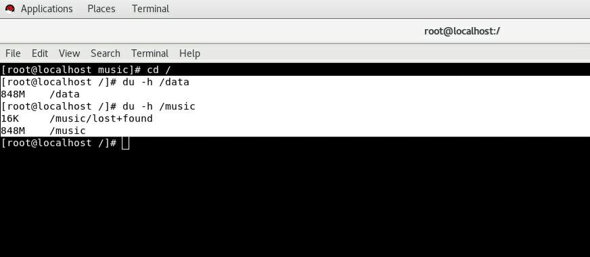

1. **Verify the disk Consumption and disk space free in the mounted partitions.**

