**Project Title : Covid-19 using cognos**

Rajiv.R(a), Gowtham.K(a), Giriprasath.S(a), Harini.A(a), Gurubaran.s(a)

(a)Students, Department of Artificial Intelligence and Data Science,

Nehru Institute of Engineering and Technology, Coimbatore-641105, India.

[Reg.no:721421243044,721421243018,721421243017,721421243020,721421243019]

**PHASE 5: PROJECT DOCUMENTATION AND SUBMISSION**

**Abstract:**

**Project Definition:** The project involves analyzing COVID-19 cases and deaths data using IBM Cognos. The objective is to compare and contrast the mean values and standard deviations of cases and associated deaths per day and by country in the EU/EEA. This project encompasses defining analysis objectives, collecting COVID-19 data, designing relevant visualizations in IBM Cognos, and deriving insights from the data.

**Design Thinking:**

1. Analysis Objectives:

* To specify the objectives of analyzing COVID-19 cases and deaths data, such as comparing mean values and standard deviations and understand the patterns of COVID-19 cases and deaths over time, identifying spikes, declines, and potential outbreaks.

2. Data Collection:

* To obtain the provided data file containing COVID-19 cases and deaths information per day and by country in the EU/EEA.
* This data is then used to generate insights and trends, assess the effectiveness of interventions, and predict future outbreaks.

3. Visualization Strategy:

* To visualize the mean values and standard deviations using IBM Cognos to create informative charts and graphs.
* Interactive dashboards with dynamic visualizations like line charts, heat maps, and geospatial representations to display trends over time and geographic regions of COVID-19 cases.

4. Insights Generation:

* To identify potential insights from the comparison of mean values and standard deviations of cases and deaths.
* These insights aid decision-makers in understanding current scenarios of , predicting future trends, and making informed choices.
* These insights guide policymakers and healthcare professionals in allocating resources, implementing containment strategies, and adjusting public health measures to manage and mitigate the impact of COVID-19 effectively.

**PHASE 2 : INNOVATION**

**STEP 1:** Data Collection and Preprocessing

Collect Covid -19 data which include date,month,year,cases,death,countries and territories and any other relevant data.

* Preprocess the data by handling missing values, encoding categorical variables, and scaling numerical features.
* Split the data into training and testing sets.

**STEP 2:** Model Selection and Development

* We need to choose an appropriate machine learning algorithm for COVID-19 Case Analysis.
* Common choices include logistic regression, decision trees, random forests, support vector machines, or gradient boosting methods like XGBoost or LightGBM.
* If the COVID-19 dataset is large we can use advance technique like neural network.

**STEP 3:** Data Spiting

* Split the data into training, validation, and test sets.
* This allows you to train the model, tune hyperparameters, and evaluate its performance on unseen data.

**STEP 4:** Model Training

* Train the selected machine learning model on the training data.
* Optimize hyperparameters using techniques like grid search or random search.

**STEP 5:** Model Evaluation

* Evaluate the model's performance using appropriate metrics, such as accuracy, precision, recall, F1-score, and ROC AUC.

**STEP 6:** Model Deployment

* Once satisfied with the model's performance, deploy it to your production environment.
* Implement a mechanism to regularly retrain the model as new data becomes available to ensure it remains accurate.

**STEP 7:** Monitor and Action

* Continuously monitor the model's predictions and act on them.
* Covid-19 case and death rate is monitored according to the Countries and Territories which helps to get valuable insight to take valuable decision

**STEP 8:** Documentation and Training

* Describe the problem and the goal of the COVID-19 Case Analysis
* Explain the data sources and features used in the model.
* Document the machine learning algorithm and its parameters.
* Describe the model evaluation metrics and results.
* Prepare the data by cleaning, preprocessing, and engineering features.
* Train the machine learning model using the prepared data.
* Evaluate the trained model on a holdout test set.
* Deploy the trained model to production to predict COVID-19 case for newly affected people.

**PHASE 3& 4 : DEVELOPMENT PART 1**

**DEVELOPMENT PART 2**

**INTRODUCTION:**

The project involves analyzing COVID-19 cases and deaths data using IBM Cognos. The objective is to compare and contrast the mean values and standard deviations of cases and associated deaths per day and by country in the EU/EEA. This project encompasses defining analysis objectives, collecting COVID-19 data, designing relevant visualizations in IBM Cognos, and deriving insights from the data.

**Data Collection and Preprocessing**

Collect Covid -19 data which include date,month,year,cases,death,countries and territories and any other relevant data.

* Preprocess the data by handling missing values, encoding categorical variables, and scaling numerical features.
* Split the data into training and testing sets.
* **Importing Libraries**

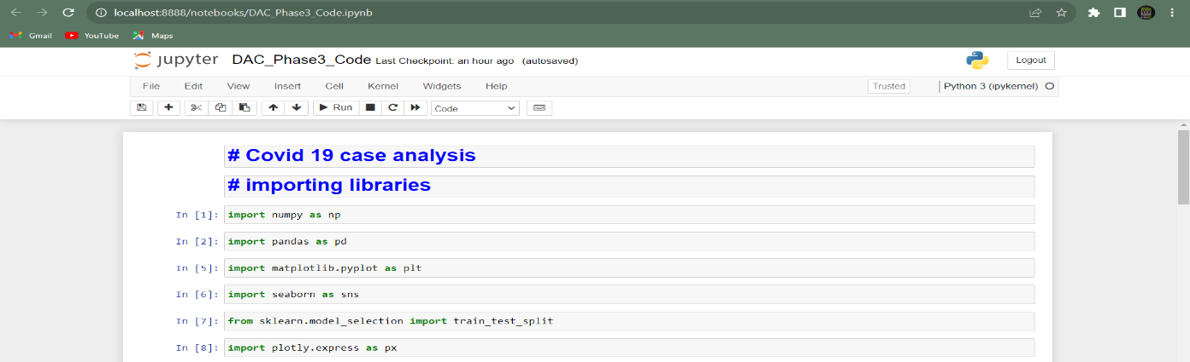

* **Importing COVID-19 Case DataSet**

**DataSet - https://www.kaggle.com/datasets/chakradharmattapalli/covid-19-cases**

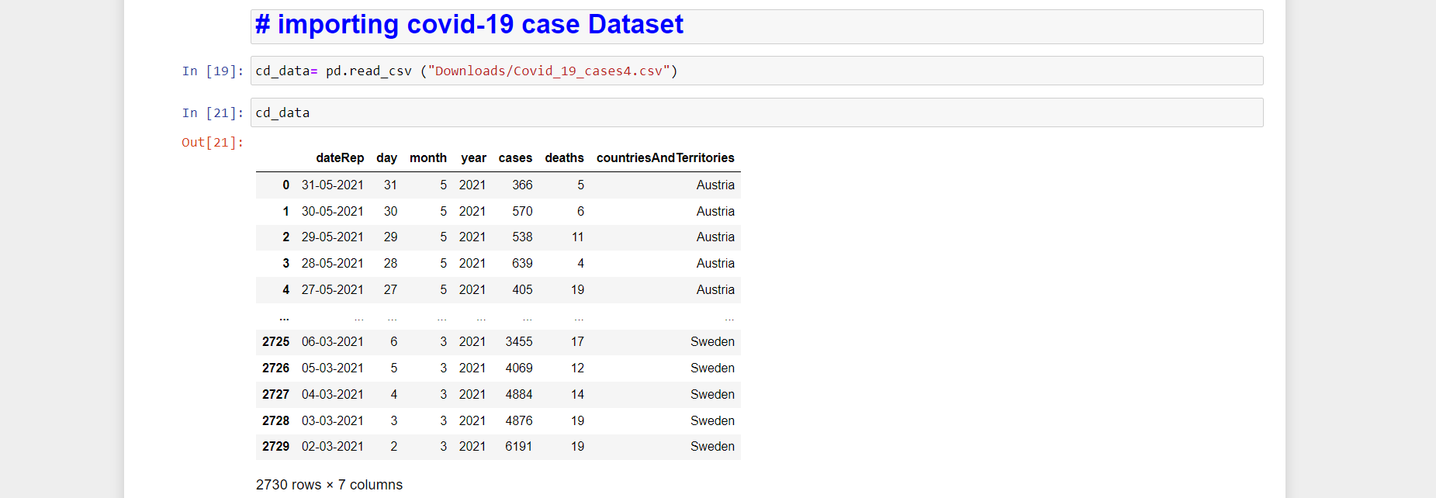

**Data Preprocessing**

* **Head , Tail and Shape of the data**

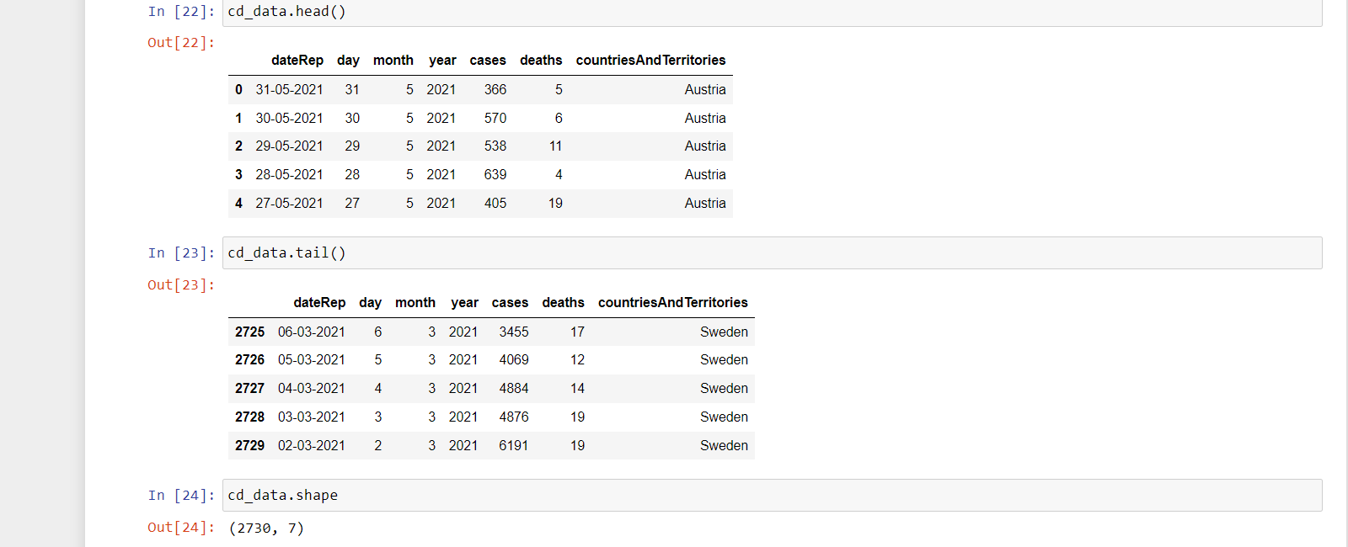

* **Describe and Information of the data**

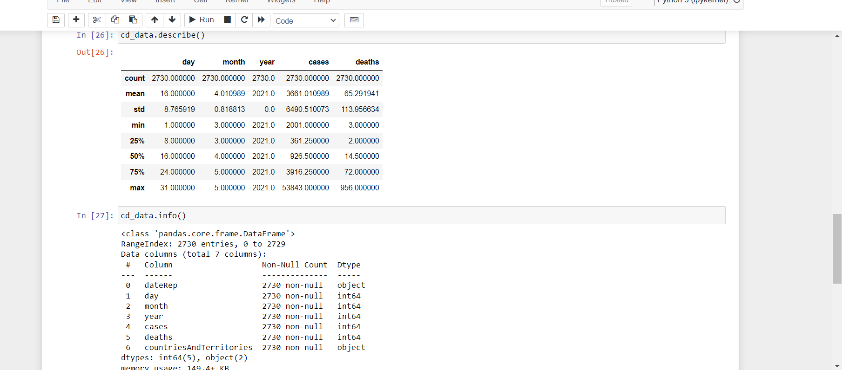

* **Null Values and Duplicates**

The dataset does not contain duplicates and missing values.

The data are split into **train and test dataset** for further development.

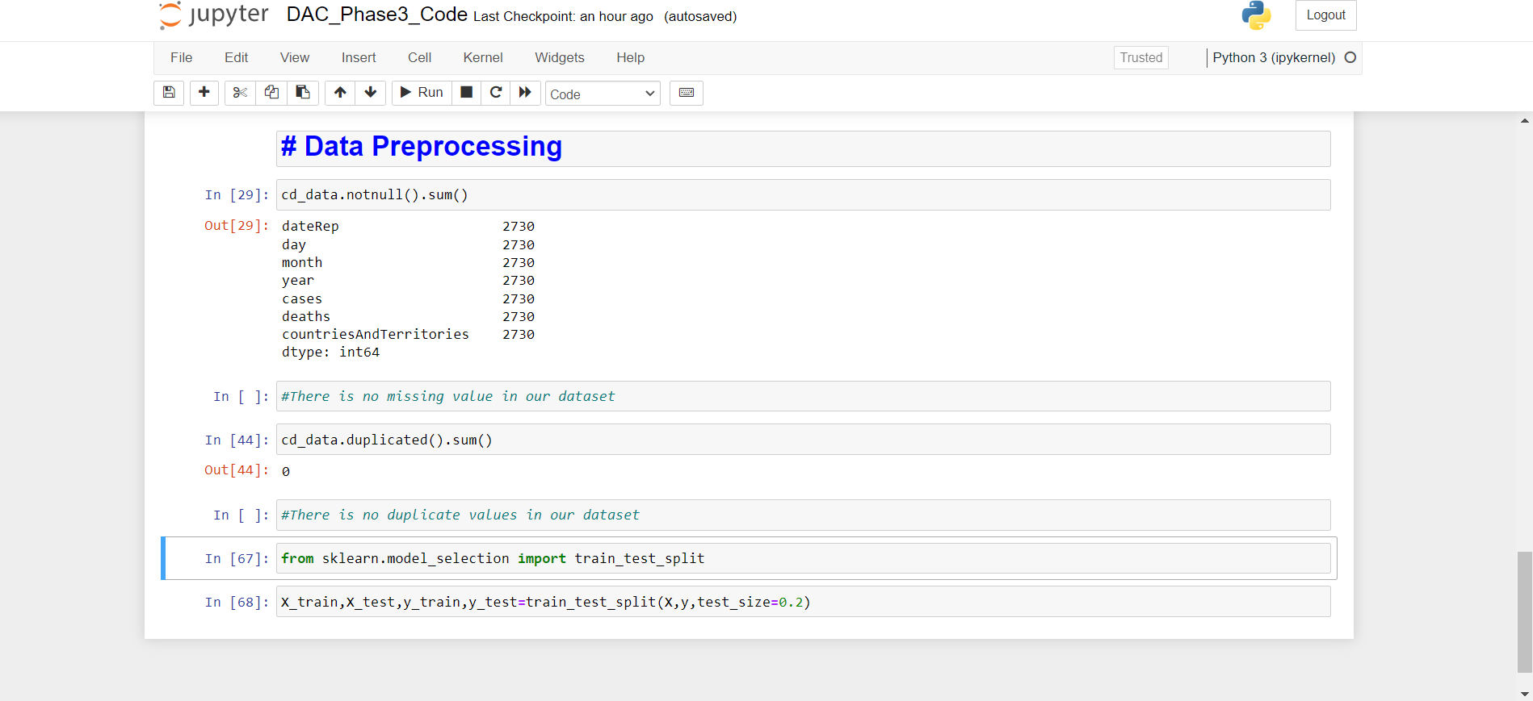

* **Data Visualization**

Creating a data visualization for COVID-19 case analysis typically involves plotting various aspects of the data to provide insights into the spread of the virus.

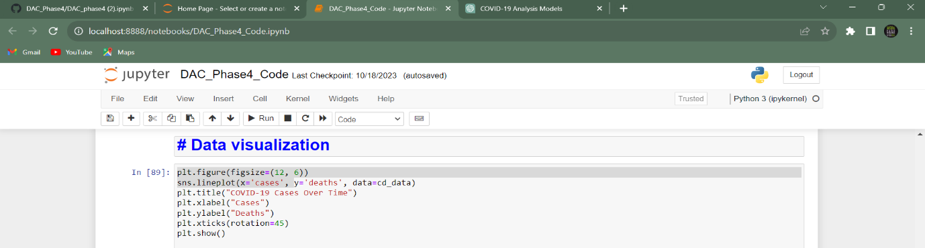

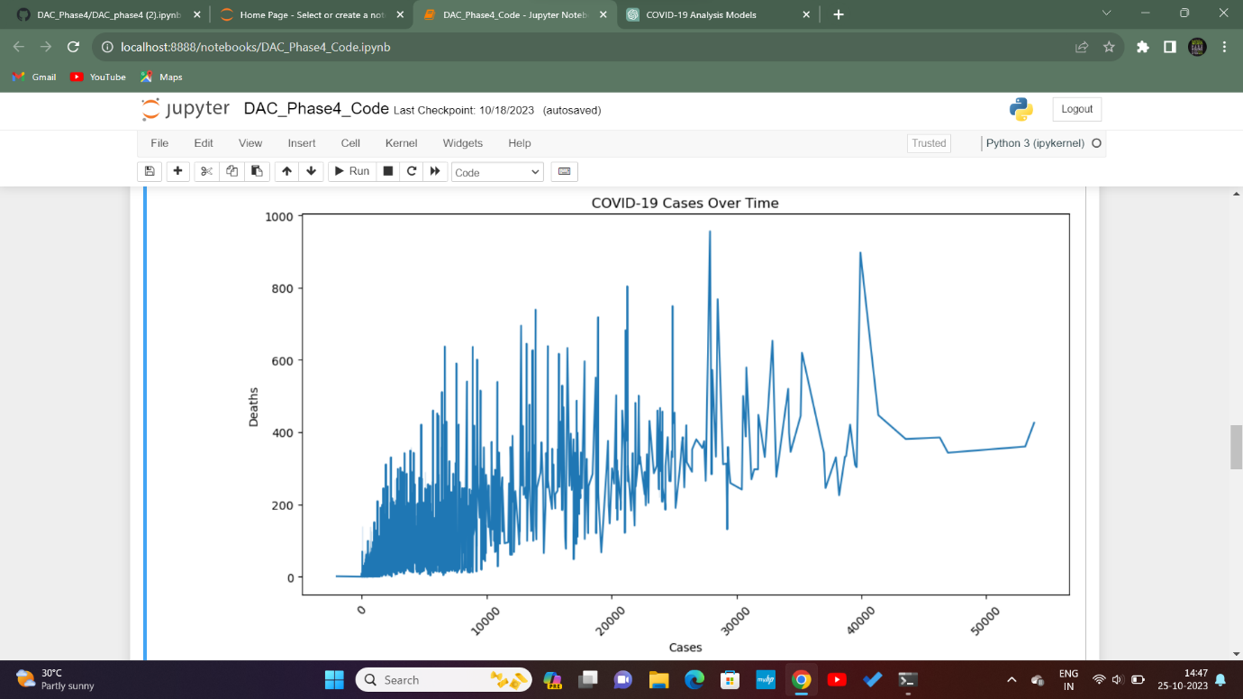

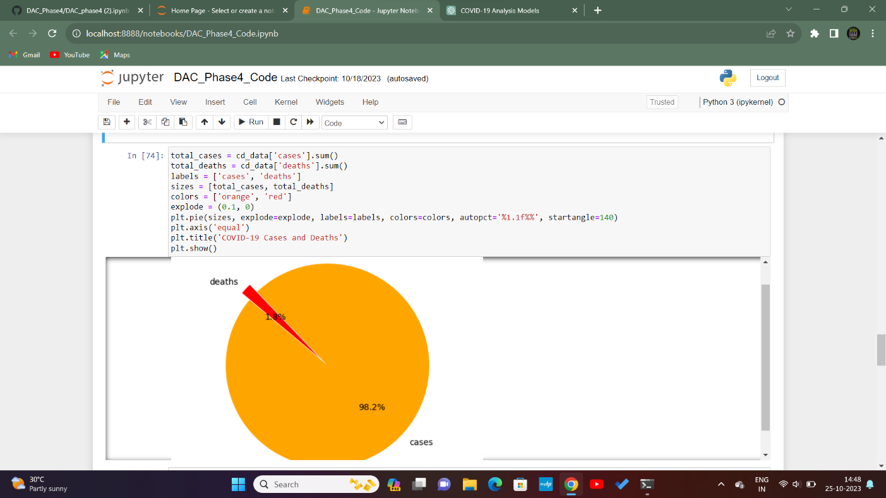

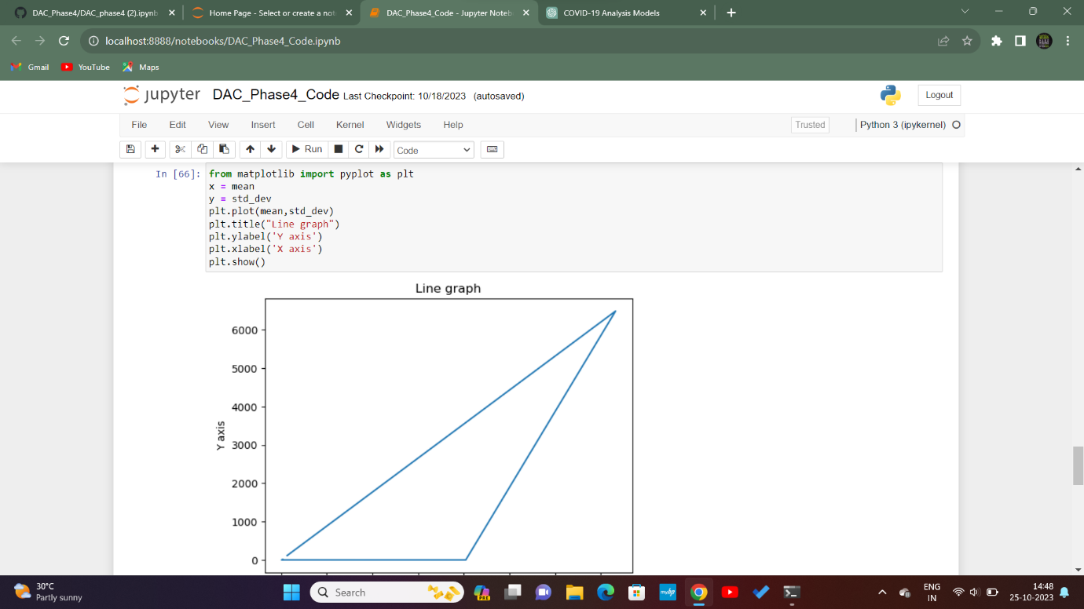

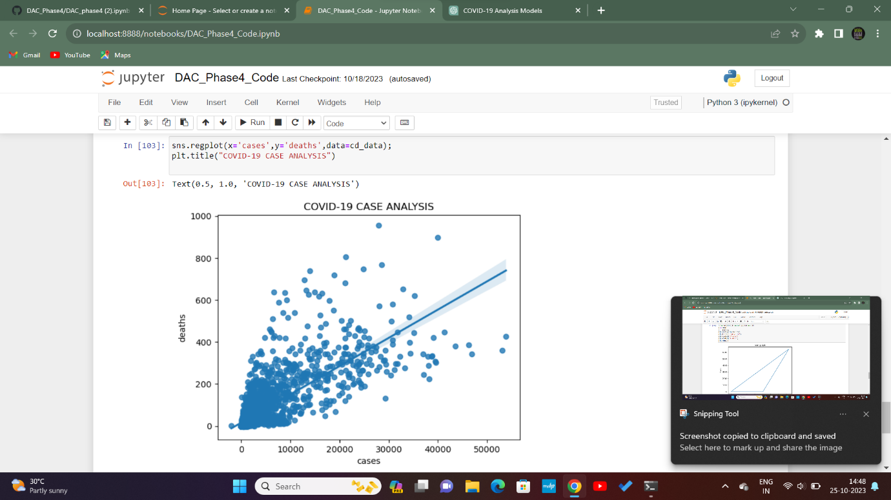

* **Model Selection**

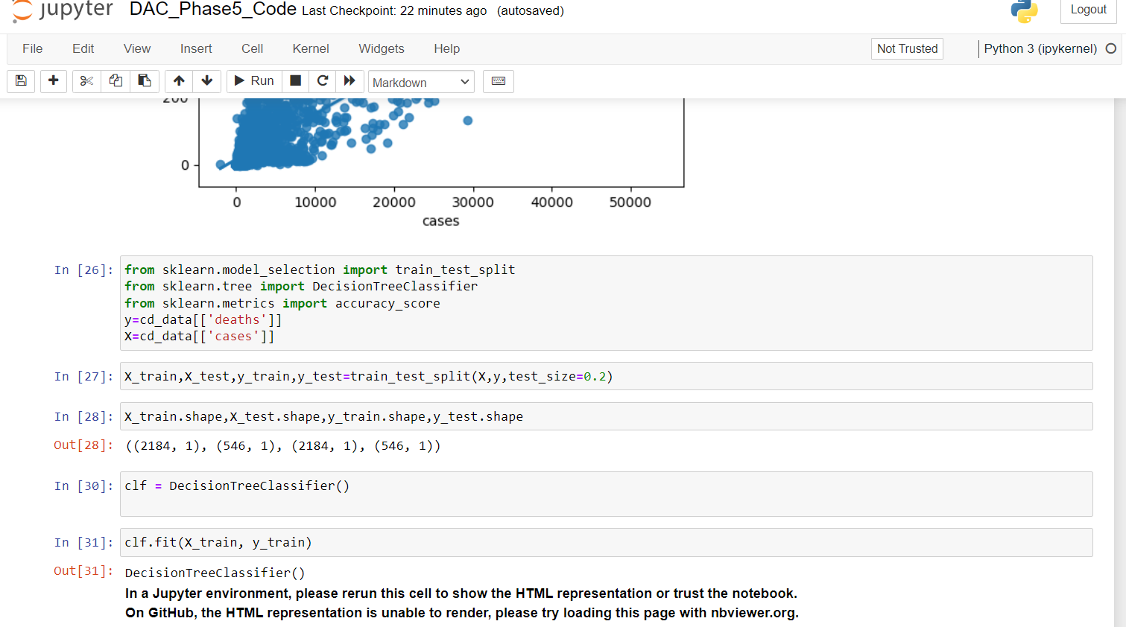

* **Model Evaluation**

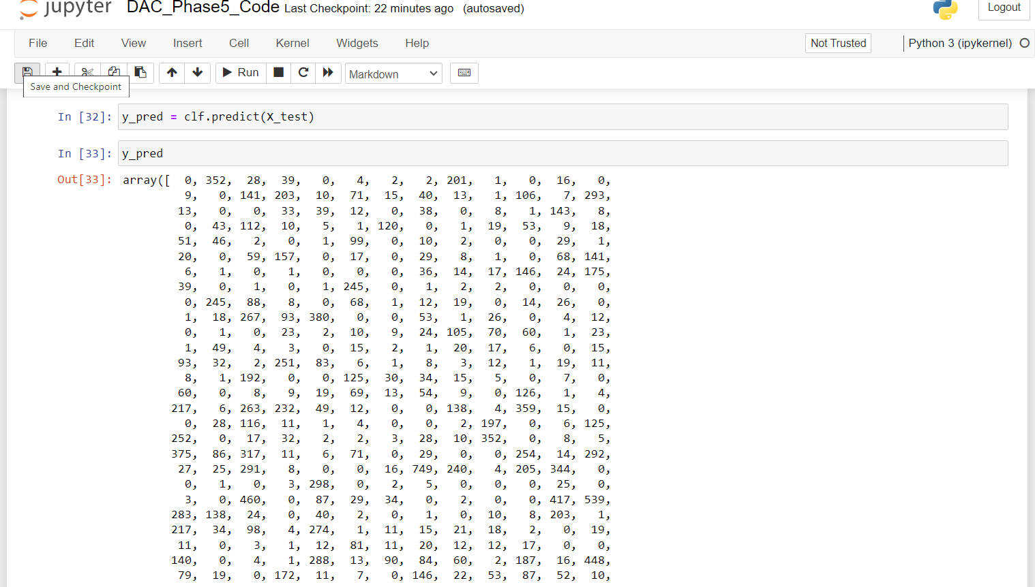

* **Accuracy**

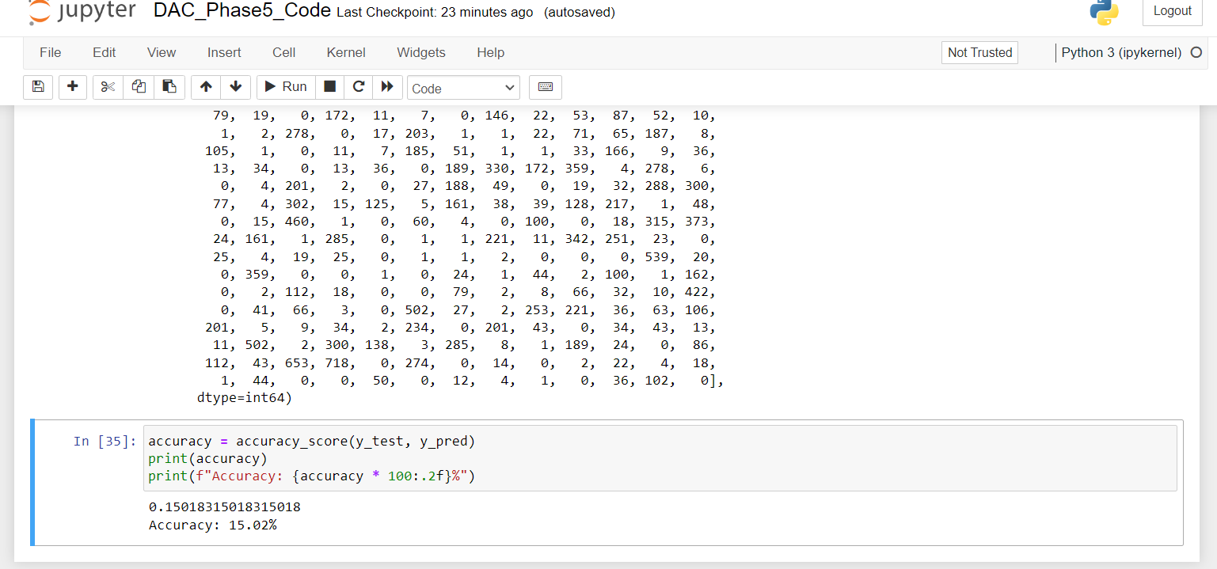

**CONCLUSION:**

COVID-19 Case Analysis insights aid decision-makers in understanding current scenarios of predicting future trends, and making informed choices .These insights guide healthcare professionals in allocating resources, implementing containment strategies, and adjusting public health measures to manage and mitigate the impact of COVID-19 effectively.