PROJECT REPORT
FOR
WEB PROGRAMMING (CS23531)
AI HOSPITAL GUIDE – TAMIL NADU GOVERNMENT HOSPITAL
A PROJECT REPORT
Submitted by
2116240701826 – GOWTHAM KUMAR PS


November, 2026

BONAFIDE CERTIFICATE
Certified that this project report “AI HOSPITAL GUIDE – TAMIL NADU GOVERNMENT HOSPITAL, TIRUVANNAMALAI” is the bonafide work of “GOWTHAM KUMAR PS (REGISTER NO: 2116240701826) awho carried out the project work under my supervision.
SIGNATURE OF THE FACULTY INCHARGE
Submitted for the Practical Examination held on ________________
SIGNATURE OF THE INTERNAL EXAMINER

TABLE OF CONTENTS
CHAPTER NO. TITLE PAGE NO.
ABSTRACT 1
1 INTRODUCTION 2
2 LITERATURE REVIEW 3
3 PROPOSED SYSTEM 4
3.1 ARCHITECTURE DIAGRAM 4
4 MODULES DESCRIPTION 5
4.1 RULE-BASED MAPPING MODULE 5
4.2 PATIENT MODULE 5
4.3 DOCTOR MODULE 6
4.4 MANAGEMENT MODULE 6
4.5 MULTILINGUAL AND VOICE MODULE 6
4.6 BACKEND AND SECURITY MODULE 6
5 IMPLEMENTATION AND RESULTS 8
5.1 EXPERIMENTAL SETUP 8
5.2 RESULTS 8
6 CONCLUSION AND FUTURE WORK 10
7 REFERENCES 11

ABSTRACT
Patients visiting a large government hospital often do not know which department, block or room they should go to, and the information is usually available in only one language. This project presents the AI Hospital Guide for Tamil Nadu Government Hospital, Tiruvannamalai, a web application that guides patients and supports hospital staff. A rule-based artificial intelligence component, built as a production-rule expert system, maps the health issue chosen by the patient to the correct hospital department using fixed IF–THEN rules. The system does not use machine learning and does not diagnose any disease. It provides three role-based workflows: Patient, Doctor and Management. Patients can view their profile, latest checkup, medicines and previous visits and can print an A4 receipt. Doctors can search patients and record checkups with prescriptions. Management can register, edit and remove doctors and add patient details. The interface is available in English, Tamil and Telugu. The application is implemented with HTML, CSS and JavaScript on the front end and a Node.js REST API with an SQLite database on the back end, so that the data is stored centrally and can be used from several devices. The system was verified with 49 automated API tests and a browser end-to-end test.
1. INTRODUCTION
1.1 Background
Government hospitals serve a very large number of patients every day. Many patients, especially first-time visitors, do not know which department to approach for their problem and which block of the hospital it is in. This causes confusion at the reception, longer waiting time and extra work for the hospital staff. Patient details and prescriptions are often kept on paper, which can be lost.
1.2 Artificial Intelligence in this project
Artificial Intelligence includes knowledge-based systems that apply expert knowledge stored as explicit rules. A rule-based expert system keeps its knowledge in a knowledge base of IF–THEN production rules and uses an inference procedure to match the facts of a case against those rules. This project uses exactly this classical, symbolic approach. The rule table is written by the developers; the system does not learn from data. It behaves as a simple reflex agent: for a given percept (the health issue selected by the patient) it applies the matching condition–action rule and returns the department. The same input always gives the same output, which makes the decision transparent and easy to explain.
1.3 Objectives
- To guide a patient from a selected health issue to the correct hospital department using a rule-based AI knowledge base.
- To provide separate, secure workflows for patients, doctors and Management.
- To store patient, doctor, visit and medicine records in a shared SQL database instead of on paper.
- To make the application usable in English, Tamil and Telugu.
- To let a patient view the latest checkup and medicines and print an A4 receipt.
1.4 Scope and limitations
The system helps with guidance and record keeping only. It does not diagnose diseases, does not recommend treatment and does not replace a doctor. The department rules are fixed, and patient login uses the mobile number only (no OTP).
2. LITERATURE REVIEW
MYCIN. Shortliffe (1976) described MYCIN, one of the earliest medical expert systems, in which clinical knowledge was written as production rules. It showed that IF–THEN rules can represent expert knowledge in a form that can be inspected and explained. The present project uses the same rule idea, but only for choosing a department and not for diagnosis or therapy.
INTERNIST-1. Miller, Pople and Myers (1982) presented INTERNIST-1, a knowledge-base driven computer system to assist diagnosis in internal medicine. Such systems demonstrated that a structured knowledge base can support decisions in healthcare, while the final responsibility remains with the physician. In our system also, the doctor takes the final decision.
Rule-based expert systems. Buchanan and Shortliffe (1984) discuss the design of rule-based expert systems, including the knowledge base, the inference engine and explanation of results. These ideas guide the structure of the department-mapping module.
Intelligent agents. Russell and Norvig (2021) define the simple reflex agent, which selects an action from the current percept using condition–action rules, and describe knowledge-based agents. The department mapping in this project is a simple reflex agent.
Web architecture. Fielding (2000) introduced the REST architectural style that is followed by the API of this project. The Node.js and SQLite documentation describe the platform and the embedded database used for the implementation.
Gap identified. Large hospital information systems exist, but a simple multilingual guide in English, Tamil and Telugu that combines department guidance, role-based access and a printable visit receipt for a single government hospital is not commonly available. This project addresses that gap at a small scale.
3. PROPOSED SYSTEM
The proposed system is a single-page web application served by a Node.js server. Users open the site in a browser, choose a language and log in as Patient, Doctor or Management. Every action is sent to the server as a JSON request. The server checks the session token and the role, validates the data, applies the rule-based department mapping where required and reads or writes the SQLite database. The response is returned as JSON and displayed by the browser.
The main features of the proposed system are as follows.
- Rule-based AI: selected health issue is mapped to a department by 15 production rules over 11 departments.
- Role-based access: Patient, Doctor and Management have separate logins and permissions that are checked on the server.
- Central database: all records are stored in SQLite so that several devices see the same data.
- Multilingual interface: English, Tamil and Telugu text with a voice welcome message on the language page.
- Printable receipt: an A4 receipt with patient, doctor and medicine details.
3.1 ARCHITECTURE DIAGRAM
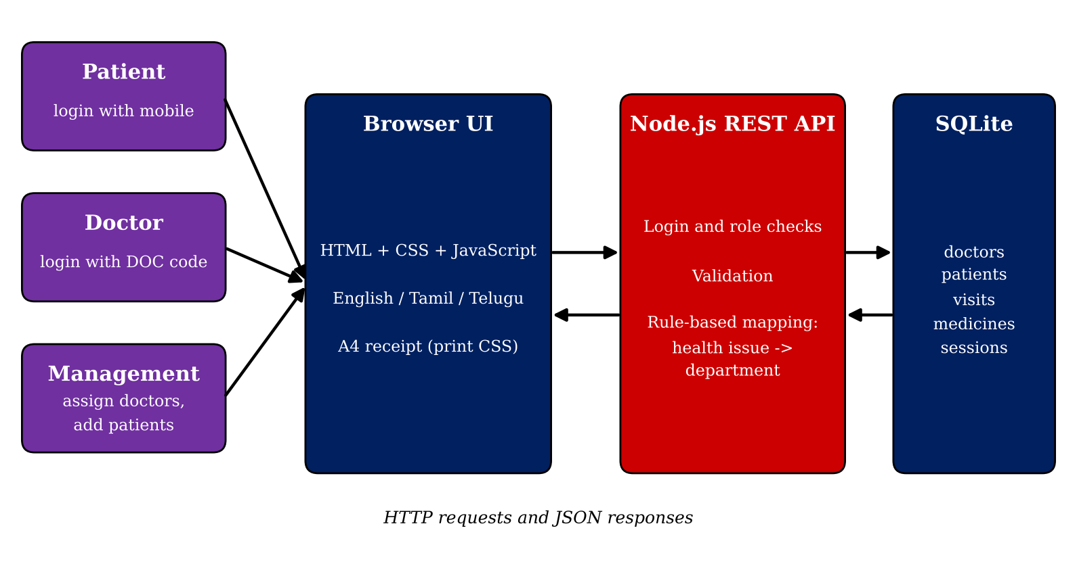
Figure 3.1 Architecture of the AI Hospital Guide
The system has three layers. The presentation layer is the browser interface. The application layer is the Node.js REST API, which contains the login and role checks, the validation and the rule-based mapping. The data layer is the SQLite database with the tables doctors, patients, visits, medicines and sessions.
4. MODULES DESCRIPTION
4.1 RULE-BASED MAPPING MODULE
This is the artificial intelligence module. The knowledge base is a table of production rules of the form IF health issue = X THEN department = Y. When a patient is registered or a doctor assigns a department, the selected health issue is matched with the rule table and the department is returned. The server also verifies that the issue and department are valid before saving. Table 4.1 lists the rules.
Table 4.1 Knowledge base: health issue to department rules
Rule | Health issue (IF) | Department (THEN)
1 | Fever | General Medicine
2 | Cold / Cough | General Medicine
3 | Heart Problem | Cardiology
4 | Diabetes | Diabetology
5 | Blood Pressure | Cardiology
6 | Stomach Problem | Gastroenterology
7 | Bone / Joint Pain | Orthopedic
8 | Skin Problem | Dermatology
9 | Eye Problem | Ophthalmology
10 | Ear, Nose and Throat (ENT) | ENT
11 | Dental Problem | Dental
12 | Child Fever | Pediatrics
13 | General Checkup | General Medicine
14 | Corona Patient | Infectious Disease
15 | Other | General Medicine

For each department the hospital has one or more blocks with numbered rooms, for example General Medicine Block (GM-101 to GM-104) and Cardiology Block (CARD-201 to CARD-204). The hospital has 12 blocks in the system. At the time of a checkup the doctor selects the block and the room from these lists.
4.2 PATIENT MODULE
A registered patient logs in with the mobile number. The dashboard shows the patient information (name, mobile number, age, health issue and department), the latest checkup (date, time, doctor name and notes), the latest medicines in a table (medicine, dosage, when to take, how often and duration), the next visit details with block and room, and the previous visits. The patient can print an A4 receipt of the visit.
4.3 DOCTOR MODULE
A doctor logs in with the mobile number and the doctor code. The code is generated automatically as DOC followed by the last three digits of the mobile number. The doctor can search a patient by mobile number, view the history, and fill the checkup form with notes, medicines, next-visit details, block and room. The checkup date and time are taken from the server in Indian Standard Time. A short guard prevents the same checkup from being saved twice by a double click.
4.4 MANAGEMENT MODULE
Management logs in with the fixed management credentials that are set on the server. The dashboard has two functions: Assign Doctor and Add Patient Details. Under Assign Doctor, Management can register a new doctor, edit the details of an existing doctor and remove a doctor. Under Add Patient Details, Management can register a patient with age, health issue, department and old visit details, and can remove a patient record. The Management number can also be used in the Doctor Login.
4.5 MULTILINGUAL AND VOICE MODULE
All labels, messages and error texts are stored in a dictionary for English, Tamil and Telugu, and the page is redrawn when the language is changed. Tamil and Telugu text is shown in the proper script. The language page shows a Vanakkam greeting and plays a voice announcement using the speech feature that is built into the web browser. This is not an AI model of the project. The front page also has an animated background slideshow of hospital photographs and the college logo.
4.6 BACKEND AND SECURITY MODULE
The backend is a Node.js server that uses only built-in modules (node:http and node:sqlite) and has no external dependency. It offers REST routes for login, logout, doctors, patients and checkups. After a successful login the server creates a random session token that is valid for 12 hours and stored in the sessions table. Every protected route checks the token and the role. Login attempts are limited to 15 failures in 10 minutes for each address. All inputs are validated on the server (10-digit mobile number, age from 1 to 120, valid issue and department). Foreign keys with cascade delete remove the visits and medicines of a deleted patient. Table 4.2 shows the database tables.
Table 4.2 Database tables
Table | Purpose and main columns
doctors | mobile (primary key), name, health issue, department, code
patients | mobile (primary key), name, age, health issue, department, first doctor
visits | patient mobile, source (Management or Doctor), date, time, doctor, issue, department, notes, next visit, block, room
medicines | visit, medicine name, dosage, when to take, frequency, duration
sessions | token, role, mobile, name, expiry time
5. IMPLEMENTATION AND RESULTS
5.1 EXPERIMENTAL SETUP
The project was developed and run on a Windows personal computer. The server was started with Node.js version 24 (version 22.13 or later is required for node:sqlite) using the command node server.js, and the application was opened in the Google Chrome browser at http://localhost:3000. The SQLite database is stored in the file hospital.db. Table 5.1 summarises the setup.
Table 5.1 Experimental setup
Item | Details
Operating system | Windows personal computer
Server | Node.js (node:http), port 3000
Database | SQLite (node:sqlite), file hospital.db
Front end | HTML, CSS and JavaScript (single file)
Browser | Google Chrome
Languages | English, Tamil, Telugu
Testing | Node.js API tests and a browser end-to-end run
5.2 RESULTS
The system was tested for correct working. No accuracy percentage is reported because the department mapping is a fixed rule table and not a trained model. The results are as follows.
- API tests: 49 automated tests of the REST API were run and all of them passed.
- End-to-end test: a browser test covered the patient, doctor and Management workflows and passed.
- Data persistence: after closing the server and starting it again from the same folder, the stored doctors, patients and visits were shown again.
- Department mapping: each of the 15 health issues returned the department given in Table 4.1.
- Receipt: the patient receipt printed on an A4 page with patient, doctor and medicine details.
Figure 5.1 shows the patient dashboard in English with the patient information, the latest checkup and the latest medicine.
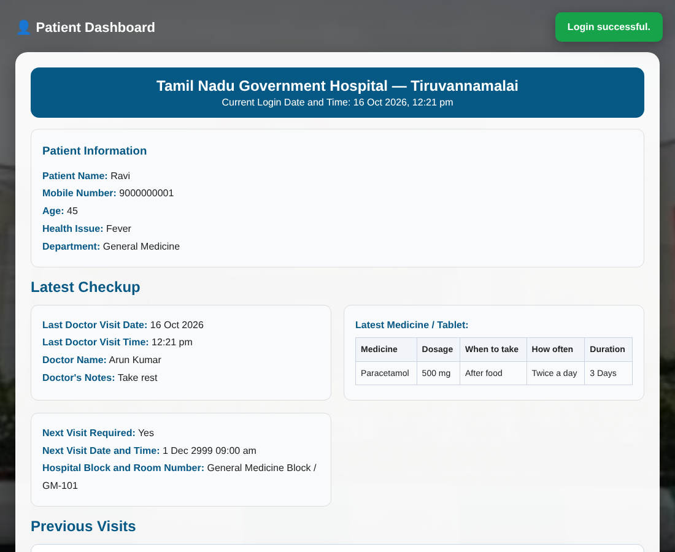
Figure 5.1 Patient dashboard
Discussion
The rule-based approach makes the result predictable and easy to explain to the hospital staff, and it needs no training data. Its limitation is that new health issues or departments must be added to the rule table by a developer. Currently the site runs only while the server is running on the host computer; a permanent public link needs hosting with a persistent disk. Patient login by mobile number alone is suitable for a demonstration but needs an OTP before real patient data is used. The doctor codes follow a fixed pattern, so they should be replaced by stronger credentials for real use.
6. CONCLUSION AND FUTURE WORK
The AI Hospital Guide is a working multilingual web application for Tamil Nadu Government Hospital, Tiruvannamalai. A transparent rule-based expert system maps a health issue to a department, and three role-based workflows let patients, doctors and Management handle records in a shared SQLite database. The system was verified by 49 automated API tests and a browser end-to-end run. It is a guidance and record-keeping tool and does not diagnose diseases.
The following improvements are planned as future work.
- OTP-based login for patients and stronger credentials for doctors.
- Appointment booking and a doctor schedule.
- More health issues, departments and rules, with an editable rule table for Management.
- Hosting on a cloud server with a persistent disk to give a permanent link.
- Optional use of machine learning for symptom-based suggestions, only after proper medical validation.
7. REFERENCES

Buchanan, B. G. and Shortliffe, E. H. (1984) Rule-Based Expert Systems: The MYCIN Experiments of the Stanford Heuristic Programming Project, Addison-Wesley, Reading, MA.
Fielding, R. T. (2000) Architectural Styles and the Design of Network-based Software Architectures, Doctoral dissertation, University of California, Irvine.
Miller, R. A., Pople, H. E. and Myers, J. D. (1982) ‘Internist-1, an experimental computer-based diagnostic consultant for general internal medicine’, New England Journal of Medicine, Vol.307, No.8, pp.468-476.
Node.js Foundation (2025) Node.js Documentation, node:http and node:sqlite modules, https://nodejs.org/docs.
Russell, S. and Norvig, P. (2021) Artificial Intelligence: A Modern Approach, 4th edition, Pearson.
Shortliffe, E. H. (1976) Computer-Based Medical Consultations: MYCIN, Elsevier, New York.
SQLite Consortium (2025) SQLite Documentation, https://www.sqlite.org/docs.html.

