Name:GOWTHAM [24MCR028]
Class: I – MCA – “A”
TASK - 1
DEVOPS TRAINING

Step 1: (Installing Ubuntu)
Enable WSL
Before installing Ubuntu, ensure that WSL is enabled on your Windows system.
Enable WSL Feature
1. Open PowerShell as Administrator and run:
2. wsl –install

Step 2: (Set New Password) Set Up Ubuntu
When Ubuntu runs for the first time, it will ask you to create a new user account.
1. Enter a username (must start with a lowercase letter or underscore, and contain only lowercase letters, digits, underscores, and dashes).
2. Set a password (enter and confirm the password). If passwords do not match, you will need to retry.
3. Once successful, Ubuntu will be set up and ready to use.

Step 3:
(New WSL Window Will Open)

Step 4:
(Check JDK Version) If not available install it .
Install Jenkins on Ubuntu
# Update package lists
sudo apt update -y
# Install Java (Required for Jenkins) sudo apt install -y openjdk-17-jdk
#verify java version java -version
Add Jenkins GPG Key
wget -q -O- https://pkg.jenkins.io/debian-stable/jenkins.io-2023.key | sudo tee /usr/share/keyrings/jenkins- keyring.asc > /dev/null
Add the Jenkins Repository
echo "deb [signed-by=/usr/share/keyrings/jenkins-keyring.asc] https://pkg.jenkins.io/debian-stable binary/" | sudo tee /etc/apt/sources.list.d/jenkins.list > /dev/null
# Install Jenkins
sudo apt update -y
sudo apt install -y jenkins
# Start and enable Jenkins service sudo systemctl start Jenkins

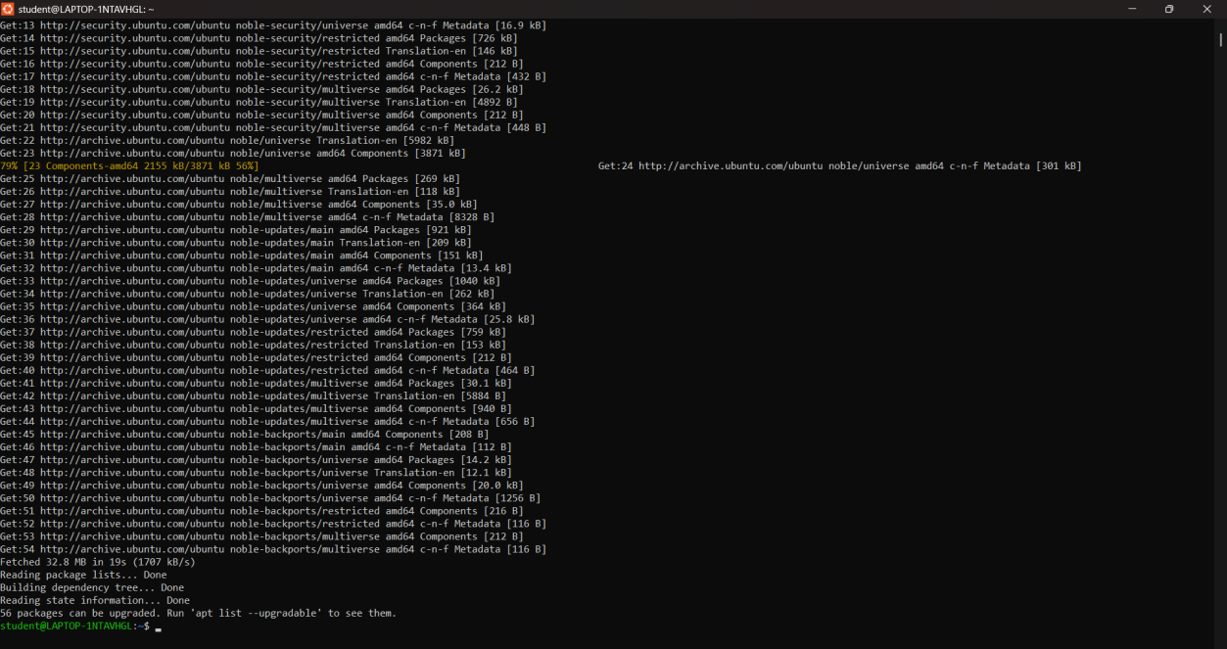

Step 5: Install Jenkins
sudo apt update -y
sudo apt install -y jenkins

Step 6: Check Jenkins Status
sudo systemctl status jenkins
cat copy the localhost:8080 admin path
display the password
=>By default, Jenkins runs as a system user (jenkins). If your script requires sudo, you must allow the Jenkins user to run commands without a password.
sudo visudo
Add the following line at the end:
jenkins ALL=(ALL) NOPASSWD: ALL
Save and exit.
Step 7: (Enter the Administrator Password)
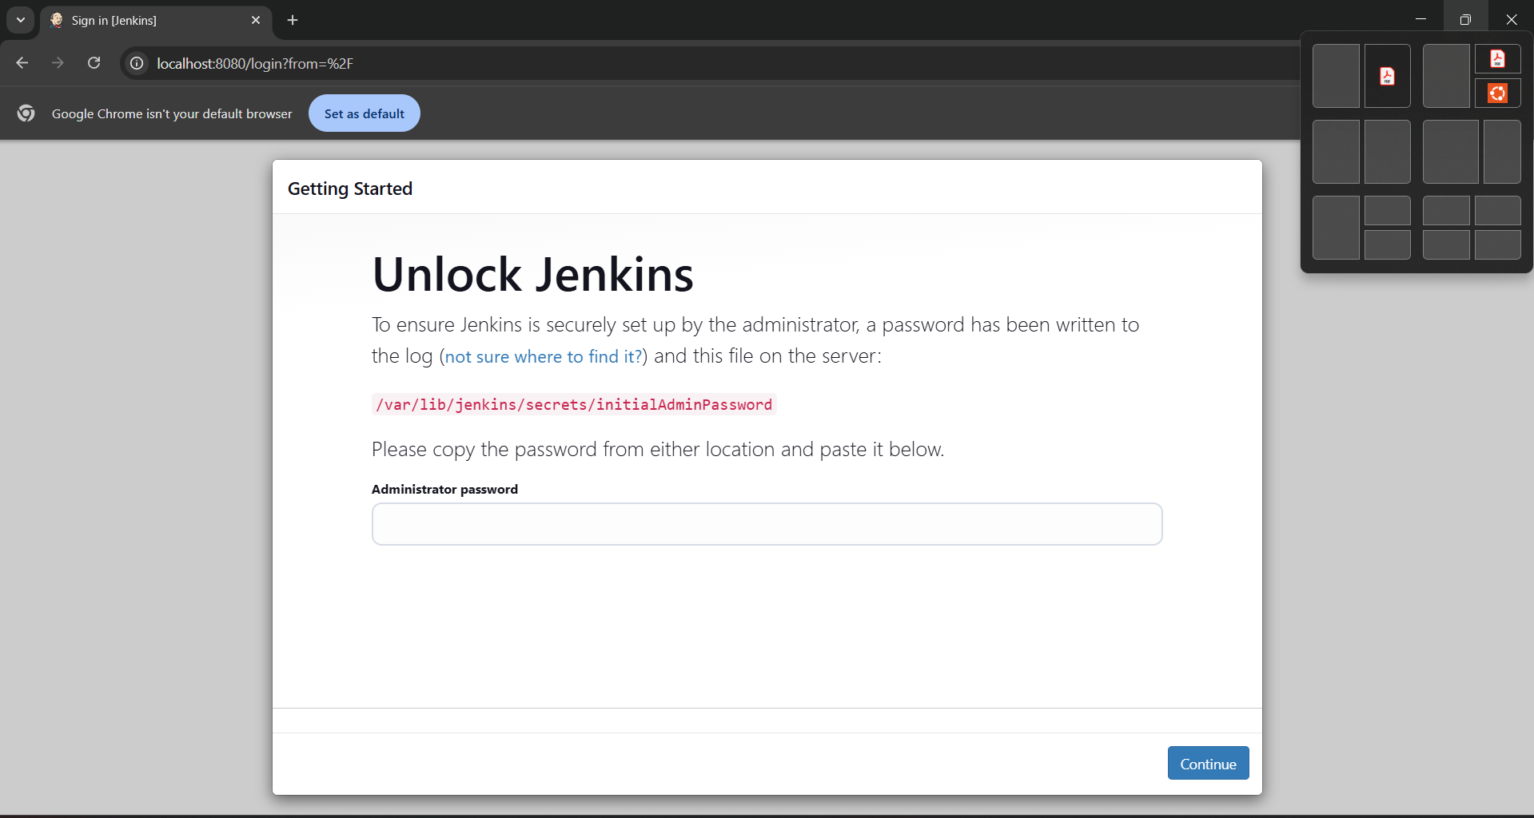

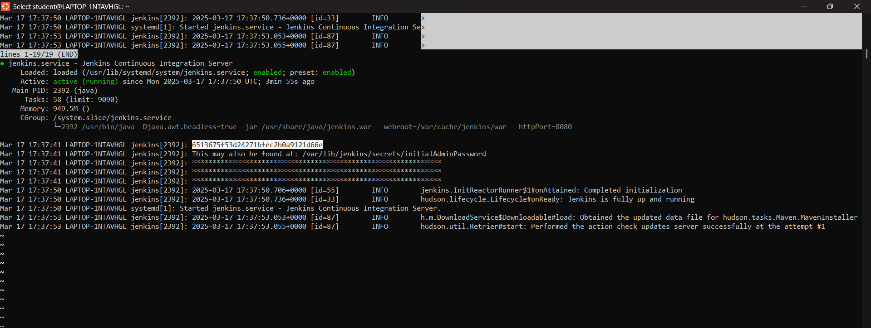

Step 8: Access Jenkins Web Interface
Jenkins will be available at http://localhost:8080
To Get the Jenkins Server URL, Follow These Steps:
Method 1: Check the Default URL
By default, Jenkins runs on port 8080. Open in a browser:
http://<your-server-ip>:8080
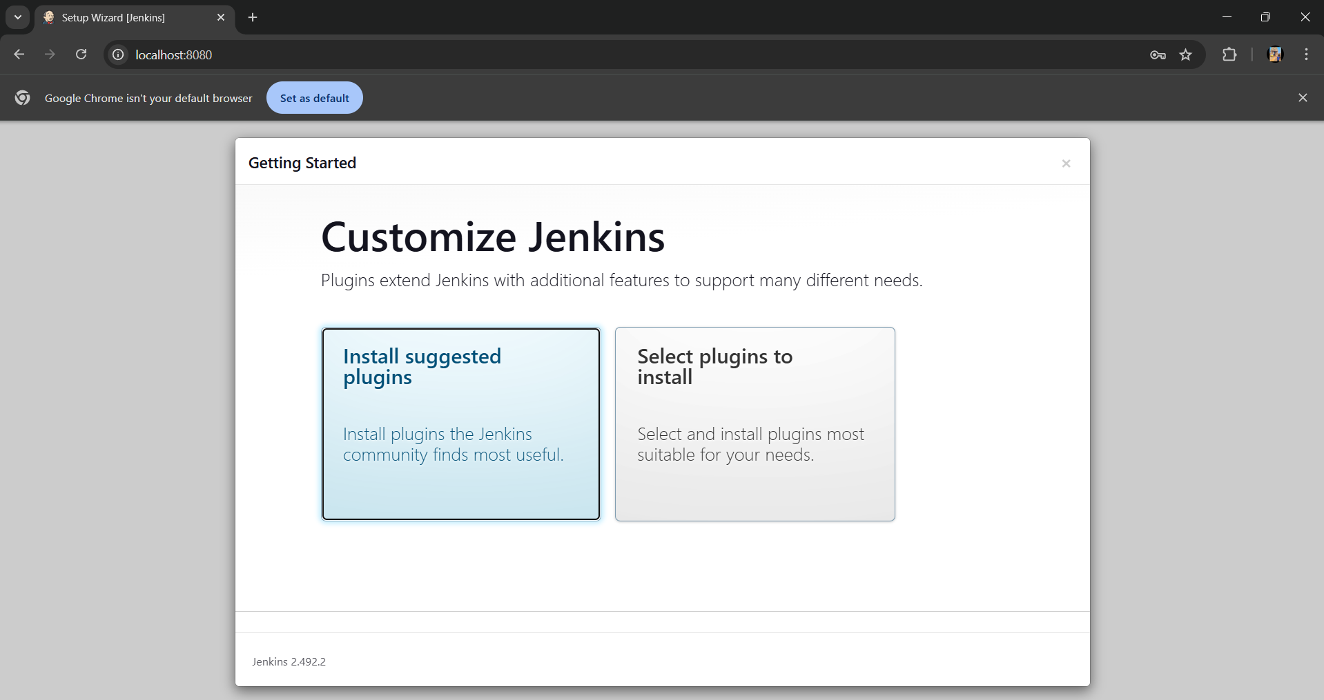

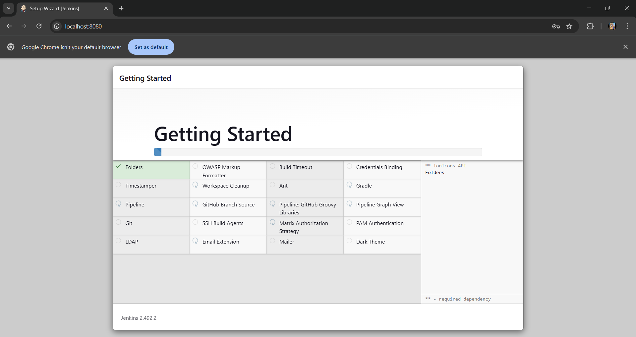

Step 9: (Create First Admin User)
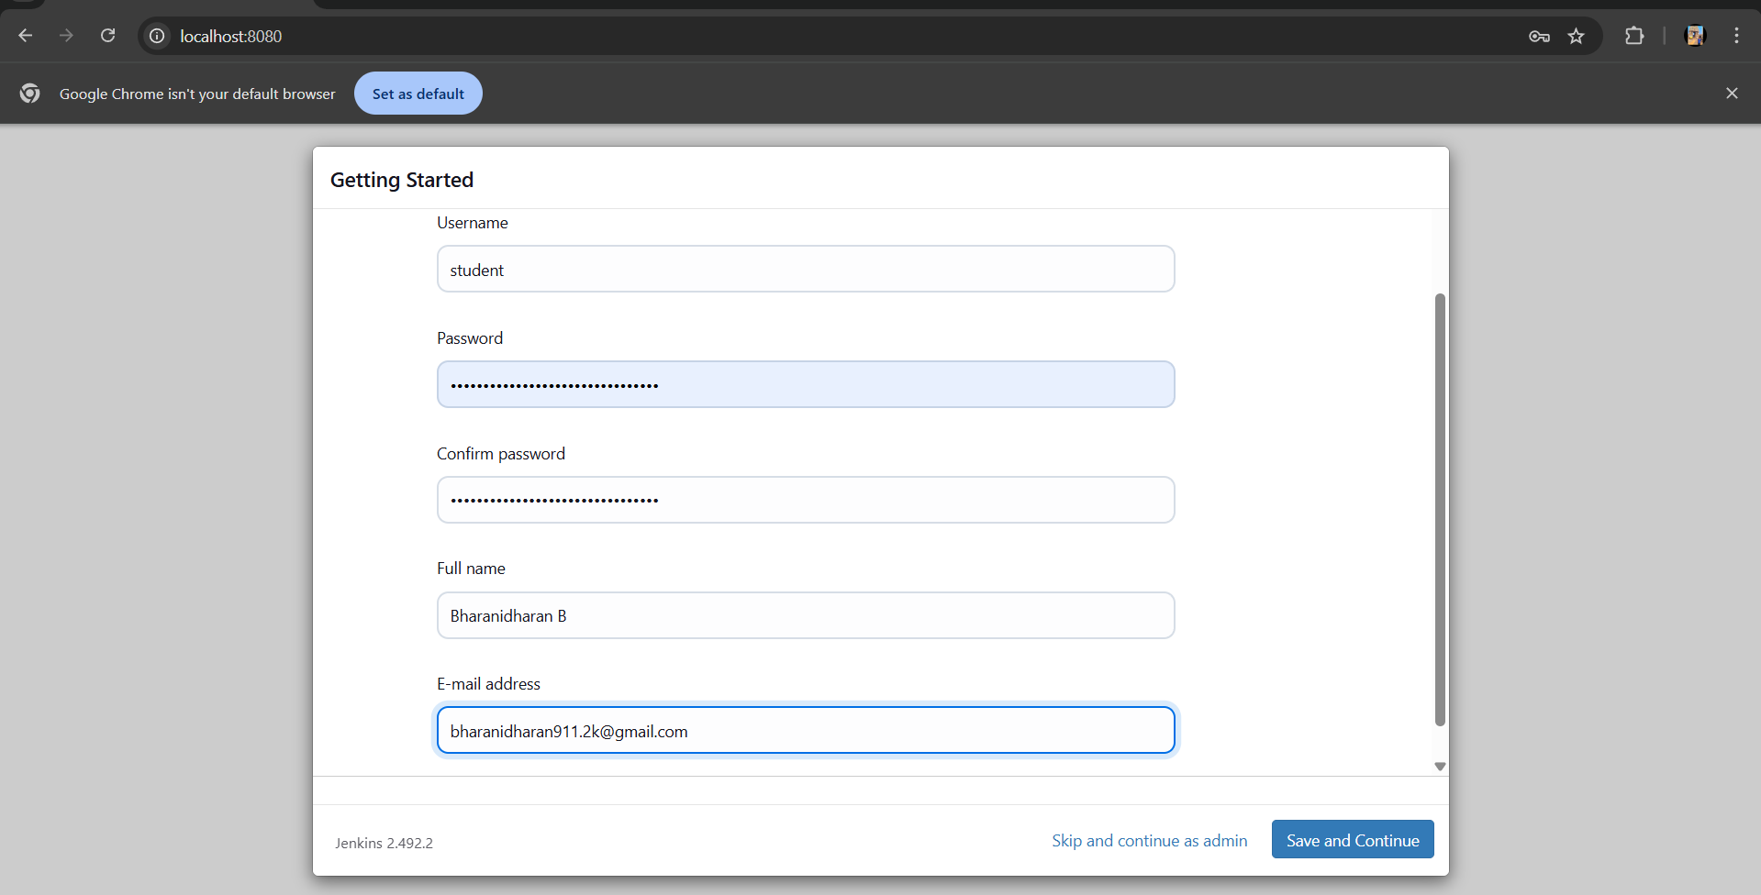

Step 10: (Enter the URL)
If you're on the same machine as Jenkins, use:
http://localhost:8080

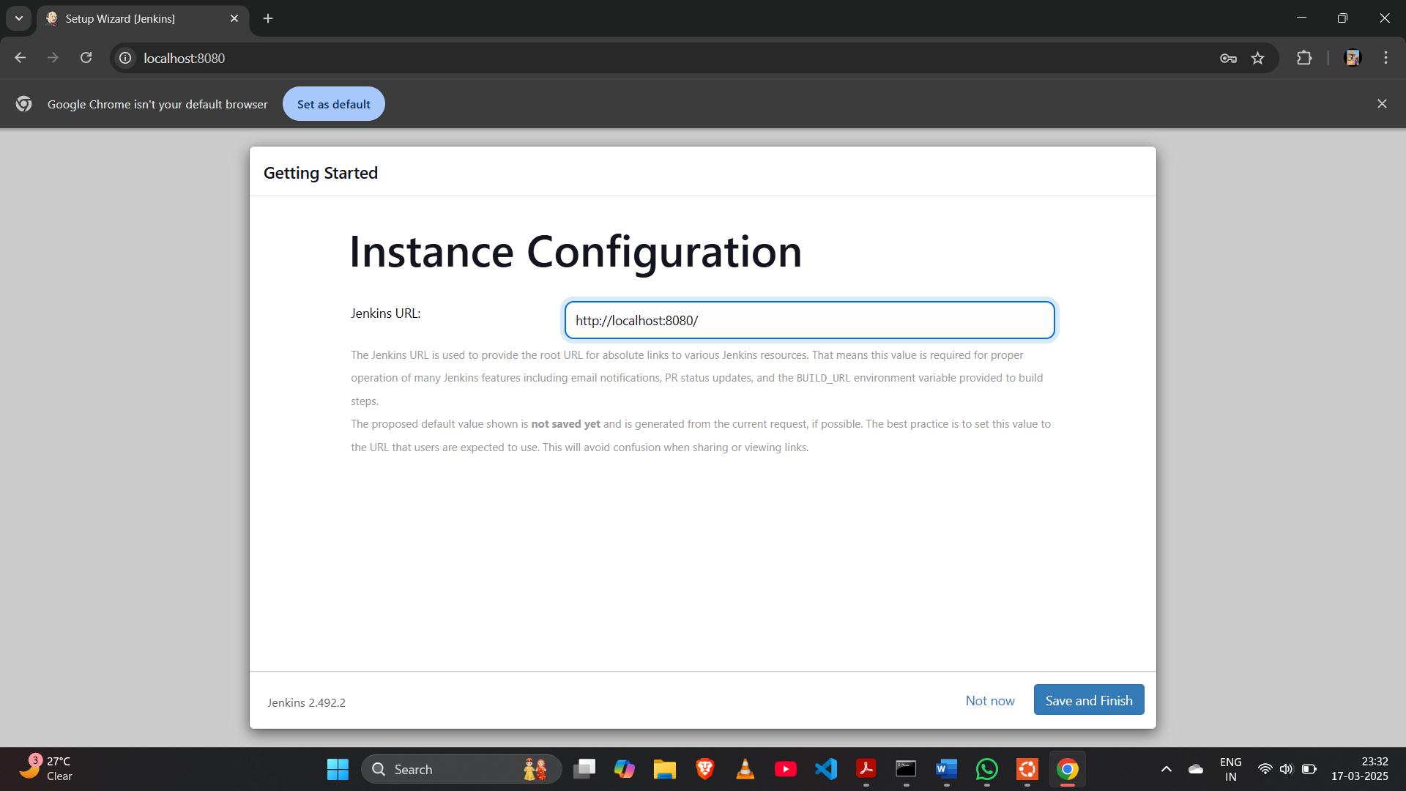
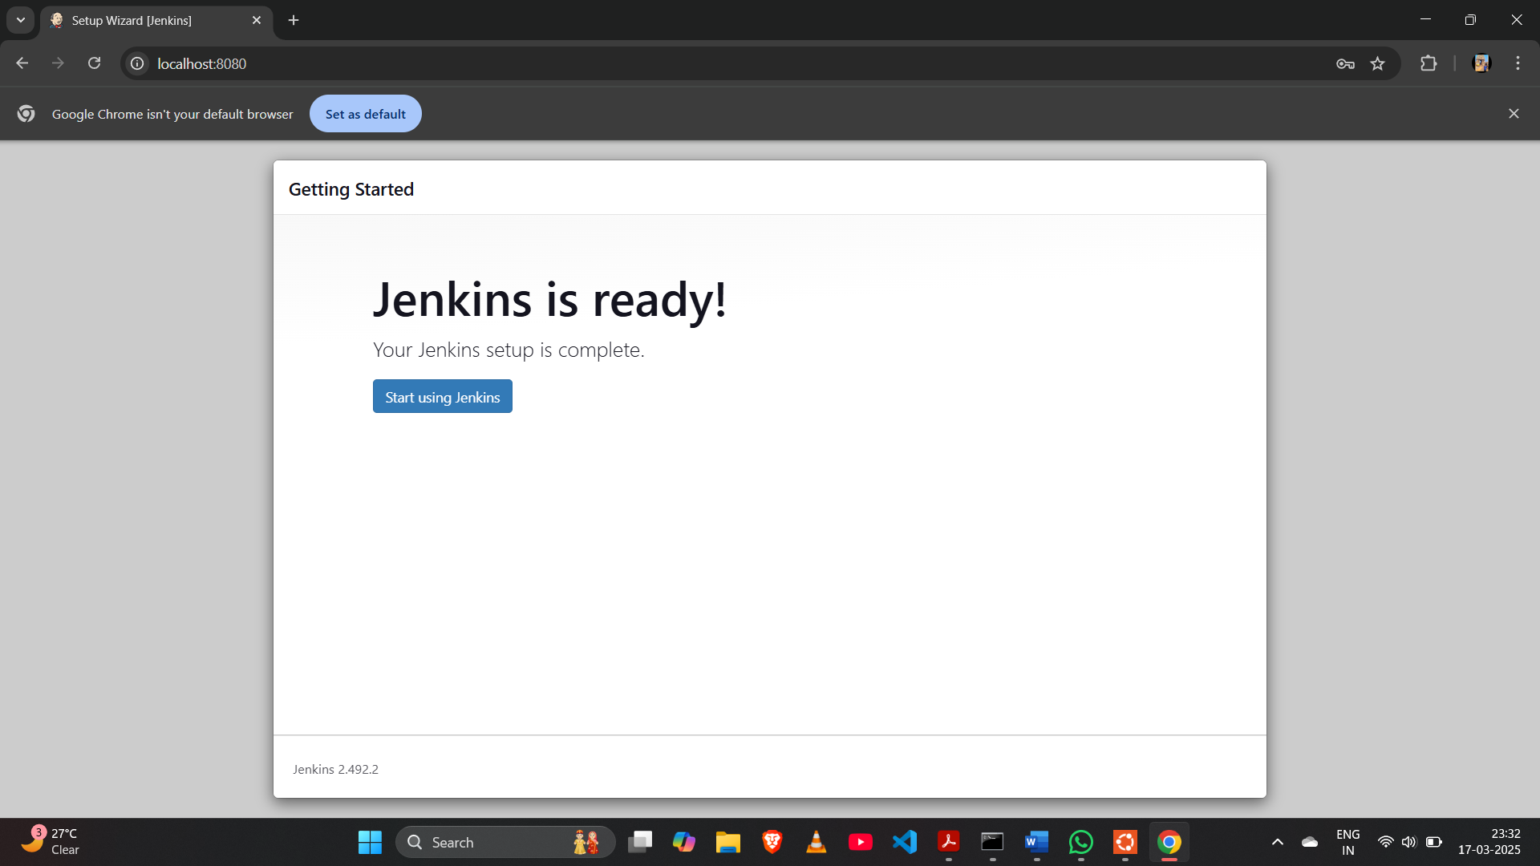

Step 11:
(Create an Project ex.ms)
(In Configure build and Select Execute shell)
(Build the Project)
SELECT BUILD NOW

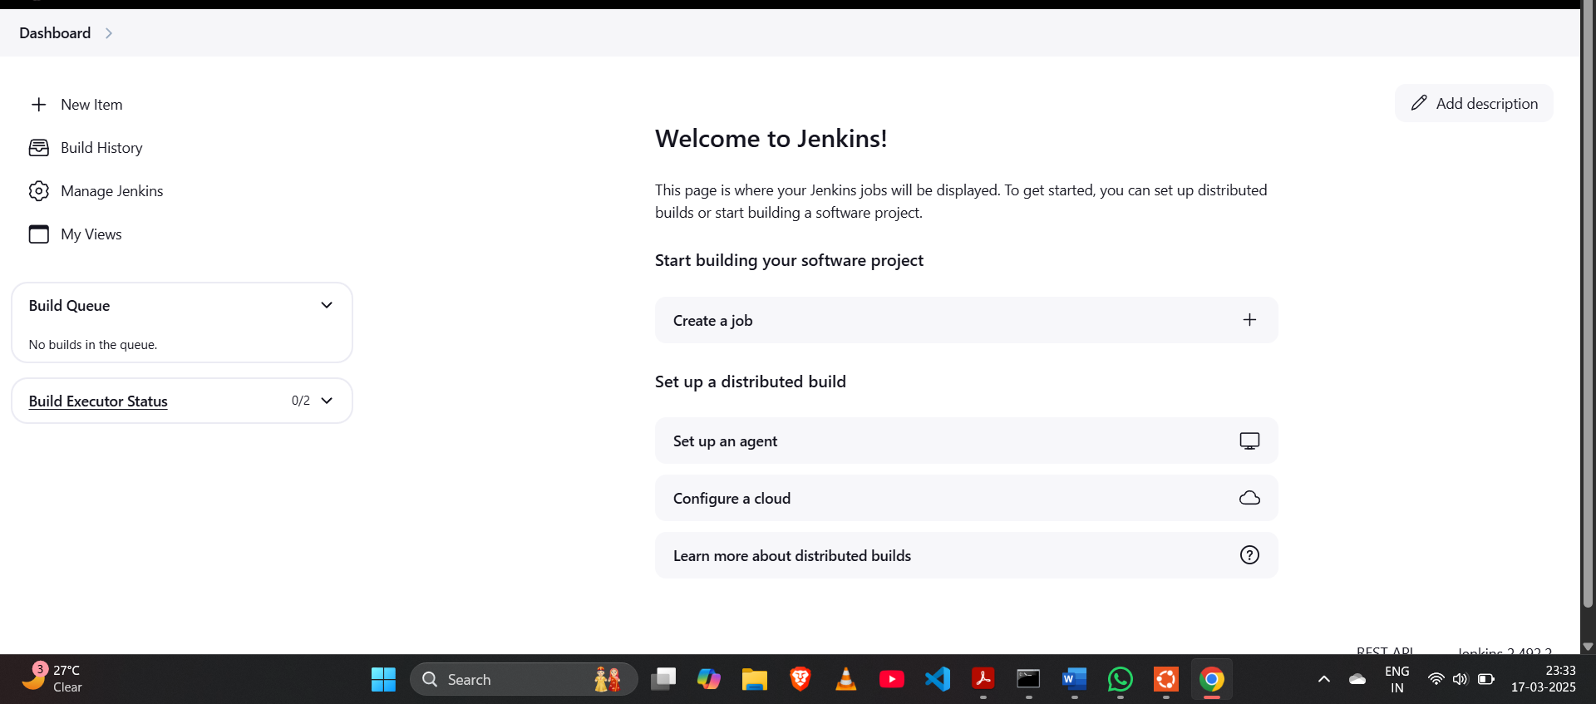

Step: 12
Step-by-Step Guide to Creating a Freestyle Job in Jenkins to Install Nginx Step 1: Create a New Freestyle Job
1. Click on New Item from the Jenkins Dashboard.
2. Enter a name for the job, e.g., Install-Nginx.
3. Select Freestyle project.
4. Click OK.
Step 2: Configure the Job
Add Build Step
1. Scroll down to Build → Click Add build step → Select Execute shell. 2. Paste the following script in the command box:
echo "Updating package lists..."
sudo apt update -y
echo "Installing Nginx..."
sudo apt install -y nginx
echo "Starting Nginx service..."
sudo systemctl start nginx
echo "Enabling Nginx to start on boot..."
sudo systemctl enable nginx
echo "Nginx Installation Completed!"
Step 3: Save and Run the Job
1. Click Save.
2. Click Build Now.
3. Check the Console Output to verify the installation.
Step 4: Verify the Installation
1. Check Nginx Status
systemctl status nginx
If running, you should see output like "active (running)".
2. Open Nginx in Browser
http://localhost:80
You should see the default Nginx welcome page

