1. What If There Were No Operating System?
Operating System is a software used to communicate between the user and the software. Operating System consists of a kernel which acts as a bridge between the application and the hardware.
- If a computer had no operating system, users will be forced to interact directly with the hardware using machine code (1s and 0s). Every application would have to include its own drivers to communicate with the CPU, monitor, keyboard, and hard drive.

- You could only run a single program at a time. We cannot do multitasking like writing in a notepad and listening to music in the same time. The OS function CPU scheduling will allow us to do multitasking.

- Users would have to interact with the machine using physical switches, punch cards, or raw machine code. The OS provides GUI and CLI which makes life easier.
- Demonstrating OS Features in Linux
1. Process Management (CPU Scheduling) If you open a Linux terminal and type ‘top’, you will see a live dashboard of every process running on the machine. We can see the OS handling many tasks together, allocating CPU time to all running applications
2. File System and Access Control Running the command ‘ls -l’ in a directory doesn't just list files; it shows the OS is managing security. You will see output like ‘-rw-r--r—', the access that a owner, group and others can have to modify, read and execute a file.
3. Memory Management Typing the command ‘free -h’ asks the Linux kernel to report on RAM. It will show exactly how much memory is total, used, and free.

Feature | Without an Operating System | With an Operating System
Booting Up | Halts at hardware initialization. User must manually load code to CPU. | Automatically loads the Kernel, drivers, and User Interface.
Interface | Machine code, binary switches, or punch cards. | Graphical Interface (Windows/macOS) or Command Line Interface(Linux).
App Execution | Only one program runs. It has total control over the whole machine. | Multiple programs run concurrently, managed and restricted by the OS.
Hardware | Every app needs custom code for every keyboard, mouse, and monitor. | Apps use standard APIs; the OS driver talks to the hardware.
Storage | Raw data blocks. No folders, no file names, no search. | Hierarchical file systems with named files and folders.
Security | Zero protection. Any code can erase the hard drive instantly. | Sandboxed apps, user accounts, and strict file permissions.

2. Cybersecurity Laboratory OS Selection Guide
When building a cybersecurity lab, different security disciplines require specialized toolsets.
Operating System | Primary Lab Role | Base Distro | Standout Feature | Best Suited For...
Kali Linux | Penetration Testing | Debian | Industry-standard toolset | General Red Team operations
Parrot OS | Penetration Testing | Debian | Cloud-friendly, lightweight | Laptops & daily-driver pentesting
BlackArch | Advanced Pentesting | Arch | 2,800+ cutting-edge tools | Advanced exploit researchers
BackBox | Vulnerability Assessment | Ubuntu | Minimalist, highly stable | Rapid, targeted security audits
CAINE | Digital Forensics | Ubuntu | Default Read-Only mounts | Handling legal digital evidence
REMnux | Malware Analysis | Ubuntu | Reverse-engineering tools | Dissecting viruses/ransomware
Security Onion | Security Monitoring | CentOS/Ubuntu | Built-in NIDS, HIDS & SIEM | Blue Team threat hunting
Tails | Anonymity | Debian | Amnesic (forgets everything) | Burner sessions & OSINT
Whonix | Secure Networking | Debian | Split-VM Tor architecture | Defeating IP leaks & malware call-homes
Qubes OS | Secure Workstation | Fedora/Xen | Hardware-level isolation | Handling highly classified/risky files

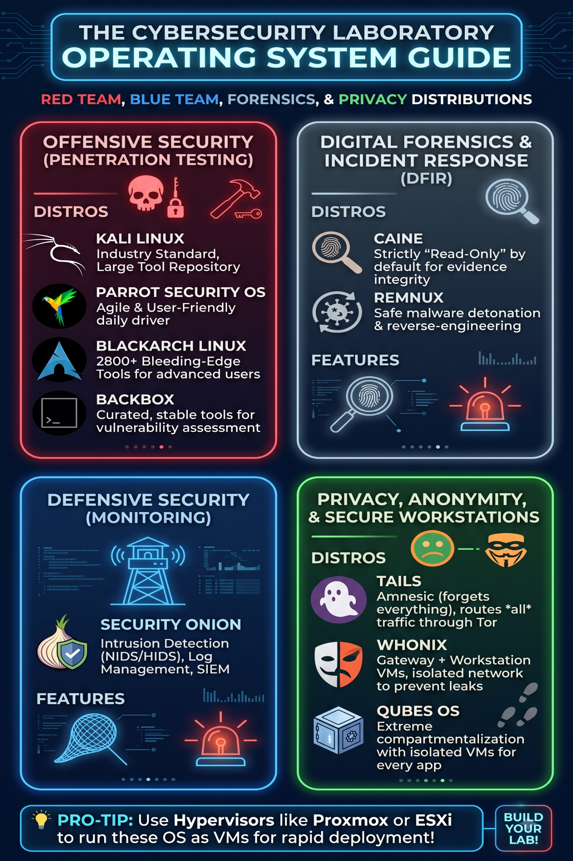
3. Exit Status ($?) in Linux
Whenever a command finishes executing in Linux, it gives a numerical "exit status" (or return code) between 0 and 255. We can check the exit status of the last command executed by typing echo $?.
An exit status of 0 means Success.
Any exit status greater than 0 means Failure or an error occurred.

Command Executed | Result Exit Status ($?) | Meaning / System Interpretation
whoami | 0 | Success: The command ran perfectly with no errors.
ls --invalid-option | 2 | Misuse of Shell Builtins/Commands: Syntax error or invalid flag provided.
update-system-now | 127 | Command Not Found: The shell could not locate the executable file in the $PATH.
sleep 100 (Ctrl+C) | 130 | Terminated by User: The process was killed by a SIGINT signal (128 + Signal 2).
expr 10 + 5 | 0 | Success: The expression was evaluated successfully.
expr 10 / 0 | 2 | Operation Error: Specific to expr, indicates an invalid mathematical operation.

What Can a Script Learn from an Exit Status?
When we encounter an error user can read the terminal error messages but the BASH cannot read and understand the English text on the terminal, so they depend on exit status to make decisions. By reading the exit status number the shell understands and act accordingly.
When to Stop or Continue (Control Flow): A script learns whether it is safe to proceed to the next step.
How to Handle Specific Errors: By analyzing specific non-zero numbers, a script can categorize why something failed and react accordingly.

