Gowtham Patel C
26110069007

Part A — Basic grep
Exercise 1 — Search File Contents

Using payload.sh:

Find the line containing wget.
: grep 'wget' payload.sh

Find the line containing nc.
: grep 'nc' payload.sh

Find the line containing chmod.
: grep 'chmod' payload.sh

Search for WGET ignoring case.
: grep 'chmod' payload.sh

Display the line numbers containing /tmp.
: grep -n '/tmp' payload.sh

Count the number of lines containing /tmp.
: grep -c '/tmp' payload.sh

Display only the matched word wget.
: grep -o 'wget' payload.sh

Search for nc as a whole word.
: grep -w 'nc' payload.sh

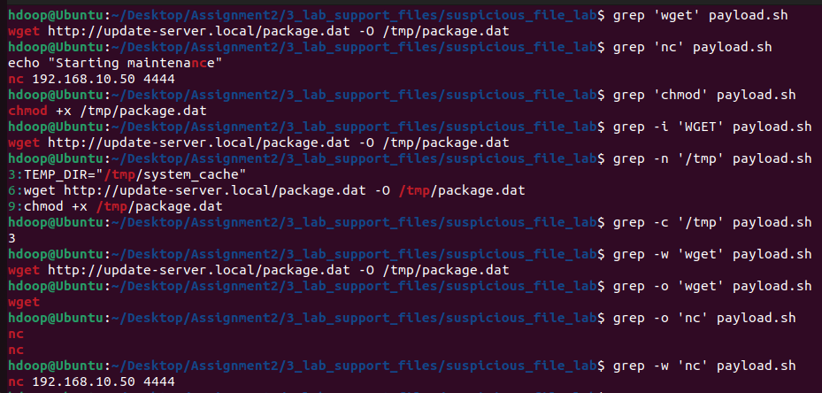

Exercise 2 — Compare Files

Search for wget in:

payload.sh
update.sh
cleanup.sh

Answer:

Which file contains wget?
: payload.sh - grep -l 'wget' payload.sh update.sh cleanup.sh

Which files do not contain wget?
: upload.sh , cleanup.sh - grep -L 'wget' payload.sh update.sh cleanup.sh

Repeat the search for /tmp.
: grep '/tmp' payload.sh update.sh cleanup.sh

Which files contain /tmp?
: payload.sh , cleanup.sh

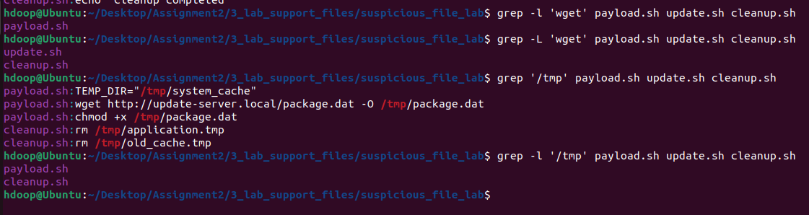

Use grep with multiple filenames.

Exercise 3 — Inverse Search

Using system.log:

Display all lines that do not contain INFO.
: grep -v 'INFO' system.log

Display all lines that do not contain ERROR.
: grep -v 'ERROR' system.log

Display all lines except those containing WARNING.
: grep -v 'WARNING' system.log

Count the number of non-INFO entries.
: grep -vc 'INFO' system.log

Part B — Security Log Analysis
Exercise 4 — Analyze system.log

Using grep:

Find all ERROR entries.
: grep 'ERROR' system.log

Find all WARNING entries.
: grep 'WARNING' system.log

Find the FAILED entry.
: grep 'FAILED' system.log

Count the number of ERROR entries.
: grep -c 'ERROR' system.log

Display line numbers containing WARNING.
: grep -n 'ERROR' system.log

Search for error irrespective of case.
: grep -i 'error' system.log

Determine whether the word Malware occurs in the file without displaying output.
: grep -q 'Malware' system.log --> echo $?

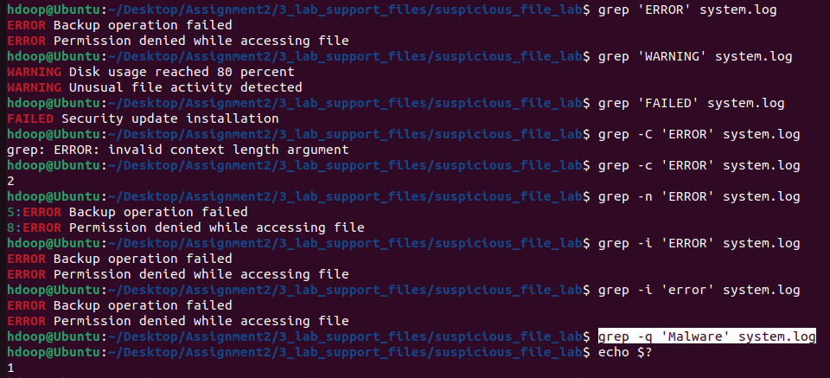

Exercise 5 — Context Investigation

An ERROR event has been detected in system.log.

Display two lines after each ERROR.
: grep -A 2 'ERROR' system.log

Display two lines before each ERROR.
: grep -B 2 'ERROR' system.log

Display one line before and one line after each ERROR.
: grep -C1 'ERROR' system.log

Display two lines around FAILED.
: grep -C2 'FAILED' system.log

Why can examining events before and after an error be useful during incident investigation?
: Examining surrounding events helps establish the timeline of an incident. Preceding lines often reveal the action or payload that triggered the error, while subsequent lines show how the system or application responded (e.g., crashing, dropping a connection, or executing a fallback script).

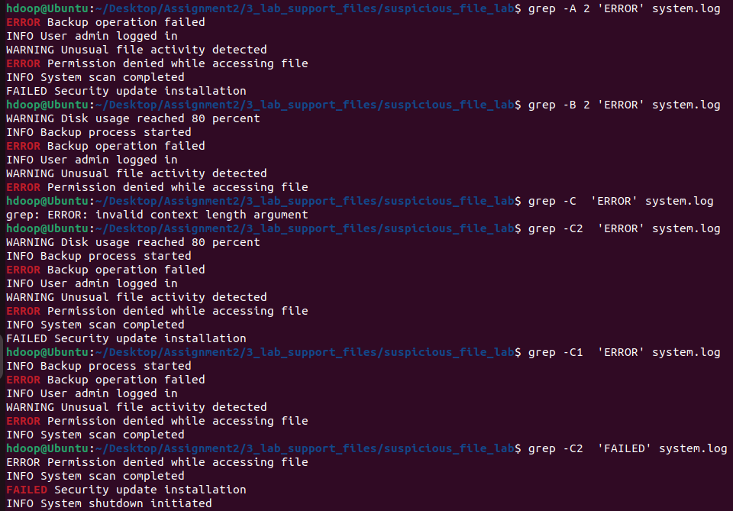

Part C — egrep / grep -E
Exercise 6 — Search Multiple Security Events

Using system.log, write a single command to find lines containing:

ERROR
WARNING
FAILED
: grep -E 'ERROR|WARNING|FAILED' system.log

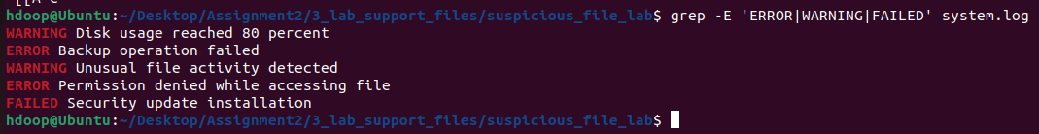

Exercise 7 — Multiple Suspicious Commands

Using payload.sh, search for any of:

wget
curl
nc
chmod

using a single extended regular expression.
: grep -E 'wget|curl|nc|chmod' payload.sh

Answer:

Which patterns were found?
: cat payload.sh | grep -E 'wget|curl|nc|chmod'

Which pattern was not found?
: cat payload.sh | grep -Ev 'wget|curl|nc|chmod'

How many lines contain at least one of these patterns?
: grep -Ec 'wget|curl|nc|chmod' payload.sh ( 4 )

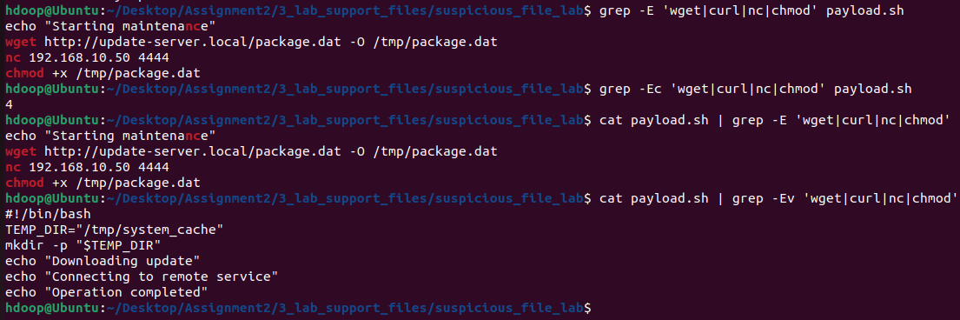
Exercise 8 — Search Multiple Files

Which files contain at least one selected command?
: grep -Ec 'wget|curl|nc|chmod' *.sh

Display only the filenames containing matches.
: grep -El 'wget|curl|nc|chmod' *.sh --> payload.sh

Display matching lines with line numbers.
: grep -En 'wget|curl|nc|chmod' *.sh

Count the matching lines in each file.
: grep -Ec 'wget|curl|nc|chmod' *.sh

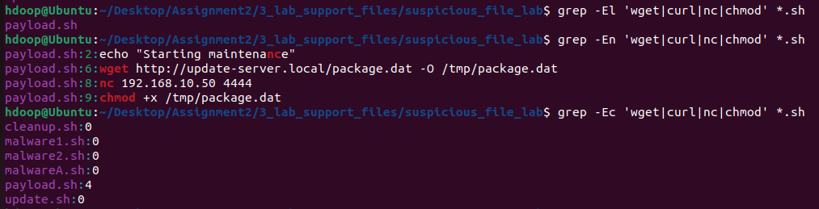

Part D — patterns.txt
Your dataset already contains patterns.txt.
Exercise 9 — Pattern File Investigation

Use patterns.txt to:

Search payload.sh.
: grep -f patterns.txt payload.sh

Search system.log.
: grep -f patterns.txt system.log

Search config.conf.
: grep -f patterns.txt config.conf

Search all .sh files.
: grep -f patterns.txt *.sh

Display only filenames containing at least one pattern from patterns.txt.
: grep -l -f patterns.txt *.sh

Display matching lines without printing filenames.
: grep -h -f patterns.txt *.sh

Which files contain indicators listed in patterns.txt?
: payload.sh
Part E — Regex Using filelist.txt
Exercise 10 — Beginning and End of Line

Using filelist.txt:

Find filenames beginning with malware.
: grep '^malware' filelist.txt

Find filenames beginning with script.
: grep '^script' filelist.txt

Find filenames ending in .sh.
: grep "\.sh$" filelist.txt

Find filenames ending in .py.
: grep "\.py$" filelist.txt

Find filenames ending in .log.
: grep "\.log$" filelist.txt

Find filenames beginning with p and ending in .sh.
: grep "^p.*\.sh$" filelist.txt

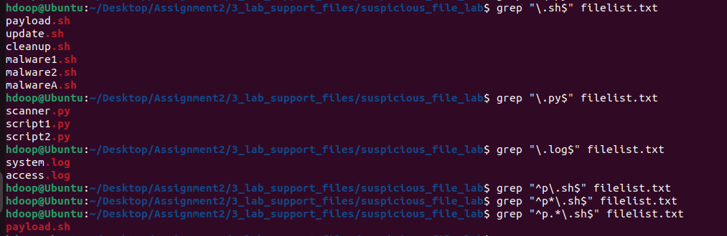

Exercise 11 — Character Classes

Using filelist.txt:

Find malware1.sh and malware2.sh using one pattern.
: grep 'malware[12].sh' filelist.txt

Find filenames containing a digit.
: grep '[0-9]' filelist.txt

Find filenames containing digits 1 or 2.
: grep '[12]' filelist.txt

Find filenames beginning with m or p.
: grep '[mp]' filelist.txt

Find filenames beginning with s or u.
: grep '^[su]' filelist.txt

Exercise 12 — Negated Character Classes

Using filelist.txt:

Find filenames that do not begin with m.
: grep '[^m]' filelist.txt

Find filenames that do not begin with m or p.
: grep '^[^mp]' filelist.txt

Find malware filenames where the character following malware is not a digit.
: grep 'malware[^0-9]' filelist.txt

Part F — File Operators
Exercise 13 —

Write a shell script that accepts a filename and determines whether it exists.

Test with:

payload.sh
report.txt
unknown.sh

#!/usr/bin/bash
read -p "Enter file name " filenm
if [ -e "$filenm" ];then
echo "File exists"
else
echo "File does not exist"
fi

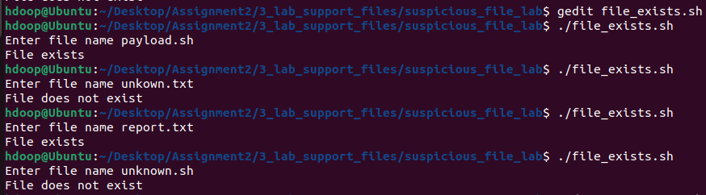

Write a script that accepts a path and determines whether it is:

a regular file,
a directory,
or neither.

Test with:

payload.sh
system.log
quarantine
backup
unknown

#!/usr/bin/bash

read -p "Enter file name " filenm
if [ -f "$filenm" ];then
echo "Regular file"
elif [ -d "$filenm" ];then
echo "File is a directory"
else
echo "Neither file neither directory"
fi

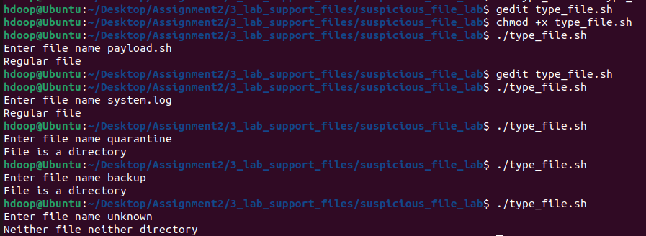

Exercise 15

Write a script that reports whether a selected file is:

readable,
writable,
executable.

Test with:

payload.sh
update.sh
report.txt
config.conf

Expected style of output:

File: payload.sh

Readable : Yes
Writable : Yes
Executable : Yes

#!/usr/bin/bash

read -p "Enter file name " filenm
if [ -r "$filenm" ]; then

echo "Readable : Yes"
else
echo "Readable : No"
fi

if [ -w "$filenm" ]; then
echo "Writable : Yes"
else
echo "Writable : No"
fi

if [ -x "$filenm" ]; then
echo "Executable : Yes"
else
echo "Executable : No"
fi

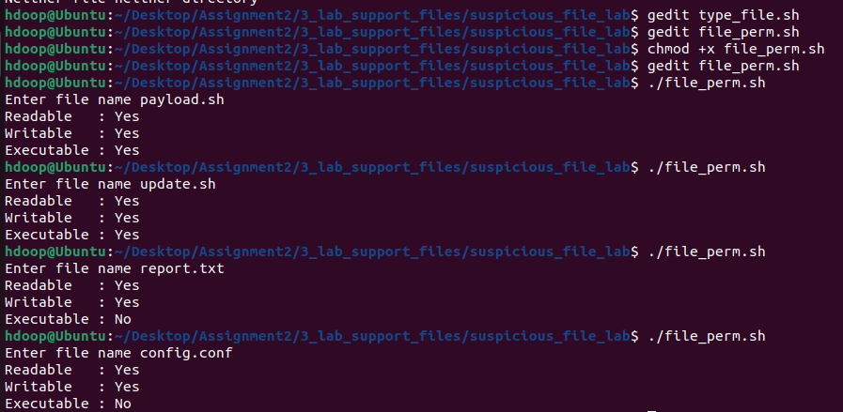

Exercise 16 —

Compare:
payload.sh
empty.txt

Write a script that determines whether each file contains data.

Display:
File contains data
or:
File is empty

#!/usr/bin/bash

read -p "Enter file name " filenm

if [ -s "$filenm" ]; then

echo "File contains data"
else
echo "File is empty"
fi

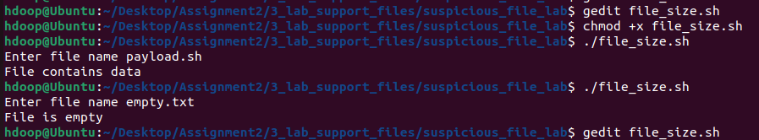

Part G
Exercise 17 — File Validation Using [ ]

Write a script that accepts a filename and checks:

Does it exist?
Is it a regular file?
Is it readable?
Is it non-empty?

#!/usr/bin/bash

read -p "Enter file name " filenm

if [ -e "$filenm" ];then
echo "File exists"
else
echo "File does not exist"
fi
if [ -f "$filenm" ];then
echo "Regular File"
else
echo "Not a regular file"
fi

if [ -r "$filenm" ];then
echo "File readable"
else
echo "File does not have read function"
fi
if [ -s "$filenm" ]; then

echo "File contains data"
else
echo "File is empty"
fi

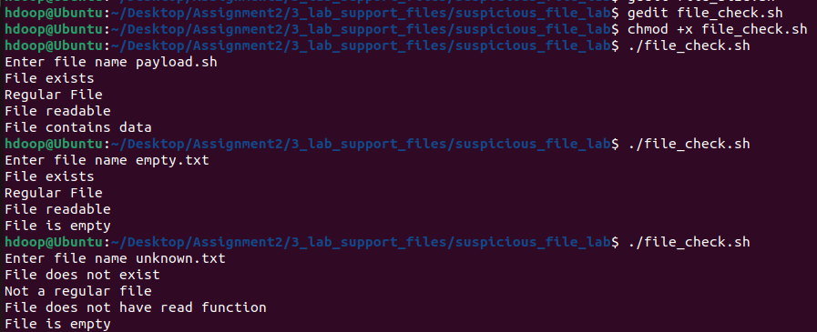

Exercise 18 — [ ] + grep

Write a script with the following logic:

Does file exist?
↓
Is it a regular file?
↓
Is it readable?
↓
Is it non-empty?
↓
Search for "wget"

If wget is detected, display:

Selected indicator detected – investigate further

Otherwise:

Selected indicator not detected

Test using both:

payload.sh
update.sh

#!/bin/bash

read -p "Enter the filename: " file

if [ ! -e "$file" ]; then
echo "File does not exist."
exit 1
fi

if [ ! -f "$file" ]; then
echo "File is not a regular file."
exit 1
fi

if [ ! -r "$file" ]; then
echo "File is not readable."
exit 1
fi

if [ ! -s "$file" ]; then
echo "File is empty."
exit 1
fi

if grep -q "wget" "$file"; then
echo "Selected indicator detected – investigate further"
else
echo "Selected indicator not detected"
fi

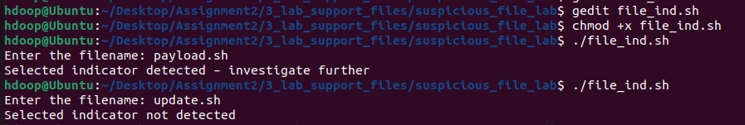

Part H
Exercise 19 — Repeat File Tests Using [[ ]]

Repeat Exercise 17 using:
#!/usr/bin/bash

read -p "Enter file name: " filenm

if [[ -e "$filenm" ]]; then
echo "File exists"
else
echo "File does not exist"
fi

if [[ -f "$filenm" ]]; then
echo "Regular File"
else
echo "Not a regular file"
fi

if [[ -r "$filenm" ]]; then
echo "File readable"
else
echo "File does not have read function"
fi

if [[ -s "$filenm" ]]; then
echo "File contains data"
else
echo "File is empty"
fi

Exercise 20 — Regex Using [[ ]]

Write a shell script that accepts a filename and checks whether the filename ends with .sh.

Use:

[[ "$filename" =~ regex ]]

Display:

Shell script identified for inspection

or:

File does not have a .sh extension

Test:

payload.sh
scanner.py
report.txt

#!/usr/bin/bash

read -p "Enter file name: " filename

if [[ "$filename" =~ \.sh$ ]]; then
echo "Shell script identified for inspection"
else
echo "File does not have a .sh extension"
fi

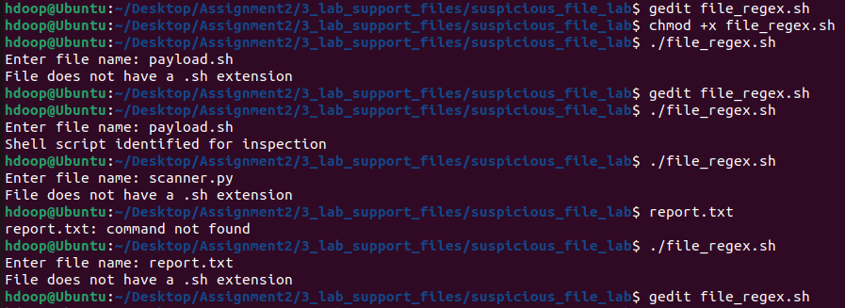

Exercise 21 — Multiple Extensions Using [[ ]]

Extend the previous script to identify:

.sh
.py
.pl

files.

Test:

payload.sh
scanner.py
report.txt
config.conf

Do not classify these as malicious. Display:

Script file – inspect if required

#!/usr/bin/bash

read -p "Enter file name: " filename

if [[ "$filename" =~ \.(sh|py|pl)$ ]]; then
echo "Script file – inspect if required"
else
echo "File is not a script file"
fi

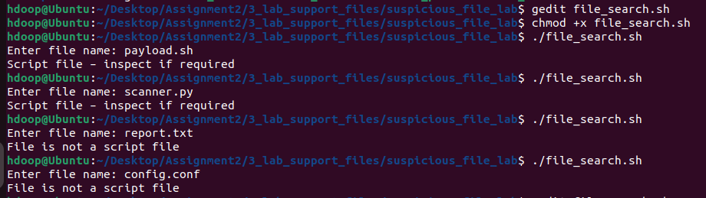

Part I — grep + File Operators + Constructs
Exercise 22 — Executable File Content Analysis

Write a script that:

Accepts a filename.
Checks whether it exists.
Checks whether it is a regular file.
Checks whether it is executable.
If executable, searches for wget

Test with:

payload.sh
update.sh
report.txt

#!/usr/bin/bash

read -p "Enter file name: " filename

if [ -e "$filename" ]; then
if [ -f "$filename" ]; then
if [ -x "$filename" ]; then
echo "Executable file identified"
grep -q "wget" "$filename"
if [ $? -eq 0 ]; then
echo "wget command found in executable file"
else
echo "wget command not found"
fi
else
echo "File exists but is not executable"
fi
else
echo "File exists but is not a regular file"
fi
else
echo "File does not exist"
fi

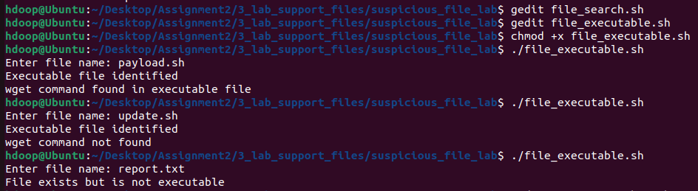

Exercise 23 — egrep + File Operators

Write a script that performs content analysis only when the selected file is:

a regular file,
readable,
non-empty.

If the checks succeed, use egrep/grep -E to search for:

wget|curl|nc|chmod

Display:

One or more selected indicators detected

if a match occurs.

Otherwise:

Selected indicators not detected

#!/usr/bin/bash

read -p "Enter file name: " filename

if [ -f "$filename" ]; then
if [ -r "$filename" ]; then
if [ -s "$filename" ]; then
grep -Eq "wget|curl|nc|chmod" "$filename"
if [ $? -eq 0 ]; then
echo "One or more selected indicators detected"
else
echo "Selected indicators not detected"
fi
else
echo "File is empty"
fi
else
echo "File is not readable"
fi
else
echo "File is not a regular file"
fi

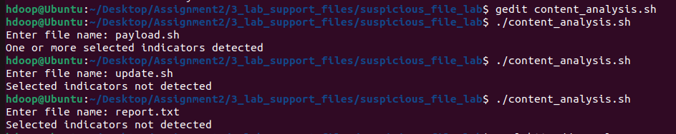

Part J — Configuration File Investigation
Exercise 24 — Sensitive Information Search

Use config.conf.
First verify that it:

exists,
is a regular file,
is readable,
is non-empty.

Then use egrep to search for:

password|username

Display the matching lines.

Why should configuration files containing authentication information receive additional protection?
#!/usr/bin/bash

filename="config.conf"

if [ -e "$filename" ]; then
if [ -f "$filename" ]; then
if [ -r "$filename" ]; then
if [ -s "$filename" ]; then

egrep "password|username" "$filename"

else
echo "File is empty"
fi
else
echo "File is not readable"
fi
else
echo "File is not a regular file"
fi
else
echo "File does not exist"
fi

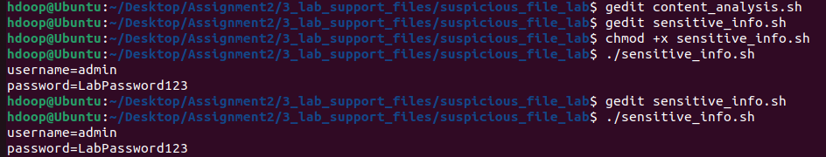

Part K
Exercise 25 — Suspicious File Triage

Write a Bash program called:

file_check.sh

The program should ask the user to enter a filename.

It should:

Determine whether the path exists.
Determine whether it is a regular file.
Determine whether it is a directory.
If it is a regular file, determine whether it is readable.
Determine whether it is writable.
Determine whether it is executable.
Determine whether it is empty/non-empty.
If readable and non-empty, use grep to search for wget.
Use egrep/grep -E to search for wget|curl|nc|chmod.
Use $? to determine whether a selected search succeeded.
Use [[ ]] with regex to determine whether the filename ends in .sh.
Display a summary of the findings.

Example:

Enter filename: payload.sh

----- FILE INVESTIGATION -----

Exists : Yes
Regular File : Yes
Directory : No
Readable : Yes
Writable : Yes
Executable : Yes
Non-empty : Yes
Shell Script : Yes

wget : Found
Selected indicators : Found

Further inspection recommended

#!/usr/bin/bash

read -p "Enter filename: " filename

if [ -e "$filename" ]; then
echo "Exists : Yes"
else
echo "Exists : No"
exit
fi

if [ -f "$filename" ]; then
echo "Regular File : Yes"
else
echo "Regular File : No"
fi

if [ -d "$filename" ]; then
echo "Directory : Yes"
else
echo "Directory : No"
fi

if [ -f "$filename" ]; then

if [ -r "$filename" ]; then
echo "Readable : Yes"
else
echo "Readable : No"
fi

if [ -w "$filename" ]; then
echo "Writable : Yes"
else
echo "Writable : No"
fi

if [ -x "$filename" ]; then
echo "Executable : Yes"
else
echo "Executable : No"
fi

if [ -s "$filename" ]; then
echo "Non-empty : Yes"
else
echo "Non-empty : No"
fi

if [[ "$filename" =~ \.sh$ ]]; then
echo "Shell Script : Yes"
else
echo "Shell Script : No"
fi

if [ -r "$filename" ] && [ -s "$filename" ]; then

# Search for wget
grep -q "wget" "$filename"

if [ $? -eq 0 ]; then
echo "wget : Found"
else
echo "wget : Not Found"
fi

grep -Eq "wget|curl|nc|chmod" "$filename"

if [ $? -eq 0 ]; then
echo "Selected indicators : Found"
echo
echo "Further inspection recommended"
else
echo "Selected indicators : Not Found"
fi

else
echo "Content analysis skipped"
fi

fi

