Gowtham Patel C
261100690007

1. 400 (r--) :

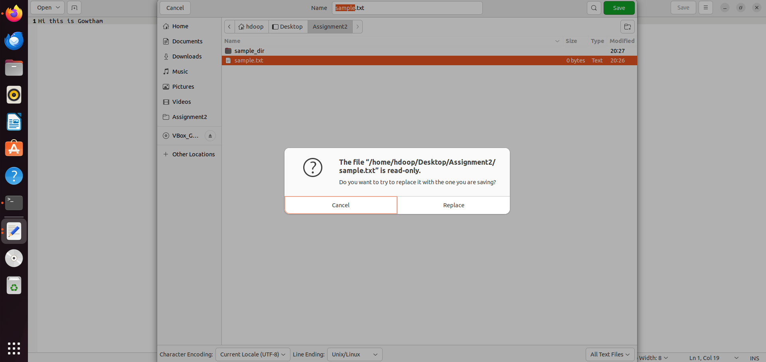
Read permission for a file

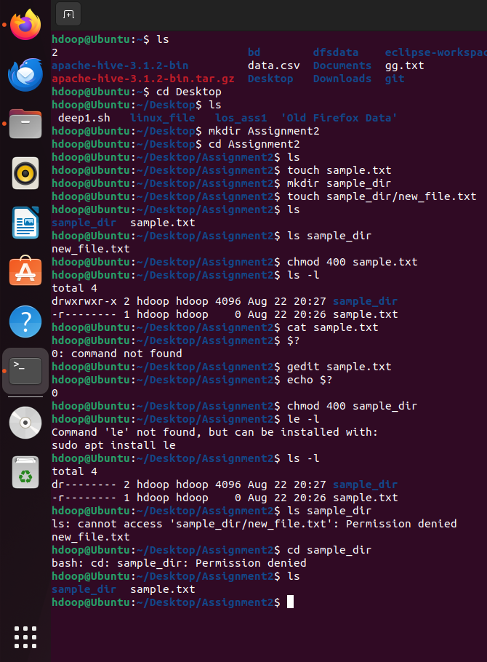
Read permission on directory
2. 200 (-w-) :

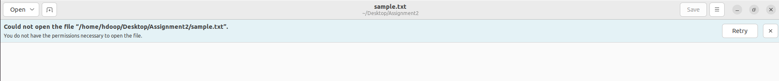
Write permission on a file

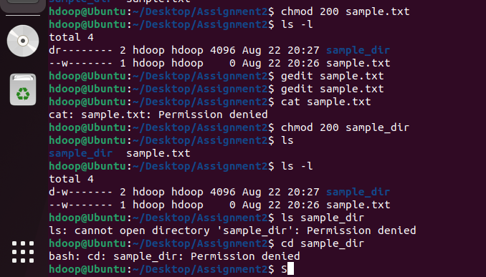
Write permission on a directory

3. 100 (--x) :

Execute permission on a file

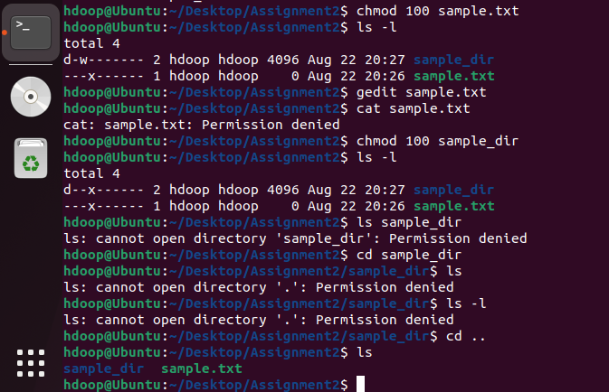
Execute permission on a directory

4. 500 (r-x) :

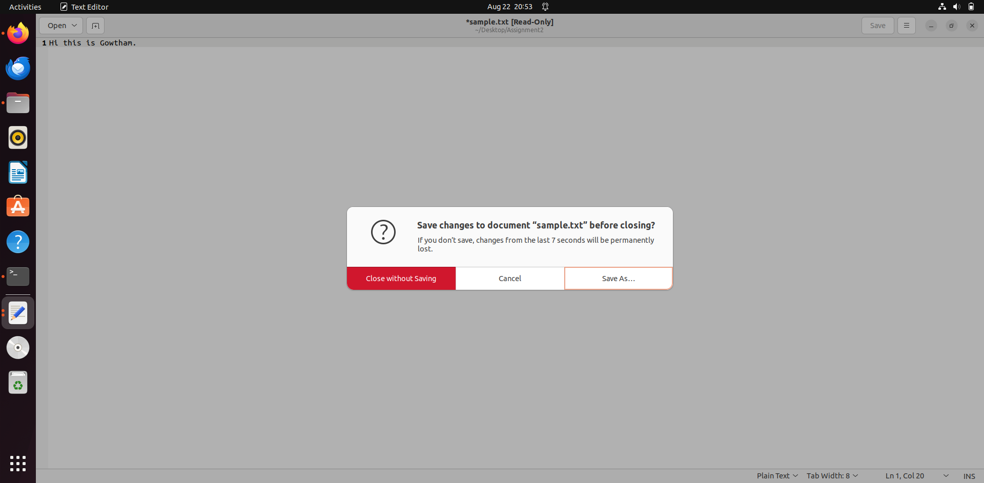
Read execute permission on a file

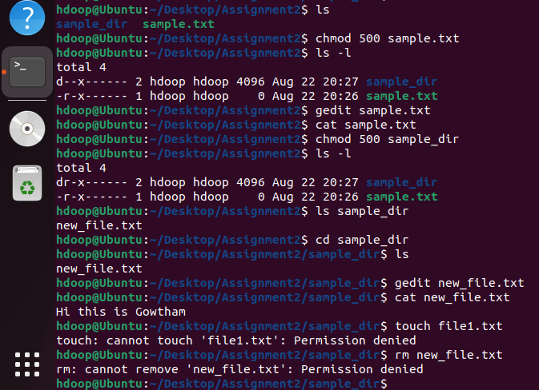
Read execute permission on a directory

5. 600 (rw-) :

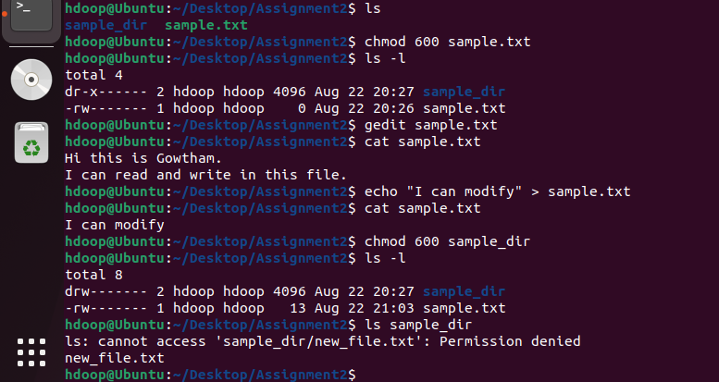
Read write permissions on a file and directory
6. 700 (rwx) :

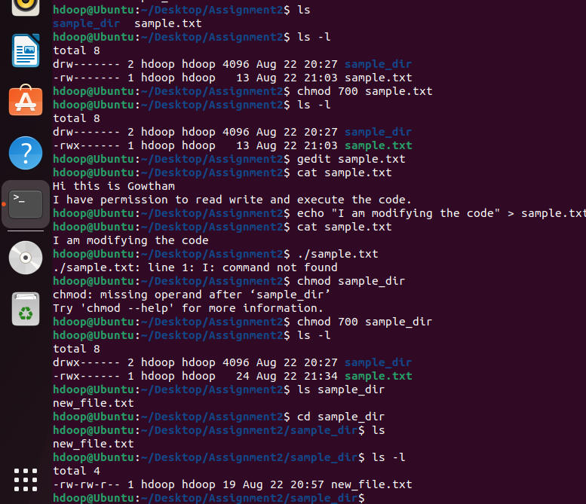
Read, write and execute permessions on file and directory

Permission | Regular File | Observation | Directory | Observation
400 (r--) | Try to read and modify the file | Read succeeds; modification fails because there is no write permission. | Try to list and enter the directory | Listing succeeds; entering fails because directory x is absent.
200 (-w-) | Try to read and modify the file | Reading fails; modification can succeed (e.g., overwrite/truncate the file) because write permission is present. | Try to list, enter, and create a file | Listing and entering fail; creating a file fails because directory x is required to access entries.
100 (--x) | Try to read and execute the file | Reading fails; execution may succeed if the file is a valid executable/script with an appropriate interpreter and format. | Try to list and enter the directory | Listing fails; entering succeeds. You can access a known entry by name, but cannot obtain a directory listing.
500 (r-x) | Try to read and modify the file | Reading succeeds; modification fails. | Try to list and enter the directory | Listing and entering both succeed.
600 (rw-) | Try to read and modify the file | Reading and modification both succeed. | Try to list, enter, and create a file | Listing, entering, and creating files fail because x is missing.
700 (rwx) | Try to read, modify, and execute the file | Reading and modification succeed; execution succeeds if the file is executable. | Try to list, enter, create, and delete files | All operations succeed.

Questions:

1. What does read (r) permission allow you to do with a regular file?
: It allows you to open and view the actual contents of the file

2. What does read (r) permission allow you to do with a directory?
: It allows you to read the directory's list of contents. You can see the names of the files and folders inside it .

3. What does write (w) permission mean for a regular file?
: It allows you to write, modify or overwrite he contents of the file.

4. What does write (w) permission mean for a directory?
: It allows you to alter the directory's contents create new files, delete existing files, or rename files within that directory.

5. What does execute (x) permission mean for a regular file?
: It allows the operating system to run the file as a program or script .

6. Why is execute (x) permission important for accessing a directory?
: You need execute permission to enter the directory , access its metadata, or access any of the files inside it.

7. Which permission combination allows the owner to fully access a regular file?
: 7(rwx) or 700 for owner-only full access.

8. Which permission combination allows the owner to fully access a directory?
: 7(rwx) or 700 for owner-only full access.

9. Based on your observations, explain why the same r, w, and x permissions behave differently for a regular file and a directory.
i. File :
When you apply permissions to a file, you are directly controlling what someone can do to the information inside it. Read permission means you are allowed to open the document and read the content. Write permission means you are allowed to change, add, or modify document. Execute permission means that if the document is a set of instructions or a program, you are allowed to actually run those files.
ii. Directory :
Read permission allows you to look at the directory’s list, see the names of all the files in it. Write permission gives you the authority to alter that directory, create new files, remove existing files etc.. Execute permission acts as the key to get inside the directory. Even if we know exactly what is inside the directory, without execute permission, the directory is locked and you cannot use any of the files inside.

