MACHINE LEARNING

REPORT

Team Members:

P.GOWTHAMRAJ (2016103024)

MAHADEVAN (2016103547)

Introduction:

The Logic Gates and the Sonar DataSet were used to train the Single Layer and MultiLayer Perceptron.

The parameters that can be changed are learning rate, number of hidden layers and number of iterations.

Perceptron:

We modify the ETA, number of iterations and the number of hidden layers.

Here we train the perceptron with Sonar DataSet.

|  |  |  |
| --- | --- | --- |
| ETA | NUMBER OF ITERATIONS | |
|  | 100 | 500 |
| 0.1 | 75.481% | 75.962% |
| 0.3 | 75.481% | 76.923% |
| 0.4 | 75.481% | 75.962% |
| 0.6 | 75.481% | 76.923% |
| 0.9 | 75.481% | 75.962% |

When eta=0.8 and iterations=1000 ,the

accuracy was 72.596 %.

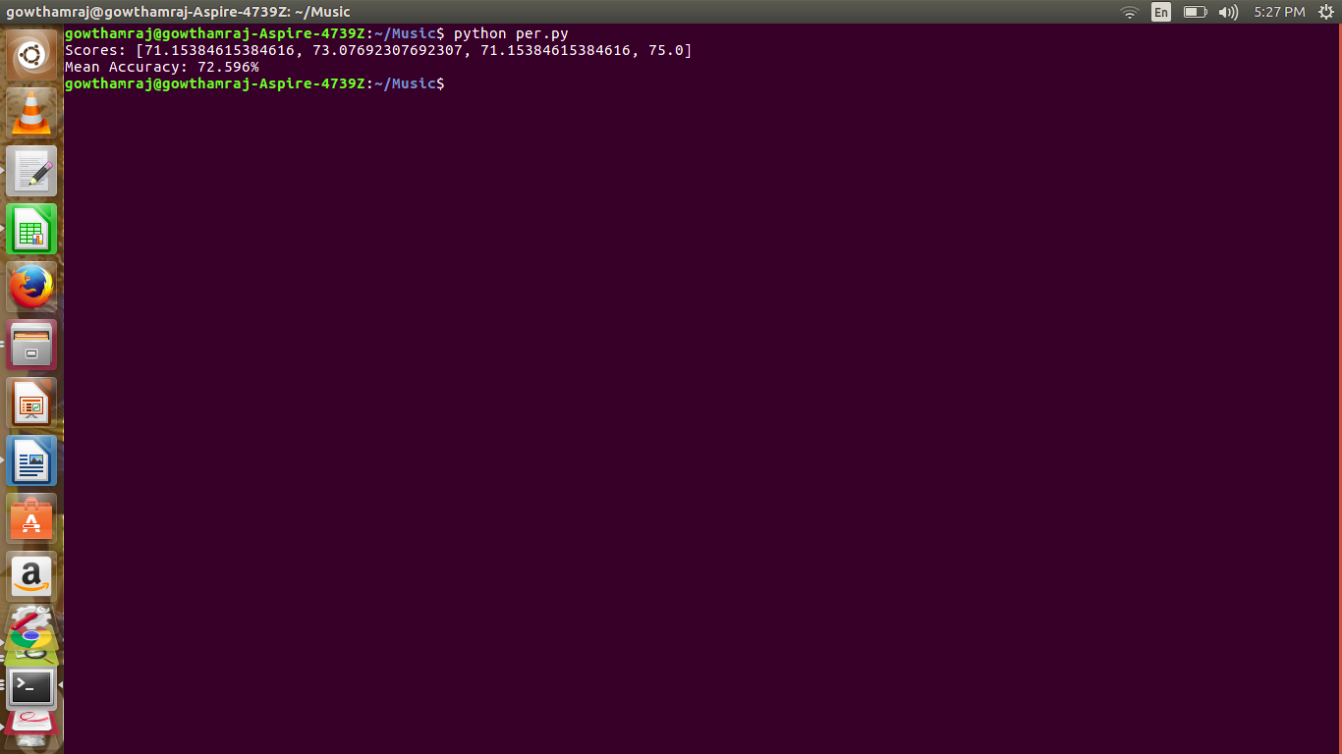

When eta=0.5 and iterations=500 ,the

accuracy was 73.077%.

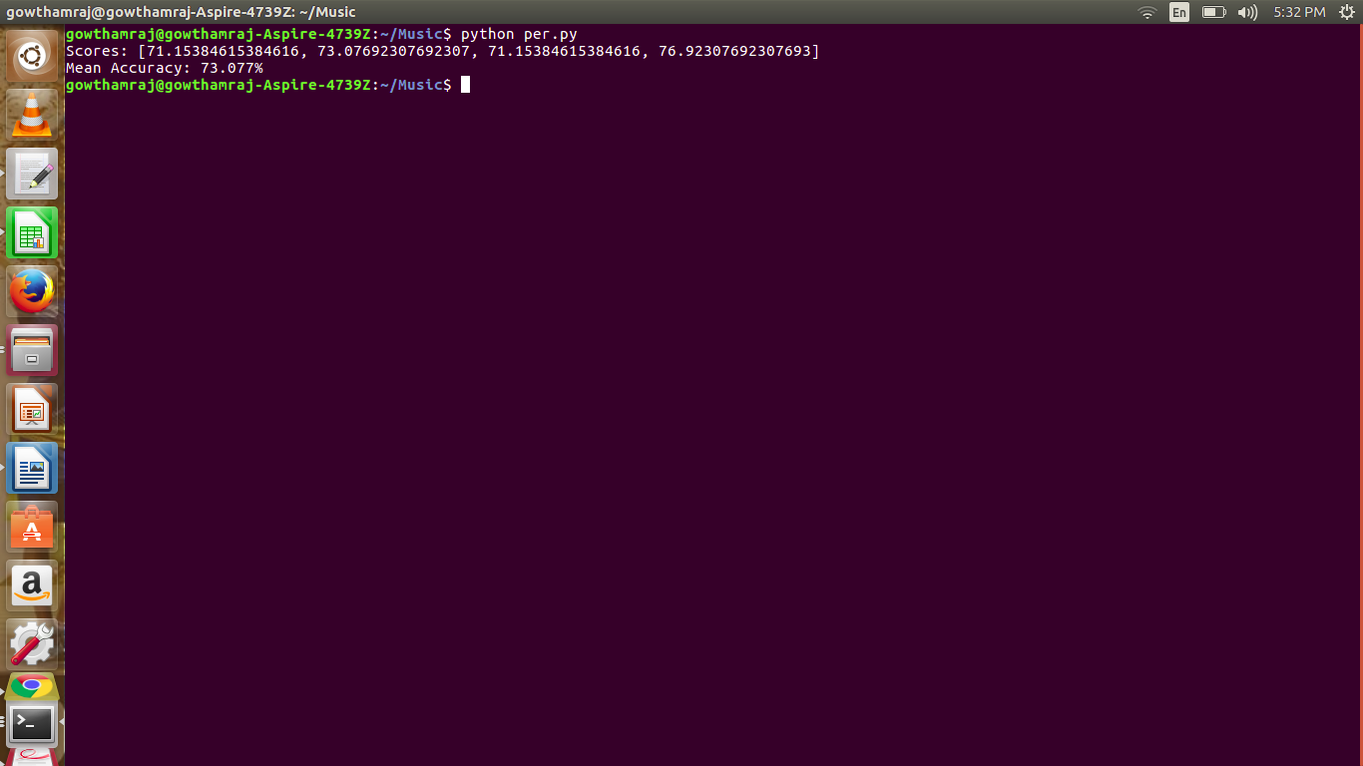

MultiLayer Perceptron:

XOR GATE:

We modify ETA also knows as Learning Rate and the number of iterations to obtain the output.

When eta=0.1, number of iterations=100, output is wrong.

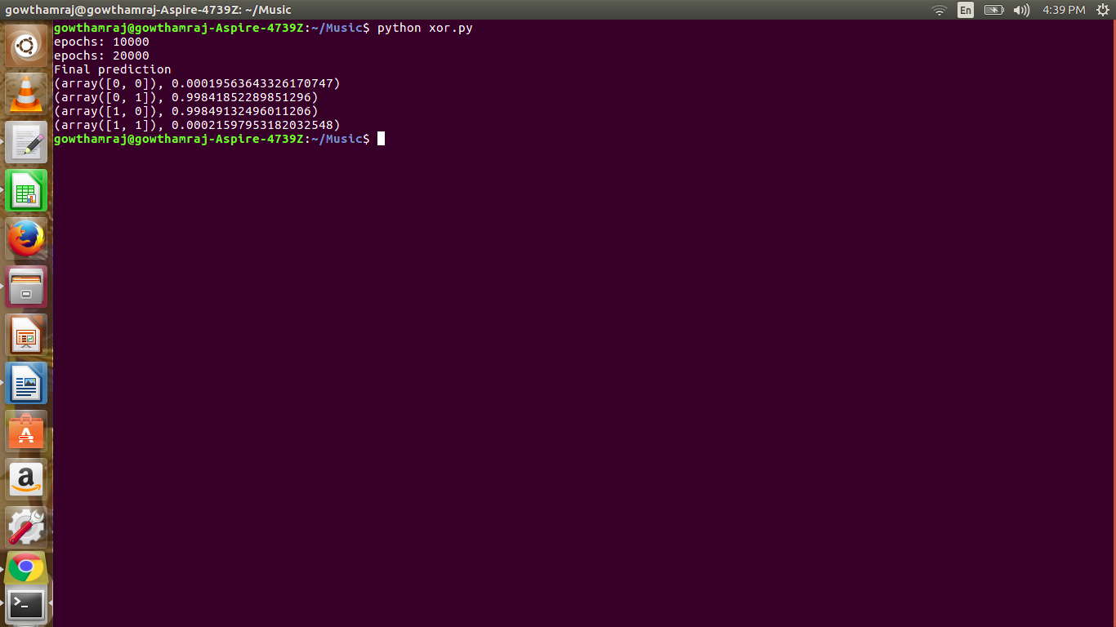

When eta=1.5, number of iterations=10,output is wrong.

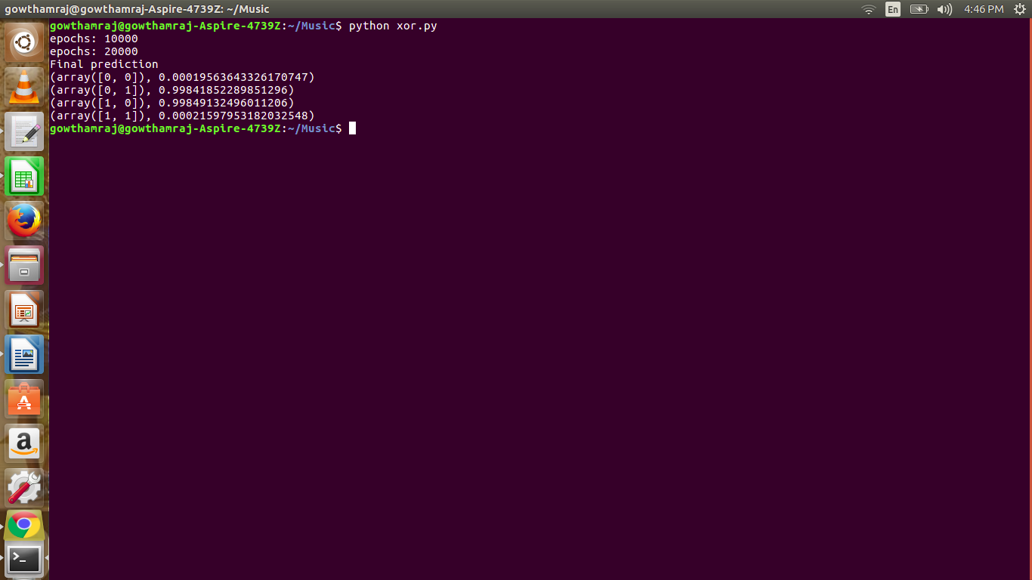

When eta=0.1, number of iterations=50000,



Output is almost correct.

SINGLE LAYER PERCEPTRON:

OR Gate:

|  |  |  |  |  |
| --- | --- | --- | --- | --- |
| ETA | Number OF Iterations | | | |
|  | | 10 | 100 | 500 |
| 0.1 | | False | True | True |
| 0.2 | | False | True | True |
| 0.3 | | False | True | True |
| 0.4 | | False | True | True |
| 0.5 | | True | True | True |
| 0.6 | | True | True | True |
| 0.7 | | True | True | True |
| 0.8 | | True | True | True |

When eta=0.4 , and number of iterations=10,

Output was wrong.

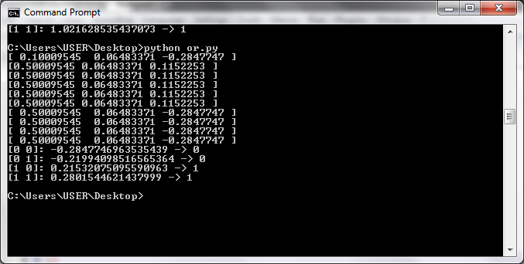

When eta=0.2 ,and number of iterations=100,

Output is correct.

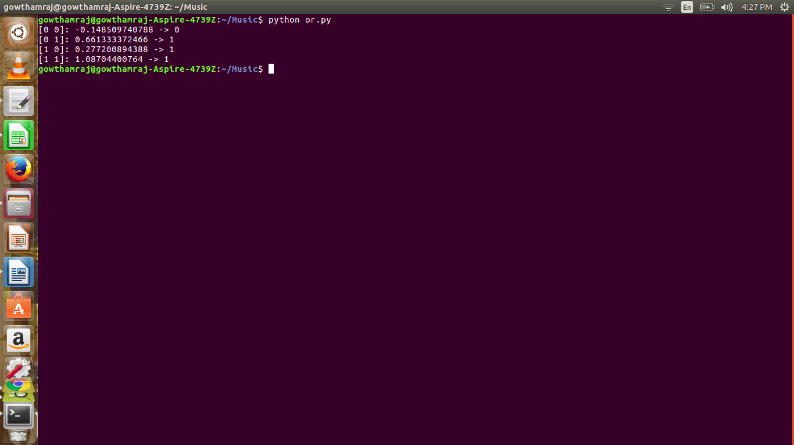

When we try to implement XOR Gate in a single layer perceptron with eta=0.1, epochs=1000,

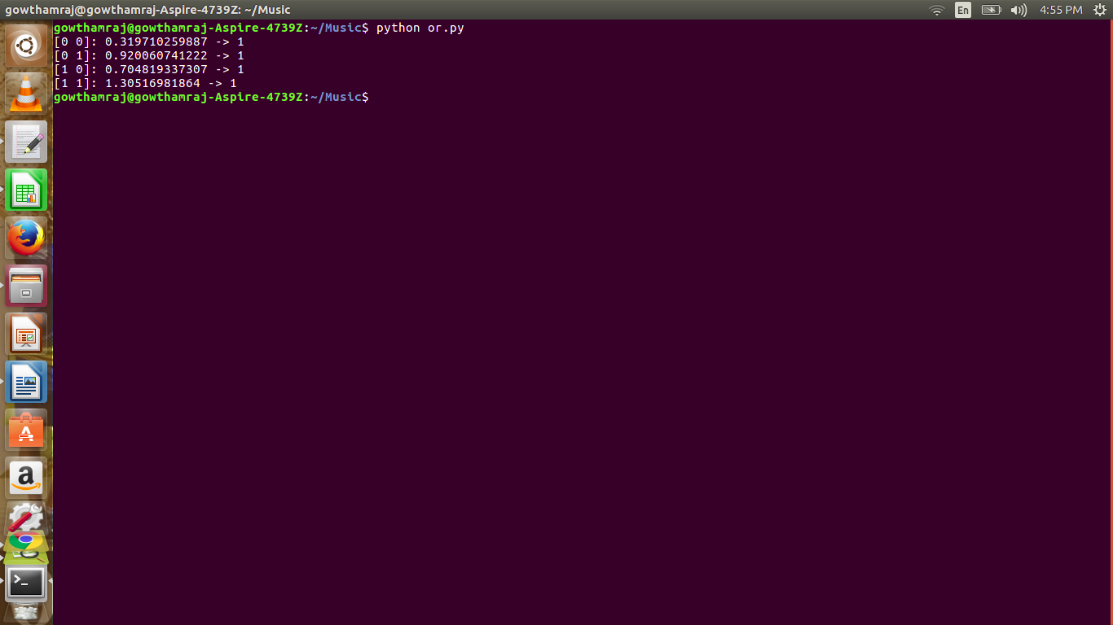

We do not get the expected output. This shows that XOR cannot be implemented in a single layer perceptron.

AND Gate:

|  |  |  |  |
| --- | --- | --- | --- |
| ETA | Number of Iterations | | |
|  | 10 | 100 | 500 |
| 0.01 | False | False | True |
| 0.1 | False | True | True |
| 0.4 | False | True | True |
| 0.5 | True | True | True |
| 0.6 | True | True | True |
| 0.7 | True | True | True |
| 0.8 | True | True | True |
| 0.9 | False | True | True |

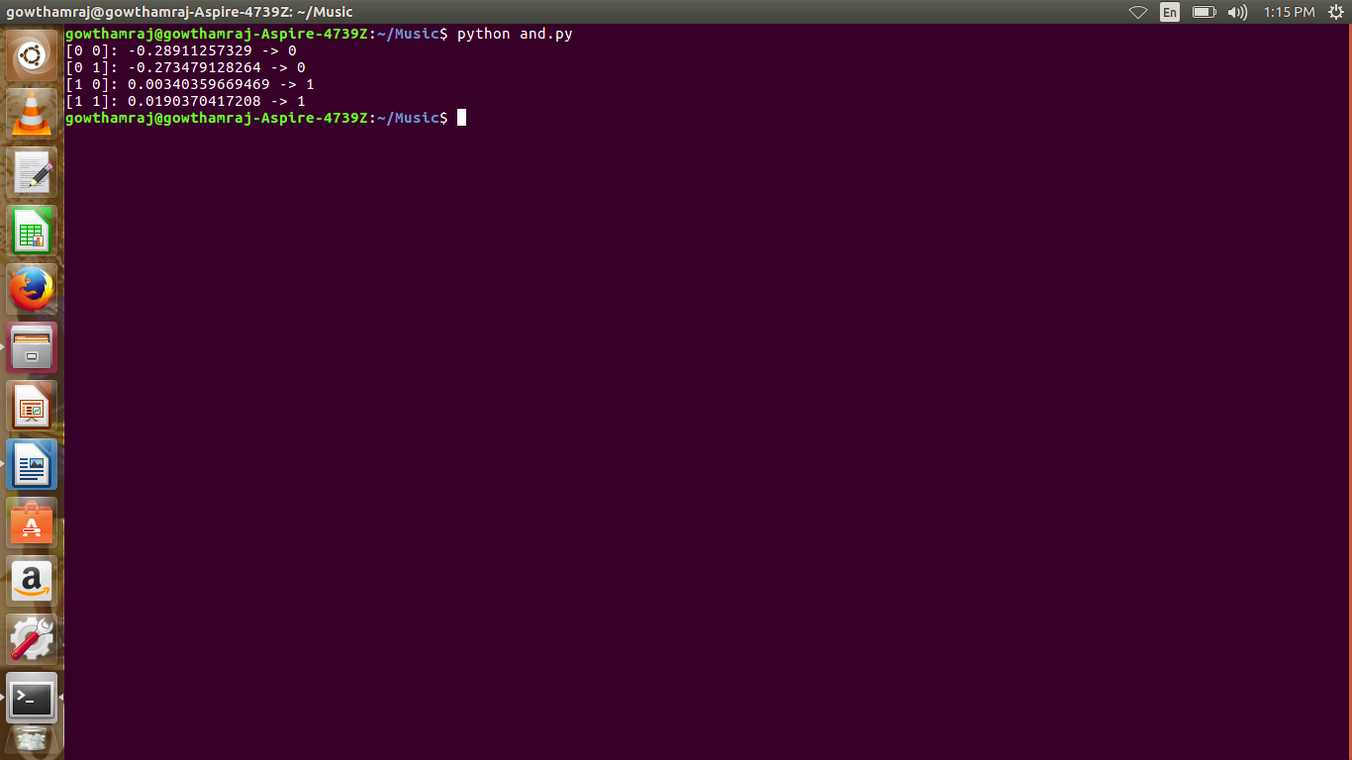

When eta=0.2 , epochs=10, expected output is not generated.

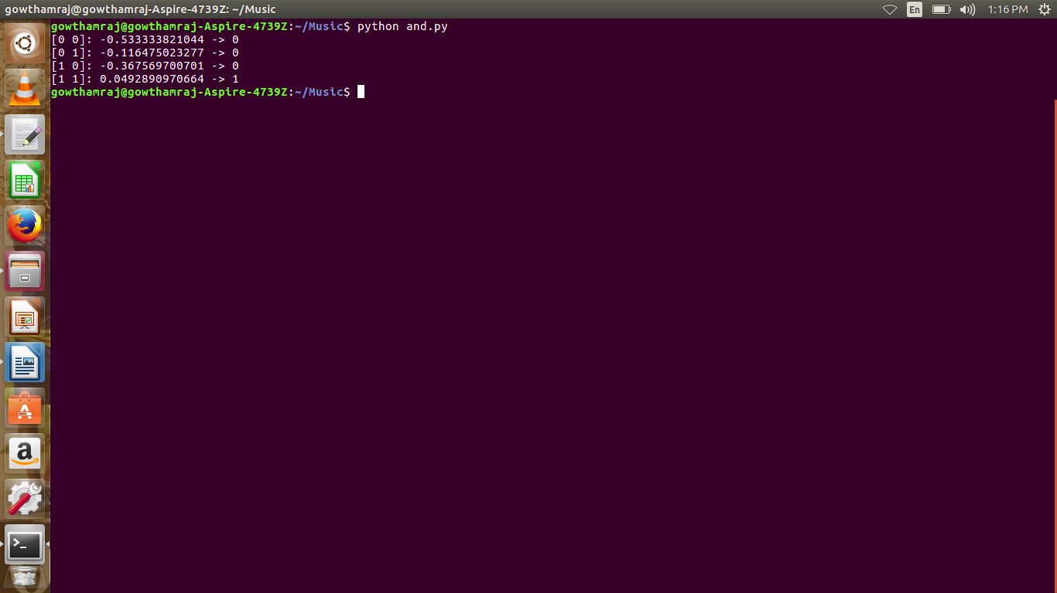

When eta=0.4 , epochs=1000, expected output is generated.

Linear Regression:

Training Set:

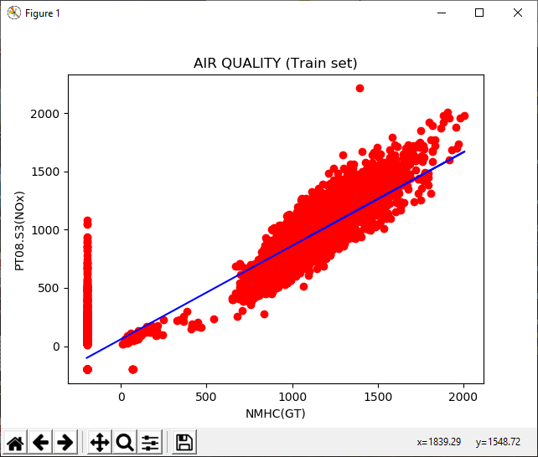

Training Set:

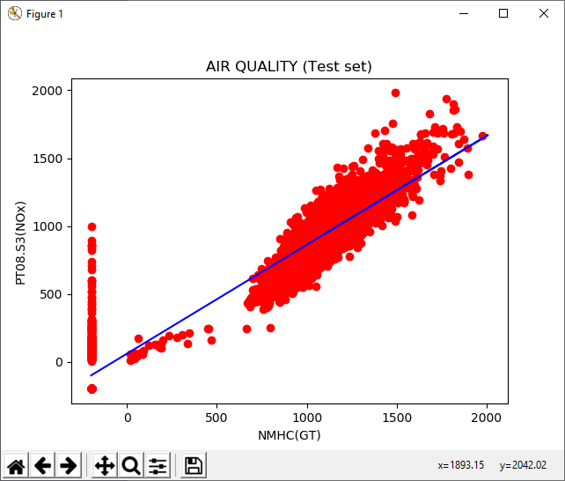

When different column of the dataset was chosen,

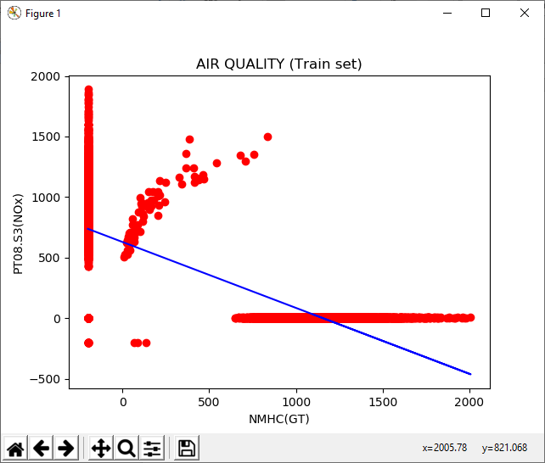

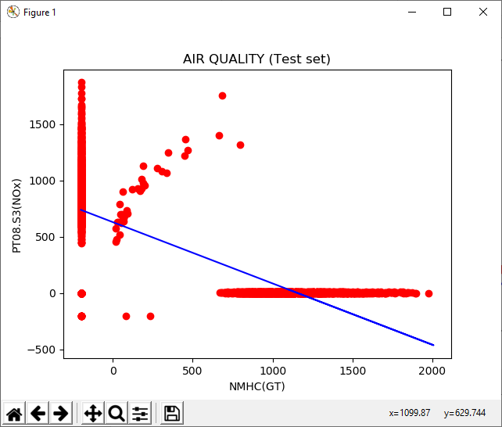

Simple Linear Regression:

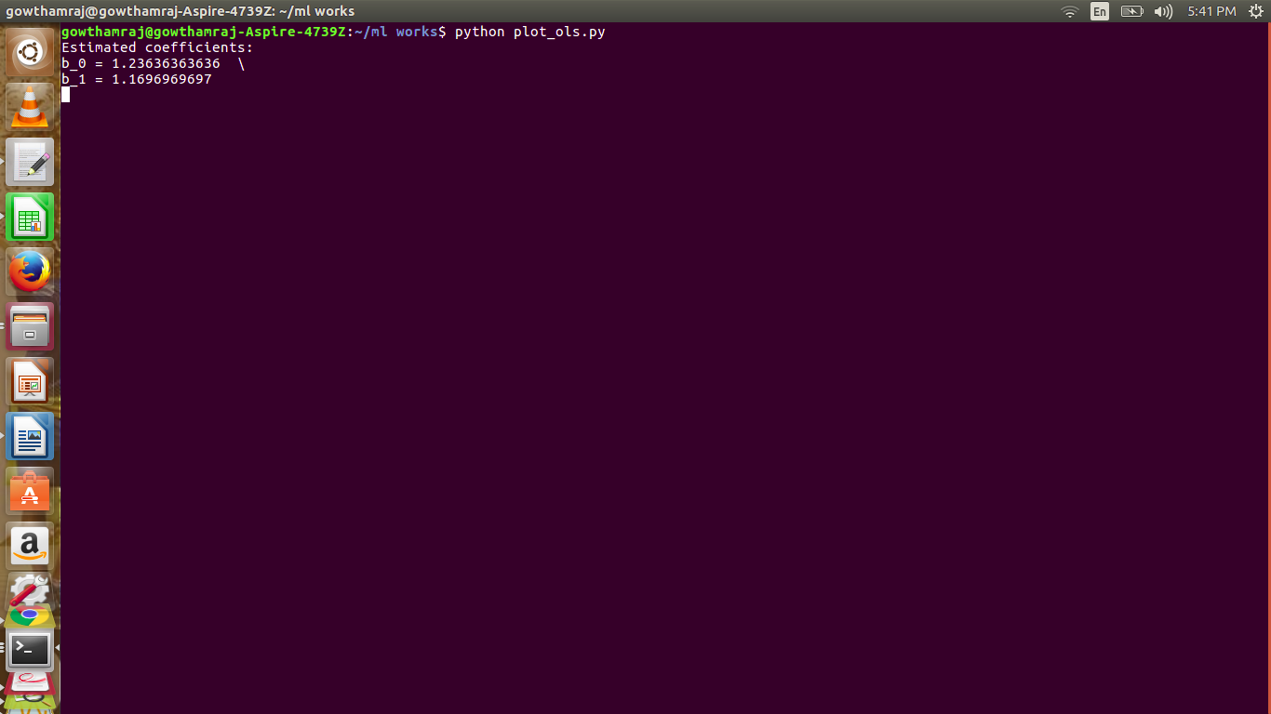

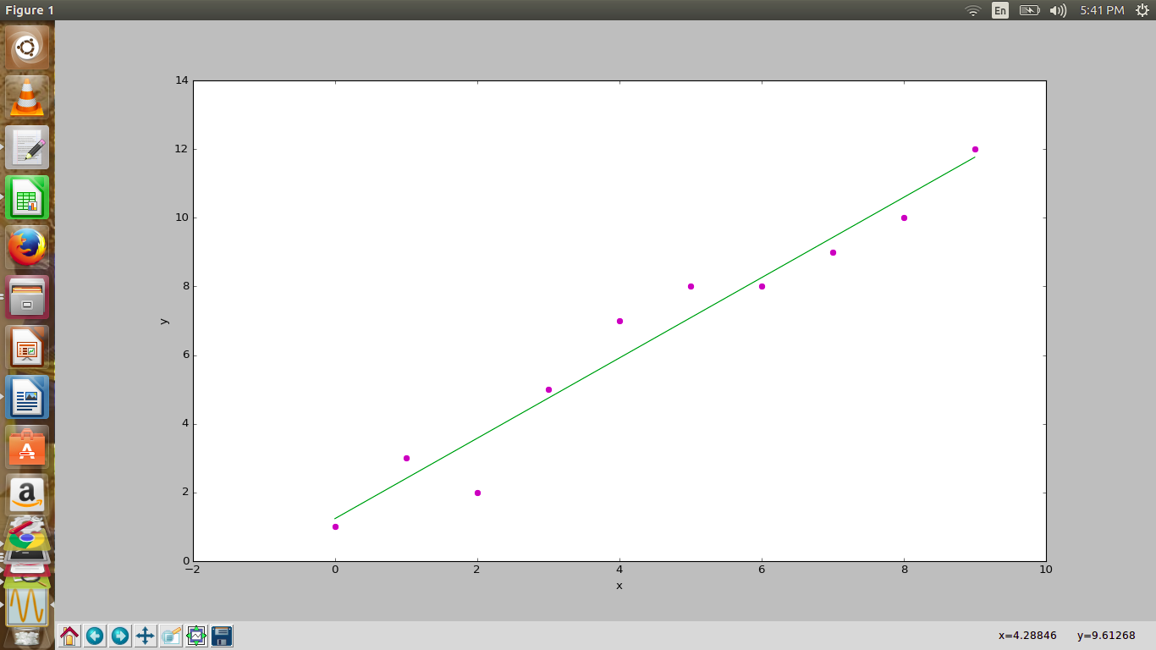

Multiple linear regression:

