

Certiﬁcate for COVID-19 Vaccination

Issued in India by Ministry of Health & Family Welfare, Govt. of India

Certiﬁcate ID

**50699786788**

# Beneﬁciary Details

Beneﬁciary Name / பலனா ெபய Age / வய

Gender / பா ன

ID Veriﬁed / அைடயாள சா Unique Health ID (UHID)

Beneﬁciary Reference ID Vaccination Status / த ைல

# Vaccination Details

Vaccinated By / த ைய வழ யவ Vaccination At / த வழ க ப ட இட

**Gowtham 20**

**Male**

**Aadhaar # XXXXXXXX2647**

**31542703368629**

**Fully Vaccinated (2 Doses)**

**Ashok Madhavan**

**Anumandai APHC, Viluppuram, Tamil Nadu**

Dose Number Date of Dose

Vaccine Name

Batch Number

Vaccine Type Manufacturer

ேடா எ ேடா வழ க ப ட

ேத

த ெபய ேப எ த வைக உ ப யாள

1/2 12 Sep 2021 COVISHIELD 4121Z205

COVID-19 vaccine,

non-replicating viral vector Serum Institute of India

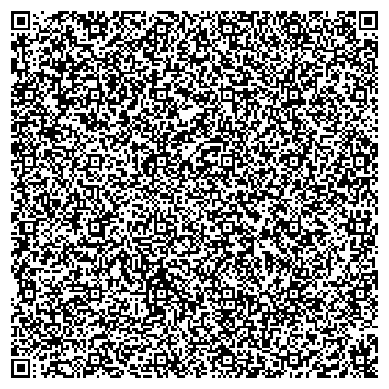

“ம ம மன ட

Together, India will defeat COVID-19”

- ரதம ம நேர ர ேமா

In case of any adverse events, kindly contact the nearest Public Health Center/

Healthcare Worker/District Immunization Oﬃcer/State Helpline No. 1075

ஏேத எ மைற ைள க ஏ ப டா , தய ெச அ காைம ள ெபா

காதார ைமய / ஆேரா ய பராம ப யாள / மாவ ட த அ வல / மா ல உத எ . 1075ஐ ெதாட ெகா ள .

This certiﬁcate can be veriﬁed by scanning the QR code at

[http://verify.cowin.gov.in](http://verify.cowin.gov.in/)

2/2 15 Dec 2021 COVISHIELD 4121Z258

COVID-19 vaccine,

non-replicating viral vector

Serum Institute of India Pvt. Ltd.