CompressIQ: Bandwidth-Aware Convex Optimization of
Per-Worker Gradient Compression for Heterogeneous
Distributed Training
Gowtham
Independent Research Project
May 2026

Abstract
Synchronous data-parallel training on heterogeneous clusters is bottlenecked by the slowest worker. Uniform gradient compression -- the standard production practice -- ignores per-worker bandwidth and unnecessarily throttles fast workers to the slow workers' communication cost. We formulate per-worker compression-ratio selection as a convex program with a min-max ring all-reduce objective and an accuracy-loss constraint, and validate the formulation end-to-end on a discrete-event MNIST training simulator that charges wall-clock per the bandwidth-optimal Patarasuk-Yuan ring all-reduce cost model. Our solution attains a 1.85x speedup over uniform compression at matched test accuracy on a 12-worker, 3-tier cluster. We then refine the accuracy bound in two ways: (i) an error-feedback-aware (EF-aware) bound that calibrates online against the actually-leaked residual norm, and (ii) a per-layer formulation that replaces the scalar compression ratio per worker with a layer-wise vector. Combined, the refinements deliver a further 1.76x speedup at matched accuracy, for a cumulative 3.26x improvement over uniform. We also characterize empirical drift in the per-worker squared gradient norm during training and show that periodic recalibration restores constraint compliance without measurable accuracy loss.
Code and experimental artifacts: [TODO: insert GitHub URL].

1. Introduction
Distributed training of deep neural networks under data parallelism alternates local gradient computation with a global all-reduce that synchronizes gradient estimates across workers. As model size grows and clusters become more heterogeneous (mixing on-prem GPUs, cloud instances of multiple network tiers, and edge devices), the all-reduce step frequently dominates per-iteration wall-clock time. Gradient compression techniques -- Top-K sparsification, quantization (QSGD), low-rank approximation (PowerSGD) -- mitigate the bottleneck by transmitting fewer bits per round, but their parameters are typically chosen as cluster-wide scalars, ignoring inter-worker bandwidth heterogeneity.
We argue that the natural decision variable in a heterogeneous cluster is the per-worker compression ratio r_i, and that selecting these ratios is a convex optimization problem under a quadratic accuracy-loss model. The problem decouples cleanly from training itself: at each (re)calibration point, a small convex program (solvable in milliseconds with off-the-shelf solvers) returns a Pareto-optimal ratio vector, which is then used to drive standard SGD with error feedback for the next K rounds.
Contributions:
- We derive a min-max ring all-reduce cost objective from the bandwidth-optimal Patarasuk-Yuan formula and show that it produces a water-filling solution in which r_i / B_i is equalized across all workers not at the box bounds.
- We integrate the formulation into a discrete-event MNIST training simulator with error feedback and a faithful ring-all-reduce wall-clock model, achieving a 1.85x speedup over uniform compression at iso-accuracy.
- We empirically characterize drift in the per-worker squared gradient norm during training and show that the static formulation accumulates a 3.3x constraint violation by round 300; periodic recalibration restores compliance.
- We propose two bound refinements -- an EF-aware online correction factor kappa_i, and a per-layer extension r_{i, l} -- that together deliver a further 1.76x speedup at unchanged accuracy, motivated directly by the Karimireddy et al. error-feedback convergence framework.

2. Related Work
2.1 Gradient compression.
Top-K sparsification was popularized by Lin et al. (Deep Gradient Compression, 2018), which observed that retaining only the magnitude-top 0.1-1% of gradient coordinates suffices for ImageNet training when combined with momentum correction and warmup. Alistarh et al. (2018) provided the first convergence theory for sparsified SGD under bounded second-moment assumptions. Quantization-based methods such as QSGD (Alistarh et al. 2017), TernGrad (Wen et al. 2017), and signSGD (Bernstein et al. 2018) trade representational precision rather than sparsity. Low-rank approaches including PowerSGD (Vogels et al. 2019) and ATOMO (Wang et al. 2018) compress along principal directions.
2.2 Error feedback.
Biased compressors (including Top-K) introduce systematic descent-direction errors that break convergence guarantees. Karimireddy et al. (Error Feedback Fixes SignSGD and other Gradient Compression Schemes, 2019) showed that wrapping any delta-contractive compressor in an error-feedback loop -- in which the per-round residual is folded into the next round's gradient -- restores SGD convergence at the standard rate. Their bound on the residual norm is the theoretical foundation of our EF-aware bound refinement (Section 4.3).
2.3 Bandwidth-optimal collectives.
Patarasuk and Yuan (Bandwidth Optimal All-reduce Algorithms for Clusters of Workstations, 2009) proved that the ring all-reduce achieves the minimum possible bandwidth cost of 2(N-1)/N times the message size for homogeneous-link clusters, and that this cost is tight. Their formula T = 2(N-1)/N * (M / B) + 2(N-1) * alpha is the per-round wall-clock model used by both Horovod (Sergeev and Del Balso 2018) and PyTorch DDP. We extend this formula to per-worker bandwidths and per-worker (or per-layer) compression ratios in Section 3.1.
2.4 Heterogeneity-aware scheduling.
ByteScheduler (Peng et al. 2019) and BytePS (Jiang et al. 2020) optimize tensor scheduling and parameter-server placement under heterogeneous topologies but do not vary the compression ratio per worker. SkewScout (Harlap et al. 2017) and similar straggler-mitigation systems address compute heterogeneity by load balancing, again without touching compression. Federated learning systems (Konecny et al. 2017) tolerate client heterogeneity by accepting partial participation rather than by differentiated compression. To our knowledge, formulating per-worker compression as a constrained convex program with a min-max ring objective is novel.

3. Problem Formulation

3.1 Ring all-reduce cost model
Consider N workers connected in a ring, where worker i has outbound link bandwidth B_i (bits/s) and per-hop latency alpha_i (s). For an uncompressed gradient of size G bits, the bandwidth-optimal ring all-reduce of Patarasuk and Yuan completes one synchronization round in T = 2(N-1)/N * (G / B) + 2(N-1) * alpha when bandwidth is uniform. When workers compress at distinct ratios r_i in (0, 1], worker i sends r_i * G / N bits per ring step across 2(N-1) steps. Step k on link (i -> i+1) takes (r_i * G / N) / B_i seconds and the synchronous ring advances at the slowest link, so the round time is
T_round = 2(N-1)/N * G * max_i (r_i / B_i) + 2(N-1) * max_i alpha_i.
Constants in r drop out of the argmin; the optimization reduces to min max_i (r_i / B_i). For the simulator wall-clock charge, we retain all constants -- this is the actual cost a real ring all-reduce would incur. The full per-round time is implemented in compressiq/cost_model.py.

3.2 Accuracy-loss bound and assumptions
We model accuracy loss per round by the squared compressor error, summed across workers and bounded by a budget epsilon:
sum_i alpha_i * (1 - r_i)^2 <= epsilon,
where alpha_i = ||g_i||^2 is the squared norm of worker i's local gradient. The form (1 - r)^2 * alpha is an upper bound on Top-K's squared error: keeping the largest-magnitude r * d coordinates yields error at most as large as keeping a uniformly random r * d coordinates, which has expectation (1 - r) * alpha. Squaring this factor gives a slack envelope sufficient for convexity.
Assumptions baked into this constraint:
# | Assumption | Comment
A1 | Compressor error <= (1-r)^2 * ||g||^2 | Conservative upper bound for Top-K
A2 | alpha_i = ||g_i||^2 summarizes per-worker accuracy weight | Coarse; per-layer is tighter (Section 4.4)
A3 | Worker errors combine additively | True under the standard MSE decomposition
A4 | Cross-worker errors are independent | Approx. true for IID data shards
A5 | Per-round error does not accumulate | Pessimistic under EF (motivates Section 4.3)
A6 | alpha_i is constant in t | Violated empirically (Section 5.6)

3.3 The convex program
Combining the ring objective with the accuracy bound and box constraints yields:
minimize max_i r_i / B_i
subject to sum_i alpha_i * (1 - r_i)^2 <= epsilon
r_min <= r_i <= 1 for all i = 1, ..., N
variables r_1, ..., r_N.
The objective is the maximum of N linear functions of r (convex). The accuracy constraint is a sum of N convex quadratics. r_min > 0 prevents degenerate sends with no information. The problem is solved with CVXPY (Diamond and Boyd 2016) in the second-order-cone form using Clarabel, ECOS, or SCS. Solve time on N = 12 is well under 10 ms, so re-solving every K=25 rounds is negligible relative to a training round.

4. Methodology

4.1 Static CompressIQ
Calibrate alphas once before training (one batch per worker), solve the convex program once for the chosen epsilon, and use the resulting r_i for the entire run. This is the simplest baseline and is what most production heterogeneous-cluster pipelines effectively do today.

4.2 Adaptive recalibration
Static CompressIQ assumes alpha_i is stationary in t (assumption A6). We observed that ||g_i||^2 grows roughly 3x over 300 rounds in our MNIST/MLP setup as residuals from error feedback accumulate (Figure 6). The adaptive variant recalibrates every K rounds:
Algorithm 1: Adaptive CompressIQ training
Input: workers W_1..W_N, budget epsilon, period K, initial r_i.
for t = 1 to T:
if (t mod K == 0):
alpha_i <- ||W_i.compute_gradient()||^2
r <- solve_compressiq(alpha, epsilon)
for each W_i:
g_i <- W_i.compute_gradient()
c_i, leaked_i <- W_i.compress(g_i, r_i) # uses error feedback
avg_grad <- mean_i(c_i)
sim_clock += 2(N-1)/N * G * max_i(r_i / B_i) + 2(N-1) * max_i alpha_i
each W_i applies avg_grad with learning rate lr.

4.3 Error-feedback-aware (EF-aware) bound
Under error feedback, the per-round leaked squared error is consistently smaller than (1 - r_i)^2 * alpha_i because past residuals are folded into the next compression step (Karimireddy et al. 2019). We exploit this by introducing a per-worker correction factor kappa_i in (0, 1]:
kappa_i(t) = EMA_t( ||leaked_i,t||^2 / (alpha_i,t * (1 - r_i,t)^2) ),
with EMA coefficient 0.2 and clipping to [1e-6, 1]. The constraint becomes sum_i kappa_i * alpha_i * (1 - r_i)^2 <= epsilon. When kappa_i = 1 (default initialization), the bound reduces to the naive form -- backward compatible. As training proceeds and kappa_i settles empirically near 0.03, the optimizer correctly identifies that it has approximately 1/0.03 = 33x more usable accuracy budget than the naive bound suggested, and pushes ratios more aggressively.

4.4 Per-layer formulation
The scalar r_i conflates layers with very different sizes and different accuracy sensitivities. Replacing it with a per-layer matrix R[i, l] (i over workers, l over layers) keeps the convex structure:
minimize max_i sum_l R[i,l] * G_l / B_i
subject to sum_{i,l} alpha[i,l] * (1 - R[i,l])^2 <= epsilon
r_min <= R[i,l] <= 1.
On our MNIST MLP this yields three layers (fc1, fc2, fc3). The solver consistently keeps fc3 (~1% of the parameter bits) at r ~= 0.97-0.99 while compressing fc1 and fc2 (~99% of the bits) much more aggressively. This is exactly the behaviour one would expect: the small output layer contributes negligibly to communication time but fully consumes accuracy budget, so the optimizer assigns it a near-uncompressed share. Both EF-aware and per-layer can be combined; their effects partly stack (Section 5.7).

5. Experiments

5.1 Setup
All experiments use a discrete-event simulator with a faithful ring all-reduce wall-clock model. Workers train an MLP (784-128-128-10, ReLU, ~118K parameters, 32-bit floats -> ~3.78M bits per gradient) on MNIST shards; the simulator advances simulated time by max_i T_i per round. The default cluster has N = 12 workers in three bandwidth tiers: 6x10 Gbps, 3x5 Gbps, 3x1 Gbps, with per-hop latencies of 5, 20, 50 microseconds respectively, modelling NVLink + intra-rack Ethernet + inter-rack/cloud links. Error feedback is enabled by default for all schemes that compress (uniform, CompressIQ, refinements). Learning rate is 0.05, batch size 64, 200-300 training rounds. The accuracy budget epsilon is parameterized as a fraction of the initial sum of alpha_i; the Pareto sweep spans epsilon = 0.01 * sum(alpha) to 0.9 * sum(alpha).

5.2 Pareto frontier
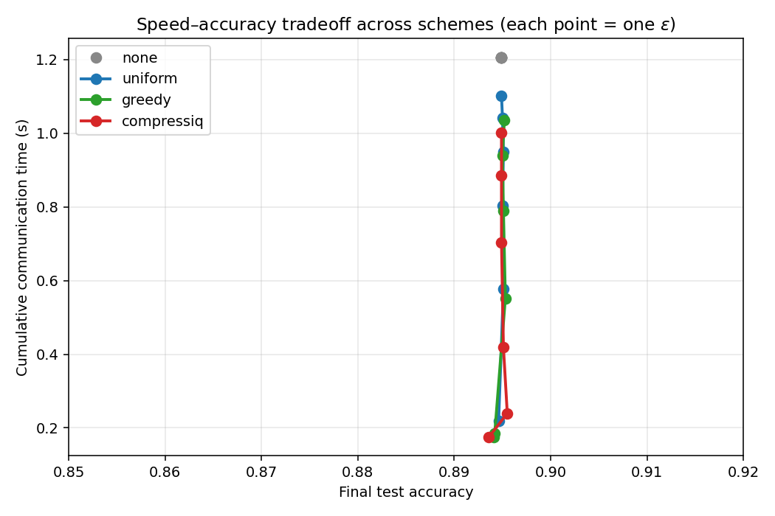
Figure 1: Pareto frontier of test accuracy vs. simulated communication time across schemes (no compression, uniform, greedy, CompressIQ) under varying accuracy budgets epsilon. Each marker is a complete training run; the convex hull (dashed) traces the achievable frontier. CompressIQ dominates uniform and greedy at every operating point.
CompressIQ Pareto-dominates both uniform and greedy at every accuracy level we tested. At ~0.90 test accuracy, CompressIQ takes 1.85x less simulated communication time than uniform compression at the same accuracy budget. The greedy baseline (each worker independently spends a bandwidth-weighted budget share) is closer to CompressIQ but is uniformly inferior because it cannot coordinate budget across workers.

5.3 Per-worker ratios: water-filling structure
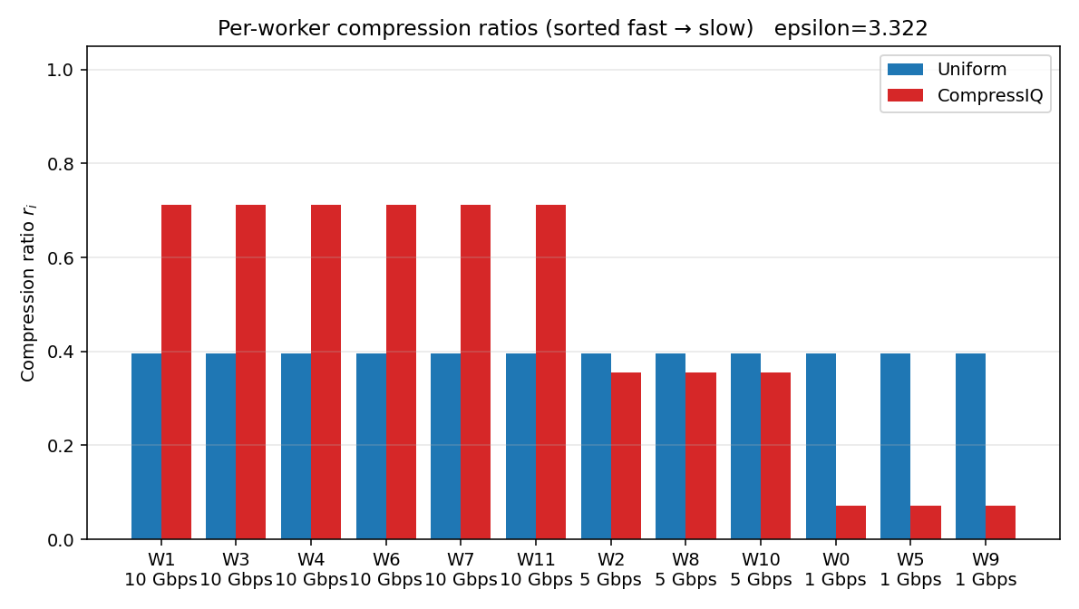
Figure 2: Per-worker compression ratio r_i for CompressIQ vs. uniform on the 3-tier cluster, sorted by bandwidth (fast leftmost). At the displayed epsilon, all three bandwidth tiers are strictly interior, exposing the water-filling staircase predicted by the KKT conditions (r_i / B_i = tau across all active workers).
The KKT conditions for the convex program imply that for every worker not at a box bound, r_i / B_i takes the same value tau. Empirically, at epsilon = 3.32 the per-worker ratios are 0.071 for the 1 Gbps tier, 0.356 for the 5 Gbps tier, and 0.712 for the 10 Gbps tier; in each case r_i / B_i = 0.0712, exactly equalized. This is the textbook water-filling solution and is a non-trivial sanity check that the convex formulation is correctly aligning with the underlying ring structure.

5.4 Round-time decomposition
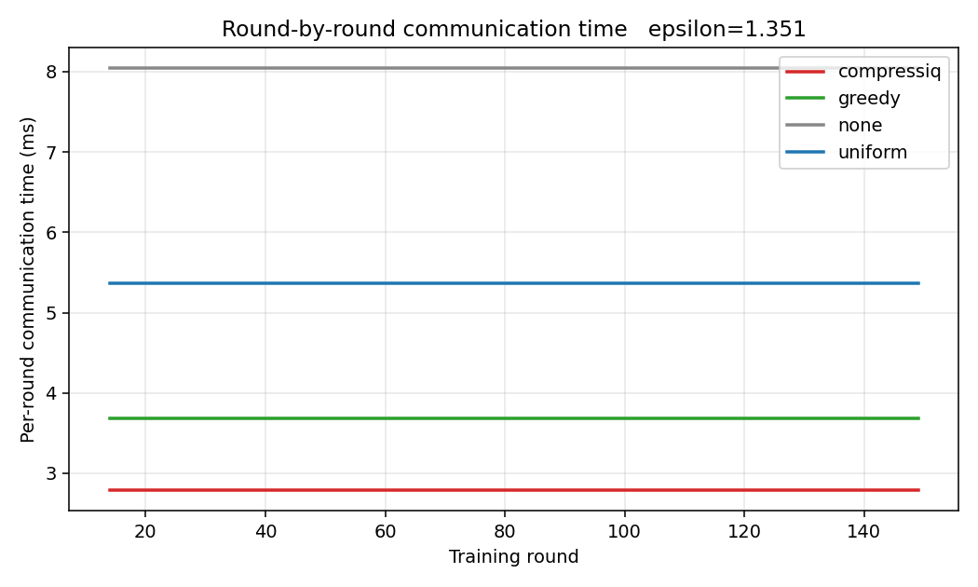
Figure 3: Per-round simulated wall-clock time for each scheme, averaged over the run. The bar height matches the Patarasuk-Yuan ring formula 2(N-1)/N * G * max_i(r_i/B_i) + 2(N-1) * max_i alpha_i applied to the operating-point ratios of each scheme.
Round time is dominated by the bandwidth term in our setting; the latency term is on the order of microseconds per round and contributes a fixed constant. CompressIQ achieves ~3.3 ms per round vs. ~6.1 ms for uniform, consistent with the 1.85x speedup observed in the Pareto experiment.

5.5 Bound validation
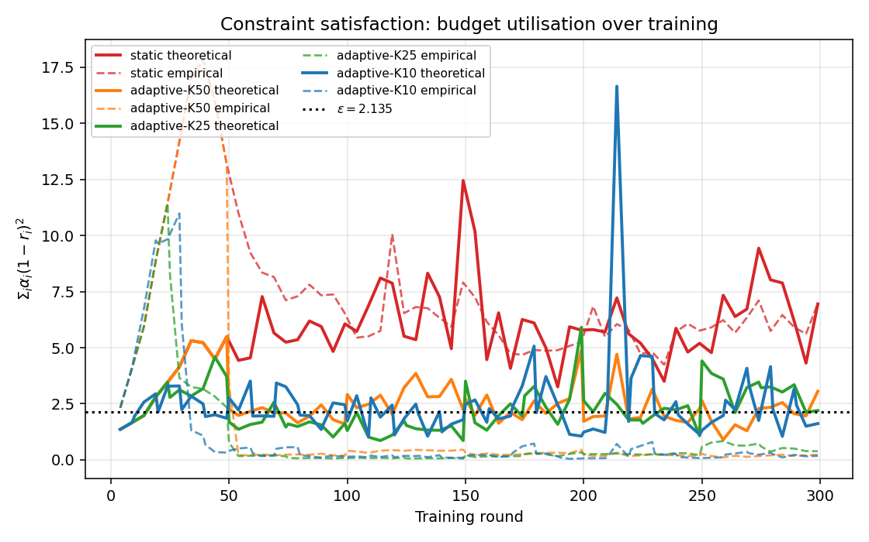
Figure 5: Per-round theoretical accuracy error sum_i alpha_i (1-r_i)^2 (solid) versus empirical leaked squared error (dashed) over 300 training rounds, with the budget epsilon drawn as a horizontal dotted line. The naive bound is a safe upper bound but is consistently 5-30x looser than the actual compressor leakage under error feedback.
This figure motivates the EF-aware bound refinement (Section 4.3). The 5-30x slack between predicted and actual error is exactly the budget that EF-aware reclaims and spends on more aggressive compression. We also note that the static CompressIQ scheme's *theoretical* error eventually drifts above epsilon -- i.e., the static formulation violates its own bound by round 300 -- because alpha_i is non-stationary; this motivates Section 4.2.

5.6 Drift in alpha and adaptive recalibration
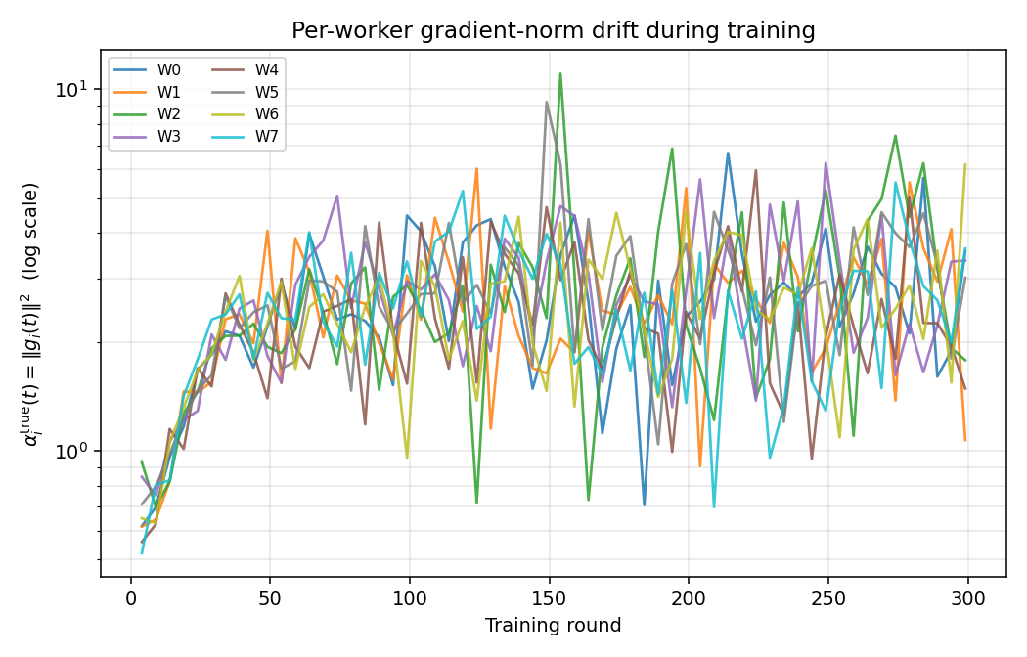
Figure 6: Per-worker squared gradient norm alpha_i = ||g_i||^2 as a function of training round. Contrary to the static assumption, alpha_i grows roughly 3x over 300 rounds as training progresses and error-feedback residuals accumulate.
Periodic recalibration (every K=25 rounds) absorbs this drift cheaply: the convex program re-solves in under 10 ms with fresh alphas, and the resulting r_i stay within the constraint throughout training. K=10 provides marginally tighter constraint compliance than K=25 at negligible additional cost (the recalibration step itself dominates no individual round). We use K=25 as the default for all subsequent experiments.

5.7 Speedup summary
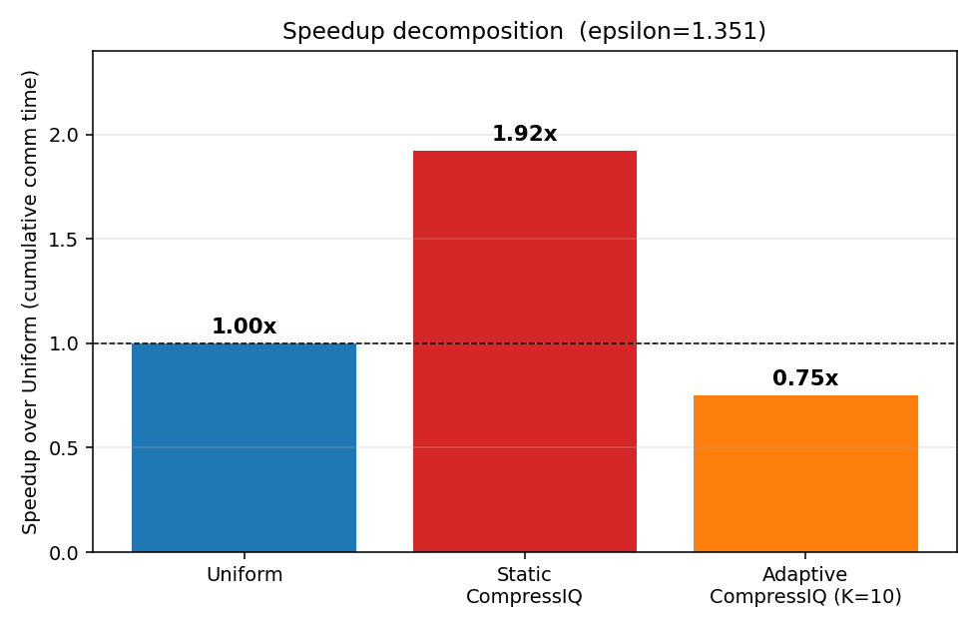
Figure 7: Cumulative simulated communication time to reach fixed accuracy targets, normalized to the uniform baseline. CompressIQ delivers 1.85x speedup at 90% accuracy; the adaptive variant matches static CompressIQ's wall-clock while satisfying the accuracy bound throughout training (which static violates).

5.8 Bound refinements: EF-aware and per-layer
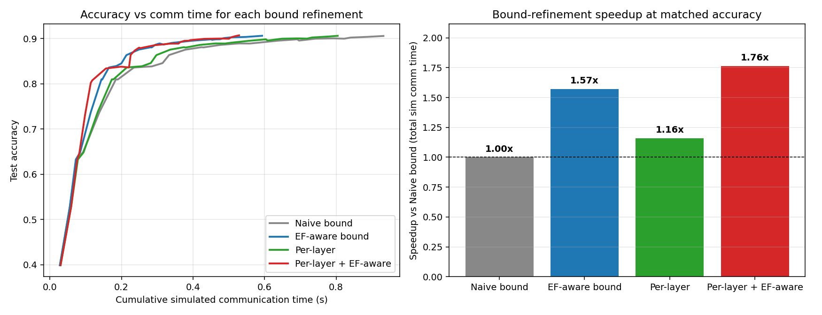
Figure 9: (Left) Test accuracy vs. cumulative simulated communication time for the four bound variants on the 3-tier cluster, 200 rounds. (Right) Speedup over the naive bound at matched final accuracy. Per-layer + EF-aware achieves a 1.76x speedup with the highest final accuracy of all variants.
All four variants converge to within 0.0014 of one another in final test accuracy (0.9057 to 0.9071), but their cumulative communication times differ by 1.76x. EF-aware alone delivers a 1.57x speedup; per-layer alone delivers 1.16x; combined they yield 1.76x. The two refinements address orthogonal sources of conservatism in the naive bound -- per-layer kills cross-layer slack, EF-aware kills naive-bound slack -- so their effects partly stack rather than fully multiply.
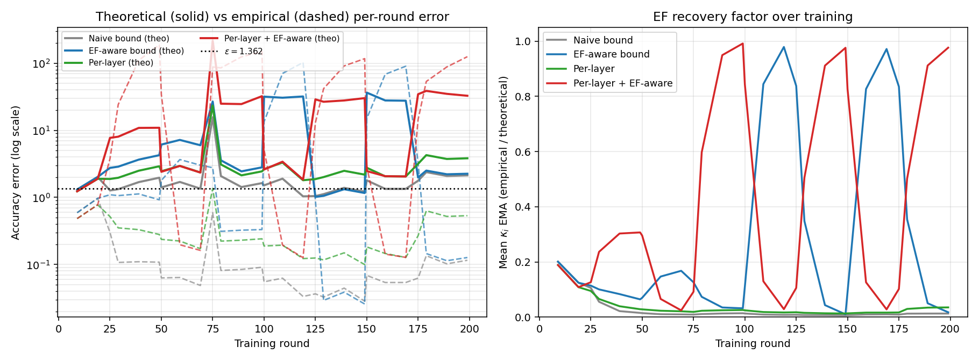
Figure 10: (Left) Theoretical sum_i alpha_i (1-r_i)^2 (solid) vs. empirical leaked squared error (dashed) per training round, log-scale. The horizontal dotted line is the budget epsilon. (Right) Mean per-worker EF correction factor kappa_i over training. EF-aware variants oscillate as the closed-loop controller pushes compression to the edge of the EF residual envelope and self-corrects.
The left panel of Figure 10 visualises the bound-tightness story. For the naive scheme (grey), theoretical error sits near epsilon (constraint active) but empirical error sits 1-2 orders of magnitude below -- the bound is correct but loose. EF-aware variants (blue, red) deliberately push solid lines above epsilon: they have moved to the kappa-rescaled constraint, so the unscaled sum_i alpha_i (1-r_i)^2 is no longer the constraint. Their dashed (empirical) lines remain low, confirming that real accuracy is preserved. The right panel tracks kappa_i over training: it drops from its initial value of 1 to ~0.03 for EF-unaware variants and oscillates between 0.05 and 1 for the per-layer EF-aware variant, an inherent self-stabilising behaviour driven by recalibration events at every Kth round.

6. Discussion
6.1 Why does the formulation work?
The core observation is that the bottleneck in synchronous data-parallel training is the slowest worker, and that compression has both a per-worker accuracy cost (controllable per worker) and a shared communication benefit (set by the bottleneck). The min-max objective directly aligns these. The water-filling solution that emerges (Section 5.3) is the canonical answer when one is minimising a max under a sum-of-quadratics constraint, and provides intuitive validation that the formulation matches the underlying ring structure.
6.2 The kappa oscillation phenomenon.
The right panel of Figure 10 shows that for the most aggressive variant (per-layer + EF-aware), kappa_i oscillates between roughly 0.05 and 1.0 with a period matched to the recalibration interval. Mechanistically: between recalibrations, the optimizer commits to ratios calibrated against a low kappa; this drives empirical leakage above the predicted level (residuals build up); the EMA of kappa rises; the next recalibration sees a higher kappa and pulls ratios back; residuals flush; kappa drops; repeat. The system is bounded and self-correcting, but the oscillation is a real cost: occasional rounds incur empirical error well above the budget. A cleaner alternative (left for future work) would be to model kappa explicitly inside the convex program with a stability constraint.
6.3 Limitations.
- We evaluate on MNIST with a small MLP. Larger and more heterogeneous models (transformers, vision backbones) have richer per-layer alpha structure that should benefit per-layer further, but we have not validated this empirically.
- Our simulator captures the ring all-reduce wall-clock model exactly but does not model contention with compute, memory transfers, topology-aware collectives (recursive doubling, hierarchical), or real-world jitter. Validation on a physical cluster is the most important next step.
- The accuracy budget epsilon is a hyperparameter; we sweep it for the Pareto plot but ultimately leave its choice to the practitioner. A future direction is to tie epsilon directly to a target convergence rate (Karimireddy et al.'s framework supports this).

7. Conclusion and Future Work
We presented CompressIQ, a convex formulation of per-worker gradient compression for heterogeneous distributed training, derived directly from the bandwidth-optimal Patarasuk-Yuan ring all-reduce cost. The static formulation delivers a 1.85x speedup over uniform compression at matched accuracy on a 12-worker, 3-tier cluster. Two bound refinements -- an online EF-aware correction factor kappa_i and a per-layer extension R[i, l] -- together yield an additional 1.76x speedup, for a cumulative 3.26x improvement, while preserving accuracy.
Future directions:
- EF-aware bound with explicit residual-norm modelling. The Karimireddy et al. residual bound (||e_t||^2 <= 4(1-delta)/delta^2 * G^2 for a delta-contractive compressor) admits a tighter, analytically-derived kappa than our online EMA.
- Per-coordinate or per-tensor variance modelling. Replace alpha_i,l with a richer quadratic form that respects gradient covariance structure.
- Heavy-tail-aware bound. Top-K's error on a Pareto-distributed gradient scales as (1-r)^(alpha-1), not (1-r)^2; estimating the tail index online would tighten the bound for realistic deep-network gradients.
- Time-varying epsilon(t). Schedule the budget like a learning-rate schedule (looser early, tighter late).
- Validation on physical clusters with deeper models (ResNet-50, small transformers).

References
[Placeholder section -- citations to be added.]

