**HBFC Personal Loan Assignment**

By Gowtham Singaram

1.According to the data, What percentage of personal loans have availed by customers?

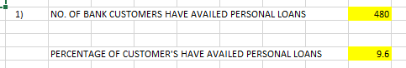

Customer took the personal loan is 480 . Percentage of it is 9.6%.

2.To generate a table for numerical data in a given data set? What are your observations?

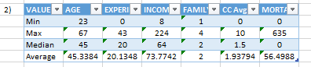

From the above data, we can see that the experience of the customer is proportional to their income. Hence, their CC Avg also have a reliable and in a descent rate.

From the Family members we can see that, in some case the income is increasing while the family members count is more.

3. Create a new categorical variable for Experience using 4 categories – a. 0 to 10 years b. 11 to 20 years c. 21 to 30 years and d. 30+ years.

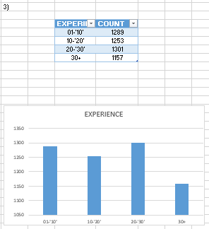

4.Create a scatter plot of the Age and the Experience variable. What do you observe?

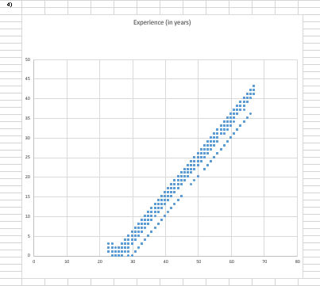

From the above plot, we can see that age and experience are correlated to each other. If the age is increasing then correspondingly the experience also increases. In the scatter plot the trend is towards the positive correlation.

5. What are the top 3 areas (ZIP Codes) where the bank’s customers are located?

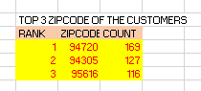

The Top three zip-code of the customers are listed above.

6. How many customers have a combination of Fixed Deposits and Credit Cards but not Personal Loan?



To know the details about the customer who has a good chances to avail the loan from the bank. 147 customers have a good score to avail loans.

7. What is the median income of the customers who have availed personal loans and compare it with the median income of those customers who have not availed personal loans? What do you infer?

 

In the above observed value, we can see that the Median value of the customers who has availed loans has higher median value than compare to the customer who haven’t availed loan. So we can come to the conclusion that who have higher income has avail the personal loans.

8. Create 4 separate Pivot Tables.

Summarise your data by percentages.

• Education vs Personal Loan

• TD Account Vs Personal Loan

• Online vs Personal Loan

• Income_Category vs Personal Loan

By comparing the personal loan with the other components, we can predict that the chances of the new customers who can be able to get the personal loan from the bank.

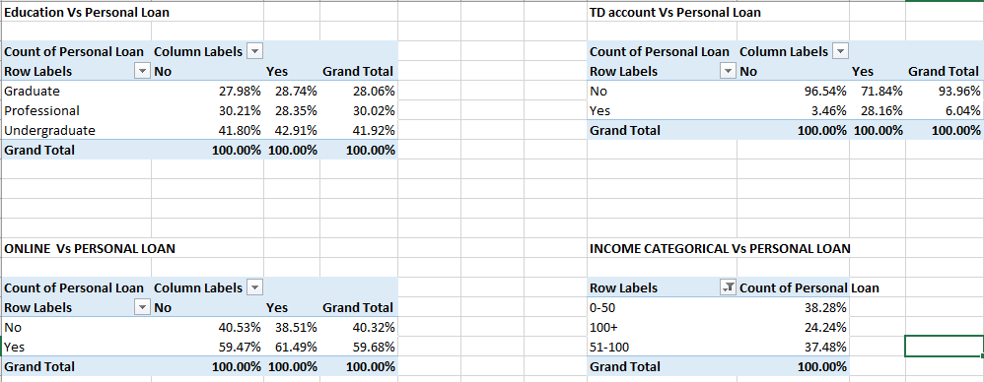

9. Analyse the Pivot tables created in the previous question and state any anomaly that you observe. Which categorical variables appear most important for your further study if you want to analyse which customers are most likely to take personal loans and why?

By analysing to the pivot table we can able to predict the customers who have a higher no. of chances to get a personal loan by the bank campaign.

From the analysis 9.6% customers have took the personal from the Bank and 90.4% to 89.56% doesn’t have any loans.

10. Strategy to increase the no. of persons to avail personal loans in campaign.

The Data given by the HBFC clearly shows that the more no. of customers are interested in online service and good in income categorical.

There is a huge possibility to accept if we run the offer through the loan campaigns.

If we execute the campaign by good advertisement and cover it with media support, we can surely achieve the good no. of loan acceptance from the customers.