Lab 2: Classification Using KNN and RNN Algorithms
Shiva Gowtham Kumar Vidiyala University of the Cumberlands MSCS-634-M20

Dataset Overview

The Wine dataset from Scikit-Learn contains information about different types of wine and their chemical properties. The dataset consists of 178 samples, 13 features, and 3 target classes. Before building the models, I explored the dataset to understand the feature distribution and class balance.

Step 1: Load and Prepare Dataset
import pandas as pd
import numpy as np
import matplotlib.pyplot as plt

from sklearn.datasets import load_wine
from sklearn.model_selection import train_test_split

# Load dataset
wine = load_wine()

X = wine.data
y = wine.target

# Dataset information
print("Features:", wine.feature_names)
print("Target Classes:", wine.target_names)

# Create DataFrame
df = pd.DataFrame(X, columns=wine.feature_names)
df['target'] = y

# Display first few rows
df.head()

Output:

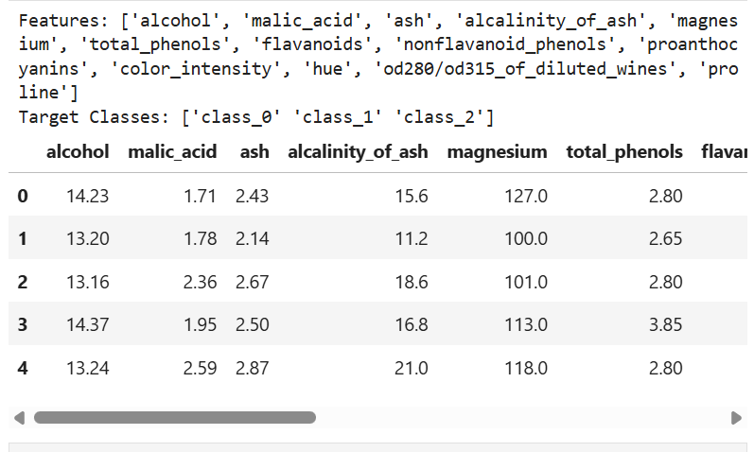

Split the dataset into 80% training and 20% testing sets.

Code:

X_train, X_test, y_train, y_test = train_test_split(
X,
y,
test_size=0.2,
random_state=42
)

Step 2: KNN Implementation

KNN is a supervised learning algorithm that classifies a data point based on the majority class of its nearest neighbors. In this lab, I tested multiple values of k (1, 5, 11, 15, and 21) and recorded the accuracy for each model to determine how the number of neighbors affects performance.

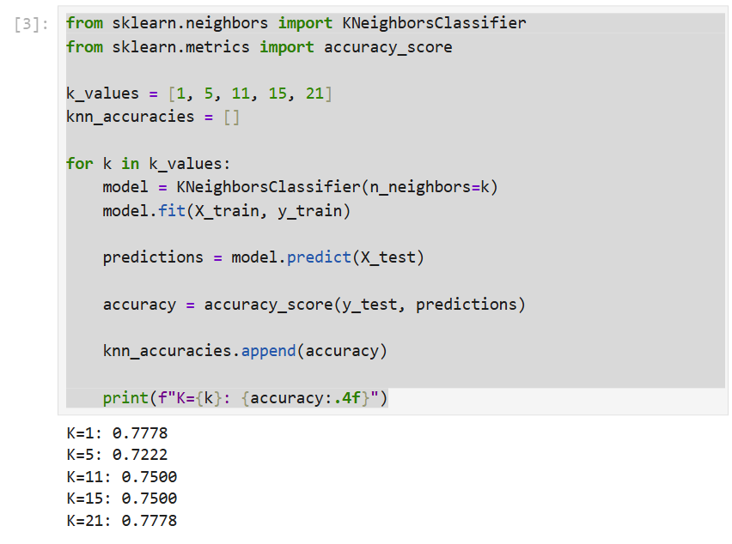

Step 3: Radius Neighbors (RNN)

Radius Neighbors Classification predicts a class based on all neighboring points within a specified radius. I tested several radius values ranging from 350 to 600 and evaluated the model performance using classification accuracy on the test dataset.

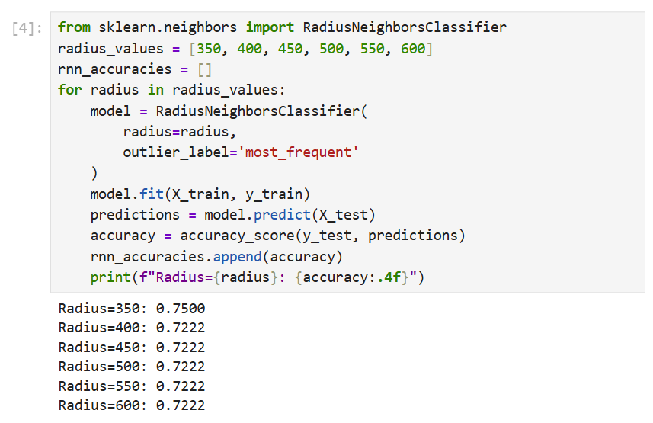

Step 4: Visualize and Compare Results

Knn plot

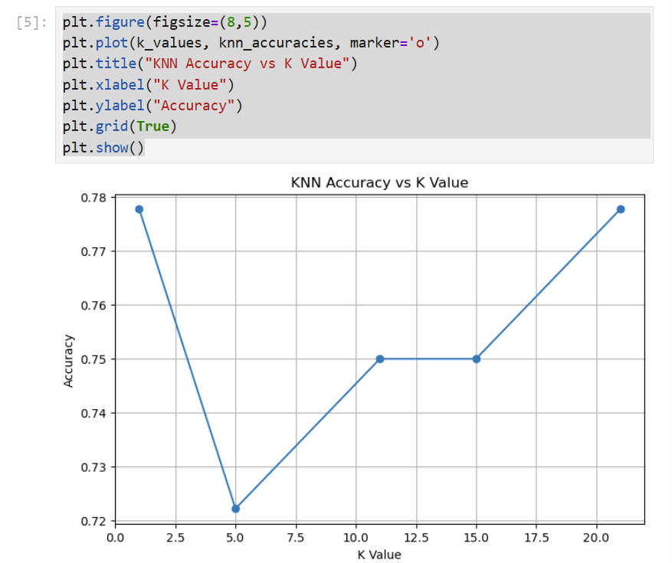

RNN Plot

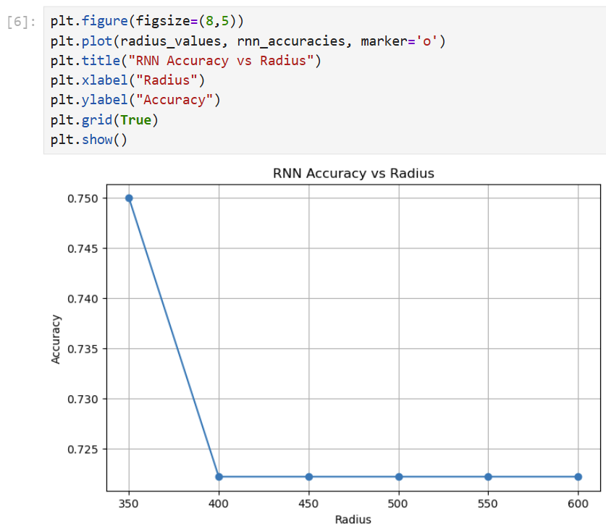

After evaluating both algorithms, I observed that KNN produced consistent classification performance across different values of k. Smaller values of k generally resulted in higher accuracy but may be more sensitive to noise, while larger values provided smoother decision boundaries. For Radius Neighbors Classification, the model performance varied depending on the selected radius value. Very small radius values may not include enough neighbors, while very large radius values can include too many points and reduce classification effectiveness.
Based on the results, KNN was easier to tune because selecting the number of neighbors is more intuitive than determining an appropriate radius. However, Radius Neighbors can be useful when the density of data points varies significantly across the dataset.

