Advanced Shell Simulation with Integrated OS Concepts
Deliverable 1: Basic Shell Implementation and Process Management
Vikram Reddy Tekula, Raghav Gurram,
Shiva Gowtham Kumar Vidiyala, Sri Varshini Sukhamanchi
University of the Cumberlands
Advanced Operating Systems (MSCS-630-M20)
Prof. Sean Perryman
October 23, 2026
Purpose and Scope
This report refers to Deliverable 1 from the provided residency project. A Python source implementation of a command interpreter, the necessary built-in utilities, foreground and background execution and simple job control have been attached. When commands are executed and are not stopped or interrupted, it is verified that they do not cause the shell to stop. It is not a true operating system, it runs real processes using the same job count as a traditional OS.
Only Deliverable 1 can be submitted. Later deliverables, such as scheduling algorithms, paging, synchronization exercises, pipelines, authentication, and simulated file permissions, are omitted. The report includes design decisions, execution evidence, handling of errors, behaviour observed and paragraph improvements.
The following sections explain the shell design and the operating system concepts used in this implementation.
Command Interpretation
One command at a time is read from the shell through an interactive prompt. Python's shlex.split can split arguments and still retain quoted argument names with spaces. The trailing unquoted ampersand will cause background execution. Empty lines are ignored and malformed quotations result in an explanatory error. This is a purposely small command language and not full POSIX shell grammar. According to the Python Software Foundation (n.d.-b), shlex is a module for shell-like lexical analysis.
Built-In Commands and Utilities
The source directly implements cd, pwd, exit, echo, clear, ls, cat, mkdir, rmdir, rm, touch, and kill. The cd command runs in the parent shell when used in the foreground, so a directory change affects subsequent commands. Pathlib and standard file operations are used for file and directory operations. The clear command prints terminal control sequences. By default, kill sends SIGTERM and also accepts selected signal options for demonstrations. Invalid argument counts and operating-system errors are reported to the user.
Process Creation and Execution
For an external command, os.fork() creates a child process and os.execvp() replaces the child with the requested program, searching the PATH environment variable. Unused pipe descriptors are closed by the parent and child. A short synchronization pipe delays child execution until the parent has assigned terminal ownership, reducing the risk that a foreground program reads from the terminal too early. Each child is placed in its own process group. These process interfaces are described by Python Software Foundation (n.d.-a), and terminal foreground control is defined by The Open Group (2018).
Built-in commands that change shell state, such as cd and exit, run directly in the parent shell when executed in the foreground. This ensures that directory changes affect later commands and that exit terminates the shell itself. Commands executed with a trailing ampersand run in a child process, so state changes in that child do not alter the parent shell.
Foreground and Background Execution
A foreground command receives terminal control, and the parent waits for it with waitpid() using WUNTRACED. When the child completes or stops, the shell reclaims the terminal. For a background command, the shell returns the prompt immediately and records the job in its job dictionary. Each record contains a job identifier, process ID (PID), command, and state. The role of foreground and background process groups in interactive job control is explained by GNU Project (n.d.).
Job Control and Signal Handling
Job States and Signals
The jobs command reports tracked background jobs and their current states, including running and stopped jobs. The fg command brings a selected job to the foreground, sends SIGCONT, and waits for the job to complete or stop again. The bg command sends SIGCONT to a stopped job and returns control to the prompt. Job identifiers can be entered with or without a percent sign. Ctrl+Z stops a foreground child, while Ctrl+C interrupts it. Before execution, the child resets inherited signal dispositions, and the parent ignores the terminal stop signals needed for terminal reassignment. This design uses the signal interface described by the Python Software Foundation (n.d.-c).
Child-Process Reaping and Exit Policy
Background polling implements nonblocking waitpid, reporting of stopped and continued status. The completed entries will be removed and generate a notification, which will prevent stale job listings. Polling is prior to prompt, prior to command dispatch, and within jobs. A child which completes when the shell is inactive can therefore not be reaped until the next shell's input round. When the shell exits or is given an end-of-input signal, it terminates and continues the tracked groups, gives them a short time to terminate themselves, and then forces the remaining direct groups to terminate and reap.
Error Handling and Input Validation
Input, filesystem, numeric-conversion, and decoding errors are caught and reported at the prompt. If an executable cannot be found, the child exits with status 127; other execution failures produce status 1. Error messages are provided for missing paths, unknown job identifiers, nonnumeric or nonpositive PIDs, missing arguments, and unmatched quotation marks. Requiring a positive PID helps prevent kill from unintentionally targeting a process group through a zero or negative identifier. Commands that must change the shell's state, such as cd and exit, are not allowed to run in the background because changes made in a child copy would not affect the parent shell.
Evidence Method
The following figures show actual output from a Linux pseudoterminal running the supplied source code. The terminal transcripts were captured and converted into images for readability; they are not desktop or IDE screenshots. Process identifiers and directory paths are from the test session. A separate workspace was used, and sample.txt was created by the test harness before the session. The sample file is not included as a fixture in the shell.
Execution Evidence
Figure 1
Built-in Commands and File Operations
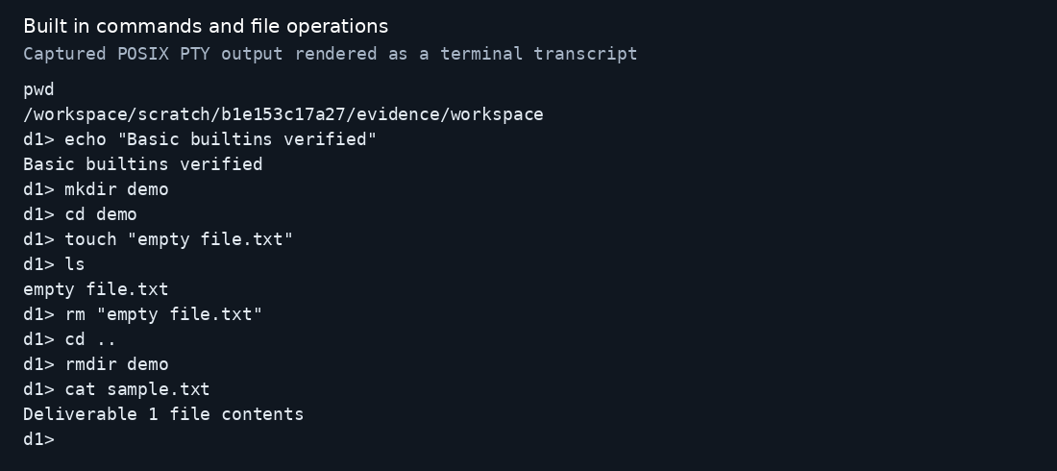
Execution Evidence
Figure 2
Background Process Management and Job Control
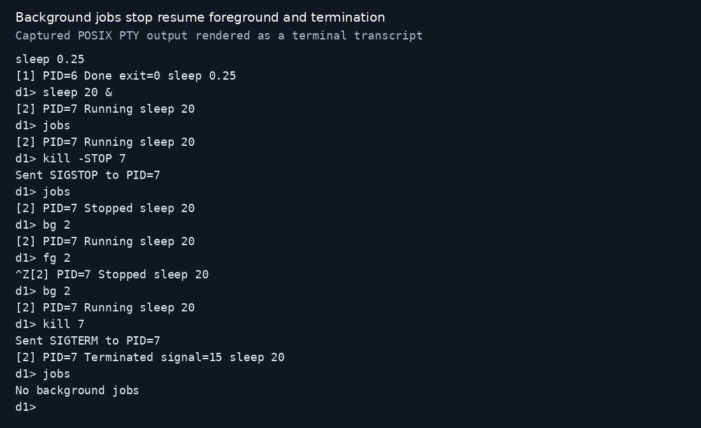
Note. Actual PTY output shows the child PID, jobs listing, SIGSTOP, stopped state, bg, fg, Ctrl+Z, and termination through the required kill command. The final jobs result confirms that the completed job was reaped.
Execution Evidence
Figure 3
Foreground Interrupt and Recovery
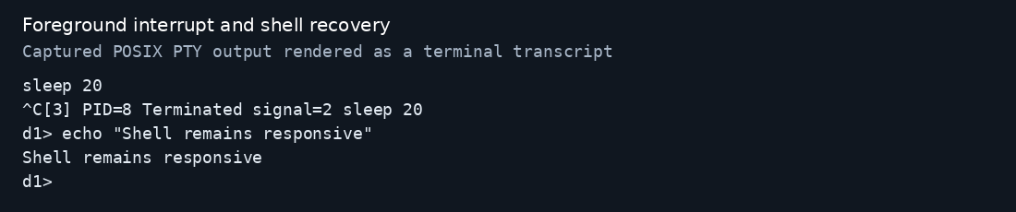
Note. Ctrl+C terminates the foreground sleep process with signal 2. The next echo demonstrates that the parent shell continues to accept commands.
Execution Evidence
Figure 4
Error Handling and Continued Execution
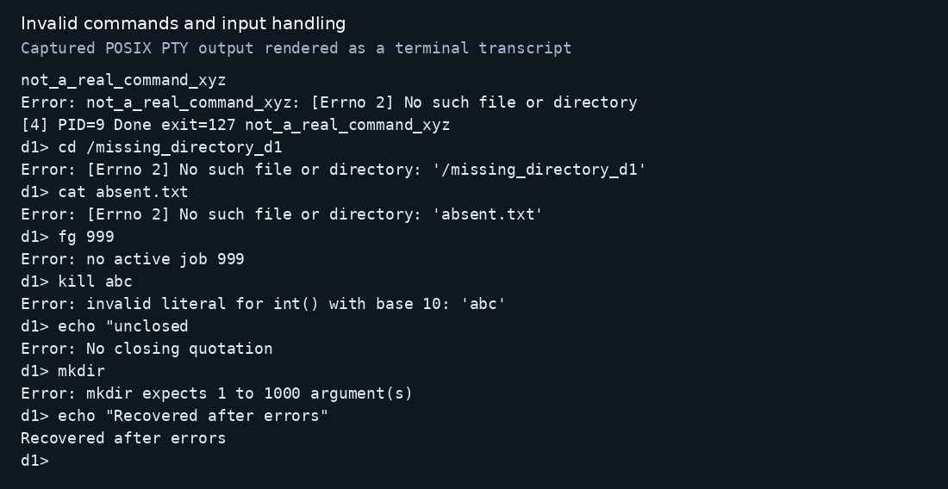
Note. Unavailable commands, missing paths, invalid job and PID inputs, unmatched quotes, and missing arguments produce errors. A final valid command confirms recovery.
Evaluation and Implementation Challenges
Observed Results
All assertions passed for the command paths covered by the reported tests. A background sleep 20 command returned after approximately 0.0033 seconds, while a foreground sleep 0.25 command returned after approximately 0.3037 seconds. These individual observations are not benchmarks. They illustrate the difference between nonblocking background execution and blocking foreground execution; they do not establish general latency, throughput, or resource-usage performance.
Further testing ensured there are no pids after exit and the control sequence was clear. The interactive scenarios as shown in the screenshots are the main ones, not all of the assertions. Tests in the foreground and background are performed with the external sleep utility that is required to be on PATH. No third-party Python packages are used in the source file.
Challenges and Resolutions
The main job-control challenge was terminal ownership. Creating a child process alone does not ensure that keyboard-generated signals reach the intended program. Process groups and tcsetpgrp() allow foreground commands to receive terminal-generated signals, while the synchronization pipe delays child execution until terminal ownership is assigned. Another challenge was avoiding competing wait operations. The shell uses a single polling path to collect background-process statuses rather than allowing a signal handler to compete for those statuses.
Limitations and Improvements
This version requires a POSIX environment and does not support native Windows command prompt use; Windows users should use WSL. Parsing removes expansion, globbing, command sequences, pipelines and redirection. If operator-only arguments are quoted, they are rejected conservatively. Documented basic forms are provided by built-ins and not the full option sets of GNU utilities. If an item in a multi-file operation succeeds before another item, a failure on the latter will not block the completion of the former. There are no full-screen programs available that have been fully validated because terminal modes set by interactive child programs are not saved/restored.
Event-driven child collection is a helpful next step that means that completion notifications show up even when the input is not moving. Other enhancements include maintaining terminal modes for programs that are stopped, more comprehensive parsing, and more extensive permission-deny and concurrent-exit tests. These changes would reinforce Deliverable 1 while not introducing features from later assignments.
Execution Instructions
Use a Linux, macOS, or WSL terminal with Python 3.10 or later. Run the shell with python3 deliverable1_shell.py. Use jobs to check job identifiers and PIDs before running fg, bg, or kill. Enter exit or press Ctrl+D to close the shell.

References
GNU Project. (n.d.). Job control basics. In Bash reference manual. https://www.gnu.org/software/bash/manual/html_node/Job-Control-Basics.html
Python Software Foundation. (n.d.-a). os—Miscellaneous operating system interfaces. In Python 3 documentation. https://docs.python.org/3/library/os.html
Python Software Foundation. (n.d.-b). shlex—Simple lexical analysis. In Python 3 documentation. https://docs.python.org/3/library/shlex.html
Python Software Foundation. (n.d.-c). signal—Set handlers for asynchronous events. In Python 3 documentation. https://docs.python.org/3/library/signal.html
The Open Group. (2018). tcsetpgrp. In The Open Group Base Specifications Issue 7, 2018 edition. https://pubs.opengroup.org/onlinepubs/9699919799/functions/tcsetpgrp.html

