Deliverable 2 Process Scheduling
Round Robin and Priority Scheduling with Paging and Synchronization
Vikram Reddy Tekula, Raghav Gurram
Shiva Gowtham Kumar, Sri Varshini Sukhamanchi
University of the Cumberlands
Advanced Operating Systems (MSCS-630-M20)
Professor Sean Perryman
October 24, 2026

Introduction

This deliverable extends the Python shell with configurable Round Robin scheduling and preemptive priority scheduling. It also addresses the Day 2 checklist through FIFO and LRU paging under memory pressure and a lock-protected shared counter. Both scheduling policies use the same Process record and repeatable workload. All numerical results in this report were obtained by running the accompanying source code.
The main workload produces average waiting times of 5 seconds for Round Robin and 3 seconds for priority scheduling. The paging workload produces 10 FIFO faults and 9 LRU faults. In the synchronization demonstration, the protected counter reaches the expected value of 200.
CPU scheduling policies govern how ready processes receive processor time; workload assumptions and performance metrics affect how policies are evaluated (Arpaci-Dusseau & Arpaci-Dusseau, n.d.-c).

Implementation and Files
The implementation consists of three Python source files. The myshell_deliverable2.py file serves as the main shell application and integrates scheduling, paging, and synchronization commands. The scheduler.py file implements Round-Robin and Priority-Based Scheduling, while os_demos.py demonstrates FIFO and LRU page replacement and synchronization using a shared counter protected by a lock.
Scheduling and paging are single-core and memory-management simulations; they do not change the kernel scheduler or replace real memory pages. The shared counter uses real Python threads. The Unix shell requires Linux, macOS, or Windows WSL.
Round Robin Scheduling
The ready queue uses collections deque. Each selected process runs for min (remaining burst, quantum). An unfinished process returns to the queue; a completed process is removed from the active run. Arrivals reached during a slice enter the queue before the expired process is requeued. The sched rr QUANTUM command accepts a positive, finite quantum. sched demo uses a quantum of 2 simulated seconds. Round Robin rotates ready jobs through time quanta to support responsiveness (Arpaci-Dusseau & Arpaci-Dusseau, n.d.-c).
The workload is P1 (arrival 0, burst 5, priority 1), P2 (arrival 2, burst 4, priority 3), and P3 (arrival 4, burst 3, priority 2). The trace shows rotation and the short final slices: P1 completes after running from 10 to 11, and P3 completes after running from 11 to 12.
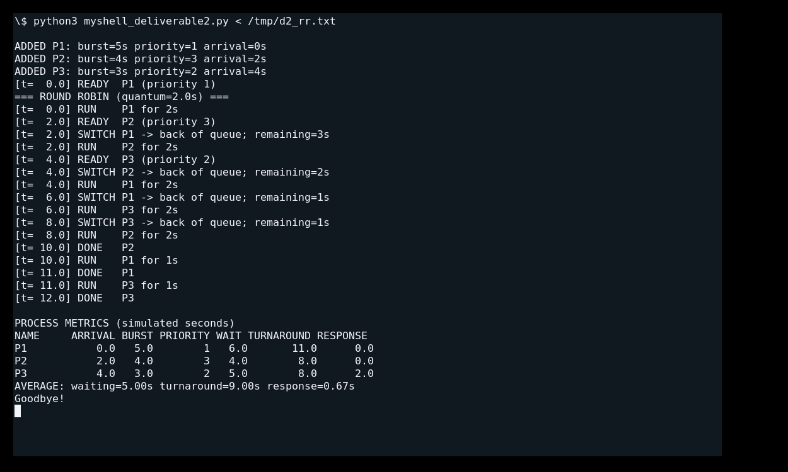
Figure 1. Executed Round Robin output shows the two-second quantum, process switching, early completion, and metrics.

Timers map virtual duration to time.sleep(duration × scale). This evidence runs scale 0.025, so a two-second virtual slice sleeps for 0.05 wall-clock seconds. Scale 0 is available for fast checks; metrics remain virtual seconds.

Preemptive Priority Scheduling
The ready heap uses heapq entries ordered by negative priority and a stable rank based on arrival time and insertion order. Larger numeric priorities run first. The stable rank is preserved when a process resumes, so equal-priority arrivals cannot overtake an older unfinished process.
Execution advances to the next arrival or completion. At arrival, the scheduler checks the heap. It switches only when a strictly higher-priority process is ready. P2 preempts P1 at t=2. At t=4, lower-priority P3 arrives and P2 continues; the trace now distinguishes PREEMPT from CONTINUE.
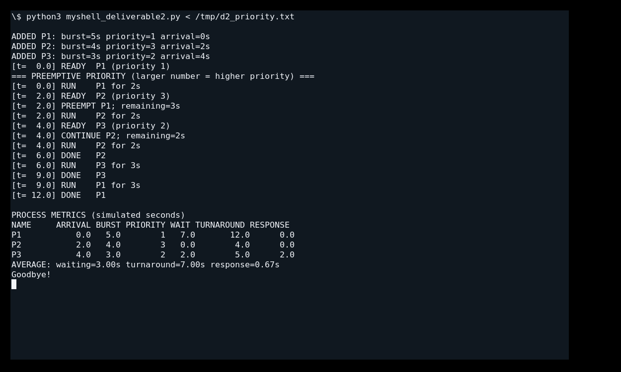
Figure 2. Executed priority output shows immediate simulated preemption at t=2 and continued execution at t=4.

Future arrivals are supplied using sched add NAME BURST PRIORITY ARRIVAL before starting a run. The synchronous shell does not accept commands during scheduling. Preemption is immediate in virtual time for those predefined arrivals, rather than live interactive insertion.
Equal Priority FCFS Verification
The regression workload uses A (arrival 0, burst 5, priority 1) and B (arrival 2, burst 1, priority 1). A continues when B arrives, finishes at t=5, and B then runs from t=5 to t=6. Checking an arrival does not constitute a context switch.
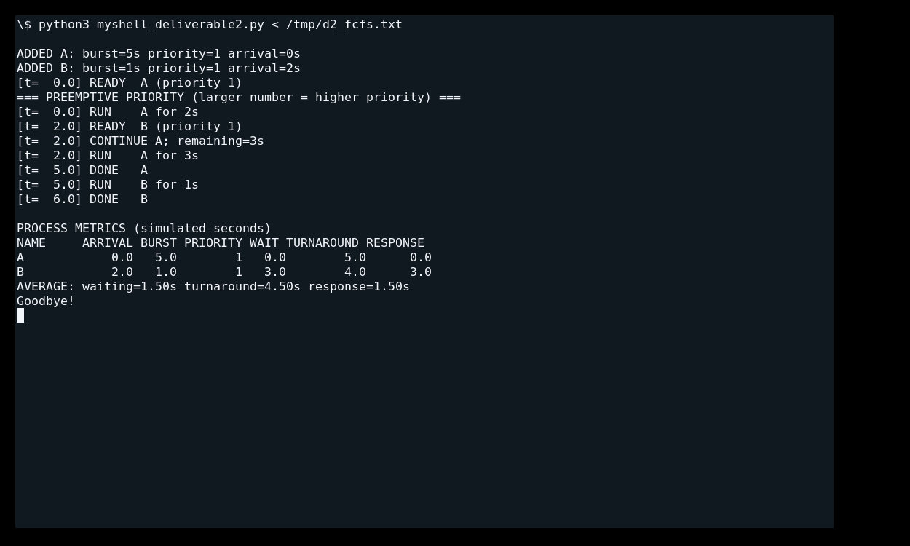
Figure 3. Equal-priority arrival preserves FCFS order. A completes before B begins.

Performance Metrics and Analysis
Turnaround time = completion time − arrival time. Waiting time = turnaround time − CPU burst. Response time = first start time − arrival time (Arpaci-Dusseau & Arpaci-Dusseau, n.d.-c). The following values are simulated seconds and exclude logging, Python overhead, and real context-switch costs.
Policy | Process |  | Waiting |  | Turnaround |  | Response
RR | P1 |  | 6 |  | 11 |  | 0
RR | P2 |  | 4 |  | 8 |  | 0
RR | P3 |  | 5 |  | 8 |  | 2
Priority | P1 |  | 7 |  | 12 |  | 0
Priority | P2 |  | 0 |  | 4 |  | 0
Priority | P3 |  | 2 |  | 5 |  | 2
Policy |  | Mean waiting |  | Mean turnaround |  | Mean response
RR |  | 5.00 |  | 9.00 |  | 0.67
Priority |  | 3.00 |  | 7.00 |  | 0.67
For this workload, priority reduces average waiting by 40% and average turnaround by 22.22%; average response is unchanged. P2 benefits from immediate priority service, while P1 waits seven seconds. Round Robin distributes execution across ready processes. Both runs finish at t=12 because total CPU burst is 12 and the simulation models have no switching penalty. These results describe this workload and do not establish a universal winner.

FIFO Paging Under Pressure
The paging demo uses three frames and the reference sequence 7, 0, 1, 2, 0, 3, 0, 4, 2, 3, 0, 3, 2. Six distinct pages compete for three frames, forcing replacement after the initial loads. Each row reports the reference, hit or fault, evicted page, and physical frame contents.
FIFO maintains a queue of load order. On a full-memory fault, it evicts the page loaded earliest. A hit does not change that queue (Arpaci-Dusseau & Arpaci-Dusseau, n.d.-a). At step 6, FIFO evicts page 0 even though page 0 was accessed at step 5; the next request for 0 therefore faults.
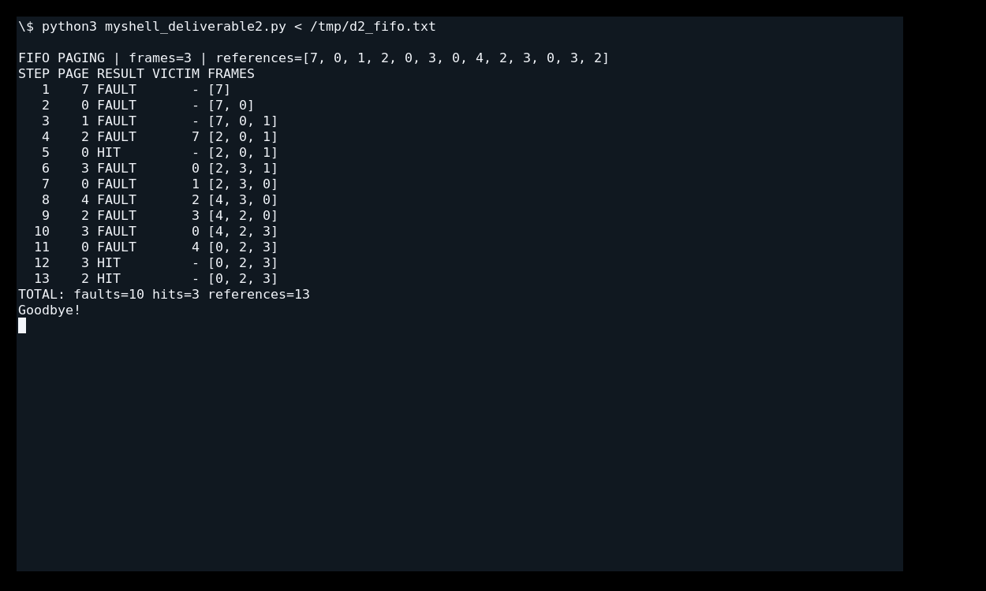
Figure 4. Executed paging fifo 3 output shows replacement under pressure, including 10 faults and 3 hits.
The frame list shows frame contents, not replacement order. FIFO order is maintained separately by the deque. Initially empty frames account for the first three faults; subsequent faults exercise replacement.

LRU Paging and Comparison
LRU uses the identical reference sequence, frame count, and initially empty memory. Its deque tracks recency: a hit moves the referenced page to the newest position, while a full-memory fault evicts the least recently used page (Arpaci-Dusseau & Arpaci-Dusseau, n.d.-a). At step 6, LRU evicts page 1 and retains recently accessed page 0, making step 7 a hit.
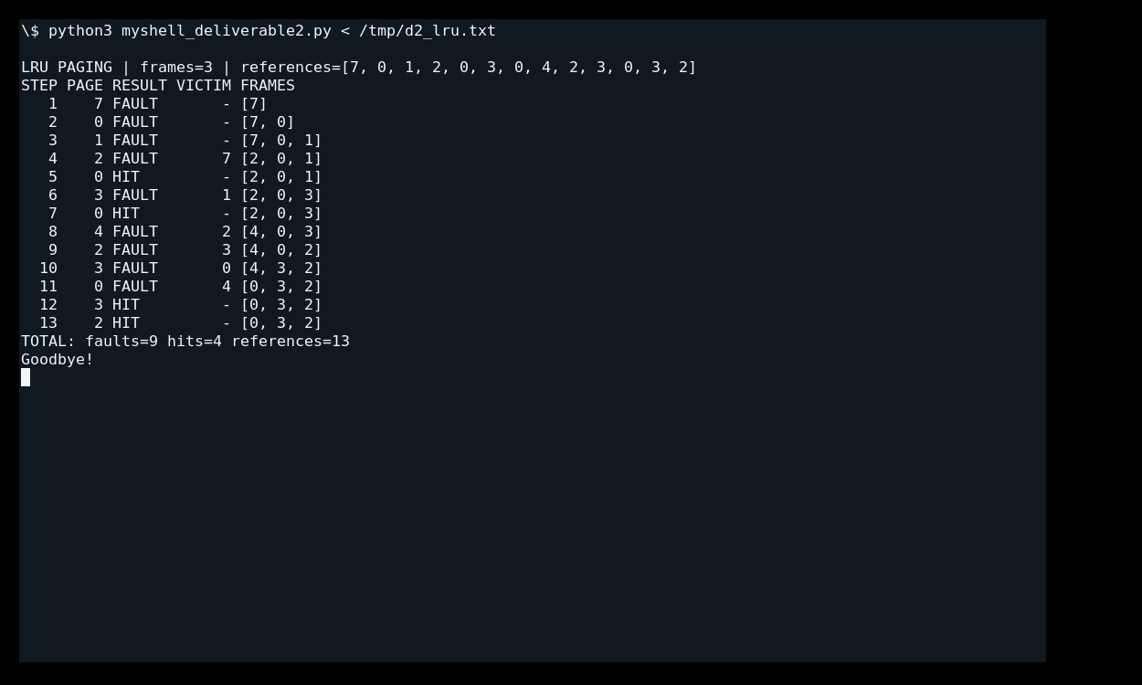
Figure 5. Executed paging lru 3 output shows 9 faults and 4 hits on the same workload.

Policy | Frames | References | Faults | Hits | Fault rate
FIFO | 3 | 13 | 10 | 3 | 76.92%
LRU | 3 | 13 | 9 | 4 | 69.23%

LRU avoids one fault here: a 10% reduction relative to the FIFO fault count, or 7.69 percentage points in fault rate. This result reflects the chosen access pattern. It does not mean LRU always produces fewer faults for every workload. The implementation simulates page residency and replacement only; it does not model disk latency or hardware reference bits.
Synchronization of a Shared Resource
The sync demo command starts with two threads that each increment one shared counter 100 times. The expected final value is 200. An update consists of reading the old value, adding one, and writing the new value. Conflicting updates can discard one increment when both threads read the same old value. Protecting the critical section with a common lock prevents conflicting updates by participating threads (Arpaci-Dusseau & Arpaci-Dusseau, n.d.-b).
The unprotected variant deliberately uses two barriers per iteration to force both reads before either subsequent iteration. Both threads then write the same old value plus one. This produces a repeatable lost-update result of 100; it is a controlled race demonstration, not a claim that every unprotected Python increment behaves this way.
The protected variant wraps the entire read-modify-write operation in with lock using threading.Lock. Every participating update uses the same lock, so only one thread updates the counter at a time. Thread.join waits for both workers before the result is checked. No barrier is placed inside the protected critical section. Python locks support context management, and join() waits for a worker thread to terminate (Python Software Foundation, n.d.).
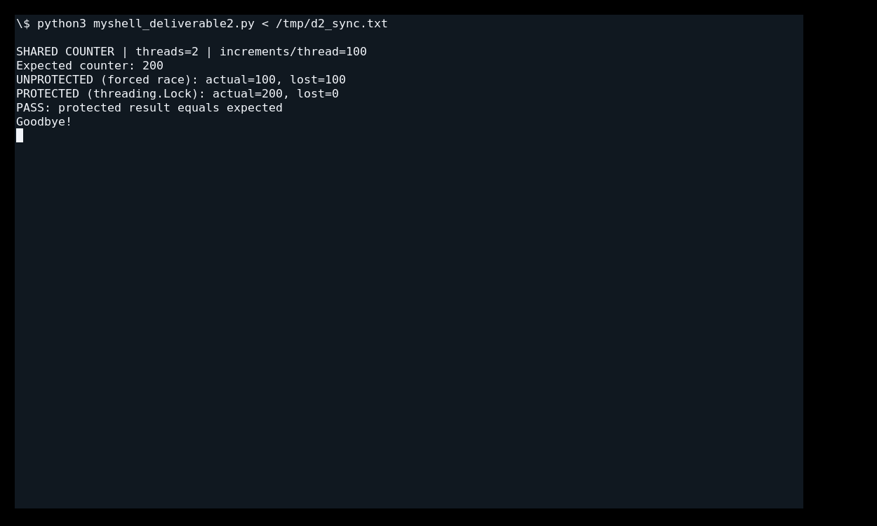
Figure 6. Executed sync demo output compares the forced race with the lock-protected shared counter.

Variant | Expected | Actual | Lost updates
Unprotected forced race | 200 | 100 | 100
Protected with Lock | 200 | 200 | 0

Mutual exclusion preserves all 200 increments in the protected run. Locking protects this shared resource; it does not imply fairness, eliminate every possible deadlock in other programs, or measure parallel speedup. This demonstration focuses on correctness.
Challenges and Improvements
Scheduling arrivals at slice boundaries required a consistent rule: enqueue new arrivals before returning the expired Round Robin process. Priority tie handling required a stable original rank; assigning a new rank after every arrival check allowed equal-priority newcomers to overtake the running job. The corrected heap preserves rank and reports CONTINUE separately from actual preemption.
Paging required separating physical frame contents from eviction order. FIFO changes eviction order on loads, while LRU also changes it on hits. The trace records the victim on every replacement so this distinction can be checked against the reference sequence.
A naturally occurring race is timing dependent, so the unprotected shared-counter example uses barriers to force a repeatable interleaving. The protected example uses a lock over the whole update. Future work could add aging for priority starvation, switching overhead, additional access patterns, configurable page references, and live arrival input.

Reproduction and Verification
The implementation was verified by executing the scheduling, paging, and synchronization demonstrations using the Python shell. The Round-Robin Scheduling demonstration confirmed process switching based on the configured time quantum, while Priority-Based Scheduling demonstrated preemption and First-Come, First-Served handling for processes with equal priorities.
The scheduling results were evaluated using waiting time, turnaround time, and response time. The paging demonstrations compared FIFO and LRU replacement using the same reference sequence and frame allocation. The synchronization demonstration verified that a shared counter protected by a lock maintained the expected final value of 200.
All three Python files should be placed in the same directory. The shell can be started using python3 myshell_deliverable2.py. The commands sched demo, paging fifo 3, paging lru 3, and syncdemo reproduce the main demonstrations presented in this report.

Conclusion
The final submission uses one job representation for both scheduling policies, exposes the Round Robin quantum and priority preemption, and reports repeatable waiting, turnaround, and response metrics. The additional paging and synchronization demonstrations address the remaining Day 2 checklist items. Each execution figure is paired with a caption and interpretation.

References
Arpaci-Dusseau, R. H., & Arpaci-Dusseau, A. C. (n.d.-a). Beyond physical memory: Policies. In Operating systems: Three easy pieces. https://pages.cs.wisc.edu/~remzi/OSTEP/vm-beyondphys-policy.pdf
Arpaci-Dusseau, R. H., & Arpaci-Dusseau, A. C. (n.d.-b). Locks. In Operating systems: Three easy pieces. https://pages.cs.wisc.edu/~remzi/OSTEP/threads-locks.pdf
Arpaci-Dusseau, R. H., & Arpaci-Dusseau, A. C. (n.d.-c). Scheduling: Introduction. In Operating systems: Three easy pieces. https://pages.cs.wisc.edu/~remzi/OSTEP/cpu-sched.pdf
Python Software Foundation. (n.d.). threading—Thread-based parallelism. Python documentation. https://docs.python.org/3/library/threading.html

