Real-Time AI Cartoonifier & Computer Vision Middleware System
Technical System Report v2.0

1. Executive Summary
This system is a real-time Computer Vision (CV) middleware application designed to pre-process live video feeds. Unlike standard video filters, its primary goal is to optimize video data for downstream machine learning applications, edge computing environments, and privacy-compliant workflows. By simplifying complex video data into cartoon-like representations, it significantly reduces entropy and bandwidth requirements while preserving semantic information vital for AI models (like edges and motion).
2. System Workflow & Architecture
The system operates on a client-server architecture. The frontend (React) manages user inputs and dashboard visualization, while the high-performance backend (Flask/Python + OpenCV) executes the mathematical pipeline.

Below is a visual representation of the complete data flow:
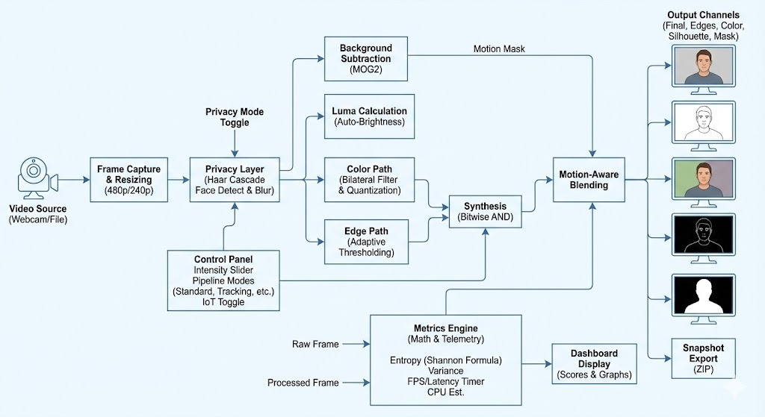

3. The Core Computer Vision Pipeline
The pipeline processes every video frame sequentially through the following stages:
Stage 1: Input Reception & Resizing
- Input Source: A VideoCapture object runs in a separate, dedicated thread (VideoGet class) to prevent I/O blocking and maintain high FPS. It accepts live webcams (index 0) or video files.
- Spatial Resizing: Every frame is immediately resized to a target height of 480p (Standard Mode) or 240p (Edge Compute Mode), while maintaining its original aspect ratio. This is the most critical step for ensuring real-time performance on non-GPU hardware.
Stage 2: The Privacy Compliance Layer
- Trigger: Activates if the "Privacy Mode" toggle is ON.
- Operation: The frame is converted to grayscale and passed to a Haar Cascade Classifier (haarcascade_frontalface_default.xml). This pre-trained ML model detects facial coordinates (x, y, w, h).
- Anonymization: For every detected face, a heavy Gaussian Blur is applied to that Region of Interest (ROI).
  - Standard Mode: Kernel size (51, 51).
  - Edge Mode: Kernel size (21, 21) for speed.
- Note: This step happens before edge detection, ensuring facial features are mathematically destroyed and cannot be recovered by downstream AI.
Stage 3: Temporal Background Subtraction
- Algorithm: MOG2 (Gaussian Mixture-based Background/Foreground Segmentation).
- Operation: The system maintains a statistical history of the last 500 frames. Pixels that remain static are modeled as background. Pixels that deviate significantly from this history are flagged as foreground (motion).
- Noise Cleaning: The raw motion mask is cleaned using Morphological Opening (erosion followed by dilation with an elliptical kernel) to remove small noise specks, followed by Dilation to close gaps in the detected subject.
Stage 4: Parallel Processing Channels
The frame is split into two parallel processing paths to generate the cartoon effect.
Path A: Color Smoothing & Quantization
- Bilateral Filtering: Unlike a standard blur that averages all pixels, a Bilateral Filter averages pixels based on spatial closeness and color similarity. This smooths flat regions (walls, skin) while perfectly preserving sharp edges.
  - Parameters affected by Intensity Slider: The filter runs for 1-4 iterative passes. The spatial (sigmaSpace) and color (sigmaColor) radii increase with intensity.
- Color Quantization: The 16.7 million possible colors (24-bit) are mathematically "crushed" into buckets.
  - Formula: pixel = (pixel // bucket_size) * bucket_size
  - Standard Mode: Reduces to ~8-12 colors per channel.
  - IoT Mode: Forces extreme quantization to exactly 4 colors per channel (64 total colors globally).
Path B: Adaptive Edge Detection
- Noise Removal: A Median Blur is applied to a grayscale copy of the frame to remove sensor noise that would cause false edges.
- Adaptive Thresholding: Instead of using a single global threshold value for the whole image, the algorithm calculates a threshold for small regions around each pixel. This allows it to detect edges correctly in both bright and shadowed areas simultaneously.
  - Parameter affected by Slider: The "Block Size" (neighboring area) increases with intensity, resulting in fewer, bolder lines.
Stage 5: Synthesis & Blending
- Cartoon Synthesis: The quantized color image and the black edge mask are combined using a bitwise_and operation. The black edges are "stamped" onto the colors.
- Motion-Aware Blending (Optional): If "Motion-Aware" is active, the final output is a mathematical blend. The MOG2 Motion Mask acts as an alpha channel.
  - Foreground (Motion): The fully processed cartoon image.
  - Background (Static): A heavily blurred and darkened version of the raw frame.
  - Result: Downstream AI focuses purely on the moving subject.

4. Control Mechanisms & Modes
The Noise Reduction Intensity Slider (0-100)
This master control linearly scales multiple CV parameters simultaneously:
- Bilateral Filter Passes: Increases from 1 pass at 0% to 4 passes at 100%.
- Bilateral Sigma Values: Increases the "reach" of the blur from 20 to 140.
- Quantization Buckets ($k$): Decreases the number of allowed colors as intensity rises.
- Adaptive Threshold Block Size: Increases from a 9x9 block to a 19x19 block, making edges bolder and less sensitive to texture.
System Toggles
- Auto Adaptive Mode: Calculates the mean brightness of the frame. If the scene is too dark or too bright, it automatically adjusts the slider's base intensity to compensate.
- Motion-Aware Simplification: Activates the Stage 5 blending using the MOG2 mask.
- Privacy Anonymization: Activates the Stage 2 Haar Cascade face blurring.
- IoT 6-Bit Compression: Activates a special pipeline branch that downsamples the image spatially by 4x (macro-blocking) and applies strict 64-color quantization, creating a retro, low-bandwidth aesthetic.

Pipeline Modes (Presets)
These buttons instantly reconfigure the entire engine for specific use cases:
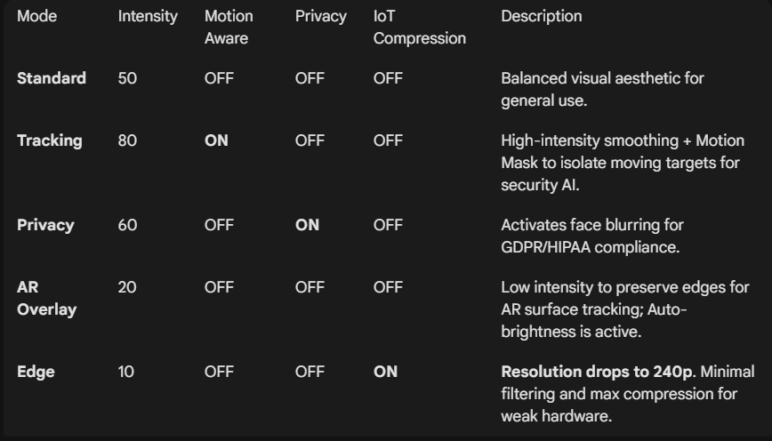

5. Mathematical Metrics & Dashboard Scores
The dashboard provides real-time telemetry calculated on every 10th frame to monitor system performance and data quality.
1. Raw / Output Entropy (bits)
- Definition: Shannon Entropy measures the average information density or "randomness" of an image. A high-texture image (trees, static noise) has high entropy. A flat cartoon image has low entropy.
- Formula
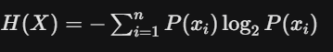
- Calculation: We compute a grayscale histogram of the image to find the probability $P(x_i)$ of each pixel intensity value occurring, then apply the formula.

2. Data Reduction (%)
- Definition: The percentage of "useless texture information" removed from the raw feed.
- Formula
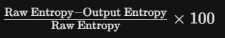
- Note: In IoT mode, an additional 35% buffer is added to account for the spatial downsampling savings.

3. Variance Drop (%)
- Definition: Variance measures contrast—the spread of pixel brightness. A high drop means the image has lost contrast (e.g., the Silhouette or Mask channels). A low drop means lighting is preserved.
- Formula
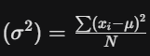
- The score is the percentage difference between raw and processed variance.

4. Compute Savings (%)
- Definition: A heuristic score estimating how much faster a downstream AI model (like YOLO) could process the simplified frame.
- Calculation

5. Identity Risk & Feature Retention
- Definition: A compliance score estimating the likelihood of re-identifying a person.
- Calculation: If Privacy Mode is ON and faces are detected, Risk is "LOW" and Retention drops to ~10%. If OFF, Risk is "HIGH" and Retention is ~85-95% based on the slider intensity (higher intensity smooths away some facial details).
6. Hardware Telemetry (FPS, Latency, CPU)
- Latency (ms): Measured using high-precision timers around the main processing function:
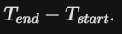
- Est. FPS: Calculated using a moving average of the time taken to process the last 10 frames.
- CPU Load (%): A simulated metric derived from latency. It assumes a target budget of 33ms (30 FPS). If latency exceeds 33ms, the estimated load scales linearly toward 100%.

