Simultaneous Q- and R-Mode Factor Analysis of Water Use Across African Countries: A Reproducible, Map-First Workflow
George Owusu — Department of Geography and Resource Development, University of Ghana
2026
Table of Contents

Keywords: Q-mode factor analysis; R-mode factor analysis; water withdrawal; spatial ordination; Africa; AQUASTAT; reproducible workflow

Abstract
Africa is described, in the same breath, as water-rich and water-stressed, yet the two claims are rarely tested together because the analysis has two sides — the structure among water-use variables and the grouping of countries — usually handled by separate tools. This study applies simultaneous Q- and R-mode factor analysis, in a single reproducible call, to six water-use indicators for 50 African countries, and writes the results back to the map. Two factors explain 74% of the variation: Factor 1 (56%) is an agriculture-driven scale of overall use; Factor 2 (18%) is a resource-versus-use contrast. Renewable availability is essentially uncorrelated with use (r between −0.04 and −0.19). Countries partition into two profiles whose heavy users draw roughly eight times more agricultural water yet hold less than half the renewable resource (mean 59 versus 128). The contribution is a workflow: one function delivers the ordination, the classification, cluster tests and choropleth maps, so applied users can move from table to map without stitching five packages together.

1. Introduction
Water security is among the defining development questions for sub-Saharan and North Africa, where irrigation dominates abstraction, renewable supply is unevenly distributed, and per-capita availability is falling with population growth. A recurring paradox frames the debate: the continent is portrayed as water-abundant — the Congo Basin alone holds a substantial share of Africa’s renewable freshwater — and simultaneously as one of the most water-stressed regions on Earth. Both statements can be true, but only if use and availability are governed by different processes and different geographies. Testing that proposition requires a method that classifies variables (which kinds of water use move together?) and samples (which countries resemble one another?) at the same time.
Factor analysis provides both lenses. R-mode analysis groups variables by their shared variation; Q-mode analysis groups observations by their similarity. In the natural sciences the two are classically run in tandem — Reyment and Jöreskog (1993) and Davis (2002) treat Q/R-mode analysis as a standard pairing in geology and geochemistry — but in practice they are computed separately, in different software, and reconciled by hand. For an applied water scientist this is a barrier: the analysis fragments across packages, the results are tables rather than maps, and reproducibility suffers.
This study has two aims. First, substantively, it characterises the structure of water use across African countries and tests whether use is decoupled from availability — the empirical core of the water paradox. Second, methodologically, it demonstrates a map-first, single-call workflow in which simultaneous Q- and R-mode factor analysis, factor scoring, clustering, cluster testing and choropleth mapping are produced from one command and written back to the geographic attribute table. The workflow is implemented in the open-source R package qrfactor (Owusu, 2026) and is fully reproducible from public data.
The remainder of the paper reviews Q/R-mode analysis and spatial ordination (Section 2), describes the data and workflow (Section 3), reports the ordination, maps and clusters (Section 4), and discusses the paradox, its policy reading and the honest limits of a single cross-section (Section 5), before concluding (Section 6).

2. Literature review
Q- and R-mode factor analysis. R-mode factor analysis summarises a set of variables by a smaller set of latent factors, each a weighted combination of the originals; the weights are loadings and the factors are ordered by the variance (eigenvalue) they capture (Rencher, 2002). Q-mode analysis applies the same algebra to the transpose, classifying observations. Reyment and Jöreskog (1993) formalised the joint use of both modes in the natural sciences, and Davis (2002) made Q/R-mode ordination a staple of quantitative geology. In hydrochemistry the pairing is routine: R-mode identifies the processes controlling solute variation while Q-mode groups samples of common origin, typically with varimax rotation and the Kaiser (1960) eigenvalue-greater-than-one rule for retention, supported by the scree test (Cattell, 1966).
Spatial ordination. Linking ordination to geography has a long lineage. Wartenberg (1985) introduced multivariate spatial correlation, maximising the product of variance and spatial autocorrelation; Dray, Saïd and Débias (2008) generalised it into multispati, the basis of modern spatial-ordination tools in R. This literature is mature, and it is important not to overstate novelty: linking multivariate structure to spatial pattern is not new. What remains awkward for the applied user is integration — reading a shapefile, running the ordination, classifying the units, testing the classes and drawing the maps still spans several packages (sf and sp for geometry; stats/psych for factors; cluster and pvclust for grouping), each with its own idioms (Bivand, Pebesma & Gómez-Rubio, 2013; Pebesma, 2018).
The gap and the framework. Two gaps motivate this study. First, most applied Q/R-mode work reports variable structure or sample grouping, seldom both on a shared set of axes; and it rarely writes the result back to a map. Second, the workflow is not reproducible end-to-end from a single object. We therefore adopt a pipeline framework (Table 1): one call ingests a shapefile or table; produces the correlation structure, eigen-decomposition, R- and Q-mode loadings and scores on shared axes; derives per-unit indices and clusters; and appends all of these to the attribute table so that mapping is the final, not a separate, step. The framework’s contribution is integration and reproducibility for applied users, not a new estimator.
Table 1. The map-first Q/R workflow: one call, six stages.
Stage | Operation | Output
1 | Ingest table or shapefile | numeric matrix + geometry
2 | Scale + correlate | correlation/covariance matrix
3 | Eigen-decompose | eigenvalues, variance, PCA loadings
4 | R- and Q-mode loadings/scores | shared-axis biplot
5 | Index, rank, cluster | per-country indices + kmeans classes
6 | Write back + map | attribute table + choropleths

3. Data and methods
Study units and variables. The analysis covers 50 African countries described by six water-use indicators derived from FAO’s AQUASTAT global water information system (FAO, 2026): municipal (Domestic), industrial (Industry) and agricultural (Agricultur) water withdrawal; total renewable water resources (Resources); total water withdrawal (withdrawal); and per-capita withdrawal (perCapitaW). Withdrawal quantities follow AQUASTAT conventions (10⁹ m³ yr⁻¹ for volumes; m³ inhabitant⁻¹ yr⁻¹ for per-capita measures). The present analysis uses the cross-section bundled with the qrfactor package (a circa-2000 AQUASTAT compilation); a refreshed extract is obtained reproducibly from the current AQUASTAT dissemination service (Appendix A), and the substantive findings should be re-confirmed on it (Section 5).
Analytical workflow. All six stages of Table 1 are executed by a single call, qrfactor(). Variables are standardised (correlation-based scaling) before decomposition, so that all indicators contribute equally rather than the largest-magnitude variable dominating. Factor retention follows the Kaiser (1960) rule with the scree test (Cattell, 1966) as a check. R- and Q-mode loadings and scores are placed on a common set of axes to permit joint interpretation. Country groupings use kmeans; group separation on each variable is tested with one-way ANOVA and the non-parametric Kruskal–Wallis test; cluster stability is assessed by multiscale bootstrap resampling (pvclust; Suzuki & Shimodaira, 2006), and multivariate outliers by the adjusted-quantile method (Filzmoser, Garrett & Reimann, 2005). Shapefiles are read with sf (Pebesma, 2018) and mapped with sp (Pebesma & Bivand, 2005). Because the factor scores, indices and cluster labels are written back to the attribute table, the final products are choropleth maps of the retained factors. Analyses were run in R 4.6 (R Core Team, 2026) with qrfactor 1.5; the complete script is given in Appendix A.

4. Results
Correlation structure. The six indicators show the pattern that underlies the paradox (Table 2). Agricultural and per-capita withdrawal are nearly interchangeable (r = 0.99): in Africa, per-capita water use is agricultural water use. Municipal and industrial use rise together (r = 0.75), the signature of a developing modern economy. Critically, renewable Resources correlates only −0.04 to −0.19 with every use variable: availability and use are decoupled.
Table 2. Pearson correlations among the six water-use indicators (n = 50).
 | Domestic | Industry | Agricultur | Resources | withdrawal | perCapitaW
Domestic | 1.00 | 0.75 | 0.33 | −0.19 | 0.29 | 0.44
Industry | 0.75 | 1.00 | 0.47 | −0.15 | 0.65 | 0.55
Agricultur | 0.33 | 0.47 | 1.00 | −0.12 | 0.63 | 0.99
Resources | −0.19 | −0.15 | −0.12 | 1.00 | −0.04 | −0.14
withdrawal | 0.29 | 0.65 | 0.63 | −0.04 | 1.00 | 0.65
perCapitaW | 0.44 | 0.55 | 0.99 | −0.14 | 0.65 | 1.00
Factor retention. The first two eigenvalues exceed unity (3.36, 1.08) and together explain 74.0% of the variation; a third (0.91) sits just below the Kaiser threshold, and the sixth collapses to zero — the arithmetic signature of the Agricultur–perCapitaW redundancy (Table 3). Two factors are retained.
Table 3. Eigenvalues and variance explained (correlation-based scaling).
Factor | Eigenvalue | Variance (%) | Cumulative (%)
1 | 3.360 | 56.01 | 56.01
2 | 1.079 | 17.98 | 73.98
3 | 0.906 | 15.10 | 89.08
4 | 0.521 | 8.69 | 97.77
5 | 0.134 | 2.23 | 100.00
6 | ~0 | ~0 | 100.00
What the factors mean. R-mode loadings (Table 4) show that five of six variables load strongly and negatively on Factor 1 (−0.67 to −0.91): it is a general scale of water use, dominated by agriculture. Resources alone loads on Factor 2 (−0.68), which is therefore a resource-versus-use contrast. The simultaneous Q/R biplot (Figure 1) places variables and countries on these axes together. It resolves into interpretable regions: the heavy agricultural users — Egypt, Sudan, Madagascar, Libya, Mali, Mauritania and Swaziland — lie at the high-use pole; the water-rich Congo and the Democratic Republic of the Congo lie alone by the Resources vector, with vast supply and negligible withdrawal; Equatorial Guinea, Algeria and Botswana define a domestic/industrial tilt; and a dense cluster of small, low-use economies fills the remainder. As Figure 1 shows, Congo and Egypt land almost as far apart as the data allow — one holds the water, the other uses it.
Table 4. R-mode loadings on the first two retained factors.
Variable | Factor 1 | Factor 2
Domestic | −0.667 | 0.529
Industry | −0.824 | 0.292
Agricultur | −0.859 | −0.353
Resources | 0.217 | −0.676
withdrawal | −0.791 | −0.249
perCapitaW | −0.909 | −0.264
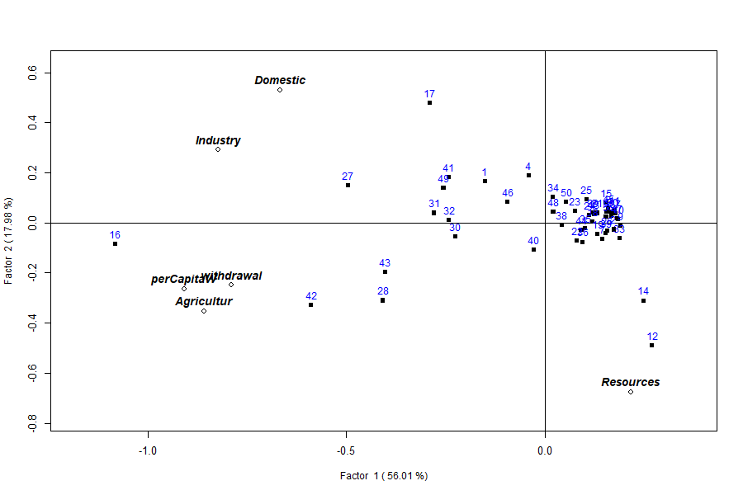
Figure 1. Simultaneous Q/R-mode biplot. Variables (labelled diamonds) and countries (numbered points) share the first two factor axes (Factor 1 = 56%, Factor 2 = 18%). Country 16 = Egypt, 42 = Sudan, 12 = Congo, 14 = DR Congo, 17 = Equatorial Guinea.
The map-first result. Because the factor indices are written to the attribute table, the ordination becomes a map. Figure 2 maps the Factor 1 index (overall water use): the high-use band across Egypt, Sudan, Libya and the Sahel contrasts with the deep lows of the Congo Basin. Figure 3 maps the Factor 2 index (the resource contrast), a distinct geography. Together they render the paradox spatially: the places using the most water are not the places that have it.
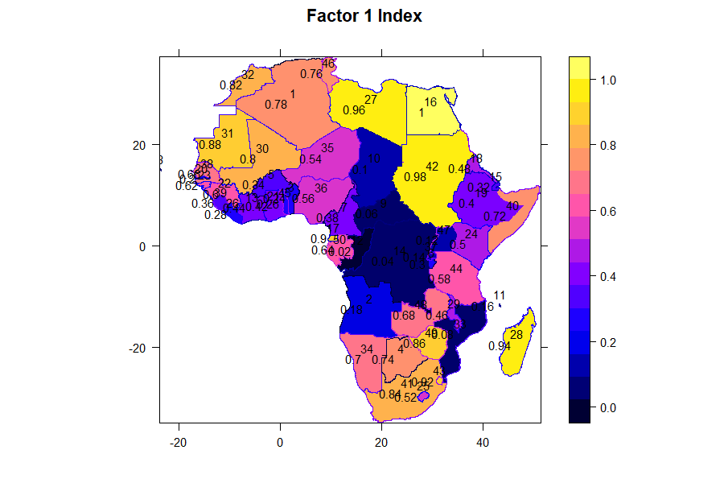
Figure 2. Factor 1 index (overall, agriculture-driven water use) mapped across Africa. Warmer colours denote higher use; the Congo Basin (dark) is lowest.
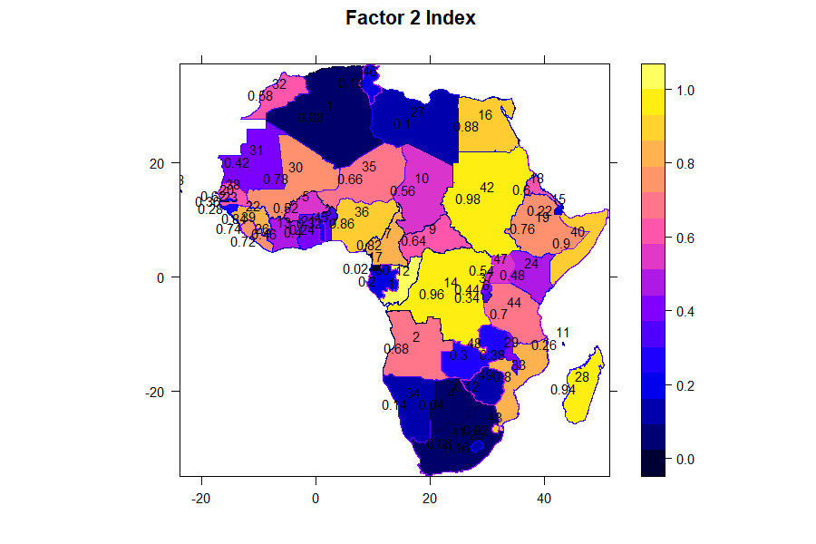
Figure 3. Factor 2 index (the resource-versus-use contrast) mapped across Africa, showing a geography distinct from Figure 2.
Country profiles. kmeans on the scores yields two robust groups whose mean profiles name them (Table 5). Cluster B — the heavy users (Egypt, Sudan, Libya, Mali, South Africa, Morocco and similar) — withdraws roughly eight times more agricultural water per country than Cluster A, yet sits on less than half the renewable resource (59 versus 128). One-way ANOVA confirms that every use variable separates the clusters at p < 0.001, whereas Resources does not (F = 0.90, p = 0.35): the split is defined by consumption, not endowment, exactly as Factor 1 implied. Kruskal–Wallis tests agree. The clustering is visualised in Figure 4.
Table 5. Cluster mean profiles and one-way ANOVA of group separation.
Variable | Cluster A (light) | Cluster B (heavy) | F (1,48) | p
Domestic | 10.7 | 52.9 | 48.79 | 7.8×10⁻⁹
Industry | 3.3 | 17.6 | 44.38 | 2.4×10⁻⁸
Agricultur | 56 | 448 | 63.14 | 2.7×10⁻¹⁰
withdrawal | 1.2 | 14.1 | 16.60 | 1.7×10⁻⁴
perCapitaW | 70 | 519 | 91.52 | 1.1×10⁻¹²
Resources | 128 | 59 | 0.90 | 0.35 (n.s.)
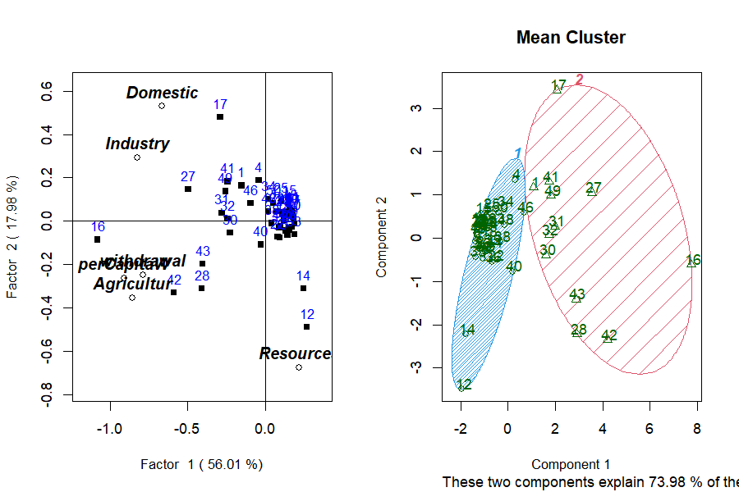
Figure 4. Cluster ordination (clusplot) of the 50 countries on the retained factors, with group hulls. Cluster stability was confirmed by multiscale bootstrap resampling.

5. Discussion
The paradox, measured. The analysis converts a rhetorical claim into a measurement. Water use in Africa is a single dominant axis (56% of the variance), driven overwhelmingly by agriculture; water availability is a nearly independent second axis (18%); and the two are statistically decoupled (Table 2). The clustering sharpens the point: the countries drawing the most water are, on average, the least resource-endowed (Table 5, Figures 2–3). Egypt, Sudan, Libya and Mali abstract heavily against limited renewable supply, while Congo and the DRC hold abundant water they scarcely use. For the water paradox, both halves are true — of different countries.
Policy reading. The decoupling implies that continental averages mislead: “Africa has enough water” is a statement about endowment (Cluster A, the Congo Basin) that says nothing about the stressed heavy users (Cluster B). Interventions — irrigation efficiency, transfer infrastructure, demand management — should be targeted to the Factor 1 high-use, low-resource band that Figures 2–3 delineate, not applied at a continental scale. The map-first output is directly usable for such targeting.
Methodological position. We deliberately do not claim a new estimator. Linking multivariate structure to spatial pattern dates to Wartenberg (1985) and is well served by multispati and its descendants (Dray et al., 2008). The contribution here is workflow: simultaneous Q- and R-mode analysis, indices, clustering, cluster testing and choropleth mapping from one reproducible call, with results written back to the geography (Table 1). For the applied water scientist that integration — not a new algorithm — is the practical advance.
Limitations. Four are material. (i) Data vintage. The cross-section analysed here is a circa-2000 AQUASTAT compilation; the substantive numbers must be re-confirmed on the current AQUASTAT extract, obtained reproducibly by the script in Appendix A, before any policy weight is placed on specific countries. (ii) Collinearity. Agricultur and perCapitaW are near-duplicates (r = 0.99), inflating agriculture’s role and collapsing the final factor; one of the pair should be dropped in confirmatory work. (iii) Cross-sectional inference. These are associations in a single snapshot of 50 countries, not causal claims; the drivers of the decoupling (climate, economy, irrigation policy, data year) are for domain analysis, not the factor model. (iv) Spatial autocorrelation not yet tested. The maps display clear regional pattern, but we have not formally tested whether the factor indices are spatially clustered.
Future work. The natural next step is a global Moran’s I and local (LISA) test of the factor indices, built from the country adjacency graph (spdep), to establish spatial-clustering significance and identify hot- and cold-spots — a capability planned for the workflow. A refreshed, multi-year AQUASTAT extract would also permit tracking whether the use–availability decoupling is widening.

6. Conclusion
This study set out to test the African water paradox and to demonstrate a reproducible, map-first workflow for doing so. Simultaneous Q- and R-mode factor analysis of six water-use indicators across 50 countries reduces to two interpretable axes — an agriculture-driven scale of use (56%) and a resource-versus-use contrast (18%) — that are statistically decoupled, and to two country profiles whose heavy users hold less than half the renewable resource of the light users. The paradox is therefore real, and geographic: abundance and stress describe different countries, mapped in Figures 2 and 3. Methodologically, the value is integration: one call moved the analysis from table to map, with every quantity written back to the geography and the whole pipeline reproducible from public data. As African water planning grows more data-driven, workflows that reach a map — not just a table — will make the difference between analysis and action.

Acknowledgments
The author thanks the FAO AQUASTAT programme for open access to the underlying data, and the R spatial community for the sf, sp, cluster and pvclust packages on which the workflow builds. The qrfactor package and the scripts reproducing every table and figure in this paper are openly available (Appendix A). The author declares no conflict of interest. [Add funding/grant details if applicable.]

References
[The list below is a real, curated starting bibliography. Verify each against the target journal’s style, and expand to the journal’s expected 30–80 entries — in particular, add the applied Q/R-mode hydrochemistry studies (e.g. northern Volta region, Ghana; Nethravathi catchment, India; Cariri Valley, Brazil), whose exact bibliographic details should be confirmed.]
- Bivand, R. S., Pebesma, E. J., & Gómez-Rubio, V. (2013). Applied Spatial Data Analysis with R (2nd ed.). Springer.
- Cattell, R. B. (1966). The scree test for the number of factors. Multivariate Behavioral Research, 1(2), 245–276.
- Davis, J. C. (2002). Statistics and Data Analysis in Geology (3rd ed.). Wiley.
- Dray, S., Saïd, S., & Débias, F. (2008). Spatial ordination of vegetation data using a generalization of Wartenberg’s multivariate spatial correlation. Journal of Vegetation Science, 19(1), 45–56.
- FAO (2026). AQUASTAT — FAO’s Global Information System on Water and Agriculture: Water withdrawal by sector. Rome: Food and Agriculture Organization of the United Nations. https://data.apps.fao.org/aquastat/
- Filzmoser, P., Garrett, R. G., & Reimann, C. (2005). Multivariate outlier detection in exploration geochemistry. Computers & Geosciences, 31(5), 579–587.
- Kaiser, H. F. (1960). The application of electronic computers to factor analysis. Educational and Psychological Measurement, 20(1), 141–151.
- Owusu, G. (2026). qrfactor: Simultaneous Q-mode and R-mode factor analysis for spatial data. R package version 1.5. https://github.com/gowusu/qrfactor
- Pebesma, E. (2018). Simple Features for R: Standardized support for spatial vector data. The R Journal, 10(1), 439–446.
- Pebesma, E. J., & Bivand, R. S. (2005). Classes and methods for spatial data in R. R News, 5(2), 9–13.
- R Core Team (2026). R: A Language and Environment for Statistical Computing. Vienna: R Foundation for Statistical Computing.
- Rencher, A. C. (2002). Methods of Multivariate Analysis (2nd ed.). Wiley.
- Reyment, R. A., & Jöreskog, K. G. (1993). Applied Factor Analysis in the Natural Sciences. Cambridge University Press.
- Suzuki, R., & Shimodaira, H. (2006). Pvclust: an R package for assessing the uncertainty in hierarchical clustering. Bioinformatics, 22(12), 1540–1542.
- Wartenberg, D. (1985). Multivariate spatial correlation: A method for exploratory geographical analysis. Geographical Analysis, 17(4), 263–283.

Appendix A — Reproducibility
The complete analysis reproduces from public data. The refreshed dataset is built by paper/build_paper3_data.R, which downloads the current AQUASTAT withdrawal series and assembles the analysis table; the analysis itself is a single call:
library(qrfactor)
# `dat` = the AQUASTAT table (columns: Domestic, Industry, Agricultur,
# Resources, withdrawal, perCapitaW) for the 50 countries
m <- qrfactor(dat[c("Domestic","Industry","Agricultur",
"Resources","withdrawal","perCapitaW")])
summary(m) # Tables 3 and 4
m$correlation # Table 2
plot(m, rowname = "COUNTRY") # Figure 1 (biplot)
# spatial version: scores/indices/clusters written back to the map
sm <- qrfactor(shapefile_dir, layer = "Africanfreshwater",
var = c("Domestic","Industry","Agricultur",
"Resources","withdrawal","perCapitaW"))
plot(sm, plot = "map") # Figures 2-3 (factor-index choropleths)
plot(sm, plot = "cluster") # Figure 4 (clusplot) + Table 5 (ANOVA)

