Table of Contents

qrfactor
A manual to simultaneous Q- and R-mode factor analysis of spatial data in R
This manual teaches the qrfactor R package from the ground up. It assumes only basic R literacy and explains every term as it appears. Part 1 runs the whole method on a table of African freshwater-use data — one qrfactor() call giving PCA, R-mode, Q-mode, simultaneous Q+R, principal coordinate analysis and multidimensional scaling. Part 2 takes the same variables into spatial mode on the bundled African shapefile, writing factor scores back to the attribute table and drawing choropleth maps. Part 3 is a full reference, a reproducibility script, and honest limits.
Dr George Owusu Department of Geography and Resource Development, University of Ghana
Version 1.5
Package: qrfactor
Core is pure R — spatial input uses 'sf' and 'sp'; maps use sp::spplot
For: geographers, hydrochemists, ecologists and anyone who classifies
both variables (R-mode) and samples (Q-mode) at once
Prerequisites: basic R literacy
License: GPL-2
Every number and figure in this manual was produced by running the package. The script that regenerates them, reproduce_manual.R, ships in this folder; its console output is repro_output.txt and its figures are in figures/. Run it and you get exactly the tables and plots printed here.

Contents
Part 1 — the method, step by step 1. What this package does 2. Installing and loading 3. The fitted object: your workbench 4. Getting the data 5. qrfactor(): the one call 6. PCA — the shared foundation 7. R-mode: structure among variables 8. Q-mode: structure among samples 9. Simultaneous Q+R: the biplot 10. Scores 11. print() and summary() 12. Scaling: the single most important choice 13. Transforming skewed variables 14. Principal coordinate analysis (PCoA) 15. Multidimensional scaling (MDS)
Part 2 — spatial mode 16. From table to map 17. Reading a shapefile 18. Scores written back to the attribute table 19. plot="map": the choropleths 20. Clustering: plot="cluster" and "compare" 21. Testing the clusters: ANOVA and Kruskal–Wallis 22. Distributional diagnostics: type="diagnose" 23. Joining a CSV to a shapefile 24. Using an in-memory spatial object
Part 3 — reference 25. qrfactor() argument reference 26. plot.qrfactor() argument reference 27. The object’s elements 28. Reproducing the figures 29. Honest limits and caveats 30. Glossary 31. Exercises

PART 1 — The method, step by step

1. What this package does
Most multivariate methods classify one thing at a time. R-mode factor analysis finds structure among your variables (which measurements move together?). Q-mode finds structure among your samples (which observations resemble each other?). Traditionally you run these separately, in different tools, and reconcile them by hand.
qrfactor does both at once, from a single call, and returns one object that carries the R-mode loadings, the Q-mode loadings, and — its distinctive move — both on a single set of axes so variables and samples can be read on the same biplot. When the input is a shapefile, it also writes the resulting scores and cluster memberships straight back to the map’s attribute table, so the last step of the analysis is a map.
Six analyses come out of the one function:
Analysis | What it answers
PCA | What are the dominant axes of variation?
R-mode factor analysis | Which variables group together?
Q-mode factor analysis | Which samples group together?
Simultaneous Q + R | How do variables and samples relate on shared axes?
Principal coordinate analysis (PCoA) | Ordination from a distance view
Multidimensional scaling (MDS) | A low-dimensional map of sample similarity
Key terms, defined once
- Loading — the correlation-like weight linking an original variable to a factor (axis). Large magnitude = the variable defines that axis.
- Score — the coordinate of a sample (or variable, in Q-mode) on a factor.
- Eigenvalue — the amount of variance an axis captures. Bigger = more important. The Kaiser rule keeps eigenvalues > 1.
- Q-mode vs R-mode — Q classifies samples/rows; R classifies variables/columns.
- Biplot — one plot showing variables and samples together.

2. Installing and loading
From GitHub:
# install.packages("remotes")
remotes::install_github("gowusu/qrfactor")
library(qrfactor)
The core is pure R. For the spatial workflow (Part 2) you also need sf (to read shapefiles) and sp (for the maps):
install.packages(c("sf", "sp"))
Three contributed packages power specific diagnostics and are pulled in automatically: cluster (cluster plots), mvoutlier (multivariate outliers), pvclust (bootstrap cluster support).
System note. Verified on R 4.6.0 (Windows) with sf 1.1-1 and sp 2.2-3. Input data must be numeric — drop or encode categorical columns before you start.

3. The fitted object: your workbench
Everything revolves around the object returned by qrfactor(). Think of it as a workbench that carries the decomposition and every derived quantity. Printing names() on it shows the full contents:
names(mod)
[1] "gisdata" "correlation" "eigen.vector" "eigen.value"
[5] "diagonal.matrix" "r.loading" "q.loading" "rloading"
[9] "qloading" "rloadings" "qloadings" "combined.loadings"
[13] "r.scores" "q.scores" "rscores" "qscores"
[17] "combined.scores" "data1" "rownames" "variables"
[21] "mds" "coordinates" "x.standard" "loadings"
[25] "scores" "pca.loadings" "pca" "pca.scores"
[29] "pcascores" "variance" "cumvariance" "data"
[33] "normal" "transform" "nfactors" "call"
Several names are convenience aliases (r.loading = rloading = rloadings; q.scores = qscores; pca = pca.loadings). Section 27 catalogues all of them with their dimensions.

4. Getting the data
The package ships a table of water use for 50 African countries. Load it — in a real study you would swap in your own numeric table in the same shape.
csv <- system.file("external", "Africanfreshwater.csv", package = "qrfactor")
raw <- read.csv(csv)
head(raw)
ID CODE COUNTRY Year Domestic Industry Agricultur Population Resources
1 1 ALG Algeria 2000 37.662273 22.605373 111.091935 35.422589 11.6
2 2 ANG Angola 2000 4.238469 3.132781 11.056876 18.992707 184.0
3 20 BEN Benin 2001 4.515976 3.245858 6.350591 9.211741 25.8
4 21 BOT Botswana 2000 39.391799 17.293960 39.391799 1.977569 14.7
5 22 BUF Burkina Faso 2000 6.385576 0.491198 42.243042 16.286706 17.5
6 23 BUR Burundi 2000 5.757935 2.042526 26.212421 8.518862 3.6
withdrawal perCapitaW perCapitaR
1 6.07 171.35958 0.327475
...
We analyse six numeric columns — domestic, industrial and agricultural water use, renewable resources, total withdrawal, and per-capita withdrawal:
var <- c("Domestic","Industry","Agricultur","Resources","withdrawal","perCapitaW")

5. qrfactor(): the one call
Point qrfactor() at the CSV and name the variables. That is the whole model.
mod <- qrfactor(csv, var = var)
mod$call
#> qrfactor.default(source = csv, var = var)
dim(mod$data)
#> [1] 50 6
qrfactor() accepts input five ways — a data frame, a CSV/txt path, a shapefile (folder + layer), an in-memory spatial object, and a CSV↔shapefile join. Part 2 covers the spatial forms. For a plain data frame you can call it with no other arguments:
# equivalent, from an in-memory data frame:
mod <- qrfactor(raw[var])

6. PCA — the shared foundation
Every analysis here starts from the eigen-decomposition of the (scaled) data. The eigenvalues tell you how many axes matter; their square roots are the familiar PCA standard deviations.
mod$eigen.value
#> [1] 3.360e+00 1.079e+00 9.059e-01 5.212e-01 1.339e-01 9.076e-07
sqrt(mod$eigen.value) # PCA standard deviations
#> [1] 1.8331 1.0386 0.9518 0.7219 0.3659 0.0010
mod$variance # % variance per axis
#> [1] 56.007 17.977 15.098 8.686 2.231 0.000
mod$cumvariance # cumulative %
#> [1] 56.01 73.98 89.08 97.77 100.00 100.00
Reading this: Factor 1 alone explains 56% of the variation, and the first two axes 74%. By the Kaiser rule (eigenvalue > 1) you retain two factors (3.36 and 1.08; the third is 0.91, just under 1). The sixth eigenvalue is essentially zero — a signal that two variables are nearly redundant (Section 29).
The PCA loadings (eigenvectors) live in mod$pca:
mod$pca # PC1..PC6 loadings
mod$pca.scores # each country's PCA scores
The equation behind this. qrfactor forms a correlation (or covariance) matrix R, then solves R v = λ v. The eigenvectors v are the PCA/eigen loadings; the eigenvalues λ are eigen.value; variance is 100·λ / Σλ. The R-mode loadings are the eigenvectors scaled by √λ (the “diagonal matrix” diag(√λ) is stored as mod$diagonal.matrix).

7. R-mode: structure among variables
R-mode loadings say how each variable projects onto each factor:
mod$r.loading
Factor1 Factor2 Factor3 Factor4 Factor5
Domestic -0.6666965 0.5294354 -0.39473279 -0.2885022 -0.19017
Industry -0.8241888 0.2915117 -0.36840674 0.1793401 0.26048
Agricultur -0.8586508 -0.3532160 0.29420431 -0.2244000 0.03233
Resources 0.2174981 -0.6759412 -0.69090766 -0.1358079 0.00091
withdrawal -0.7906390 -0.2489536 -0.04561234 0.5314104 -0.16863
perCapitaW -0.9093557 -0.2640636 0.21991029 -0.2336569 0.01965
Interpretation. On Factor 1, five of six variables load strongly and negatively (−0.67 to −0.91) — this is a general “scale of water use” axis: countries high on domestic, industrial, agricultural and per-capita use sit at one end. Only Resources (renewable water availability) breaks ranks (+0.22), loading instead on Factor 2 (−0.68) — a “resource-rich vs use-heavy” contrast.
plot(mod, type = "loadings", plot = "r")
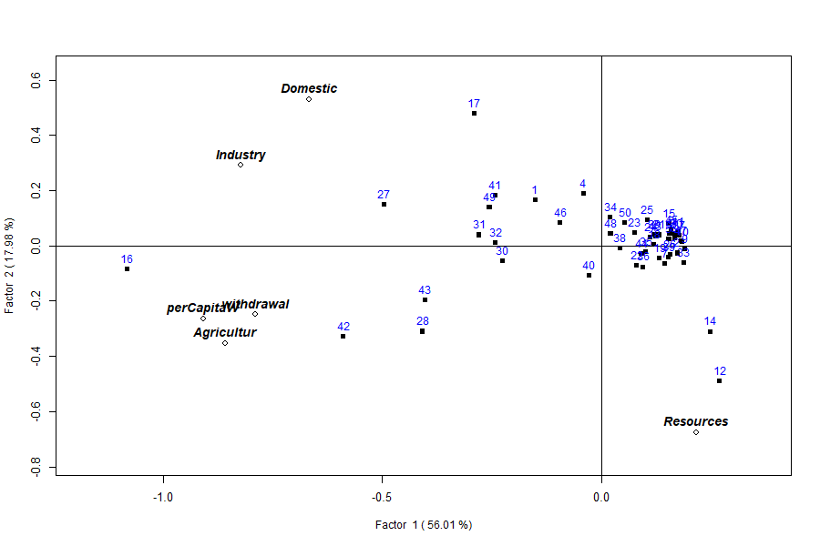
R-mode loadings

8. Q-mode: structure among samples
Q-mode loadings place each country (sample) on the factors:
head(mod$q.loading)
Factor1 Factor2 Factor3 Factor4 Factor5
1 -0.15096354 0.16396565 -0.09845319 0.06320278 0.11746 # Algeria
2 0.17385345 -0.02725198 -0.02076715 0.03416281 0.01751 # Angola
3 0.16418932 0.04313861 0.05101351 0.05296878 0.01864 # Benin
...
plot(mod, type = "loadings", plot = "q") # Q-mode loading map
plot(mod, type = "scores", plot = "q") # Q-mode scores

Q-mode loadings

9. Simultaneous Q + R: the biplot
The headline output. Called with no plot= argument, plot() draws variables (hollow diamonds, bold labels) and countries (filled squares, numbered) on the same two factors, so you read both classifications at once:
plot(mod) # or plot(mod, type = "loadings")

Simultaneous Q/R biplot
The axis labels carry the variance explained (Factor 1 = 56%, Factor 2 = 18%). Variables pointing the same way are correlated; countries near a variable score high on it. Resources sits opposite the use variables, and the countries strung along the bottom-right (e.g. 12, 14) are the resource-heavy, low-use cases.
The combined loadings and scores are available directly:
head(mod$loadings) # R-mode rows first, then Q-mode rows (56 x 6)
head(mod$scores) # combined scores
Use rowname= to label points with a column instead of row numbers:
plot(mod, rowname = "COUNTRY")
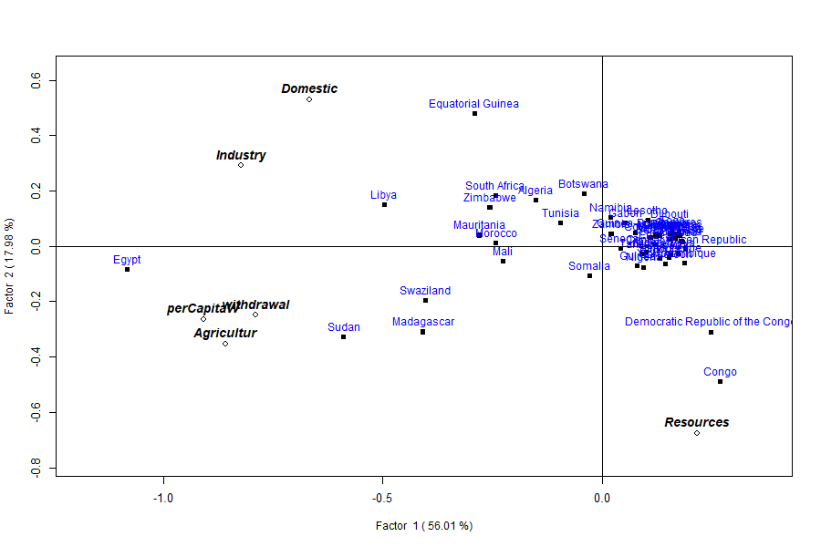
Labelled by country

10. Scores
type="scores" plots the factor scores rather than loadings. plot= selects the panel(s): "q", "r", "qr" (side by side), or "all" (a 3-panel layout).
plot(mod, type = "scores") # combined
plot(mod, type = "scores", plot = "qr") # R and Q side by side
plot(mod, type = "loadings", plot = "all")
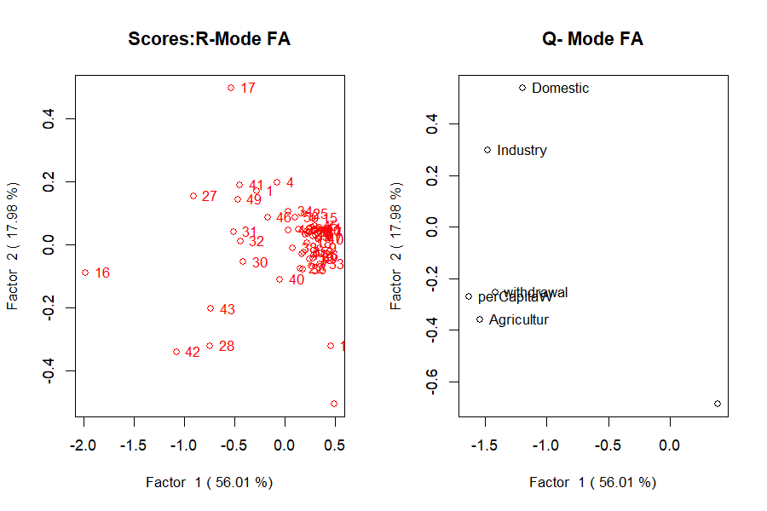
Scores, R and Q side by side

11. print() and summary()
print(mod) dumps the loadings, scores and eigenvalues. summary(mod) is the compact report a factor-analysis paper wants:
summary(mod)
Call:
qrfactor.default(source = csv, var = var)
eigen value
[1] 3.360 1.079 0.906 0.521 0.134 0.000
Percentage Explained
[1] 56.007 17.977 15.098 8.686 2.231 0.000
Cumulative Percentage Explained
[1] 56.01 73.98 89.08 97.77 100.00 100.00
R-loadings
Factor1 Factor2 ...
Domestic -0.6666965 0.5294354 ...
...

12. Scaling: the single most important choice
scale= decides what matrix is decomposed, and it changes everything. The default "sd" standardises each variable (correlation-based, so all variables count equally). The covariance options ("n", "centre", "data") leave the raw magnitudes in, so big-numbered variables dominate.
for (sc in c("sd","normal","n","centre","data"))
print(qrfactor(csv, var = var, scale = sc)$eigen.value)
scale | Basis | Eigenvalue 1 | Cumulative % (1st two)
sd (default) | correlation | 3.36 | 74.0
normal | correlation | 3.36 | 74.0
n | covariance / √n | 106 622 | 99.3
centre | covariance | 5 331 116 | 99.3
data | raw cross-product | 8 119 872 | 99.4
The lesson: on the correlation scale the six variables share the variance (56%/18%); on a covariance scale one or two large-magnitude variables swallow almost all of it (99%+). Use "sd" unless you have a specific reason not to — and always report which you used.

13. Transforming skewed variables
Water-use data are strongly right-skewed (see the histograms in Section 22). Two tools: transform all variables with scale="log"/"sqrt", or transform named variables with t=.
qrfactor(csv, var = var, scale = "log")$eigen.value
#> [1] 3.4400 1.1768 1.0055 0.1807 0.1541 0.0429
# square-root just the two most skewed:
m <- qrfactor(csv, var = var, t = c("withdrawal","Resources"))
m$eigen.value
#> [1] 3.4196 1.1454 0.8854 0.3786 0.1710 0.0000
plot(m, main = "sqrt-transformed withdrawal & Resources")
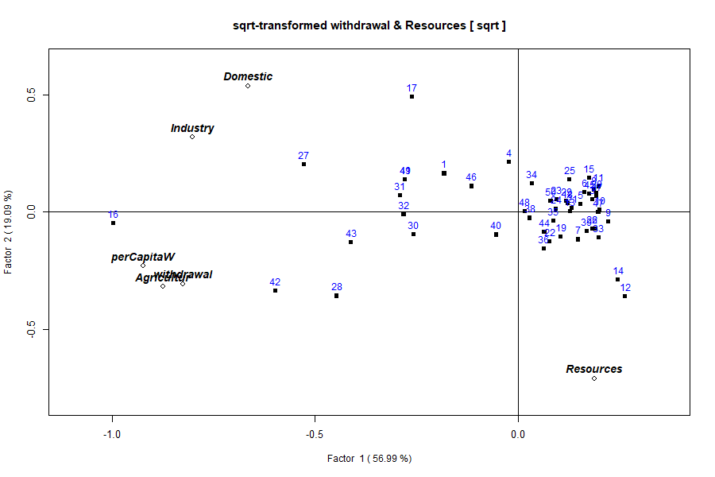
Transformed model

14. Principal coordinate analysis (PCoA)
type="coord" (aliases "coordinate", "pca2") plots the ordination from the principal-coordinate view. Choose any pair of axes with factors=:
plot(qrfactor(csv, var = var), plot = "all", type = "coord", factors = c(1,3))
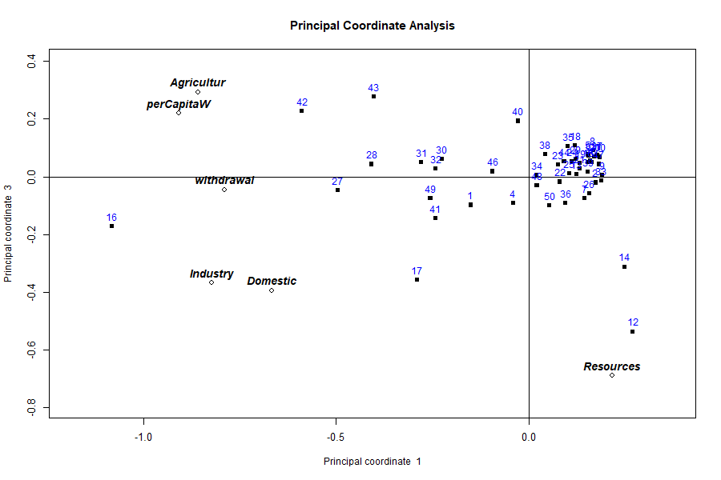
Principal coordinate analysis

15. Multidimensional scaling (MDS)
MDS is simulated with type="mds", conventionally on the centred/√n scale (scale="n") so the axes reflect raw dissimilarity:
plot(qrfactor(csv, var = var, scale = "n"), plot = "r", type = "mds", factors = c(1,2))
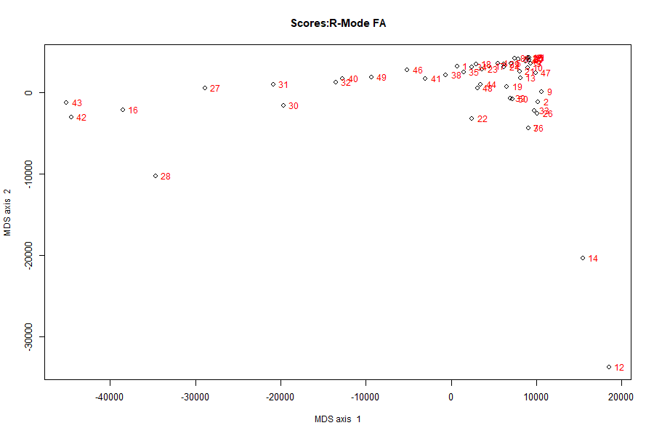
MDS
The large axis range (tens of thousands) is expected on the covariance scale — it is the dissimilarity in the original units, not standardised.

PART 2 — Spatial mode

16. From table to map
Part 1 produced one row of scores per country. But these are places, and the natural last step is a map. Give qrfactor() a shapefile instead of a table and it does the identical analysis, then writes every score, rank, index and cluster back onto the map’s attribute table — ready to draw.

17. Reading a shapefile
The bundled Africanfreshwater shapefile has the same 50 countries. Pass the folder as source and the layer name (no extension) as layer:
source <- system.file("external", package = "qrfactor")
smod <- qrfactor(source, layer = "Africanfreshwater", var = var)
class(smod$gisdata)
#> [1] "SpatialPolygonsDataFrame"
nrow(smod$gisdata)
#> [1] 50
Internally the shapefile is read with sf::st_read() and converted to an sp Spatial*DataFrame for plotting — you do not have to manage that.

18. Scores written back to the attribute table
Because p="Yes" by default, the fit appends its results to the attribute table. The six input variables become 41 columns:
names(as.data.frame(smod$gisdata))
[1] "ID" "CODE" "COUNTRY" "Year" "Domestic" "Industry" "Agricultur"
[8] "Population" "Resources" "withdrawal" "perCapitaW" "perCapitaR"
[13] "cluster" "means" "meanrank1" "meanindex1"
[17] "Factor1" "rank1" "index1" "cluster1"
[21] "Factor2" "rank2" "index2" "cluster2" ... (Factor3..6, etc.)
[41] "index"
For each retained factor you get the score (Factor1…), a rank, a normalised index (0–1), and a cluster id; plus an overall mean, mean-rank and mean-index. A worked row (Algeria) confirms the join:
gd <- as.data.frame(smod$gisdata)
gd[gd$COUNTRY == "Algeria",
c("COUNTRY","Domestic","Factor1","Factor2","index","means","cluster")]
#> COUNTRY Domestic Factor1 Factor2 index means cluster
#> 1 Algeria 37.66227 -0.276737 0.170291 0.78 60 2
Algeria’s Factor1 score (−0.277) is exactly the value from the non-spatial model in Part 1 — the analysis is identical; only the container changed.
Caveat — cluster ids are arbitrary labels. The cluster* columns come from kmeans(), whose starting points are random and not seeded. The grouping is stable but the numbers (which group is “1” vs “2”) can swap between runs — Algeria was cluster 1 in one run and cluster 2 in the next. Loadings, scores, eigenvalues and indices are fully deterministic. If you need reproducible cluster ids, call set.seed() before qrfactor().

19. plot="map": the choropleths
plot(smod, plot = "map")
This first draws the Q/R biplot, then a stream of sp::spplot choropleths: all variables together, the scaled variables, each variable on its own, the factor scores, the factor indices, the means, and the cluster maps. Two examples:
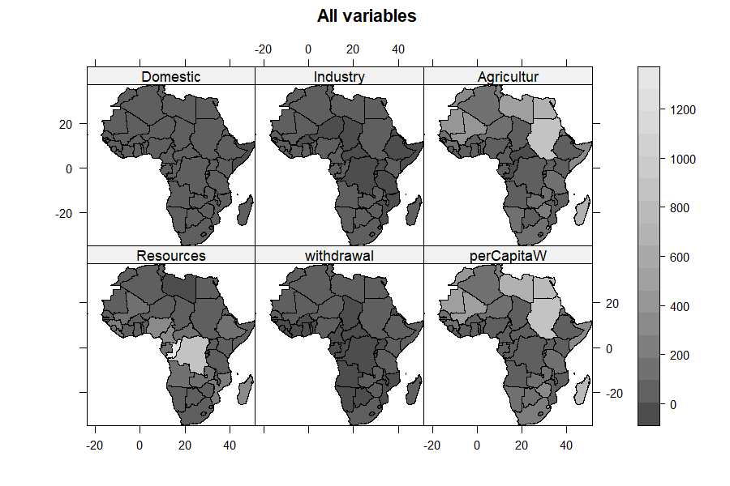
All variables
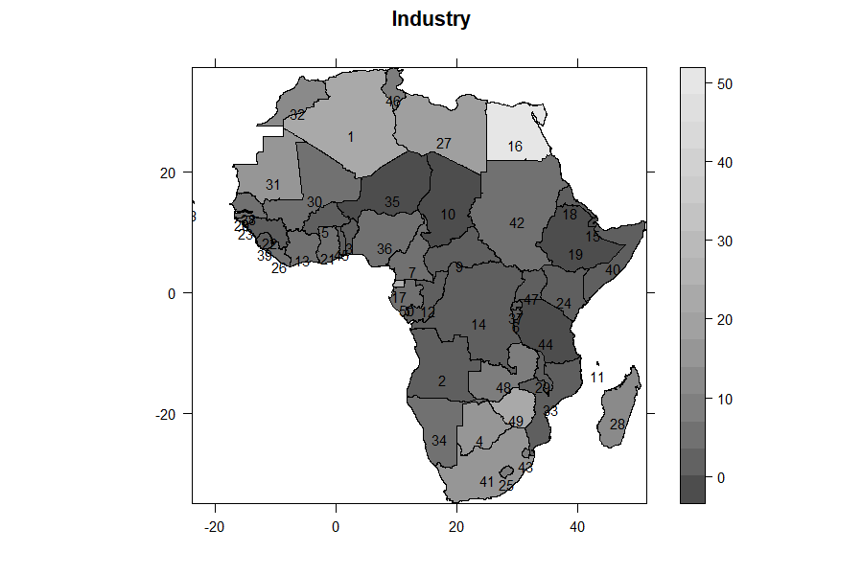
Single-variable choropleth with labels

20. Clustering: plot="cluster" and "compare"
plot="cluster" runs kmeans on the scores, draws cluster::clusplot ordination-and-hull plots, and bootstraps cluster stability with pvclust. plot="compare" is the companion that contrasts the mean-based and factor-based clusterings.
plot(smod, plot = "cluster")
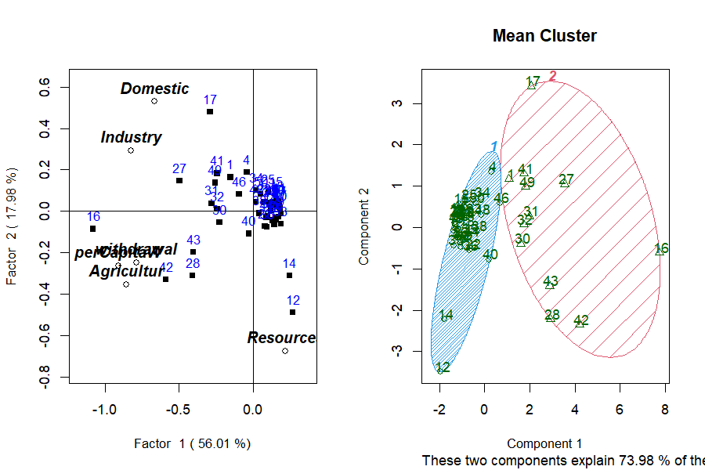
Cluster plot

21. Testing the clusters: ANOVA and Kruskal–Wallis
plot="anova" (parametric) and plot="nonparametric" (Kruskal–Wallis) test whether the variables differ across the clusters the analysis produced — the formal check that the grouping is real. For the two mean-clusters, each variable is tested in turn:
ANOVA Table Domestic for 2 Mean clusters
Df Sum Sq Mean Sq F value Pr(>F)
cluster 1 16249 16249 48.79 7.76e-09 ***
Residuals 48 15987 333
Kruskal-Wallis: Domestic by cluster
chi-squared = 22.539, df = 1, p-value = 2.06e-06
Domestic, Industry, Agricultur, withdrawal and perCapitaW all separate the two clusters at p < 0.001; Resources does not (F = 0.90, p = 0.35) — the clusters are defined by use, not by availability, exactly as Factor 1 suggested.

22. Distributional diagnostics: type="diagnose"
type="diagnose" draws a histogram (with a fitted normal curve) for every variable, a χ² Q–Q plot of Mahalanobis distances, and flags multivariate outliers with mvoutlier::aq.plot:
plot(smod, type = "diagnose")
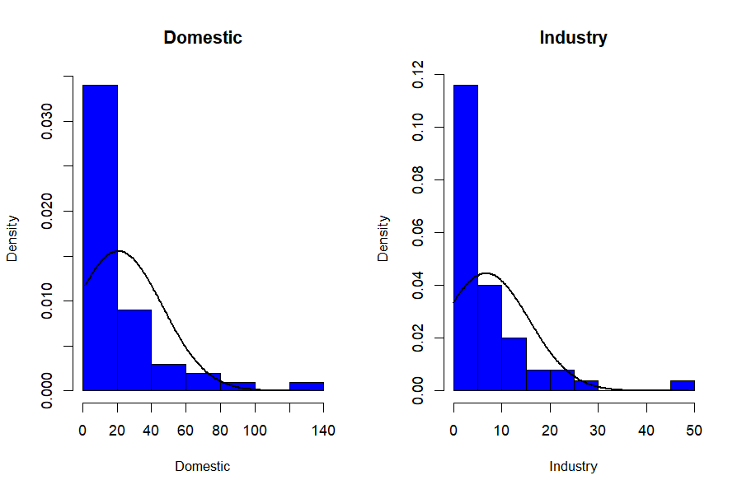
Diagnostic histograms
The histograms show the strong right skew typical of water-use data — the case for the transforms in Section 13.
Caveat — collinearity. The Mahalanobis/outlier panel inverts the covariance matrix. In this dataset Agricultur and perCapitaW are almost the same variable (correlation 0.992), which makes that matrix singular. qrfactor now catches this: it draws the histograms, skips the multivariate-normality panel, and prints a warning telling you to drop or combine the near-duplicate variables — instead of failing outright. For a clean outlier panel, run diagnose on a non-collinear subset, e.g. drop perCapitaW.

23. Joining a CSV to a shapefile
If your measurements live in a CSV and your geometry in a shapefile, join them in the call with m= (the shared key column) and f= (the CSV path):
mjoin <- qrfactor(source, layer = "Africanfreshwater",
var = var, m = "COUNTRY", f = csv)
The CSV rows are matched to features by COUNTRY, combined (row alignment is preserved by the internal spCbind replacement), and the analysis proceeds as if the data had been in the shapefile all along.

24. Using an in-memory spatial object
You can also hand qrfactor() a spatial object you already have in the session — set layer="gisobject":
gisobj <- smod$gisdata # a Spatial*DataFrame (or an sf object)
m2 <- qrfactor(gisobj, layer = "gisobject", var = var)
class(m2)
#> [1] "qrfactor"

PART 3 — Reference

25. qrfactor() argument reference
qrfactor(source, layer='', var=NULL, type='', p="Yes",
scale="sd", t='', nf=2, m=NULL, f=NULL, ...)
Arg | Meaning
source | data frame, CSV/txt path, shapefile folder, or spatial object
layer | shapefile layer name; "gisobject" for an in-memory object; a filename for CSV/txt
var | character vector of variable (column) names to analyse — must be numeric
type | analysis flavour carried to plot (e.g. "mds", "coord"); usually set on plot()
p | "Yes" (default) writes scores/clusters back to the attribute table
scale | "sd" (default, correlation), "normal", "n", "centre", "data", "log", "sqrt"
t | character vector of variables to transform (e.g. c("withdrawal","Resources"))
nf | number of factors for clustering (default 2)
m, f | join key column and CSV path for CSV↔shapefile joins

26. plot.qrfactor() argument reference
plot(x, factors=c(1,2), type="loading", plot="",
cex="", pch=15, pos=3, main="", xlim="optimise", ylim="optimise",
abline=TRUE, legend="topright", legendvalues=c(100),
values=FALSE, nfactors=3, rowname=TRUE, par=c(1,2), ...)
- type — what to draw: "loadings" (default), "scores", "pca" (lowercase — "PCA" falls through to the default biplot), "coord"/"coordinate", "mds", "diagnose", "cluster".
- plot — which panels: "" (combined), "r", "q", "qr", "all", "map", "cluster", "compare", "anova", "nonparametric".
- factors — the two axes to draw, e.g. c(1,2), c(1,3).
- rowname — a column name to label points (e.g. "COUNTRY").
- cex — magnify text, or a variable name to size points by a variable.
- values — TRUE, or a variable name, to annotate points with values.
- xlim/ylim — "optimise" (auto), numeric c(lo,hi), or the shortcuts "r"/"q"/"qr".
- abline — TRUE for reference axes, or c(intercept, slope).
plot(mod, factors = c(1,3)) # other axes
plot(mod, xlim = c(-1.5,1.5), ylim = c(-1.5,1.5)) # fixed limits
plot(mod, cex = c("withdrawal"), values = TRUE, pch = 23) # size + annotate
plot(mod, abline = c(-0.5, 0.5)) # custom reference line
plot(mod, rowname="COUNTRY", cex=c("withdrawal"), # the full-dress plot
legend="topleft", values=TRUE, pch=23)
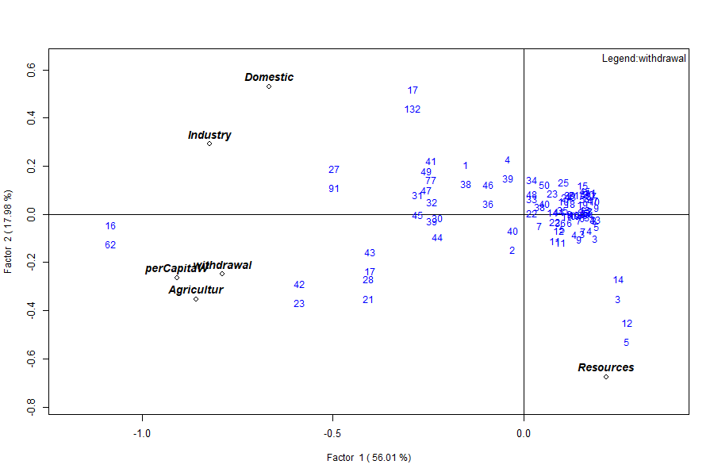
Sized and annotated

27. The object’s elements
Element | Class | Dim
gisdata | data.frame / Spatial | 50 × 41 (spatial)
correlation | matrix | 6 × 6
eigen.value / eigen.vector | numeric / matrix | 6 / 6×6
r.loading (rloading, rloadings) | matrix | 6 × 6
q.loading (qloading, qloadings) | matrix | 50 × 6
combined.loadings / loadings | matrix | 56 × 6
r.scores / q.scores / combined.scores / scores | matrix | 50×6 / 6×6 / 56×6
pca (pca.loadings) / pca.scores | matrix / df | 6×6 / 50×6
variance / cumvariance | numeric | 6
x.standard | matrix | 50 × 6
data | data.frame | 50 × 6
variance, normal, transform, nfactors, call | metadata | —

28. Reproducing the figures
Every table and figure here comes from reproduce_manual.R in this folder:
source("reproduce_manual.R")
# writes repro_output.txt and figures/*.png
It exercises all five input modes, all six analyses, every scale/type/plot option, the print/summary/plot methods, the spatial maps, the diagnostics and the join — and logs each figure ok/FAIL.

29. Honest limits and caveats
- Numeric data only. Categorical or character columns must be dropped or encoded first.
- Collinearity. Near-duplicate variables (here Agricultur ≈ perCapitaW, r = 0.992) drive the smallest eigenvalue to ~0 and make the Mahalanobis diagnostic singular. The last factor is then numerical noise; consider dropping one of the pair.
- Cluster ids are random labels. kmeans is unseeded — groupings are stable, id numbers are not. Seed for reproducibility.
- scale= dominates the result. Correlation vs covariance scaling changes the variance split from 56%/18% to 99%/… . Report your choice.
- Case sensitivity. type="pca" works; type="PCA" silently gives the default biplot.
- plot="map" is verbose — it emits the biplot plus many spplot pages; send it to a multi-page device (PDF) or a PNG sequence if you want to keep them.

30. Glossary
- Loading — weight relating a variable (R-mode) or sample (Q-mode) to a factor.
- Score — a sample’s/variable’s coordinate on a factor.
- Eigenvalue — variance captured by an axis; Kaiser rule keeps > 1.
- R-mode / Q-mode — classification of variables / of samples.
- Biplot — variables and samples on one set of axes.
- PCoA — principal coordinate analysis; ordination from distances.
- MDS — multidimensional scaling; a similarity map.
- Choropleth — a map coloured by a variable’s value per area.
- clusplot — cluster’s ordination plot with group hulls.
- Mahalanobis distance — multivariate distance used for outlier detection.

31. Exercises
- Retention. From mod$eigen.value, how many factors pass the Kaiser rule? What cumulative variance do they carry? (Answer: two; 74%.)
- Scaling. Run qrfactor(csv, var=var, scale="data") and compare variance to the default. Why does Factor 1 jump to ~99%? (Covariance scale lets the largest-magnitude variable dominate.)
- Collinearity. Drop perCapitaW from var and refit. What happens to the smallest eigenvalue, and does type="diagnose" now draw the outlier panel? (The near-zero eigenvalue lifts; the covariance matrix is no longer singular, so the panel renders.)
- Spatial. Fit the shapefile model, then map index2 for every country by colouring smod$gisdata$index2. Which countries top Factor 2?
- Reproducibility. Add set.seed(1) before the shapefile fit and confirm the cluster ids are now stable across two runs.

qrfactor — simultaneous Q- and R-mode factor analysis for spatial data. This manual and all its numbers were produced by running the package on the bundled African freshwater data (50 countries). Restoration of the CRAN-archived package; see NEWS.md for the 1.5 change list.

