**Assignment-10**

**PL/sql-3**

**Name-Ashish Goyal**

**Id-2016ucp1100**

**Batch-A (1, 2)**

**1- Write procedure to check whether a number is prime or not.**

**Procedure-**

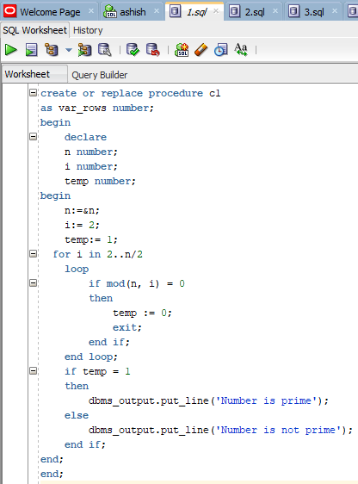

**Input-**

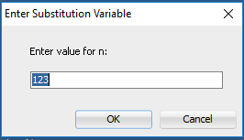

**Result-**

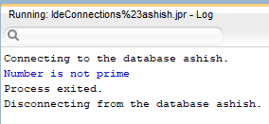

**2- Write a function to check whether a number is prime or not.**

**Function-**

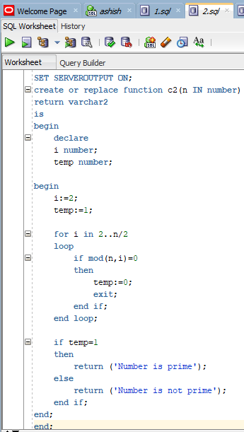

**Function Call-**

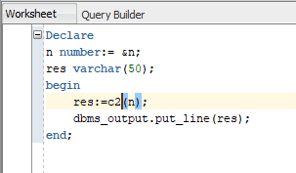

**Input-**

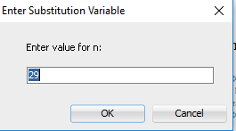

**Result-**

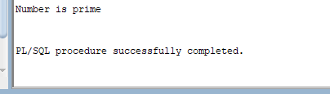

**3- Write procedure to check whether a string is palindrome or not.**

**Procedure**

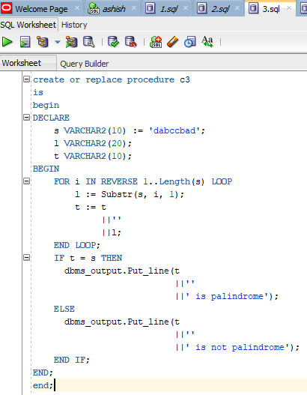

**Result-**

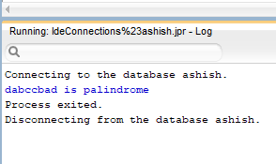

**4- Write function to check whether string is palindrome or not.**

**Function-**

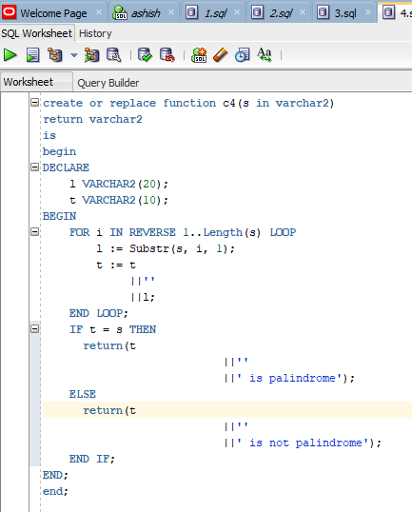

**Function Call-**

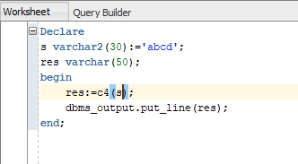

**Result-**

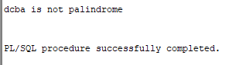

**5- Create package to find area and circumference of circle with given radius.**

**Procedure and Package-**

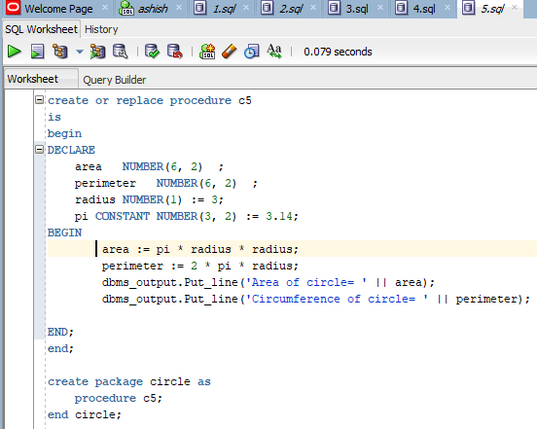

**Result-**

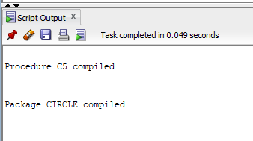

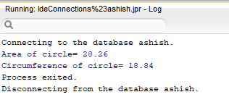

**6- Create a trigger to delete tuple from table A even if foreign key violation is there by first deleting tuples from table B.**

**Creating Tables-**

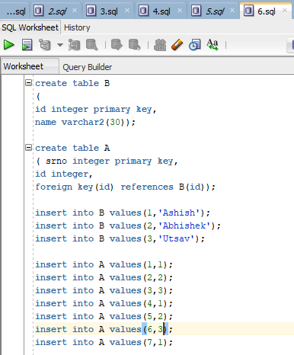

**Show Tables-**

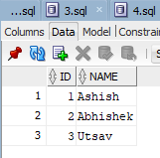

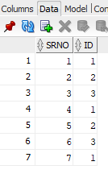

**Trigger-**

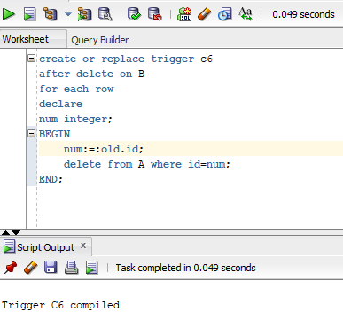

**Delete Query-**

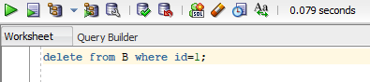

**Final Result-**

