**Assignment-8**

**Mid2**

**Name-Ashish Goyal**

**Id-2016ucp1100**

**Batch-A (1, 2)**

**Flights (flno,frm,too,distance,departs,arrives,price)**

**Aircraft (aid,aname,cruisingrange)**

**Certified (eid,aid)**

**Employee (eid,ename,salary)**

**Create Tables:**

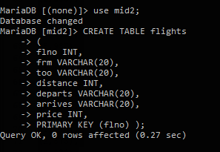

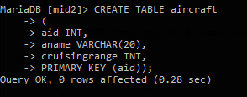

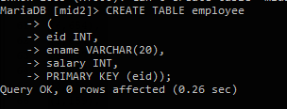

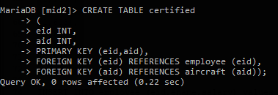

**Insert values into table:**

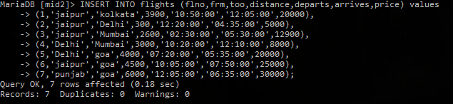

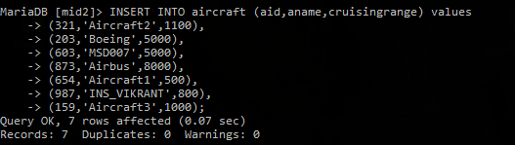

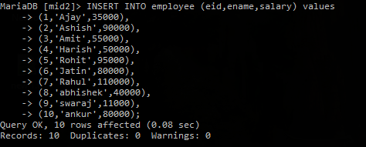

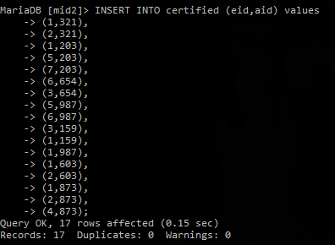

**Show tables:**

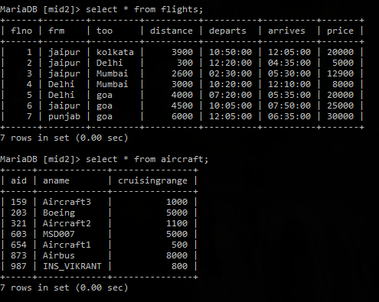

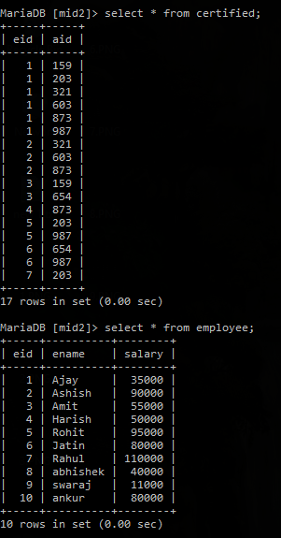

**Queries:**

**1-find the names of pilots certified for some Boeing aircraft.**

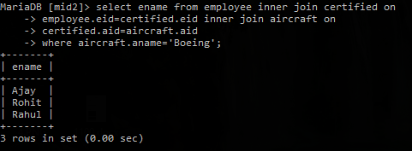

**2-print name and salary of every non pilot whose salary is more than average salary of pilots.**

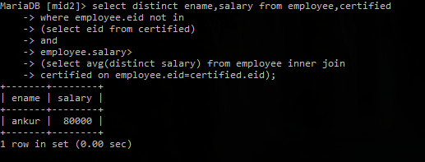

**3-print names of employees who are certified only on aircrafts with cruisingrange longer than 1000 miles, but on at least 2 such aircrafts.**

