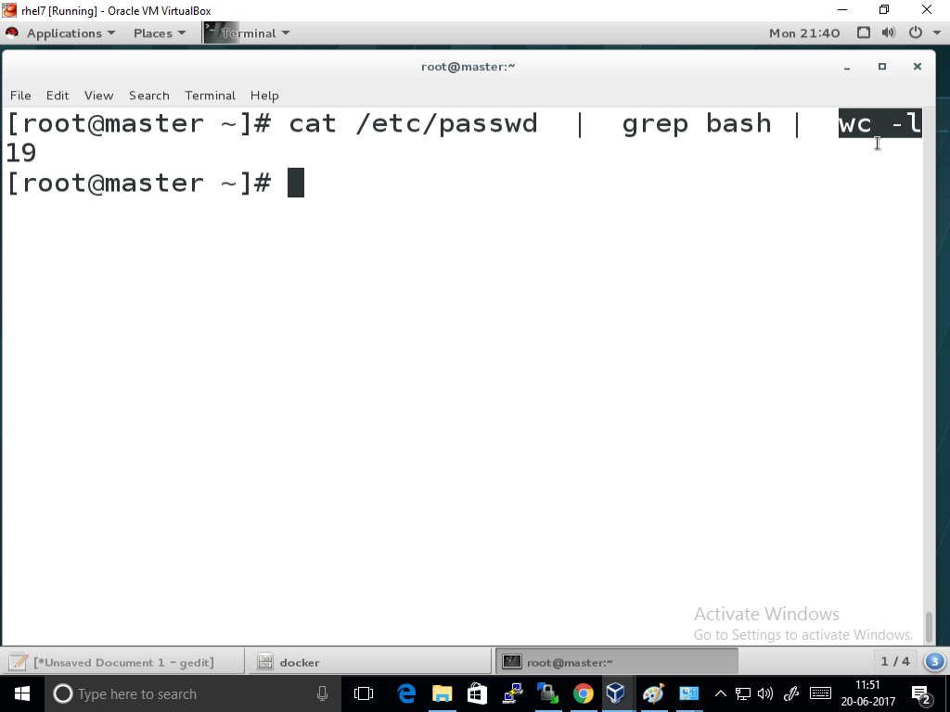

Step 1:

Do you have ip address at your n/w card

Step 2:

All system must ping each other with hostname

Step 3:

Firewall stop

Step 4:

Check your spelling

Step 5:

Name and data node , dir remove,

Create new dir

Update this in your conf

Start service

